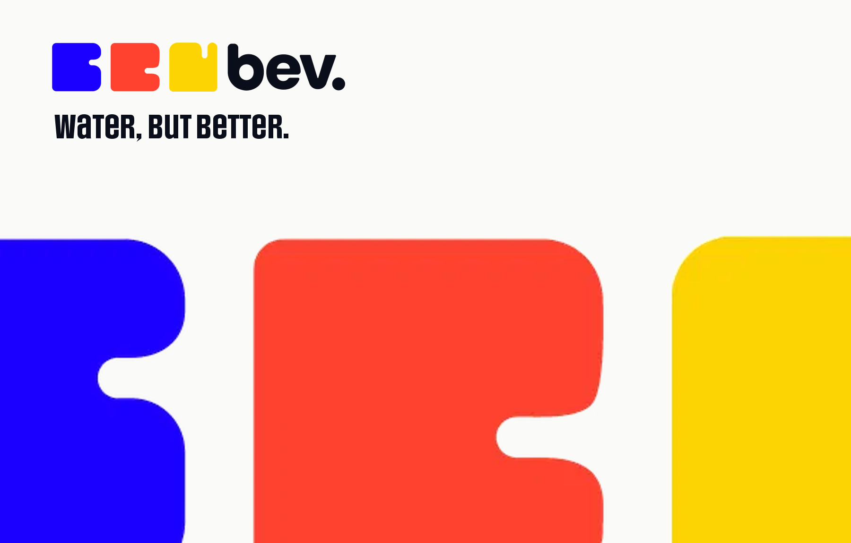
Identity and brand system
Brand guidelines
bev. is a modern hydration and wellness brand built around a simple idea: make the functional stuff easier, more enjoyable and more human. This document holds the parts of the brand that do not change, and the rules that keep them recognisable everywhere they appear.

Document | Brand guidelines
Owner | Utopia Foodworks Pvt Ltd
Applies to | All bev. packaging, documents, retail and digital work
Web | bevhydration.com
Contact | contact@utopiafoodworks.com

Confidential. Provided for the sole purpose of work on the bev. brand.
01 Brand strategy
The foundation of the brand: its story, mission, vision and personality. Everything after this section is downstream of it.

About the brand
bev. is a modern hydration and wellness brand built around a simple idea: make the functional stuff easier, more enjoyable and more human. With flavour enhancers and electrolytes that turn everyday water into something you actually want to drink, bev. sits where wellness meets everyday enjoyment.

Functional without feeling clinical.
Playful without feeling childish.
Designed without feeling overly designed.
Because feeling good doesn't have to be complicated.
Brand story
We all know we should drink more water. Yet somehow, a simple glass of water is one of the easiest things to forget.
The problem isn't that people don't understand hydration. It's that hydration has become another task on an already endless list of things.
bev. exists to change that. What started with a simple functional need becomes something more enjoyable. bev. brings together the things that usually live in separate worlds: function and fun, wellness and personality, structure and spontaneity. Because taking care of yourself shouldn't always feel serious.
Mission and vision
Mission | Make everyday hydration more enjoyable.
 | We make functional hydration simple, flavourful and easy to fit into real life, helping people build better hydration habits without making wellness feel like work.
Vision | Build a world where choosing better feels effortless.
 | bev. aims to make functional wellness feel less intimidating, less complicated and much more enjoyable, starting with hydration and expanding into the everyday rituals that help people feel good.
Brand insights
Function isn't enough.
People know they need to hydrate. The challenge is making them want to.
Wellness doesn't have to be serious.
There is space for a functional brand that feels colourful, social and full of life.
Small habits matter.
bev. makes one everyday behaviour, drinking water, easier and more enjoyable.
People choose what they enjoy.
Flavour and personality can turn a functional product into something people actively reach for.
Tone and persona
bev. is the person who makes better choices feel easy, social and enjoyable. It understands the functional side of wellness, but never communicates from a position of authority or instruction.
It is informed, not clinical. Expressive, not chaotic. Playful, not childish.

bev. is | bev. is not
Fun | Frivolous
Smart | Serious
Confident | Preachy
Human | Perfect
02 The mark
Three coloured forms and a rounded wordmark. Structured and approachable at the same time, which is the whole point.

Primary logo
The three coloured forms give the logo its immediate energy and recognisability, while the rounded typography adds a sense of fun, friendliness and ease. Together they capture the core of bev.: functional at its heart, but never boring.
The primary logo is the default brand signature across key touchpoints. Icon and wordmark are drawn as one object. Never rebuild the lockup by setting the word bev. next to the forms, and never redraw the forms.
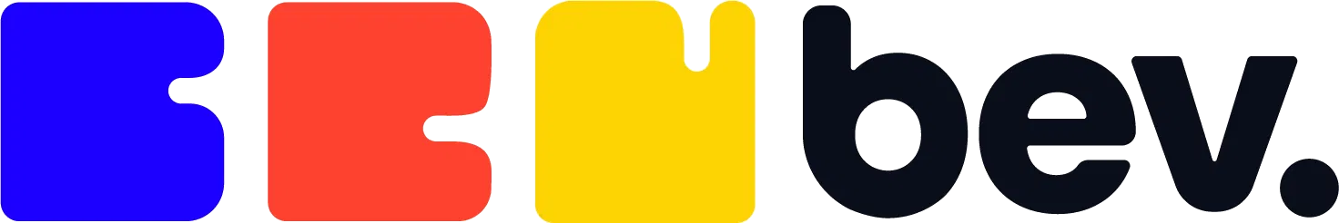
Primary logo. Blue, red and yellow forms, ink wordmark.
Secondary logo
The secondary system gives bev. more flexibility across touchpoints while retaining the core identity. It holds two expressions: the standalone bev. wordmark inside a circular container, and the three-part modular symbol used on its own.
The circular wordmark suits smaller contained applications such as social avatars, stickers and merchandise. The standalone symbol works as a graphic device across packaging, patterns and communication.
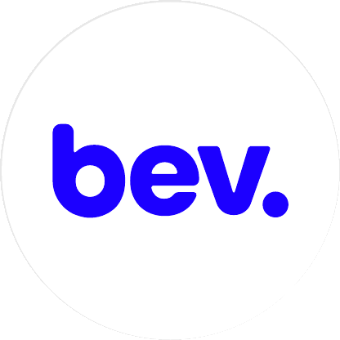 | 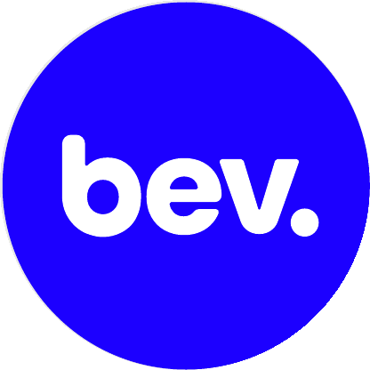 | 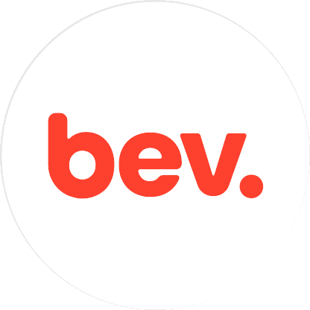
Circular wordmark. Blue on white, reversed on blue, red on white.

The three-part modular symbol, used independently as the brand icon.
Clear space
Clear space on all four sides equals X, the unit marked on the construction diagrams. Nothing sits inside that field: no text, no rule, no image edge, no page trim. X scales with the mark, so the rule holds at every size.
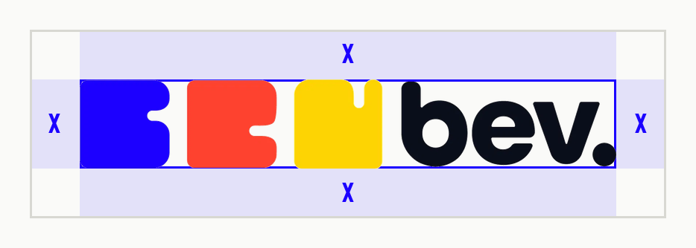
Full logo. X on every side.
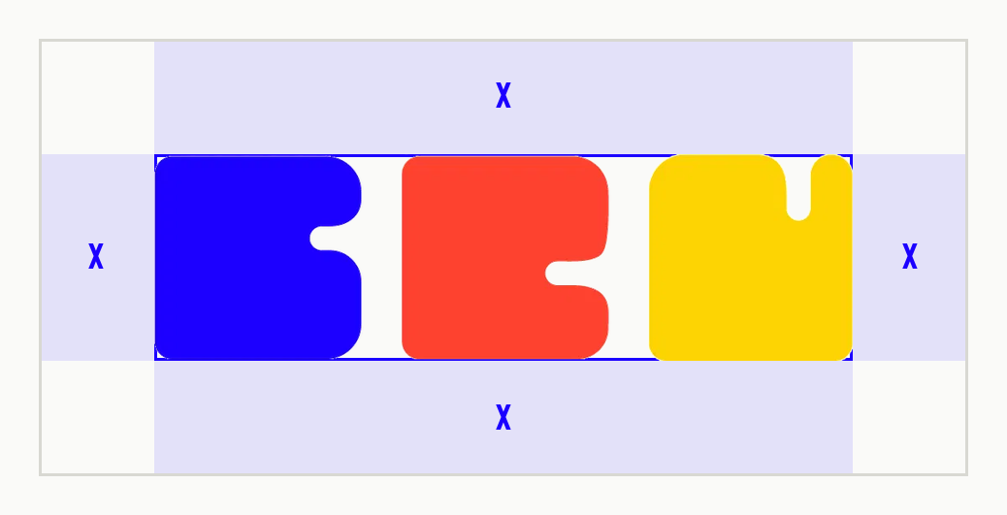
Standalone symbol. The same rule, the same unit.
Minimum size
Below these sizes the notches close up and the mark reads as a smudge. If the space is smaller than the floor for the full logo, use the symbol alone rather than shrinking further.
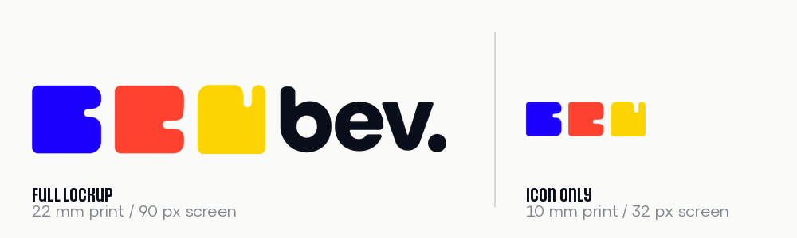
Correct usage
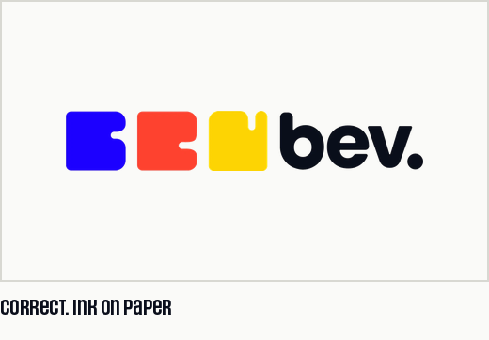 | 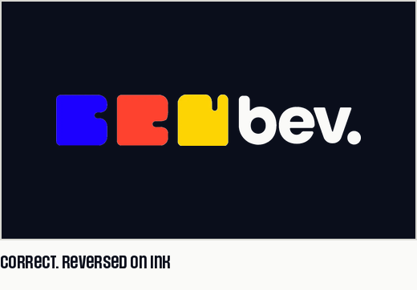
Incorrect uses
Each tile below is a real manipulation of the real artwork, so it is recognisable when it turns up in a supplier proof. The logo always retains its original proportions and its fixed blue, red, yellow sequence.
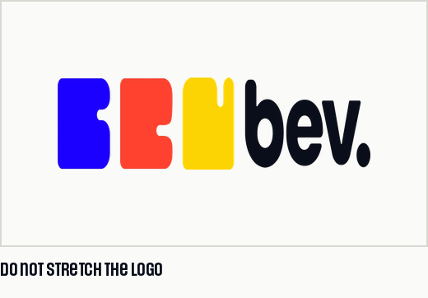 | 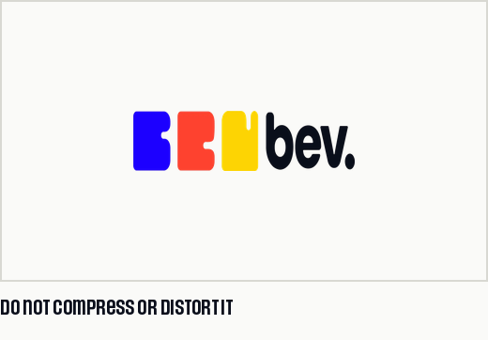 | 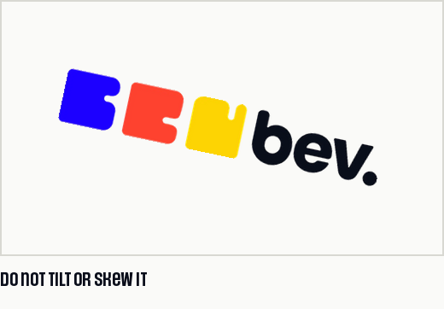

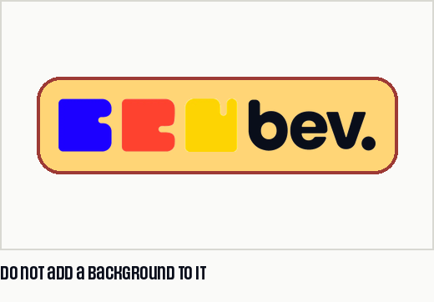 | 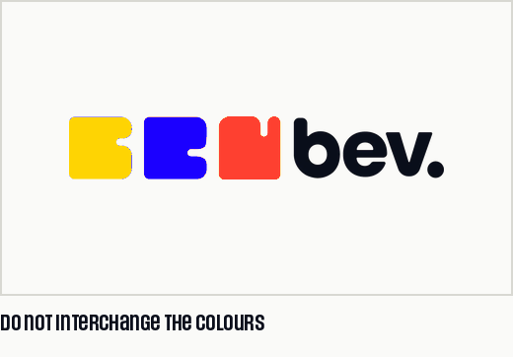 | 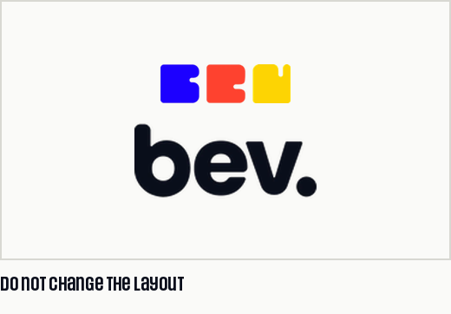

One more, which no tile can show
Do not type the mark. bev. set in a font is not the wordmark, however close the font looks. The mark is always placed as artwork.
Co-branding
In a partner lockup, the bev. logo sits left, the partner mark sits right, and a divider separates the two at a distance of X. The two marks are balanced optically rather than by matching widths, and clear space applies to the pair. bev. never sits inside another brand's container shape, and no partner colour is applied to the forms.
Favicon
The symbol alone carries the brand at favicon size, centred with full clear space, on bevhydration.com and anywhere else a square or circular crop is the only option.
03 Colour
Three primaries, each carrying a meaning. Blue hydrates, red performs, yellow recovers. The order they run in is fixed.

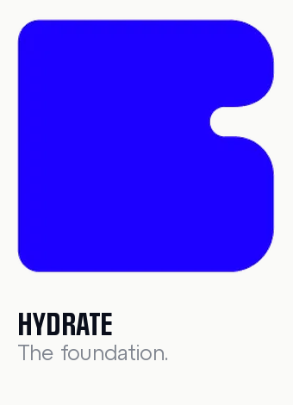 | 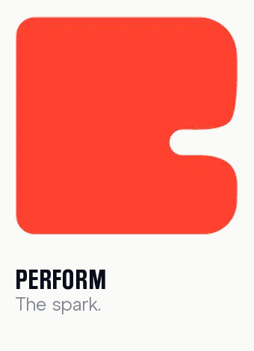 | 

What each colour carries
Blue | Hydrate. The foundation. Energy starts with hydration, recovery starts with hydration, performance starts with hydration. Blue represents balance, clarity and everyday wellness.
Red | Perform. The spark. Movement, focus, energy. This is the active side of the brand, the part that helps people do more.
Yellow | Recover. The reward. Rest, recovery, restoration. The reminder that wellness isn't only about output. It's also about feeling good.

The palette
 | Name | Hex | Role
 | Blue | #1B00FF | Primary. Hydrate. Links and the key call to action
 | Red | #FE4030 | Primary. Perform. Energy moments and alerts
 | Yellow | #FED403 | Primary. Recover. Highlights and packaging pop
 | Berry | #9D3A35 | Extended. Depth behind fruit and flavour work
 | Sky | #89A4FF | Extended. Soft, cool support for blue
 | Sand | #FFD576 | Extended. Warm, quiet support for yellow
 | Ink | #0A0E1B | Wordmark and all body text
 | Paper | #FAFAF8 | Backgrounds, cards, negative space
 | Grey | #80858F | Captions, secondary text, eyebrow labels

How the palette is used
- The three primaries always run blue, red, yellow. That sequence is part of the mark and never changes.
- One colour leads per layout. The other two may sit in the mark or a rule, but never compete.
- The extended three are support. They never lead a layout and never appear in the logo.
- Never set body copy in a primary colour. Blue is for links and the one action you want taken.
- Primaries are never tinted, screened back or gradient filled. Full strength or not at all.
- Hex is the truth for screen. For print, match to coated stock and sign off a drawdown.

Accessibility
- Ink on paper clears WCAG AAA at every size. Paper on ink clears AAA reversed.
- Blue on paper clears AA at 14 pt and up. Safe for links and headings, not long copy.
- Red and yellow clear AA at no size. Use them as fills and rules only.
04 Typography
Two faces do the work. Social Gothic carries the headline, Atyp BL carries the information. A third adds personality where it is earned.

The stack
Face | Role | Where it works
Social Gothic | Primary | Clean and confident. Headlines, packaging, navigation and key information.
Atyp BL | Secondary | The workhorse. Legible and neutral. Body copy, product information and long form.
Sys Falso | Supporting | The unexpected detail. Special mentions, numbers and labels. Not embedded in this file.

Social Gothic weights
The family ships Regular, Medium, Demibold and Bold, plus Soft, Rough and Stencil display cuts. These documents use Regular and Bold for headlines, Demibold for section headings and Medium for labels. Soft, Rough and Stencil are reserved for packaging and campaign work.
Hierarchy
Level | Face | Use
Heading 1 | Social Gothic | Page and section headlines, packaging front
Heading 2 | Atyp BL | Subheads and standfirsts
Body | Atyp BL | Running copy
Body 2 | Atyp BL | Captions and legal
Quotes | Sys Falso | Quotes, dialogue and hand-written moments

Rules
- Weight and size carry the hierarchy. Never add a fourth face to make a headline louder.
- One headline size per page. If two compete, one of them is a subhead.
- Set body copy flush left, ragged right. Never justify, never centre it.
- Sys Falso is a seasoning, not a serving. Once on a layout is plenty.
- Social Gothic is unicase, so lowercase comes out as capitals. Never set bev. in it.
Social Gothic and Atyp BL are embedded in this file. Sys Falso is not, so quotes fall back to Atyp BL.
05 Voice
bev. makes better choices feel easy, social and enjoyable. It never speaks from a position of authority or instruction.

How it sounds
- Say the thing. The first sentence carries the point, not the wind up.
- Short sentences. If a line needs a comma to survive, it probably needs a full stop instead.
- Specific over abstract. A 4 pm slump beats an energy dip.
- Invite, never instruct. bev. does not tell people what their body needs.
- No promises we cannot keep. Electrolytes are a fact. Your best self is not.

Sounds like bev. | Does not sound like bev.
Squeeze. Swirl. Sip. | Optimise your hydration protocol.
Water you will actually finish. | You are chronically dehydrated.
For the 4 pm slump and the 6 am run. | Unlock your best self, every single day.
Hydration, with benefits. | Clinically engineered wellness science.

Lines that belong to the brand
water, but better. | The signature line. The one that closes a piece.
Squeeze. Swirl. Sip. | Product and pack. How it actually works.
Hydrate. Perform. Recover. | The three colours, said out loud.
Simple. Effective. Enjoyable. | What the brand is, in three words.

What to avoid
Not a banned word list, a banned posture. Avoid anything that lectures, diagnoses, shames or oversells: clinical language, medical claims, guilt about yesterday, and the tired vocabulary of transformation.

Writing the name
bev. is lowercase with the full stop, always. It is never capitalised, never italicised, and never set in the display face mid sentence. The legal entity, Utopia Foodworks Pvt Ltd, is written in full on first mention.
06 Application
Where the system meets the real world. When a surface is not covered here, the closest case wins.

Packaging
- Symbol on the cap, full logo on the front panel, always on a paper or ink ground.
- Flavour is carried by a single colour band, never by recolouring the forms.
- Product and legal copy in Atyp BL at 8 pt minimum, ink on paper, never reversed.
- The claim block stays factual. Flavour and electrolytes, with no extra adjectives.
Social
- Avatar is the circular wordmark or the symbol alone, centred, with full clear space.
- One colour leads per post. Rotate the lead across the grid so the feed keeps moving.
- Headlines in Social Gothic, captions in Atyp BL. No third face, no outlined type.
- Copy is written the way it would be said out loud. If it cannot be read in one breath, cut it.
Documents
Every outgoing document carries the masthead: the logo, the Utopia Foodworks line, the tricolour bar and a hairline. The footer carries a context line and a page number. The letterhead template that ships with this document is the starting point for anything on the company's name. Overwrite the bracketed placeholders and leave the frame alone.
Retail and events
- Ink or paper ground. Colour reserved for the mark, the flavour band and the price flash.
- At distance the symbol does the work. Do not set a headline the eye cannot catch at speed.
- Event and race collateral may run the symbol at scale, cropped and bled, but never rotated.
Before anything ships
- The mark is placed as artwork, never typed, and the clear space is intact.
- The forms run blue, red, yellow, in that order, at full strength.
- One colour leads, and no body copy is set in a primary colour.
- Headlines are Social Gothic, running copy is Atyp BL, Sys Falso appears at most once.
- bev. is lowercase with the full stop in every instance, including headlines.
- Nothing on the page lectures, diagnoses or oversells.

Quick reference
Everything a supplier, a freelancer or a new hire needs on one page. If a detail is not here, it is in the section above.
Item | Value
The one line | water, but better.
Name in text | bev. Lowercase, full stop, always.
Legal entity | Utopia Foodworks Pvt Ltd
Primary face | Social Gothic. Headlines and key information
Secondary face | Atyp BL. Body copy and long form
Supporting face | Sys Falso. Sparing emphasis only
Primaries | #1B00FF blue, #FE4030 red, #FED403 yellow
Extended | #9D3A35 berry, #89A4FF sky, #FFD576 sand
Ink, paper, grey | #0A0E1B, #FAFAF8, #80858F
Minimum size | 22 mm or 90 px full logo. 10 mm or 32 px symbol.
Clear space | X on all four sides, at every size.
Web | bevhydration.com
Artwork and assets | [link to the shared brand folder]

Questions about anything in this document go to Utopia Foodworks Pvt Ltd at contact@utopiafoodworks.com. water, but better.

