1. **Problem statement**

This project is about lexical analysis. The main purpose of the project is writing a code that can read in a line of code in Rat18s and distinguish all tokens from each other. The language of code does not matter but our group has used C++ to write the code for the project. As it was mentioned the program is responsible for being able to distinguish the tokens that are used in language Rat18s and in order to do so we wrote our code in C++.

1. **How to use our program**

Our program can be used using executable file a.out. In order to run the program, the .exe file needs to be run but before the user needs to enter the RAT18S code into a file called sample.rat18s which is the file that the executable reads from. After these processes are done the program will distinguish tokens used in RAT18S and outputs the result to the console.

1. **Design of your program**

We used a class in our project called lexer which is being called from the main. The class consists of two different parts, the header and the .cpp, which is basically the body for all the functions that we use in our class. In our main we only make an object of the laxer class and we have the object to read rat18s lines from the .rat18s file using a function in our class called checkFile(). It reads all the lines from that file and the class analyzes the lines inside of it and outputs the tokens. 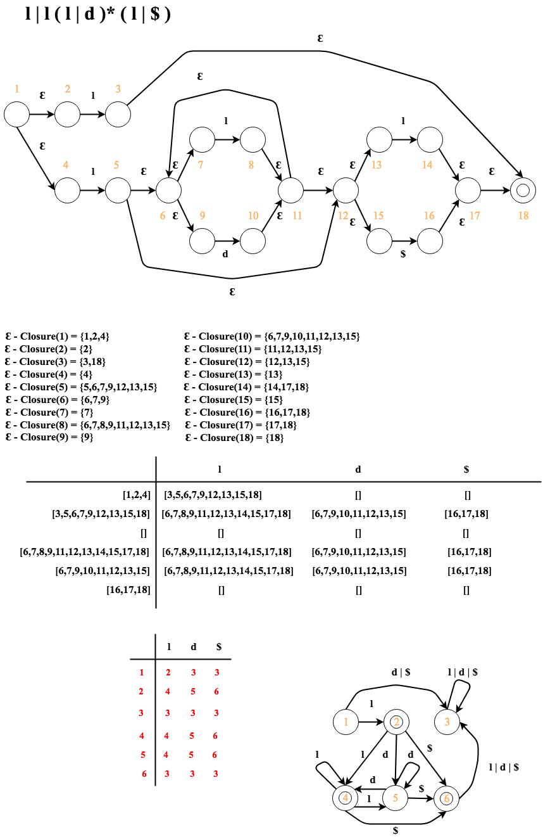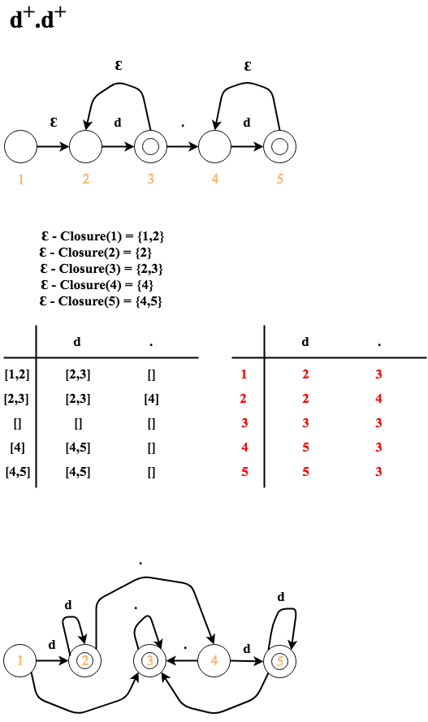

1. **Any Limitation**

­­The lexeme maximum character allowance is one of our limitations. It is limited to 100 characters.

1. **Any Shortcomings**

None