Báo cáo chung

Trịnh Quang Quân 20200511 nhóm 19

1. Use case diagram

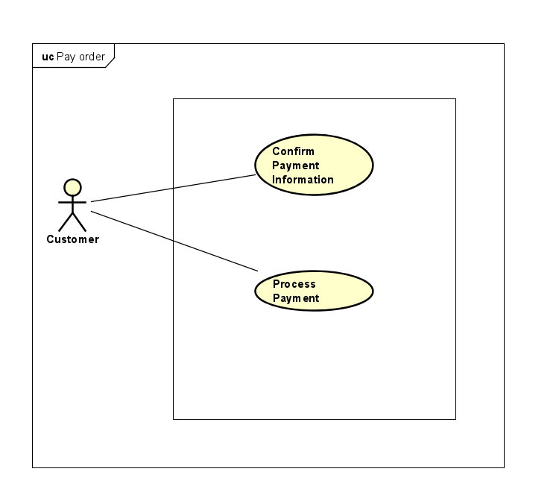

1. Class diagram

1. Activity diagram

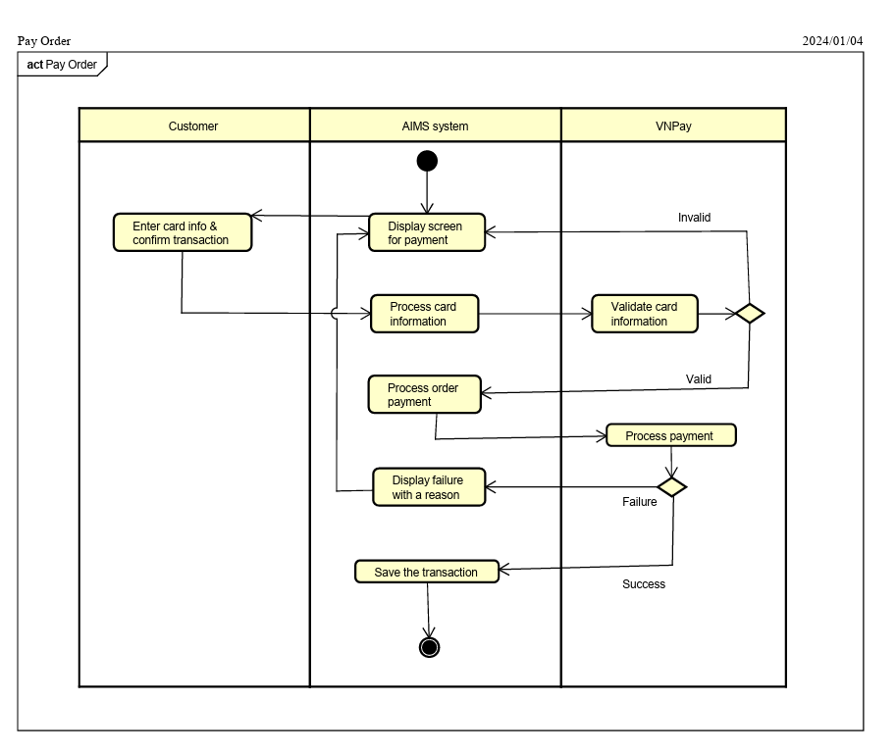

1. Sequence diagram

