HW2

1. sol

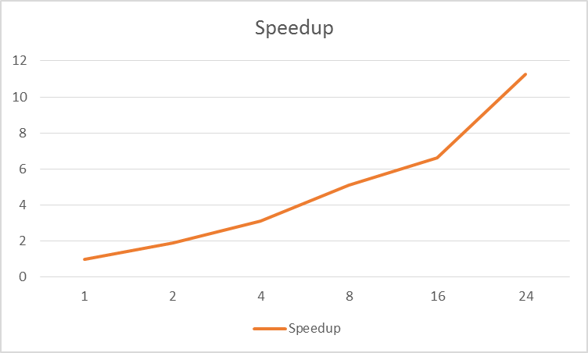

|  |  |  |
| --- | --- | --- |
| Threads | Runtime | Speedup |
| 1 | 1027.39s | 1 |
| 2 | 544.11s | 1.89 |
| 4 | 332.52s | 3.10 |
| 8 | 201.46s | 5.10 |
| 16 | 154.72s | 6.64 |
| 24 | 91.27s | 11.26 |

$$S\left(n\right)= \frac{1}{\left(1-P\right)+\frac{P}{n}}$$

As rough estimation, substitute the 5 records, $P=\frac{1}{5}\sum_{k=0}^{4}{P_{k}≈0.922}$

I.e. approximately 7.8% of the code is strictly serial.

$S\left(∞\right)= \frac{1}{\left(1-P\right)+\frac{P}{∞}}=$ 12.82, T(min) = 80.14s

1. sol

Suppose we have a k-issue machine, assuming $T_{i}$ is the time taken on one processor;

For the cases no more than k instruction per cycle, and more than k instruction per cycle,

$$S_{sub}= \sum_{i=0}^{k}{{i*f}_{i}}{ ; S}_{sur}= \sum_{i=k+1}^{∞}{k*f_{i}}$$

For the cases,

Thus, $S_{sub}= \sum_{i=0}^{k}{{i*f}_{i}}+ \sum_{i=k+1}^{∞}{k*f_{i}}$

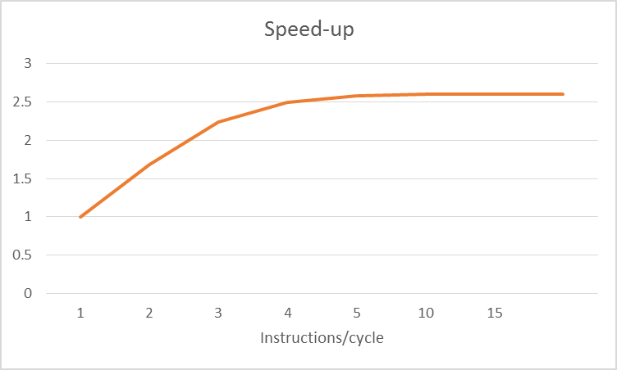Substituting the data in the left graph of P1.7

|  |  |
| --- | --- |
| K-issue | Speedup |
| 1 | 1 |
| 2 | 1.68 |
| 3 | 2.24 |
| 4 | 2.5 |
| 5 | 2.58 |
| 10 | $>$ 2.6 |
| 15 | $>$ 2.6 |
| $$∞$$ | $>$ 2.6 |

3.

Systolic array architecture seems a combination of parallelism and pipeline. The core of this architecture is “clocked parallelism”, with high throughput but low memory bandwidth.

For example, it will be very high efficient using a n*n systolic array, for which each computation unit has an adder and a multiplier, to realize the multiplication of two matrix, just as shown,

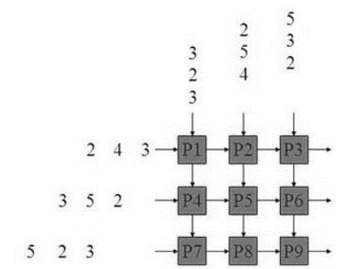

Thus, systolic array is very fit for those kind of applications like image processing and other two-dimensional data processing.