[[INSERT: SLIIT logo image]]
IT3060 Human Computer Interaction
Milestones 01–03 (Final Report)

Appointment Booking and Queue Management System
for Government Hospital OPDs
QueueCare – mobile application
Year 3, Semester 2, 2026 | Campus: Malabe
Group number: WE_85
Group name: [[INSERT: group name – all members]]
Student ID | Name | Workload distribution (Milestone 03 interfaces + extra role)
IT23681088 | Dayarathna A A D N | Hospital and appointment booking: Splash, Welcome, Patient Home, Hospital Search, Hospital Details, Book Appointment, Booking Confirmation. Project coordination and report compilation.
IT23686038 | Perera K N T | Patient account, bookings and patient priority: Create Account, Patient Sign In, My Bookings, Booking Details, Request Priority, Priority Request Status. Usability test coordination.
IT23682146 | Shaveena K W K | OPD session management: Role Selection, Staff Sign In, Reception Dashboard, Manage OPD Sessions, Add/Edit Session, queue and check-in API. Issue logging and analysis.
IT23673922 | Rajarathna P E G | Priority request management: Staff Registration, Priority Requests Inbox, Request Details, Notifications, Profile. Gantt chart and requirement traceability.

Table of Contents
1. Executive Summary 3
2. Milestone 01 Summary 3
2.1 Problem statement 3
2.2 Stakeholders 4
2.3 User research 4
2.4 Personas and empathy maps 5
2.5 User stories and How-Might-We statements 5
2.6 Requirements 5
3. Milestone 02 Summary 6
3.1 Sketches and chosen variants 6
3.2 Wireframes and low-fidelity prototype 6
3.3 High-fidelity prototype 7
3.4 Milestone 02 user testing and recommendations 7
4. Tech Stack Selection and Justification 8
5. System / App Architecture Overview 9
5.1 Authentication and role-based access 10
5.2 Data model 11
6. Implementation Details and Screenshots 11
6.1 Shared structure and team workflow 11
6.2 Hospital and appointment booking – Dayarathna A A D N (IT23681088) 12
6.3 Patient account, bookings and patient priority – Perera K N T (IT23686038) 14
6.4 OPD session management – Shaveena K W K (IT23682146) 16
6.5 Priority request management – Rajarathna P E G (IT23673922) 18
6.6 Deviations from the high-fidelity prototype 20
7. Traceability Matrix 21
8. Functional Test Cases and Results 22
8.1 Test approach 22
8.2 Key test cases 23
8.3 Summary of results 25
9. Usability Testing – Plan, Execution and Results 25
9.1 Plan 25
9.2 Tasks 26
9.3 Metrics 26
9.4 Results 26
9.5 Comparison with Milestone 02 testing 27
10. Issues Identified and Fixes / Recommendations 27
11. Overall Time Schedule (Gantt Chart) 29
12. Conclusion and Lessons Learned 29
References 31
Appendix A – Full Functional Test Log 32
Appendix B – Usability Session Materials 34
Appendix C – Additional Screenshots 35
Appendix D – Source Code Excerpts 37
Appendix E – Repository, Setup and Build 38
Appendix F – Full Requirement List from Milestone 01 39

1. Executive Summary
Outpatient departments (OPDs) in government hospitals still depend on paper tokens and a crowded registration counter. In Milestone 01 we surveyed 50 OPD users and staff and interviewed a patient, a hospital staff member and a medical officer. The largest group of respondents (26%) said they wait more than two hours, and about two thirds had missed their turn at least sometimes (46.8% yes, 21.3% sometimes). Patients knew their token number, but not their position in the queue or how much longer they had to wait.
Our answer is QueueCare, a mobile app with two connected sides. A patient registers with an NIC, finds a hospital, picks an OPD session, books it, can cancel it, and can ask for priority if they are elderly, pregnant or need mobility help. Reception staff create and close OPD sessions, see how many patients are waiting in each session, and accept or decline priority requests. Every booking receives an appointment time inside the session, and every sixth position is kept for accepted priority patients, so priority does not push other people back.
The app was designed in Milestone 02 as a Figma prototype and tested with users. In Milestone 03 we built it with React Native (Expo SDK 57, TypeScript) + Node.js/Express 5 REST API + MongoDB + JWT login. Notifications are stored in the database and shown inside the app. Section 4 explains why each part was chosen.
Table 1.1 – Project at a glance
Item | Result
Prototype screens implemented | 23 of the 24 high-fidelity screens. The Verify Number (OTP) screen was not built; the reason is given in Section 6.6.
Backend | 35 REST endpoints under /api/v1 plus a health check; 9 MongoDB collections.
Automated mobile tests | 493 tests in 30 suites, run on 8 Oct 2026: 490 passed, 3 failed (99.4%). The 3 failures are logged as issue F-08 in Section 10.
Automated API tests | 443 tests passed in the last full recorded run on 7 Oct 2026 (real HTTP requests against a temporary MongoDB replica set). [[INSERT: result of the final re-run before submission – Dayarathna]]
Usability testing of the working app | [[INSERT: number of participants (min. 5), overall task success %, average SUS score – Perera]]
Version control | GitHub repository with 314 commits and 49 pull requests between 29 Sep and 8 Oct 2026.
Installable build | [[INSERT: APK link and Android version tested – Dayarathna]]
Most important improvement after testing: in Milestone 02 a receptionist tester could not answer “how many patients are waiting?” because the OPD Sessions screen did not show it (High severity). The working app now shows a live “waiting” count and the session status on every session card, refreshed about every 10 seconds.

2. Milestone 01 Summary

2.1 Problem statement
Government hospital OPDs see a large number of patients every day, but booking and queueing are still manual: registers, paper tokens and a registration counter. Patients arrive very early to get a low number and then wait for hours without knowing their position. Reception staff spend much of their time answering the same questions (“how many are ahead of me?”) while also entering patient details by hand. Doctors feel the pressure too: the medical officer we interviewed sees about 60–80 patients in a six-hour session and said that counselling is the first thing that gets cut when the queue is long. Our project is a digital appointment booking and queue management system that gives patients a time, gives staff a clear view of each session, and handles priority patients in a fair and visible way.

2.2 Stakeholders
Table 2.1 – Stakeholders identified in Milestone 01
Level | Who | How the system affects them
Primary | Patients; reception staff; nurses / queue controllers; doctors | Use the system directly: book and track visits, register and check in patients, control patient flow, see the session list.
Secondary | Hospital administrators; IT support; medical records staff; pharmacy and laboratory staff | Use reports, keep the system running, or depend on a smoother flow of patients from the OPD.
Tertiary | Family members and caretakers; government health authorities; other hospital departments; the public | Help elderly patients use the app, monitor hospital performance, or benefit from a better OPD service.

2.3 User research
We used two methods. A Google Forms questionnaire collected 50 responses (34% patients, 20% nurses, 18% reception staff, 14% doctors, 14% other) and was analysed with frequencies and percentages. Three semi-structured interviews (an OPD patient, a hospital staff member and a medical officer) were analysed with thematic analysis [5]: we grouped repeated problems and suggestions into themes and then compared them with the questionnaire numbers. The interview scripts asked about the last real visit first and kept all questions about a possible app to the end, so that people described their own experience and not our idea.
Table 2.2 – Main research findings and what they meant for the design
Finding | Evidence from Milestone 01 | Design consequence
Long waiting times | 26% wait more than 2 hours (largest group); the patient interviewee waits 1–2 hours; the doctor said elderly patients arriving at 9 am often wait 3–4 hours. | Book a session in advance and give each booking an appointment time (US-01, FR-10).
No queue visibility | Patients know only their token number, not their position or waiting time; staff are asked the same question all day. | Show booking status, appointment time and queue type to the patient; show waiting counts to staff (US-03, US-04).
Missed turns | 46.8% have missed a turn and 21.3% sometimes; the patient interviewee left the waiting area and came back after the number was called. | In-app notifications and a clear booking record (NFR-14).
Booking is manual | Only 14% book through a website or app; 32% said no appointment system is used. | Digital registration before arrival and online booking (US-02, FR-02).
Tokens alone do not stop crowding | The medical officer said a token system was tried, but everyone still came at 7 am; peak is 8:30–11:30 am. | Time-based sessions with a capacity that staff control (FR-09, FR-11).
Vulnerable patients | Pregnant mothers are usually taken first, elderly patients are not “because there are so many”; questionnaire answers asked for a priority queue. | Priority request reviewed by reception (US-05, FR-19).
Digital confidence | 52% would use a digital system, 16% maybe; the doctor worried about older users. | Simple screens, large touch targets, predefined choices instead of typing (NFR-04, NFR-13).

2.4 Personas and empathy maps
Three personas and three empathy maps were built from the combined analysis. Their full versions are in the Milestone 01 report.
Table 2.3 – Personas (summarised)
Persona | Main frustrations | What they need from the system
Sunil Perera, 67, retired teacher, patient with regular clinic visits. Low technology confidence. “I just want to know when my turn is coming.” | Long waiting, confusing queue order, no queue updates, crowded waiting area. | Book easily, see his queue details, get reminders, large and readable interface.
Nadeesha Fernando, 31, OPD reception staff. “A simple digital system would help us serve patients faster.” | Long patient queues, manual registration, repeated questions. | Manage appointments quickly, see queue status in real time, less paperwork.
Dr. Kasun Perera, 42, medical officer. “A time-slot system could reduce crowding.” | Peak-hour volume, queue confusion and disputes, pressure to rush consultations. | Organised schedule, time slots, better queue visibility.
A nursing officer role (Anjali Fernando) was also used in user story US-04 and in the second journey map.

2.5 User stories and How-Might-We statements
Table 2.4 – User stories carried through all three milestones
ID | As a … | I want … | So that …
US-01 | Patient | to book my hospital appointment through a mobile app before visiting | I avoid long registration queues and save time.
US-02 | Reception staff member | patients to complete registration online before arriving | I reduce paperwork and register patients faster.
US-03 | Patient | to see my queue number and waiting status in real time | I know when it is my turn.
US-04 | Nursing officer | to monitor the live patient queue | I can manage patient flow and reduce overcrowding.
US-05 | Reception staff member | elderly, pregnant and disabled patients to go to a priority queue | they get timely attention with less waiting.
The three HMW statements were: (1) how might we reduce waiting times with online booking and digital registration before arrival; (2) how might we give patients real-time queue updates so they always know their position and estimated wait; (3) how might we support elderly, pregnant and disabled patients with a priority queue.

2.6 Requirements
Milestone 01 defined 23 functional requirements (FR-01 to FR-23) and 15 non-functional requirements (NFR-01 to NFR-15). Table 2.5 groups them; the full list is in Appendix F and the status of each one is in the traceability matrix (Section 7).
Table 2.5 – Requirement groups
Group | IDs | Summary
User authentication | FR-01 to FR-04 | Secure login, registration with NIC / email / phone, password reset, role-based access.
Patient management | FR-05 to FR-07 | Profile create and update, appointment history, contact details update.
Appointment booking | FR-08 to FR-14 | Show OPD departments and schedules, book online, prevent double booking, unique appointment ID, cancel, reschedule.
Queue management | FR-15 to FR-19 | Queue number after check-in, queue position, estimated wait, real-time update, priority queues.
Doctor functions | FR-20 to FR-23 | Daily appointment list, call next patient, mark completed or skipped, update availability.
Key non-functional | NFR-03, 04, 05, 09, 10, 12, 13, 14, 15 | Hashed passwords and JWT; simple and responsive interface; no duplicate appointments; data integrity; privacy; accessibility (readable fonts, contrast); reliable notifications; audit logging.

3. Milestone 02 Summary

3.1 Sketches and chosen variants
Each member sketched two variants of every screen in their workload on paper and chose one with a short reason. Table 3.1 gives the decision that mattered most for each member.
Table 3.1 – Sketch variants chosen in Milestone 02
Member | Screens sketched | Chosen variant and reason
Dayarathna | Splash, Patient Login, Patient Home, Hospital Search, Hospital Details, Book Appointment, Booking Confirmation | Variant A. Home shows the search bar, the upcoming appointment and quick actions at once. Book Appointment uses radio-style session cards so all decisions are on one screen. The confirmation makes the Booking ID the main element, as a reference for later.
Perera | Create Account, My Bookings, Booking Details, Request Priority, Priority Request Status | Sketch 2. The NIC field prevents duplicate registrations. Request Priority uses predefined reasons instead of free text, because free text can be misused and is harder for staff to read. The status screen shows a timeline so progress is easy to follow.
Shaveena | Role Selection, Receptionist Login, Receptionist Dashboard, Manage OPD Sessions, Add/Edit Session | Variant A. The dashboard shows today’s sessions, priority waiting, checked-in patients and now serving at a glance. Sessions use Today / Upcoming tabs with Edit and Close actions.
Rajarathna | Notifications, Priority Requests, Request Details, Request Access, Profile, Verify | New notifications are listed first. Pending and decided requests are separated into two tabs. Request details are shown step by step. Wider input fields suit all users.

3.2 Wireframes and low-fidelity prototype
The chosen sketches were redrawn as greyscale wireframes in Figma and linked into a clickable low-fidelity prototype (https://www.figma.com/design/1KjSZn6kHVXRYJnI01CHjO/). The group reviewed each flow together before adding colour. The review changed three things:
- Book Appointment became one screen. The sketch had “select session” and “enter patient details” as two steps. The patient’s registered details do not need to be typed again, so the two were merged (3 taps reduced to 2).
- “Request Priority” moved onto Booking Details as a visible button, instead of sitting in a menu on My Bookings where it was easy to miss.
- Staff priority flow kept two levels: a list of pending requests, and a separate Request Details screen with the reason, the booking and clear Accept / Decline buttons.

3.3 High-fidelity prototype
The high-fidelity prototype has 24 screens (17 patient, 7 reception) in one teal and white healthcare theme, with the same buttons, cards, status badges and bottom navigation on every screen (https://www.figma.com/design/DWtNh55RUCvdxnpsiT667N/1design). Figure 3.1 shows one representative screen per member.
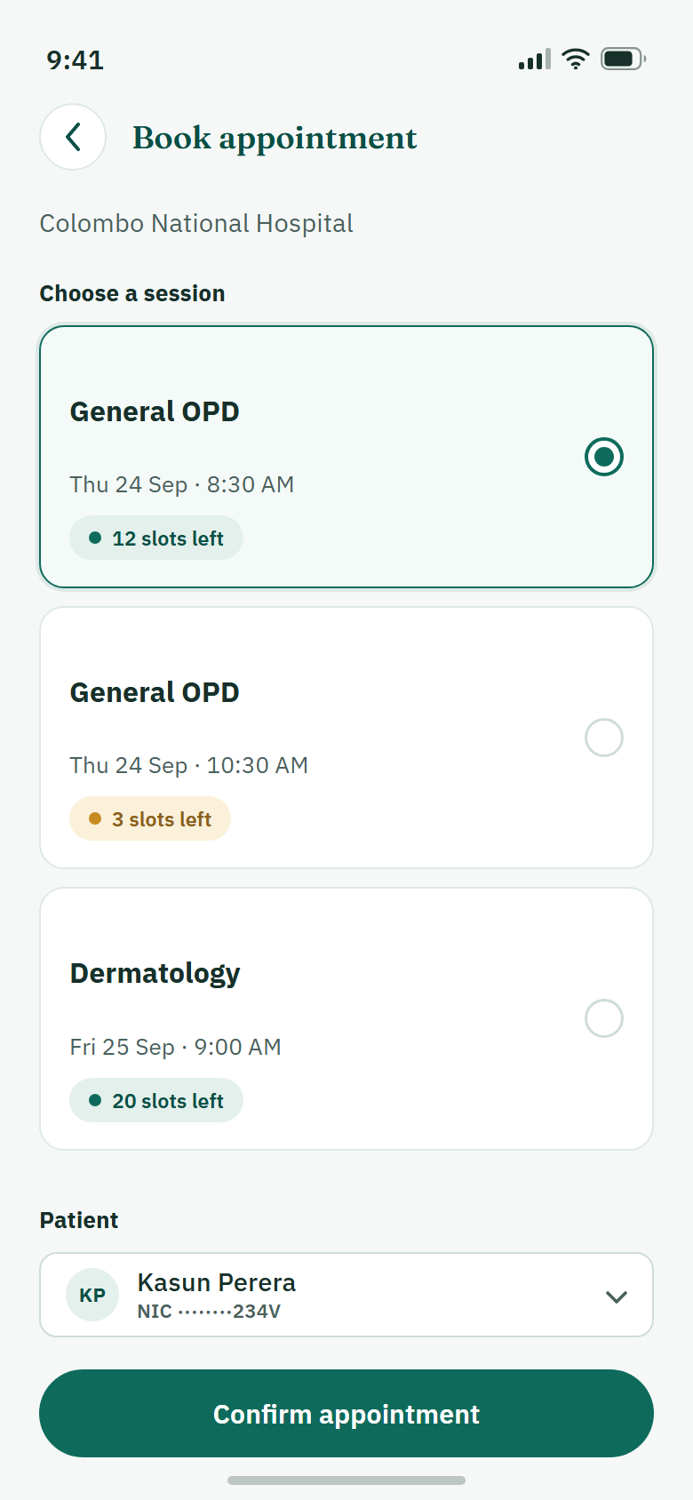 | 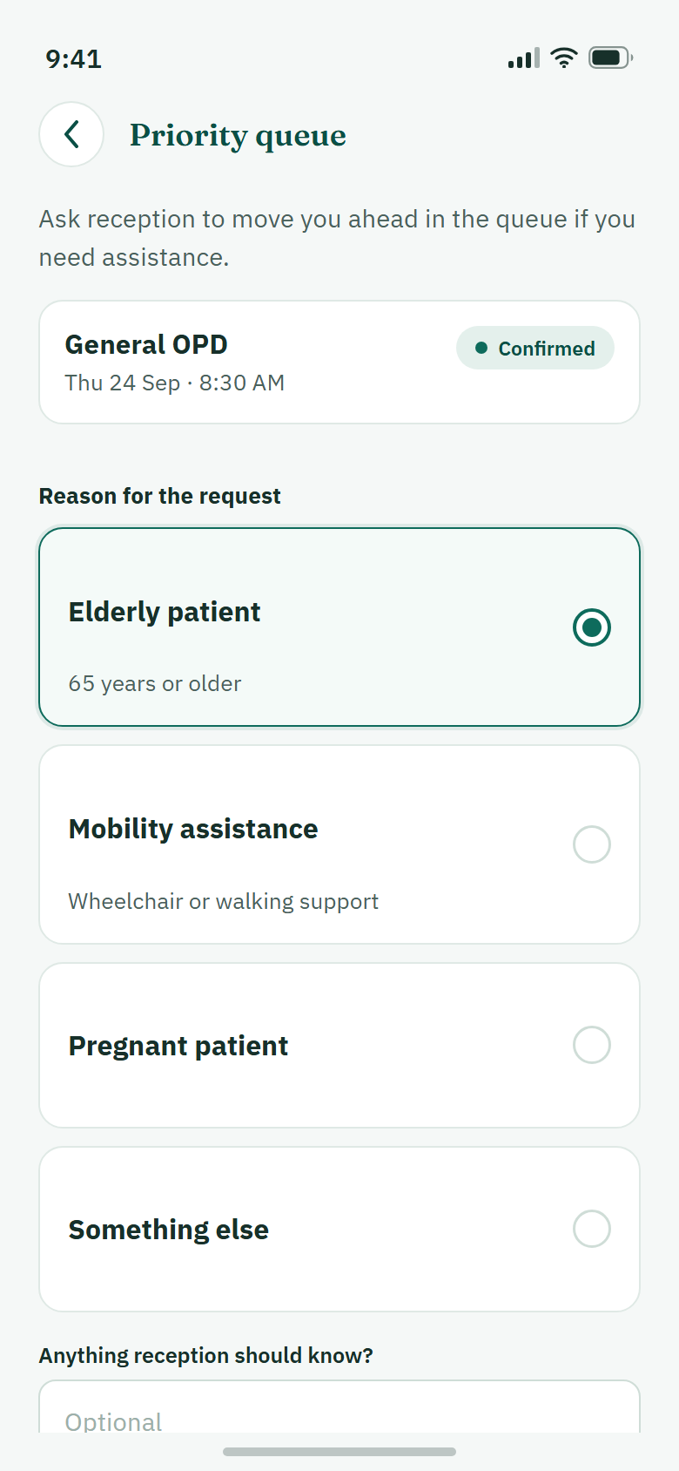 | 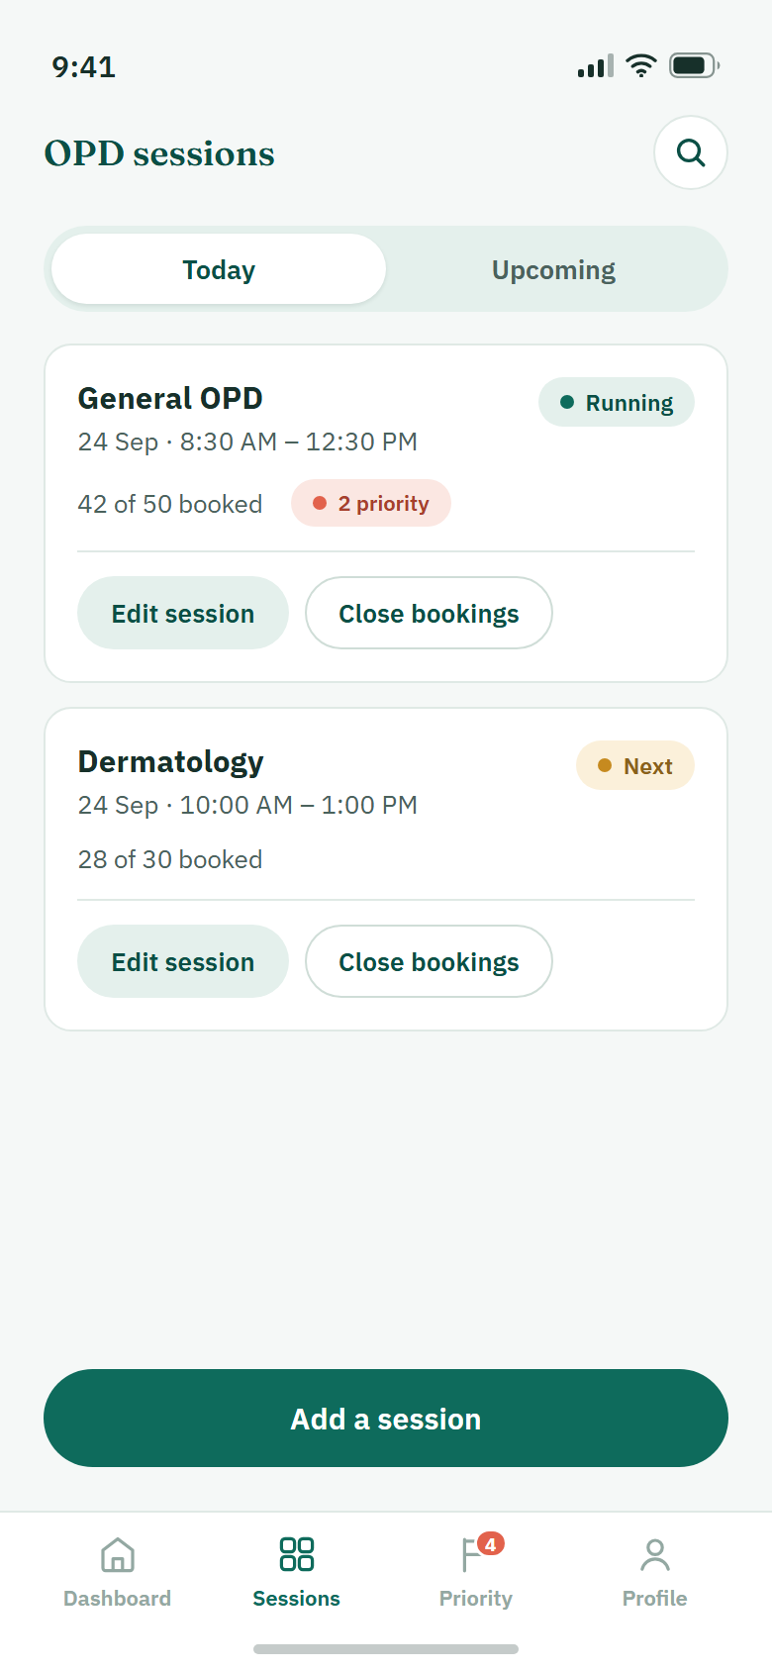 | 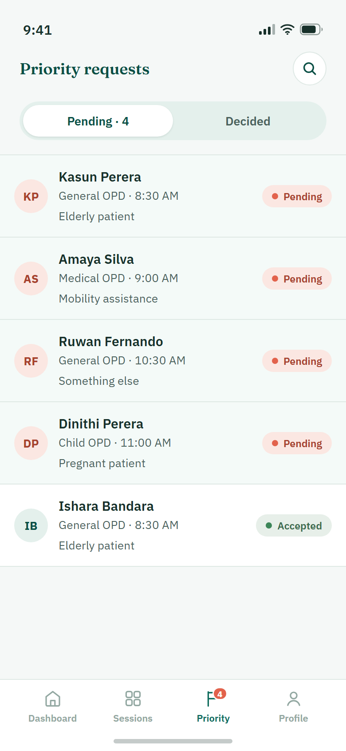
Book appointment – Dayarathna | Request priority – Perera | OPD sessions – Shaveena | Priority requests – Rajarathna
Figure 3.1 – One high-fidelity prototype screen from each member (Milestone 02)

3.4 Milestone 02 user testing and recommendations
The prototype was tested in recorded sessions with proxy users: an older relative and a classmate who did patient tasks (book the next General OPD slot; check that tomorrow’s appointment is confirmed), and a hospital reception staff member who reviewed the staff screens. The older tester rated the booking task 4 out of 5 but the “check my booking” task only 2 out of 5, because the tiles she tapped did not respond. Table 3.2 lists the recommendations. They became tasks in Milestone 03 and their final status is in Section 10.
Table 3.2 – Usability issues and recommendations from Milestone 02
# | Issue found | Severity | Recommendation
1 | No live “patients waiting” count on Manage OPD Sessions; the receptionist tester could not answer a basic staffing question. | High | Add a live count badge and the session status to each session.
2 | Older tester was unsure whether the search bar and the “Find Hospital” card on Home were different actions. | Medium | Keep one clear entry point, or show clearly that both do the same thing.
3 | Greyed-out “My Bookings” and “Priority Queue” tiles were tapped and looked broken. | Medium | Make them work once all modules are merged; never show dead tiles.
4 | Short hesitation before tapping “View OPD Sessions” on Hospital Details. | Low | Make the button stand out more (larger tap target).
5 | Priority reason tags shown in the Priority Requests list worked very well. | Positive | Keep, and reuse the “reason visible without opening” pattern.
E | Receptionist feedback: search patients quickly by NIC or patient ID; show the priority reason without opening many screens; show session status and waiting count clearly. | Expert | Add quick search; keep reason tags; add status and waiting count.

4. Tech Stack Selection and Justification
We chose the stack on the first day of Milestone 03 and did not change it. The choice was made against real limits: four members who all know JavaScript, about ten days to build and test, patients who mostly use Android phones and often have low digital confidence (NFR-04, NFR-13), a security requirement for hashed passwords and JWT (NFR-03), queue information that must stay fresh (FR-18), a rule that a session can never be double-booked or over-booked (FR-11, NFR-05), and no budget for paid services.
Table 4.1 – Technology chosen for each layer, with alternatives
Layer | Technology chosen | Why it fits this project | Alternatives considered | Why not chosen
Mobile frontend | React Native 0.86 with Expo SDK 57, React 19, TypeScript | One JavaScript codebase that all four members can write; real native inputs, scrolling and accessibility labels for older users (NFR-04, NFR-13); Expo Go let each of us test on our own phone by scanning a QR code. | Flutter; native Android (Kotlin); web app / PWA | Dart or Kotlin would be new to the team. A PWA is not the installable mobile app the brief asks for.
UI and navigation | React Navigation 7 (native stack + bottom tabs); our own components built from the prototype’s colours and fonts | Separate guest, patient and staff stacks match the two flows in the prototype; own components keep the screens faithful to the Figma design. | Expo Router; React Native Paper / NativeBase | A ready-made UI kit would impose its own look and reduce fidelity to the Milestone 02 prototype.
State management | React hooks, an in-memory session object, and one shared “fetch on focus + polling” hook | Each screen mostly shows server data, so a small hook per feature is enough and easy to explain in the viva. | Redux Toolkit; React Query | Extra setup and concepts for very little shared client state.
Backend / API | Node.js 22 with Express 5 (REST, JSON) | Same language as the app; one module folder per member avoided merge conflicts; all business rules stay on the server (FR-04). | Firebase (BaaS); Spring Boot; NestJS | Firebase rules make capacity and priority-slot transactions hard and hide the logic we must explain. Spring Boot / NestJS are slower to start in ten days.
Database | MongoDB with the official Node driver (replica set, shared development cluster) | Document model fits hospitals, sessions, bookings and notifications; unique indexes and multi-document transactions stop duplicate and over-capacity bookings (FR-11, NFR-05, NFR-10). | MySQL / PostgreSQL; Firestore | A relational schema needs migrations each time four members change the model. Firestore has weaker multi-document guarantees for our booking rule.
Authentication | JWT (HS256, 24-hour expiry) signed with the jose library; passwords hashed with salted scrypt from Node crypto | Meets NFR-03 directly. Every protected request re-checks the account’s role and status in the database, so a patient cannot call staff routes (FR-04, NFR-12). | Firebase Auth; server sessions with cookies; bcrypt package | Firebase Auth adds an outside service. Cookies suit browsers more than mobile apps. scrypt is built into Node, so no native add-on is needed.
Notifications | In-app notifications saved in MongoDB and read through the API | Works on every phone without extra accounts or cost; a booking and its notification are written in the same transaction (NFR-14). | Firebase Cloud Messaging push; SMS gateway; email (Nodemailer) | Push needs a native build and Google services that Expo Go does not provide. SMS costs money. Many OPD patients do not check email.
Queue freshness | REST polling: about every 10 s on staff screens, 15 s on Alerts | Reuses the same endpoints; simple to test; good enough for a waiting count (FR-18). | WebSockets / Socket.IO | A second server technology to host and debug within the timeframe.
Media | Profile photos uploaded through the API (multer) and saved as files on the server; only the link is stored in MongoDB | Keeps secrets out of the app and binary data out of the database. | Cloudinary; images inside MongoDB | Cloudinary was the first plan and the adapter still exists, but the file store works without external keys for the demo.
Hosting and build | API on a team laptop over the same Wi-Fi for the demo; Expo Go during development; Android APK for submission [[INSERT: APK build method and link]] | No cost and nothing to keep running after the viva. | Render / Railway free tier | Cold starts and setup time; not needed for an assessed demo.
Version control and testing | Git + GitHub (feature branches, pull requests into develop); Node test runner with real HTTP and temporary MongoDB; Jest with jest-expo; ESLint; TypeScript checks | Pull requests gave every merge a review point; automated tests gave repeatable evidence for the CRUD rules. | Postman-only manual testing | Manual API checks cannot repeat the concurrency cases (for example 12 patients competing for 3 places).

5. System / App Architecture Overview
QueueCare is a three-tier system (Figure 5.1). The phone runs the React Native app. The app talks only to our Express API with JSON over HTTP. The API is the only part that reads or writes MongoDB.
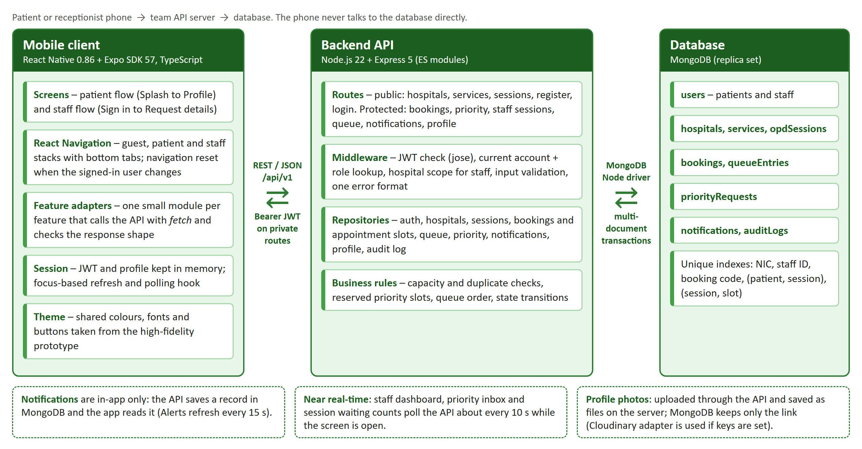
Figure 5.1 – Layered architecture of QueueCare
- Mobile client. Screens are grouped by flow (guest, patient, staff). Each feature has a small adapter file that calls the API and checks that the response has the expected shape before the screen uses it. Loading, empty and error states are handled on every data screen.
- API. Each area (auth, hospitals, sessions, bookings, queue, priority, notifications, profile) is a module with a routes file and a repository file. Routes validate the input and reject unknown fields; repositories contain the database logic. All errors use one JSON format with a stable code such as SESSION_FULL or BOOKING_ALREADY_EXISTS.
- Database. Nine collections (Figure 5.2). Booking, cancellation, check-in and priority decisions run inside MongoDB transactions [11], so capacity, the booking, the notification and the audit record are saved together or not at all.

5.1 Authentication and role-based access
- The user signs in: patients with NIC and password (POST /auth/patient/login), staff with Staff ID and password (POST /staff/auth/sign-in).
- The API checks the salted scrypt hash and the account status, then returns a JWT [7] that is valid for 24 hours.
- The app keeps the token in memory and sends it as Authorization: Bearer <token> on every private request.
- Middleware verifies the signature and expiry, then loads the user’s current role and status from MongoDB. Patient routes require the PATIENT role; staff routes require RECEPTION or NURSE and are limited to the staff member’s own hospital.
- Ownership is checked on the server: a patient who asks for another patient’s booking receives 404, so the API does not even reveal that the booking exists (NFR-12).
Table 5.1 – What each role can do
Action | Guest | Patient | Reception / Nurse
Browse hospitals, services and sessions | Yes | Yes | Yes
Create, view and cancel own booking; request priority | – | Yes | –
Create, edit and close OPD sessions (own hospital) | – | – | Yes
View dashboard, waiting counts and queue; check in a patient | – | – | Yes
Accept or decline priority requests (own hospital) | – | – | Yes
Read own notifications; edit own profile and photo | – | Yes | Yes

5.2 Data model
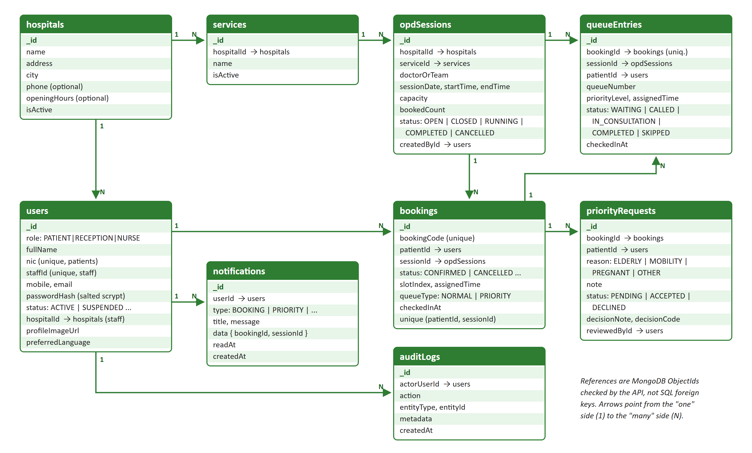
Figure 5.2 – MongoDB collections, key fields and relationships
Navigation map. Patient: Splash → Welcome → Choose Role → Sign In / Create Account → Home → Find a Hospital → Hospital Details → Book Appointment → Booking Confirmed; bottom tabs Home, Bookings (My Bookings → Booking Details → Request Priority → Request Status), Alerts and Profile. Staff: Choose Role → Staff Sign In / Staff Registration → bottom tabs Dashboard, Sessions (OPD Sessions → Add/Edit Session), Priority (Priority Requests → Request Details) and Profile.

6. Implementation Details and Screenshots

6.1 Shared structure and team workflow
- One repository, three workspaces. apps/mobile holds the React Native app (src/screens, src/features, src/navigation, src/components, src/theme, __tests__). apps/api holds the Express API (src/modules/<area> with a routes file and a repository file, plus middleware, config, seeds, tests). docs/ holds the API contracts, the setup guide and the Milestone 03 evidence.
- Vertical slices. Each member built the screen, the endpoint, the database code and the tests for their own interfaces, so everyone can explain their part from the tap to the database in the viva.
- Branches and pull requests. main is the release branch and develop is the integration branch. Each member worked on a feature branch (for example member1-hospital-booking, patient_signup-priority_request, member3-final-ui-refinement, priority_request_management) and merged through a pull request: 49 pull requests and 314 commits in total.
- Avoiding merge conflicts. New files of Shaveena start with k_ and new files of Rajarathna start with g_, so two members rarely edited the same file. Shared files (navigation, app.js) were changed in small commits.
- Merging the four modules. We first agreed the request and response shape of each endpoint in docs/API.md. The modules meet in two places: the navigators in the app and the route list in app.js. Two automated cross-member journeys check the joins: npm run test:patient-flow (register → sign in → search → book → My Bookings → alert) and npm run test:staff-patient-flow (staff creates a session → patient books it → staff edits, closes and checks in).
- Links. Source code: https://github.com/Queue-Care/QueueCare (README has setup and run steps; summary in Appendix E). Installable build: [[INSERT: APK download link – Dayarathna]].
About “two CRUD operations per interface”. Every data screen below performs at least two real database operations and they are listed with their endpoints. Search and detail screens are read-only by design, so their two operations are both reads; we did not add meaningless edit or delete buttons to them. Splash, Welcome and Role Selection only route the user and store no data.

6.2 Hospital and appointment booking – Dayarathna A A D N (IT23681088)
Prototype (M2) | Working app (M3) | Prototype (M2) | Working app (M3)
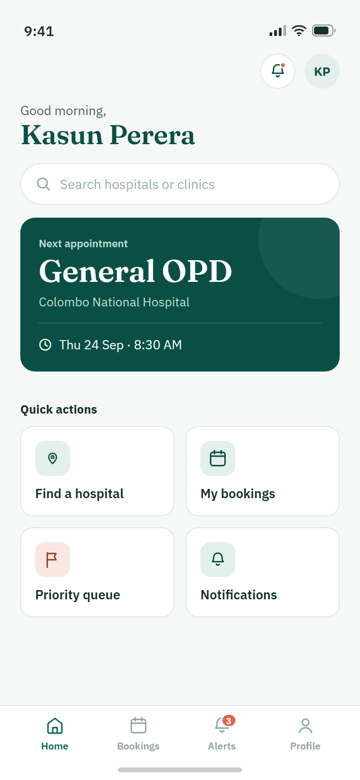 | [[INSERT: app screenshot – Dayarathna]] | 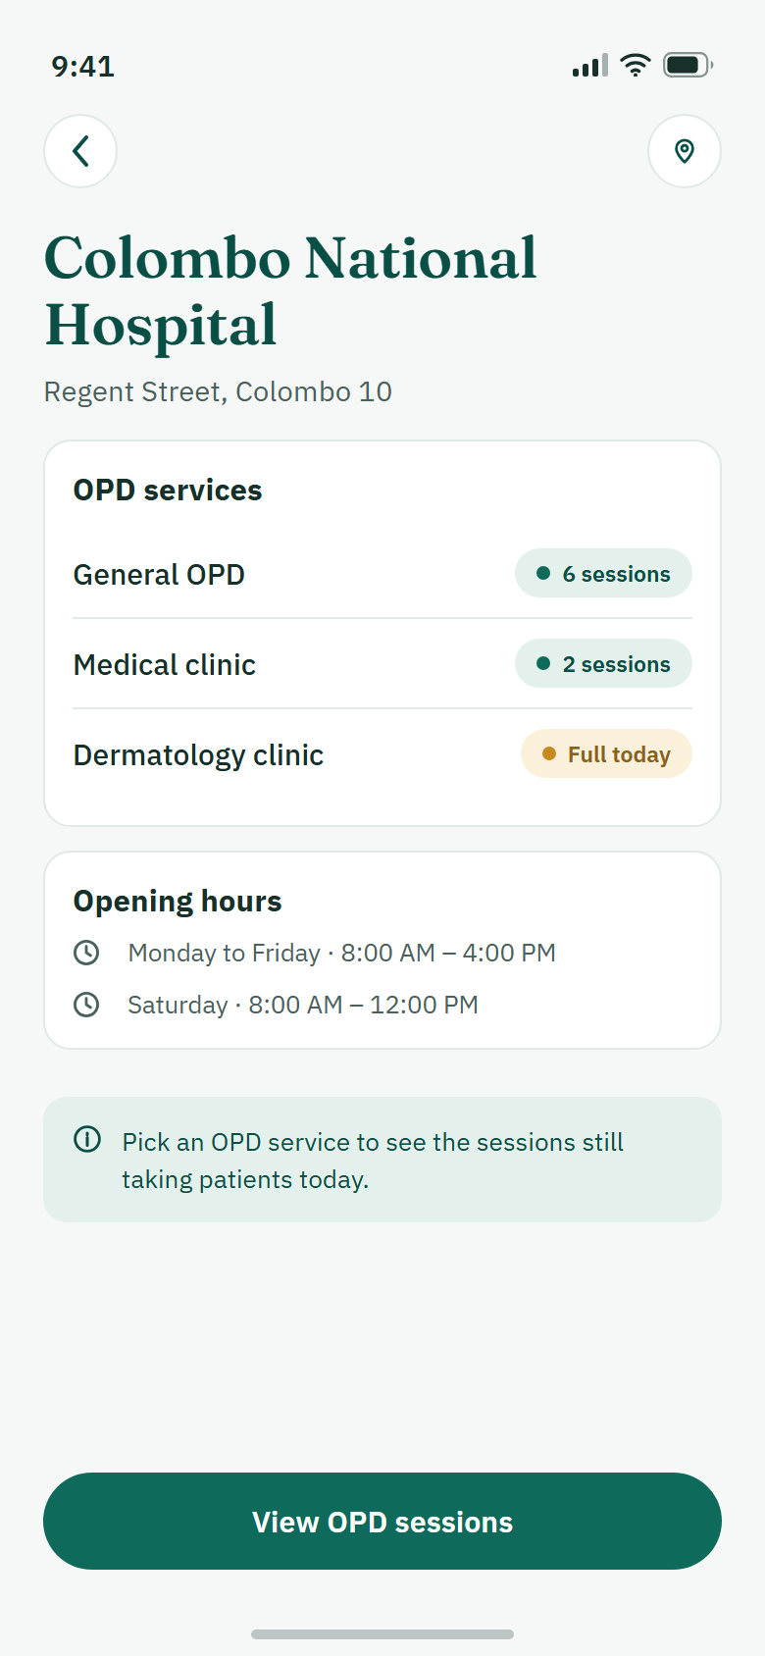 | [[INSERT: app screenshot – Dayarathna]]
Home | Home | Hospital details | Hospital details

Prototype (M2) | Working app (M3) | Prototype (M2) | Working app (M3)
 | [[INSERT: app screenshot – Dayarathna]] | 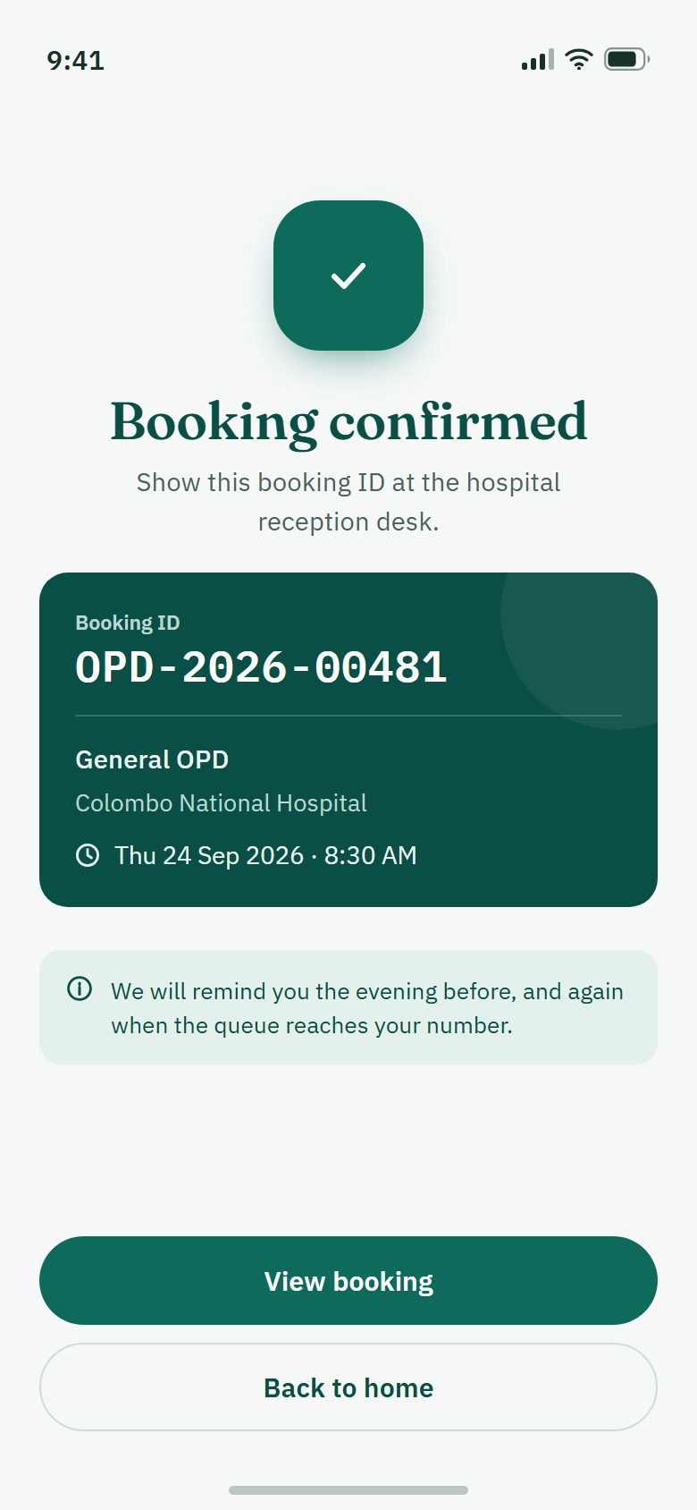 | [[INSERT: app screenshot – Dayarathna]]
Book appointment | Book appointment | Booking confirmed | Booking confirmed
Figure 6.1 – Prototype and implemented screens, hospital and booking module
Table 6.1 – CRUD operations per interface (Dayarathna)
Interface | Op | What it does | API endpoint | Req.
Splash, Welcome | – | Start-up check and routing only (Get started, I already have an account, Continue as guest). No stored data. | – | FR-01
Patient Home | R | Loads the next upcoming appointment of the signed-in patient. | GET /bookings/me?status=upcoming&limit=1 | FR-06
Patient Home | R | Search bar and “Find a hospital” tile open the hospital list (guests can browse too). | GET /hospitals | US-01
Hospital Search | R | Searches active hospitals by name or city, with pages. | GET /hospitals?search=&city=&page= | US-01
Hospital Search | R | Opens the selected hospital record. | GET /hospitals/:id | US-01
Hospital Details | R | Hospital name, address and opening hours. | GET /hospitals/:id | FR-08
Hospital Details | R | Active OPD services of that hospital. | GET /hospitals/:id/services | FR-08
Book Appointment | R | Open future sessions for the chosen date and service, with places left. | GET /hospitals/:id/sessions?date=&serviceId= | FR-09
Book Appointment | C | Creates the booking with a unique code (OPD-XXXXXX) and an appointment time. | POST /bookings | FR-10, FR-12
Book Appointment | U | In the same transaction the session’s booked count goes up by one, only if a place is still free. | inside POST /bookings | FR-11
Booking Confirmation | R | Reads the saved booking (code, hospital, service, date and time) from the database, not from the form. | GET /bookings/:id | FR-12
Booking Confirmation | C | A “booking confirmed” notification is saved together with the booking. | inside POST /bookings | NFR-14
Key implementation points.
- No double booking. A unique index on (patient, session) and a conditional update stop duplicates and over-capacity, even when requests arrive at the same moment. In our test 12 patients compete for 3 places: exactly 3 succeed and 9 see “This session is fully booked”.
- Honest feedback. The Confirm button is disabled while a request is being sent. If the network drops after Confirm, the app says the result is uncertain and asks the patient to check My Bookings; it never shows a fake confirmation.
- States. Every screen has loading, empty and error states with a Try again action, and pull-to-refresh.
- Accessibility (NFR-13). Buttons are at least 52 points high, text scales with the phone’s font setting, session cards behave as radio buttons for screen readers, and contrast is checked by automated tests. The date is picked from a calendar, not typed.
// bookingRepository.js – a place is taken only if one is still free (FR-11)
const updated = await db.collection('opdSessions').updateOne(
{ _id: sessionId, status: 'OPEN',
$expr: { $and: [{ $lt: ['$bookedCount', '$capacity'] },
{ $gt: [timestamp('startTime'), now()] }] } },
{ $inc: { bookedCount: 1 }, $set: { updatedAt: at } }, options);
if (updated.modifiedCount !== 1) throw unavailable(); // transaction rolls back

6.3 Patient account, bookings and patient priority – Perera K N T (IT23686038)
Prototype (M2) | Working app (M3) | Prototype (M2) | Working app (M3)
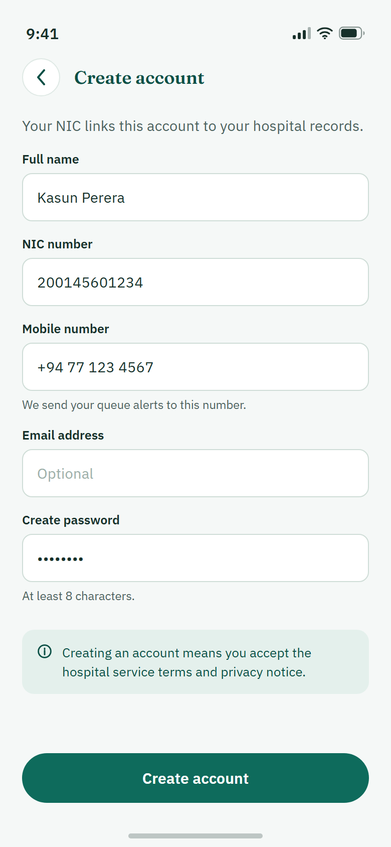 | [[INSERT: app screenshot – Perera]] | 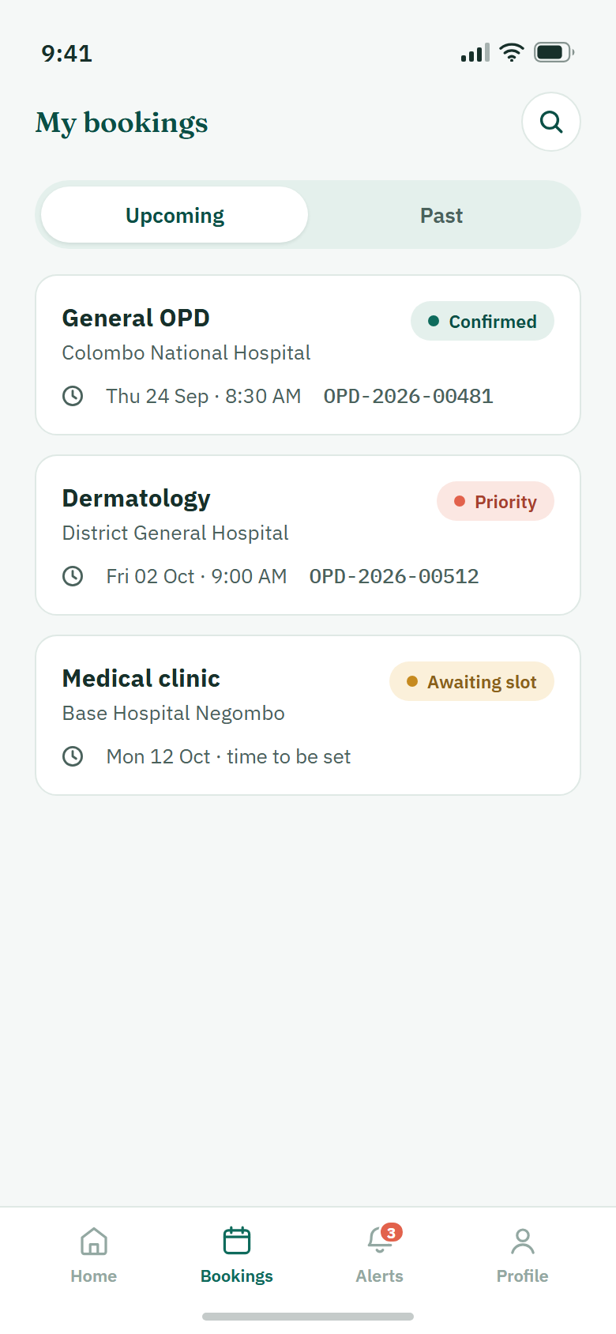 | [[INSERT: app screenshot – Perera]]
Create account | Create account | My bookings | My bookings

Prototype (M2) | Working app (M3) | Prototype (M2) | Working app (M3)
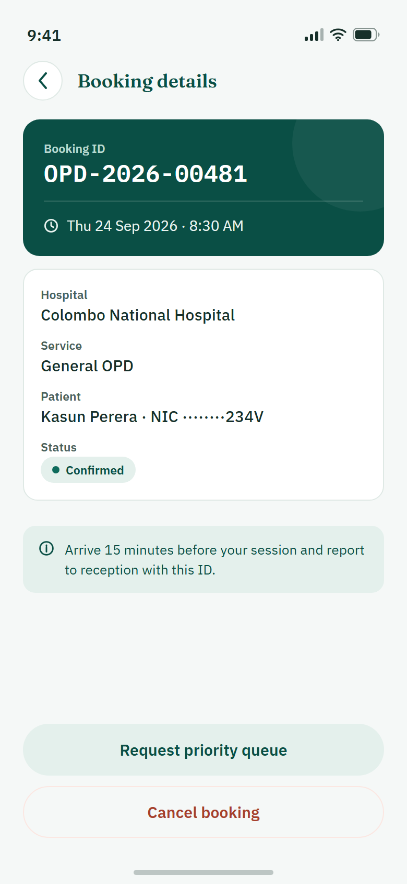 | [[INSERT: app screenshot – Perera]] |  | [[INSERT: app screenshot – Perera]]
Booking details | Booking details | Request priority | Request priority
Figure 6.2 – Prototype and implemented screens, patient account and bookings module
Table 6.2 – CRUD operations per interface (Perera)
Interface | Op | What it does | API endpoint | Req.
Create Account | C | Creates an active patient account. NIC is upper-cased, mobile is stored as +947XXXXXXXX, the password is hashed. | POST /auth/patient/register | FR-02, US-02
Create Account | R | Server checks that NIC, mobile and email are not already used; a duplicate returns ACCOUNT_EXISTS. | inside the same request | NFR-10
Patient Sign In | R | Checks NIC and password and returns the JWT and the patient summary. | POST /auth/patient/login | FR-01
Patient Sign In | U | An older “pending verification” account becomes ACTIVE after the correct password. | inside the same request | FR-01
My Bookings | R | Upcoming and Past lists of the patient’s own bookings, 20 per page. | GET /bookings/me?status=upcoming|past&page= | FR-06
My Bookings | R | Opens one booking from the list. | GET /bookings/:id | FR-06
Booking Details | R | Booking ID, hospital, service, appointment time, queue type and status. | GET /bookings/:id | US-03
Booking Details | U / D | Cancel booking: status becomes CANCELLED (soft delete), the place is released and an audit record is written. | PATCH /bookings/:id/cancel | FR-13
Request Priority | R | Loads the booking that the request belongs to. | GET /bookings/:id | US-05
Request Priority | C | Creates a priority request (Elderly, Mobility, Pregnant or Other, optional note up to 500 characters) and notifies the staff of that hospital. | POST /bookings/:id/priority-requests | US-05, FR-19
Request Status | R | Own requests with status Pending, Accepted or Declined and the reception note. | GET /priority-requests/me | US-05
Request Status | R | Linked booking with its (possibly new) appointment time and queue type. | GET /bookings/:id | US-03
Key implementation points.
- Validation before sending. Both NIC formats are accepted, the two passwords must match, and field errors appear under the field without calling the API. Password fields have a show / hide (eye) button.
- Safe cancel. Cancel asks for confirmation first. Only a confirmed booking that has not been checked in and whose session has not started can be cancelled; other cases return a clear message.
- One active request per booking. A unique partial index blocks a second pending or accepted request. If the session has no reserved priority place left, the request is saved as Declined with the reason and the patient gets a notification.
- Privacy. A patient can open only their own bookings and requests; raw server errors are never shown on screen.

6.4 OPD session management – Shaveena K W K (IT23682146)
Prototype (M2) | Working app (M3) | Prototype (M2) | Working app (M3)
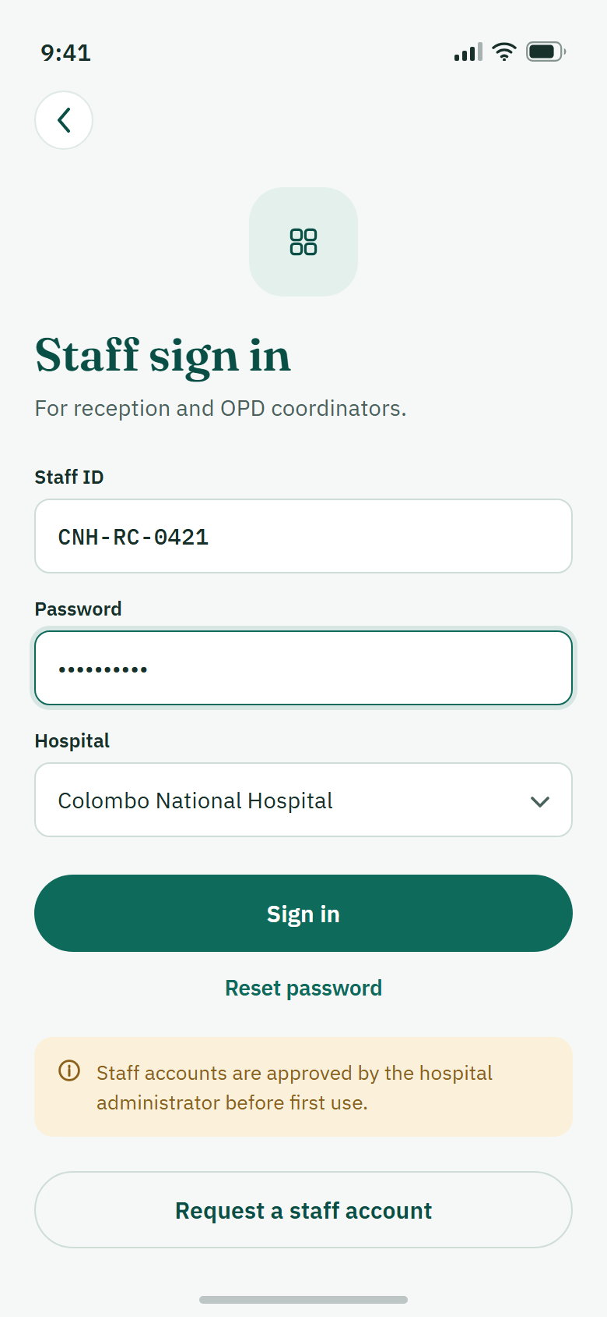 | [[INSERT: app screenshot – Shaveena]] | 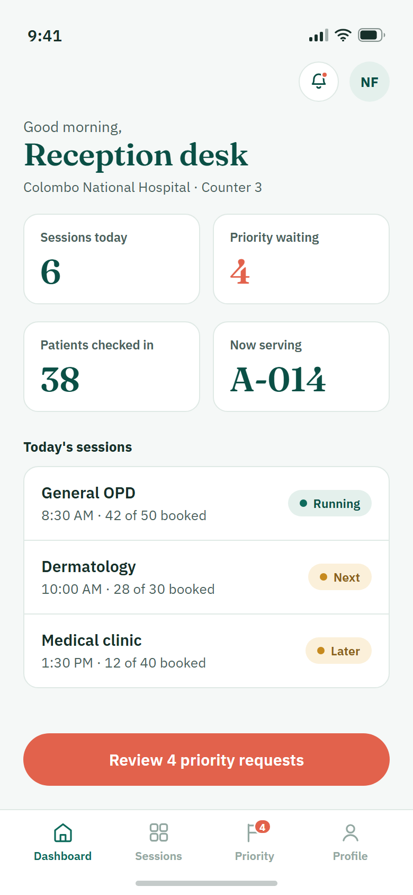 | [[INSERT: app screenshot – Shaveena]]
Staff sign in | Staff sign in | Reception dashboard | Reception dashboard

Prototype (M2) | Working app (M3) | Prototype (M2) | Working app (M3)
 | [[INSERT: app screenshot – Shaveena]] | 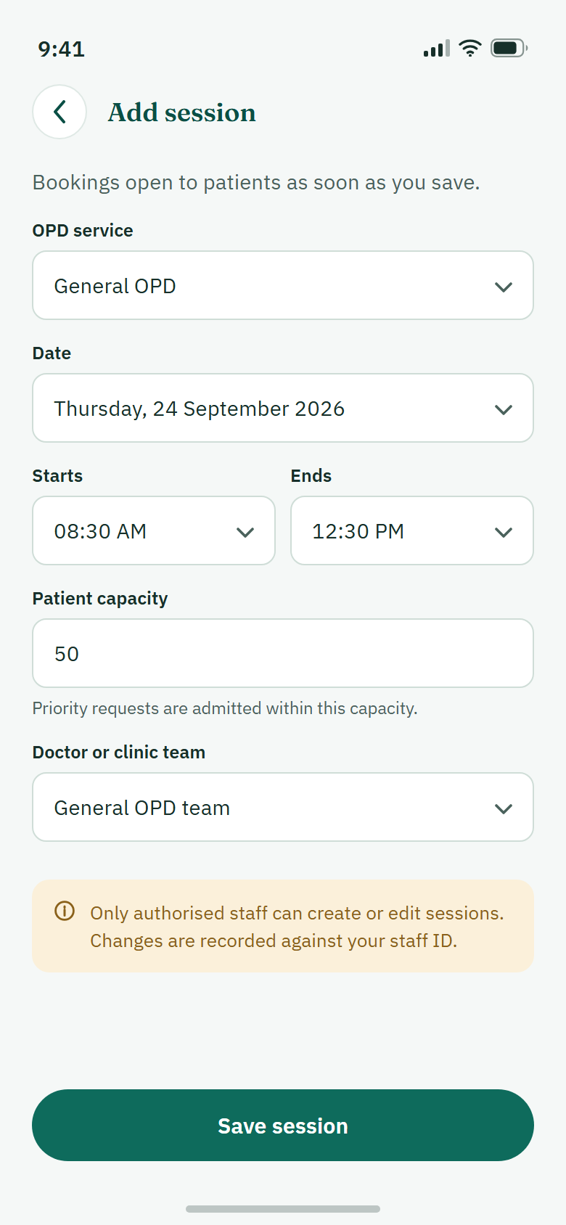 | [[INSERT: app screenshot – Shaveena]]
OPD sessions | OPD sessions | Add session | Add session
Figure 6.3 – Prototype and implemented screens, OPD session management module
Table 6.3 – CRUD operations per interface (Shaveena)
Interface | Op | What it does | API endpoint | Req.
Role Selection | – | Routing only: Patient or Hospital staff. No stored data. | – | FR-04
Staff Sign In | R | Checks Staff ID and password (active reception or nurse accounts only) and returns a JWT tied to the staff member’s hospital. Screen and validation by Shaveena; endpoint shared with Rajarathna. | POST /staff/auth/sign-in | FR-01, FR-04
Reception Dashboard | R | Sessions today, priority waiting, patients checked in, now serving. | GET /staff/dashboard | US-04
Reception Dashboard | R | Today’s session cards, priority badge and unread notification count; a card opens that session in the list. | same response, refreshed by polling | US-04
OPD Sessions | R | Today / Upcoming sessions of the staff member’s hospital, with search by session or doctor and a date filter. | GET /staff/sessions?...&page= | US-04
OPD Sessions | R | Live waiting count for each session card, refreshed by polling. | GET /staff/sessions/:id/metrics | US-04, FR-18
OPD Sessions | U | Close bookings: the session is no longer offered to patients; existing bookings stay. | PATCH /staff/sessions/:id/close-bookings | US-04
Add/Edit Session | C | Creates a session: OPD service, date, start, end, patient capacity, doctor or clinic team. | POST /staff/sessions | FR-09
Add/Edit Session | R | Loads an existing session into the form. | GET /staff/sessions/:id | FR-09
Add/Edit Session | U | Saves changes. Date, time and capacity are locked once patients hold appointment times. | PATCH /staff/sessions/:id | FR-09
Queue and check-in (API) | C | Check-in creates one queue entry with a queue number for the booking. | POST /bookings/:id/check-in | FR-15
Queue and check-in (API) | R | Ordered queue of a session; patient search by NIC, patient ID or name. | GET /staff/sessions/:id/queue, GET /staff/patients/search?q= | FR-16
Queue and check-in (API) | U | Call next patient; set Called, In consultation, Completed or Skipped. | POST /staff/sessions/:id/queue/next, PATCH /staff/queue/:entryId/status | FR-18
Key implementation points.
- Form validation. All six fields are required; the end time must be after the start, a new session must start in the future (Sri Lanka time), capacity must be a positive whole number and cannot go below the number already booked. Errors are shown beside the field; a second tap while saving is ignored.
- Live waiting count (M2 issue 1). Each session card shows “n waiting” and its status. If a refresh fails, the last value stays on screen with a “Last updated” label instead of disappearing. Polling stops when the screen is hidden or the app goes to the background.
- No hard delete. Sessions are closed, not deleted, so that existing bookings and the audit history are kept.
- Limit. The check-in, queue and patient-search endpoints are finished and covered by API tests, but they do not have buttons on a mobile screen yet (Section 10, planned).

6.5 Priority request management – Rajarathna P E G (IT23673922)
Prototype (M2) | Working app (M3) | Prototype (M2) | Working app (M3)
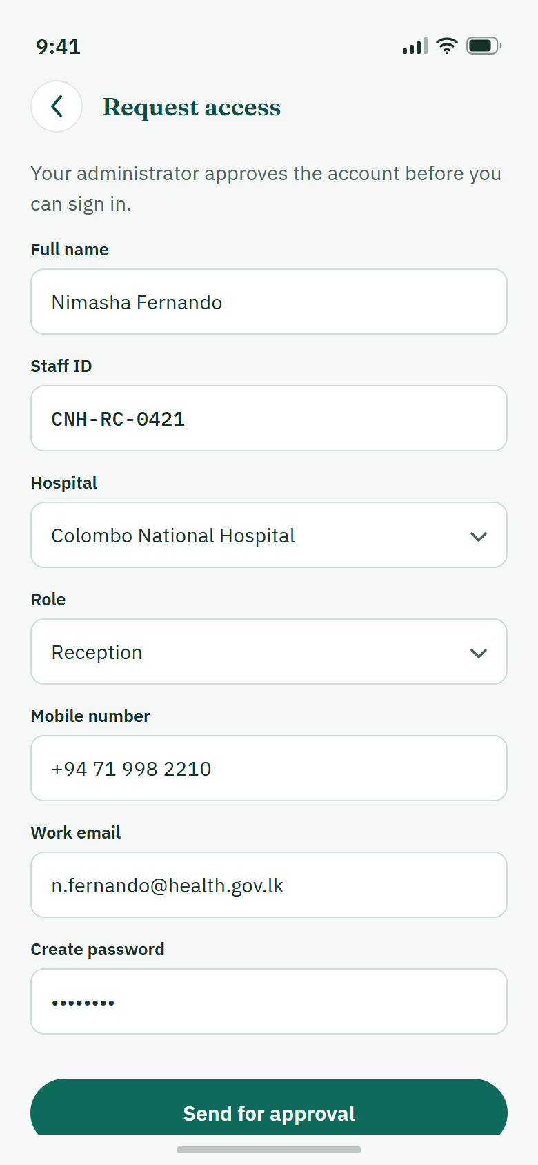 | [[INSERT: app screenshot – Rajarathna]] |  | [[INSERT: app screenshot – Rajarathna]]
Staff registration | Staff registration | Priority requests | Priority requests

Prototype (M2) | Working app (M3) | Prototype (M2) | Working app (M3)
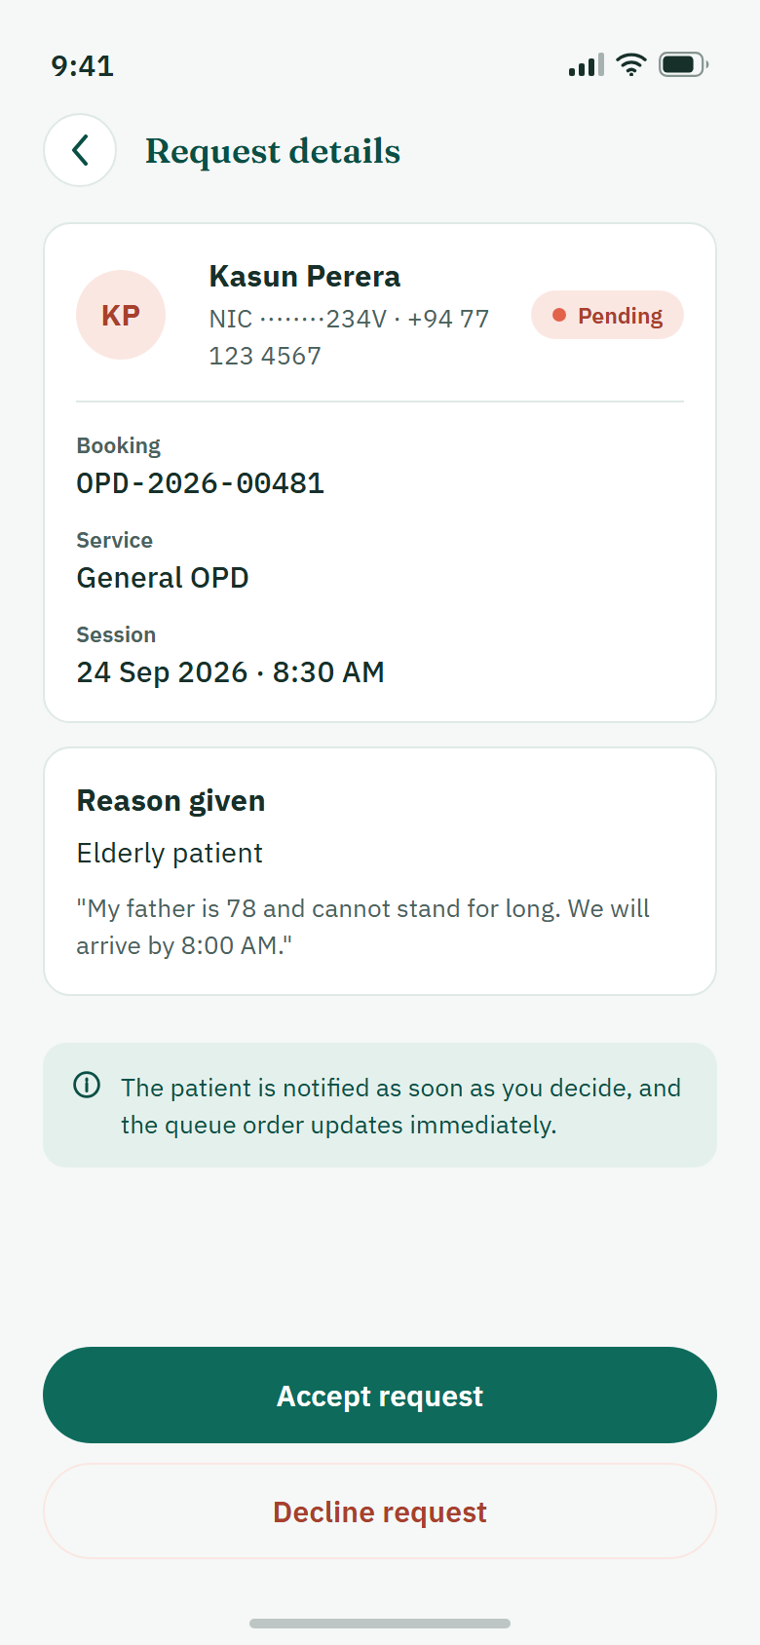 | [[INSERT: app screenshot – Rajarathna]] | 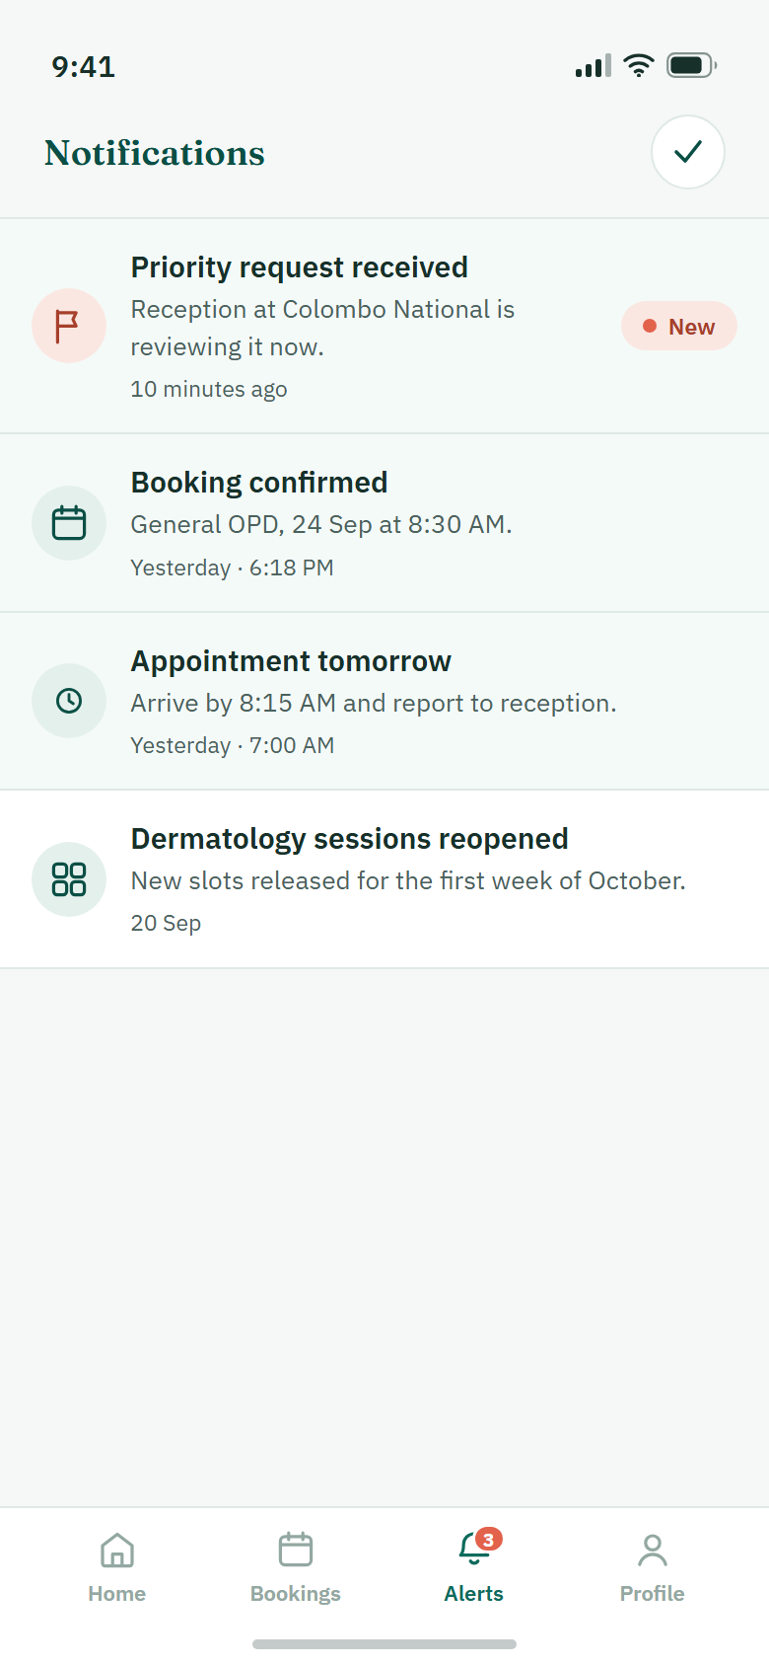 | [[INSERT: app screenshot – Rajarathna]]
Request details | Request details | Notifications | Notifications
Figure 6.4 – Prototype and implemented screens, priority request management module
Table 6.4 – CRUD operations per interface (Rajarathna)
Interface | Op | What it does | API endpoint | Req.
Staff Registration | C | Creates a reception or nurse account linked to the chosen hospital; the password is hashed. A welcome notification and an audit record are written in the same request. | POST /staff/auth/register | FR-01, NFR-15
Staff Registration | R | The hospital picker reads the hospital list. | GET /hospitals | FR-04
Priority Requests | R | Pending and Decided tabs for the staff member’s own hospital, with the reason tag and pending count; refreshes about every 10 s. | GET /staff/priority-requests?status=pending|decided | US-05
Priority Requests | R | Opens one request. | GET /staff/priority-requests/:id | US-05
Request Details | R | Patient, booking, service, session, appointment time, reason and the patient’s note. | GET /staff/priority-requests/:id | US-05
Request Details | U | Accept or Decline with an optional note. On accept the patient moves to the next reserved priority time; the patient is notified and the action is audited. | PATCH /staff/priority-requests/:id/decision | FR-19, NFR-15
Notifications | R | The signed-in user’s notifications, newest first, unread ones marked. | GET /notifications | NFR-14
Notifications | U | Mark one as read (on open) or mark all as read. | PATCH /notifications/:id/read, PATCH /notifications/read-all | NFR-14
Notifications | D | Deletes a notification that belongs to the user. | DELETE /notifications/:id | NFR-14
Profile | R | Shows the current patient or staff profile. | GET /me | FR-05
Profile | U | Edit name, phone and email; change language and notification settings. | PATCH /me, PATCH /me/preferences | FR-05, FR-07
Profile | C / D | Add or replace the profile photo, or remove it. | POST /me/profile-image, DELETE /me/profile-image | FR-05
Key implementation points.
- Reason visible at once (M2 finding 5 and receptionist feedback). The inbox row shows the patient, service, time and the reason tag, so staff do not need to open each request.
- A decision is made once. The update only matches a request that is still Pending and runs in a transaction, so two receptionists cannot decide the same request. If the last priority place was taken in the meantime, the request is saved as Declined with the reason; the app never shows Accepted without a real place.
- Hospital scope. Staff linked to another hospital cannot list, open or decide these requests.
- Registration validation. Staff ID (3–40 letters, numbers or hyphens), work email, mobile number and a password of at least 8 characters with a confirm field; the hospital is chosen from a list.

6.6 Deviations from the high-fidelity prototype
The implemented screens keep the structure, labels, colours and flow of the prototype. Table 6.5 lists every place where the working app is different and why. The first four are deliberate fixes for Milestone 02 findings.
Table 6.5 – Deviations and their justification
Screen | Prototype design | Implemented version | Reason | Impact on usability
OPD Sessions | Session cards show booked count only. | Each card also shows a live “n waiting” badge and status; search and date filter added. | M2 issue 1 (High) and receptionist feedback. | Staff can answer “how many are waiting?” without leaving the screen.
Patient Home | Search bar and “Find a hospital” tile look like two actions. | Search bar placed first; the tile is kept under Quick actions and labelled as opening the same search. | M2 issue 2 (Medium). | One clear starting point; to be confirmed with first-time users in Section 9.
Home tiles and tabs | My Bookings / Priority tiles were inactive in the tested prototype. | All tiles and tabs open working screens. | M2 issue 3 (Medium). | Nothing looks broken.
Hospital Details | “View OPD sessions” at the bottom of the screen. | Button sits directly under the service list in a highlighted panel, 52 points high. | M2 issue 4 (Low). | Next step is obvious after choosing a service.
Book Appointment | Fixed list of three sessions. | Calendar date button loads the sessions of that day; each booking gets an appointment time. | Real data has many dates; typing dates is error-prone for older users. | Fewer input errors; patient sees an actual time.
Verify Number (17) and staff verification | Six-digit code sent to the phone or email. | Not built. Accounts are active after registration. | No SMS or email service in the approved stack and no budget. | One step less for low-confidence users, but identity is not verified. Listed as future work.
Staff Registration | “Send for approval” by a hospital administrator. | Account is created and can sign in at once. | No administrator screens were designed in Milestone 02. | Faster demo; a real hospital would need approval.
Priority request | Accepted patient “moves to the front of the queue”. | Accepted patient moves to the next reserved priority time (every sixth position). | Fair to other patients; their times do not change. | Clear new appointment time shown to the patient.
All data screens | Some screens had a refresh button. | Pull down to refresh; lists also reload when opened. | Consistent gesture and less clutter. | Less discoverable for some users; Try again stays on error states.
Notifications and queue | Text promises reminders “when the queue reaches your number”. | In-app notifications for booking and priority events; staff screens refresh by polling. | No push service in the stack (Section 4). | Patient must open the app to see updates.
Sign-in session | Not specified. | The login is kept in memory; closing the app signs the user out. | Secure storage was left out to finish core flows. | User signs in again after restart.
Profile photo | Not specified (plan: Cloudinary). | Photo saved as a file on the API server; link in MongoDB. | Works without external keys. | None for the user.

7. Traceability Matrix
Table 7.1 follows each requirement from Milestone 01 to the prototype screen (numbers 01–24 of the high-fidelity prototype), the implemented feature, the responsible member, the functional test cases of Section 8 and the usability tasks of Section 9.
Table 7.1 – Requirement → prototype → implementation → test cases
Req. | Requirement | Prototype screen | Implemented feature (M3) | Member | Test cases | Usab. task | Status
US-01 | Book an appointment through the app | 06–10 | Home, Hospital Search, Hospital Details, Book Appointment, Confirmation | Dayarathna | TC-M1-01 to 08 | T2 | Implemented
US-02 | Register digitally before arrival | 05 | Create Account, Patient Sign In | Perera | TC-M2-01 to 04 | T1 | Implemented
US-03 | See queue / waiting status | 12, 14 | Booking Details shows appointment time, queue type and status; alerts | Perera, Shaveena | TC-M2-05, TC-M3-07 | T3 | Partial
US-04 | Staff monitor sessions and queue | 20–22 | Dashboard, OPD Sessions with waiting count, Add/Edit Session | Shaveena | TC-M3-02 to 08 | T5, T6 | Implemented
US-05 | Priority queue for elderly, pregnant, disabled | 13, 14, 23, 24 | Request Priority, Request Status, Priority Requests, Request Details | Perera, Rajarathna | TC-M2-07, 08; TC-M4-02 to 04 | T4, T6 | Implemented
FR-01 | Secure login | 04, 18 | Patient and staff sign-in with JWT | Perera, Shaveena, Rajarathna | TC-M2-04, TC-M3-01, TC-M4-01 | T1 | Implemented
FR-02 | Register with NIC, email, phone | 05 | Create Account | Perera | TC-M2-01 to 03 | T1 | Implemented
FR-03 | Password reset | 04, 18 | Link is shown; flow not built | – | – | – | Future work
FR-04 | Role-based access | 03 | Role Selection; role and hospital checks on the server | Shaveena, all | TC-M1-07, TC-M4-02 | – | Implemented
FR-05 | Create and update profile | 16 | Profile, Edit profile, photo | Rajarathna | TC-M4-07 | – | Implemented
FR-06 | Appointment history | 11 | My Bookings (Upcoming / Past) | Perera | TC-M2-05 | T3 | Implemented
FR-07 | Update contact information | 16 | Profile → Edit profile | Rajarathna | TC-M4-07 | – | Implemented
FR-08 | Show OPD departments | 08 | Service list on Hospital Details | Dayarathna | TC-M1-02 | T2 | Implemented
FR-09 | Show doctors and schedules | 09, 21, 22 | Sessions with doctor / team; staff create and edit them | Dayarathna, Shaveena | TC-M1-03, TC-M3-02 to 04 | T2, T5 | Implemented
FR-10 | Book online | 09, 10 | Confirm appointment | Dayarathna | TC-M1-04 | T2 | Implemented
FR-11 | Prevent double booking | 09 | Unique index and transaction | Dayarathna | TC-M1-05, 06 | – | Implemented
FR-12 | Unique appointment ID | 10, 12 | Booking code OPD-XXXXXX | Dayarathna | TC-M1-04 | T2 | Implemented
FR-13 | Cancel appointment | 12 | Cancel booking on Booking Details | Perera | TC-M2-06 | T3 | Implemented
FR-14 | Reschedule appointment | – | Not built; the patient cancels and books another session | – | – | – | Future work
FR-15 | Queue number after check-in | – | Check-in endpoint creates the queue entry; no button on a screen yet | Shaveena | TC-M3-07 | – | Partial
FR-16 | Show queue position | 12 | Staff queue endpoint; patient sees appointment time and queue type | Shaveena, Perera | TC-M3-07 | T3 | Partial
FR-17 | Estimated waiting time | 12 | Appointment time calculated from session length and capacity | Dayarathna, Shaveena | TC-M1-04 | T3 | Partial
FR-18 | Real-time queue update | 20, 21, 23 | Polling: about 10 s on staff screens, 15 s on Alerts | Shaveena, Rajarathna | TC-M3-06 | T6 | Partial
FR-19 | Priority queues | 13, 23, 24 | Reserved priority places; staff decision | Perera, Rajarathna | TC-M2-07, TC-M4-03, 04 | T4, T6 | Implemented
FR-20 to 23 | Doctor functions | none | No doctor screens were designed in M2; call-next and status endpoints exist for staff | – | – | – | Future work
NFR-03 | Hashed passwords and JWT | – | Salted scrypt hashes; signed tokens checked on every private request | All | TC-M2-01, TC-M1-07 | – | Implemented
NFR-05, 10 | No duplicates; consistent data | – | Unique indexes and transactions for booking, cancel, decision | Dayarathna, Perera, Rajarathna | TC-M1-05, 06; TC-M2-06 | – | Implemented
NFR-13 | Accessibility | all | Touch targets, scalable text, contrast, labels | All | TC-M1-08 | all | Partial
NFR-14, 15 | Notifications; audit log | 15 | In-app notifications; audit records for cancel, decision, registration | Rajarathna | TC-M4-05, 06 | T4 | Implemented
“Partial” means the server part is implemented and tested but the patient-facing or on-screen part is not complete; details are in Section 10. NFR-13 is marked partial because screen-reader and large-text checks on a real phone are still to be recorded. NFR-08 (web browsers) does not apply: the product is a mobile app, as required by this milestone.

8. Functional Test Cases and Results

8.1 Test approach
We tested the app as a black box at three levels and covered positive, negative and boundary cases for every create, read, update and delete operation.
- API level (automated). The Node test runner starts the real Express app and a temporary MongoDB replica set and sends real HTTP requests with real tokens. Nothing is mocked, so the database rules (unique indexes, transactions) are truly exercised. Last full recorded run: 443 tests passed on 7 Oct 2026.
- App level (automated). Jest renders the real screens and navigation and simulates only the network replies. Run on 8 Oct 2026: 493 tests in 30 suites, 490 passed and 3 failed.
- Device level (manual). The same cases are executed by hand on an Android phone against the running API. [[INSERT: device model, Android version, date and tester for the manual run – all members]]. Patient sign-in and the main booking path were confirmed on a phone on 7 Oct 2026; the complete device log is in Appendix A.

8.2 Key test cases
Table 8.1 lists the main cases per member. “Pass” in the status column is the result of the automated run named above; the device result for each case is recorded in Appendix A.
Table 8.1 – Functional test cases and results (key cases)
TC ID | Req. | Pre-condition and steps | Test data | Expected result | Actual result | Status
Hospital and appointment booking – Dayarathna
TC-M1-01 | US-01 | Open Find a Hospital, type a name, then a city. | “central”, “Colombo” | Only active hospitals that match; pages work; no match shows an empty state. | As expected. | Pass
TC-M1-02 | FR-08 | Open a hospital and view its services. | Active and inactive hospital IDs | Details and active services shown; inactive or missing hospital gives “not found”. | As expected. | Pass
TC-M1-03 | FR-09 | Pick a service and a date on Book Appointment. | Date with 2 sessions, one full | Future open sessions with places left; full session visible but not bookable. | As expected. | Pass
TC-M1-04 | FR-10, 12 | Signed-in patient confirms the last free place. | Session with 1 place left | Booking Confirmed with unique code; places drop to 0; one notification saved. | As expected. | Pass
TC-M1-05 | FR-11 | Same patient books the same session again (also 6 requests at once). | Existing booking | Refused with BOOKING_ALREADY_EXISTS; no extra place used. | One booking only. | Pass
TC-M1-06 | FR-11 | 12 patients confirm at the same moment. | 3 places left | Exactly 3 succeed; 9 get SESSION_FULL. | 3 succeeded, 9 refused. | Pass
TC-M1-07 | FR-04 | Call booking with no token, a bad token and a staff token. | Invalid / wrong-role JWT | 401 or 403; nothing is saved. | As expected. | Pass
TC-M1-08 | NFR-13 | Double-tap Confirm; lose the network after Confirm. | Slow reply | One request only; “uncertain” message, no fake confirmation; button labels and contrast pass checks. | As expected. | Pass
Patient account, bookings and patient priority – Perera
TC-M2-01 | FR-02 | Fill Create Account correctly and submit. | Valid NIC, +94 mobile, 8+ char password | Account created as active; password stored only as a hash; app opens sign-in. | As expected. | Pass
TC-M2-02 | NFR-10 | Register again with a used NIC. | Existing NIC | Refused with ACCOUNT_EXISTS message. | As expected. | Pass
TC-M2-03 | FR-02 | Submit with empty fields, wrong email, different confirm password. | Invalid inputs | Field errors shown; no request sent. | As expected. | Pass
TC-M2-04 | FR-01 | Sign in with the right, then a wrong password. | Registered NIC | Right: Home opens. Wrong: “NIC or password is incorrect”. | As expected. | Pass
TC-M2-05 | FR-06 | Open My Bookings, switch Upcoming / Past. | Two patients with bookings | Only own bookings, in the right tab; other patient’s booking not reachable. | As expected. | Pass
TC-M2-06 | FR-13 | Cancel a confirmed booking, then cancel it again. | Booking before session start | Status Cancelled, place released once, audit record written; second cancel changes nothing. | As expected. | Pass
TC-M2-07 | US-05 | From Booking Details request priority; submit twice. | Reason: Elderly patient | Request saved as Pending and seen by that hospital’s staff; second request refused. | As expected. | Pass
TC-M2-08 | US-05 | Send a request with a wrong reason or a very long note. | Unknown reason; note over 500 characters | 400 validation error; nothing saved. | As expected. | Pass
OPD session management – Shaveena
TC-M3-01 | FR-01 | Staff Sign In with empty Staff ID or password. | Blank fields | Field messages; no request sent. | As expected. | Pass
TC-M3-02 | FR-09 | Add a session with all six fields. | Future date and time, capacity 2 | Session saved and visible to patients in Book Appointment. | As expected. | Pass
TC-M3-03 | FR-09 | Add a session with a past start, end before start, capacity 0. | Invalid values | Save blocked; error beside each field. | As expected. | Pass
TC-M3-04 | FR-09 | Edit capacity and team; try as staff of another hospital. | Capacity 2 → 3 | Patient side shows new values; other hospital’s staff refused. | As expected. | Pass
TC-M3-05 | US-04 | Close bookings, then a patient tries a stale selection. | Open session with 1 booking | Session disappears for patients; new booking refused (SESSION_UNAVAILABLE); old booking kept. | As expected. | Pass
TC-M3-06 | FR-18 | Watch the waiting badge while patients are checked in; cut the network. | Running session | Count updates by polling; on failure the last value stays with “Last updated”. | As expected. | Pass
TC-M3-07 | FR-15 | Check in a booking twice. | Confirmed booking | One queue number; second check-in returns the same entry. | As expected. | Pass
TC-M3-08 | US-04 | Open the Reception Dashboard. | Hospital with sessions today | Real figures for this hospital only; zero values shown as 0, not as an error. | As expected. | Pass
Priority request management – Rajarathna
TC-M4-01 | FR-01 | Register a staff account, then sign in. | Valid Staff ID, hospital from list | Account linked to the hospital; sign-in opens the dashboard. | As expected. | Pass
TC-M4-02 | FR-04 | Open Priority Requests as staff of hospital A and B. | Request for hospital A | Only hospital A staff see it; patients get 403. | As expected. | Pass
TC-M4-03 | FR-19 | Accept a pending request. | Elderly patient request | Status Accepted; patient gets the next priority time and a notification; request moves to Decided. | As expected. | Pass
TC-M4-04 | FR-19 | Decline with a note; two staff decide at once. | Short decision note | Patient sees Declined and the note; only one decision is recorded. | As expected. | Pass
TC-M4-05 | NFR-14 | Open Alerts, open one, mark all read, delete one. | User with 3 notifications | Read state and delete are saved for this user only. | As expected. | Pass
TC-M4-06 | NFR-15 | Check the audit collection after a decision. | – | One audit record per decision. | As expected. | Pass
TC-M4-07 | FR-05, 07 | Edit profile details; add and remove a photo. | New phone number; JPEG photo | Changes saved; photo link stored in MongoDB, file on server; remove clears it. | As expected. | Pass
TC-M4-08 | US-04 | Older staff regression tests that open the reception dashboard, its notification button and an expired token. | 3 tests in g_StaffMember4.test.tsx | All three pass. | 3 tests fail after the dashboard was reworked (the 16 newer dashboard tests pass). See F-08. | Fail

8.3 Summary of results
Table 8.2 – Test summary
Module (member) | Key cases | Passed | Failed | Pass rate
Hospital and booking (Dayarathna) | 8 | 8 | 0 | 100%
Patient account, bookings, priority (Perera) | 8 | 8 | 0 | 100%
OPD session management (Shaveena) | 8 | 8 | 0 | 100%
Priority request management (Rajarathna) | 8 | 7 | 1 | 87.5%
All key cases | 32 | 31 | 1 | 96.9%
Automated app suite (Jest, 8 Oct 2026) | 493 | 490 | 3 | 99.4%
Automated API suite (last full run, 7 Oct 2026) | 443 | 443 | 0 | 100%
Manual run on Android device | [[INSERT: totals from Appendix A – all members]]

9. Usability Testing – Plan, Execution and Results
Status of this section. The plan, tasks and measures below are final. The sessions on the working app are scheduled for [[INSERT: session dates – Perera]]; every result cell marked in yellow must be filled from the real observation sheets before submission. No result in this section has been estimated.

9.1 Plan
Goals. (1) Check that first-time users can finish the core patient and staff tasks on the working app without help. (2) Measure effectiveness, efficiency and satisfaction. (3) Confirm that the problems found on the Milestone 02 prototype no longer appear.
Participants. At least five proxy users, which is enough to reveal most problems in one round of testing [6]: three for the patient side, including at least one person aged 60 or over with low digital confidence (close to our persona Sunil Perera), and two for the reception side, one of them with real hospital front-desk experience if available. Participants are identified by a code only.
Table 9.1 – Participants
P-ID | Role / proxy type | Age group | Phone experience | Digital confidence (1–5) | Tasks
P1 | [[INSERT: e.g. patient proxy, older relative]] | [[INSERT]] | [[INSERT]] | [[INSERT]] | T1–T4
P2 | [[INSERT: patient proxy]] | [[INSERT]] | [[INSERT]] | [[INSERT]] | T1–T4
P3 | [[INSERT: patient proxy]] | [[INSERT]] | [[INSERT]] | [[INSERT]] | T1–T4
P4 | [[INSERT: reception / staff proxy]] | [[INSERT]] | [[INSERT]] | [[INSERT]] | T5–T6
P5 | [[INSERT: reception / staff proxy]] | [[INSERT]] | [[INSERT]] | [[INSERT]] | T5–T6
Setting and method. [[INSERT: in person or remote, and place]]. The participant uses an Android phone with the installed build; the API runs on a team laptop on the same Wi-Fi with fictional hospitals, sessions and accounts. We use task-based testing with think-aloud: one member reads the task, a second member records time, wrong taps and comments on the observation sheet (Appendix B). We do not help unless the participant is stuck for more than one minute; that is recorded as “completed with help”. Problems are grouped afterwards using Nielsen’s heuristics [1].
Ethics. Before starting we read the consent script in Appendix B: the purpose, that we test the app and not the person, that they can stop at any time, that no name or medical detail is recorded, and that the screen is recorded only if they agree.

9.2 Tasks
Table 9.2 – Usability tasks and success criteria
ID | Task scenario given to the participant | Success criterion | Req.
T1 | You are new to the app. Create a patient account and sign in. | Reaches Patient Home without help. | US-02, FR-01, FR-02
T2 | Book the next available General OPD session at the hospital we name. | Booking Confirmed screen with a booking ID, within 3 minutes. | US-01, FR-08 to FR-12
T3 | Find the booking you just made and tell us its appointment time and status. | Says the correct time and “Confirmed” from Booking Details. | US-03, FR-06
T4 | You are an elderly patient. Ask for priority for that booking, then check what happened to your request. | Request submitted; participant can say its current status. | US-05, FR-19
T5 | You work at reception. Add a new General OPD session for tomorrow morning with 20 patients. | Session appears in the OPD Sessions list. | US-04, FR-09
T6 | Tell us how many patients are waiting in today’s session, then deal with the pending priority request. | Reads the waiting count from the session card; accepts or declines the request. | US-04, US-05, FR-18

9.3 Metrics
- Effectiveness: task success (completed / completed with help / not completed) and number of wrong taps per task.
- Efficiency: time on task in seconds, from the end of reading the task to the success screen.
- Satisfaction per task: Single Ease Question, “Overall, how easy was this task?”, 1 (very difficult) to 7 (very easy) [3].
- Overall satisfaction: System Usability Scale after the last task, scored 0–100; 68 is the usual average, so a higher score means above-average usability [2], [3].
- Qualitative: think-aloud comments and what the observer saw.

9.4 Results
Table 9.3 – Results per task [[INSERT: all values from observation sheets – Perera, Shaveena]]
Task | Participants | Completed | With help | Not completed | Success rate | Avg. time (s) | Avg. errors | Avg. SEQ (1–7)
T1 | [[INSERT]] | [[INSERT]] | [[INSERT]] | [[INSERT]] | [[INSERT]] | [[INSERT]] | [[INSERT]] | [[INSERT]]
T2 | [[INSERT]] | [[INSERT]] | [[INSERT]] | [[INSERT]] | [[INSERT]] | [[INSERT]] | [[INSERT]] | [[INSERT]]
T3 | [[INSERT]] | [[INSERT]] | [[INSERT]] | [[INSERT]] | [[INSERT]] | [[INSERT]] | [[INSERT]] | [[INSERT]]
T4 | [[INSERT]] | [[INSERT]] | [[INSERT]] | [[INSERT]] | [[INSERT]] | [[INSERT]] | [[INSERT]] | [[INSERT]]
T5 | [[INSERT]] | [[INSERT]] | [[INSERT]] | [[INSERT]] | [[INSERT]] | [[INSERT]] | [[INSERT]] | [[INSERT]]
T6 | [[INSERT]] | [[INSERT]] | [[INSERT]] | [[INSERT]] | [[INSERT]] | [[INSERT]] | [[INSERT]] | [[INSERT]]
[[INSERT: Figure 9.1 – bar chart of success rate and average time per task, made from Table 9.3 – Shaveena]]
Table 9.4 – SUS score per participant
 | P1 | P2 | P3 | P4 | P5 | Average
SUS score (0–100) | [[INSERT]] | [[INSERT]] | [[INSERT]] | [[INSERT]] | [[INSERT]] | [[INSERT]]
Interpretation and key quotes. [[INSERT: 4–6 sentences – which tasks were easy, which were slow and why, whether the average SUS is above 68, and two or three short quotes from participants with their P-ID – Perera]]

9.5 Comparison with Milestone 02 testing
Table 9.5 – Milestone 02 problems re-checked on the working app
M2 problem | What changed in the app | Checked in task | Seen again in M3 testing?
1. No “patients waiting” count for staff | Waiting badge and status on every session card | T6 | [[INSERT: Yes / No + note]]
2. Two entry points to Hospital Search | Search bar first; tile labelled as the same search | T2 | [[INSERT: Yes / No + note]]
3. Tiles that looked broken | All tiles and tabs work | T3 | [[INSERT: Yes / No + note]]
4. Hesitation at “View OPD Sessions” | Button moved under the service list, larger | T2 | [[INSERT: Yes / No + note]]
M2: older tester rated “check my booking” 2 out of 5 | My Bookings tab and Home card open the saved booking | T3 | [[INSERT: SEQ of older participant for T3]]

10. Issues Identified and Fixes / Recommendations
Table 10.1 brings together the issues from Milestone 02 testing, the receptionist’s feedback, defects found by functional testing during Milestone 03, and the usability issues from Section 9.
Table 10.1 – Issue and fix log
ID | Source | Description | Severity | Fix applied or planned | Status | Evidence
M2-1 | M2 test (staff) | No live “patients waiting” count on OPD Sessions. | High | Waiting badge and status on each session card, refreshed by polling; last value kept if refresh fails. | Fixed | TC-M3-06; 19 tests in k_OpdSessionsWaitingCount
M2-2 | M2 test (older user) | Search bar and Find Hospital card looked like different actions. | Medium | Search placed first on Home; tile kept but described as the same search. | Fixed | PatientHome.test.tsx; re-check in T2
M2-3 | M2 test | Greyed-out tiles looked broken. | Medium | All modules merged; every tile and tab opens a working screen. | Fixed | Navigation.test.tsx, patient journey test
M2-4 | M2 test | Hesitation before View OPD Sessions. | Low | Button moved under service selection, highlighted, 52-point height. | Fixed | PR #26; HospitalDetails.test.tsx
M2-5 | M2 test (positive) | Reason tags in the priority list worked well. | – | Pattern kept in the inbox and reused on Request Details and Request Status. | Kept | Figure 6.4
EX-1 | Receptionist | Search patients quickly by NIC or patient ID. | Medium | Search endpoint by NIC, patient ID or name is built and tested; a search box on the dashboard is still to be added. | Partly | k_patientSearch.test.js
EX-2 | Receptionist | Show session status and waiting count clearly. | High | Same fix as M2-1; dashboard also shows priority waiting, checked-in and now serving. | Fixed | TC-M3-08
F-01 | Functional test | Switching from one patient account to another during a booking kept the old screens. | High | Navigation is reset whenever the signed-in user changes. | Fixed | PR #22; ConfirmAppointment.test.tsx
F-02 | Integration test | Home and My Bookings could not load saved bookings: the list endpoint was missing. | High | Added the owner-only bookings list with Upcoming / Past filter and pages. | Fixed | PR #28; TC-M2-05
F-03 | Integration test | Tapping a booking alert only marked it read; it did not open the booking. | Medium | Alerts keep the booking link and show “View booking”. | Fixed | PR #29; TC-M4-05
F-04 | Regression test | A merged Home redesign brought back the duplicate search entry; 5 tests failed. | Medium | Search entry restored as the first action; tests updated. | Fixed | PatientHome.test.tsx
F-05 | Device test | Phone sign-in showed “This service is not available yet”. | High | Cause was a missing API address and JWT secret on the laptop. Added a setup guide and the npm run check:setup command. | Fixed | docs/SETUP.md; confirmed on phone 7 Oct
F-06 | Device test | A session added by staff did not appear for patients and booking failed. | High | The local database had no transaction support. The team moved to a MongoDB replica set; the API now reports this case clearly. | Fixed | docs/SETUP.md section 4
F-07 | Device test | API stopped at start-up when the database was briefly unreachable. | Low | Connection is retried five times before giving up. | Fixed | Commit e034ce5
F-08 | Automated app tests | Three older staff tests (dashboard figures, notifications from the dashboard, expired token) fail after the dashboard rework. | Medium | [[INSERT: cause and fix, or update of the tests – Rajarathna]] | Open | Jest run 8 Oct: 490 / 493
U-01 … | Usability P# | [[INSERT: each usability issue from Section 9 – one row per issue]] | [[INSERT]] | [[INSERT]] | [[INSERT]] | [[INSERT: screenshot or commit]]
Recommended future improvements, in priority order.
- Patient live queue screen and a reception check-in button. The endpoints exist (FR-15 to FR-18); the screens would complete US-03.
- Phone number verification (OTP) and password reset through an SMS provider, with administrator approval of staff accounts.
- Sinhala and Tamil language support and SMS reminders for patients without smartphones, which matter most to our older persona.
- Stay signed in using secure storage on the phone, and rescheduling of a booking (FR-14).
- Doctor module (FR-20 to FR-23) and a kiosk mode at the registration counter for assisted booking.

11. Overall Time Schedule (Gantt Chart)
Figure 11.1 – Gantt chart for Milestones 01 to 03 (green cell = work in that period, ◆ = submission)
Task | Milestone 01 (Aug 2026) |  |  |  | Milestone 02 (9–20 Sep) |  |  |  | Milestone 03 (28 Sep–9 Oct)
Period | Wk 1 | Wk 2 | Wk 3 | Wk 4 | 9–11 | 12–14 | 15–17 | 18–20 | 28–29 | 30–1 | 2–3 | 4–5 | 6–7 | 8–9
Topic, problem statement, stakeholders
Research plan, questionnaire, interviews
Data analysis, personas, empathy maps
User stories, journey maps, HMW, requirements
Requirement review and screen mapping
Sketches with variants; wireframes
Low-fidelity prototype and internal review
High-fidelity prototype (Figma)
M2 test plan, user testing, analysis
Stack selection, repository and project setup
Hospital and booking module – Dayarathna
Patient account, bookings, priority – Perera
OPD sessions, dashboard, queue – Shaveena
Staff registration, priority, alerts, profile – Rajarathna
Integration of the four modules
Functional testing and fixes
Usability testing with 5+ participants and fixes
Final report, viva preparation
Submission |  |  |  | ◆ |  |  |  | ◆ |  |  |  |  |  | ◆
Milestone 02 dates come from our Milestone 02 Gantt chart and Milestone 03 dates from the Git history (first commit 29 Sep, latest 8 Oct 2026). [[INSERT: confirm the exact Milestone 01 weeks and the usability-testing dates – Rajarathna]]

12. Conclusion and Lessons Learned
We started from a problem that our research participants described in very plain words: they wait for hours and do not know when their turn will come. The working app answers the largest parts of that problem. A patient can register, find a hospital, book a session and receive an appointment time before leaving home; reception staff can plan sessions, see how many people are waiting and handle priority requests with the reason in front of them. Of the five user stories, four are fully implemented and one (US-03, live queue for the patient) is partly implemented.
User-centred design changed the product at each step. The interviews moved us from “a token app” to time-based sessions, because the medical officer explained why tokens alone had failed. The internal review of the low-fidelity prototype removed a step from booking and brought the priority button into view. The Milestone 02 tests produced the waiting count, the clearer search entry and the larger session button. In Milestone 03 the tests found defects we would not have seen by looking at the screens, such as the account-switch problem and the missing bookings list.
Limitations. Phone verification, password reset, rescheduling, the doctor role and the patient’s live queue screen are not built. Updates reach the phone by polling inside the app, not by push or SMS. The sign-in is not remembered after the app is closed. The demo uses fictional hospitals and sessions and runs on a laptop server. [[INSERT: one sentence on what the usability results showed overall – Perera]]

Lessons learned by each member
Dayarathna A A D N: [[INSERT: 3–4 sentences in first person – Dayarathna]]
Perera K N T: [[INSERT: 3–4 sentences in first person – Perera]]
Shaveena K W K: [[INSERT: 3–4 sentences in first person – Shaveena]]
Rajarathna P E G: [[INSERT: 3–4 sentences in first person – Rajarathna]]

References
[1] J. Nielsen, “Enhancing the explanatory power of usability heuristics,” in Proc. SIGCHI Conf. Human Factors in Computing Systems (CHI ’94), Boston, MA, USA, 1994, pp. 152–158.
[2] J. Brooke, “SUS: A ‘quick and dirty’ usability scale,” in Usability Evaluation in Industry, P. W. Jordan, B. Thomas, B. A. Weerdmeester, and I. L. McClelland, Eds. London, U.K.: Taylor & Francis, 1996, pp. 189–194.
[3] J. Sauro and J. R. Lewis, Quantifying the User Experience: Practical Statistics for User Research, 2nd ed. Cambridge, MA, USA: Morgan Kaufmann, 2016.
[4] H. Sharp, J. Preece, and Y. Rogers, Interaction Design: Beyond Human-Computer Interaction, 5th ed. Indianapolis, IN, USA: Wiley, 2019.
[5] V. Braun and V. Clarke, “Using thematic analysis in psychology,” Qualitative Research in Psychology, vol. 3, no. 2, pp. 77–101, 2006.
[6] J. Nielsen, “Why you only need to test with 5 users,” Nielsen Norman Group, Mar. 2000. [Online]. Available: https://www.nngroup.com/articles/why-you-only-need-to-test-with-5-users/
[7] M. Jones, J. Bradley, and N. Sakimura, “JSON Web Token (JWT),” RFC 7519, May 2015. [Online]. Available: https://www.rfc-editor.org/rfc/rfc7519
[8] Meta Platforms, “React Native documentation.” [Online]. Available: https://reactnative.dev/docs/getting-started
[9] Expo, “Expo documentation.” [Online]. Available: https://docs.expo.dev
[10] OpenJS Foundation, “Express – Node.js web application framework.” [Online]. Available: https://expressjs.com
[11] MongoDB Inc., “Transactions,” MongoDB Manual. [Online]. Available: https://www.mongodb.com/docs/manual/core/transactions/
[12] React Navigation, “Getting started.” [Online]. Available: https://reactnavigation.org/docs/getting-started
Online sources accessed 8 Oct 2026. [[INSERT: remove any source the group did not actually use and add any that are missing – Dayarathna]]

Appendix A – Full Functional Test Log
Table A.1 – Automated test suites in the repository
Member | API suites (apps/api/src/tests) | App suites (apps/mobile/__tests__)
Dayarathna | hospitals, hospitalQuery, hospitalDetails, hospitalSessions, bookings, bookingDetails, bookingList, discoveryBookingFlow, staffPatientBookingFlow, notificationIndexes, mongodb, checkSetup | Startup, Navigation, PatientHome, NextAppointment, HospitalSearch, HospitalSearchApi, HospitalDetails, HospitalDetailsApi, AvailableSessionsApi, BookAppointment, ConfirmAppointment, CreateBookingApi, BookingConfirmation, BookingDetailsApi, BookingList, BookingNotifications, PatientBookingJourney, Accessibility
Perera | patientRegistration, patientLogin, bookingCancel, patientPriority, appointmentSlots | PatientPages, PatientPage
Shaveena | k_sessions, k_checkIn, k_queue, k_queueMutations, k_sessionMetrics, k_sessionQueueConsistency, k_patientSearch, k_staffDashboard | k_StaffSignInValidation, k_ReceptionDashboard, k_OpdSessionsScreen, k_OpdSessionsWaitingCount, k_AddEditSessionScreen, k_StaffSessionsApi, k_SessionsNavigation
Rajarathna | g_member4 (staff registration and sign-in, priority decisions, notifications, profile, profile photo) | g_StaffMember4, g_PasswordField
Commands: npm run test:api, npm run test:mobile -- --watchman=false, npm run test:patient-flow, npm run test:staff-patient-flow. [[INSERT: paste the final terminal summary of each command, or a screenshot – Dayarathna]]
Table A.2 – Manual execution on an Android device [[INSERT: fill every row – each member for own cases]]
TC ID | Date | Device / Android version | Tester | Result | Evidence (screenshot no.)
TC-M1-01 | [[INSERT]] | [[INSERT]] | [[INSERT]] | [[INSERT]] | [[INSERT]]
TC-M1-02 | [[INSERT]] | [[INSERT]] | [[INSERT]] | [[INSERT]] | [[INSERT]]
TC-M1-03 | [[INSERT]] | [[INSERT]] | [[INSERT]] | [[INSERT]] | [[INSERT]]
TC-M1-04 | [[INSERT]] | [[INSERT]] | [[INSERT]] | [[INSERT]] | [[INSERT]]
TC-M1-05 | [[INSERT]] | [[INSERT]] | [[INSERT]] | [[INSERT]] | [[INSERT]]
TC-M1-06 | [[INSERT]] | [[INSERT]] | [[INSERT]] | [[INSERT]] | [[INSERT]]
TC-M1-07 | [[INSERT]] | [[INSERT]] | [[INSERT]] | [[INSERT]] | [[INSERT]]
TC-M1-08 | [[INSERT]] | [[INSERT]] | [[INSERT]] | [[INSERT]] | [[INSERT]]
TC-M2-01 | [[INSERT]] | [[INSERT]] | [[INSERT]] | [[INSERT]] | [[INSERT]]
TC-M2-02 | [[INSERT]] | [[INSERT]] | [[INSERT]] | [[INSERT]] | [[INSERT]]
TC-M2-03 | [[INSERT]] | [[INSERT]] | [[INSERT]] | [[INSERT]] | [[INSERT]]
TC-M2-04 | [[INSERT]] | [[INSERT]] | [[INSERT]] | [[INSERT]] | [[INSERT]]
TC-M2-05 | [[INSERT]] | [[INSERT]] | [[INSERT]] | [[INSERT]] | [[INSERT]]
TC-M2-06 | [[INSERT]] | [[INSERT]] | [[INSERT]] | [[INSERT]] | [[INSERT]]
TC-M2-07 | [[INSERT]] | [[INSERT]] | [[INSERT]] | [[INSERT]] | [[INSERT]]
TC-M2-08 | [[INSERT]] | [[INSERT]] | [[INSERT]] | [[INSERT]] | [[INSERT]]
TC-M3-01 | [[INSERT]] | [[INSERT]] | [[INSERT]] | [[INSERT]] | [[INSERT]]
TC-M3-02 | [[INSERT]] | [[INSERT]] | [[INSERT]] | [[INSERT]] | [[INSERT]]
TC-M3-03 | [[INSERT]] | [[INSERT]] | [[INSERT]] | [[INSERT]] | [[INSERT]]
TC-M3-04 | [[INSERT]] | [[INSERT]] | [[INSERT]] | [[INSERT]] | [[INSERT]]
TC-M3-05 | [[INSERT]] | [[INSERT]] | [[INSERT]] | [[INSERT]] | [[INSERT]]
TC-M3-06 | [[INSERT]] | [[INSERT]] | [[INSERT]] | [[INSERT]] | [[INSERT]]
TC-M3-07 | [[INSERT]] | [[INSERT]] | [[INSERT]] | [[INSERT]] | [[INSERT]]
TC-M3-08 | [[INSERT]] | [[INSERT]] | [[INSERT]] | [[INSERT]] | [[INSERT]]
TC-M4-01 | [[INSERT]] | [[INSERT]] | [[INSERT]] | [[INSERT]] | [[INSERT]]
TC-M4-02 | [[INSERT]] | [[INSERT]] | [[INSERT]] | [[INSERT]] | [[INSERT]]
TC-M4-03 | [[INSERT]] | [[INSERT]] | [[INSERT]] | [[INSERT]] | [[INSERT]]
TC-M4-04 | [[INSERT]] | [[INSERT]] | [[INSERT]] | [[INSERT]] | [[INSERT]]
TC-M4-05 | [[INSERT]] | [[INSERT]] | [[INSERT]] | [[INSERT]] | [[INSERT]]
TC-M4-06 | [[INSERT]] | [[INSERT]] | [[INSERT]] | [[INSERT]] | [[INSERT]]
TC-M4-07 | [[INSERT]] | [[INSERT]] | [[INSERT]] | [[INSERT]] | [[INSERT]]
TC-M4-08 | [[INSERT]] | [[INSERT]] | [[INSERT]] | [[INSERT]] | [[INSERT]]

Appendix B – Usability Session Materials

B.1 Briefing and consent script (read to every participant)
“We are third-year IT students from SLIIT. We built a mobile app for booking OPD appointments at government hospitals and we would like you to try a few tasks on it. We are testing the app, not you, so there are no right or wrong answers. Please say what you are thinking as you go. We will note how long each task takes and where the app is confusing. We will not write down your name and we will not ask about any illness or treatment; all hospitals and accounts in the app are made up. You can skip a task or stop at any time. May we continue, and may we record the screen and your voice?”

B.2 System Usability Scale (answered 1 = strongly disagree to 5 = strongly agree) [2]
- I think that I would like to use this system frequently.
- I found the system unnecessarily complex.
- I thought the system was easy to use.
- I think that I would need the support of a technical person to be able to use this system.
- I found the various functions in this system were well integrated.
- I thought there was too much inconsistency in this system.
- I would imagine that most people would learn to use this system very quickly.
- I found the system very cumbersome to use.
- I felt very confident using the system.
- I needed to learn a lot of things before I could get going with this system.
Scoring: for odd items subtract 1 from the answer; for even items subtract the answer from 5; add the ten values and multiply by 2.5.

B.3 Observation sheet (one per participant)
Task | Start–end time | Result (done / with help / not done) | Wrong taps | SEQ (1–7) | What the participant said or did
T1
T2
T3
T4
T5
T6

B.4 Session records
[[INSERT: for each participant P1–P5 – date, duration, link to the recording, and the filled observation sheet and SUS form (photo or typed) – Perera]]
The interview and test recordings of Milestones 01 and 02 are linked in the appendices of those reports.

Appendix C – Additional Screenshots
High-fidelity prototype screens for each member’s workload (Milestone 02). The matching screenshots of the working app follow each row.
Dayarathna – hospital and appointment booking
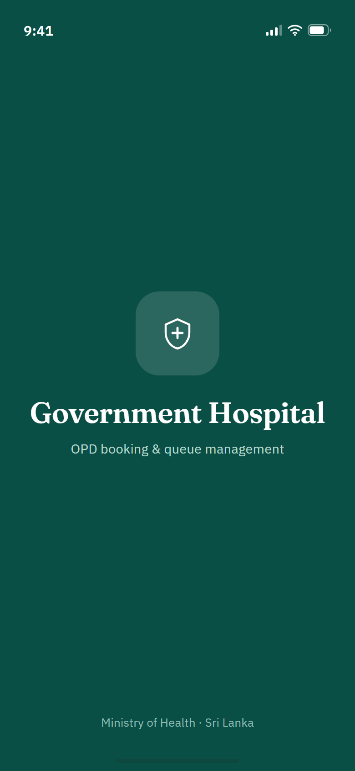 | 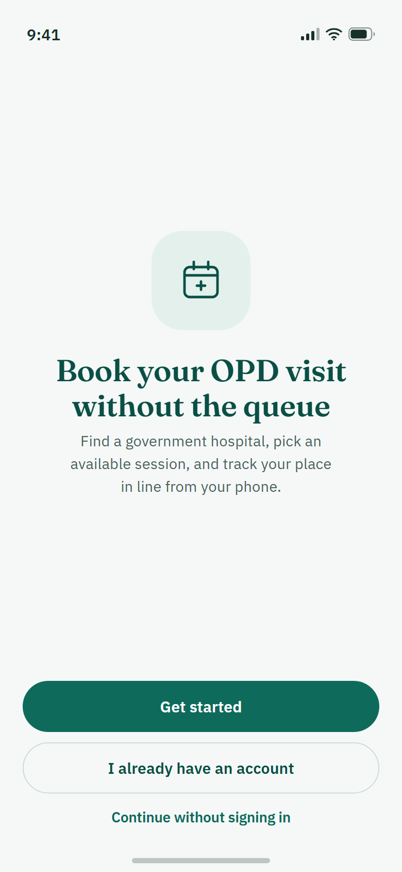 |  | 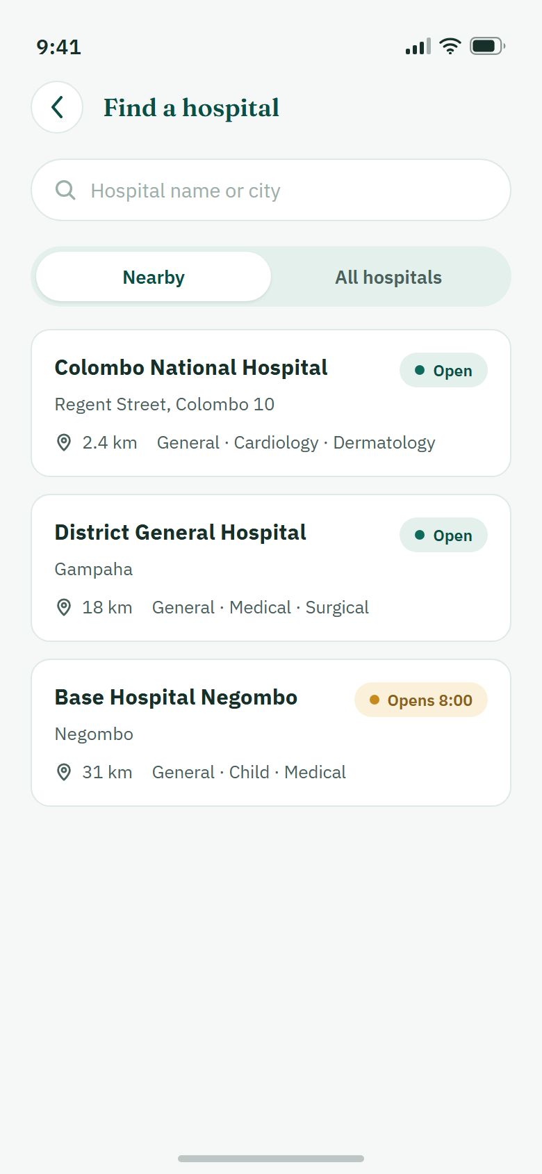
01 Splash | 02 Welcome | 06 Home | 07 Find a hospital | 08 Hospital details | 09 Book appointment | 10 Booking confirmed
[[INSERT: working-app screenshots of the same screens, in the same order – Dayarathna]]
Perera – patient account, bookings and priority
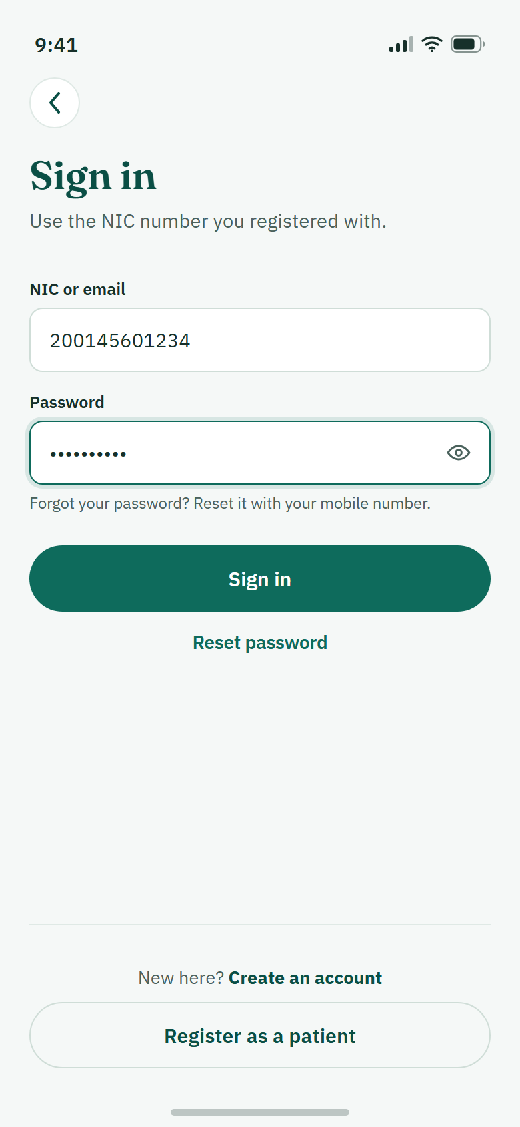 |  |  |  |  | 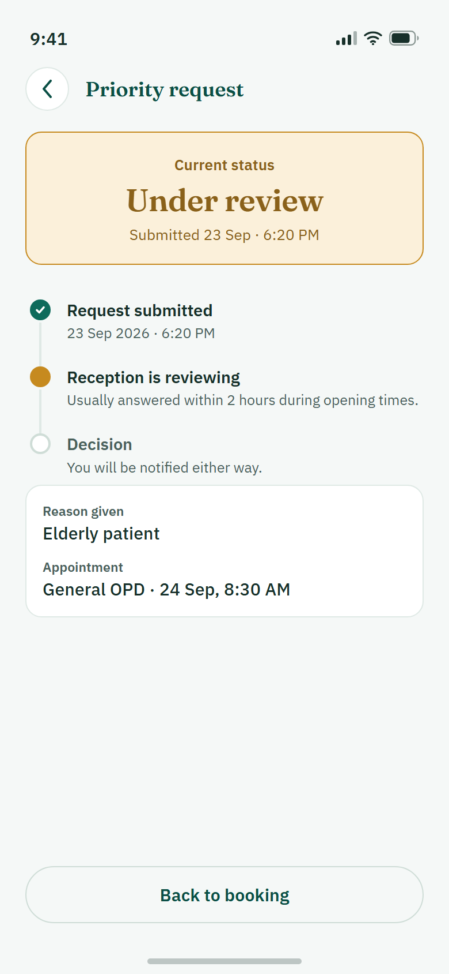
04 Patient sign in | 05 Create account | 11 My bookings | 12 Booking details | 13 Request priority | 14 Request status
[[INSERT: working-app screenshots of the same screens, in the same order – Perera]]
Shaveena – OPD session management
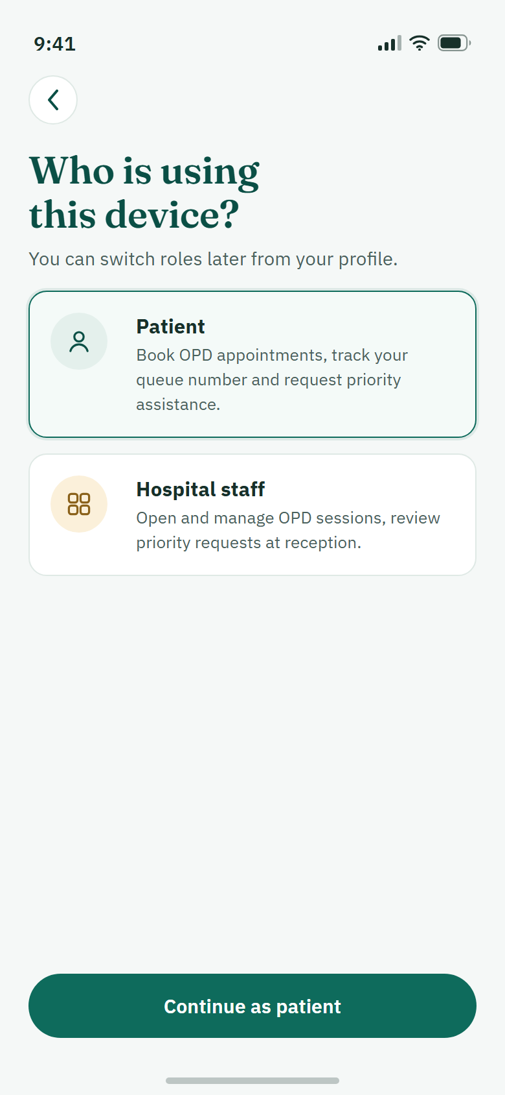
03 Choose role | 18 Staff sign in | 20 Reception dashboard | 21 OPD sessions | 22 Add session
[[INSERT: working-app screenshots of the same screens, in the same order – Shaveena]]
Rajarathna – priority request management
 |  |  |  | 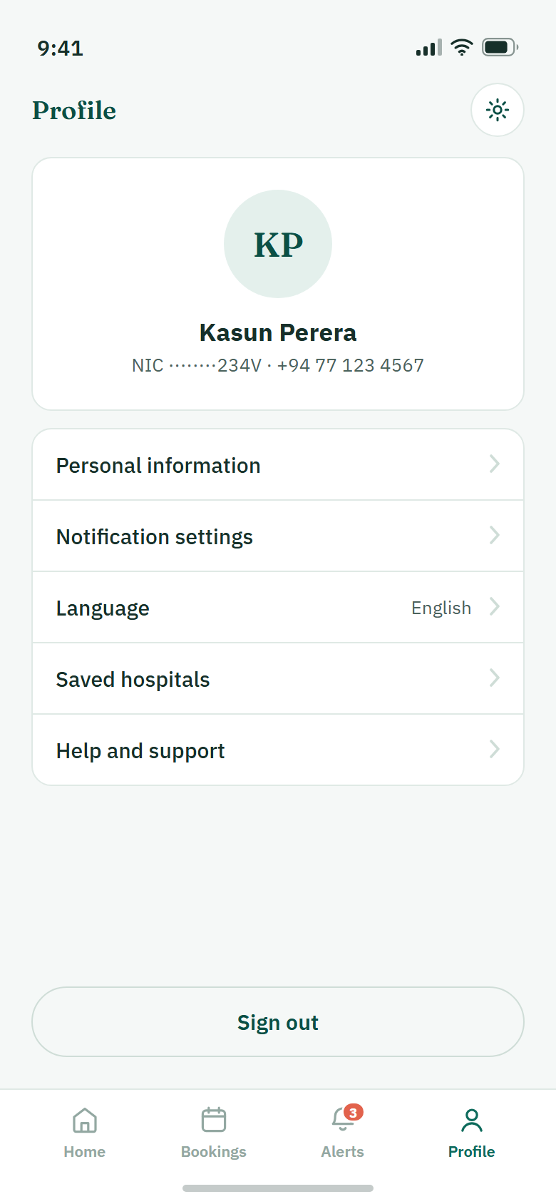 | 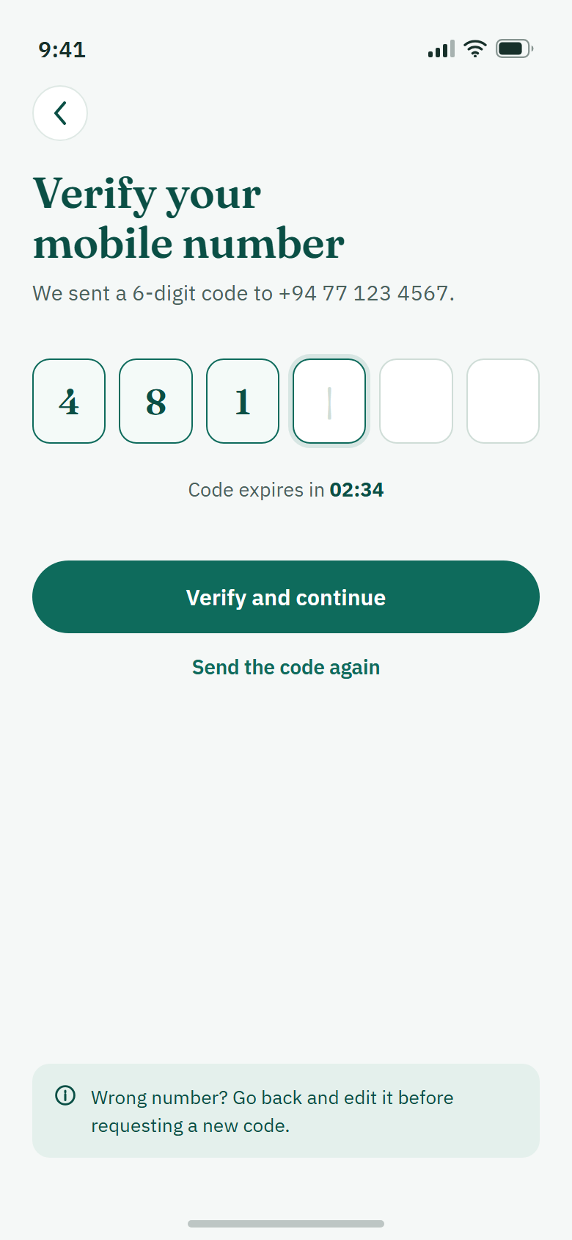
19 Staff registration | 23 Priority requests | 24 Request details | 15 Notifications | 16 Profile | 17 Verify number (not built)
[[INSERT: working-app screenshots of the same screens, in the same order – Rajarathna]]

Appendix D – Source Code Excerpts
D.1 Booking transaction: reserve a place, then save the booking and its notification (apps/api/src/modules/bookings/bookingRepository.js)
const updated = await db.collection('opdSessions').updateOne(
{
_id: sessionId,
status: 'OPEN',
$expr: {
$and: [
{ $lt: ['$bookedCount', '$capacity'] },
{ $gt: [timestamp('startTime'), now()] },
],
},
},
{ $inc: { bookedCount: 1 }, $set: { updatedAt: at } },
options
);
if (updated.modifiedCount !== 1) throw unavailable();
const booking = {
_id: bookingId, bookingCode, patientId, sessionId,
status: 'CONFIRMED', ...slotFields(slot), createdAt: at, updatedAt: at,
};
await db.collection('bookings').insertOne(booking, options);
await insertBookingConfirmation(db, booking, transaction);
D.2 Staff-only access and decision validation (apps/api/src/modules/priority/g_priorityRoutes.js)
const STAFF_ROLES = ['RECEPTION', 'NURSE', 'ADMIN'];

// Patients can never review requests, including their own.
export function requireStaff(request, _response, next) {
if (!request.auth)
throw new HttpError(401, 'UNAUTHORIZED', 'Please sign in to continue.');
if (!STAFF_ROLES.includes(request.auth.role))
throw new HttpError(403, 'FORBIDDEN', 'A staff account is required.');
next();
}

router.patch('/:requestId/decision', async (request, response) => {
const id = requestId(request);
const data = await repository.decide(
request.auth.userId, id, parseDecision(request.body));
response.json({ success: true, data });
});

Appendix E – Repository, Setup and Build
Repository: https://github.com/Queue-Care/QueueCare (branch develop). Installable build: [[INSERT: APK download link and how it was built – Dayarathna]]
How to run (summary of the README and `docs/SETUP.md`). Requirements: Node.js 22.13 or newer, npm, a MongoDB replica set (or an Atlas cluster), and Expo Go for SDK 57 on an Android phone that is on the same Wi-Fi as the computer.
- Install dependencies from the repository root: npm ci.
- Copy apps/api/.env.example to apps/api/.env and set MONGODB_URI, MONGODB_DB_NAME and a random JWT_SECRET (at least 32 bytes).
- Copy apps/mobile/.env.example to apps/mobile/.env and set EXPO_PUBLIC_API_BASE_URL=http://<computer LAN IP>:4000/api/v1.
- Check the configuration and the database: npm run check:setup, then npm run check:db.
- Add demo hospitals, services and sessions for tomorrow: npm run db:seed:sessions.
- Start the API: npm run dev:api and open http://localhost:4000/health.
- Start the app: npm run dev:mobile -- --clear and scan the QR code with Expo Go.
- Create a patient account in the app and sign in with the NIC and password; staff accounts are created from Staff Registration.
Booking and session changes need MongoDB transactions, so a plain standalone server is not enough. Tests: npm run test:api, npm run test:mobile -- --watchman=false, npm run typecheck:mobile, npm run lint:mobile.

Appendix F – Full Requirement List from Milestone 01
Table F.1 – Functional requirements
ID | The system shall …
FR-01 | allow patients, doctors and administrators to log in securely.
FR-02 | allow patients to register using their NIC, email and phone number.
FR-03 | allow users to reset their password if forgotten.
FR-04 | provide role-based access for patients, doctors and administrators.
FR-05 | allow patients to create and update their profiles.
FR-06 | display a patient’s appointment history.
FR-07 | allow patients to update their contact information.
FR-08 | display available OPD departments.
FR-09 | display available doctors and schedules.
FR-10 | allow patients to book appointments online.
FR-11 | prevent double-booking of appointment slots.
FR-12 | generate a unique appointment ID for every booking.
FR-13 | allow patients to cancel appointments.
FR-14 | allow patients to reschedule appointments if slots are available.
FR-15 | generate a queue number after patient check-in.
FR-16 | display the patient’s current queue position.
FR-17 | calculate and display the estimated waiting time.
FR-18 | update the queue in real time.
FR-19 | support priority queues for emergency and special-needs patients.
FR-20 | allow doctors to view their daily appointments.
FR-21 | allow doctors to call the next patient.
FR-22 | allow doctors to mark appointments as completed or skipped.
FR-23 | allow doctors to update their availability.
Table F.2 – Non-functional requirements
ID | Requirement | Description
NFR-01 | Performance | Most pages load within 3 seconds under normal usage.
NFR-02 | Availability | Available 24/7 except during scheduled maintenance.
NFR-03 | Security | Passwords are encrypted and JWT authentication is used.
NFR-04 | Usability | Simple, responsive and easy-to-use interface.
NFR-05 | Reliability | Prevent duplicate appointments and keep queue data accurate.
NFR-06 | Scalability | Support growing numbers of users, appointments and departments.
NFR-07 | Maintainability | Modular, documented code.
NFR-08 | Compatibility | Works on modern web browsers (Chrome, Firefox, Edge, Safari).
NFR-09 | Responsiveness | Interface adapts to desktop, tablet and mobile devices.
NFR-10 | Data integrity | Appointment, queue and patient information stay accurate and consistent.
NFR-11 | Backup and recovery | Regular database backups; recovery minimises data loss.
NFR-12 | Privacy | Patient information is protected; only authorised users access sensitive data.
NFR-13 | Accessibility | Readable fonts, clear navigation and sufficient colour contrast.
NFR-14 | Notification reliability | Notifications are delivered promptly for appointments and queue updates.
NFR-15 | Audit logging | Important actions (creation, cancellation, queue updates) are logged.

