**Chat Module:**

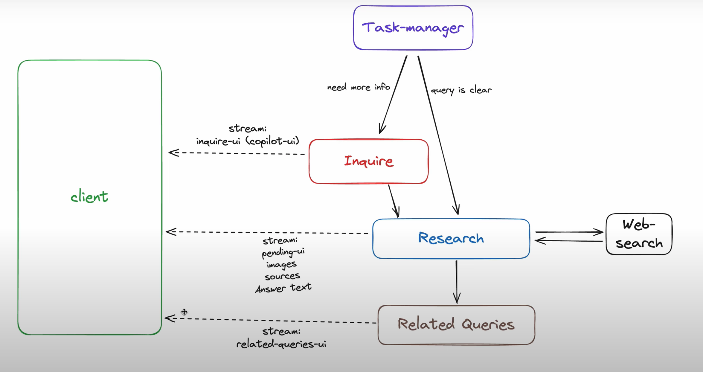

Chat Architecture (Without Maps Functionality)

Description:

First when the user submits the search query the system calls a server action and the server action calls the first agent called task manager to understand the question

If the question is not clear then it moves on to the inquiry step.

In the inquiry step an agent will generate some options for the user to select and get more details about the query.

Once they select it it will add the selected details to the query and move to the next step.

The Next Step goes to the agent called researcher this researcher agent has access to tools to search the web and get the web search results once it gets the web search results with images and sources information both the images and sources information are popped into UI and streamed to the client side while the language model prepares The Final Answer.

Once the final answer is available then the researcher agent streams in the final text.

The query suggestion agent kicks in and gets related queries based on the user query and streams the output along with the UI and finally the follow up panel UI is streamed to the client.

Application Programming interfaces:

Generative UI application programming interfaces from the AI SDK.

**AI State**

<https://sdk.vercel.ai/docs/reference/ai-sdk-rsc/use-ai-state>

The AI state is a Json input passed into the language model and can be accessed both on the server and the client side.

**UI State**

<https://sdk.vercel.ai/docs/reference/ai-sdk-rsc/use-ui-state>

Holds all the messages we show to the user and it can only be accessed on the client side.

**create streamable UI**.

<https://sdk.vercel.ai/docs/reference/ai-sdk-rsc/create-streamable-ui>

Creates a UI stream which is used to send react nodes to the client site as part of a stream from the server site.

You can send both client and server component updates as part of this API.

**Generate object**

<https://sdk.vercel.ai/docs/reference/ai-sdk-core/generate-object>

enables the language model to give output based on a schema.

**Stream object**

<https://sdk.vercel.ai/docs/reference/ai-sdk-core/stream-object>

enables the language model to stream the generated object.

the stream object helps in generating UI as we stream outputs from the language model.

**stream text**

<https://sdk.vercel.ai/docs/reference/ai-sdk-core/stream-text>

stream text back to the client side.

**React Components**

UI components for chat and co-pilot which is is used to generate the inquiry UI

Language Model Agents:

Task manager

Researcher

Inquire

Query suggestion

**Server Action and Query Processing Documentation**

This documentation outlines the server actions and query processing workflow. It details the steps from when a user enters a query to when the final results and related queries are displayed on the UI.

Workflow

**User Query Handling**

When the user enters a query, the system checks if more resolution about the search is needed.

The task manager handles the system state to determine if the query requires further resolution.

**Inquire Agent**

If more resolution is needed, the inquire agent receives a stream object.

The inquire agent updates the co-pilot UI with this stream object.

Once the inquiry is complete, the updated UI is streamed back to the client side.

**Researcher Agent and Web Search API**

The system then passes the query to the researcher agent.

The researcher agent calls the web search API to obtain search results.

Inside the researcher agent, a function handles web searches, and pending UI updates are streamed back to the client in parallel.

**Web Search Result Processing**

The web search result is processed by the language model.

**Streaming Text to the UI**

The language model generates tokens from the web search results.

These tokens are streamed to the **streamText** value.

**Updating the Answer Section UI**

The **streamText** value updates the answer section of the UI with the generated tokens.

Once the language model completes its task, the final UI updates are handed over.

**Query Suggestion Agent**

The query suggestion agent takes over to generate related queries.

These related queries are displayed in the related queries UI section.

**Follow-Up Panel**

After the related queries are generated, the follow-up panel is streamed and displayed.

**Closing the UI Stream**

The UI stream is closed after the follow-up panel is streamed.

