Homework 1

Class 7

Jorune Simpkins

1. Create instance

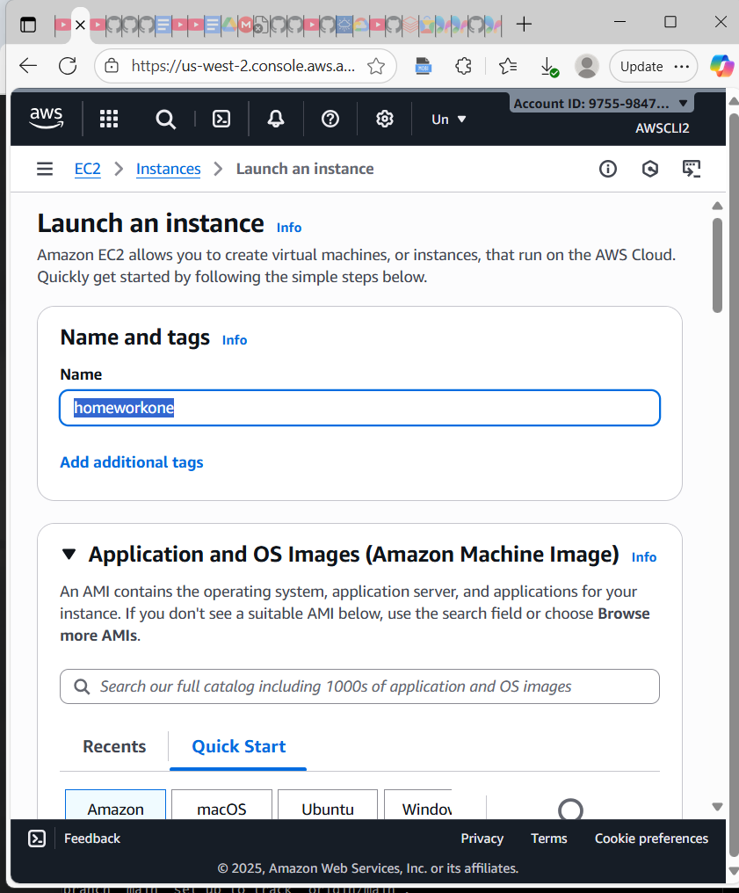

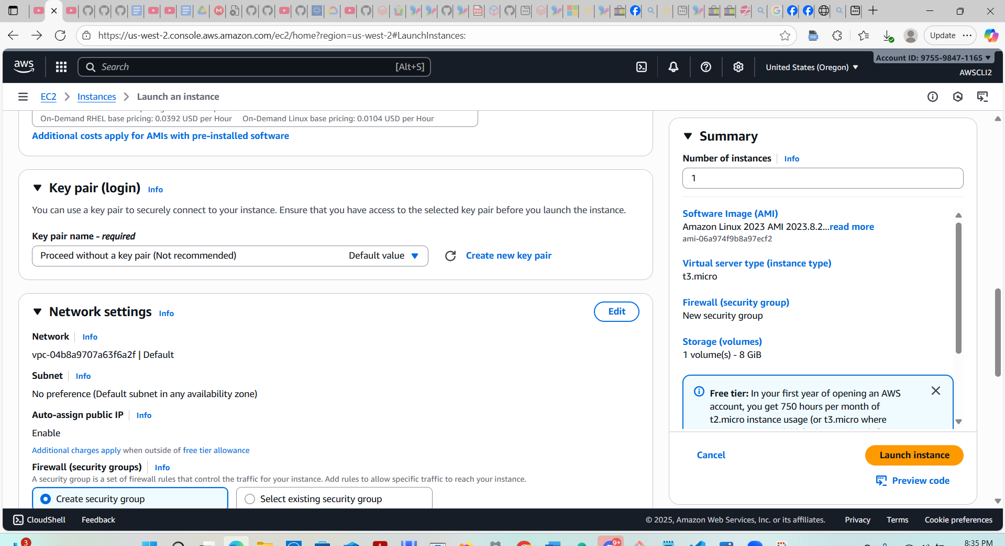

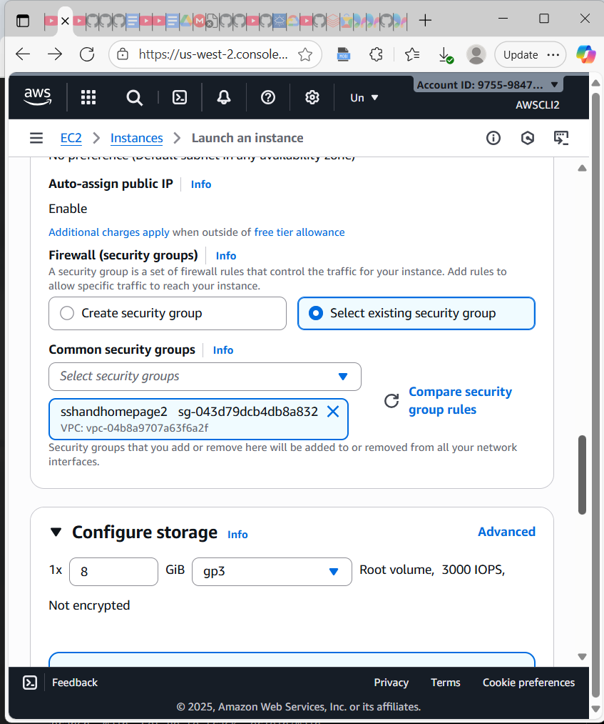

Launching instance

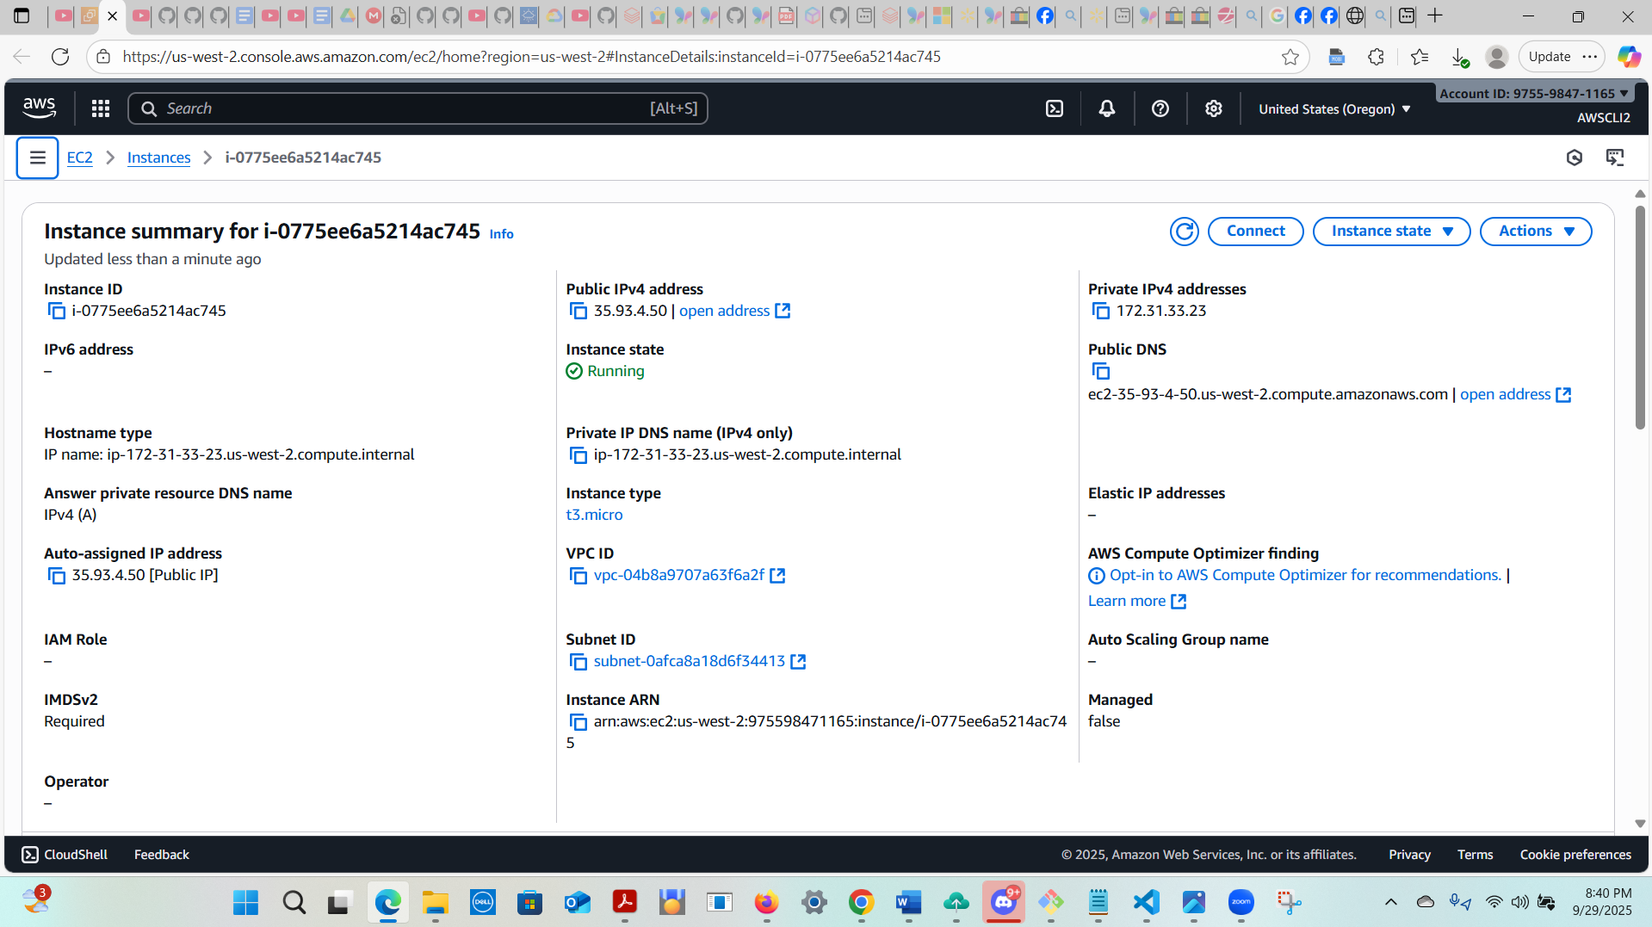

Copying public DNS

ec2-35-93-4-50.us-west-2.compute.amazonaws.com

Launched Website

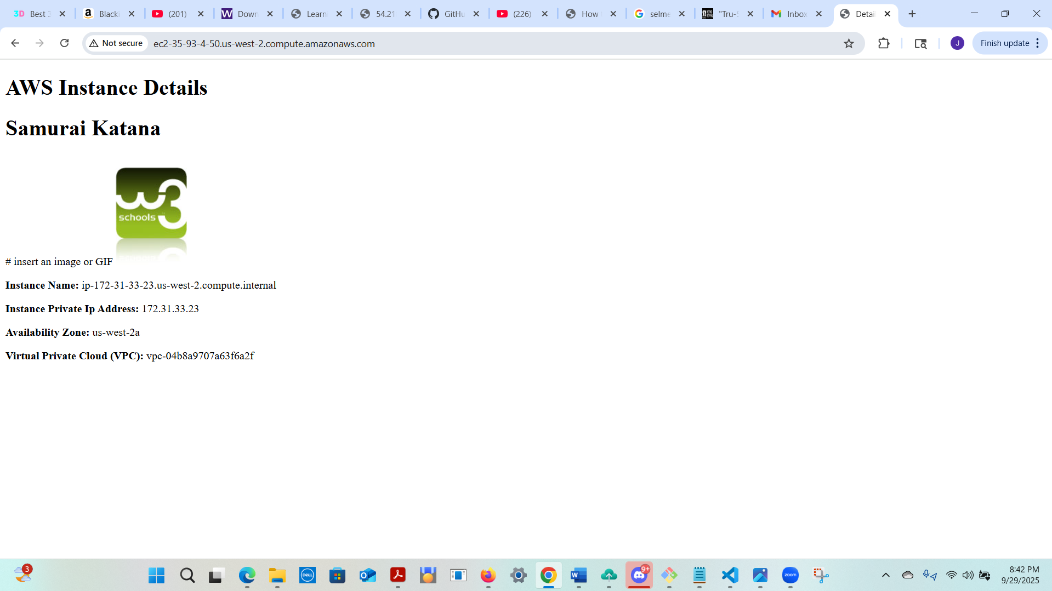

Connected to website

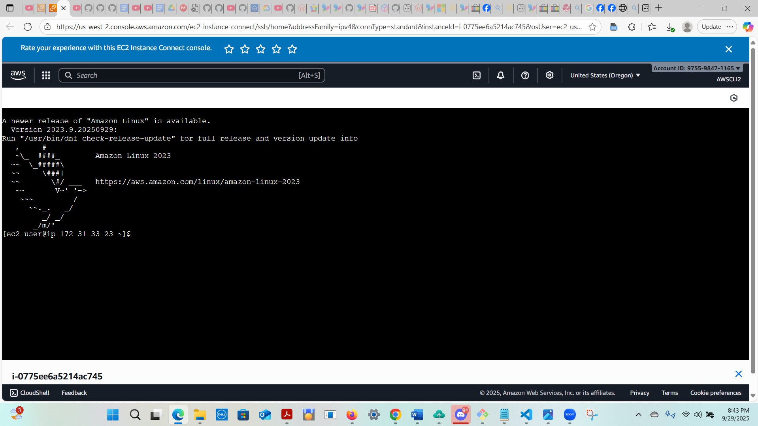

Ping 8.8.8.8 -c 6 (Google’s public DNS Server)

