Jorune Simpkins
03/30/2026 – Python File Run Proof
Lab 3B: Armageddon – Python Files Output

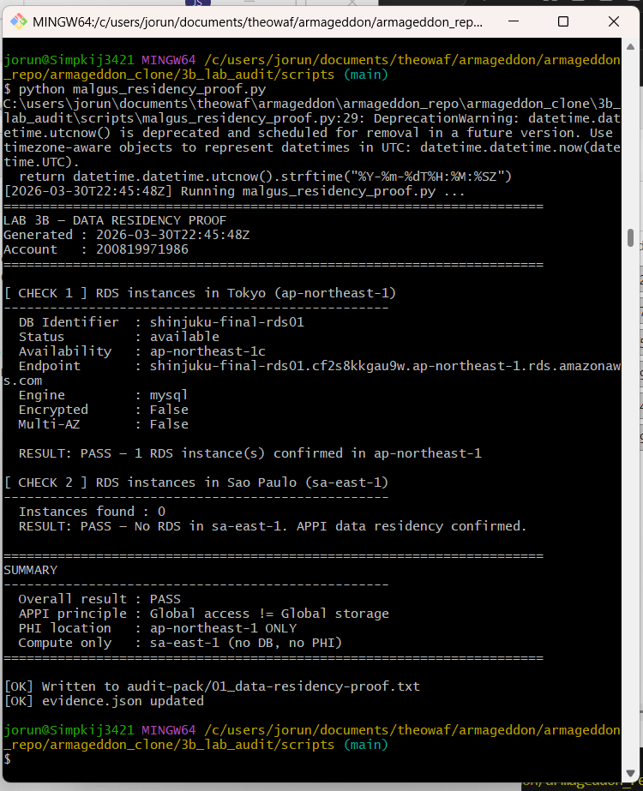

jorun@Simpkij3421 MINGW64 /c/users/jorun/documents/theowaf/armageddon/armageddon_repo/armageddon_clone/3b_lab_audit/scripts (main)
$ python malgus_residency_proof.py
C:\users\jorun\documents\theowaf\armageddon\armageddon_repo\armageddon_clone\3b_lab_audit\scripts\malgus_residency_proof.py:29: DeprecationWarning: datetime.datetime.utcnow() is deprecated and scheduled for removal in a future version. Use timezone-aware objects to represent datetimes in UTC: datetime.datetime.now(datetime.UTC).
return datetime.datetime.utcnow().strftime("%Y-%m-%dT%H:%M:%SZ")
[2026-03-30T22:45:48Z] Running malgus_residency_proof.py ...
======================================================================
LAB 3B — DATA RESIDENCY PROOF
Generated : 2026-03-30T22:45:48Z
Account : 200819971986
======================================================================

[ CHECK 1 ] RDS instances in Tokyo (ap-northeast-1)
--------------------------------------------------
DB Identifier : shinjuku-final-rds01
Status : available
Availability : ap-northeast-1c
Endpoint : shinjuku-final-rds01.cf2s8kkgau9w.ap-northeast-1.rds.amazonaws.com
Engine : mysql
Encrypted : False
Multi-AZ : False

RESULT: PASS — 1 RDS instance(s) confirmed in ap-northeast-1

[ CHECK 2 ] RDS instances in Sao Paulo (sa-east-1)
--------------------------------------------------
Instances found : 0
RESULT: PASS — No RDS in sa-east-1. APPI data residency confirmed.

======================================================================
SUMMARY
--------------------------------------------------
Overall result : PASS
APPI principle : Global access != Global storage
PHI location : ap-northeast-1 ONLY
Compute only : sa-east-1 (no DB, no PHI)
======================================================================
Findings:
Encrypted : False
NOTE: RDS is not encrypted at rest

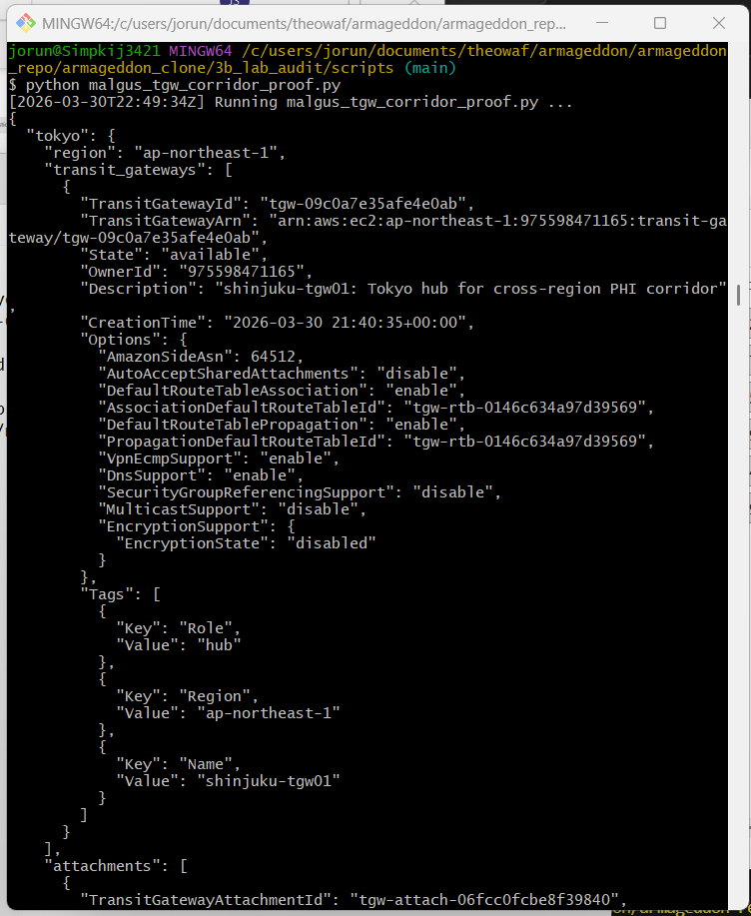

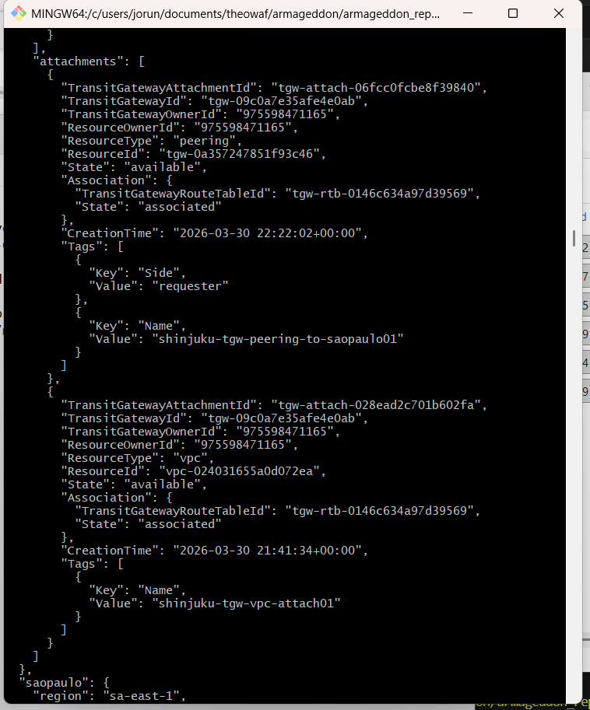

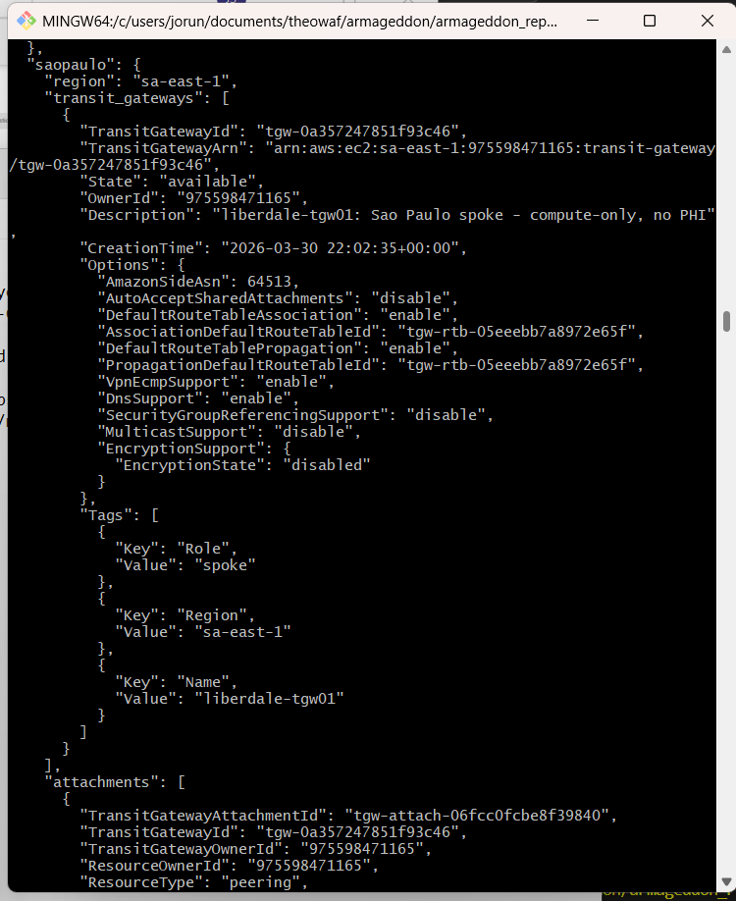

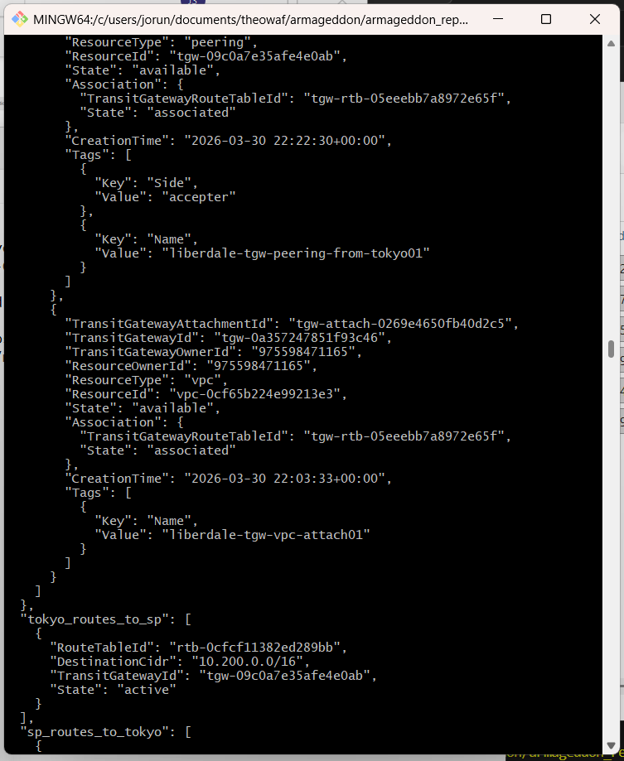
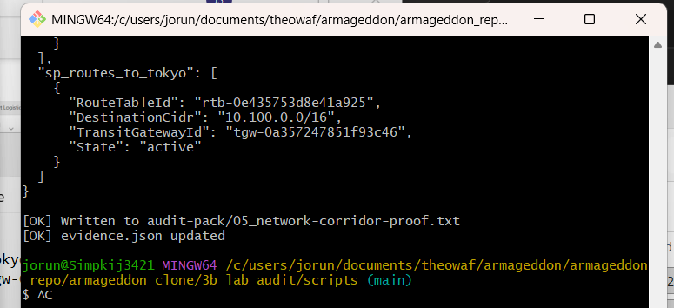



jorun@Simpkij3421 MINGW64 /c/users/jorun/documents/theowaf/armageddon/armageddon_repo/armageddon_clone/3b_lab_audit/scripts (main)
$ python malgus_tgw_corridor_proof.py
[2026-03-30T22:49:34Z] Running malgus_tgw_corridor_proof.py ...
{
"tokyo": {
"region": "ap-northeast-1",
"transit_gateways": [
{
"TransitGatewayId": "tgw-09c0a7e35afe4e0ab",
"TransitGatewayArn": "arn:aws:ec2:ap-northeast-1:975598471165:transit-gateway/tgw-09c0a7e35afe4e0ab",
"State": "available",
"OwnerId": "975598471165",
"Description": "shinjuku-tgw01: Tokyo hub for cross-region PHI corridor",
"CreationTime": "2026-03-30 21:40:35+00:00",
"Options": {
"AmazonSideAsn": 64512,
"AutoAcceptSharedAttachments": "disable",
"DefaultRouteTableAssociation": "enable",
"AssociationDefaultRouteTableId": "tgw-rtb-0146c634a97d39569",
"DefaultRouteTablePropagation": "enable",
"PropagationDefaultRouteTableId": "tgw-rtb-0146c634a97d39569",
"VpnEcmpSupport": "enable",
"DnsSupport": "enable",
"SecurityGroupReferencingSupport": "disable",
"MulticastSupport": "disable",
"EncryptionSupport": {
"EncryptionState": "disabled"
}
},
"Tags": [
{
"Key": "Role",
"Value": "hub"
},
{
"Key": "Region",
"Value": "ap-northeast-1"
},
{
"Key": "Name",
"Value": "shinjuku-tgw01"
}
]
}
],
"attachments": [
{
"TransitGatewayAttachmentId": "tgw-attach-06fcc0fcbe8f39840",
"TransitGatewayId": "tgw-09c0a7e35afe4e0ab",
"TransitGatewayOwnerId": "975598471165",
"ResourceOwnerId": "975598471165",
"ResourceType": "peering",
"ResourceId": "tgw-0a357247851f93c46",
"State": "available",
"Association": {
"TransitGatewayRouteTableId": "tgw-rtb-0146c634a97d39569",
"State": "associated"
},
"CreationTime": "2026-03-30 22:22:02+00:00",
"Tags": [
{
"Key": "Side",
"Value": "requester"
},
{
"Key": "Name",
"Value": "shinjuku-tgw-peering-to-saopaulo01"
}
]
},
{
"TransitGatewayAttachmentId": "tgw-attach-028ead2c701b602fa",
"TransitGatewayId": "tgw-09c0a7e35afe4e0ab",
"TransitGatewayOwnerId": "975598471165",
"ResourceOwnerId": "975598471165",
"ResourceType": "vpc",
"ResourceId": "vpc-024031655a0d072ea",
"State": "available",
"Association": {
"TransitGatewayRouteTableId": "tgw-rtb-0146c634a97d39569",
"State": "associated"
},
"CreationTime": "2026-03-30 21:41:34+00:00",
"Tags": [
{
"Key": "Name",
"Value": "shinjuku-tgw-vpc-attach01"
}
]
}
]
},
"saopaulo": {
"region": "sa-east-1",
"transit_gateways": [
{
"TransitGatewayId": "tgw-0a357247851f93c46",
"TransitGatewayArn": "arn:aws:ec2:sa-east-1:975598471165:transit-gateway/tgw-0a357247851f93c46",
"State": "available",
"OwnerId": "975598471165",
"Description": "liberdale-tgw01: Sao Paulo spoke - compute-only, no PHI",
"CreationTime": "2026-03-30 22:02:35+00:00",
"Options": {
"AmazonSideAsn": 64513,
"AutoAcceptSharedAttachments": "disable",
"DefaultRouteTableAssociation": "enable",
"AssociationDefaultRouteTableId": "tgw-rtb-05eeebb7a8972e65f",
"DefaultRouteTablePropagation": "enable",
"PropagationDefaultRouteTableId": "tgw-rtb-05eeebb7a8972e65f",
"VpnEcmpSupport": "enable",
"DnsSupport": "enable",
"SecurityGroupReferencingSupport": "disable",
"MulticastSupport": "disable",
"EncryptionSupport": {
"EncryptionState": "disabled"
}
},
"Tags": [
{
"Key": "Role",
"Value": "spoke"
},
{
"Key": "Region",
"Value": "sa-east-1"
},
{
"Key": "Name",
"Value": "liberdale-tgw01"
}
]
}
],
"attachments": [
{
"TransitGatewayAttachmentId": "tgw-attach-06fcc0fcbe8f39840",
"TransitGatewayId": "tgw-0a357247851f93c46",
"TransitGatewayOwnerId": "975598471165",
"ResourceOwnerId": "975598471165",
"ResourceType": "peering",
"ResourceId": "tgw-09c0a7e35afe4e0ab",
"State": "available",
"Association": {
"TransitGatewayRouteTableId": "tgw-rtb-05eeebb7a8972e65f",
"State": "associated"
},
"CreationTime": "2026-03-30 22:22:30+00:00",
"Tags": [
{
"Key": "Side",
"Value": "accepter"
},
{
"Key": "Name",
"Value": "liberdale-tgw-peering-from-tokyo01"
}
]
},
{
"TransitGatewayAttachmentId": "tgw-attach-0269e4650fb40d2c5",
"TransitGatewayId": "tgw-0a357247851f93c46",
"TransitGatewayOwnerId": "975598471165",
"ResourceOwnerId": "975598471165",
"ResourceType": "vpc",
"ResourceId": "vpc-0cf65b224e99213e3",
"State": "available",
"Association": {
"TransitGatewayRouteTableId": "tgw-rtb-05eeebb7a8972e65f",
"State": "associated"
},
"CreationTime": "2026-03-30 22:03:33+00:00",
"Tags": [
{
"Key": "Name",
"Value": "liberdale-tgw-vpc-attach01"
}
]
}
]
},
"tokyo_routes_to_sp": [],
"sp_routes_to_tokyo": []
}

[OK] Written to audit-pack/05_network-corridor-proof.txt
[OK] evidence.json updated
NOTE: The TGWs and peering attachments are all available and correctly connected
"tokyo_routes_to_sp": [],
"sp_routes_to_tokyo": []
NOTE: The routes are empty. This means the script is checking the VPC route tables for TGW routes, but the script is looking for routes in the wrong VPC IDs. Notice the script has hardcoded VPC IDs in its locked values:
TOKYO_VPC = "vpc-0b9de40ee844fa645" # ← old/wrong VPC ID
SP_VPC = "vpc-0c90d6182b218c5ae" # ← old/wrong VPC ID
But your **actual VPC IDs** from Terraform output are:
Tokyo VPC : vpc-024031655a0d072ea
SP VPC : vpc-0cf65b224e99213e3

_____________________________________________________________________________
jorun@Simpkij3421 MINGW64 /c/users/jorun/documents/theowaf/armageddon/armageddon_repo/armageddon_clone/3b_lab_audit/scripts (main)
$ python malgus_tgw_corridor_proof.py
[2026-03-30T22:55:16Z] Running malgus_tgw_corridor_proof.py ...
{
"tokyo": {
"region": "ap-northeast-1",
"transit_gateways": [
{
"TransitGatewayId": "tgw-09c0a7e35afe4e0ab",
"TransitGatewayArn": "arn:aws:ec2:ap-northeast-1:975598471165:transit-gateway/tgw-09c0a7e35afe4e0ab",
"State": "available",
"OwnerId": "975598471165",
"Description": "shinjuku-tgw01: Tokyo hub for cross-region PHI corridor",
"CreationTime": "2026-03-30 21:40:35+00:00",
"Options": {
"AmazonSideAsn": 64512,
"AutoAcceptSharedAttachments": "disable",
"DefaultRouteTableAssociation": "enable",
"AssociationDefaultRouteTableId": "tgw-rtb-0146c634a97d39569",
"DefaultRouteTablePropagation": "enable",
"PropagationDefaultRouteTableId": "tgw-rtb-0146c634a97d39569",
"VpnEcmpSupport": "enable",
"DnsSupport": "enable",
"SecurityGroupReferencingSupport": "disable",
"MulticastSupport": "disable",
"EncryptionSupport": {
"EncryptionState": "disabled"
}
},
"Tags": [
{
"Key": "Role",
"Value": "hub"
},
{
"Key": "Region",
"Value": "ap-northeast-1"
},
{
"Key": "Name",
"Value": "shinjuku-tgw01"
}
]
}
],
"attachments": [
{
"TransitGatewayAttachmentId": "tgw-attach-06fcc0fcbe8f39840",
"TransitGatewayId": "tgw-09c0a7e35afe4e0ab",
"TransitGatewayOwnerId": "975598471165",
"ResourceOwnerId": "975598471165",
"ResourceType": "peering",
"ResourceId": "tgw-0a357247851f93c46",
"State": "available",
"Association": {
"TransitGatewayRouteTableId": "tgw-rtb-0146c634a97d39569",
"State": "associated"
},
"CreationTime": "2026-03-30 22:22:02+00:00",
"Tags": [
{
"Key": "Side",
"Value": "requester"
},
{
"Key": "Name",
"Value": "shinjuku-tgw-peering-to-saopaulo01"
}
]
},
{
"TransitGatewayAttachmentId": "tgw-attach-028ead2c701b602fa",
"TransitGatewayId": "tgw-09c0a7e35afe4e0ab",
"TransitGatewayOwnerId": "975598471165",
"ResourceOwnerId": "975598471165",
"ResourceType": "vpc",
"ResourceId": "vpc-024031655a0d072ea",
"State": "available",
"Association": {
"TransitGatewayRouteTableId": "tgw-rtb-0146c634a97d39569",
"State": "associated"
},
"CreationTime": "2026-03-30 21:41:34+00:00",
"Tags": [
{
"Key": "Name",
"Value": "shinjuku-tgw-vpc-attach01"
}
]
}
]
},
"saopaulo": {
"region": "sa-east-1",
"transit_gateways": [
{
"TransitGatewayId": "tgw-0a357247851f93c46",
"TransitGatewayArn": "arn:aws:ec2:sa-east-1:975598471165:transit-gateway/tgw-0a357247851f93c46",
"State": "available",
"OwnerId": "975598471165",
"Description": "liberdale-tgw01: Sao Paulo spoke - compute-only, no PHI",
"CreationTime": "2026-03-30 22:02:35+00:00",
"Options": {
"AmazonSideAsn": 64513,
"AutoAcceptSharedAttachments": "disable",
"DefaultRouteTableAssociation": "enable",
"AssociationDefaultRouteTableId": "tgw-rtb-05eeebb7a8972e65f",
"DefaultRouteTablePropagation": "enable",
"PropagationDefaultRouteTableId": "tgw-rtb-05eeebb7a8972e65f",
"VpnEcmpSupport": "enable",
"DnsSupport": "enable",
"SecurityGroupReferencingSupport": "disable",
"MulticastSupport": "disable",
"EncryptionSupport": {
"EncryptionState": "disabled"
}
},
"Tags": [
{
"Key": "Role",
"Value": "spoke"
},
{
"Key": "Region",
"Value": "sa-east-1"
},
{
"Key": "Name",
"Value": "liberdale-tgw01"
}
]
}
],
"attachments": [
{
"TransitGatewayAttachmentId": "tgw-attach-06fcc0fcbe8f39840",
"TransitGatewayId": "tgw-0a357247851f93c46",
"TransitGatewayOwnerId": "975598471165",
"ResourceOwnerId": "975598471165",
"ResourceType": "peering",
"ResourceId": "tgw-09c0a7e35afe4e0ab",
"State": "available",
"Association": {
"TransitGatewayRouteTableId": "tgw-rtb-05eeebb7a8972e65f",
"State": "associated"
},
"CreationTime": "2026-03-30 22:22:30+00:00",
"Tags": [
{
"Key": "Side",
"Value": "accepter"
},
{
"Key": "Name",
"Value": "liberdale-tgw-peering-from-tokyo01"
}
]
},
{
"TransitGatewayAttachmentId": "tgw-attach-0269e4650fb40d2c5",
"TransitGatewayId": "tgw-0a357247851f93c46",
"TransitGatewayOwnerId": "975598471165",
"ResourceOwnerId": "975598471165",
"ResourceType": "vpc",
"ResourceId": "vpc-0cf65b224e99213e3",
"State": "available",
"Association": {
"TransitGatewayRouteTableId": "tgw-rtb-05eeebb7a8972e65f",
"State": "associated"
},
"CreationTime": "2026-03-30 22:03:33+00:00",
"Tags": [
{
"Key": "Name",
"Value": "liberdale-tgw-vpc-attach01"
}
]
}
]
},
"tokyo_routes_to_sp": [
{
"RouteTableId": "rtb-0cfcf11382ed289bb",
"DestinationCidr": "10.200.0.0/16",
"TransitGatewayId": "tgw-09c0a7e35afe4e0ab",
"State": "active"
}
],
"sp_routes_to_tokyo": [
{
"RouteTableId": "rtb-0e435753d8e41a925",
"DestinationCidr": "10.100.0.0/16",
"TransitGatewayId": "tgw-0a357247851f93c46",
"State": "active"
}
]
}

[OK] Written to audit-pack/05_network-corridor-proof.txt
[OK] evidence.json updated

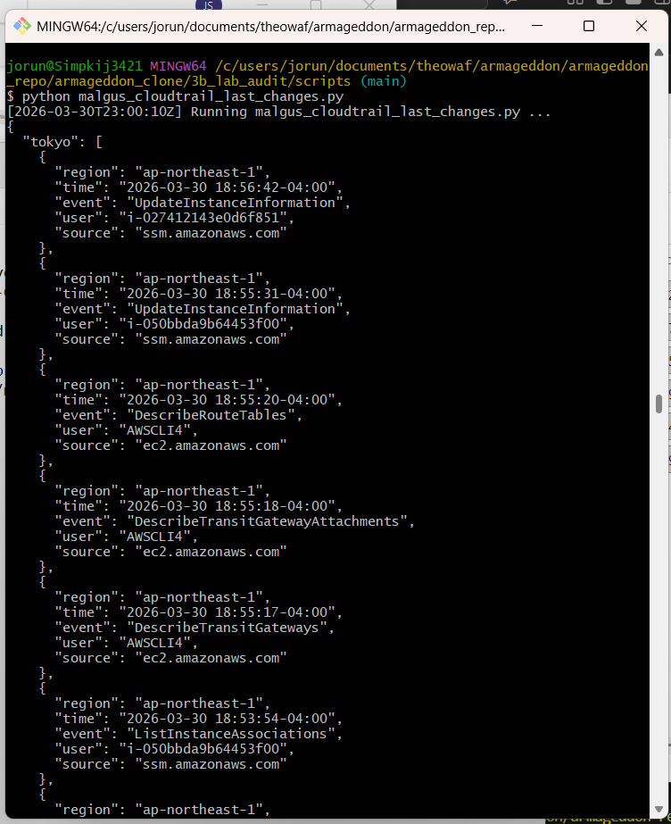

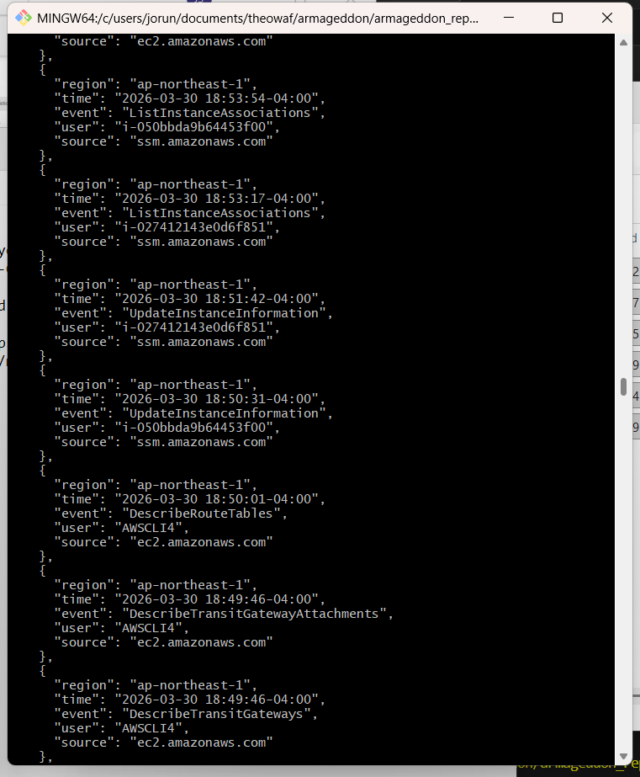
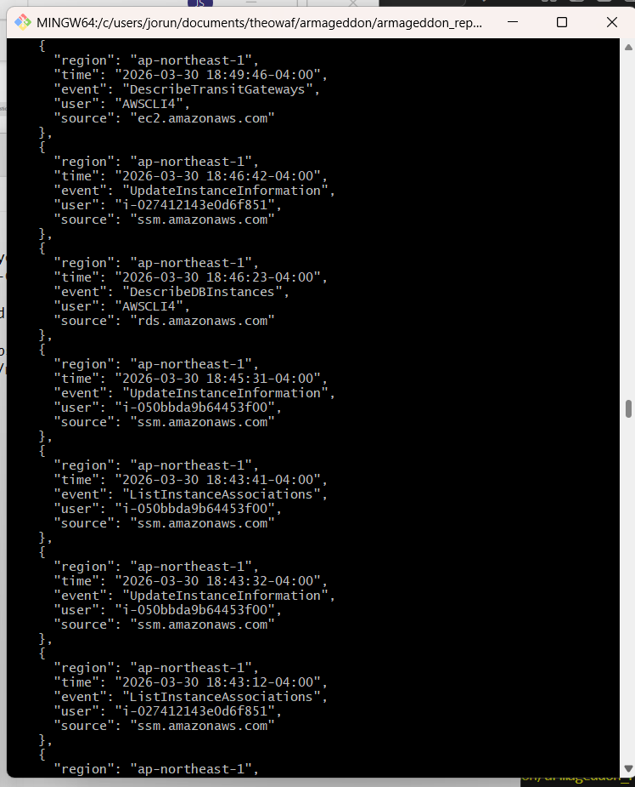

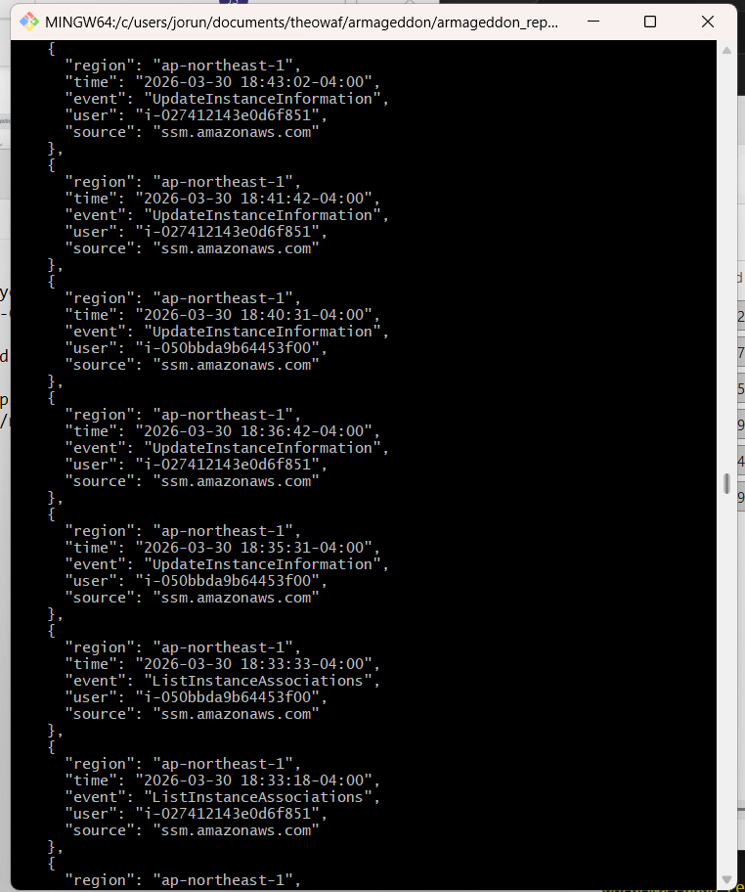

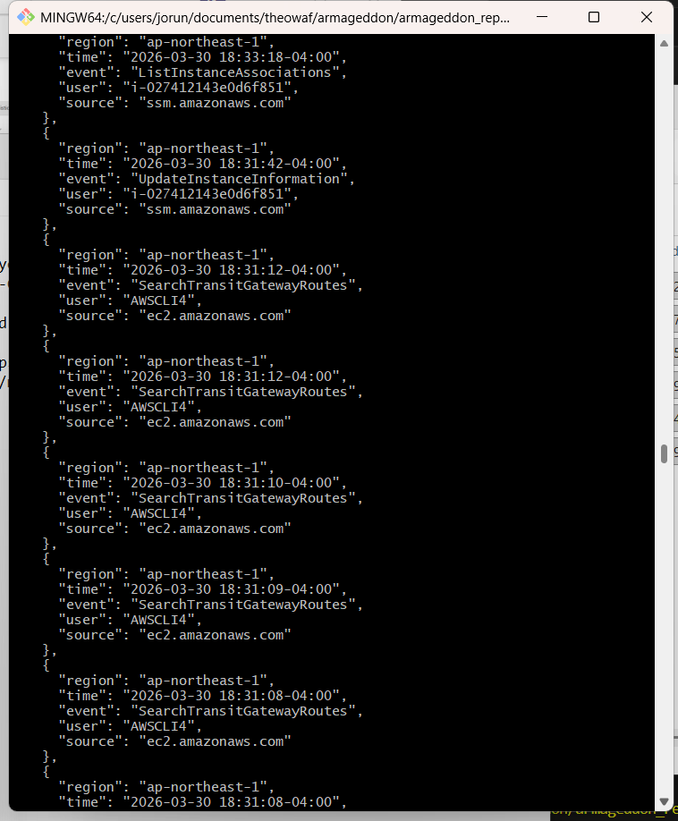

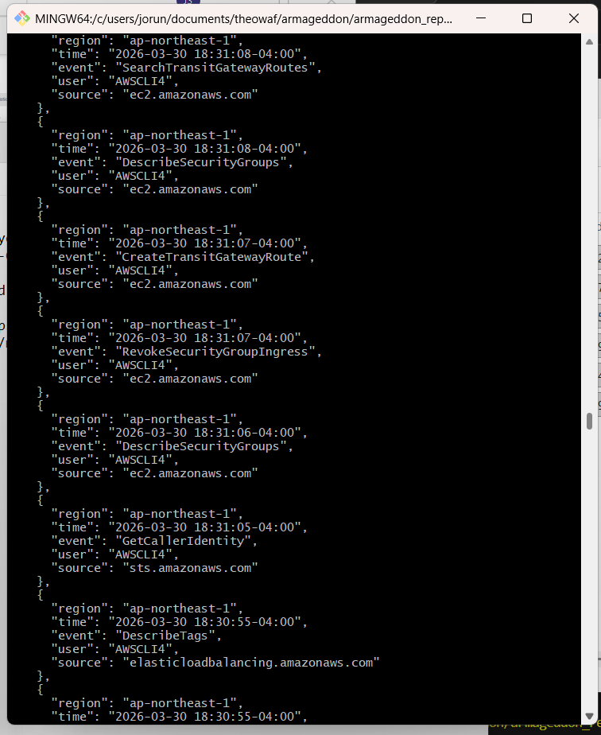

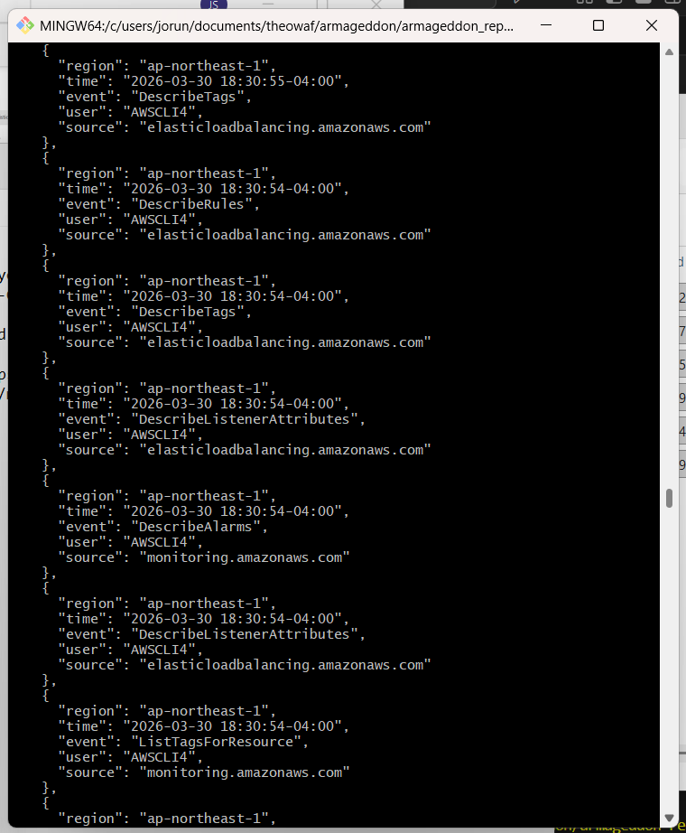

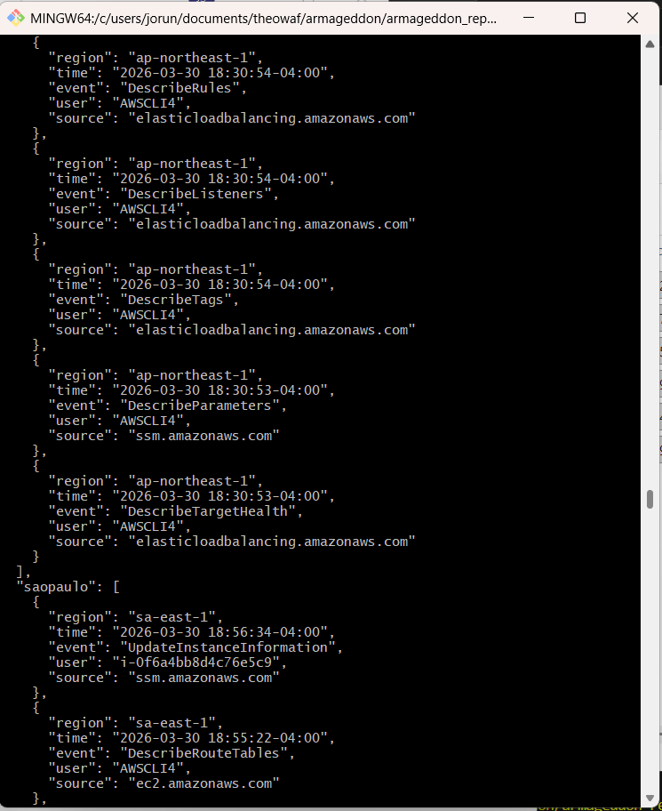

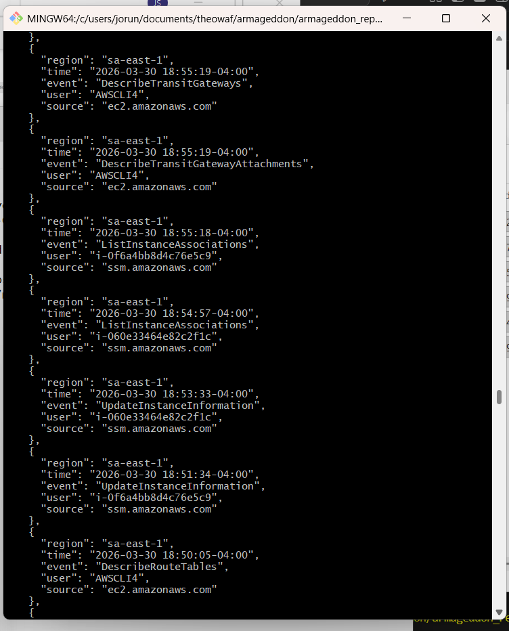

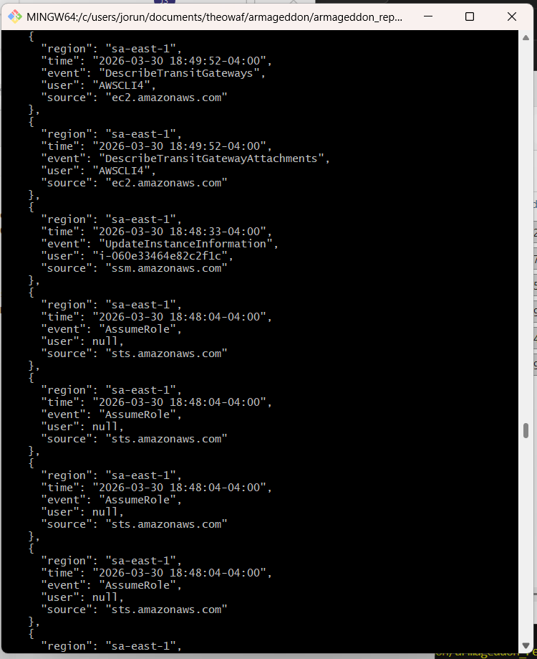
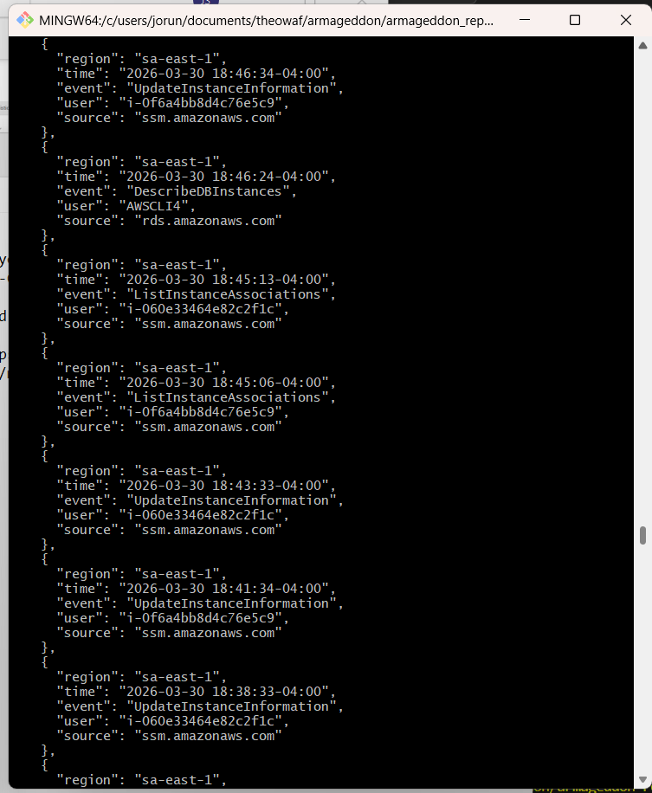

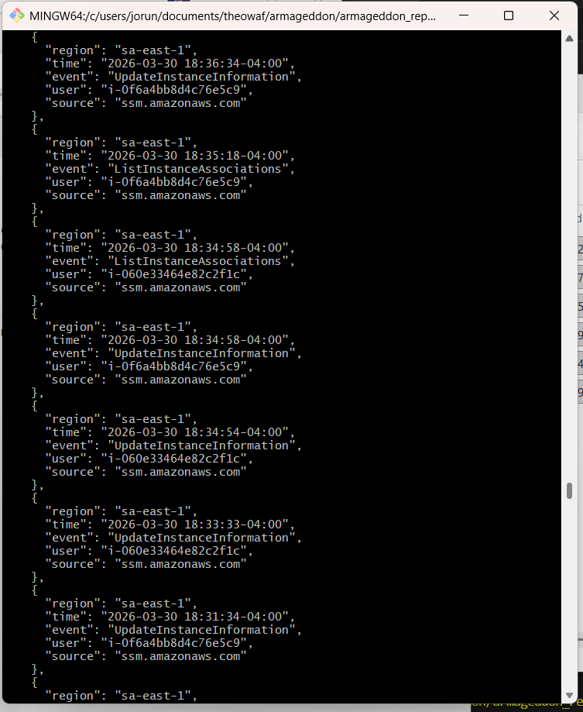

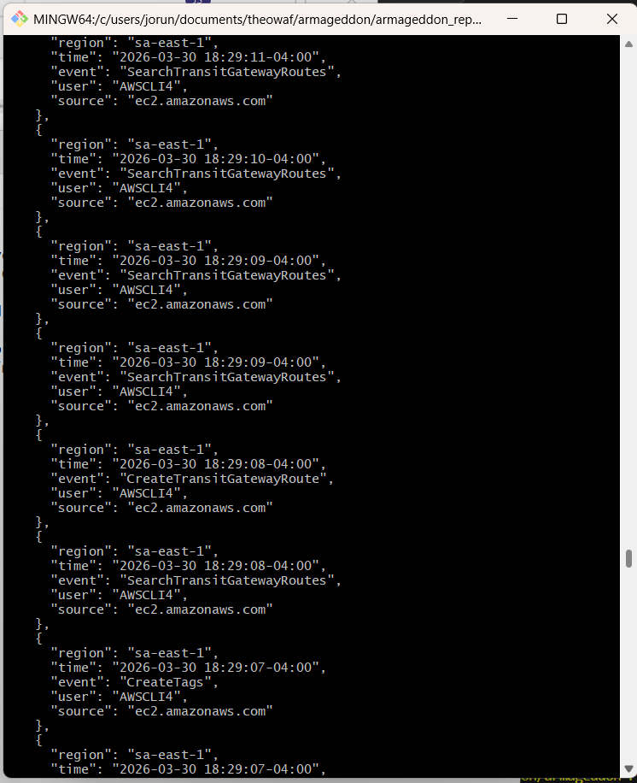

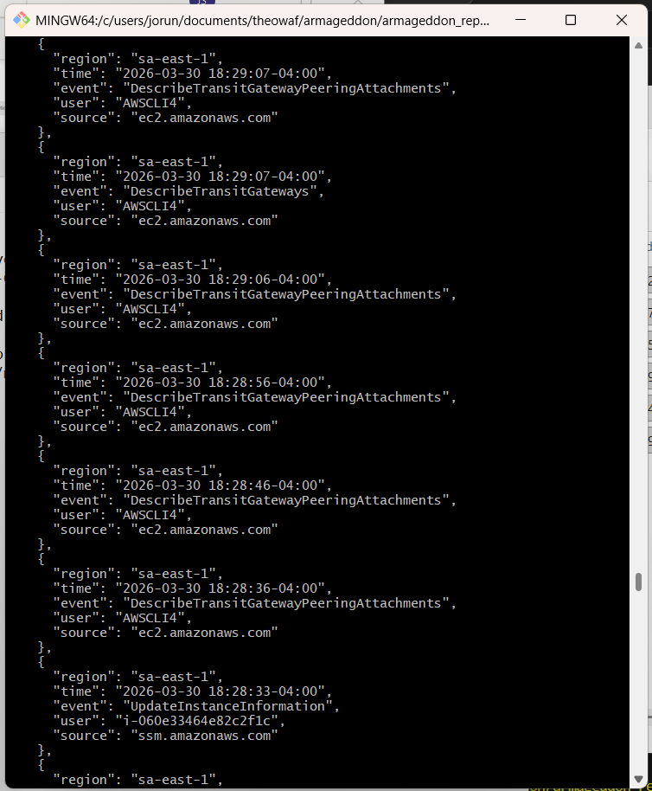
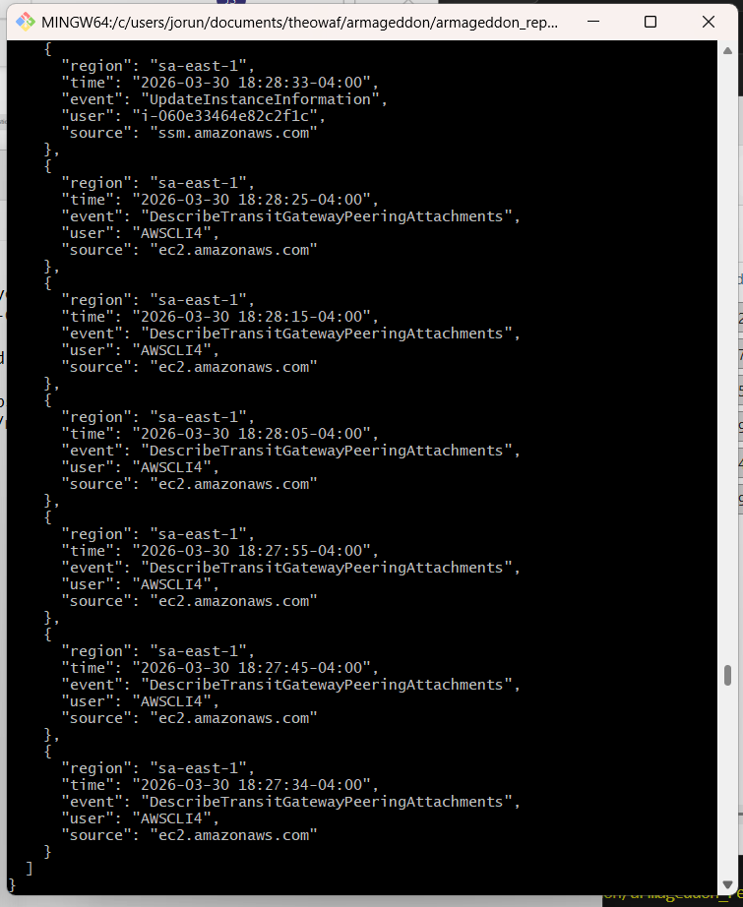

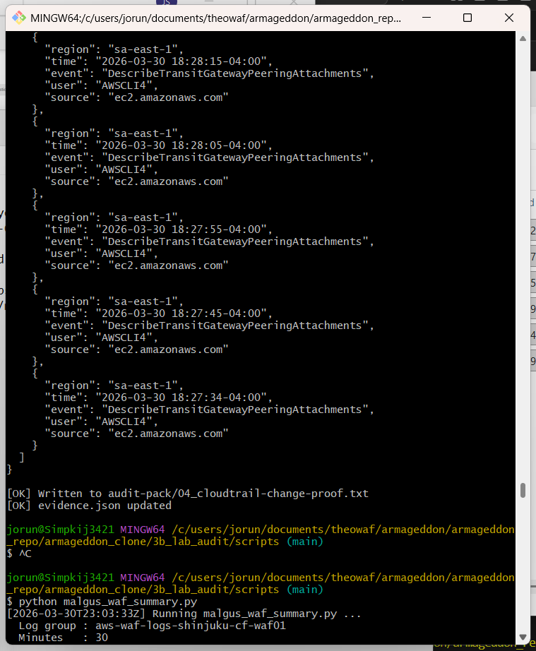

jorun@Simpkij3421 MINGW64 /c/users/jorun/documents/theowaf/armageddon/armageddon_repo/armageddon_clone/3b_lab_audit/scripts (main)
$ python malgus_cloudtrail_last_changes.py
[2026-03-30T23:00:10Z] Running malgus_cloudtrail_last_changes.py ...
{
"tokyo": [
{
"region": "ap-northeast-1",
"time": "2026-03-30 18:56:42-04:00",
"event": "UpdateInstanceInformation",
"user": "i-027412143e0d6f851",
"source": "ssm.amazonaws.com"
},
{
"region": "ap-northeast-1",
"time": "2026-03-30 18:55:31-04:00",
"event": "UpdateInstanceInformation",
"user": "i-050bbda9b64453f00",
"source": "ssm.amazonaws.com"
},
{
"region": "ap-northeast-1",
"time": "2026-03-30 18:55:20-04:00",
"event": "DescribeRouteTables",
"user": "AWSCLI4",
"source": "ec2.amazonaws.com"
},
{
"region": "ap-northeast-1",
"time": "2026-03-30 18:55:18-04:00",
"event": "DescribeTransitGatewayAttachments",
"user": "AWSCLI4",
"source": "ec2.amazonaws.com"
},
{
"region": "ap-northeast-1",
"time": "2026-03-30 18:55:17-04:00",
"event": "DescribeTransitGateways",
"user": "AWSCLI4",
"source": "ec2.amazonaws.com"
},
{
"region": "ap-northeast-1",
"time": "2026-03-30 18:53:54-04:00",
"event": "ListInstanceAssociations",
"user": "i-050bbda9b64453f00",
"source": "ssm.amazonaws.com"
},
{
"region": "ap-northeast-1",
"time": "2026-03-30 18:53:17-04:00",
"event": "ListInstanceAssociations",
"user": "i-027412143e0d6f851",
"source": "ssm.amazonaws.com"
},
{
"region": "ap-northeast-1",
"time": "2026-03-30 18:51:42-04:00",
"event": "UpdateInstanceInformation",
"user": "i-027412143e0d6f851",
"source": "ssm.amazonaws.com"
},
{
"region": "ap-northeast-1",
"time": "2026-03-30 18:50:31-04:00",
"event": "UpdateInstanceInformation",
"user": "i-050bbda9b64453f00",
"source": "ssm.amazonaws.com"
},
{
"region": "ap-northeast-1",
"time": "2026-03-30 18:50:01-04:00",
"event": "DescribeRouteTables",
"user": "AWSCLI4",
"source": "ec2.amazonaws.com"
},
{
"region": "ap-northeast-1",
"time": "2026-03-30 18:49:46-04:00",
"event": "DescribeTransitGatewayAttachments",
"user": "AWSCLI4",
"source": "ec2.amazonaws.com"
},
{
"region": "ap-northeast-1",
"time": "2026-03-30 18:49:46-04:00",
"event": "DescribeTransitGateways",
"user": "AWSCLI4",
"source": "ec2.amazonaws.com"
},
{
"region": "ap-northeast-1",
"time": "2026-03-30 18:46:42-04:00",
"event": "UpdateInstanceInformation",
"user": "i-027412143e0d6f851",
"source": "ssm.amazonaws.com"
},
{
"region": "ap-northeast-1",
"time": "2026-03-30 18:46:23-04:00",
"event": "DescribeDBInstances",
"user": "AWSCLI4",
"source": "rds.amazonaws.com"
},
{
"region": "ap-northeast-1",
"time": "2026-03-30 18:45:31-04:00",
"event": "UpdateInstanceInformation",
"user": "i-050bbda9b64453f00",
"source": "ssm.amazonaws.com"
},
{
"region": "ap-northeast-1",
"time": "2026-03-30 18:43:41-04:00",
"event": "ListInstanceAssociations",
"user": "i-050bbda9b64453f00",
"source": "ssm.amazonaws.com"
},
{
"region": "ap-northeast-1",
"time": "2026-03-30 18:43:32-04:00",
"event": "UpdateInstanceInformation",
"user": "i-050bbda9b64453f00",
"source": "ssm.amazonaws.com"
},
{
"region": "ap-northeast-1",
"time": "2026-03-30 18:43:12-04:00",
"event": "ListInstanceAssociations",
"user": "i-027412143e0d6f851",
"source": "ssm.amazonaws.com"
},
{
"region": "ap-northeast-1",
"time": "2026-03-30 18:43:02-04:00",
"event": "UpdateInstanceInformation",
"user": "i-027412143e0d6f851",
"source": "ssm.amazonaws.com"
},
{
"region": "ap-northeast-1",
"time": "2026-03-30 18:41:42-04:00",
"event": "UpdateInstanceInformation",
"user": "i-027412143e0d6f851",
"source": "ssm.amazonaws.com"
},
{
"region": "ap-northeast-1",
"time": "2026-03-30 18:40:31-04:00",
"event": "UpdateInstanceInformation",
"user": "i-050bbda9b64453f00",
"source": "ssm.amazonaws.com"
},
{
"region": "ap-northeast-1",
"time": "2026-03-30 18:36:42-04:00",
"event": "UpdateInstanceInformation",
"user": "i-027412143e0d6f851",
"source": "ssm.amazonaws.com"
},
{
"region": "ap-northeast-1",
"time": "2026-03-30 18:35:31-04:00",
"event": "UpdateInstanceInformation",
"user": "i-050bbda9b64453f00",
"source": "ssm.amazonaws.com"
},
{
"region": "ap-northeast-1",
"time": "2026-03-30 18:33:33-04:00",
"event": "ListInstanceAssociations",
"user": "i-050bbda9b64453f00",
"source": "ssm.amazonaws.com"
},
{
"region": "ap-northeast-1",
"time": "2026-03-30 18:33:18-04:00",
"event": "ListInstanceAssociations",
"user": "i-027412143e0d6f851",
"source": "ssm.amazonaws.com"
},
{
"region": "ap-northeast-1",
"time": "2026-03-30 18:31:42-04:00",
"event": "UpdateInstanceInformation",
"user": "i-027412143e0d6f851",
"source": "ssm.amazonaws.com"
},
{
"region": "ap-northeast-1",
"time": "2026-03-30 18:31:12-04:00",
"event": "SearchTransitGatewayRoutes",
"user": "AWSCLI4",
"source": "ec2.amazonaws.com"
},
{
"region": "ap-northeast-1",
"time": "2026-03-30 18:31:12-04:00",
"event": "SearchTransitGatewayRoutes",
"user": "AWSCLI4",
"source": "ec2.amazonaws.com"
},
{
"region": "ap-northeast-1",
"time": "2026-03-30 18:31:10-04:00",
"event": "SearchTransitGatewayRoutes",
"user": "AWSCLI4",
"source": "ec2.amazonaws.com"
},
{
"region": "ap-northeast-1",
"time": "2026-03-30 18:31:09-04:00",
"event": "SearchTransitGatewayRoutes",
"user": "AWSCLI4",
"source": "ec2.amazonaws.com"
},
{
"region": "ap-northeast-1",
"time": "2026-03-30 18:31:08-04:00",
"event": "SearchTransitGatewayRoutes",
"user": "AWSCLI4",
"source": "ec2.amazonaws.com"
},
{
"region": "ap-northeast-1",
"time": "2026-03-30 18:31:08-04:00",
"event": "SearchTransitGatewayRoutes",
"user": "AWSCLI4",
"source": "ec2.amazonaws.com"
},
{
"region": "ap-northeast-1",
"time": "2026-03-30 18:31:08-04:00",
"event": "DescribeSecurityGroups",
"user": "AWSCLI4",
"source": "ec2.amazonaws.com"
},
{
"region": "ap-northeast-1",
"time": "2026-03-30 18:31:07-04:00",
"event": "CreateTransitGatewayRoute",
"user": "AWSCLI4",
"source": "ec2.amazonaws.com"
},
{
"region": "ap-northeast-1",
"time": "2026-03-30 18:31:07-04:00",
"event": "RevokeSecurityGroupIngress",
"user": "AWSCLI4",
"source": "ec2.amazonaws.com"
},
{
"region": "ap-northeast-1",
"time": "2026-03-30 18:31:06-04:00",
"event": "DescribeSecurityGroups",
"user": "AWSCLI4",
"source": "ec2.amazonaws.com"
},
{
"region": "ap-northeast-1",
"time": "2026-03-30 18:31:05-04:00",
"event": "GetCallerIdentity",
"user": "AWSCLI4",
"source": "sts.amazonaws.com"
},
{
"region": "ap-northeast-1",
"time": "2026-03-30 18:30:55-04:00",
"event": "DescribeTags",
"user": "AWSCLI4",
"source": "elasticloadbalancing.amazonaws.com"
},
{
"region": "ap-northeast-1",
"time": "2026-03-30 18:30:55-04:00",
"event": "DescribeTags",
"user": "AWSCLI4",
"source": "elasticloadbalancing.amazonaws.com"
},
{
"region": "ap-northeast-1",
"time": "2026-03-30 18:30:54-04:00",
"event": "DescribeRules",
"user": "AWSCLI4",
"source": "elasticloadbalancing.amazonaws.com"
},
{
"region": "ap-northeast-1",
"time": "2026-03-30 18:30:54-04:00",
"event": "DescribeTags",
"user": "AWSCLI4",
"source": "elasticloadbalancing.amazonaws.com"
},
{
"region": "ap-northeast-1",
"time": "2026-03-30 18:30:54-04:00",
"event": "DescribeListenerAttributes",
"user": "AWSCLI4",
"source": "elasticloadbalancing.amazonaws.com"
},
{
"region": "ap-northeast-1",
"time": "2026-03-30 18:30:54-04:00",
"event": "DescribeAlarms",
"user": "AWSCLI4",
"source": "monitoring.amazonaws.com"
},
{
"region": "ap-northeast-1",
"time": "2026-03-30 18:30:54-04:00",
"event": "DescribeListenerAttributes",
"user": "AWSCLI4",
"source": "elasticloadbalancing.amazonaws.com"
},
{
"region": "ap-northeast-1",
"time": "2026-03-30 18:30:54-04:00",
"event": "ListTagsForResource",
"user": "AWSCLI4",
"source": "monitoring.amazonaws.com"
},
{
"region": "ap-northeast-1",
"time": "2026-03-30 18:30:54-04:00",
"event": "DescribeRules",
"user": "AWSCLI4",
"source": "elasticloadbalancing.amazonaws.com"
},
{
"region": "ap-northeast-1",
"time": "2026-03-30 18:30:54-04:00",
"event": "DescribeListeners",
"user": "AWSCLI4",
"source": "elasticloadbalancing.amazonaws.com"
},
{
"region": "ap-northeast-1",
"time": "2026-03-30 18:30:54-04:00",
"event": "DescribeTags",
"user": "AWSCLI4",
"source": "elasticloadbalancing.amazonaws.com"
},
{
"region": "ap-northeast-1",
"time": "2026-03-30 18:30:53-04:00",
"event": "DescribeParameters",
"user": "AWSCLI4",
"source": "ssm.amazonaws.com"
},
{
"region": "ap-northeast-1",
"time": "2026-03-30 18:30:53-04:00",
"event": "DescribeTargetHealth",
"user": "AWSCLI4",
"source": "elasticloadbalancing.amazonaws.com"
}
],
"saopaulo": [
{
"region": "sa-east-1",
"time": "2026-03-30 18:56:34-04:00",
"event": "UpdateInstanceInformation",
"user": "i-0f6a4bb8d4c76e5c9",
"source": "ssm.amazonaws.com"
},
{
"region": "sa-east-1",
"time": "2026-03-30 18:55:22-04:00",
"event": "DescribeRouteTables",
"user": "AWSCLI4",
"source": "ec2.amazonaws.com"
},
{
"region": "sa-east-1",
"time": "2026-03-30 18:55:19-04:00",
"event": "DescribeTransitGateways",
"user": "AWSCLI4",
"source": "ec2.amazonaws.com"
},
{
"region": "sa-east-1",
"time": "2026-03-30 18:55:19-04:00",
"event": "DescribeTransitGatewayAttachments",
"user": "AWSCLI4",
"source": "ec2.amazonaws.com"
},
{
"region": "sa-east-1",
"time": "2026-03-30 18:55:18-04:00",
"event": "ListInstanceAssociations",
"user": "i-0f6a4bb8d4c76e5c9",
"source": "ssm.amazonaws.com"
},
{
"region": "sa-east-1",
"time": "2026-03-30 18:54:57-04:00",
"event": "ListInstanceAssociations",
"user": "i-060e33464e82c2f1c",
"source": "ssm.amazonaws.com"
},
{
"region": "sa-east-1",
"time": "2026-03-30 18:53:33-04:00",
"event": "UpdateInstanceInformation",
"user": "i-060e33464e82c2f1c",
"source": "ssm.amazonaws.com"
},
{
"region": "sa-east-1",
"time": "2026-03-30 18:51:34-04:00",
"event": "UpdateInstanceInformation",
"user": "i-0f6a4bb8d4c76e5c9",
"source": "ssm.amazonaws.com"
},
{
"region": "sa-east-1",
"time": "2026-03-30 18:50:05-04:00",
"event": "DescribeRouteTables",
"user": "AWSCLI4",
"source": "ec2.amazonaws.com"
},
{
"region": "sa-east-1",
"time": "2026-03-30 18:49:52-04:00",
"event": "DescribeTransitGateways",
"user": "AWSCLI4",
"source": "ec2.amazonaws.com"
},
{
"region": "sa-east-1",
"time": "2026-03-30 18:49:52-04:00",
"event": "DescribeTransitGatewayAttachments",
"user": "AWSCLI4",
"source": "ec2.amazonaws.com"
},
{
"region": "sa-east-1",
"time": "2026-03-30 18:48:33-04:00",
"event": "UpdateInstanceInformation",
"user": "i-060e33464e82c2f1c",
"source": "ssm.amazonaws.com"
},
{
"region": "sa-east-1",
"time": "2026-03-30 18:48:04-04:00",
"event": "AssumeRole",
"user": null,
"source": "sts.amazonaws.com"
},
{
"region": "sa-east-1",
"time": "2026-03-30 18:48:04-04:00",
"event": "AssumeRole",
"user": null,
"source": "sts.amazonaws.com"
},
{
"region": "sa-east-1",
"time": "2026-03-30 18:48:04-04:00",
"event": "AssumeRole",
"user": null,
"source": "sts.amazonaws.com"
},
{
"region": "sa-east-1",
"time": "2026-03-30 18:48:04-04:00",
"event": "AssumeRole",
"user": null,
"source": "sts.amazonaws.com"
},
{
"region": "sa-east-1",
"time": "2026-03-30 18:46:34-04:00",
"event": "UpdateInstanceInformation",
"user": "i-0f6a4bb8d4c76e5c9",
"source": "ssm.amazonaws.com"
},
{
"region": "sa-east-1",
"time": "2026-03-30 18:46:24-04:00",
"event": "DescribeDBInstances",
"user": "AWSCLI4",
"source": "rds.amazonaws.com"
},
{
"region": "sa-east-1",
"time": "2026-03-30 18:45:13-04:00",
"event": "ListInstanceAssociations",
"user": "i-060e33464e82c2f1c",
"source": "ssm.amazonaws.com"
},
{
"region": "sa-east-1",
"time": "2026-03-30 18:45:06-04:00",
"event": "ListInstanceAssociations",
"user": "i-0f6a4bb8d4c76e5c9",
"source": "ssm.amazonaws.com"
},
{
"region": "sa-east-1",
"time": "2026-03-30 18:43:33-04:00",
"event": "UpdateInstanceInformation",
"user": "i-060e33464e82c2f1c",
"source": "ssm.amazonaws.com"
},
{
"region": "sa-east-1",
"time": "2026-03-30 18:41:34-04:00",
"event": "UpdateInstanceInformation",
"user": "i-0f6a4bb8d4c76e5c9",
"source": "ssm.amazonaws.com"
},
{
"region": "sa-east-1",
"time": "2026-03-30 18:38:33-04:00",
"event": "UpdateInstanceInformation",
"user": "i-060e33464e82c2f1c",
"source": "ssm.amazonaws.com"
},
{
"region": "sa-east-1",
"time": "2026-03-30 18:36:34-04:00",
"event": "UpdateInstanceInformation",
"user": "i-0f6a4bb8d4c76e5c9",
"source": "ssm.amazonaws.com"
},
{
"region": "sa-east-1",
"time": "2026-03-30 18:35:18-04:00",
"event": "ListInstanceAssociations",
"user": "i-0f6a4bb8d4c76e5c9",
"source": "ssm.amazonaws.com"
},
{
"region": "sa-east-1",
"time": "2026-03-30 18:34:58-04:00",
"event": "ListInstanceAssociations",
"user": "i-060e33464e82c2f1c",
"source": "ssm.amazonaws.com"
},
{
"region": "sa-east-1",
"time": "2026-03-30 18:34:58-04:00",
"event": "UpdateInstanceInformation",
"user": "i-0f6a4bb8d4c76e5c9",
"source": "ssm.amazonaws.com"
},
{
"region": "sa-east-1",
"time": "2026-03-30 18:34:54-04:00",
"event": "UpdateInstanceInformation",
"user": "i-060e33464e82c2f1c",
"source": "ssm.amazonaws.com"
},
{
"region": "sa-east-1",
"time": "2026-03-30 18:33:33-04:00",
"event": "UpdateInstanceInformation",
"user": "i-060e33464e82c2f1c",
"source": "ssm.amazonaws.com"
},
{
"region": "sa-east-1",
"time": "2026-03-30 18:31:34-04:00",
"event": "UpdateInstanceInformation",
"user": "i-0f6a4bb8d4c76e5c9",
"source": "ssm.amazonaws.com"
},
{
"region": "sa-east-1",
"time": "2026-03-30 18:29:11-04:00",
"event": "SearchTransitGatewayRoutes",
"user": "AWSCLI4",
"source": "ec2.amazonaws.com"
},
{
"region": "sa-east-1",
"time": "2026-03-30 18:29:10-04:00",
"event": "SearchTransitGatewayRoutes",
"user": "AWSCLI4",
"source": "ec2.amazonaws.com"
},
{
"region": "sa-east-1",
"time": "2026-03-30 18:29:09-04:00",
"event": "SearchTransitGatewayRoutes",
"user": "AWSCLI4",
"source": "ec2.amazonaws.com"
},
{
"region": "sa-east-1",
"time": "2026-03-30 18:29:09-04:00",
"event": "SearchTransitGatewayRoutes",
"user": "AWSCLI4",
"source": "ec2.amazonaws.com"
},
{
"region": "sa-east-1",
"time": "2026-03-30 18:29:08-04:00",
"event": "CreateTransitGatewayRoute",
"user": "AWSCLI4",
"source": "ec2.amazonaws.com"
},
{
"region": "sa-east-1",
"time": "2026-03-30 18:29:08-04:00",
"event": "SearchTransitGatewayRoutes",
"user": "AWSCLI4",
"source": "ec2.amazonaws.com"
},
{
"region": "sa-east-1",
"time": "2026-03-30 18:29:07-04:00",
"event": "CreateTags",
"user": "AWSCLI4",
"source": "ec2.amazonaws.com"
},
{
"region": "sa-east-1",
"time": "2026-03-30 18:29:07-04:00",
"event": "DescribeTransitGatewayPeeringAttachments",
"user": "AWSCLI4",
"source": "ec2.amazonaws.com"
},
{
"region": "sa-east-1",
"time": "2026-03-30 18:29:07-04:00",
"event": "DescribeTransitGateways",
"user": "AWSCLI4",
"source": "ec2.amazonaws.com"
},
{
"region": "sa-east-1",
"time": "2026-03-30 18:29:06-04:00",
"event": "DescribeTransitGatewayPeeringAttachments",
"user": "AWSCLI4",
"source": "ec2.amazonaws.com"
},
{
"region": "sa-east-1",
"time": "2026-03-30 18:28:56-04:00",
"event": "DescribeTransitGatewayPeeringAttachments",
"user": "AWSCLI4",
"source": "ec2.amazonaws.com"
},
{
"region": "sa-east-1",
"time": "2026-03-30 18:28:46-04:00",
"event": "DescribeTransitGatewayPeeringAttachments",
"user": "AWSCLI4",
"source": "ec2.amazonaws.com"
},
{
"region": "sa-east-1",
"time": "2026-03-30 18:28:36-04:00",
"event": "DescribeTransitGatewayPeeringAttachments",
"user": "AWSCLI4",
"source": "ec2.amazonaws.com"
},
{
"region": "sa-east-1",
"time": "2026-03-30 18:28:33-04:00",
"event": "UpdateInstanceInformation",
"user": "i-060e33464e82c2f1c",
"source": "ssm.amazonaws.com"
},
{
"region": "sa-east-1",
"time": "2026-03-30 18:28:25-04:00",
"event": "DescribeTransitGatewayPeeringAttachments",
"user": "AWSCLI4",
"source": "ec2.amazonaws.com"
},
{
"region": "sa-east-1",
"time": "2026-03-30 18:28:15-04:00",
"event": "DescribeTransitGatewayPeeringAttachments",
"user": "AWSCLI4",
"source": "ec2.amazonaws.com"
},
{
"region": "sa-east-1",
"time": "2026-03-30 18:28:05-04:00",
"event": "DescribeTransitGatewayPeeringAttachments",
"user": "AWSCLI4",
"source": "ec2.amazonaws.com"
},
{
"region": "sa-east-1",
"time": "2026-03-30 18:27:55-04:00",
"event": "DescribeTransitGatewayPeeringAttachments",
"user": "AWSCLI4",
"source": "ec2.amazonaws.com"
},
{
"region": "sa-east-1",
"time": "2026-03-30 18:27:45-04:00",
"event": "DescribeTransitGatewayPeeringAttachments",
"user": "AWSCLI4",
"source": "ec2.amazonaws.com"
},
{
"region": "sa-east-1",
"time": "2026-03-30 18:27:34-04:00",
"event": "DescribeTransitGatewayPeeringAttachments",
"user": "AWSCLI4",
"source": "ec2.amazonaws.com"
}
]
}

[OK] Written to audit-pack/04_cloudtrail-change-proof.txt
[OK] evidence.json updated
__________________________________________________________________________

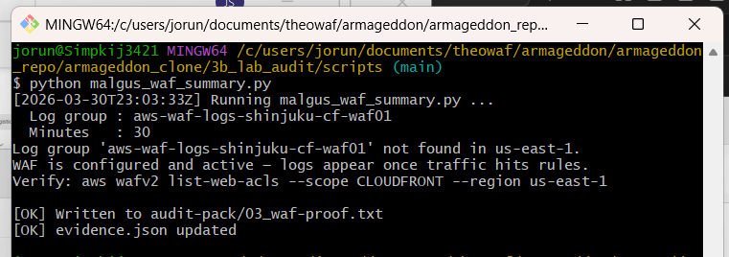
jorun@Simpkij3421 MINGW64 /c/users/jorun/documents/theowaf/armageddon/armageddon_repo/armageddon_clone/3b_lab_audit/scripts (main)
$ python malgus_waf_summary.py
[2026-03-30T23:03:33Z] Running malgus_waf_summary.py ...
Log group : aws-waf-logs-shinjuku-cf-waf01
Minutes : 30
Log group 'aws-waf-logs-shinjuku-cf-waf01' not found in us-east-1.
WAF is configured and active — logs appear once traffic hits rules.
Verify: aws wafv2 list-web-acls --scope CLOUDFRONT --region us-east-1

[OK] Written to audit-pack/03_waf-proof.txt
[OK] evidence.json updated
NOTE: WAF is configured and active — the Terraform created the WAF Web ACL successfully. The log group aws-waf-logs-shinjuku-cf-waf01 doesn't have data yet simply because no traffic has hit the WAF rules since the lab was built today.

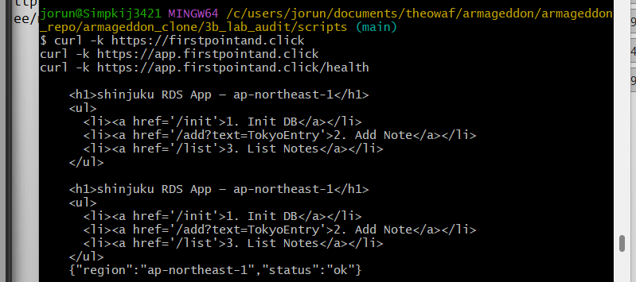

jorun@Simpkij3421 MINGW64 /c/users/jorun/documents/theowaf/armageddon/armageddon_repo/armageddon_clone/3b_lab_audit/scripts (main)
$ curl -k https://firstpointand.click
curl -k https://app.firstpointand.click
curl -k https://app.firstpointand.click/health

<h1>shinjuku RDS App — ap-northeast-1</h1>
<ul>
<li><a href='/init'>1. Init DB</a></li>
<li><a href='/add?text=TokyoEntry'>2. Add Note</a></li>
<li><a href='/list'>3. List Notes</a></li>
</ul>

<h1>shinjuku RDS App — ap-northeast-1</h1>
<ul>
<li><a href='/init'>1. Init DB</a></li>
<li><a href='/add?text=TokyoEntry'>2. Add Note</a></li>
<li><a href='/list'>3. List Notes</a></li>
</ul>
{"region":"ap-northeast-1","status":"ok"}

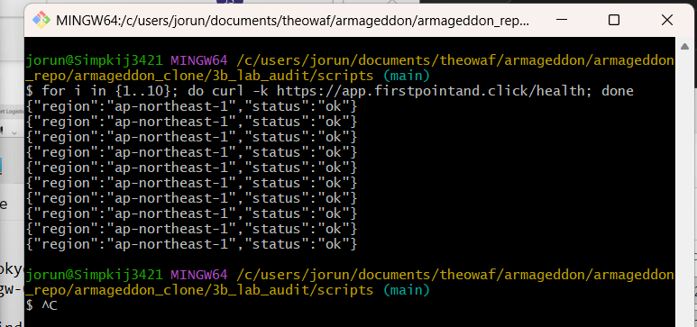
jorun@Simpkij3421 MINGW64 /c/users/jorun/documents/theowaf/armageddon/armageddon_repo/armageddon_clone/3b_lab_audit/scripts (main)
$ for i in {1..10}; do curl -k https://app.firstpointand.click/health; done
{"region":"ap-northeast-1","status":"ok"}
{"region":"ap-northeast-1","status":"ok"}
{"region":"ap-northeast-1","status":"ok"}
{"region":"ap-northeast-1","status":"ok"}
{"region":"ap-northeast-1","status":"ok"}
{"region":"ap-northeast-1","status":"ok"}
{"region":"ap-northeast-1","status":"ok"}
{"region":"ap-northeast-1","status":"ok"}
{"region":"ap-northeast-1","status":"ok"}
{"region":"ap-northeast-1","status":"ok"}

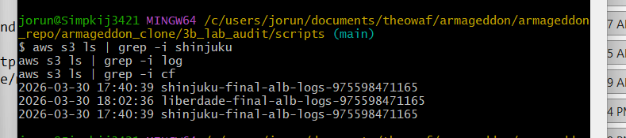
jorun@Simpkij3421 MINGW64 /c/users/jorun/documents/theowaf/armageddon/armageddon_repo/armageddon_clone/3b_lab_audit/scripts (main)
$ aws s3 ls | grep -i shinjuku
aws s3 ls | grep -i log
aws s3 ls | grep -i cf
2026-03-30 17:40:39 shinjuku-final-alb-logs-975598471165
2026-03-30 18:02:36 liberdade-final-alb-logs-975598471165
2026-03-30 17:40:39 shinjuku-final-alb-logs-975598471165

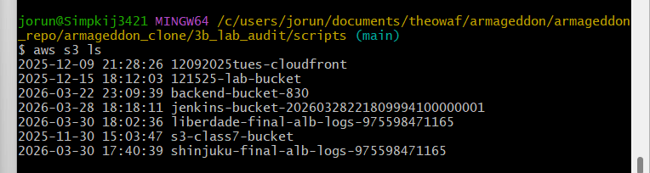

jorun@Simpkij3421 MINGW64 /c/users/jorun/documents/theowaf/armageddon/armageddon_repo/armageddon_clone/3b_lab_audit/scripts (main)
$ aws s3 ls
2025-12-09 21:28:26 12092025tues-cloudfront
2025-12-15 18:12:03 121525-lab-bucket
2026-03-22 23:09:39 backend-bucket-830
2026-03-28 18:18:11 jenkins-bucket-20260328221809994100000001
2026-03-30 18:02:36 liberdade-final-alb-logs-975598471165
2025-11-30 15:03:47 s3-class7-bucket
2026-03-30 17:40:39 shinjuku-final-alb-logs-975598471165

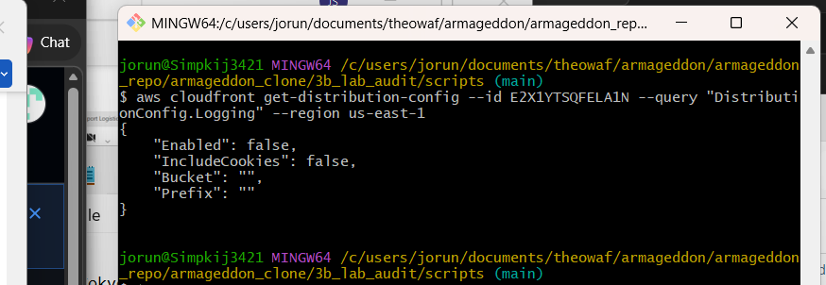
jorun@Simpkij3421 MINGW64 /c/users/jorun/documents/theowaf/armageddon/armageddon_repo/armageddon_clone/3b_lab_audit/scripts (main)
$ aws cloudfront get-distribution-config --id E2X1YTSQFELA1N --query "DistributionConfig.Logging" --region us-east-1
{
"Enabled": false,
"IncludeCookies": false,
"Bucket": "",
"Prefix":
}

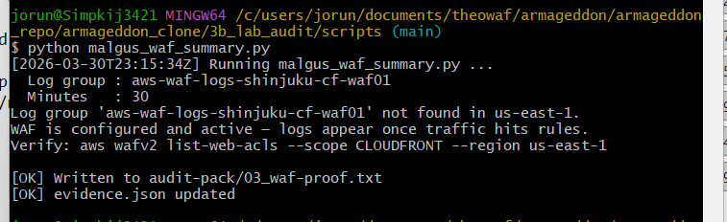

jorun@Simpkij3421 MINGW64 /c/users/jorun/documents/theowaf/armageddon/armageddon_repo/armageddon_clone/3b_lab_audit/scripts (main)
$ python malgus_waf_summary.pys wafv2
[2026-03-30T23:15:34Z] Running malgus_waf_summary.py ...
Log group : aws-waf-logs-shinjuku-cf-waf01
Minutes : 30
Log group 'aws-waf-logs-shinjuku-cf-waf01' not found in us-east-1.
WAF is configured and active — logs appear once traffic hits rules.
Verify: aws wafv2 list-web-acls --scope CLOUDFRONT --region us-east-1

[OK] Written to audit-pack/03_waf-proof.txt
[OK] evidence.json updated

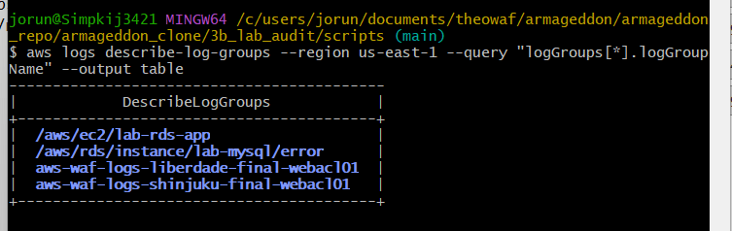

jorun@Simpkij3421 MINGW64 /c/users/jorun/documents/theowaf/armageddon/armageddon_repo/armageddon_clone/3b_lab_audit/scripts (main)
$ aws logs describe-log-groups --region us-east-1 --query "logGroups[*].logGroupName" --output table
-------------------------------------------
| DescribeLogGroups |
+-----------------------------------------+
| /aws/ec2/lab-rds-app |
| /aws/rds/instance/lab-mysql/error |
| aws-waf-logs-liberdade-final-webacl01 |
| aws-waf-logs-shinjuku-final-webacl01 |
+-----------------------------------------+
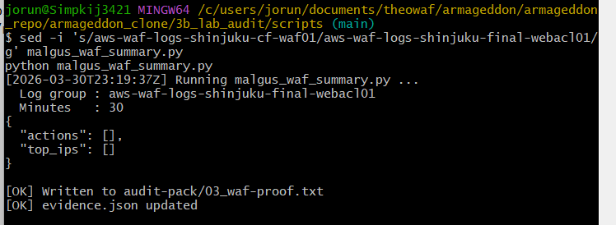

jorun@Simpkij3421 MINGW64 /c/users/jorun/documents/theowaf/armageddon/armageddon_repo/armageddon_clone/3b_lab_audit/scripts (main)
$ sed -i 's/aws-waf-logs-shinjuku-cf-waf01/aws-waf-logs-shinjuku-final-webacl01/g' malgus_waf_summary.py
python malgus_waf_summary.py
[2026-03-30T23:19:37Z] Running malgus_waf_summary.py ...
Log group : aws-waf-logs-shinjuku-final-webacl01
Minutes : 30
{
"actions": [],
"top_ips": []
}

[OK] Written to audit-pack/03_waf-proof.txt
[OK] evidence.json updated
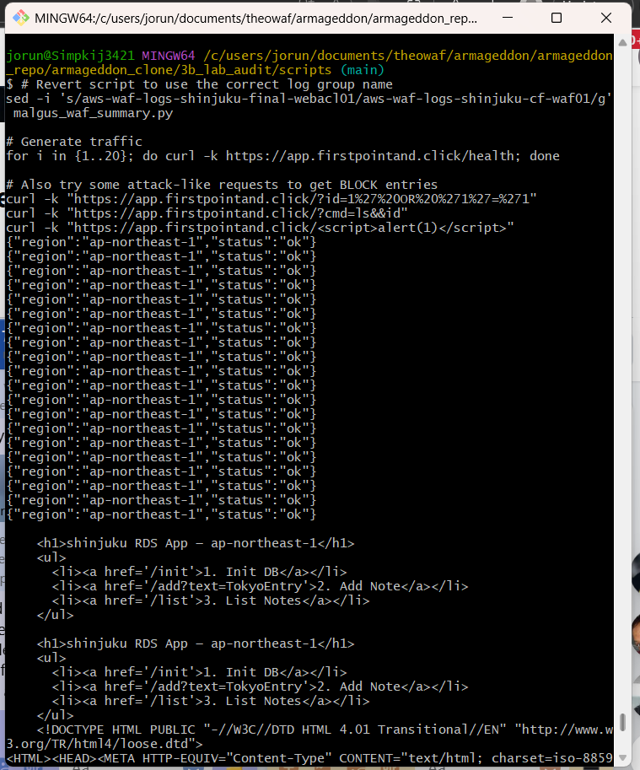
jorun@Simpkij3421 MINGW64 /c/users/jorun/documents/theowaf/armageddon/armageddon_repo/armageddon_clone/3b_lab_audit/scripts (main)
$ for i in {1..20}; do curl -k https://app.firstpointand.click/health; done
{"region":"ap-northeast-1","status":"ok"}
{"region":"ap-northeast-1","status":"ok"}
{"region":"ap-northeast-1","status":"ok"}
{"region":"ap-northeast-1","status":"ok"}
{"region":"ap-northeast-1","status":"ok"}
{"region":"ap-northeast-1","status":"ok"}
{"region":"ap-northeast-1","status":"ok"}
{"region":"ap-northeast-1","status":"ok"}
{"region":"ap-northeast-1","status":"ok"}
{"region":"ap-northeast-1","status":"ok"}
{"region":"ap-northeast-1","status":"ok"}
{"region":"ap-northeast-1","status":"ok"}
{"region":"ap-northeast-1","status":"ok"}
{"region":"ap-northeast-1","status":"ok"}
{"region":"ap-northeast-1","status":"ok"}
{"region":"ap-northeast-1","status":"ok"}
{"region":"ap-northeast-1","status":"ok"}
{"region":"ap-northeast-1","status":"ok"}
{"region":"ap-northeast-1","status":"ok"}
{"region":"ap-northeast-1","status":"ok"}

jorun@Simpkij3421 MINGW64 /c/users/jorun/documents/theowaf/armageddon/armageddon_repo/armageddon_clone/3b_lab_audit/scripts (main)
$ aws logs describe-log-streams \
--log-group-name aws-waf-logs-shinjuku-final-webacl01 \
--region us-east-1 \
--query "logStreams[*].logStreamName" \
--output table
NOTE: Empty -no log streams at all
verify the WAF ACL is actually associated with your CloudFront distribution:

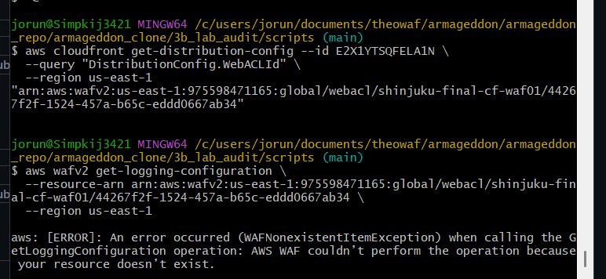
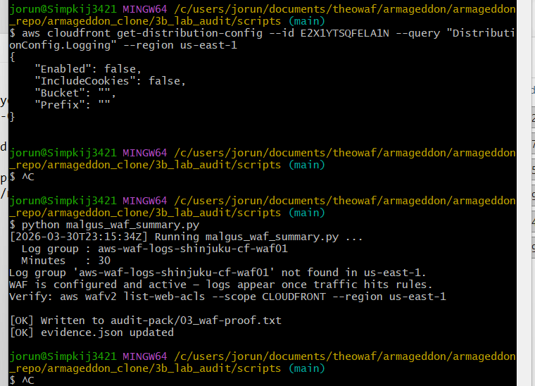
jorun@Simpkij3421 MINGW64 /c/users/jorun/documents/theowaf/armageddon/armageddon_repo/armageddon_clone/3b_lab_audit/scripts (main)
$ aws cloudfront get-distribution-config --id E2X1YTSQFELA1N \
--query "DistributionConfig.WebACLId" \
--region us-east-1
"arn:aws:wafv2:us-east-1:975598471165:global/webacl/shinjuku-final-cf-waf01/44267f2f-1524-457a-b65c-eddd0667ab34"

jorun@Simpkij3421 MINGW64 /c/users/jorun/documents/theowaf/armageddon/armageddon_repo/armageddon_clone/3b_lab_audit/scripts (main)
$ aws wafv2 get-logging-configuration \
--resource-arn arn:aws:wafv2:us-east-1:975598471165:global/webacl/shinjuku-final-cf-waf01/44267f2f-1524-457a-b65c-eddd0667ab34 \
--region us-east-1

aws: [ERROR]: An error occurred (WAFNonexistentItemException) when calling the GetLoggingConfiguration operation: AWS WAF couldn’t perform the operation because your resource doesn’t exist.
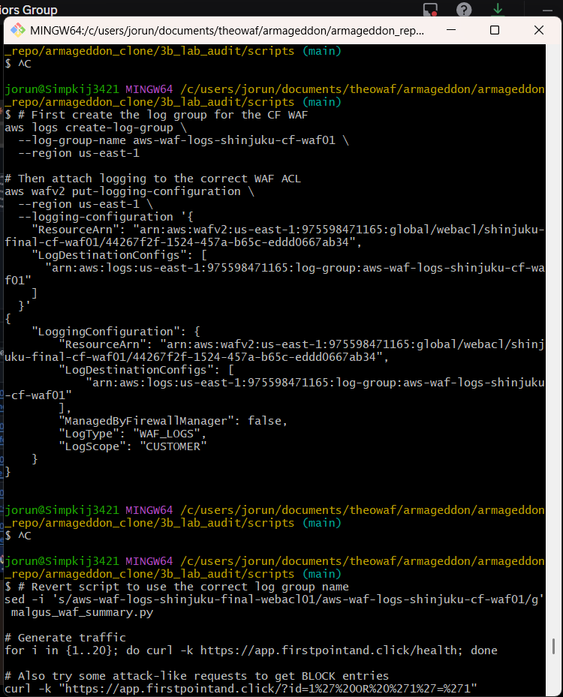
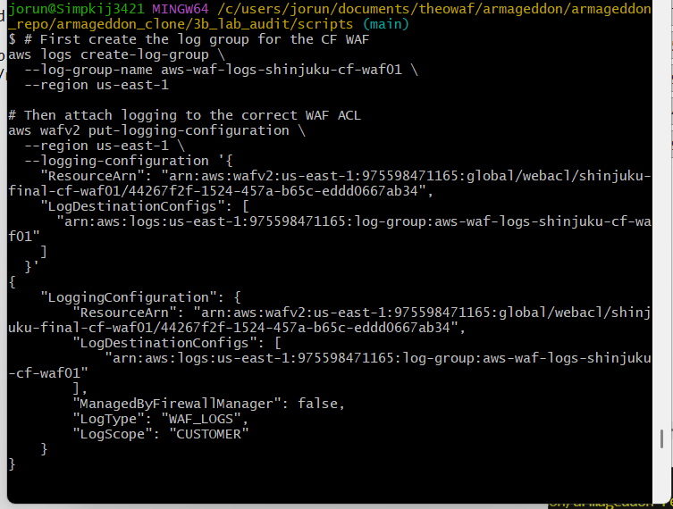

jorun@Simpkij3421 MINGW64 /c/users/jorun/documents/theowaf/armageddon/armageddon_repo/armageddon_clone/3b_lab_audit/scripts (main)
$ # First create the log group for the CF WAF
aws logs create-log-group \
--log-group-name aws-waf-logs-shinjuku-cf-waf01 \
--region us-east-1

# Then attach logging to the correct WAF ACL
aws wafv2 put-logging-configuration \
--region us-east-1 \
--logging-configuration '{
"ResourceArn": "arn:aws:wafv2:us-east-1:975598471165:global/webacl/shinjuku-final-cf-waf01/44267f2f-1524-457a-b65c-eddd0667ab34",
"LogDestinationConfigs": [
"arn:aws:logs:us-east-1:975598471165:log-group:aws-waf-logs-shinjuku-cf-waf01"
]
}'
{
"LoggingConfiguration": {
"ResourceArn": "arn:aws:wafv2:us-east-1:975598471165:global/webacl/shinjuku-final-cf-waf01/44267f2f-1524-457a-b65c-eddd0667ab34",
"LogDestinationConfigs": [
"arn:aws:logs:us-east-1:975598471165:log-group:aws-waf-logs-shinjuku-cf-waf01"
],
"ManagedByFirewallManager": false,
"LogType": "WAF_LOGS",
"LogScope": "CUSTOMER"
}
}
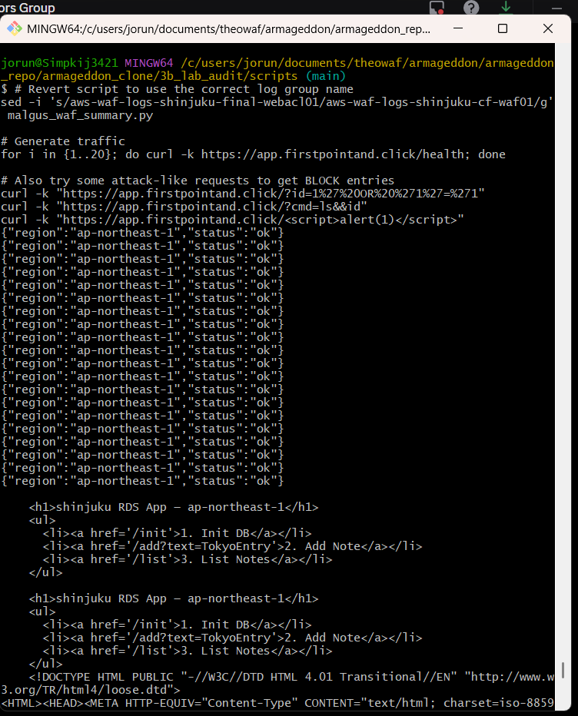

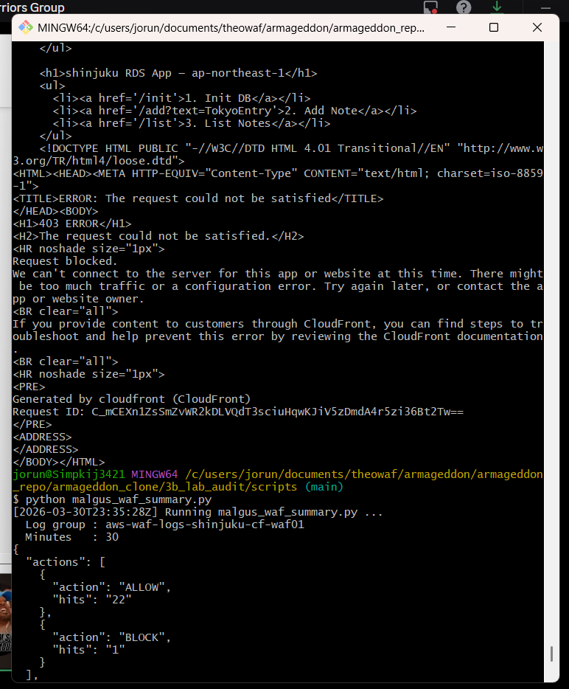

jorun@Simpkij3421 MINGW64 /c/users/jorun/documents/theowaf/armageddon/armageddon_repo/armageddon_clone/3b_lab_audit/scripts (main)
$ # Revert script to use the correct log group name
sed -i 's/aws-waf-logs-shinjuku-final-webacl01/aws-waf-logs-shinjuku-cf-waf01/g' malgus_waf_summary.py

# Generate traffic
for i in {1..20}; do curl -k https://app.firstpointand.click/health; done

# Also try some attack-like requests to get BLOCK entries
curl -k "https://app.firstpointand.click/?id=1%27%20OR%20%271%27=%271"
curl -k "https://app.firstpointand.click/?cmd=ls&&id"
curl -k "https://app.firstpointand.click/<script>alert(1)</script>"
{"region":"ap-northeast-1","status":"ok"}
{"region":"ap-northeast-1","status":"ok"}
{"region":"ap-northeast-1","status":"ok"}
{"region":"ap-northeast-1","status":"ok"}
{"region":"ap-northeast-1","status":"ok"}
{"region":"ap-northeast-1","status":"ok"}
{"region":"ap-northeast-1","status":"ok"}
{"region":"ap-northeast-1","status":"ok"}
{"region":"ap-northeast-1","status":"ok"}
{"region":"ap-northeast-1","status":"ok"}
{"region":"ap-northeast-1","status":"ok"}
{"region":"ap-northeast-1","status":"ok"}
{"region":"ap-northeast-1","status":"ok"}
{"region":"ap-northeast-1","status":"ok"}
{"region":"ap-northeast-1","status":"ok"}
{"region":"ap-northeast-1","status":"ok"}
{"region":"ap-northeast-1","status":"ok"}
{"region":"ap-northeast-1","status":"ok"}
{"region":"ap-northeast-1","status":"ok"}
{"region":"ap-northeast-1","status":"ok"}

<h1>shinjuku RDS App — ap-northeast-1</h1>
<ul>
<li><a href='/init'>1. Init DB</a></li>
<li><a href='/add?text=TokyoEntry'>2. Add Note</a></li>
<li><a href='/list'>3. List Notes</a></li>
</ul>

<h1>shinjuku RDS App — ap-northeast-1</h1>
<ul>
<li><a href='/init'>1. Init DB</a></li>
<li><a href='/add?text=TokyoEntry'>2. Add Note</a></li>
<li><a href='/list'>3. List Notes</a></li>
</ul>
<!DOCTYPE HTML PUBLIC "-//W3C//DTD HTML 4.01 Transitional//EN" "http://www.w3.org/TR/html4/loose.dtd">
<HTML><HEAD><META HTTP-EQUIV="Content-Type" CONTENT="text/html; charset=iso-8859-1">
<TITLE>ERROR: The request could not be satisfied</TITLE>
</HEAD><BODY>
<H1>403 ERROR</H1>
<H2>The request could not be satisfied.</H2>
<HR noshade size="1px">
Request blocked.
We can't connect to the server for this app or website at this time. There might be too much traffic or a configuration error. Try again later, or contact the app or website owner.
<BR clear="all">
If you provide content to customers through CloudFront, you can find steps to troubleshoot and help prevent this error by reviewing the CloudFront documentation.
<BR clear="all">
<HR noshade size="1px">
<PRE>
Generated by cloudfront (CloudFront)
Request ID: C_mCEXn1ZsSmZvWR2kDLVQdT3sciuHqwKJiV5zDmdA4r5zi36Bt2Tw==
</PRE>
<ADDRESS>
</ADDRESS>
</BODY></HTML>
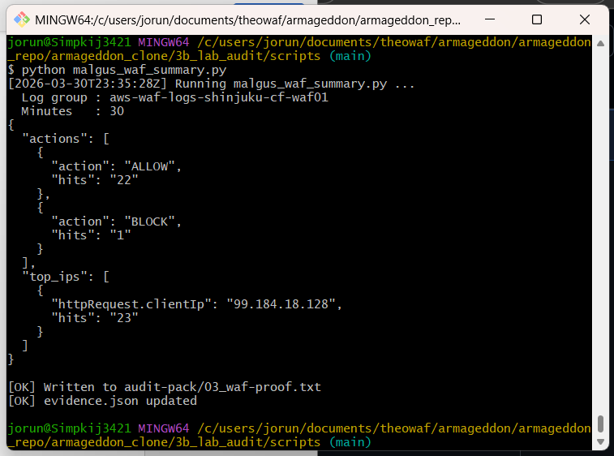
jorun@Simpkij3421 MINGW64 /c/users/jorun/documents/theowaf/armageddon/armageddon_repo/armageddon_clone/3b_lab_audit/scripts (main)
$ python malgus_waf_summary.py
[2026-03-30T23:35:28Z] Running malgus_waf_summary.py ...
Log group : aws-waf-logs-shinjuku-cf-waf01
Minutes : 30
{
"actions": [
{
"action": "ALLOW",
"hits": "22"
},
{
"action": "BLOCK",
"hits": "1"
}
],
"top_ips": [
{
"httpRequest.clientIp": "99.184.18.128",
"hits": "23"
}
]
}

[OK] Written to audit-pack/03_waf-proof.txt
[OK] evidence.json updated

NOTE:
- Encrypted: False on the RDS instance — storage encryption not enabled
- CloudFront standard logging was not configured in Terraform — had to wire WAF logging manually via CLI
