Day 05 10/22/2022

* Animation Rigging

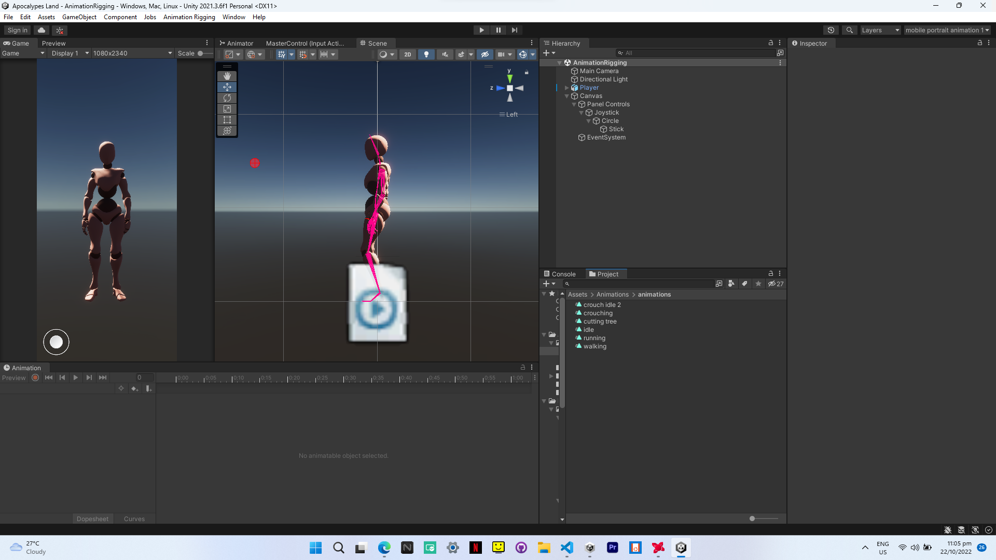

Day 06 10/23/2022

* Animation Rigging
* Player Control

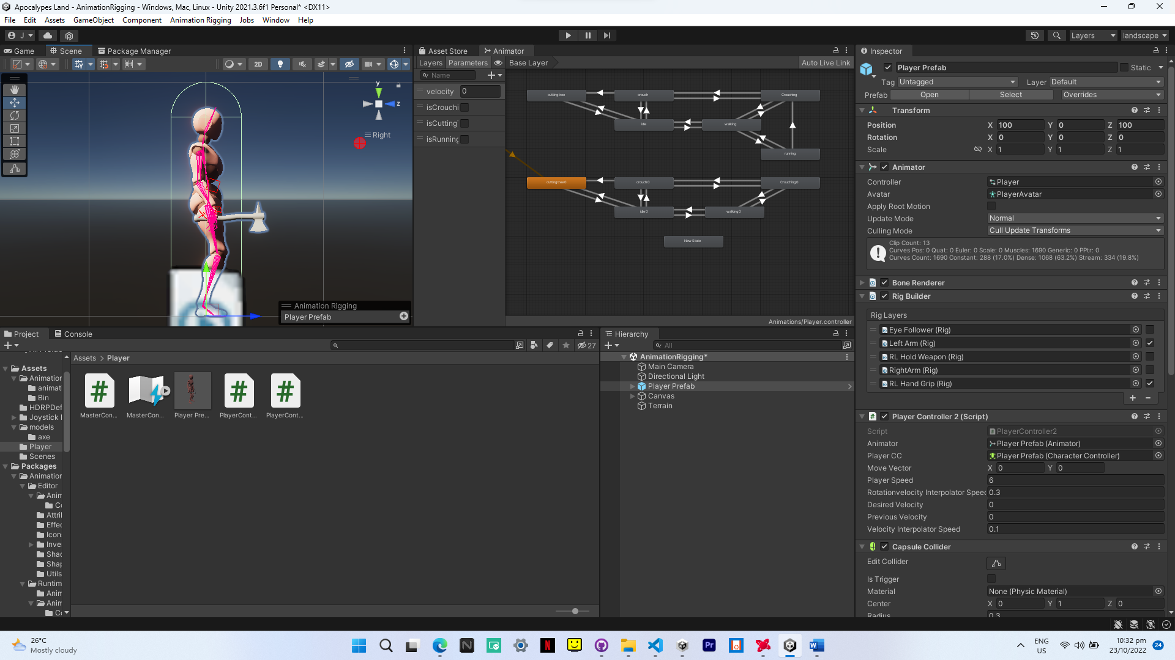

Day 07 10/24/2022

* Animation Rigging
* Player Control
* HDRP to URP
* Test Build

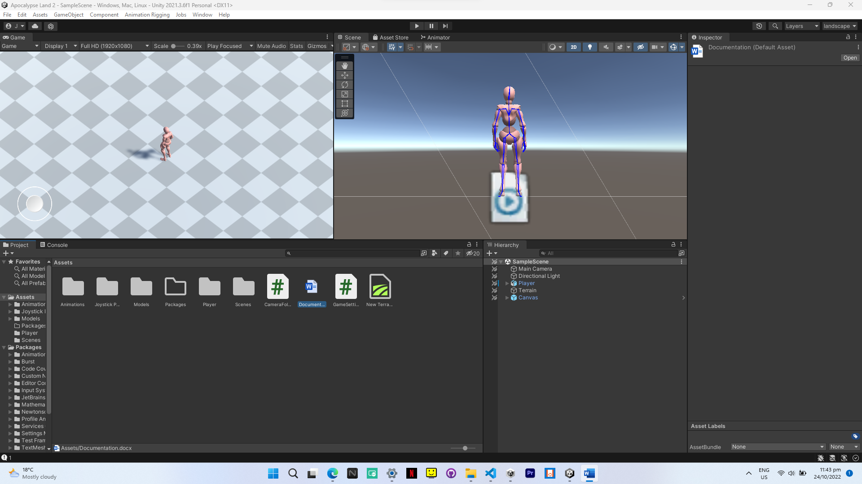

Day 08 10/25/2022

* New scene and improved
* Testing multiplayer with fish-net
* Android building
* Windows building
* Latest version 0.1.1.2

