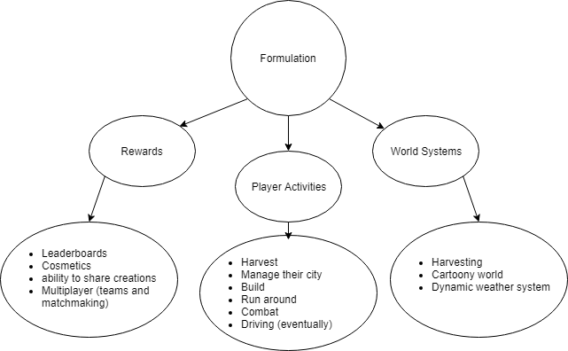

The feature(s) I will be testing are Harvesting and Building. I will be doing these because if you can’t harvest materials then you literally can’t do anything else.

The one action per turn rule enforces players to focus and prioritize their actions to strategize.

Starting with one citizen sort of forces the player to build from almost nothing while also allowing the player to gather resources because how would you otherwise.

Player’s found the map confusing. The player didn’t know that they could put citizens on tiles without the improvements. Rules/building requirements need to be written more clearly. Should limit buildings per turn and specify that taking control of an NPC is the action they take. Player said building costs were too cheap.

New Rules:

Player replacing, “taking control” of citizen counts as an action.

1 building per resource tile.