**A**

**Mini Project Report on**

**VIRTUAL ASSISTANT SISIRA**

*submitted in partial fulfillment of the requirements for the award of the degree of*

**S.Y. B. Tech.**

in

**Computer Science & Engineering**

*by*

**Student Names**

**Miss. Madhuri Baburao Kamble (21)**

**Miss. Amruta Sitaram Katharut (22)**

**Miss. Rutuja Ramesh Mokale (32)**

under the guidance of

**Mrs. R. V. Jadhav**



Department of Computer Science & Engineering

**BHARATI VIDYAPEETH’S COLLEGE OF ENGINEERING, KOLHAPUR**

**YEAR: 2022-23**



# CERTIFICATE

This is to certify that the project report entitled **“VIRTUAL ASSISTANT SISIRA”** submitted by **Miss. Madhuri Kamble, Miss. Amruta Katharut, Miss. Rutuja Mokale** for the partial fulfillment of the requirement for the award of degree of S. Y. B. Tech. in **Computer Science &** **Engineering** to the **Shivaji University**.

This report is record of students’ teamwork carried out by them under my supervision and guidance.

Date:

Place:

**Guide**  **HOD**

Mrs. R. V. Jadhav Mrs. S. M. Mulla

**Ext. Examiner** **Principal**

Dr. V. R. Ghorpad

**Acknowledgement**

It is our privilege to acknowledge with deep sense of gratitude to our project guide **Mrs**. **R. V. Jadhav** for his valuable suggestions and guidance throughout our course of study and project.

We express our gratitude to **Mrs. S. M. Mulla (HOD)** for their kind help and co-operation and special thanks to our **Principal Dr. V. R. Ghorpade** for giving us an opportunity to work on this topic.

We are highly obliged to the entire staff of the Computer Science &Engineering Department for their kind co-operation and help. We also take this opportunity to thank all our colleagues, who backed our interest by giving useful suggestions and all possible help.

**Miss. Madhuri Baburao Kamble**

**Miss. Amruta Sitaram Katharut**

**Miss. Rutuja Ramesh Mokale**

**Abstract**

The Virtual Assistant project, named "**Sisira**" is designed to provide users with various assistance and perform tasks based on user queries. The project utilizes C++ programming language and includes features such as password authentication, greetings based on the time of day, reminders, date and time display, and interaction with the user through both text and speech. The Virtual Assistant greets the user with appropriate messages depending on the time of day and provides reminders for activities such as waking up, college time, gym time, lunchtime, study time, and sleep time. The project utilizes the "espeak" library to convert text into speech for a more interactive user experience. The Virtual Assistant accepts user queries and responds accordingly. It can handle common greetings like "hi," "hey," and "hello" by responding with a friendly "hello." It also provides information about itself when asked about its identity and responds positively to questions about its well-being. Additionally, the Virtual Assistant can provide the current date and time upon request. It can open applications such as Notepad and websites like Google, YouTube , and Instagram based on user commands. Furthermore, it can play music, display information about the college, and show images of flowers. The project aims to provide a user-friendly and versatile virtual assistant that can assist users with various tasks and provide relevant information. By combining text-based interaction and speech synthesis, the Virtual Assistant enhances the user experience and offers a more interactive and intuitive interface.

**Index**

|  |  |  |
| --- | --- | --- |
| **SR.NO** | **TITLE** | **PAGE NO** |
| 1. | INTRODUCUTION | 6 |
| 2. | AN OVERVIEW OF EXISTING SYSTEM AND CHALANGES IDENTIFIED   * Literature Review * Challenges of existing system | 7 |
| 3. | PROBLEM STATEMENT   * Problem Statement * Reason for topic selection | 9 |
| 4. | OUTLINE OF PROPOSED WORK   * System Architecture Diagram * List of modules | 11 |
| 5 | REQUIREMENT ANALYSIS   * H/W REQUIREMENTS * S/W REQUIREMENTS | 13 |
| 6. | FLOWCHART | 14 |
| 7. | USAGE OF THE LOGIC AND ALGORITHM | 15 |
| 8. | IMPLEMENTATION | 16 |
| 9. | RESULT | 17 |
| 10. | CONCLUSION | 18 |
| 11. | REFERENCE   * Books * Websites | 23 |
| 12 | OVERALL COMLETITON CHART | 24 |

# INTRODUCTION

The Virtual Assistant Project, named "Sisira," is a command-line based application designed to assist users with various tasks and provide helpful information. This project leverages C++ programming language and integrates multiple functionalities to create an interactive and efficient virtual assistant The primary goal of the project is to develop a virtual assistant that can understand user commands and respond accordingly. Sisira incorporates features like voice recognition, text-to-speech conversion, and basic natural language processing to enhance user interaction. By utilizing the Espeak library, Sisira can vocalize responses, creating a more user-friendly experience. The project encompasses various functionalities to assist users in their day-to-day activities. It provides personalized greetings based on the time of day, offers reminders for specific events, and displays the current date and time. Sisira can also perform tasks such as opening applications like Notepad, accessing popular websites like Google, YouTube, and Instagram, playing music, and retrieving specific files or information based on user queries. To enhance the user experience, Sisira utilizes external libraries and system calls. It leverages the Windows API for process creation and management, enabling the assistant to launch applications seamlessly. Additionally, it uses the Ctime library to retrieve the current date and time information and display it to the user. Throughout the project development process, various programming concepts such as conditional statements, functions, string manipulation, and library integration were employed to implement the desired functionalities. The project's modular structure allows for easy maintenance and expansion of features in the future.

# AN OVERVIEW OF EXISTING SYSTEM AND CHALLENGES IDENTIFIED

* **Literature review**

Virtual assistant is boon for everyone in this new era of 21st century. It has paved way for a new technology where we can ask questions to machine and can interact with IVAs as people do with humans. This new technology attracted almost whole world in many ways like smart phones, laptops, computers etc. Some of the significant VPs are like Siri, Google Assistant, Cortana, and Alexa. Voice recognition, contextual understanding and human interaction are the issues which are not solved yet in this IVAs. So, to solve those issues 100 users Participated a survey for this research and shared their experiences. All users’ task was to ask questions from the survey to all personal assistants and from their experiences this research paper came up with the actual results. According to that Results many services were covered by these assistants but still there are some improvements required in voice recognition, contextual understanding and hand free interaction. After addressing these improvements in IVAs will definitely Increased its use is the main goal for this research paper. [1].

* **Challenges in the Existing System:**

1. Lack of Contextual Understanding: Virtual assistants may struggle with understanding the context of a conversation or the user's intent. They may not be able to accurately infer meaning from ambiguous or complex queries, resulting in inadequate responses or the need for additional clarifications from the user.

2. Limited Knowledge Base: The existing system may have a limited knowledge base, restricting its ability to provide comprehensive and accurate information. It may struggle to answer complex or specialized queries that require in-depth knowledge from various domains.

3. Lack of Personalization: Personalization is an essential aspect of virtual assistants to tailor responses and recommendations based on individual user preferences. The existing system may lack the capability to learn and adapt to user behavior, resulting in generic or irrelevant responses that do not meet user expectations.

4. Lack of Multimodal Interaction: The existing system may rely primarily on text-based interaction, limiting the user's ability to engage through other modalities such as voice, gestures, or visual interfaces. Incorporating multimodal interaction can enhance user experience and accessibility.

1. **PROBLEM STATEMENT**

The problem addressed in this project is the development of an advanced virtual assistant system that overcomes the limitations of existing systems in understanding natural language, providing accurate responses, and integrating with external services. The goal is to create a virtual assistant that offers enhanced contextual understanding, extensive knowledge base, personalized interactions, robust privacy and security measures, and seamless integration with various external APIs and applications. By addressing these challenges, the project aims to provide users with an intelligent and efficient virtual assistant that can effectively assist them in their daily tasks, retrieve information, perform actions, and improve overall user experience.

* **Reasons for Project Topic Selection:**

1. Growing Popularity: Virtual assistants have gained significant popularity in recent years, with widespread adoption across various devices and platforms. By selecting this project topic, you are focusing on an area of technology that is in high demand and has a growing user base.

2. Advancements in AI: The advancements in artificial intelligence and natural language processing have greatly improved the capabilities of virtual assistants. Choosing this project allows you to leverage these advancements and explore the potential of these technologies in creating a more intelligent and efficient virtual assistant.

3. Practical Applications: Virtual assistants have practical applications in various domains, such as personal assistance, customer service, and smart home automation. By working on this project, you are addressing a real-world problem and developing a solution that can have a direct impact on improving daily tasks and enhancing user experiences.

4. Learning Opportunities: Developing a virtual assistant involves working with a range of technologies, including speech recognition, machine learning, and API integration. By selecting this project, we have the opportunity to gain valuable skills and knowledge in these areas, which are highly relevant and in-demand in the technology industry.

5. Innovation and Research Potential: The field of virtual assistants is still evolving, and there are ample opportunities for innovation and research. By selecting this project topic, we can contribute to the advancement of virtual assistant technology, explore new algorithms and approaches, and potentially make novel contributions to the field.

**4. OUTLINE OF PROPOSED WORK**

* **System Architecture Diagram**

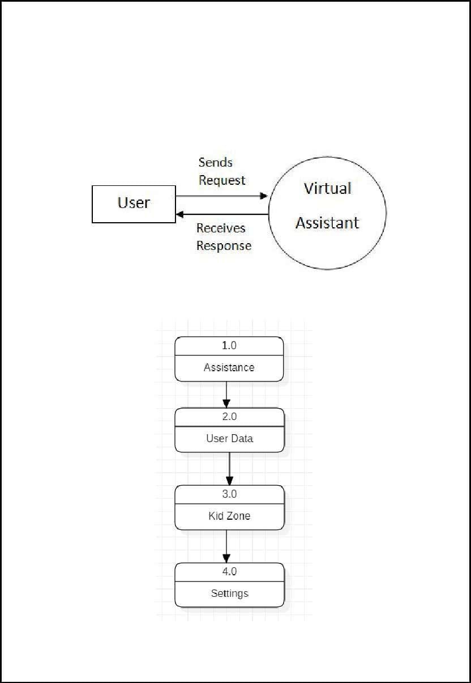

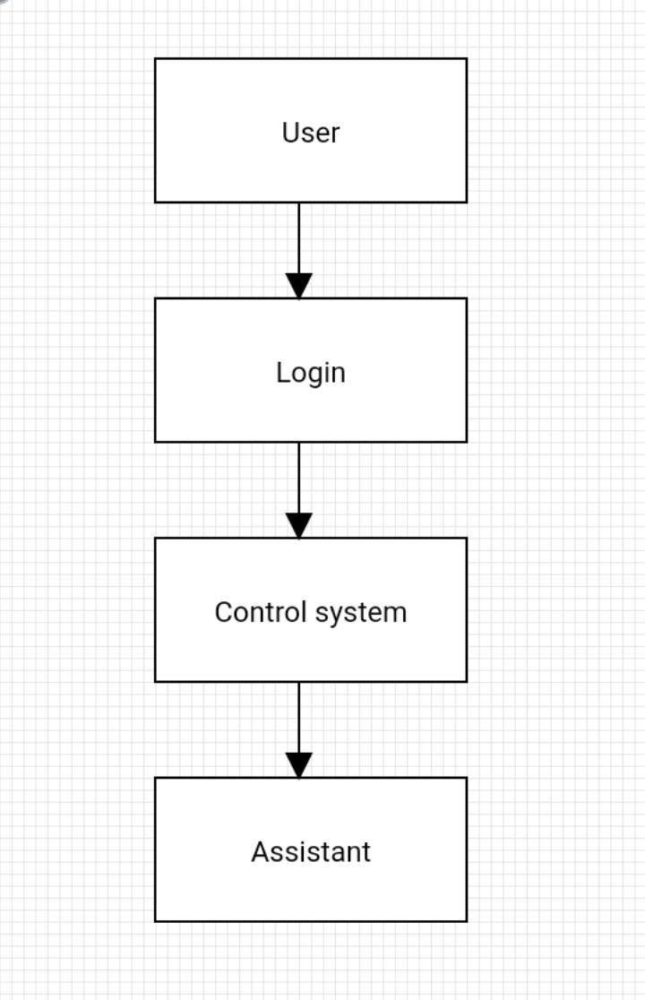

* **List of Modules**

**Admin module**

Virtual assistants have become more prominent as small businesses and startups rely on [virtual offices](https://www.investopedia.com/terms/v/virtual-office.asp) to keep costs down and businesses of all sizes increase their use of the internet for daily operations. Because a virtual assistant is an independent contractor, a business does not have to provide the same benefits or pay the same taxes that it would for a full-time employee. Also, since the virtual assistant works offsite, there is no need for a desk or other workspace at the company's office. A virtual assistant is expected to pay for and provide their own computer equipment, commonly used software programs, and high-speed Internet service.

**User module**

When it comes to communicating with your virtual assistant, it is a little bit trickier than working with someone in person. When you are just chatting and emailing with someone, some of the tone and intention of your communication might get lost in it. You really need to make sure that you can set up the correct communication systems. You must bear in mind that one of the fastest ways for a work relationship to fail when it comes to working online is miscommunication

**5.REQUIREMENT ANALYSIS FOR EXPERIMENTAL SETUP**

**Software Requirement:**

* Operating System - Windows 8
* Compiler – Visual Studio Code
* Browser - Chrome.
* Language - C, C++

**Hardware Requirement:**

* Processor - Intel Pentium 4.
* RAM - Minimum 6 GB required.
* Hard Disk - 32 GB.

**6. FLOWCHAT**

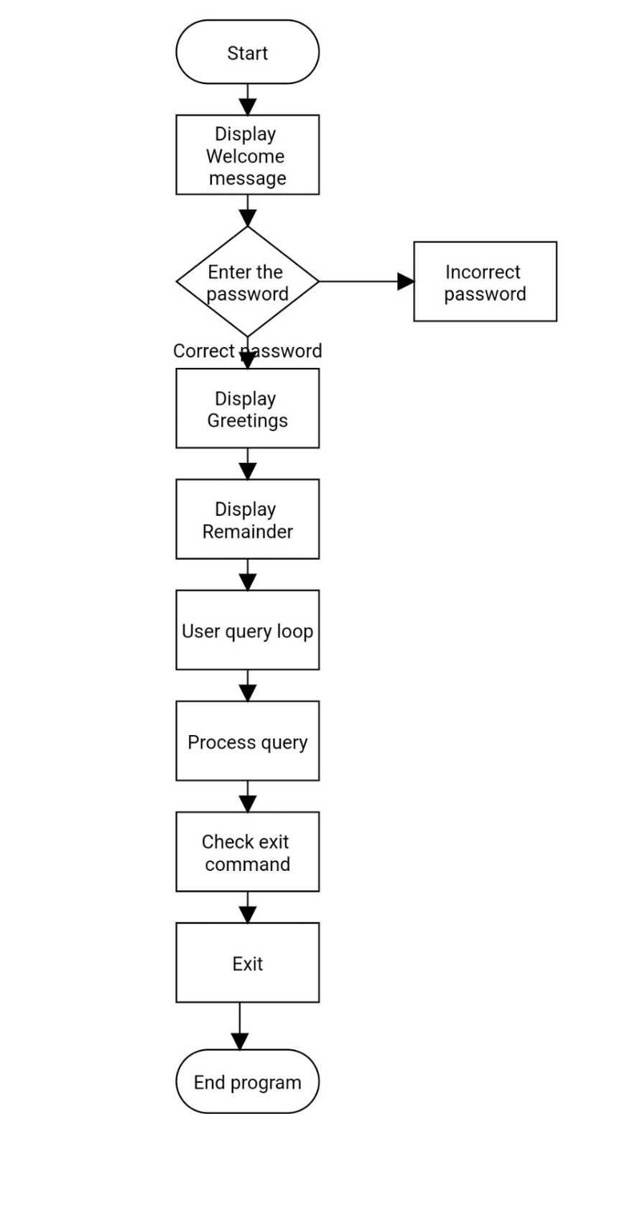

**7. USAGE OF LOGIC AND ALGORITHM**

**USAGE OF LOGIC**

The provided code is for a virtual assistant named "Sisira." It greets the user based on the time of day and provides reminders for specific activities. The program runs in a loop, asking the user for a password. If the password is correct, it proceeds to handle user queries. It recognizes greetings, termination commands, and various queries about the assistant's identity, time, and applications to open. The program uses the "espeak" tool for text-to-speech functionality. However, the code could be improved in terms of input validation and security as it uses the unsafe `gets()` function and directly executes user input as commands.

**ALGORITHM**

Step 1: Start

Step 2: Display welcome messages

Step 3: Enter password if wrong exit

Step 4: Display Greetings

Step 5: User Query loop

Step 6: Process Query

Step 7: End

**8. IMPLEMENTATION**

The code provided in the question represents a basic implementation of a virtual assistant project. It includes functionality for greeting the user, providing reminders, performing actions based on user input, and integrating with external services.

1. Libraries and Dependencies:

The code includes necessary libraries such as `iostream`, `windows.h`, `stdio.h`, `string.h`, and `ctime` to enable functionalities like input/output operations, Windows API usage, string manipulation, and time-related operations.

2. Function Definitions:

The code defines several functions to handle specific tasks:

- `wish()`: This function greets the user based on the current time and uses the `espeak` command to provide spoken greetings.

- `datetime()`: This function retrieves the current date and time and displays it to the user.

- `Remind()`: This function provides reminders based on the current time and uses the `espeak` command for spoken reminders.

3. Main Function:

The `main()` function is the entry point of the program and contains the main logic and user interaction.

- It starts by clearing the console screen using the `system("cls")` command and displaying a welcome message.

- The user is prompted to enter a password, and the program verifies it against a predefined password ("sisi").

- If the password is correct, the program proceeds to greet the user, provide reminders, and enter a loop for user interaction.

- Inside the loop, the user is prompted to enter a query, and the program performs specific actions based on the query:

- It handles common greetings like "hi," "hey," or "hello" and responds with a corresponding message.

- It handles commands like "bye," "stop," or "exit" to terminate the program.

- It provides information about the virtual assistant when the user asks "who are you" or "tell me about yourself."

- It responds to queries about the assistant's well-being or current state with appropriate messages.

- It handles queries about time or date by invoking the `datetime()` function to display the current date and time.

- It handles commands to open external applications or websites like Notepad, Google, YouTube, or Instagram using the `CreateProcess` or `system` functions.

- It responds to custom queries like "play music," "show me about your college," or "show me images of flowers" by performing specific actions using system commands.

- For unrecognized queries, it provides a default error message.

4. Usage of External Commands:

The code utilizes external commands like `espeak` for text-to-speech synthesis, `notepad.exe` for opening Notepad, and system commands for opening websites or executing system-dependent actions.

**9. RESULT**

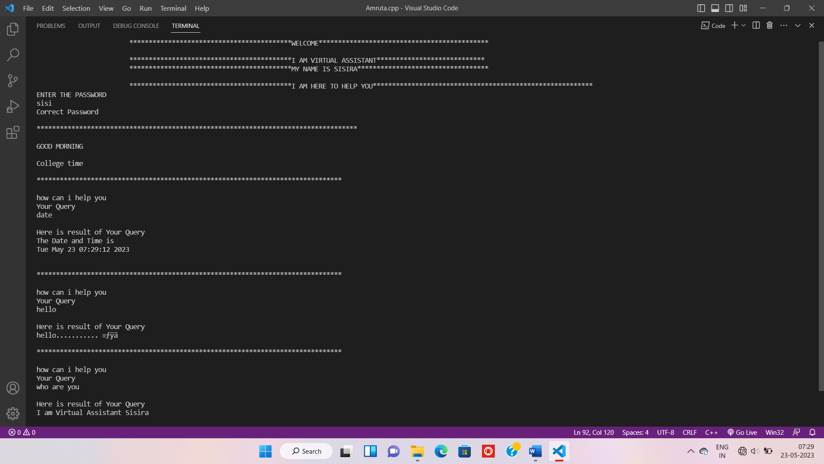

**Fig 9.1(a)**

In Image above `main()` function, the initial welcome message is displayed using `cout`. The user is prompted to enter a password, and the `espeak` command is used to speak "Enter your password" using text-to-speech. The `Remind()` function is defined to provide reminders based on the current time of the day. It uses the `time()` function and `localtime()` function to get the current time. Depending on the hour, it prints different reminders (e.g., "Wake up," "College time," "Gym time") and uses the `espeak` command to speak the reminder.

The `datetime()` function is defined to display the current date and time. It uses the `time()` function to get the current time and `ctime()` function to convert it into a string format.

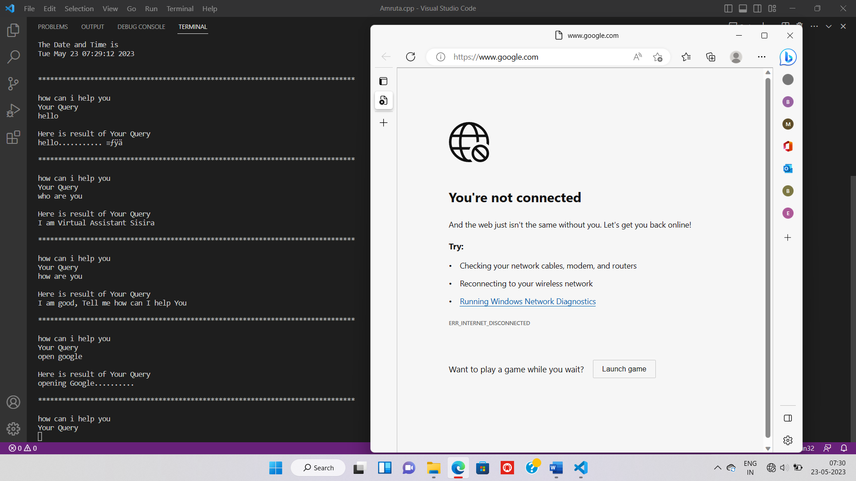

**Fig 9.1(b)**

In Image above Based on the user's query, different actions are performed:-

* If the query is to open notepad, Google.

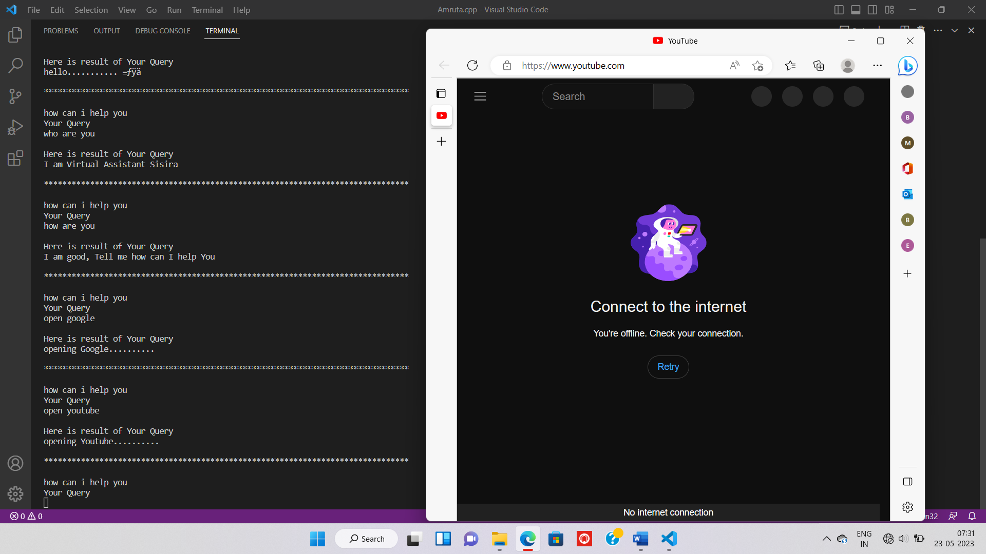

**Fig 9.1(c)**

In Image above Based on the user's query, different actions are performed:-

* If the query is to open notepad, YouTube.

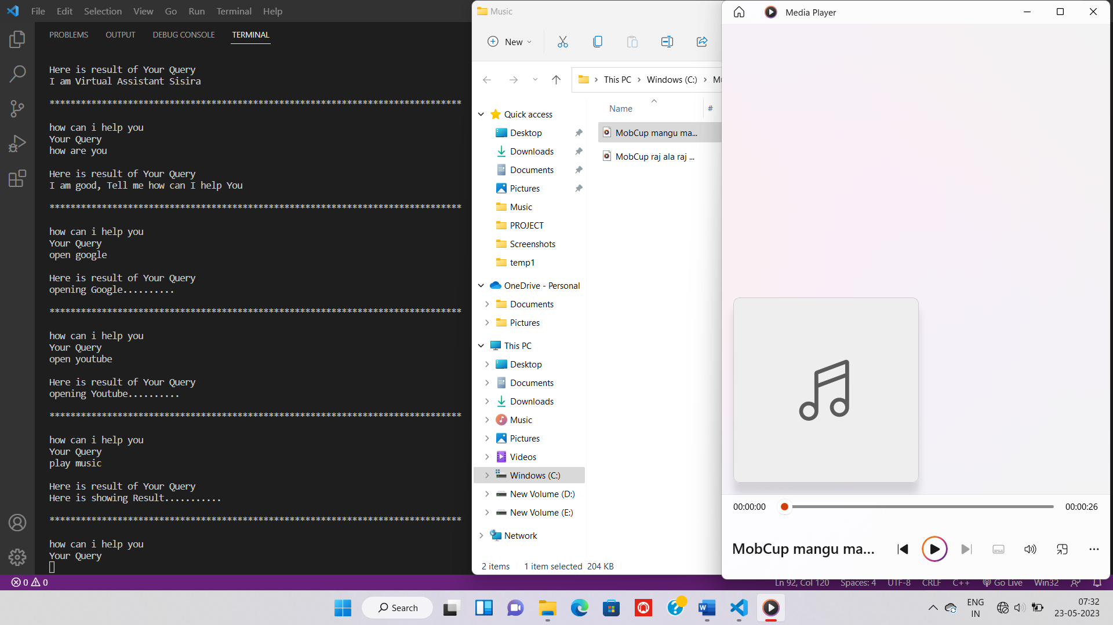

**Fig 9.1(d)**

In Image above Based on the user's query, different actions are performed:-

* If the query is to play music.

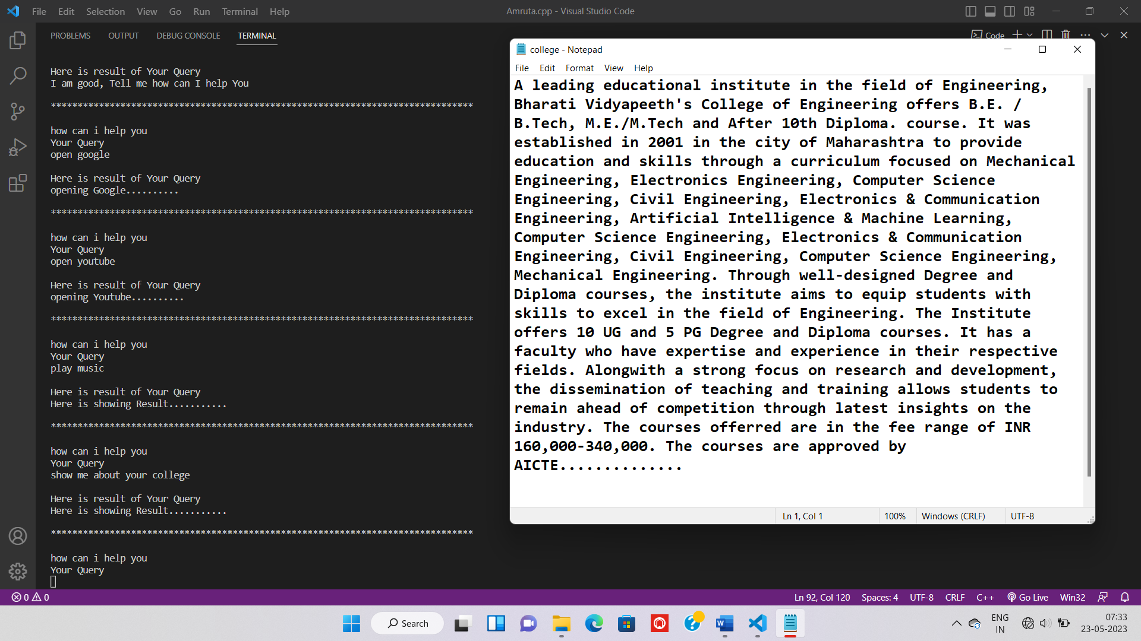

**Fig 9.1(e)**

In Image above Based on the user's query, different actions are performed:-

* -If the query is to show information about a college.

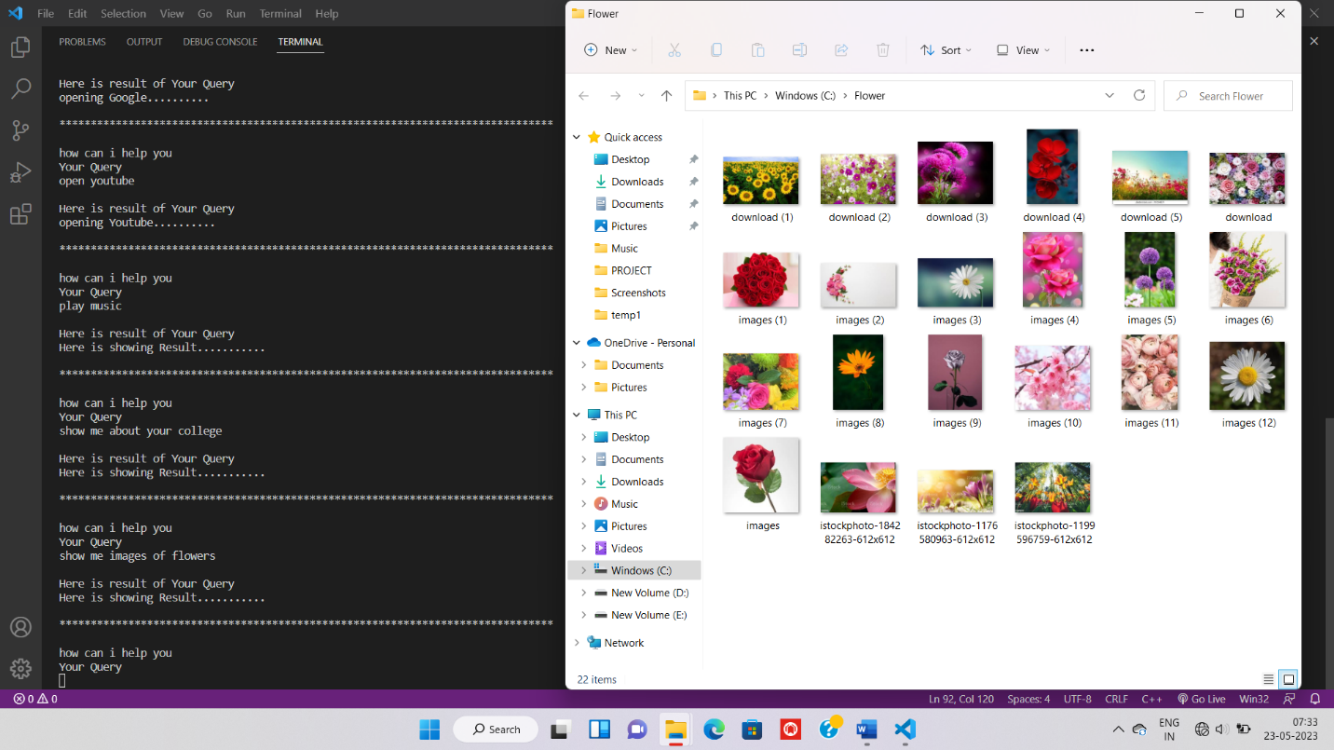

**Fig 9.1(f)**

In Image above Based on the user's query, different actions are performed:-

* If the query is to show images of flowers.

**10. CONCLUSION**

The project implemented a basic virtual assistant using C++ programming language. The virtual assistant greets the user, provides reminders based on the current time, and performs various actions based on user input. It integrates with external services like speech synthesis and opens applications or websites upon request. While the project serves as a simple demonstration of a virtual assistant, further enhancements can be made to expand its functionalities and improve user experience. This project showcases the potential of virtual assistants in providing assistance and automation in various tasks.

**11.REFERENCES**

**Websites**

* <https://coderspacket.com/voice-assistant-in-cpp>
* <https://www.geeksforgeeks.org/project-idea-virtual-health-assistant/>
* <https://www.quora.com/How-do-I-write-a-virtual-assistant-software-in-C>

**Books**

* The C++ Programming Language.
* Intoduction to Virtual Assistants and their Platforms.
* Hey Cyba: The Inner Workings of a Virtual Personal Assistant.

# 12. OVERALL COMLETITON CHART

|  |  |
| --- | --- |
| **PERIOD** | **WORK TO BE COMPLETED** |
| 10/02/2023 - 17/02/2023 | Importance of Mini-Project |
| 17/02/2023 - 24/02/2023 | Topic Selection |
| 24/12/2023 – 03/03/2023 | Brief group discussion |
| 03/03/2023 – 10/03/2023 | Module listing |
| 10/03/2023 – 17/03/2023 | Flowchart and System diagram |
| 17/03/2023 – 31/03/2023 | Submission of Synopsis |
| 31/03/2023 – 07/04/2023 | Program Coding |
| 07/04/2023 – 28/04/2023 | Analyzing program |
| 28/04/2023 – 12/05/2023 | Report project |
| 12/05/2023 – 23/05/2023 | Final project submission |

|  |  |  |  |  |
| --- | --- | --- | --- | --- |
| **Roll No.** | **Names of the Project Group Members** | **Mobile No** | **E-mail** | **Signature** |
| 21 | Madhuri Baburao Kamble | 8856075992 | [kamblemadhuri115@gmail.com](mailto:kamblemadhuri115@gmail.com) |  |
| 22 | Amruta Sitaram Katharut | 8080911056 | [amrutakatharut@gmail.com](mailto:amrutakatharut@gmail.com) |  |
| 33 | Rutuja Ramesh Mokale | 9529259355 | [rutujamokale2003@gmail.com](mailto:rutujamokale2003@gmail.com) |  |

|  |  |
| --- | --- |
| Mrs. R.V. Jadhav | Mrs. S. M. Mulla |
| **PROJECT GUIDE** | **H.O.D – CSE** |