Library Management System

**Introduction**

**Purpose:** To automate the Library Activities

**Objective:** To develop a website to automate the library activities.

**Scope:** Performs very basic library activities such as issue, return, renew.

**References:**

* Java Documentation ([www.docs.oracle.com](http://www.docs.oracle.com) ) for JAVAX libraries and JDBC libraries
* W3Schools ([www.w3schools.com](http://www.w3schools.com) ) for HTML, CSS, JS
* MVC-2 Architecture ([www.javatpoint.com/model-1-and-model-2-mvc-architecture#m2](http://www.javatpoint.com/model-1-and-model-2-mvc-architecture#m2) )
* SRS with IEEE Standard ([www.ifs.host.cs.st-andrews.ac.uk/Books/SE9/Web/Requirements/IEEE-standard.html](http://www.ifs.host.cs.st-andrews.ac.uk/Books/SE9/Web/Requirements/IEEE-standard.html) )

**Definitions and Acronyms and Abbreviations:**

* **Librarian:** Faculty or In-charge who is responsible for performing library activities
* **Patron:** Any other person who is not Librarian who visited the Library. (Student, Teacher, Faculty, etc.)
* **Transaction:** Either issuing or returning or renewing a book
* **MVC:** Model-View-Controller
* **JSP:** Java Servlet Page

**General Description:**

The current library activities involve recording of transaction in a physical format and storing them. These activities can be automated with required resources. The product is a webpage so that it is available thorough out the LAN.

This website performs basic library activities such as issue, return, search, etc. It uses Apache Tomcat as a Server to take in request and send responses. And it uses MySQL Database to perform necessary database operations.

Since, it is a dynamic web project most of the webpage(s) are written in JSP’s for dynamic content. This product is designed using MVC-2 Design Pattern.

This product is only available within the LAN or the room. It is not accessible through internet.

A Librarian can issue/return/renew a book for a Patron only if the Patron has a membership for the library, i.e., the details of the Patron are existing with the Librarian.

Super User Id :- root, pass :- 23571113171923

**User Characteristics:**

This product considers there are two types of users:-

1. Librarian
2. Patron (Anyone other than the Librarian)

Librarian has the following functionalities:-

1. Add Book
2. Remove Book
3. Issue
4. Renew
5. Return
6. View Student Transaction Details

Patron has the following functionalities:-

1. Search for a book (Voice Search Enabled)
2. View Latest News Articles

**Assumptions & Dependencies**

1. Only Librarian can issue/return a book
2. Internet Connectivity is available for News Articles
3. Dedicated System/Server to deploy the web page
4. Patron ID to be Student/Faculty ID, otherwise provided by Librarian

**Specific Requirement**

**Functional Requirement**

For Librarian

|  |  |
| --- | --- |
| **FR-LMS-XX** | **Description** |
| FR-LMS-01 | Login Page for librarian |
| FR-LMS-02 | A webpage to add book to the database |
| FR-LMS-03 | A webpage to remove a book from the database |
| FR-LMS-04 | A webpage to issue a book to a student and log the transaction |
| FR-LMS-05 | A webpage to return the book from student and log the transaction |
| FR-LMS-06 | A webpage to view a particular students all transactions |
| FR-LMS-07 | A webpage to renew the book |
| FR-LMS-08 | A webpage to add new Patron |
| FR-LMS-09 | A webpage to modify book details |
| FR-LMS-10 | A webpage to modify patron details |
| FR-LMS-11 | A webpage to change the librarian details |
| FR-LMS-12 | Searching of book based on title, author, tags |
| FR-LMS-13 | Cannot issue a book which is already been issued |
| FR-LMS-14 | Cannot return a book which is already been returned |
| FR-LMS-15 | Penalty amount to be displayed on late returning |

For Patron

|  |  |
| --- | --- |
| **FR-LMS-XX** | **Description** |
| FR-LMS-16 | A webpage to search for a book in the library database |
| FR-LMS-17 | Voice Search a book in the library database |
| FR-LMS-18 | A webpage to view Top News |

**Non Functional Requirement**

|  |  |
| --- | --- |
| **NFR-LMS-XX** | **Description** |
| NFR-LMS-01 | Security – Only Authorized Librarian can Login |
| NFR-LMS-02 | Portable – Can be used in any computer which has a web browser |
| NFR-LMS-03 | Privacy of Patron Information |
| NFR-LMS-04 | Email is sent to the patron about the Patron ID |
| NFR-LMS-05 | Email is sent to Patron on Issue of every book |
| NFR-LMS-06 | Patron can have at most 2 books issued |

**Software Requirements**

|  |  |
| --- | --- |
| OS | Any |
| Browser | Google Chrome, Microsoft Edge |
| Server | Apache Tomcat 9.0 |
| Database | MySQL 8.0 |
| RAM | 128MB |
| Additional Required Devices | Microphone |

**Diagrams  
  
ER - Diagram**

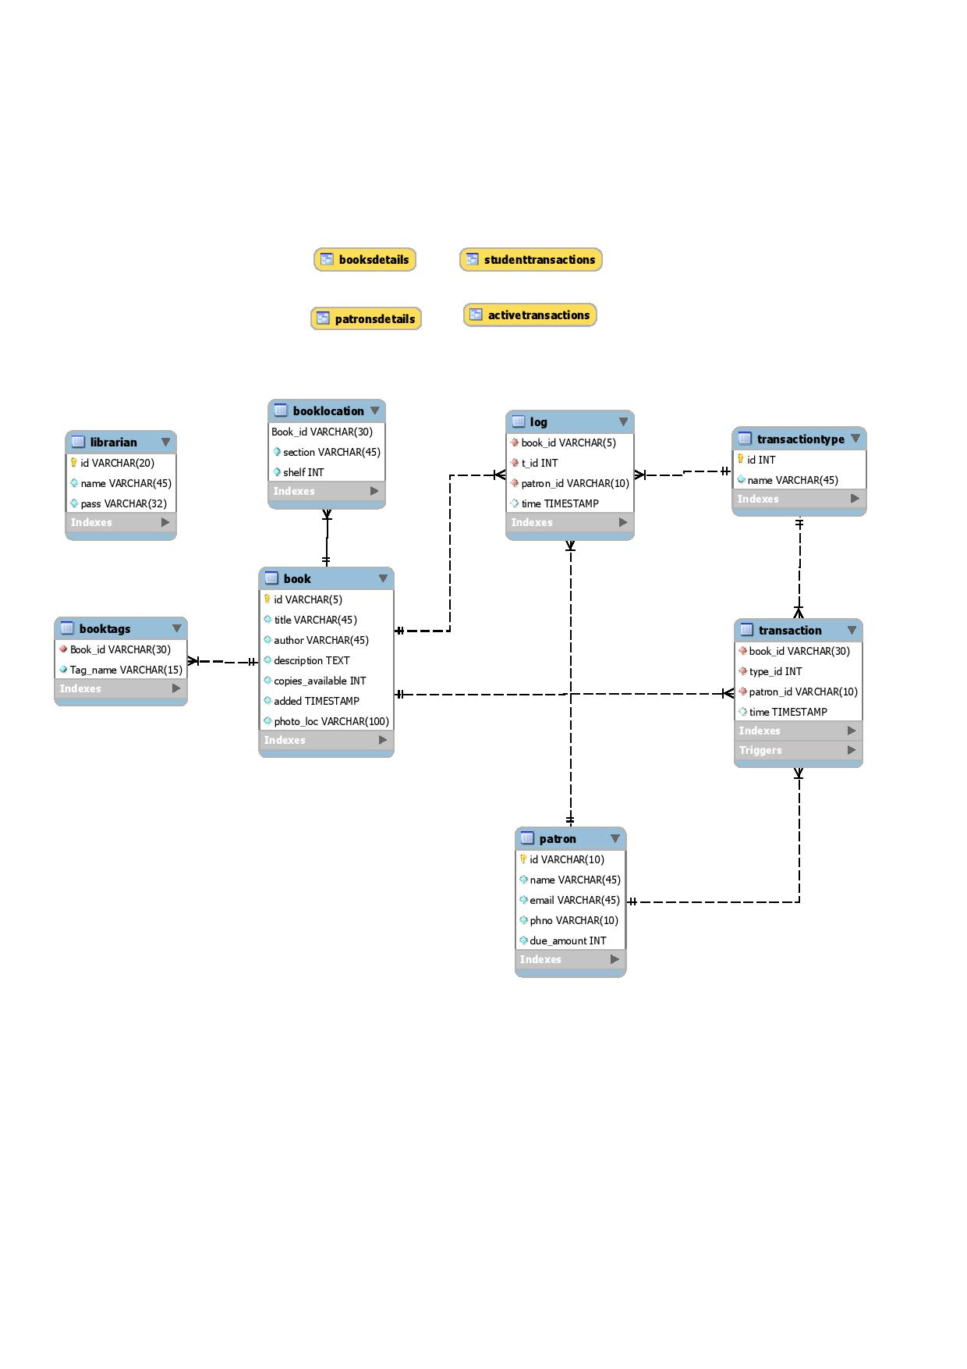

**Use Case Diagram**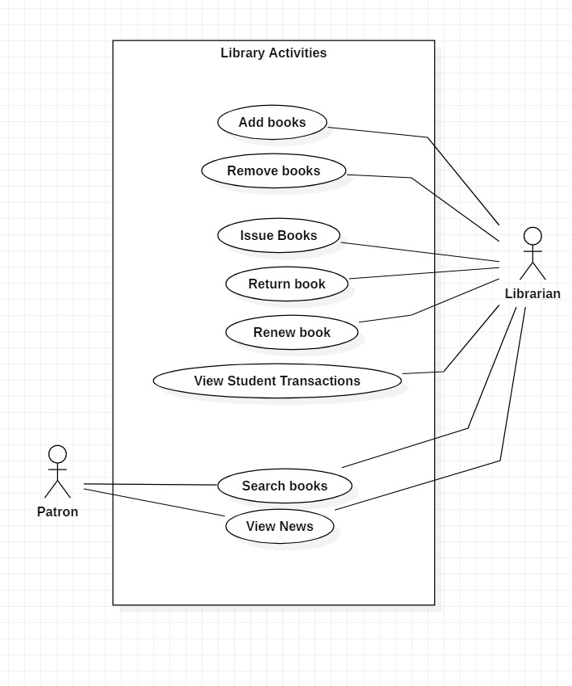

**Activity Diagram**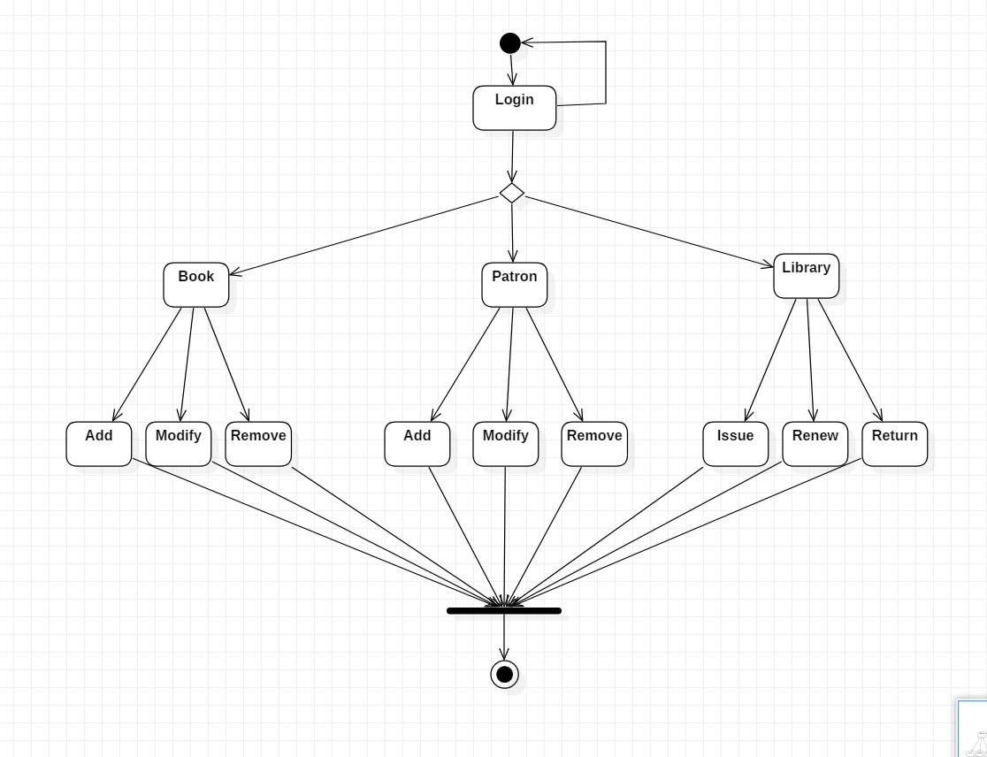

**MVC-2 Architecture** 