Assignment 2 report

Adamzhanov Adil

Team members: Adil Adamzhanov , Tamerlan Murat , Isain Bexultan

Team name: FC Ertis

Group: SE-2402

Step 1. Cretaing external CSS style file

1)I set the style for heading which will be at the top of the page. I set needed the needed font size and add a background color so it will fit as the top of the page title.

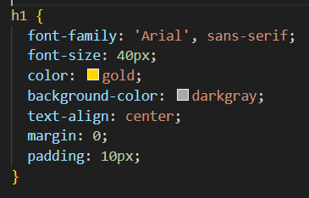



2)I create the style for navigation panel of the page. I set margins of both h1 and navigation to 0 so they will have no gap between them. Hyperlink right-margin is set to 30 px to space them out. Pseudoclass hover is used to make hyperlinks change color when hovered over.

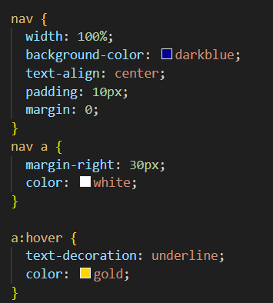

3)Styling the headings and common text that will be used in the main part, setting needed size and color to them, and aligning all headings in the center.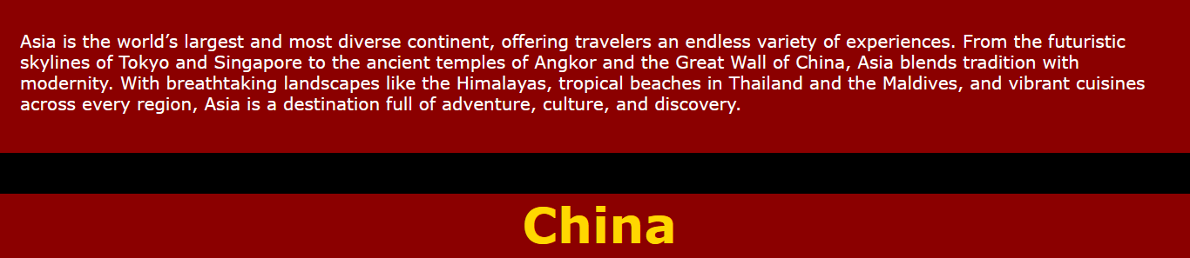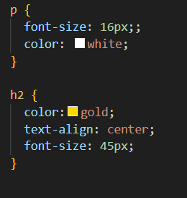

4)Changing background color of the whole page by styling background color of body tag.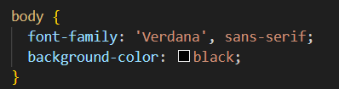

5)Styling main boxes with information. I added class selector to describe behavior of elements used in part of the page that describes countries.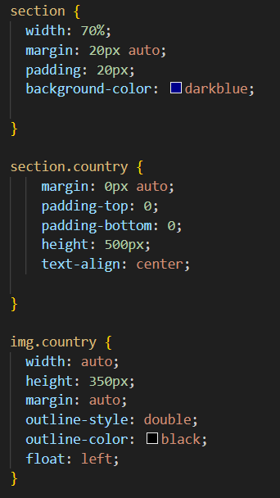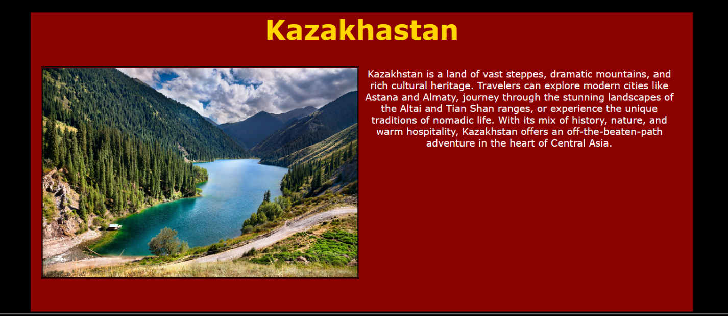

Step 2. HTML files for pages.

1)Linking external style file.



2) Internally changing style of elements to make two pages have different color.

Europe page:

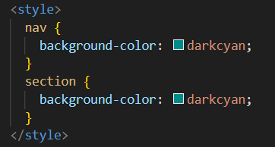

Asia page: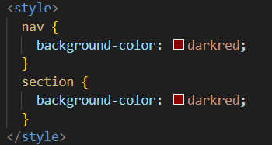

3)Adding all the elements. Adding a class attribute to elements that should be affected by this class styling.

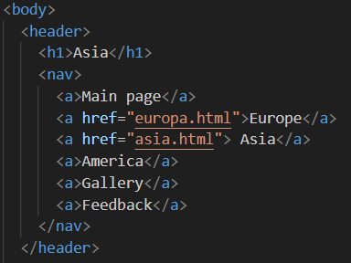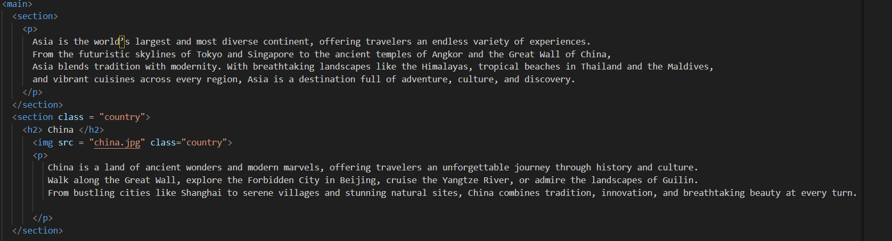

Step 10

https://graceful-begonia-11262d.netlify.app/