End-to-End Data Management Pipeline for a Recommendation System
  - ROLL NUMBER: 2025AG05563

1. Abstract
This project implements an end-to-end data management pipeline for an explicit-feedback movie recommendation system. MovieLens ratings are ingested, validated, cleaned, split into training and test sets, transformed into user/item statistical features, persisted in Parquet, used to train a transparent baseline model, and evaluated using RMSE and MAE. An Apache Airflow DAG provides scheduled orchestration.

2. Objectives
- Build a reproducible ingestion-to-evaluation workflow.
- Apply data quality checks before training.
- Prepare and transform interactions into reusable features.
- Train and evaluate a baseline recommender.
- Automate execution using a DAG and document limitations.

3. Dataset and schema
MovieLens latest-small is a public movie-rating dataset. The ratings table contains userId, movieId, rating (0.5–5.0 stars), and timestamp. Each row represents one user–movie rating.

4. Pipeline architecture
Source dataset → ingestion → validation gate → preparation/split → feature transformation → offline feature store → baseline training → test evaluation → metrics/recommendations. Airflow schedules and monitors the pipeline.
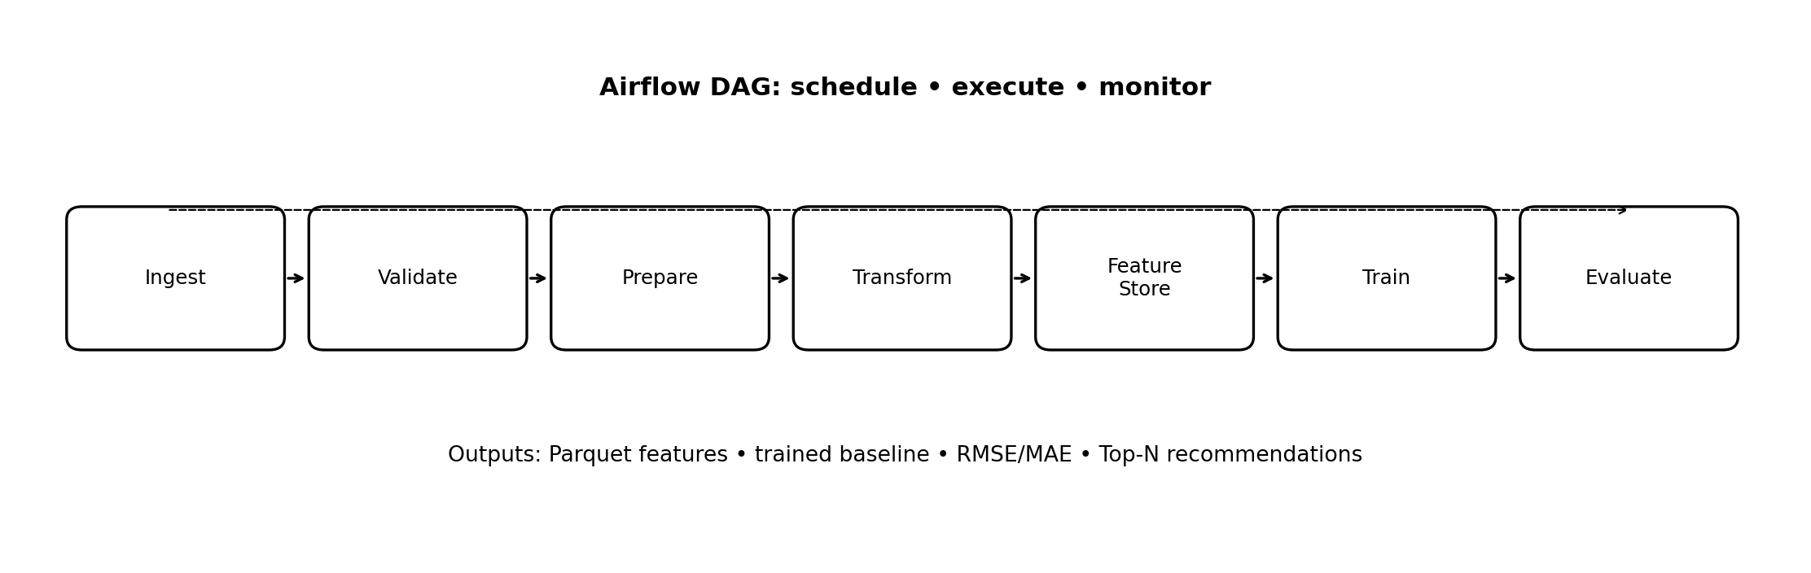

5. Components

5.1 Ingestion
Downloads the GroupLens archive if ratings.csv is absent; reads ratings into a Pandas DataFrame.

5.2 Validation
Checks required columns, missing cells, duplicate user–movie pairs, and rating range. Invalid data stops execution rather than silently passing.

5.3 Preparation
Retains required columns and creates a reproducible 80/20 train/test split with fixed random seed.

5.4 Transformation
Computes user mean rating, item mean rating, user/item interaction counts, and global mean on training data only.

5.5 Feature management
Stores transformed training features in Parquet using a small offline feature-store abstraction, enabling reusable and compact feature data

5.6 Training
Fits a transparent baseline: prediction averages global mean plus available user and item means; unseen entities back off to the global mean

5.7 Evaluation
Calculates RMSE and MAE on held-out ratings. Lower values indicate predictions closer to actual ratings

5.8 Orchestration
Airflow DAG invokes the pipeline weekly. Task logs and output metrics support traceability; production deployments should add retries, alerts, and task-level dependencies

6. Model and metrics
For user u and movie i, the baseline prediction is the arithmetic mean of the global rating mean, the user’s training mean (if available), and the movie’s training mean (if available). This is an intentionally interpretable benchmark. RMSE = sqrt(mean((rating − prediction)^2)); MAE = mean(|rating − prediction|). Run the pipeline to populate outputs/metrics.json with actual dataset results.

7. Recommendation generation
For a chosen user, movies already rated in training are removed from the candidate catalogue. The remaining movies are scored by the baseline and sorted descending; the top N are returned. A baseline’s scores are coarse and should not be interpreted as personalized ranking quality.

8. Reproducibility and execution
Install requirements.txt, then execute python src/pipeline.py from the project root. The first run requires internet access to download MovieLens. The notebook mirrors the same steps. Set the absolute PROJECT path in the Airflow DAG before deployment.

9. Limitations and future enhancements
- Random interaction split may leak temporal information; use time-based evaluation.
- Mean baseline is not a latent-factor or content-aware model.
- Cold-start users/items are weakly handled by global fallback.
- Add SVD/ALS or neural models, item metadata, implicit feedback, and ranking metrics such as Precision@K, Recall@K, and NDCG@K.
- Add schema versioning, data lineage, model registry, monitoring, drift checks, alerts, and online serving.
- Use Feast or a managed feature platform for online/offline consistency.

10. Conclusion
The deliverable demonstrates a complete and modular recommendation data pipeline. Its clear separation of ingestion, validation, preparation, features, model, evaluation, and orchestration makes it extensible and reproducible. The baseline establishes a reference point for more advanced recommenders.

Appendix: Deliverables
Python source modules, notebook, Airflow DAG, requirements, README, metrics output placeholder, and presentation are packaged with this report.

