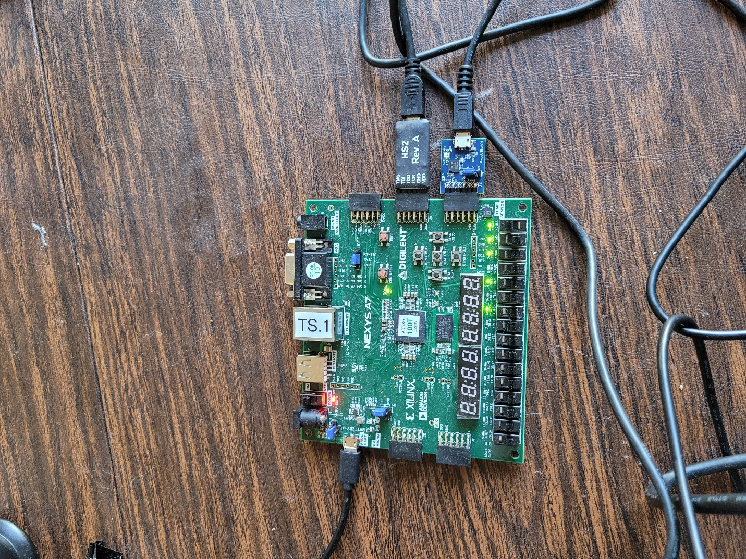

reset

SW0

(jtag-trstn)

PmodUSBUART

(Digilent)

HS2

JTAG

(debug)