LoKy Tutorial

# **Arduino IDE:**

## Setup board information:

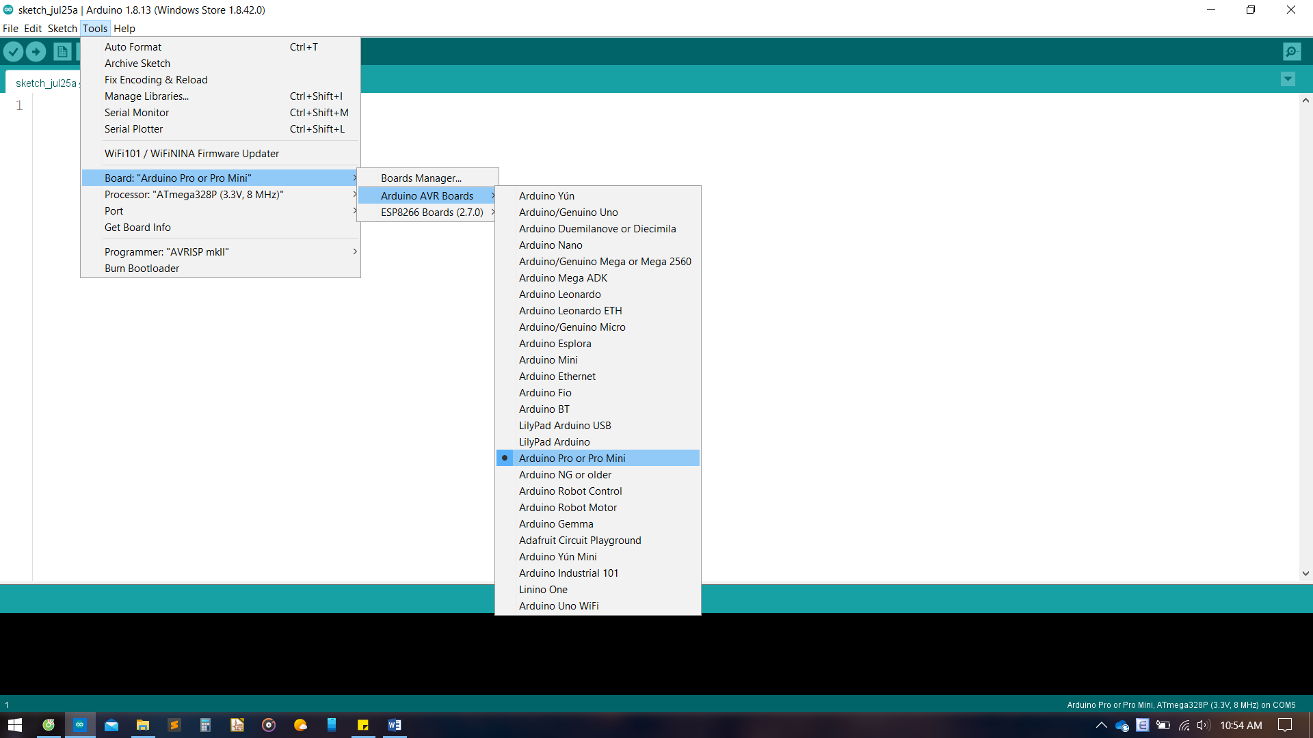

## Install version **1.6.21** on Boards Manager (the higher versions have bugs for LMiC library)

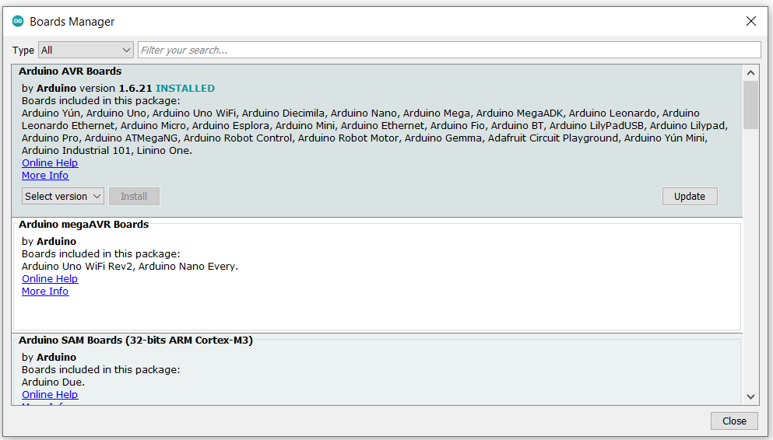

* + Select Processor: “ATmega328P (3.3V, 8MHz)” and Port that is connecting to ProMini
  + Install Libraries following this instruction: <https://www.arduino.cc/en/guide/libraries>

# **The Things Network (TTN)**

1. Login to TTN console: <https://console.thethingsnetwork.org/> and add a new Application

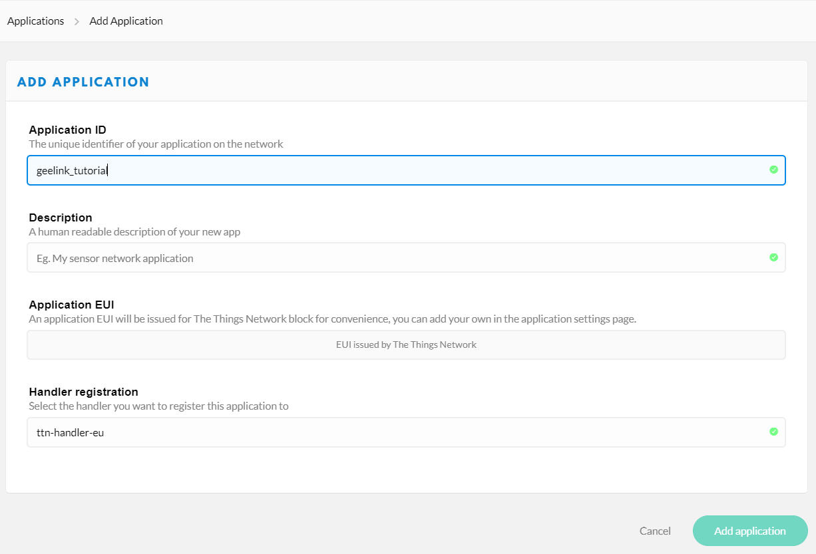

1. Device register

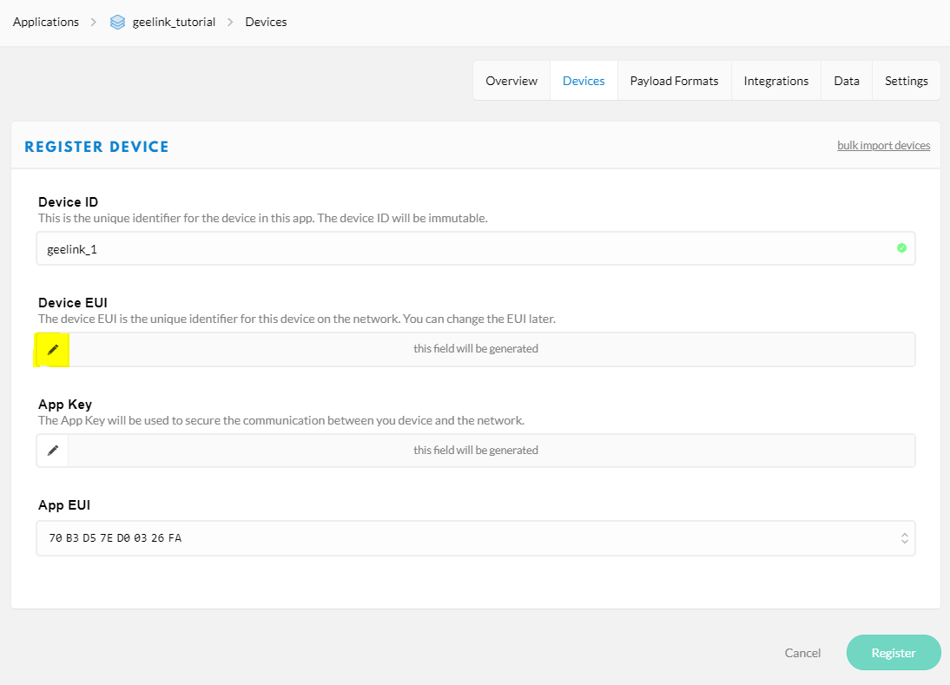

1. After registering an OTAA device, adjust the keys into the following format

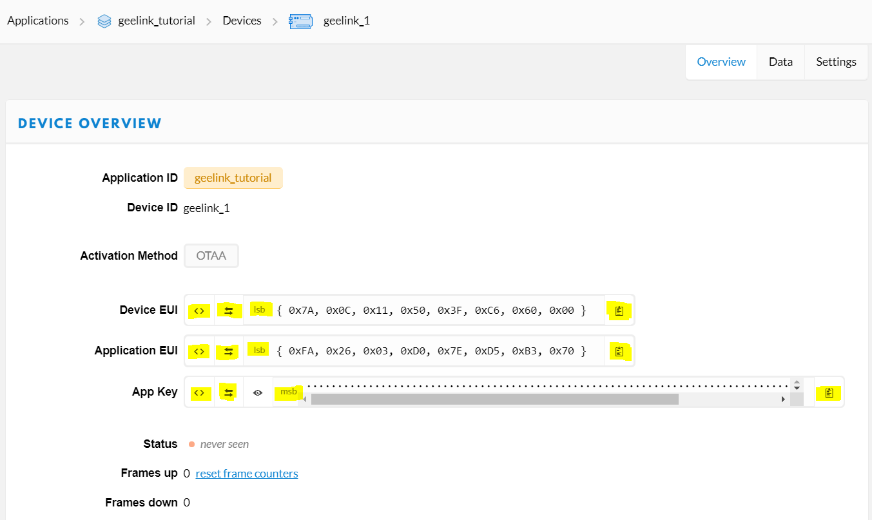

# **Payload decoder on TTN**

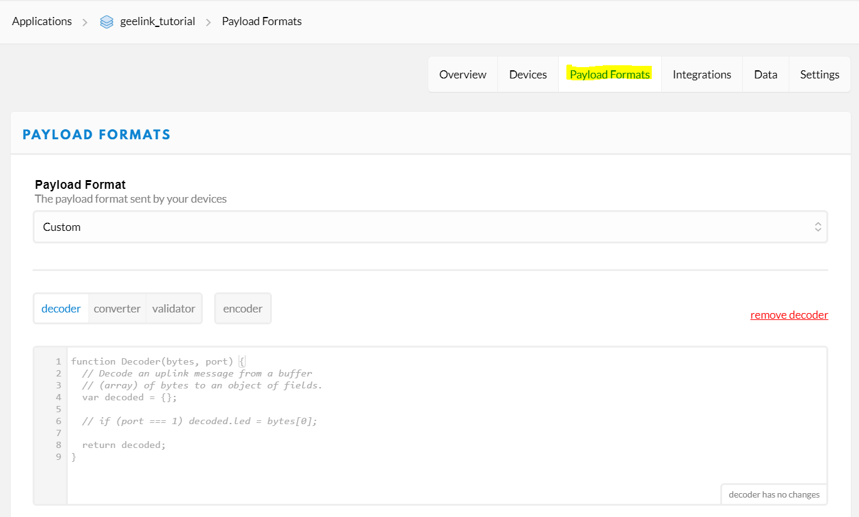

* Change the decoder to the LoKy_decoder and *remember* to **SAVE** before add integration

# **Integrations on TTN**

* Add **Data Storage** integration: 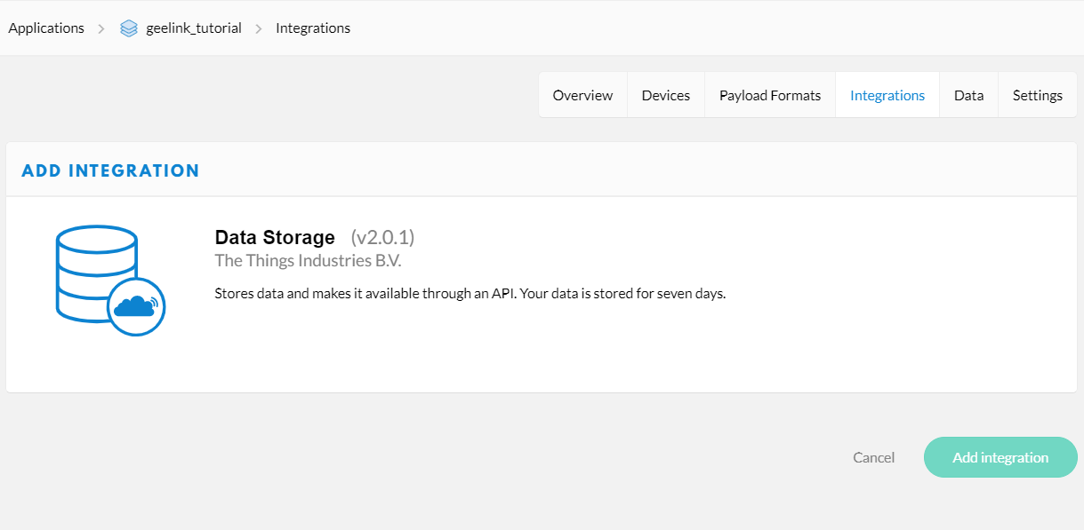
* **Now, we have everything to run:**

- LoKy main board

- Arduino and its stuff

- last but not least, TTN configured.

# **LoKy Firmware upload:**

* + - * First we need to replace the keys (in section 2.c) from TTN in *“****3_Device_Keys.h”***
      * Depending on the “option tarifaire” of Linky, we can use BASE or HCHP for our device by comment and uncomment line 11 or 12 of the main sketch.

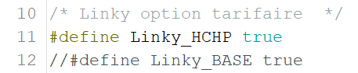

* + - * Upload the sketch and check the operation of device from the Serial Monitor on Arduino IDE.
      * Finally, we can plug LoKy to the compteur and done!
* Section 6 is used for Application server and Database.

# **Application Server**

* Install InfluxDB and Grafana following this instruction:

<https://github.com/ITU-PITLab/public/blob/master/TheThingsNetwork%2Bnode-red%2Binfluxdb%2Bgrafana.md>

* Install Node-RED

If Git is not installed on your PC: https://git-scm.com/downloads. After that, run this command on Gitbash npm install -g --unsafe-perm node-red

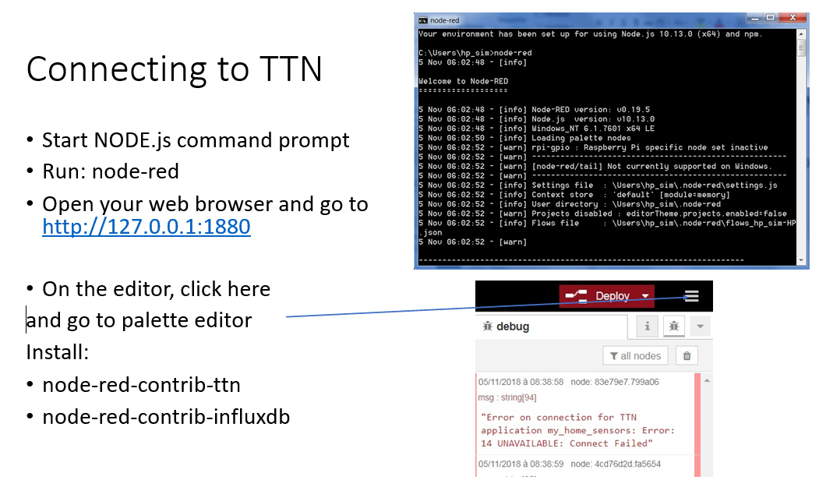

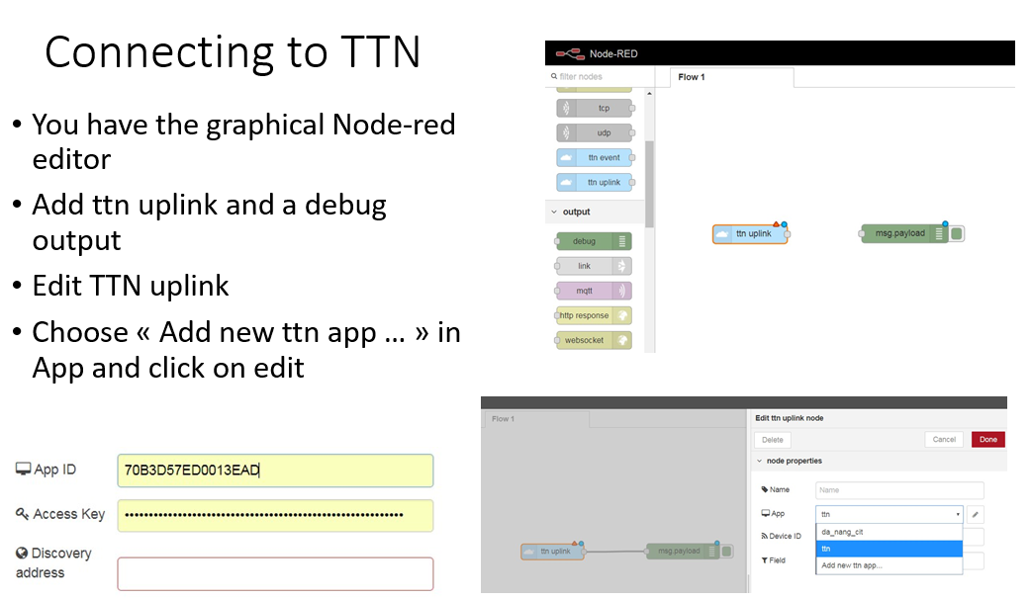

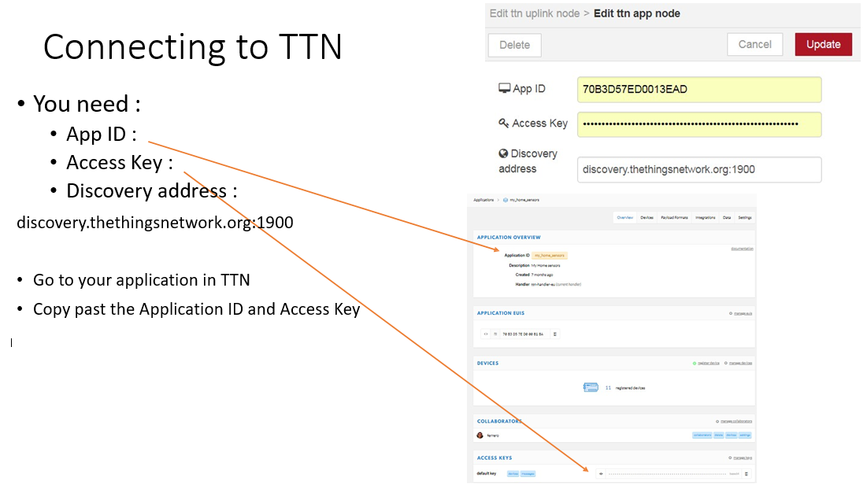

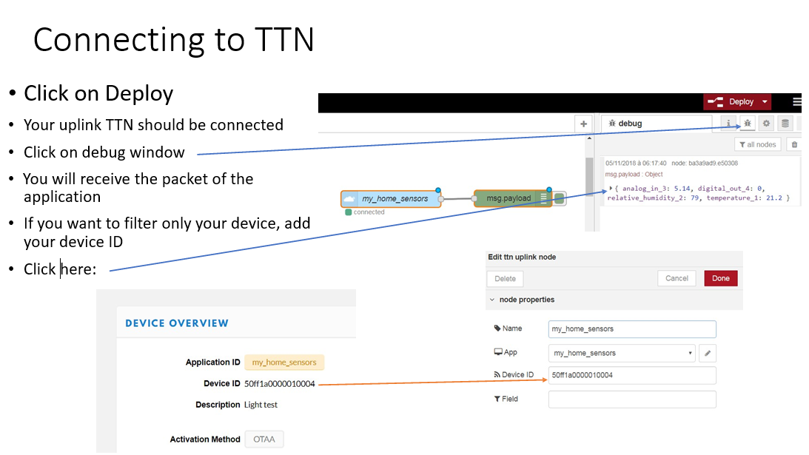

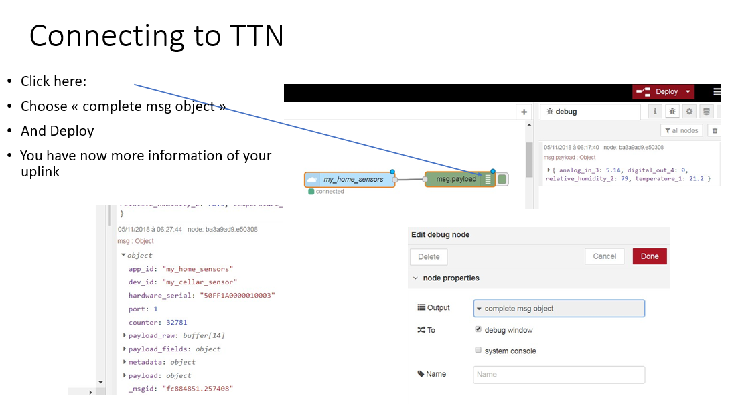

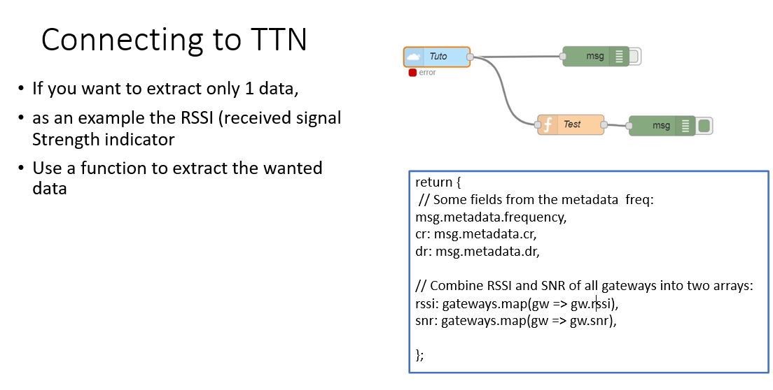

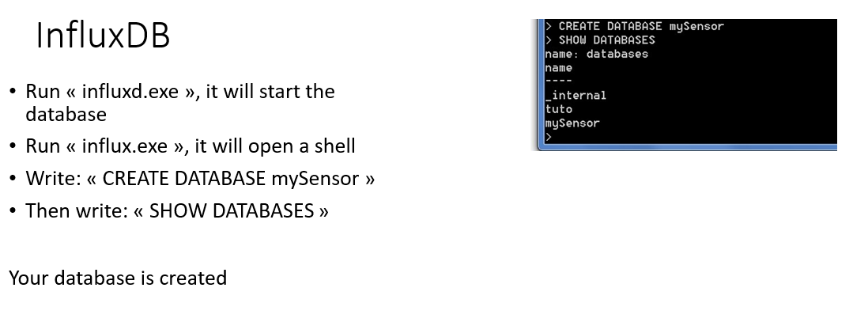

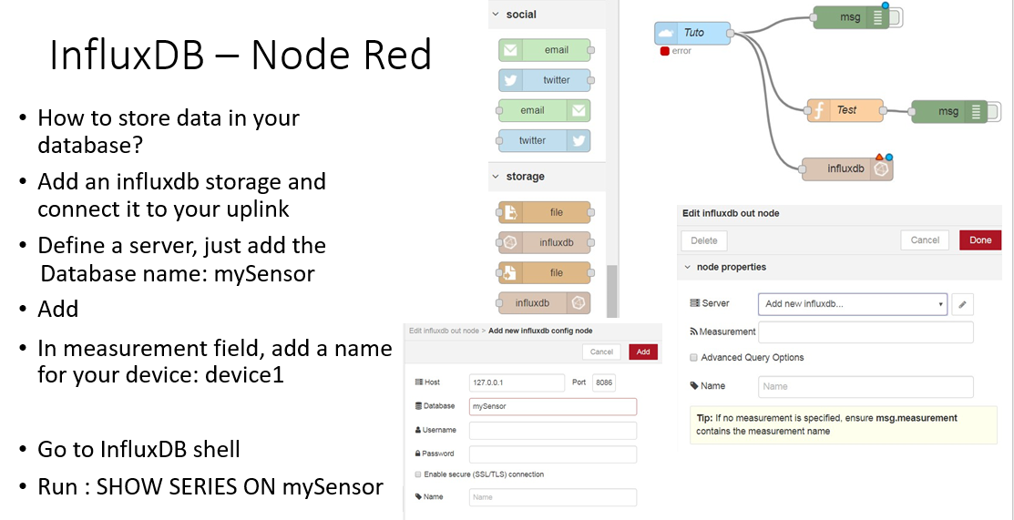

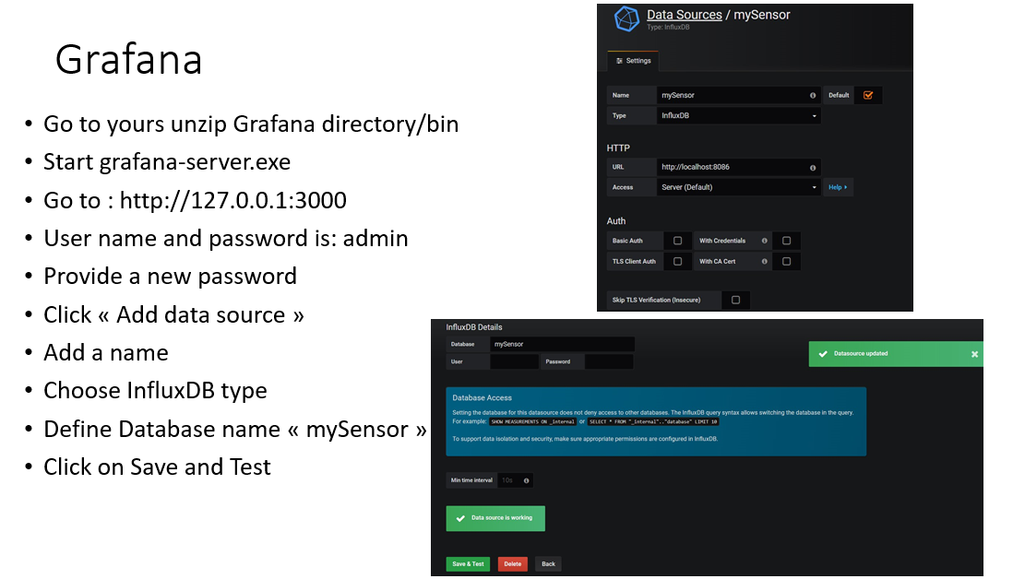

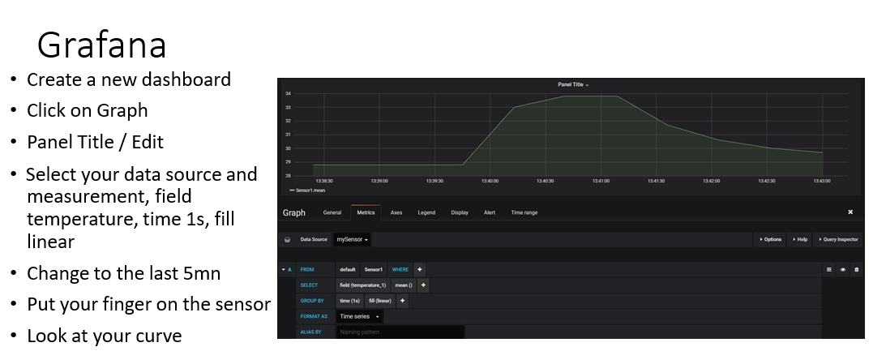

*Credit to GitHub: Fabien FERRERO – UCA board