BirdClone: Documentation

Table of Contents
Requirements 2
Use-cases 3
Contextdiagram 5
Conceptual model 5
UI sketch 6
Tests 7
Testmatrix 7
Class Diagram 8

Requirements
- Sending messages
  - limitations:
    - Maximum of 500 characters
    - No images
    - requires being logged in to an account
  - Quality requirements:
    - messages will show datetime of posting, user that posted it, link to user profile
- Displaying messages
  - limitations:
    - none
  - Quality requirements:
    - messages will show up on index page
- Creating an account
  - limitations:
    - image must be a link to where the image is hosted
    - bio must be max 1000 characters
  - Quality requirements:
    - user data will show up in personal account pages
    - the username will show up on messages the user sends.
    - Country, email, username, password,bio and profile picture will be possible to be set
- Homepage/indexpage
  - limitations:
    - apart from footer/header, will only display messages
  - Quality requirements:
    - messages will be diplayed with cards
    - header will have login, register, accountsettings pagelinks.
- Accountsettings page
  - limitations:
    - will only display settings for username, password, country, bio and profile picture (simple form)
  - Quality requirements:
    - will be a simple form with nothing else

- Accountpage
  - limitations:
    - will not display all messages
  - Quality requirements:
    - will display all messages of the given user
    - will display profile picture, bio, country if set, account creation datetime, last login datetime..

Use-cases
Name | Sending messages
Summary | Send messages with a maximum of 500 characters. Messages will show datetime of posting, user that posted it, link to user profile.
Actors | User
Assumptions | User is logged in. Message is less than 500 characters.
Scenario | User sends message. System receives message and stores it in the database. System displays message on index page with datetime of posting, user that posted it and link to user profile.
Exceptions | User tries to send a message longer than 500 characters. User is not logged in.
Result | Message is displayed on index page with datetime of posting, user that posted it and link to user profile.

Name | Displaying messages
Summary | Display messages on index page. Messages will be displayed with cards.
Actors | User
Assumptions | None.
Scenario | User opens index page. System retrieves all messages from the database and displays them on index page with cards.
Exceptions | None.
Result | Messages are displayed on index page with cards.

Name | Creating an account
Summary | Create an account and add it to the database.
Actors | User
Assumptions | None.
Scenario | User opens register page and fills out the form with valid data. System receives data and stores it in the database. System logs in the user automatically after successful registration and redirects them to the indexpage.
Exceptions | None.
Result | The account has been created and added to the database.

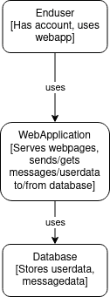
Contextdiagram

Conceptual model
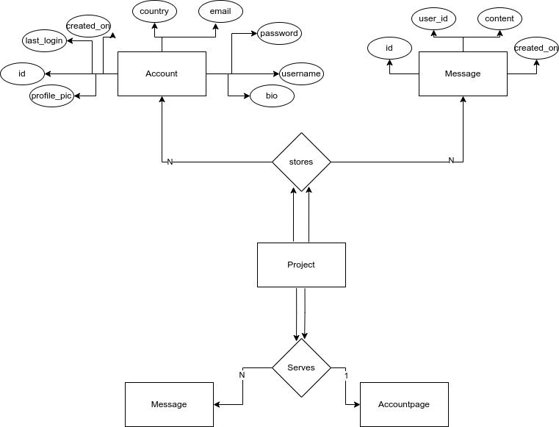

UI sketch
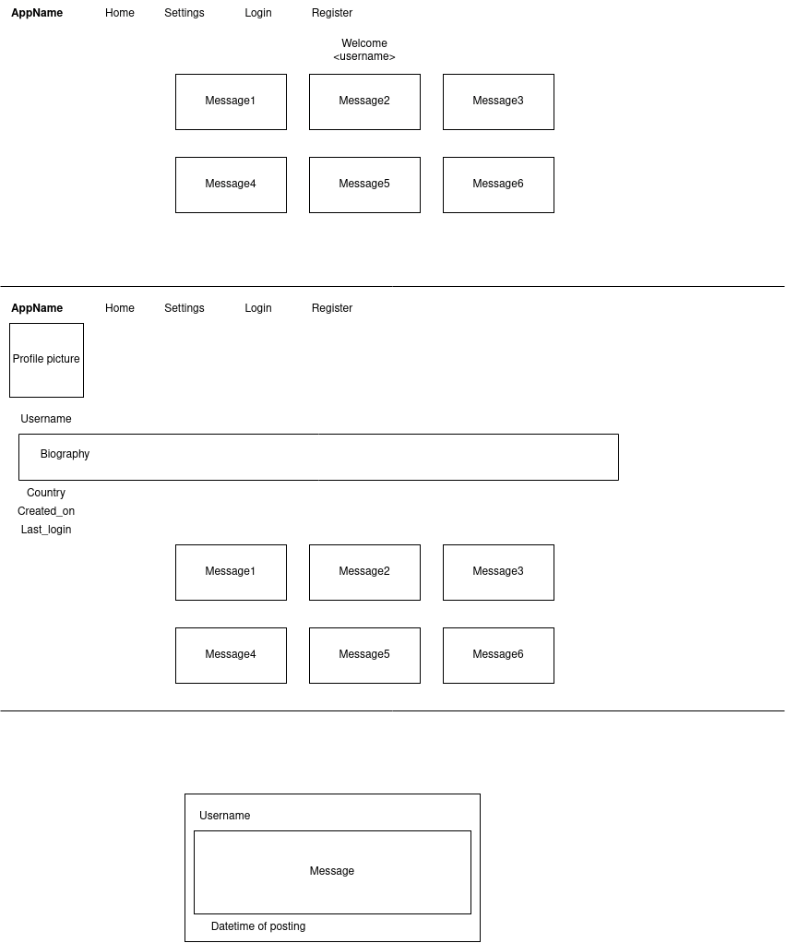

Tests
Test case | Use case(s) | Input | Expected output
TC01 | Sending messages | Message: “This is a test message”  User: “testuser1” | The message is added to the database and displayed on the main page and accountpage of testuser1, with a datetime of posting
TC02 | Sending messages | Message: “This is a test message”  User: null | System throws an error, no user is logged in.  An errormessage is displayed.
TC03 | Displaying messages | None. | On the homepage, all the messages are displayed, each with a username which links to the accountpage of said username, the content (text) and a datetime of the message
TC04 | Creating an account | None. | System throws error, missing username, email and password. An errormessage is displayed.
TC05 | Creating an account | Username: “testuser2”  email: “test@mail.com”  password: “testpassword123” | The account is made, and can be logged into with the proper credentials. The userid is saved locally as a cookie.

Testmatrix
 | Sending messages | Displaying messages | Creating an account
TC01 | X
TC02 | X
TC03 |  | X
TC04 |  |  | X
TC05 |  |  | X

Class Diagram
