**Resources Table**

**Purpose**: Stores all learning materials and project entries available in the platform.

**Reviews Table**

**Purpose**: Stores user feedback and ratings for resources.

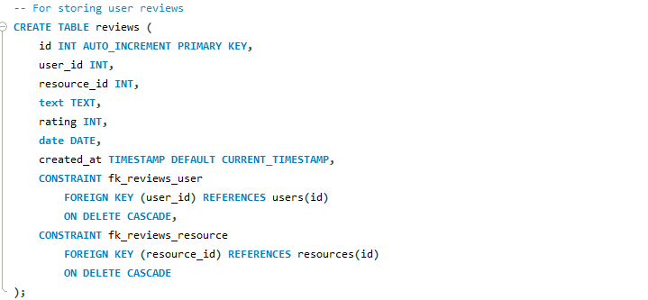

**Saved Resources Table**

**Purpose**: Tracks which resources users have bookmarked/saved for later.

**getSaved (saved resources controller)**

**Purpose:** Retrieves all resources a user has saved/bookmarked.

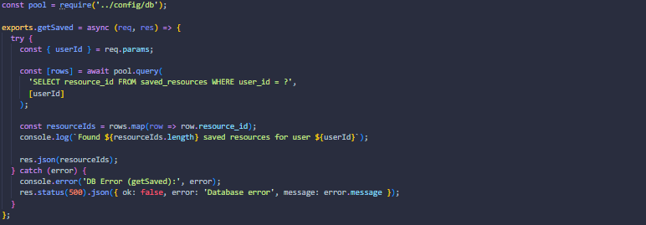

**toggleSaved (saved resources controller)**

**Purpose:** Toggles whether a resource is saved or unsaved for a user.

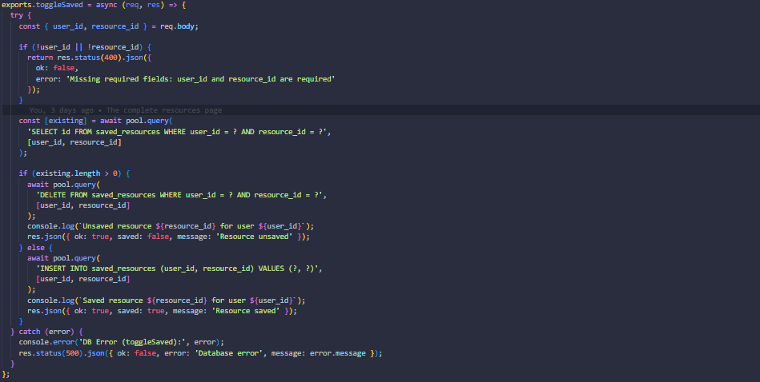

**getReviews (reviews controller)**

**Purpose:** Fetches all reviews for a given resource.

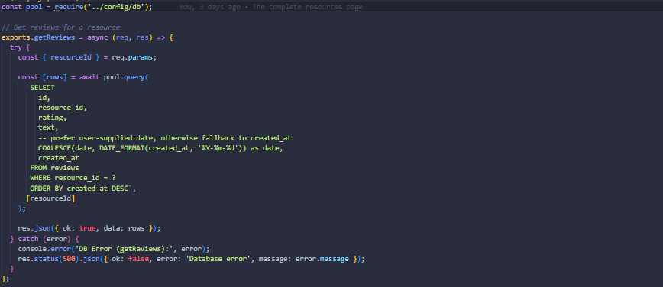

**addReview (reviews controller)**

**Purpose:** Adds a new review for a resource.

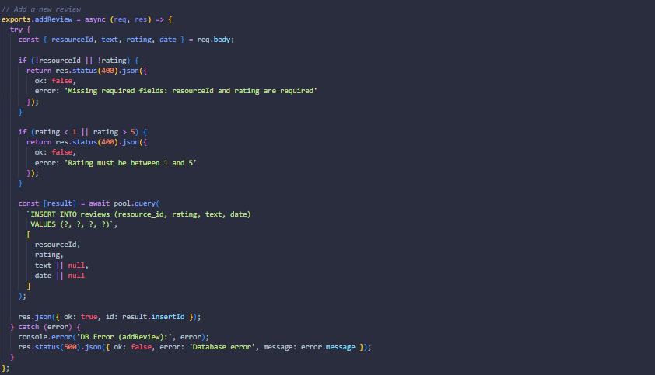

**getResources (resources controller)**

**Purpose:** Retrieves resources with optional filters.

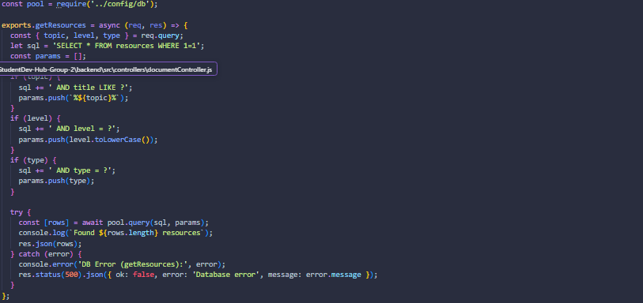

**createResource (resources controller)**

**Purpose:** Creates a new resource entry.

**File Upload (Multer config + upload handler)**

**Purpose:** Handles document uploads (PDF, Word, PowerPoint).

**Database Pool (db.js)**

**Purpose:** Centralized MySQL connection pool.

