

Final Project Assignment
Topic: Pharmacy Claims

ALY 6030: Data Warehousing & SQL
Professor: Kayalvizhi Chandrasekaran

Name: Jayesh Patil

Due: November 13th, 2025

Introduction
This project focuses on building a small pharmacy claims data warehouse that our company can use to test reports before the full production feed arrives from the Pharmacy Benefit Manager (PBM). I started by normalizing the raw spreadsheet into clean fact and dimension tables that follow 3NF, then loaded them into MySQL and defined appropriate primary and foreign keys. From there, I designed a star-schema ERD with a central prescription fact table linked to member and drug dimensions to support flexible analysis.
Finally, I wrote SQL queries that answer typical business questions, such as utilization by drug, cost by age group, and each member’s most recent prescription, so the test warehouse can directly support future reporting needs.
PART 1 - Normalization
When I first looked at the raw “Final Project Data Set” file, it was clear that it did not meet 3NF.
Each row mixed member information, drug details and up to three fills (fill_date1/2/3, copay1/2/3, insurancepaid1/2/3). Those repeating groups meant the data was not even in 1NF, and member and drug attributes were being repeated across many rows.

Step 1 - Bringing the data to 1NF
The first step was to flatten the repeating fill groups so that each row contained the details for one prescription fill.
I unpivoted the fill_date1/2/3, copay1/2/3, and insurancepaid1/2/3 columns into a single set of columns:
- fill_date
- copay
- insurance_paid
For every non-null fill, I created a separate row while keeping the same member and drug information.
The result is the fact_drug table where each record represents one prescription fill event instead of a mixture of up to three events in the same row.

Step 2 - Progress to 2NF
Next, I looked for partial dependencies. In the flattened table, member attributes
(member_first_name, member_last_name, member_birth_date, member_age, member_gender) depend only on member_id, and drug attributes (such as drug_name and the drug codes) depend only on drug_ndc.
To remove these partial dependencies, I separated the data into dimension tables:
- dim_member - one row per member_id with all member demographics.
- dim_drug_ndc - one row per drug_ndc with the drug name and associated codes.

Step 3 - Achieve 3NF
Finally, I removed transitive dependencies inside the drug data.
The descriptions for drug form and brand/generic status depend on their codes, not directly on drug_ndc.
To satisfy 3NF, I split these out into separate lookup dimensions:
- dim_drug_form_code - drug_form_code and its description.
- dim_brand_generic - drug_brand_generic_code and its description.
The dim_drug_ndc table now keeps only drug_ndc, drug_name, drug_form_code, and drug_brand_generic_code, and those codes link to the two smaller dimensions.
At this point all non-key attributes in every table depend only on the whole key and not on other non-key attributes, so the design satisfies 3NF and forms a clean star schema.

Resulting tables
- Fact table
fact_drug – one row per prescription fill (member_id, drug_ndc, fill_date, copay, insurance_paid).
- Dimension tables
  - dim_member - member details by member_id.
  - dim_drug_ndc - drug details by drug_ndc.
  - dim_drug_form_code - descriptions for each drug_form_code.
  - dim_brand_generic - descriptions for each drug_brand_generic_code.

Fact types
Answer the following questions:
- For each fact variable in your fact table, what type of fact is it? Additive, semi-additive, or non-additive?
In the fact_drug table, the fact variables are:
- copay
- insurance_paid
Both of these are additive facts.
They can be summed across any combination of dimensions, by member, by drug, by pharmacy, or by time period, to get meaningful totals of patient copay amounts or total insurance payments.
2. In your fact table, describe the grain in one sentence. What does each fact row represent?

Fact table grain
The grain of the fact_drug table is:
“One row represents a single prescription fill event for a specific member and drug on a specific fill date, including the copay and the insurance amount paid for that transaction.”

Part 2 - Primary and Foreign Key Setup in MySQL

Primary keys by table
After loading the 3NF tables into the Pharmacy_Claims database, I defined a primary key for each table.
- fact_drug - fact_drug_id
- Type: Surrogate key (INT NOT NULL AUTO_INCREMENT).
- Reason: the natural business key would have to combine several columns (member, drug, fill date, etc.) and would be long. A single surrogate key makes joins simpler, keeps the fact table stable even if business rules change, and still guarantees uniqueness for every prescription fill event.
- dim_member - member_id
- Type: Natural key.
- Reason: each member already has a unique ID in the source file and that value is meaningful to the business, so re-using it as the PK avoids creating an extra column.
- dim_drug_ndc - drug_ndc
- Type: Natural key.
- Reason: the National Drug Code is the standard business identifier for a drug, is unique by design, and is the value people expect to see in reports and downstream systems.
- dim_drug_form_code - drug_form_code (defined as VARCHAR(100) NOT NULL)
- Type: Natural key.
- Reason: each drug form code uniquely identifies one form/route (e.g., tablet, solution). It is a short, stable code, so it serves well as the PK once it is stored as VARCHAR.

- dim_brand_generic - drug_brand_generic_code (defined as VARCHAR(100) NOT NULL)
- Type: Natural key.
- Reason: this code clearly distinguishes brand versus generic status. It is also unique and descriptive enough to act as the primary key in this small lookup table.

Foreign keys and referenced tables
I then set up foreign keys so that the fact table and drug dimension always line up with their lookup tables.
- In fact_drug
  - member_id → dim_member(member_id)
    - Constraint name: fk_fact_drug_member
    - This links each prescription fill to the correct member demographic record.
  - drug_ndc → dim_drug_ndc(drug_ndc)
    - Constraint name: fk_fact_drug_drug
    - This ties each fill event to the drug’s NDC and, through that, to the drug form and brand/generic status.
- In dim_drug_ndc
  - drug_form_code → dim_drug_form_code(drug_form_code)
    - Constraint name: fk_dim_drug_ndc_form
    - This connects each drug to its dosage form description.
  - drug_brand_generic_code → dim_brand_generic(drug_brand_generic_code)
    - Constraint name: fk_dim_drug_ndc_brand
    - This connects each drug to the correct brand/generic classification.
These relationships complete the star schema: fact_drug sits in the center, joined to dim_member and dim_drug_ndc, and dim_drug_ndc in turn joins to the two small lookup dimensions.

Delete and update rules (CASCADE, SET NULL, RESTRICT)
For each foreign key I chose:
- ON DELETE RESTRICT
- ON UPDATE CASCADE
Why RESTRICT on DELETE?
In this warehouse, the fact table holds the detailed history of prescriptions. I do not want a member or drug record to be deleted while there are still fact rows that depend on it, because that would create orphaned facts that no longer have meaningful context. Using RESTRICT forces anyone who tries to delete a member or drug to resolve the dependent facts first, which preserves referential integrity and protects reporting accuracy.
Why CASCADE on UPDATE?
Occasionally there may be a data-quality fix where an identifier is corrected (for example, if a drug NDC or member ID was entered incorrectly and needs to be updated). In that case I want the change to flow automatically to all related rows. Setting ON UPDATE CASCADE ensures that if a key value is corrected in a dimension table, all linked rows in fact_drug or dim_drug_ndc are updated at the same time, without manual updates to every child row.
Overall, this combination, natural keys on the dimensions, a surrogate key on the fact table, and RESTRICT/CASCADE rules on the foreign keys, gives me a clean star schema that is both easy to query and robust against accidental data loss or inconsistencies.
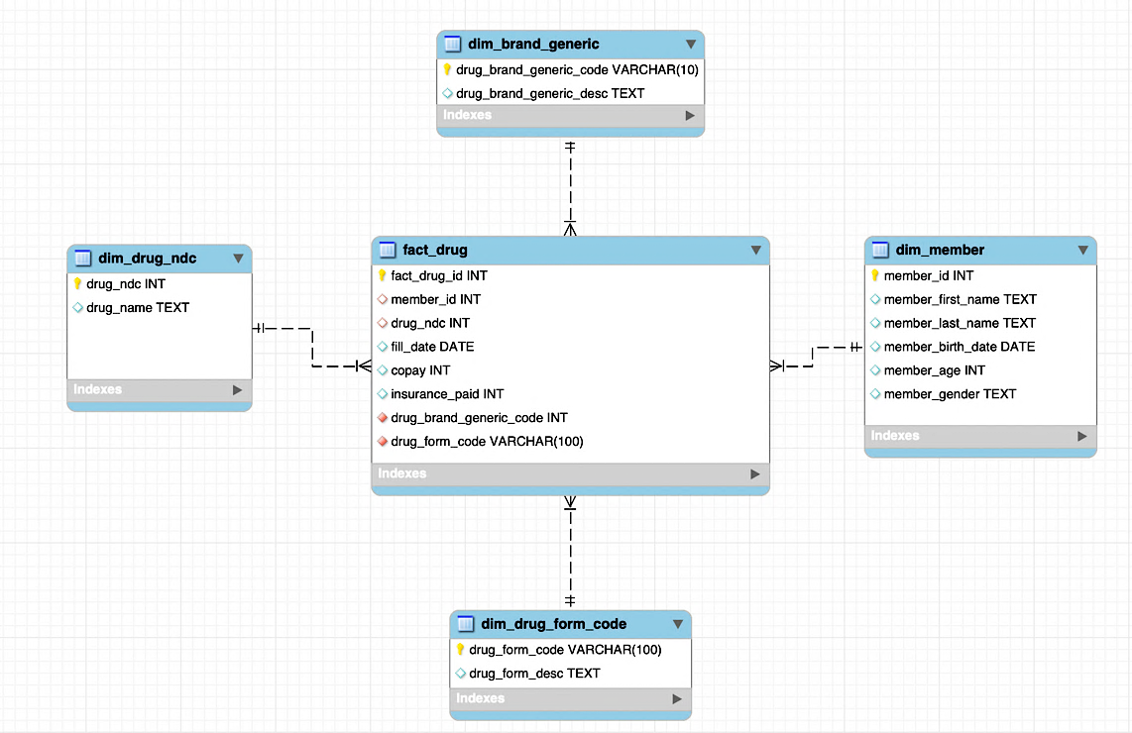
Part 3 - Entity Relationship Diagram (ERD)

To document the final star schema, I created an ERD in MySQL Workbench based on the Pharmacy_Claims database.
Each dimension has its own key (member ID, drug NDC, form code, brand/generic code), and those keys are used as foreign keys in the fact table so every fill is tied to the right member and drug details.
Overall, the diagram gives a clear picture of how the data is organized and how users can join the tables for reporting.Overall, the ERD gives a clean visual of the star schema and makes it straightforward for the PBM and business users to see how the data is structured for reporting.

Part 4 - Analytics and Reporting

1. Prescriptions grouped by drug name
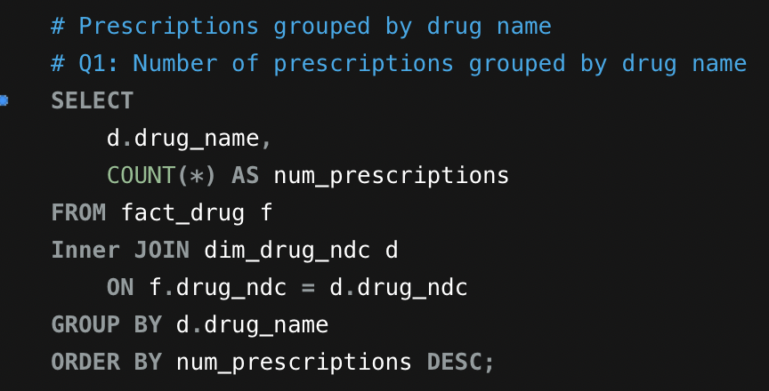
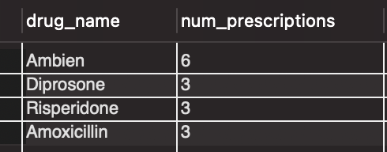
To understand which medications are used most often, I joined the fact table to the drug dimension and grouped fills by drug_name. The query counts each row in fact_drug, so every prescription fill is included once.

There were 6 prescriptions filled for Ambien, making it the most frequently dispensed drug in this sample.

2. Utilization by age segment (65+ vs < 65)
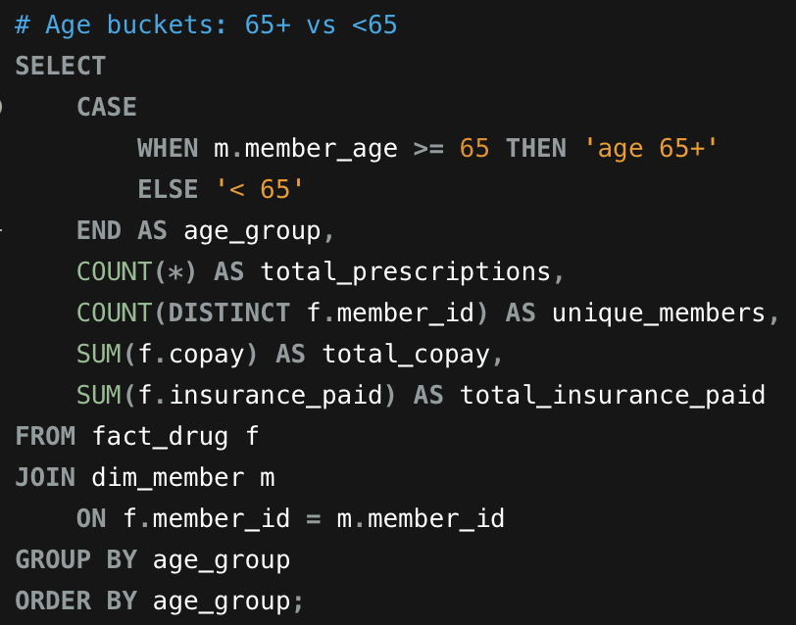
Next, I used a CASE expression on member_age to create two age buckets: < 65 and age 65+.
For each group, the query returns total prescriptions, the number of distinct members, and the sums of copay and insurance paid.

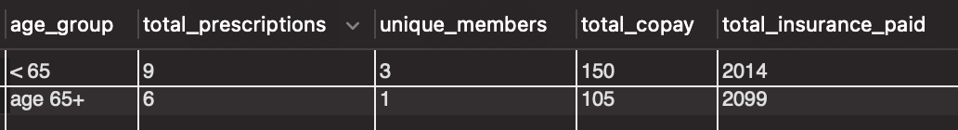

There is 1 unique member over 65 years of age, and that member filled 6 prescriptions.
This view makes it easy for business users to see that, even with only one senior member, the 65+ segment drives a large share of insurance spending in this small sample.

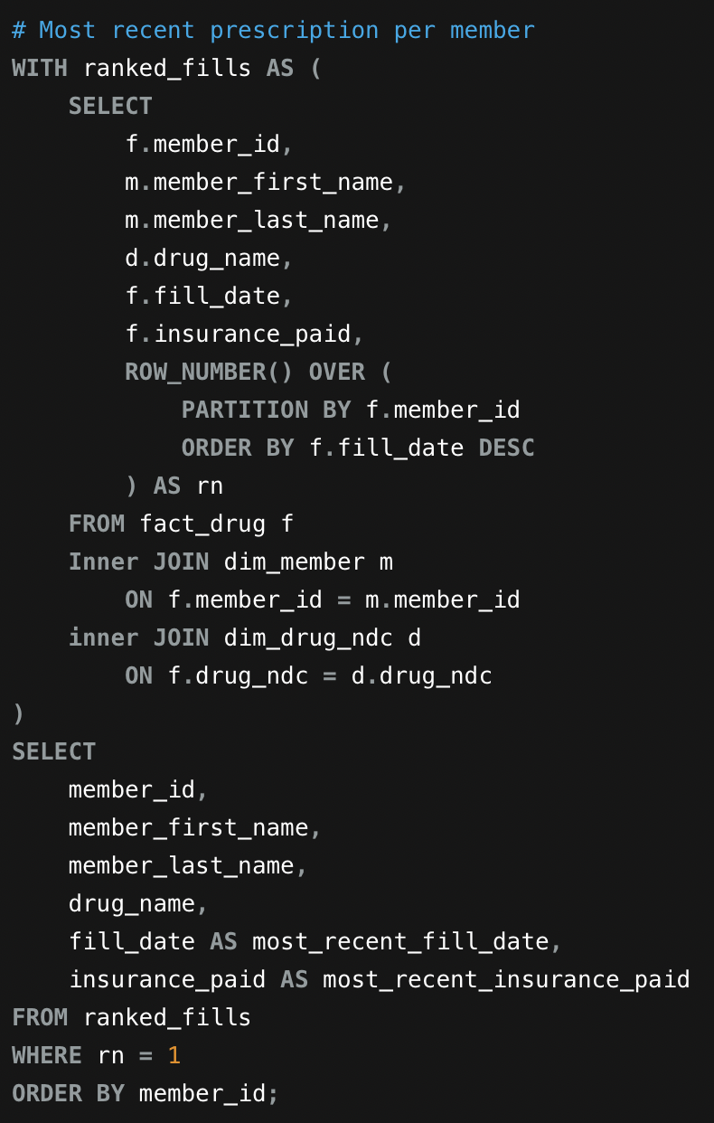
3. Most recent prescription and insurance paid (window function)
I used a window function to identify the most recent fill for each member.
Inside a CTE (ranked_fills), I applied ROW_NUMBER() OVER (PARTITION BY member_id ORDER BY fill_date DESC) and then selected only the rows where rn = 1.
The final output includes member_id, member name, drug_name, the most recent fill_date, and the corresponding insurance_paid amount.

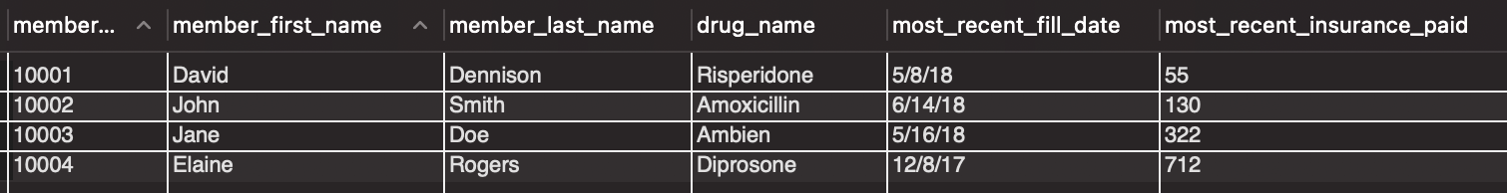

Q. For member ID 10003, what was the drug name listed on their most recent fill date?
For member ID 10003, the drug on the most recent fill date is Ambien.
Q. How much did their insurance pay for that medication?
Their insurance paid $322 for that prescription.

Conclusion
Overall, this project turned a messy sample spreadsheet into a well-structured pharmacy claims data warehouse. By normalizing the data into 3NF, defining clear fact and dimension tables, and enforcing primary and foreign keys in MySQL, I now have a schema that is both reliable and easy to maintain. The ERD ties everything together visually and gives business and technical users a shared understanding of how prescriptions, members, and drug attributes relate to each other.
On top of that foundation, the analytic queries show that the model is immediately useful for real questions, such as which drugs are used most, how utilization differs by age group, and what each member’s latest claim looks like.
As the PBM begins sending larger production files, this same design can be scaled up with confidence, knowing the data structure, relationships, and reporting patterns have already been tested on this smaller but realistic dataset.
References
- Kimball Group. (2003, January 1). Fact tables and dimension tables. https://www.kimballgroup.com/2003/01/fact-tables-and-dimension-tables/
- Project Guru. (2025, August 23). A guided introduction to MySQL Workbench and EER modeling. https://www.projectguru.in/a-guided-introduction-to-mysql-workbench-and-eer-modeling/
- Holistics. (n.d.). Kimball’s dimensional data modeling. In The analytics setup guidebook. https://www.holistics.io/books/setup-analytics/kimball-s-dimensional-data-modeling/
- Datacamp. (2024, November 18). What is third normal form (3NF)? https://www.datacamp.com/tutorial/third-normal-form

