README:
- Use proper parentheses in your formulas or equations. For instance, 1/a-1 is NOT acceptable, as it could denote either (1/a)-1 or 1/(a-1).
- Submit your homework to Webcourse.

Q1 (10 pts)
Consider a datagram network using 8-bit host addresses. Suppose a router uses longest prefix matching and has the following forwarding table:
Prefix Match | Interface
1 | 0
10 | 1
111 | 2
otherwise | 3
For each of the four interfaces, give the associated range of destination host addresses and the number of addresses in the range.

Q2 (30 pts)
Consider the following network. With the indicated link costs, using Dijkstra’s shortest-path algorithm, and showing your work using a table similar to Table 5.1 in textbook (or the one in Chapter 4-2 slide 22), do the following:
a. Compute the shortest path from x to all network nodes.
b. Compute the shortest path from v to all network nodes.
c. Compute the shortest path from u to all network nodes.
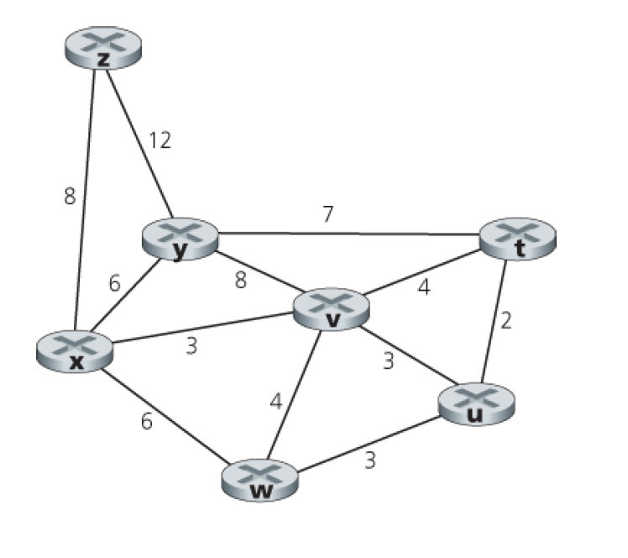

Q3 (20 pts)
Consider the network shown below, and assume that each node initially knows the costs to each of its neighbors. Consider the distance-vector algorithm and show the distance table entries at node z for the first 4 iteration.
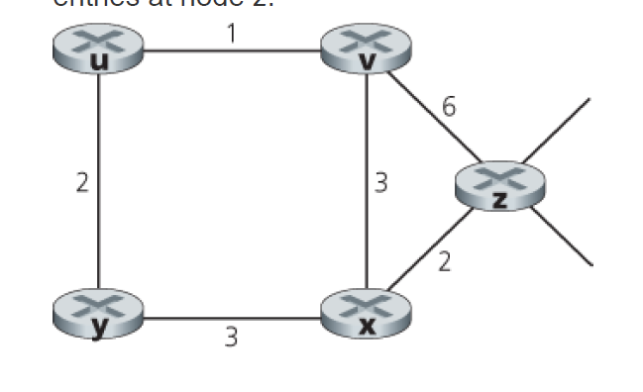

Q4 (10 pts)
Consider a subnet with prefix 128.119.40.128/26. Give an example of one IP address (of form xxx.xxx.xxx.xxx) that can be assigned to this network. Suppose an ISP owns the block of addresses of the form 128.119.40.64/26. Suppose it wants to create four subnets from this block, with each block having the same number of IP addresses. What are the prefixes (of form a.b.c.d/x) for the four subnets?

Q5 (15 pts)
Consider the network setup in the Figure below. Suppose that the ISP instead assigns the router the address 24.34.112.235 and that the network address of the home network is 192.168.1/24.
a. Assign addresses to all interfaces in the home network.
b. Suppose each host has two ongoing TCP connections, all to port 80 at host 128.119.40.86. Provide the six corresponding entries in the NAT translation table.
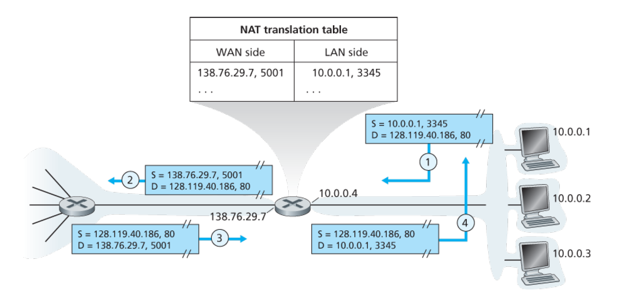

Q6 (10 pts)
Consider the count-to-infinity problem in the distance vector routing. Will the count-to-infinity problem occur if we decrease the cost of a link? Why? How about if we connect two nodes which do not have a link?

Q7 (5 pts)
Consider the network shown below. Suppose AS3 and AS2 are running OSPF for their intra-AS routing protocol. Suppose AS1 and AS4 are running RIP for their intra-AS routing protocol. Suppose eBGP and iBGP are used for the inter-AS routing protocol. Initially suppose there is no physical link between AS2 and AS4.
a. Router 3c learns about prefix x from which routing protocol: OSPF, RIP, eBGP, or iBGP?
b. Router 3a learns about x from which routing protocol?
c. Router 1c learns about x from which routing protocol?
d. Router 1d learns about x from which routing protocol?
