README:
- Submit your homework to Webcourse.

- You are encouraged to consult AI tools for assistance. However, please ensure that you fully understand the material and concepts.
- Run TCP Programs (10 pts): Execute the Server_TCP and Client_TCP codes using the command prompt (Windows) or the terminal (macOS), and provide a screenshot showing the programs in operation:
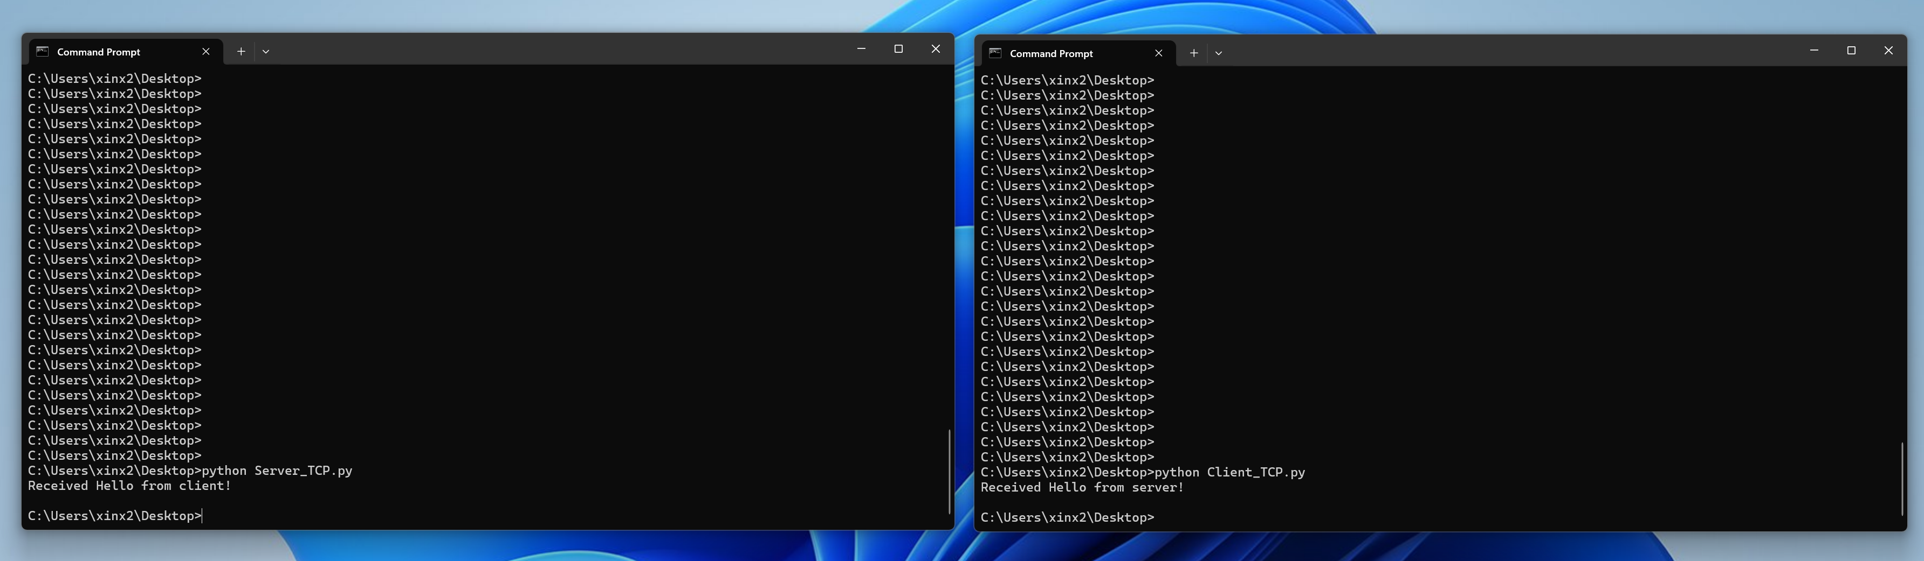
Fig.1 screenshot example

- Developing UDP Programs (10 pts): Using the Server_TCP and Client_TCP codes as references, write a Server_UDP code and a Client_UDP code. Provide a screenshot showing the programs in operation.
- Modify the TCP Server (5 pts): Modify the Server_TCP code to make the server as always-on. Also provide a screenshot showing the programs in operation.
- Answer the following questions:
- (5 pts): The Server_TCP code does not explicitly declare the client’s IP address and port in its initial setup. How does it send messages to the Client_TCP?
- (5 pts): Is it possible to avoid using serverSocket.bind or clientSocket.bind in these programs? Explain your answer.
- (15 pts): Summarize the differences between TCP and UDP programs. For example: Which functions or keywords are unique to TCP? Which functions or keywords are specific to UDP?

