README:
- Use proper parentheses in your formulas or equations. For instance, 1/a-1 is NOT acceptable, as it could denote either (1/a)-1 or 1/(a-1).
- Submit your homework to Webcourse.

Q1 (10 pts)
In Chapter 5-2, slide 12 (corresponding to Section 6.3 in textbook), we provided an outline of the derivation of the efficiency of slotted ALOHA. In this problem we’ll complete the derivation.
a. Recall that when there are N active nodes, the efficiency of slotted ALOHA is Np(1−p)^{N−1}. Find the value of p that maximizes this expression.
b. Using the value of p found in (a), find the efficiency of slotted ALOHA by letting N approach infinity. Hint: (1−1/N)^{N} approaches 1/e as N approaches infinity.

Q2 (15 pts)
Suppose four active nodes—nodes A, B, C and D—are competing for access to a channel using slotted ALOHA. Assume each node has an infinite number of packets to send. Each node attempts to transmit in each slot with probability p. The first slot is numbered slot 1, the second slot is numbered slot 2, and so on.
a. What is the probability that node A succeeds for the first time in slot 5?
b. What is the probability that some node (either A, B, C or D) succeeds in slot 4?
c. What is the probability that the first success occurs in slot 3?
d. What is the efficiency of this four-node system?

Q3 (15 pts)
Consider the Figure below. MAC addresses and IP addresses have been provided on the right side. Suppose Host A sends a datagram to Host F.
a. Give the source and destination MAC addresses in the frame encapsulating this IP datagram as the frame is transmitted (i) from A to the left router, (ii) from the left router to the right router, (iii) from the right router to F. Also give the source and destination IP addresses in the IP datagram encapsulated within the frame at each of these points in time.
b. Suppose now that the leftmost router in the Figure is replaced by a switch. Hosts A, B, C, and D and the right router are all star-connected into this switch. Give the source and destination MAC addresses in the frame encapsulating this IP datagram as the frame is transmitted (i) from A to the switch, (ii) from the switch to the right router, (iii) from the right router to F. Also give the source and destination IP addresses in the IP datagram encapsulated within the frame at each of these points in time.

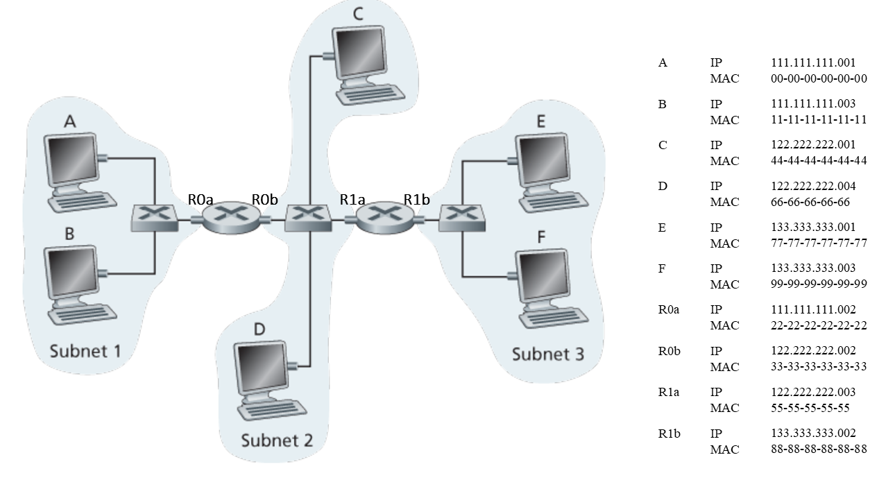

Q4 (10 pts)
Short Answer:
- Suppose two nodes start to transmit at the same time a packet of length L over a broadcast channel of rate R. Denote the propagation delay between the two nodes as d_{prop}. Will there be a collision if d_{prop}<L/R? Why or why not?
- In CSMA/CD, after the fifth collision, what is the probability that a node chooses K=4? The result K=4 corresponds to a delay of how many seconds on a 10 Mbps Ethernet?
- How big is the MAC address space? The IPv4 address space? The IPv6 address space?

