README:
- Use proper parentheses in your formulas or equations. For instance, 1/a-1 is NOT acceptable, as it could denote either (1/a)-1 or 1/(a-1).
- Submit your homework to Webcourse.

Q1 (10 pts)
Suppose within your Web browser you click on a link to obtain a Web page. The IP address for the associated URL is not cached in your local host, so a DNS lookup is necessary to obtain the IP address. Suppose that n DNS servers are visited before your host receives the IP address from DNS; the successive visits incur an RTT of RTT1, …, RTTn. Further suppose that the Web page associated with the link contains exactly one object, consisting of a small amount of HTML text. Let RTT0 denote the RTT between the local host and the server containing the object. Assuming zero transmission time of the object, how much time elapses from when the client clicks on the link until the client receives the object?

Q2 (15 pts)
Referring to the above Problem Q1, suppose the HTML file references eight very small objects on the same server. Neglecting transmission times, how much time elapses with
a. Non-persistent HTTP with no parallel TCP connections?
b. Non-persistent HTTP with the browser configured for 5 parallel connections?
c. Persistent HTTP?

Q3 (20 pts)
Consider the Figure blow, for which there is an institutional network connected to the Internet. Suppose that the average object size is 850,000 bits and that the average request rate from the institution’s browsers to the origin servers is 16 requests per second. Also suppose that the amount of time it takes from when the router on the Internet side of the access link forwards an HTTP request until it receives the response is three seconds on average. Model the total average response time as the sum of the average access delay (that is, the delay from Internet router to institution router) and the average Internet delay. For the average access delay, use Δ/(1−Δβ), where Δ is the average time required to send an object over the access link and β is the arrival rate of objects to the access link.
a. Find the total average response time.
b. Now suppose a cache is installed in the institutional LAN. Suppose the miss rate is 0.4. Find the total response time.
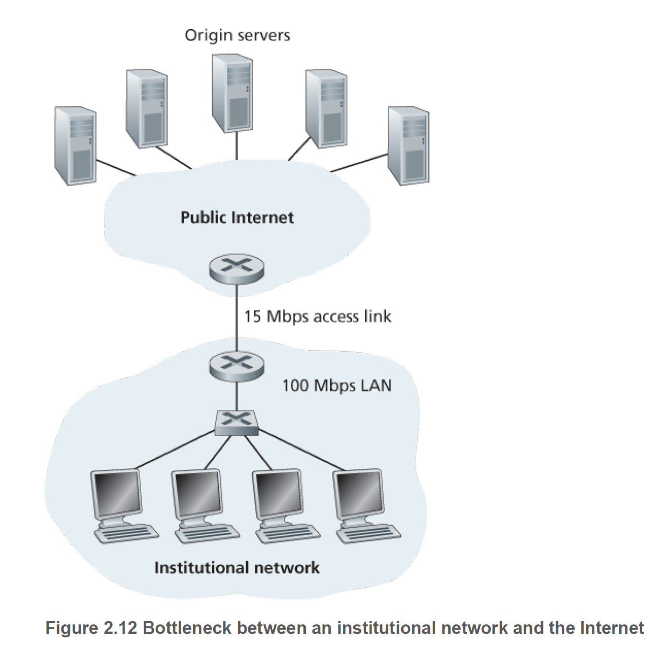

Q4 (20 pts)
Consider distributing a file of F=15Gbits to N peers. The server has an upload rate of us=30Mbps, and each peer has a download rate of di=2Mbps and an upload rate of u. For N=10 and 1,000 and u =300Kbps and 2 Mbps, prepare a chart giving the minimum distribution time for each of the combinations of N and u for both client-server distribution and P2P distribution.

Q5 (15 pts)
Consider distributing a file of F bits to N peers using a client-server architecture. Assume a fluid model where the server can simultaneously transmit to multiple peers, transmitting to each peer at different rates, as long as the combined rate does not exceed us.
a. Suppose that us/N≤dmin. Specify a distribution scheme that has a distribution time of NF/us.
b. Suppose that us/N≥dmin. Specify a distribution scheme that has a distribution time of F/dmin.
c. Conclude that the minimum distribution time is in general given by max{NF/us, F/dmin}.

Q6 (15 pts)
Print out the header of an e-mail message you have recently received (similar to the example below). How many ‘Received:’ header lines are there? Why are there multiple ‘Received’ header lines?
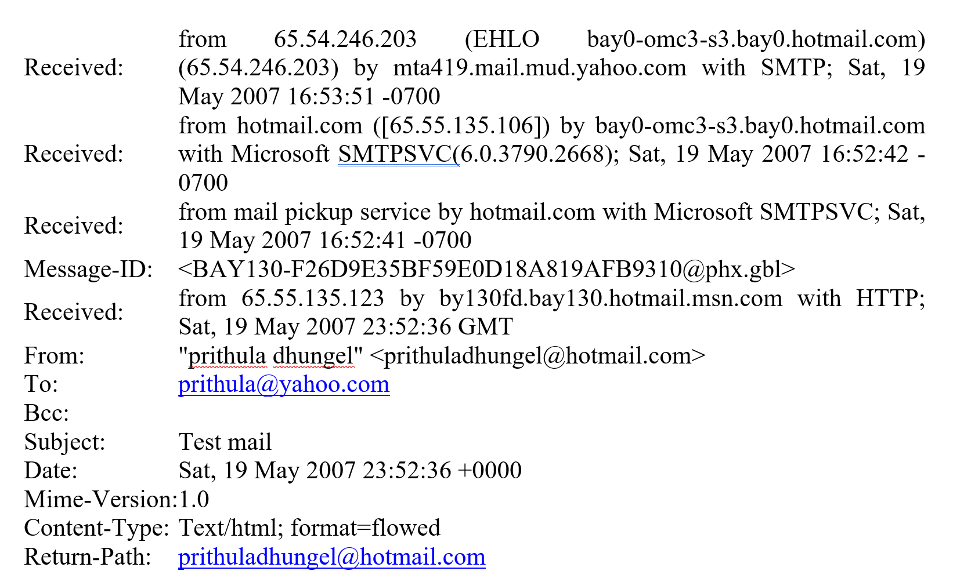
example

Q7 (5 pts)
CDNs typically adopt one of two different server placement philosophies. Name and briefly describe them.

