**Project Report 2**

***Yousef Alaa Awad***

[yousef.awad@ucf.edu](mailto:yousef@ucf.edu)

*EEL3801: Computer Organization*

Due Date: 7th July, 2025

Submission Date: 6th July, 2025

**1.0 Pre-Optimization**

**1.1 Number of Instructions Executed**

*Sentence 1*: DeMara finds logic beautiful.

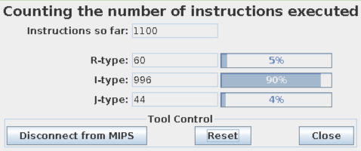

*Sentence 2:* He coolly sketches hypothetical CPU architectures for fun.

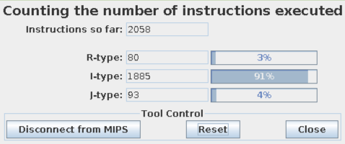

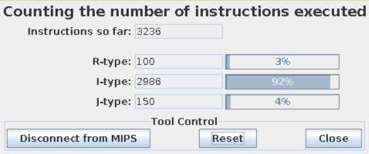*Sentence 3:* While others see tangled wires, he perceives the elegant, hierarchical structure of a computer.

*Sentence 4:* His focus is so absolute that he once debugged a complex pipeline hazard in a simulated processor during a loud concert.

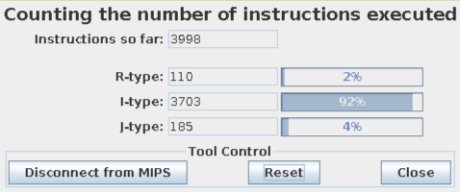

*Sentence 5:* This calm and quiet mastery over the fundamental principles of how a machine truly functions gives him an unshakable confidence that many people around him often mistake for simple aloofness.

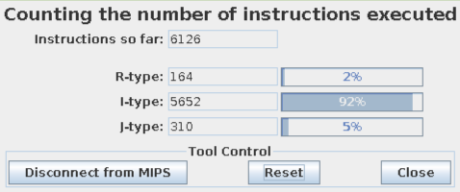

*Subsequent Graph:*

**1.2 CPI Calculations**

*Sentence 1***: $\frac{6∗60+4∗996+3∗44}{1100}=4.069$**

Sentence 2**: $\frac{6∗80+4∗1885+3∗93}{2058}=4.033$**

Sentence 3**: $\frac{6∗100+4∗2986+3∗150}{3236}=4.015$**

Sentence 4**: $\frac{6∗110+4∗3703+3∗185}{3998}=4.009$**

Sentence 5**: $\frac{6∗164+4∗5752+3∗310}{6126}=4.003$**

*Subsequent Graph:*

**1.3 Energy Consumption**

*Sentence 1*: DeMara finds logic beautiful.

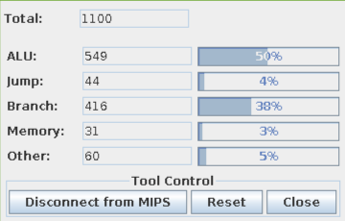

*Sentence 2:* He coolly sketches hypothetical CPU architectures for fun.

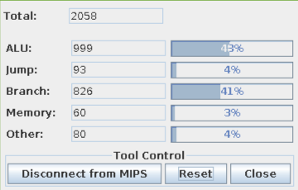

*Sentence 3:* While others see tangled wires, he perceives the elegant, hierarchical structure of a computer.

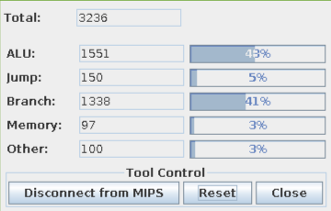

*Sentence 4:* His focus is so absolute that he once debugged a complex pipeline hazard in a simulated processor during a loud concert.

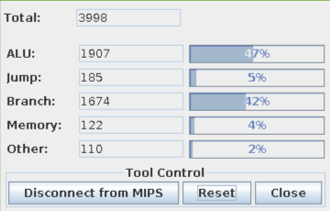

*Sentence 5:* This calm and quiet mastery over the fundamental principles of how a machine truly functions gives him an unshakable confidence that many people around him often mistake for simple aloofness.

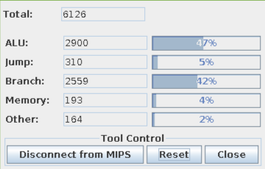

*Subsequent Calculations:*

Sentence 1: $6∗549+3∗44+7∗416+110∗31+9∗60=10,288fJ$

Sentence 2: $6∗999+3∗93+7∗826+110∗60+9∗80=19,375fJ$

Sentence 3: $6∗1551+3∗150+7∗1338+110∗97+9∗100=30,692fJ$

Sentence 4: $6∗1907+3∗185+7∗1674+110∗122+9∗110=38,125fJ$

Sentence 5: $6∗2900+3∗310+7∗2559+110∗193+9∗164=58,949fJ$

*Subsequent Graph:*

**1.4 MIPS/mW**

*Required Calculations:*

$$exectutiontime=clocks∗clockcycle$$

$$MIPS=\frac{\frac{instructions}{1,000,000}}{executiontime}$$

$$mW=\frac{1000∗energy∗{10}^{−15}}{executiontime}$$

*Will not be done in parts, only end result will be shown, assume units are MIPS/mW:*

*Sentence 1:* 106,920.68

*Sentence 2:* 106,219.35

*Sentence 3:* 105,434.64

*Sentence 4:* 104,865.57

*Sentence 5:* 103,920.33

**2.0 Post-Optimization**

**2.1 Energy Consumption**

*Sentence 1*: DeMara finds logic beautiful.

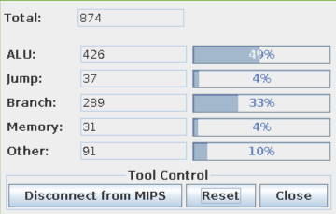

*Sentence 2:* He coolly sketches hypothetical CPU architectures for fun.

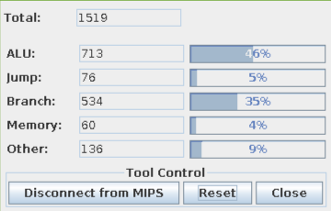

*Sentence 3:* While others see tangled wires, he perceives the elegant, hierarchical structure of a computer.

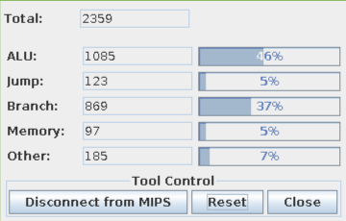

*Sentence 4:* His focus is so absolute that he once debugged a complex pipeline hazard in a simulated processor during a loud concert.

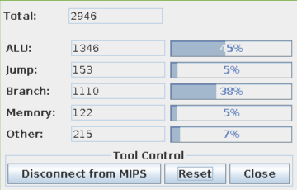

*Sentence 5:* This calm and quiet mastery over the fundamental principles of how a machine truly functions gives him an unshakable confidence that many people around him often mistake for simple aloofness.

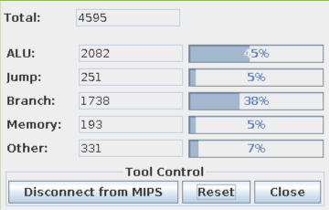

*Subsequent Calculations:*

Sentence 1: $6∗426+3∗37+7∗289+110∗31+9∗91=8,919fJ$

Sentence 2: $6∗713+3∗76+7∗534+110∗60+9∗136=16,068fJ$

Sentence 3: $6∗1085+3∗123+7∗869+110∗97+9∗185=25,297fJ$

Sentence 4: $6∗1346+3∗153+7∗1110+110∗122+9∗215=31,660fJ$

Sentence 5: $6∗2082+3∗251+7∗1738+110∗193+9∗331=49,620fJ$

*Subsequent Graph:*

**2.2 MIPS/mW**

*Required Calculations:*

$$exectutiontime=clocks∗clockcycle$$

$$MIPS=\frac{\frac{instructions}{1,000,000}}{executiontime}$$

$$mW=\frac{1000∗energy∗{10}^{−15}}{executiontime}$$

*Will not be done in parts, only end result will be shown, assume units are MIPS/mW:*

*Sentence 1:* 123,332.21

*Sentence 2:* 128,080.66

*Sentence 3:* 127,920.31

*Sentence 4:* 126,279.22

*Sentence 5:* 123,458.28

**3.0 Data Cache Stuff**

**3.1 Pictures**

**Part B:**

Default

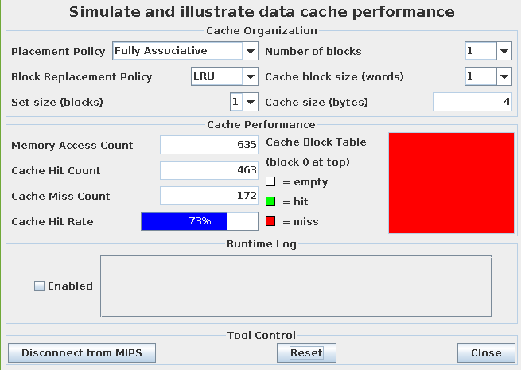*Middle*

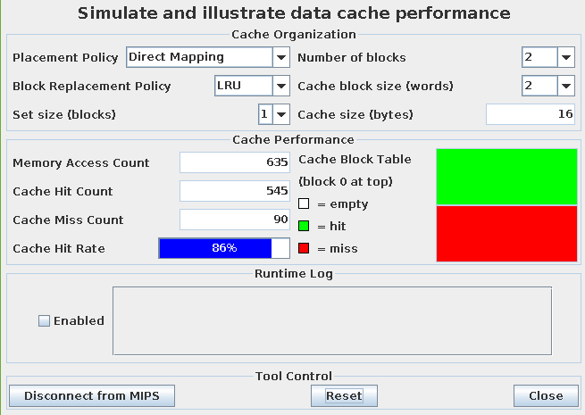

*Best*

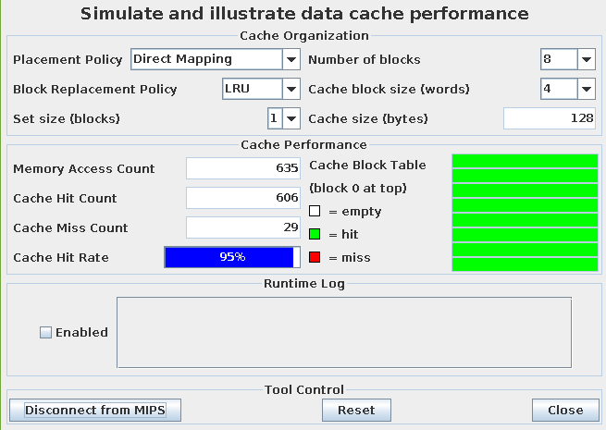

**Part A:**

Default



*Middle*

*Best*



**3.2 Explanation**

The reason for the massive jump between cache hit rate is due to the fact that the increase in memory blocks and word size per block means that it can access more data at once, specifically with the characters in the inputted string.

**8.0 References**

**8.1 MARS Simulator**

The MARS Simulator for MIPS processors, available at:

<http://courses.missouristate.edu/kenvollmar/mars/>

and MARS syscall functions listed at:

<http://courses.missouristate.edu/kenvollmar/mars/help/syscallhelp.html>