“Slight increase.pt”

Test set: Average loss: 0.6849, Average CER: 0.210506 Average WER: 0.5919

COMET INFO: ---------------------------------------------------------------------------------------

COMET INFO: Comet.ml Experiment Summary

COMET INFO: ---------------------------------------------------------------------------------------

COMET INFO: Data:

COMET INFO: display_summary_level : 1

COMET INFO: url : https://www.comet.com/jacksontrexler/speechrecognition/00895e8dedf24450a6a98f9ef43e3248

COMET INFO: Metrics [count] (min, max):

COMET INFO: cer [4] : (0.21050595527340396, 0.3852399063884261)

COMET INFO: test_loss [4] : (0.6848941263351734, 1.3048863392749817)

COMET INFO: train_learning_rate [11416] : (2.0000000000314905e-09, 0.0004999874862849134)

COMET INFO: train_loss [12558] : (0.6457685828208923, 8.311984062194824)

COMET INFO: wer [4] : (0.5919121499996718, 0.9126051631232692)

COMET INFO: Others:

COMET INFO: Name : speechrecognition-linux

COMET INFO: Parameters:

COMET INFO: batch_size : 10

COMET INFO: dropout : 0.1

COMET INFO: epochs : 4

COMET INFO: learning_rate : 0.0005

COMET INFO: n_class : 29

COMET INFO: n_cnn_layers : 3

COMET INFO: n_feats : 128

COMET INFO: n_rnn_layers : 5

COMET INFO: rnn_dim : 512

COMET INFO: stride : 2

COMET INFO: Uploads:

COMET INFO: environment details : 1

COMET INFO: filename : 1

COMET INFO: git metadata : 1

COMET INFO: installed packages : 1

COMET INFO: model graph : 1

COMET INFO: os packages : 1

COMET INFO: source_code : 1 (19.15 KB)

COMET INFO:

COMET INFO: ---------------------------------------------------------------------------------------

<https://mega.nz/file/DngCSbyT#DkDfZ3LKAhgw0UlFQ1iJA0H5NJOOatGpfCniLWTP51s>

Now attempting same as before but with 10 epochs…

Comet didn’t connect successfully

Test set: Average loss: 0.5110, Average CER: 0.151027 Average WER: 0.4533

^^ only info present

This noticeably improved the results so I’m going to bump it up to a further 20 epochs and let it sit for while.

Test set: Average loss: 0.4336, Average CER: 0.120936 Average WER: 0.3706

COMET INFO: ---------------------------------------------------------------------------------------

COMET INFO: Comet.ml Experiment Summary

COMET INFO: ---------------------------------------------------------------------------------------

COMET INFO: Data:

COMET INFO: display_summary_level : 1

COMET INFO: url : https://www.comet.com/jacksontrexler/speechrecognition/efef54181581486c84c4f328672cf666

COMET INFO: Metrics [count] (min, max):

COMET INFO: cer [20] : (0.12093585759152008, 0.49047702235270557)

COMET INFO: test_loss [20] : (0.43360108432878997, 1.6735288355186702)

COMET INFO: train_learning_rate [57080] : (2.0000000000314905e-09, 0.0005)

COMET INFO: train_loss [62785] : (0.2598991096019745, 8.315417289733887)

COMET INFO: wer [20] : (0.37056839161211885, 0.9803877763691115)

COMET INFO: Others:

COMET INFO: Name : speechrecognition-linux

COMET INFO: Parameters:

COMET INFO: batch_size : 10

COMET INFO: dropout : 0.1

COMET INFO: epochs : 20

COMET INFO: learning_rate : 0.0005

COMET INFO: n_class : 29

COMET INFO: n_cnn_layers : 3

COMET INFO: n_feats : 128

COMET INFO: n_rnn_layers : 5

COMET INFO: rnn_dim : 512

COMET INFO: stride : 2

COMET INFO: Uploads:

COMET INFO: environment details : 1

COMET INFO: filename : 1

COMET INFO: git metadata : 1

COMET INFO: installed packages : 1

COMET INFO: model graph : 1

COMET INFO: os packages : 1

COMET INFO: source_code : 1 (19.15 KB)

COMET INFO:

COMET INFO: ---------------------------------------------------------------------------------------

Log your models to better track, deploy, share, and reproduce your work using: 'comet_ml.integration.pytorch.log_model'.

Learn more at: https://comet.com/docs/v2/pytorch_log_model

---------------------------------------------------------------------------------------------------

Hide this message by setting environment variable "COMET_DISABLE_ANNOUNCEMENT=1"

COMET INFO: Uploading metrics, params, and assets to Comet before program termination (may take several seconds)

COMET INFO: The Python SDK has 3600 seconds to finish uploading collected data

COMET INFO: Uploading 1 metrics, params and output messages

daisy@daisy-G7-7588:~/Desktop/seniordesign$

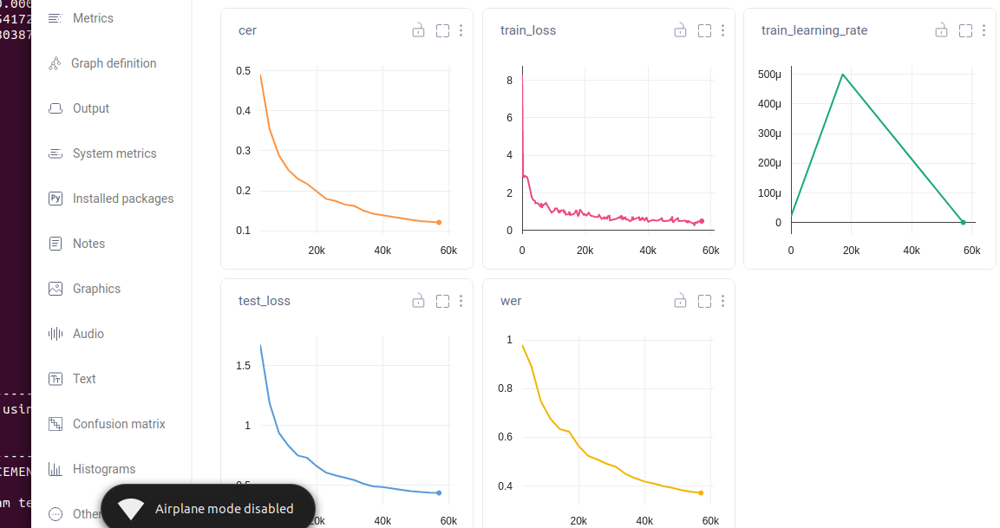

40 epochs, expected to take 1 day…: Expecting to overfit?

Test set: Average loss: 0.4067, Average CER: 0.106610 Average WER: 0.3294

COMET INFO: ---------------------------------------------------------------------------------------

COMET INFO: Comet.ml Experiment Summary

COMET INFO: ---------------------------------------------------------------------------------------

COMET INFO: Data:

COMET INFO: display_summary_level : 1

COMET INFO: url : https://www.comet.com/jacksontrexler/speechrecognition/16a193af04a7412facd999e784ef7dc5

COMET INFO: Metrics [count] (min, max):

COMET INFO: cer [40] : (0.10661013665961534, 0.5567570083009078)

COMET INFO: test_loss [40] : (0.4065920565533275, 1.9107474730214997)

COMET INFO: train_learning_rate [114160] : (2.0000000000314905e-09, 0.0005)

COMET INFO: train_loss [125569] : (0.16659994423389435, 8.315851211547852)

COMET INFO: wer [40] : (0.32937425378371565, 1.0198494072755213)

COMET INFO: Others:

COMET INFO: Name : speechrecognition-linux

COMET INFO: Parameters:

COMET INFO: batch_size : 10

COMET INFO: dropout : 0.1

COMET INFO: epochs : 40

COMET INFO: learning_rate : 0.0005

COMET INFO: n_class : 29

COMET INFO: n_cnn_layers : 3

COMET INFO: n_feats : 128

COMET INFO: n_rnn_layers : 5

COMET INFO: rnn_dim : 512

COMET INFO: stride : 2

COMET INFO: Uploads:

COMET INFO: environment details : 1

COMET INFO: filename : 1

COMET INFO: git metadata : 1

COMET INFO: installed packages : 1

COMET INFO: model graph : 1

COMET INFO: os packages : 1

COMET INFO: source_code : 1 (19.15 KB)

COMET INFO:

COMET INFO: ---------------------------------------------------------------------------------------

Log your models to better track, deploy, share, and reproduce your work using: 'comet_ml.integration.pytorch.log_model'.

Learn more at: https://comet.com/docs/v2/pytorch_log_model

---------------------------------------------------------------------------------------------------

Hide this message by setting environment variable "COMET_DISABLE_ANNOUNCEMENT=1"

COMET INFO: Using '/home/daisy/Desktop/seniordesign/.cometml-runs' path as offline directory. Pass 'offline_directory' parameter into constructor or set the 'COMET_OFFLINE_DIRECTORY' environment variable to manually choose where to store offline experiment archives.

COMET WARNING: Could not send live data to Comet during experiment runtime. An offline experiment will be available for upload:

comet upload --force-reupload /home/daisy/Desktop/seniordesign/.cometml-runs/16a193af04a7412facd999e784ef7dc5-aDoGwV.zip

Getting depreciating returns,

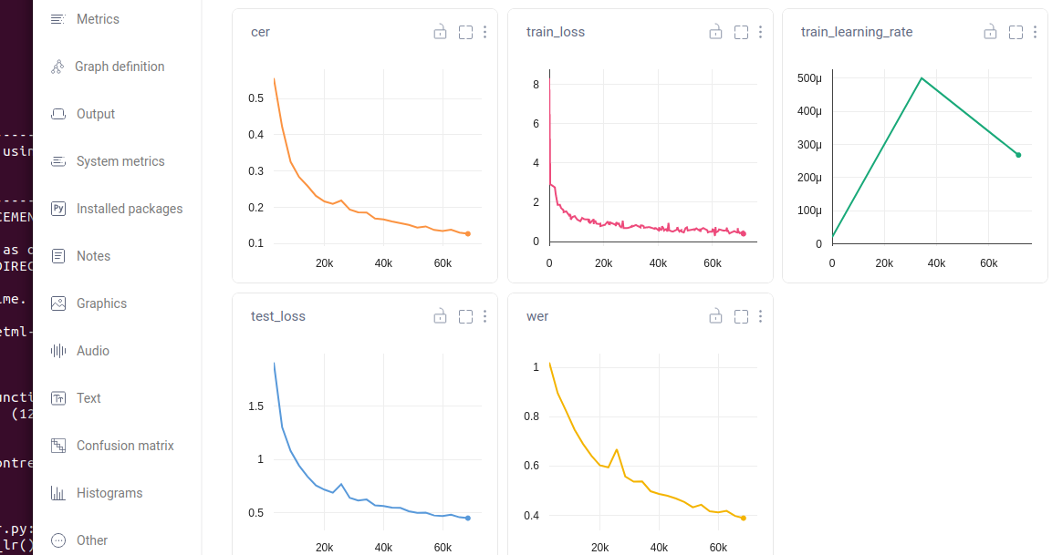

Now with 4 cnn layers

Test set: Average loss: 0.3945, Average CER: 0.100880 Average WER: 0.3130

COMET INFO: ---------------------------------------------------------------------------------------

COMET INFO: Comet.ml Experiment Summary

COMET INFO: ---------------------------------------------------------------------------------------

COMET INFO: Data:

COMET INFO: display_summary_level : 1

COMET INFO: url : https://www.comet.com/jacksontrexler/speechrecognition/87c997e522cf47ffbecafb9d6e6afe60

COMET INFO: Metrics [count] (min, max):

COMET INFO: cer [40] : (0.10088027130636458, 0.5386748614546594)

COMET INFO: test_loss [40] : (0.39287011308296954, 1.8868795173768782)

COMET INFO: train_learning_rate [114160] : (2.0000000000314905e-09, 0.0005)

COMET INFO: train_loss [125569] : (0.16085170209407806, 6.991458892822266)

COMET INFO: wer [40] : (0.3129794736012921, 1.1265362933988012)

COMET INFO: Others:

COMET INFO: Name : speechrecognition-linux

COMET INFO: Parameters:

COMET INFO: batch_size : 10

COMET INFO: dropout : 0.1

COMET INFO: epochs : 40

COMET INFO: learning_rate : 0.0005

COMET INFO: n_class : 29

COMET INFO: n_cnn_layers : 4

COMET INFO: n_feats : 128

COMET INFO: n_rnn_layers : 5

COMET INFO: rnn_dim : 512

COMET INFO: stride : 2

COMET INFO: Uploads:

COMET INFO: environment details : 1

COMET INFO: filename : 1

COMET INFO: git metadata : 1

COMET INFO: installed packages : 1

COMET INFO: model graph : 1

COMET INFO: os packages : 1

COMET INFO: source_code : 1 (19.15 KB)

COMET INFO:

COMET INFO: ---------------------------------------------------------------------------------------

Log your models to better track, deploy, share, and reproduce your work using: 'comet_ml.integration.pytorch.log_model'.

Learn more at: https://comet.com/docs/v2/pytorch_log_model

---------------------------------------------------------------------------------------------------

Hide this message by setting environment variable "COMET_DISABLE_ANNOUNCEMENT=1"

COMET INFO: Uploading metrics, params, and assets to Comet before program termination (may take several seconds)

COMET INFO: The Python SDK has 3600 seconds to finish uploading collected data

COMET INFO: Uploading 1 metrics, params and output messages

Variable._execution_engine.run_backward( # Calls into the C++ engine to run the backward pass

torch.cuda.OutOfMemoryError: CUDA out of memory. Tried to allocate 274.00 MiB (GPU 0; 5.94 GiB total capacity; 4.29 GiB already allocated; 233.56 MiB free; 4.96 GiB reserved in total by PyTorch) If reserved memory is >> allocated memory try setting max_split_size_mb to avoid fragmentation. See documentation for Memory Management and PYTORCH_CUDA_ALLOC_CONF

COMET INFO: ---------------------------------------------------------------------------------------

COMET INFO: Comet.ml Experiment Summary

COMET INFO: ---------------------------------------------------------------------------------------

COMET INFO: Data:

COMET INFO: display_summary_level : 1

COMET INFO: url : https://www.comet.com/jacksontrexler/speechrecognition/3c6bfbf4f23445bda1ee67f5401e6f7b

COMET INFO: Metrics [count] (min, max):

COMET INFO: cer [3] : (0.2838919154072568, 0.38730395604159906)

COMET INFO: test_loss [3] : (0.9569058422328662, 1.2980248548952087)

COMET INFO: train_learning_rate [57705] : (2e-05, 0.0004999951961607563)

COMET INFO: train_loss [63477] : (0.5599499940872192, 7.531454563140869)

COMET INFO: wer [3] : (0.6740895344153337, 0.8502444759113948)

COMET INFO: Others:

COMET INFO: Name : speechrecognition-linux

COMET INFO: Parameters:

COMET INFO: batch_size : 10

COMET INFO: dropout : 0.1

COMET INFO: epochs : 5

COMET INFO: learning_rate : 0.0005

COMET INFO: n_class : 29

COMET INFO: n_cnn_layers : 3

COMET INFO: n_feats : 128

COMET INFO: n_rnn_layers : 5

COMET INFO: rnn_dim : 512

COMET INFO: stride : 2

COMET INFO: Uploads:

COMET INFO: environment details : 1

COMET INFO: filename : 1

COMET INFO: git metadata : 1

COMET INFO: installed packages : 1

COMET INFO: model graph : 1

COMET INFO: os packages : 1

COMET INFO: source_code : 1 (19.15 KB)

COMET INFO:

COMET INFO: ---------------------------------------------------------------------------------------

Log your models to better track, deploy, share, and reproduce your work using: 'comet_ml.integration.pytorch.log_model'.

Learn more at: https://comet.com/docs/v2/pytorch_log_model

---------------------------------------------------------------------------------------------------

Hide this message by setting environment variable "COMET_DISABLE_ANNOUNCEMENT=1"

COMET INFO: Using '/home/daisy/Desktop/seniordesign/.cometml-runs' path as offline directory. Pass 'offline_directory' parameter into constructor or set the 'COMET_OFFLINE_DIRECTORY' environment variable to manually choose where to store offline experiment archives.

COMET WARNING: Could not send live data to Comet during experiment runtime. An offline experiment will be available for upload:

comet upload --force-reupload /home/daisy/Desktop/seniordesign/.cometml-runs/3c6bfbf4f23445bda1ee67f5401e6f7b-VIcZeb.zip

**Now reducing batch size**

evaluating...

Test set: Average loss: 0.8114, Average CER: 0.237806 Average WER: 0.5887

COMET INFO: ---------------------------------------------------------------------------------------

COMET INFO: Comet.ml Experiment Summary

COMET INFO: ---------------------------------------------------------------------------------------

COMET INFO: Data:

COMET INFO: display_summary_level : 1

COMET INFO: url : https://www.comet.com/jacksontrexler/speechrecognition/2b91cec8ec4143dbbb92ced0800f9ba2

COMET INFO: Metrics [count] (min, max):

COMET INFO: cer [5] : (0.23780605478018285, 0.3868330433149819)

COMET INFO: test_loss [5] : (0.8114185224732625, 1.2954913275721285)

COMET INFO: train_learning_rate [92930] : (2.0000000000314905e-09, 0.0005)

COMET INFO: train_loss [102223] : (0.4789222776889801, 7.644865989685059)

COMET INFO: wer [5] : (0.588749595972115, 0.8486113784270221)

COMET INFO: Others:

COMET INFO: Name : speechrecognition-linux

COMET INFO: Parameters:

COMET INFO: batch_size : 8

COMET INFO: dropout : 0.1

COMET INFO: epochs : 5

COMET INFO: learning_rate : 0.0005

COMET INFO: n_class : 29

COMET INFO: n_cnn_layers : 3

COMET INFO: n_feats : 128

COMET INFO: n_rnn_layers : 5

COMET INFO: rnn_dim : 512

COMET INFO: stride : 2

COMET INFO: Uploads:

COMET INFO: environment details : 1

COMET INFO: filename : 1

COMET INFO: git metadata : 1

COMET INFO: installed packages : 1

COMET INFO: model graph : 1

COMET INFO: os packages : 1

COMET INFO: source_code : 1 (19.15 KB)

COMET INFO:

Still overfitting…

Now reducing layers, increasing dropout, introducing weight_decay

evaluating...

Test set: Average loss: 0.9204, Average CER: 0.266607 Average WER: 0.6383

COMET INFO: ---------------------------------------------------------------------------------------

COMET INFO: Comet.ml Experiment Summary

COMET INFO: ---------------------------------------------------------------------------------------

COMET INFO: Data:

COMET INFO: display_summary_level : 1

COMET INFO: url : https://www.comet.com/jacksontrexler/speechrecognition/8a014f6dcb5349fb8c55e6edf2fff885

COMET INFO: Metrics [count] (min, max):

COMET INFO: cer [5] : (0.26660734498899574, 0.40796071646502013)

COMET INFO: test_loss [5] : (0.9203724761534, 1.3987613411053375)

COMET INFO: train_learning_rate [92930] : (2.0000000000314905e-09, 0.0005)

COMET INFO: train_loss [102223] : (0.5736894011497498, 8.209046363830566)

COMET INFO: wer [5] : (0.6382583152428557, 0.8712417790711948)

COMET INFO: Others:

COMET INFO: Name : speechrecognition-linux

COMET INFO: Parameters:

COMET INFO: batch_size : 8

COMET INFO: dropout : 0.2

COMET INFO: epochs : 5

COMET INFO: learning_rate : 0.0005

COMET INFO: n_class : 29

COMET INFO: n_cnn_layers : 3

COMET INFO: n_feats : 128

COMET INFO: n_rnn_layers : 4

COMET INFO: rnn_dim : 512

COMET INFO: stride : 2

COMET INFO: Uploads:

COMET INFO: environment details : 1

COMET INFO: filename : 1

COMET INFO: git metadata : 1

COMET INFO: installed packages : 1

COMET INFO: model graph : 1

COMET INFO: os packages : 1

COMET INFO: source_code : 1 (19.17 KB)

COMET INFO:

Loss increase as expected, still overfit

Really ramping up dropout, reducing epochs even further

Test set: Average loss: 1.2673, Average CER: 0.353317 Average WER: 0.7914

COMET INFO: ---------------------------------------------------------------------------------------

COMET INFO: Comet.ml Experiment Summary

COMET INFO: ---------------------------------------------------------------------------------------

COMET INFO: Data:

COMET INFO: display_summary_level : 1

COMET INFO: url : https://www.comet.com/jacksontrexler/speechrecognition/7aac3bb60a074bd88bad466a6bd94373

COMET INFO: Metrics [count] (min, max):

COMET INFO: cer [3] : (0.35331710365042435, 0.4410694077050798)

COMET INFO: test_loss [3] : (1.2673039570774716, 1.5571118016605794)

COMET INFO: train_learning_rate [55758] : (2.0000000000314905e-09, 0.0004999923137538239)

COMET INFO: train_loss [61334] : (0.8820682764053345, 8.241850852966309)

COMET INFO: wer [3] : (0.7914297952282918, 0.8858860108939829)

COMET INFO: Others:

COMET INFO: Name : speechrecognition-linux

COMET INFO: Parameters:

COMET INFO: batch_size : 8

COMET INFO: dropout : 0.4

COMET INFO: epochs : 3

COMET INFO: learning_rate : 0.0005

COMET INFO: n_class : 29

COMET INFO: n_cnn_layers : 3

COMET INFO: n_feats : 128

COMET INFO: n_rnn_layers : 4

COMET INFO: rnn_dim : 512

COMET INFO: stride : 2

COMET INFO: Uploads:

COMET INFO: environment details : 1

COMET INFO: filename : 1

COMET INFO: git metadata : 1

COMET INFO: installed packages : 1

COMET INFO: model graph : 1

COMET INFO: os packages : 1

COMET INFO: source_code : 1 (19.17 KB)

COMET INFO:

COMET INFO: ---------------------------------------------------------------------------------------

Log your models to better track, deploy, share, and reproduce your work using: 'comet_ml.integration.pytorch.log_model'.

Learn more at: https://comet.com/docs/v2/pytorch_log_model

---------------------------------------------------------------------------------------------------

Hide this message by setting environment variable "COMET_DISABLE_ANNOUNCEMENT=1"

COMET INFO: Uploading metrics, params, and assets to Comet before program termination (may take several seconds)

COMET INFO: The Python SDK has 3600 seconds to finish uploading collected data

COMET INFO: Uploading 1 metrics, params and output messages

**Maxing dropout now as its still overfit, only running single epoch**

Test set: Average loss: 1.7778, Average CER: 0.477399 Average WER: 0.9588

COMET INFO: ---------------------------------------------------------------------------------------

COMET INFO: Comet.ml Experiment Summary

COMET INFO: ---------------------------------------------------------------------------------------

COMET INFO: Data:

COMET INFO: display_summary_level : 1

COMET INFO: url : https://www.comet.com/jacksontrexler/speechrecognition/b02fc51b44bc4712b5e539a895169ccc

COMET INFO: Metrics [count] (min, max):

COMET INFO: cer : 0.47739851638399694

COMET INFO: test_loss : 1.7778064385056491

COMET INFO: train_learning_rate [18586] : (2.0000000000314905e-09, 0.0004999923137538239)

COMET INFO: train_loss [20445] : (1.379181146621704, 8.259614944458008)

COMET INFO: wer : 0.9588463753895936

COMET INFO: Others:

COMET INFO: Name : speechrecognition-linux

COMET INFO: Parameters:

COMET INFO: batch_size : 8

COMET INFO: dropout : 0.5

COMET INFO: epochs : 1

COMET INFO: learning_rate : 0.0005

COMET INFO: n_class : 29

COMET INFO: n_cnn_layers : 3

COMET INFO: n_feats : 128

COMET INFO: n_rnn_layers : 4

COMET INFO: rnn_dim : 512

COMET INFO: stride : 2

COMET INFO: Uploads:

COMET INFO: environment details : 1

COMET INFO: filename : 1

COMET INFO: git metadata : 1

COMET INFO: installed packages : 1

COMET INFO: model graph : 1

COMET INFO: os packages : 1

COMET INFO: source_code : 1 (19.17 KB)

COMET INFO:

COMET INFO: ---------------------------------------------------------------------------------------

Log your models to better track, deploy, share, and reproduce your work using: 'comet_ml.integration.pytorch.log_model'.

Learn more at: https://comet.com/docs/v2/pytorch_log_model

---------------------------------------------------------------------------------------------------

Hide this message by setting environment variable "COMET_DISABLE_ANNOUNCEMENT=1"

COMET INFO: Uploading metrics, params, and assets to Comet before program termination (may take several seconds)

COMET INFO: The Python SDK has 3600 seconds to finish uploading collected data

daisy@daisy-G7-7588:~/Desktop/seniordesign$ python3 openme.py

/home/daisy/.local/lib/python3.10/site-packages/torchaudio/functional/functional.py:576: UserWarning: At least one mel filterbank has all zero values. The value for `n_mels` (128) may be set too high. Or, the value for `n_freqs` (201) may be set too low.

warnings.warn(

Num Model Parameters 18978589

evaluating...

[' gcro woo o o the a wo o i o a a woa o oa wo therol o e gii oi wo boo t o caa qo poe shinbo coa cro w worco']

Test set: Average loss: 0.0000, Average CER: 25.500000 Average WER: 37.0000