DFT investigation of green stabilizer reactions: curcumin in nitrocellulose-based propellants

Nathália M. P. Rosaa, Matheus Máximo-Canadasa, João Luís do Nascimento Mossri, a Rodrigo Leonard Barboza Rodrigues,b Jakler Nichele, a,c and Itamar Borges Jr., a,c, *

a Department of Chemical Engineering, Military Institute of Engineering, Praça General Tibúrcio 80, Rio de Janeiro, Brazil;

b Institute of Chemical, Biological, Radiological and Nuclear Defense, Avenida das Américas 28705, Rio de Janeiro, Brazil;

c Department of Defense Engineering, Military Institute of Engineering, Praça General Tibúrcio 80, Rio de Janeiro, Brazil

*Corresponding author: I. Borges Jr., Email: itamar@ime.eb.br

**Table of Contents**

**Table 1S.** DFT/B3LYP/6-311+g(d) geometry data related to the different reactions in the NCL solvent. The breaking bond and the forming bond are related to the respective transition state geometries as explained in Figure 1S, where are shown mechanisms R1 and R2 also. 2

**Table 2S**. Thermodynamic data for the reactions R1 and R2 at two different temperatures. The energy difference between the product and the reactant was computed in the NCL solvent. 3

**Figure 1S.** Angles in degrees and distances in angstroms of the transition state geometries. 4

Figure 2S. NBO Charges of Additional Atoms in Reactant 1 at the M06-2X/6-311G(d) level theory. 5

Figure 3S. NBO Charges of Additional Atoms in Transition State 1 at the M06-2X/6-311G(d) level theory 6

Figure 3S. NBO Charges of Additional Atoms in Product 1 7

Figure 5S. NBO Charges of Additional Atoms in Reactant 2 at the M06-2X/6-311G(d) level theory. 8

Figure 3S. NBO Charges of Additional Atoms in Transition State 2 at the M06-2X/6-311G(d) level theory. 9

Figure 3S. NBO Charges of Additional Atoms in Product 2 at the M06-2X/6-311G(d) level theory. 10

**~~Reaction R1 - Intrinsic reaction path calculation~~** 11

**~~Reaction R1 - 298.15 K - Reactant optimization to transition state~~** 13

**~~Reaction R1 - 298.15 K - Reactant optimization to transition state output - Z-Matrix~~** 14

**~~Reaction R1 - 298.15 K - Reactant optimization to minimum~~** 15

**~~Reaction R1 - 298.15 K - Reactant optimization to minimum output - Z-Matrix~~** 16

**~~Reaction R1 - 363.15 K - Optimization to transition state~~** 17

**~~Reaction R1 - 363.15 K - Optimization to transition state output - Z-Matrix~~** 18

**~~Reaction R1 - 363.15 K - Reactant optimization to minimum~~** 19

**~~Reaction R1 - 363.15 K - Reactant optimization to minimum output - Z-Matrix~~** 20

**~~Reaction R2 - Intrinsic reaction path calculation~~** 21

**~~Reaction R2 - 298.15 K - Optimization to transition state~~** 22

**~~Reaction R2 - 298.15 K - Optimization to transition state output - Z-Matrix~~** 23

**~~Reaction R2 - 298.15 K - Reactant optimization to minimum~~** 24

**~~Reaction R2 - 298.15 K - Reactant optimization to minimum output - Z-Matrix~~** 25

**~~Reaction R2 - 363.15 K - Optimization to transition state~~** 26

**~~Reaction R2 - 363.15 K - Optimization to transition state output - Z-Matrix~~** 27

**~~Reaction R2 - 363.15 K - Reactant optimization to minimum~~** 28

**~~Reaction R2 - 363.15 K - Reactant optimization to minimum output - Z-Matrix~~** 29

### **Table 1S.** DFT/B3LYP/6-311+g(d) geometry data related to the different reactions in the NCL solvent. The breaking bond and the forming bond are related to the respective transition state geometries as explained in Figure 1S, where are shown mechanisms R1 and R2 also.

|  |  |  |  |  |  |
| --- | --- | --- | --- | --- | --- |
| Nº | Reaction | Temperature (K) | Breaking bond  (Å) | Forming bond  (Å) | Angle  (degrees) |
| 1 | R1 | 298.15 | 1.93057 | 1.50026 | 94.230 |
| 2 | 363.15 | 1.92838 | 1.50079 | 93.982 |
| 3 | R2 | 298.15 | 1.29610 | 1.29762 | 175.718 |
| 4 | 363.15 | 1.29442 | 1.29423 | 175.733 |

### **Table 2S**. Thermodynamic data for the reactions R1 and R2 at two different temperatures. The energy difference between the product and the reactant was computed in the NCL solvent.

|  |  |  |  |  |  |
| --- | --- | --- | --- | --- | --- |
| **Reaction** | **Method** | **298.15K** | | **363.15K** | |
| **ΔGR** | **ΔHR** | **ΔGR** | **ΔHR** |
| **R1** | *B3LYP/6-311+G(d)* | 34.99 | 38.81 | 34.15 | 38.93 |
| *B3LYP/6-311G(d)* | 35.61 | 38.50 | 33.94 | 38.63 |
| *M06-2X/6-311+G(d)* | 32.93 | 36.31 | 32.25 | 36.45 |
| *M06-2X/6-311G(d)* | 35.07 | 35.60 | 34.73 | 35.60 |
| *wb97M-V/6-311+G(d)* | 33.85 | 35.88 | 34.27 | 36.21 |
| *wb97M-V/6-311G(d)* | 34.79 | 36.12 | 34.80 | 36.27 |
| **R2** | *B3LYP/6-311+G(d)* | 10.04 | 9.10 | 10.26 | 9.15 |
| *B3LYP/6-311G(d)* | 9.62 | 10.16 | 9.50 | 10.21 |
| *M06-2X/6-311+G(d)* | 10.50 | 9.66 | 10.59 | 9.70 |
| *M06-2X/6-311G(d)* | 10.57 | 10.14 | 10.67 | 10.19 |
| *wb97M-V/6-311+G(d)* | 12.03 | 8.86 | 9.40 | 10.86 |
| *wb97M-V/6-311G(d)* | 10.90 | 10.20 | 11.57 | 10.37 |

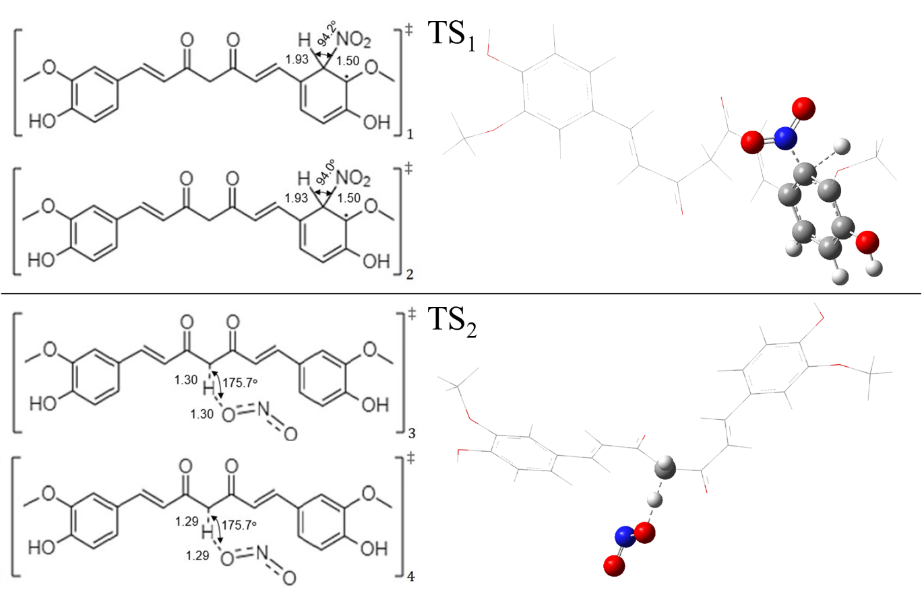

### **Figure 1S.** Angles in degrees and distances in angstroms of the transition state geometries. The index in the bottom right corner of each geometry corresponds to No column in Table 1S. The transition state geometries 1 and 2 present a bond between the ring carbon and the released hydrogen, referred here as the “breaking bond” from R1. The corresponding bonds between this ring carbon and the nitro group are called the “forming bond” from R1. The transition state geometries 3 and 4 present a bond between the center carbon and the attacked hydrogen, referred to as the “breaking bond” from R2. Its respective bonds between this hydrogen and the bonded oxygen are referred to as the “forming bond” from R2.

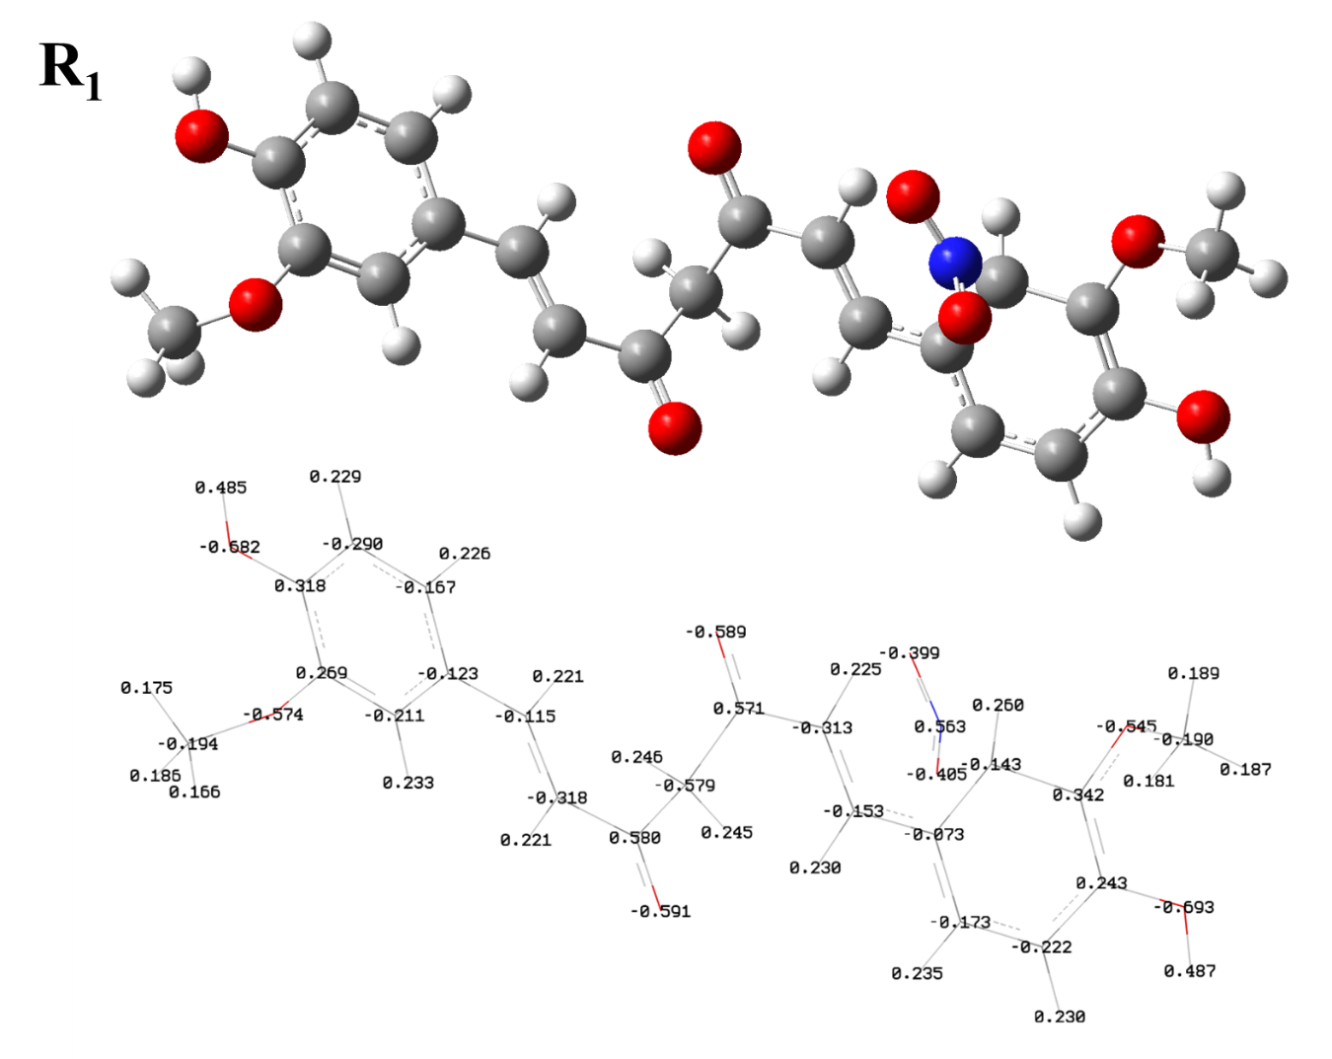

### Figure 2S. NBO Charges of Additional Atoms in Reactant 1 at the M06-2X/6-311G(d) level theory.

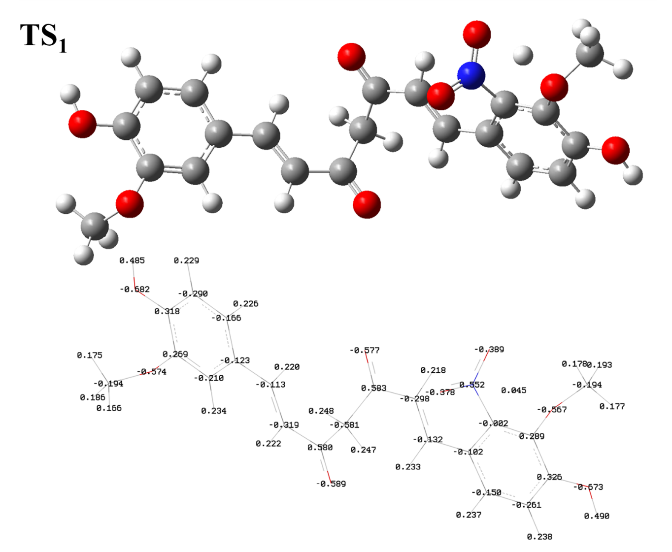

Figure 3S. NBO Charges of Additional Atoms in Transition State 1 at the M06-2X/6-311G(d) level theory.

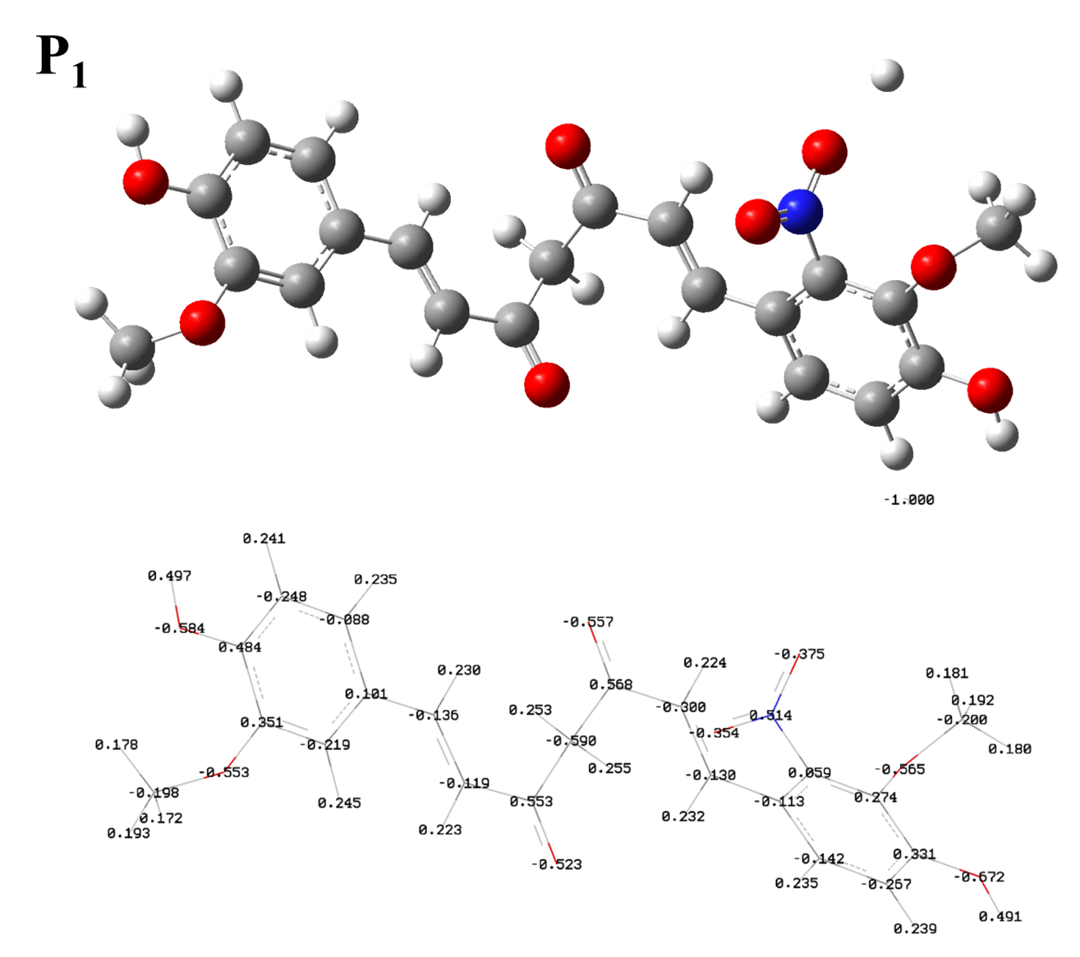

Figure 3S. NBO Charges of Additional Atoms in Product 1.

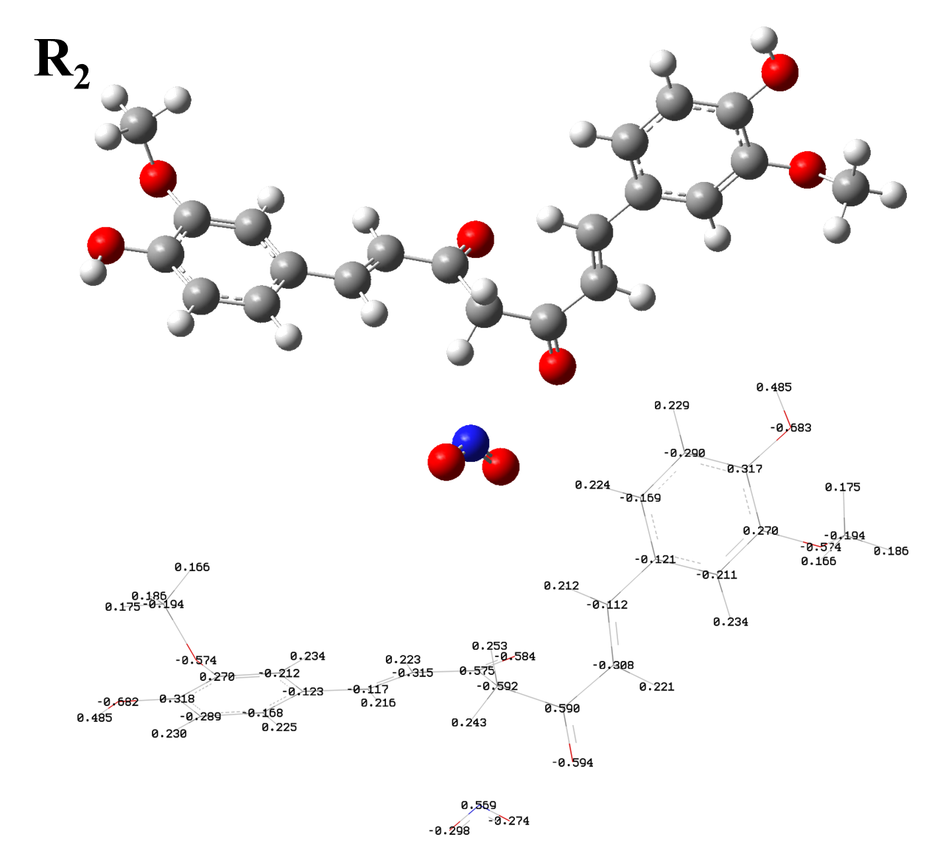

### Figure 5S. NBO Charges of Additional Atoms in Reactant 2 at the M06-2X/6-311G(d) level theory.

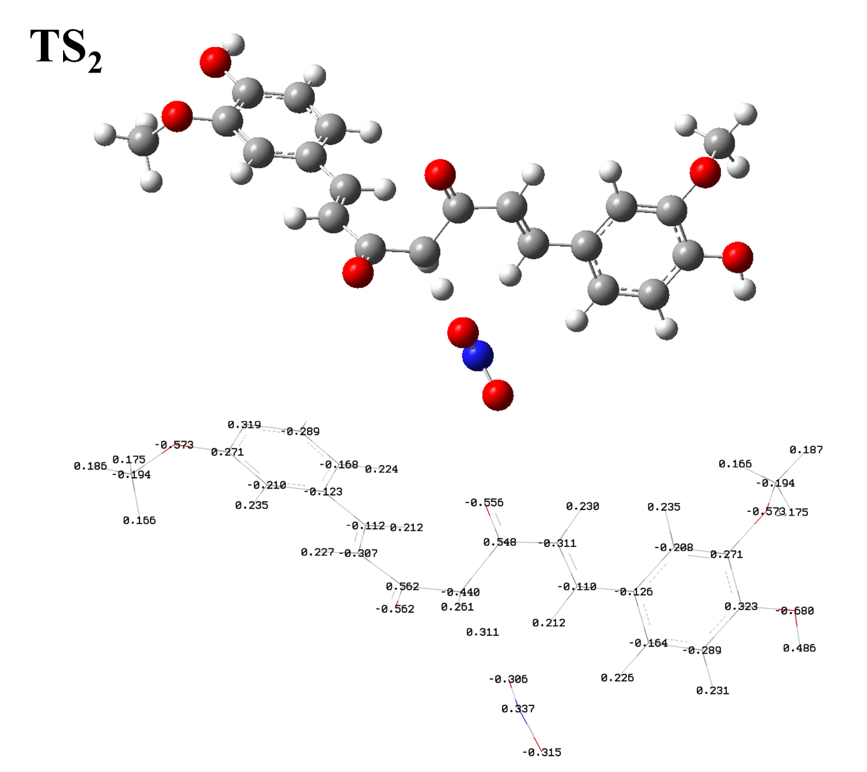

### Figure 3S. NBO Charges of Additional Atoms in Transition State 2 at the M06-2X/6-311G(d) level theory.

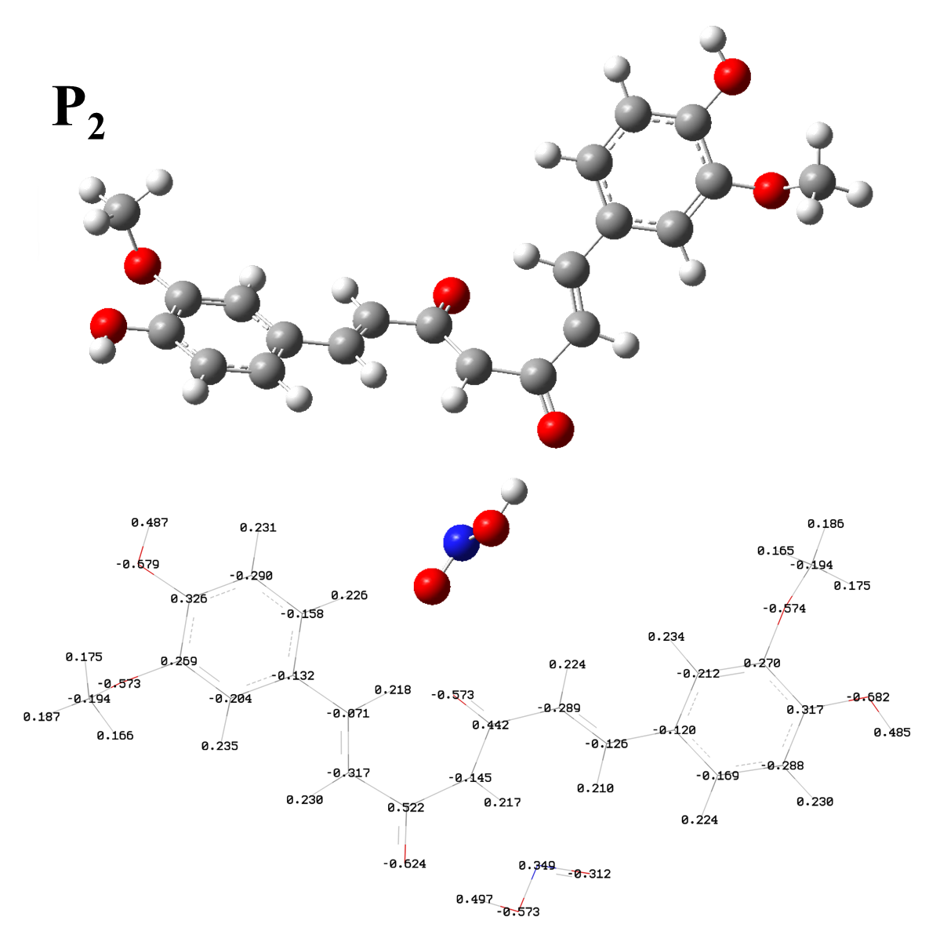

### Figure 3S. NBO Charges of Additional Atoms in Product 2 at the M06-2X/6-311G(d) level theory.

### **~~Reaction R1 - Intrinsic reaction path calculation~~**

~~%Mem=24000MB~~

~~%nprocshared=8~~

~~%chk=~~

~~# irc=(calcfc,maxpoints=30) b3lyp/6-311+g(d)~~

~~scrf(smd,solvent=generic,read) temperature=363.15~~

~~maxdisk=250GB~~

~~XXX~~

~~0 2~~

~~C 2.23752000 1.13249000 0.67009000~~

~~H 1.85624300 2.12172600 0.43825300~~

~~C 1.49955700 0.32512200 1.45908000~~

~~H 1.84273800 -0.65772000 1.76457500~~

~~C 0.18344800 0.67116400 2.01829200~~

~~O -0.39437900 -0.12800800 2.74494800~~

~~C 3.54889500 0.87608500 0.09111800~~

~~C 4.32059500 1.97652400 -0.29919700~~

~~C 4.17907400 -0.39342100 -0.02518000~~

~~C 5.60371700 1.84008400 -0.81497500~~

~~H 3.90012200 2.96990500 -0.18928400~~

~~C 5.43700100 -0.56770000 -0.62971700~~

~~H 4.72060900 -0.50594200 1.82217600~~

~~C 6.16599600 0.57700600 -0.99575800~~

~~H 6.16448600 2.72182400 -1.11123100~~

~~O 7.38208700 0.37950400 -1.55922000~~

~~H 7.77937300 1.22567400 -1.81383500~~

~~O 5.86532500 -1.82295400 -0.90651300~~

~~C 7.00997700 -2.30547900 -0.16436800~~

~~H 6.79896200 -2.28574000 0.90702600~~

~~H 7.15743300 -3.33300100 -0.49083600~~

~~H 7.89702900 -1.71355400 -0.38921900~~

~~C -3.06484700 0.79155900 0.79392900~~

~~H -2.72178600 0.65356100 1.81511400~~

~~C -2.30153800 1.51514800 -0.05507900~~

~~H -2.60169300 1.66762600 -1.08779300~~

~~C -1.02530800 2.14511300 0.28405300~~

~~O -0.40329500 2.77906700 -0.56308800~~

~~C -4.33180100 0.13733200 0.49697300~~

~~C -4.95139900 -0.61989700 1.50445800~~

~~C -4.97642000 0.22624200 -0.75285200~~

~~C -6.15580400 -1.27261900 1.27379700~~

~~H -4.47715900 -0.70612200 2.47655100~~

~~C -6.18045400 -0.41347200 -0.99423600~~

~~H -4.54346700 0.79882500 -1.56552500~~

~~C -6.77641800 -1.18489400 0.02761500~~

~~H -6.61522200 -1.86560300 2.06006300~~

~~O -7.94053300 -1.82289400 -0.26200200~~

~~H -8.24633700 -2.32531600 0.50738600~~

~~O -6.74011700 -0.34937700 -2.24427700~~

~~C -7.93417100 0.44346100 -2.34721900~~

~~H -7.72079500 1.48788900 -2.09802300~~

~~H -8.25412600 0.37775900 -3.38665300~~

~~H -8.72457300 0.06021600 -1.69897900~~

~~C -0.45920600 2.02729600 1.70807500~~

~~H -1.24819300 2.18075800 2.44441100~~

~~H 0.27447500 2.82590500 1.82450000~~

~~O 3.61350500 -2.48653900 0.88053200~~

~~O 2.50052900 -1.76238500 -0.83127600~~

~~N 3.36091800 -1.65040700 0.02930100~~

~~Eps=7~~

~~EpsInf=1.85341~~

~~HbondAcidity=0~~

~~HbondBasicity=0.48~~

~~SurfaceTensionAtInterface=60.62~~

~~CarbonAromaticity=0~~

~~ElectronegativeHalogenicity=0~~

### **~~Reaction R1 - 298.15 K - Reactant optimization to transition state~~**

~~! CPCM B3LYP 6-311+G(d) RIJDX TIGHTSCF OptTS Freq~~

~~PAL8~~

~~%maxcore 20000~~

~~%scf~~

~~MaxDisk 250000~~

~~Convergence VeryTight~~

~~Maxiter 1000~~

~~Lshift 1.0~~

~~end~~

~~%cpcm~~

~~epsilon 7 # Dielectric constant~~

~~refrac 1.85341 # Refractive index~~

~~end~~

~~* xyz 0 2~~

~~C 2.23752000 1.13249000 0.67009000~~

~~H 1.85624300 2.12172600 0.43825300~~

~~C 1.49955700 0.32512200 1.45908000~~

~~H 1.84273800 -0.65772000 1.76457500~~

~~C 0.18344800 0.67116400 2.01829200~~

~~O -0.39437900 -0.12800800 2.74494800~~

~~C 3.54889500 0.87608500 0.09111800~~

~~C 4.32059500 1.97652400 -0.29919700~~

~~C 4.17907400 -0.39342100 -0.02518000~~

~~C 5.60371700 1.84008400 -0.81497500~~

~~H 3.90012200 2.96990500 -0.18928400~~

~~C 5.43700100 -0.56770000 -0.62971700~~

~~H 4.72060900 -0.50594200 1.82217600~~

~~C 6.16599600 0.57700600 -0.99575800~~

~~H 6.16448600 2.72182400 -1.11123100~~

~~O 7.38208700 0.37950400 -1.55922000~~

~~H 7.77937300 1.22567400 -1.81383500~~

~~O 5.86532500 -1.82295400 -0.90651300~~

~~C 7.00997700 -2.30547900 -0.16436800~~

~~H 6.79896200 -2.28574000 0.90702600~~

~~H 7.15743300 -3.33300100 -0.49083600~~

~~H 7.89702900 -1.71355400 -0.38921900~~

~~C -3.06484700 0.79155900 0.79392900~~

~~H -2.72178600 0.65356100 1.81511400~~

~~C -2.30153800 1.51514800 -0.05507900~~

~~H -2.60169300 1.66762600 -1.08779300~~

~~C -1.02530800 2.14511300 0.28405300~~

~~O -0.40329500 2.77906700 -0.56308800~~

~~C -4.33180100 0.13733200 0.49697300~~

~~C -4.95139900 -0.61989700 1.50445800~~

~~C -4.97642000 0.22624200 -0.75285200~~

~~C -6.15580400 -1.27261900 1.27379700~~

~~H -4.47715900 -0.70612200 2.47655100~~

~~C -6.18045400 -0.41347200 -0.99423600~~

~~H -4.54346700 0.79882500 -1.56552500~~

~~C -6.77641800 -1.18489400 0.02761500~~

~~H -6.61522200 -1.86560300 2.06006300~~

~~O -7.94053300 -1.82289400 -0.26200200~~

~~H -8.24633700 -2.32531600 0.50738600~~

~~O -6.74011700 -0.34937700 -2.24427700~~

~~C -7.93417100 0.44346100 -2.34721900~~

~~H -7.72079500 1.48788900 -2.09802300~~

~~H -8.25412600 0.37775900 -3.38665300~~

~~H -8.72457300 0.06021600 -1.69897900~~

~~C -0.45920600 2.02729600 1.70807500~~

~~H -1.24819300 2.18075800 2.44441100~~

~~H 0.27447500 2.82590500 1.82450000~~

~~O 3.61350500 -2.48653900 0.88053200~~

~~O 2.50052900 -1.76238500 -0.83127600~~

~~N 3.36091800 -1.65040700 0.02930100~~

~~*~~

### **~~Reaction R1 - 298.15 K - Reactant optimization to transition state output - Z-Matrix~~**

~~C~~

~~H 1 1.08545~~

~~C 1 1.34962 2 118.47630~~

~~H 3 1.08505 1 122.24271 2 182.40891~~

~~C 3 1.46986 1 124.76687 2 1.40848~~

~~O 5 1.22700 3 119.65991 1 179.36622~~

~~C 1 1.45644 2 113.19648 3 182.03147~~

~~C 7 1.40032 1 117.84299 2 19.04397~~

~~C 7 1.42344 1 126.16480 2 193.26830~~

~~C 8 1.38996 7 122.44384 1 177.04692~~

~~H 8 1.08454 7 118.58479 1 357.42981~~

~~C 9 1.40716 7 122.74326 1 179.11261~~

~~H 9 1.93057 7 95.54161 1 283.36611~~

~~C 10 1.39520 8 120.64272 7 1.34219~~

~~H 10 1.08598 8 120.05135 7 179.48523~~

~~O 14 1.35352 10 123.42343 8 176.71890~~

~~H 16 0.96783 14 110.98172 10 0.73968~~

~~O 12 1.35728 9 119.40563 7 190.84642~~

~~C 18 1.44959 12 116.82469 9 249.43784~~

~~H 19 1.09173 18 109.78803 12 61.20993~~

~~H 19 1.08777 18 105.43834 12 179.69054~~

~~H 19 1.08967 18 110.64121 12 298.81712~~

~~C 6 3.43604 5 84.07493 3 219.82318~~

~~H 23 1.08616 6 38.69115 5 236.48750~~

~~C 23 1.35311 6 91.63733 5 13.24057~~

~~H 25 1.08640 23 121.27331 6 150.48204~~

~~C 25 1.46140 23 125.21160 6 331.00260~~

~~O 27 1.22985 25 120.33642 23 179.67886~~

~~C 23 1.45600 6 132.31327 5 160.93200~~

~~C 29 1.40576 23 118.69501 6 41.52202~~

~~C 29 1.40979 23 123.40310 6 221.52274~~

~~C 30 1.38958 29 121.19512 23 180.48959~~

~~H 30 1.08540 29 119.51162 23 0.07242~~

~~C 31 1.38419 29 121.45285 23 179.67449~~

~~H 31 1.08439 29 121.17750 23 0.15563~~

~~C 32 1.39600 30 120.24361 29 0.03732~~

~~H 32 1.08651 30 120.36759 29 179.31658~~

~~O 36 1.35810 32 123.01503 30 178.69233~~

~~H 38 0.96734 36 110.63775 32 359.51910~~

~~O 34 1.37504 31 119.60056 29 183.23994~~

~~C 40 1.43968 34 115.36447 31 252.71994~~

~~H 41 1.09409 40 110.20674 34 60.99598~~

~~H 41 1.08902 40 106.12052 34 179.67682~~

~~H 41 1.09178 40 111.03996 34 298.85017~~

~~C 5 1.53300 3 120.57958 1 358.98720~~

~~H 45 1.08976 5 106.88447 3 201.04904~~

~~H 45 1.09030 5 110.55805 3 318.65992~~

~~O 9 2.34926 7 132.16462 1 351.34617~~

~~O 48 2.16561 9 61.47339 7 74.67597~~

~~N 48 1.21968 9 33.91201 7 73.44348~~

### **~~Reaction R1 - 298.15 K - Reactant optimization to minimum~~**

~~! CPCM B3LYP 6-311+G(d) RIJDX TIGHTSCF Opt Freq~~

~~PAL4~~

~~%maxcore 20000~~

~~%scf~~

~~MaxDisk 250000~~

~~Convergence VeryTight~~

~~Maxiter 1000~~

~~Lshift 1.0~~

~~end~~

~~%cpcm~~

~~epsilon 7 # Dielectric constant~~

~~refrac 1.85341 # Refractive index~~

~~end~~

~~* xyz 0 2~~

~~C 2.22082200 1.06285700 0.70738000~~

~~H 1.81237100 2.04710300 0.49884400~~

~~C 1.46766400 0.18327500 1.42506300~~

~~H 1.82848600 -0.81535200 1.65003400~~

~~C 0.13863800 0.46043400 1.96666700~~

~~O -0.45613900 -0.40139600 2.60975800~~

~~C 3.53253400 0.85122400 0.17670100~~

~~C 4.19596500 1.88352500 -0.47261600~~

~~C 4.23976400 -0.46391600 0.31378000~~

~~C 5.52334700 1.77305800 -0.88338100~~

~~H 3.67798600 2.82474700 -0.62522200~~

~~C 5.68779600 -0.48508300 -0.04441600~~

~~H 4.07908500 -0.93726600 1.28279200~~

~~C 6.28614000 0.61049200 -0.62953000~~

~~H 6.00793900 2.61515000 -1.36789000~~

~~O 7.61934900 0.57396000 -0.92740400~~

~~H 7.89415300 1.41655000 -1.31610800~~

~~O 6.24335500 -1.66899500 0.27767800~~

~~C 7.41998300 -2.17255600 -0.39157100~~

~~H 8.31124700 -1.63403100 -0.07673300~~

~~H 7.48656200 -3.21569300 -0.08857500~~

~~H 7.29963100 -2.10899600 -1.47347500~~

~~C -3.14393400 0.66510100 0.81149600~~

~~H -2.76608500 0.43855800 1.80427800~~

~~C -2.39824300 1.44575400 -0.00149200~~

~~H -2.72440900 1.68055800 -1.01076100~~

~~C -1.10352100 2.03316700 0.34797500~~

~~O -0.48557000 2.70087000 -0.47639300~~

~~C -4.42980900 0.05096400 0.50824400~~

~~C -5.01116600 -0.79905000 1.46336200~~

~~C -5.13118200 0.26992900 -0.69397700~~

~~C -6.23363400 -1.41542000 1.22710300~~

~~H -4.49279100 -0.98583200 2.39816700~~

~~C -6.35443300 -0.33094100 -0.93861500~~

~~H -4.73025100 0.91801100 -1.46535500~~

~~C -6.91286100 -1.19413900 0.02911500~~

~~H -6.66292000 -2.08263400 1.96980000~~

~~O -8.10186200 -1.78310800 -0.26354500~~

~~H -8.38081900 -2.35387600 0.46739300~~

~~O -6.97395600 -0.13570500 -2.14640100~~

~~C -8.14832400 0.69099900 -2.10907600~~

~~H -7.89503300 1.69820400 -1.76279700~~

~~H -8.51765400 0.74277100 -3.13280500~~

~~H -8.91861400 0.26052600 -1.46601000~~

~~C -0.51693400 1.83187100 1.75257600~~

~~H -1.29689500 1.93019400 2.50755800~~

~~H 0.21001400 2.62924600 1.90946900~~

~~O 2.86518400 -2.40873400 -0.13930700~~

~~O 3.68109800 -1.38492400 -1.86386500~~

~~N 3.52495000 -1.53041900 -0.66507600~~

~~*~~

### **~~Reaction R1 - 298.15 K - Reactant optimization to minimum output - Z-Matrix~~**

~~C~~

~~H 1 1.08587~~

~~C 1 1.36340 2 118.36015~~

~~H 3 1.08542 1 121.42651 2 179.37173~~

~~C 3 1.45993 1 124.89607 2 359.49796~~

~~O 5 1.23140 3 120.18782 1 179.26597~~

~~C 1 1.43047 2 114.06527 3 180.16069~~

~~C 7 1.38866 1 120.01342 2 2.83151~~

~~C 7 1.49936 1 122.09797 2 182.15142~~

~~C 8 1.39480 7 122.33433 1 173.10547~~

~~H 8 1.08537 7 118.87614 1 356.09244~~

~~C 9 1.49227 7 116.62963 1 192.08393~~

~~H 9 1.09033 7 113.40115 1 321.93274~~

~~C 12 1.38082 9 120.83071 7 350.97556~~

~~H 10 1.08587 8 119.64356 7 181.36314~~

~~O 14 1.36591 12 119.60302 9 179.38839~~

~~H 16 0.96696 14 110.53290 12 182.35793~~

~~O 12 1.34786 9 110.73769 7 171.38687~~

~~C 18 1.44589 12 122.27963 9 155.95338~~

~~H 19 1.08779 18 110.81156 12 74.19000~~

~~H 19 1.08784 18 104.69695 12 193.24956~~

~~H 19 1.08994 18 110.23646 12 311.74948~~

~~C 6 3.44537 5 84.59563 3 218.79562~~

~~H 23 1.08627 6 39.01668 5 236.80172~~

~~C 23 1.35284 6 91.08576 5 14.11667~~

~~H 25 1.08647 23 121.20507 6 150.43862~~

~~C 25 1.46206 23 125.33631 6 330.60029~~

~~O 27 1.23045 25 120.13404 23 179.81613~~

~~C 23 1.45643 6 132.99776 5 161.68182~~

~~C 29 1.40567 23 118.77247 6 42.07291~~

~~C 29 1.40976 23 123.34089 6 221.79208~~

~~C 30 1.38973 29 121.20627 23 180.11370~~

~~H 30 1.08542 29 119.52331 23 359.77479~~

~~C 31 1.38412 29 121.46079 23 180.06977~~

~~H 31 1.08439 29 121.16047 23 0.45057~~

~~C 32 1.39608 30 120.24019 29 359.99670~~

~~H 32 1.08662 30 120.42094 29 179.37169~~

~~O 36 1.35811 32 123.05192 30 178.88857~~

~~H 38 0.96731 36 110.65560 32 359.83770~~

~~O 34 1.37523 31 119.62171 29 183.13722~~

~~C 40 1.43981 34 115.30244 31 253.39877~~

~~H 41 1.09408 40 110.20314 34 61.08057~~

~~H 41 1.08902 40 106.11501 34 179.78407~~

~~H 41 1.09179 40 111.00099 34 298.95221~~

~~C 27 1.53522 25 120.53989 23 359.67615~~

~~H 45 1.08973 27 110.83268 25 321.42527~~

~~H 45 1.09024 27 106.95801 25 203.67138~~

~~O 13 2.38241 9 79.29112 7 110.61488~~

~~O 48 2.16425 13 89.53438 9 9.02172~~

~~N 48 1.21782 13 62.28978 9 7.00979~~

### **~~Reaction R1 - 363.15 K - Optimization to transition state~~**

~~%Mem=24000MB~~

~~%nprocshared=4~~

~~%chk=~~

~~# opt=qst2 b3lyp/6-311+g(d) scrf(smd,solvent=generic,read)~~

~~temperature=363.15 freq=noraman MaxDisk=250GB~~

~~XXX~~

~~0 2~~

~~C -2.72654100 0.97274400 -0.34148400~~

~~H -2.26572800 1.29111900 -1.27270100~~

~~C -2.04449900 1.15303200 0.81240500~~

~~H -2.46232100 0.85282300 1.76887400~~

~~C -0.72022800 1.75682400 0.90694300~~

~~O -0.17995600 1.89623100 2.01000800~~

~~C -4.04722400 0.38440200 -0.50277000~~

~~C -4.58484100 0.28093700 -1.79810000~~

~~C -4.82251000 -0.08973300 0.57475400~~

~~C -5.84113200 -0.26893900 -2.01528100~~

~~H -4.00912600 0.63995900 -2.64468100~~

~~C -6.07377700 -0.63975700 0.36650200~~

~~H -4.46233300 -0.02944300 1.59554200~~

~~C -6.59660900 -0.73346600 -0.93829900~~

~~H -6.24914100 -0.34053600 -3.01887700~~

~~O -7.84062000 -1.27345600 -1.08511100~~

~~H -8.09652000 -1.27590400 -2.01900300~~

~~O -6.84677400 -1.04499100 1.44229500~~

~~C -6.71115400 -2.44031000 1.77911700~~

~~H -5.68421500 -2.66016200 2.08250400~~

~~H -7.38765500 -2.62154400 2.61303900~~

~~H -6.99055200 -3.07407700 0.93410000~~

~~C 2.53301400 0.61846400 -0.16997200~~

~~H 1.58481400 0.11769500 -0.34564900~~

~~C 2.54164300 1.96503700 -0.03362500~~

~~H 3.46624400 2.50426500 0.15110700~~

~~C 1.35953000 2.81177500 -0.09622100~~

~~O 1.46611500 4.03512700 0.07031900~~

~~C 3.67548200 -0.27873000 -0.10478300~~

~~C 3.45731300 -1.66031700 -0.24927900~~

~~C 4.99852900 0.16436300 0.09507900~~

~~C 4.50780300 -2.56595900 -0.19360600~~

~~H 2.44783600 -2.02682100 -0.40274700~~

~~C 6.05100600 -0.73073000 0.14715800~~

~~H 5.22416900 1.21779100 0.21554100~~

~~C 5.81282700 -2.11208700 0.00415400~~

~~H 4.32750100 -3.63126900 -0.30053300~~

~~O 6.88697900 -2.94939800 0.07588600~~

~~H 6.60626400 -3.87053300 -0.02658800~~

~~O 7.33869700 -0.28436500 0.39611400~~

~~C 8.09316200 0.03687400 -0.78997800~~

~~H 7.61092500 0.84919900 -1.33997600~~

~~H 9.07702400 0.35694100 -0.44991200~~

~~H 8.19298500 -0.83941700 -1.43505500~~

~~C -0.01644400 2.22557600 -0.36540100~~

~~H 0.02851700 1.39988700 -1.07833500~~

~~H -0.62631800 3.00685500 -0.82662700~~

~~O -6.07151283 1.39364748 2.20359922~~

~~O -4.25207268 2.22819193 1.27613897~~

~~N -5.10026302 1.41497146 1.50429378~~

~~XXX~~

~~0 2~~

~~C -2.72654100 0.97274400 -0.34148400~~

~~H -2.26572800 1.29111900 -1.27270100~~

~~C -2.04449900 1.15303200 0.81240500~~

~~H -2.46232100 0.85282300 1.76887400~~

~~C -0.72022800 1.75682400 0.90694300~~

~~O -0.17995600 1.89623100 2.01000800~~

~~C -4.04722400 0.38440200 -0.50277000~~

~~C -4.58484100 0.28093700 -1.79810000~~

~~C -4.82251000 -0.08973300 0.57475400~~

~~C -5.84113200 -0.26893900 -2.01528100~~

~~H -4.00912600 0.63995900 -2.64468100~~

~~C -6.07377700 -0.63975700 0.36650200~~

~~H -4.08261873 -1.61750508 0.84383217~~

~~C -6.59660900 -0.73346600 -0.93829900~~

~~H -6.24914100 -0.34053600 -3.01887700~~

~~O -7.84062000 -1.27345600 -1.08511100~~

~~H -8.09652000 -1.27590400 -2.01900300~~

~~O -6.84677400 -1.04499100 1.44229500~~

~~C -6.71115400 -2.44031000 1.77911700~~

~~H -5.68421500 -2.66016200 2.08250400~~

~~H -7.38765500 -2.62154400 2.61303900~~

~~H -6.99055200 -3.07407700 0.93410000~~

~~C 2.53301400 0.61846400 -0.16997200~~

~~H 1.58481400 0.11769500 -0.34564900~~

~~C 2.54164300 1.96503700 -0.03362500~~

~~H 3.46624400 2.50426500 0.15110700~~

~~C 1.35953000 2.81177500 -0.09622100~~

~~O 1.46611500 4.03512700 0.07031900~~

~~C 3.67548200 -0.27873000 -0.10478300~~

~~C 3.45731300 -1.66031700 -0.24927900~~

~~C 4.99852900 0.16436300 0.09507900~~

~~C 4.50780300 -2.56595900 -0.19360600~~

~~H 2.44783600 -2.02682100 -0.40274700~~

~~C 6.05100600 -0.73073000 0.14715800~~

~~H 5.22416900 1.21779100 0.21554100~~

~~C 5.81282700 -2.11208700 0.00415400~~

~~H 4.32750100 -3.63126900 -0.30053300~~

~~O 6.88697900 -2.94939800 0.07588600~~

~~H 6.60626400 -3.87053300 -0.02658800~~

~~O 7.33869700 -0.28436500 0.39611400~~

~~C 8.09316200 0.03687400 -0.78997800~~

~~H 7.61092500 0.84919900 -1.33997600~~

~~H 9.07702400 0.35694100 -0.44991200~~

~~H 8.19298500 -0.83941700 -1.43505500~~

~~C -0.01644400 2.22557600 -0.36540100~~

~~H 0.02851700 1.39988700 -1.07833500~~

~~H -0.62631800 3.00685500 -0.82662700~~

~~O -4.50447695 -0.94855946 2.66104172~~

~~O -3.80099367 1.00067590 2.29488107~~

~~N -4.34161199 -0.00674981 1.94043184~~

~~Eps=7~~

~~EpsInf=1.85341~~

~~HbondAcidity=0~~

~~HbondBasicity=0.48~~

~~SurfaceTensionAtInterface=60.62~~

~~CarbonAromaticity=0~~

~~ElectronegativeHalogenicity=0~~

### **~~Reaction R1 - 363.15 K - Optimization to transition state output - Z-Matrix~~**

~~C~~

~~H 1 1.0852227~~

~~C 1 1.34868 2 118.582351~~

~~H 3 1.0849326 1 122.2728603 2 -177.2356735~~

~~C 3 1.47126 1 124.8220049 2 1.3729425~~

~~O 5 1.2249853 3 119.6026869 1 -178.7120822~~

~~C 1 1.4562474 3 128.3105161 5 179.1807021~~

~~C 7 1.399583 1 117.9669918 3 -158.5012044~~

~~C 7 1.4220746 1 126.0684914 3 16.1986382~~

~~C 8 1.3896204 7 122.3732604 1 177.540167~~

~~H 8 1.0842897 7 118.5714062 1 -2.1726493~~

~~C 9 1.4064916 7 122.8267148 1 178.3003011~~

~~H 9 1.9283789 7 95.634951 1 -77.3966189~~

~~C 10 1.3943479 8 120.624905 7 1.6007145~~

~~H 10 1.0861376 8 119.8849263 7 179.6029114~~

~~O 14 1.3547597 10 123.2274366 8 176.3837077~~

~~H 16 0.9688491 14 110.4913382 10 -0.4874057~~

~~O 12 1.3548949 9 119.0351246 7 -168.816624~~

~~C 18 1.4470099 12 117.0157836 9 -113.2843324~~

~~H 19 1.0921548 18 110.137096 12 58.6940134~~

~~H 19 1.0881756 18 105.557045 12 177.0724211~~

~~H 19 1.0898598 18 110.9111156 12 -63.9204205~~

~~C 6 3.4327071 5 81.6652534 3 -135.584864~~

~~H 23 1.0860723 6 35.494082 5 -130.5699074~~

~~C 23 1.3516791 6 93.5020637 5 7.4031295~~

~~H 25 1.0862048 23 121.0830701 6 152.9650415~~

~~C 25 1.463089 23 125.2744843 6 -26.3402506~~

~~O 27 1.2273735 25 120.2962681 23 179.6900934~~

~~C 23 1.4564918 6 132.2419897 5 158.148512~~

~~C 29 1.4043943 23 118.6658784 6 35.1017766~~

~~C 29 1.4090781 23 123.3973522 6 -145.0951901~~

~~C 30 1.3891875 29 121.1130322 23 -179.5607113~~

~~H 30 1.085036 29 119.5198285 23 -0.2228906~~

~~C 31 1.3846292 29 121.552806 23 179.9090251~~

~~H 31 1.0843141 29 121.0262361 23 0.0953842~~

~~C 32 1.394929 30 120.2990911 29 -0.0843075~~

~~H 32 1.0866964 30 120.1844819 29 179.1663237~~

~~O 36 1.3587074 32 122.825655 30 178.6888774~~

~~H 38 0.9684533 36 110.1698273 32 -0.1758043~~

~~O 34 1.3711066 31 119.490889 29 -177.0146291~~

~~C 40 1.4369948 34 115.4852475 31 -109.9677223~~

~~H 41 1.094741 40 110.371845 34 62.3832743~~

~~H 41 1.0895462 40 106.2055363 34 -179.1500399~~

~~H 41 1.0917084 40 111.4309619 34 -60.0540848~~

~~C 5 1.5324271 3 120.4206626 1 0.6895254~~

~~H 45 1.090065 5 106.9406687 3 -163.2213819~~

~~H 45 1.0906965 5 110.1365778 3 -45.9160362~~

~~O 9 2.3497501 7 131.0738635 1 -10.0644695~~

~~O 48 2.1664259 9 61.4016572 7 77.1733596~~

~~N 48 1.2196357 9 33.9159076 7 76.0419639~~

### **~~Reaction R1 - 363.15 K - Reactant optimization to minimum~~**

~~%Mem=35000MB~~

~~%nprocshared=8~~

~~%chk=~~

~~# opt freq=noraman b3lyp/6-311+g(d)~~

~~scrf(smd,solvent=generic,read) temperature=363.15~~

~~maxdisk=250GB~~

~~XXX~~

~~0 2~~

~~C 2.22649300 1.17999700 0.68512200~~

~~H 1.84618600 2.17462500 0.47434400~~

~~C 1.46824900 0.34619800 1.45009100~~

~~H 1.80746600 -0.64616600 1.72830300~~

~~C 0.16570900 0.68446500 2.01983500~~

~~O -0.41155900 -0.11546600 2.75219900~~

~~C 3.51740700 0.92781200 0.12667100~~

~~C 4.27179600 1.99603900 -0.35159800~~

~~C 4.22691400 -0.39809000 0.23982800~~

~~C 5.57052300 1.85516700 -0.83585100~~

~~H 3.83355700 2.98833900 -0.32269400~~

~~C 5.45287600 -0.55151500 -0.63172500~~

~~H 4.54499900 -0.53748800 1.28324300~~

~~C 6.14372400 0.57009700 -1.01534400~~

~~H 6.12883700 2.73222300 -1.14867100~~

~~O 7.37009000 0.40992400 -1.58709200~~

~~H 7.71277900 1.26191500 -1.89351000~~

~~O 5.86113700 -1.81530600 -0.88680100~~

~~C 7.01335000 -2.30350200 -0.16076800~~

~~H 6.82130700 -2.27675300 0.91458700~~

~~H 7.15110300 -3.33437300 -0.48143700~~

~~H 7.89924500 -1.71636700 -0.40293200~~

~~C -3.08073500 0.80470600 0.79916400~~

~~H -2.73698800 0.66597600 1.82001500~~

~~C -2.31755500 1.52827900 -0.04963500~~

~~H -2.61719700 1.68047100 -1.08257100~~

~~C -1.04219600 2.16032200 0.29135200~~

~~O -0.42029600 2.79410000 -0.55636200~~

~~C -4.34810200 0.15070400 0.50227000~~

~~C -4.96781500 -0.60636000 1.50969000~~

~~C -4.99283700 0.23980200 -0.74739000~~

~~C -6.17235900 -1.25895200 1.27903100~~

~~H -4.49353500 -0.69269000 2.48176200~~

~~C -6.19694000 -0.39991000 -0.98883900~~

~~H -4.55977500 0.81228700 -1.56007800~~

~~C -6.79292200 -1.17130200 0.03288000~~

~~H -6.63183500 -1.85186100 2.06534000~~

~~O -7.95719800 -1.80943100 -0.25671000~~

~~H -8.26275700 -2.31181400 0.51276900~~

~~O -6.75653900 -0.33573500 -2.23901100~~

~~C -7.95032000 0.45737700 -2.34188600~~

~~H -7.73677400 1.50172200 -2.09239800~~

~~H -8.27020600 0.39208300 -3.38137300~~

~~H -8.74091200 0.07419200 -1.69381400~~

~~C -0.47982200 2.04227700 1.71551800~~

~~H -1.27069800 2.19101300 2.45075000~~

~~H 0.25032400 2.84345100 1.83676400~~

~~O 3.53255200 -2.54931700 0.85686200~~

~~O 2.53612700 -1.69769800 -0.86684200~~

~~N 3.33812500 -1.65430100 0.04715900~~

~~Eps=7~~

~~EpsInf=1.85341~~

~~HbondAcidity=0~~

~~HbondBasicity=0.48~~

~~SurfaceTensionAtInterface=60.62~~

~~CarbonAromaticity=0~~

~~ElectronegativeHalogenicity=0~~

### **~~Reaction R1 - 363.15 K - Reactant optimization to minimum output - Z-Matrix~~**

~~C~~

~~H 1 1.0858451~~

~~C 1 1.3623437 2 118.5838349~~

~~H 3 1.0853849 1 121.2945728 2 179.3677485~~

~~C 3 1.4616642 1 125.1309849 2 -0.9529958~~

~~O 5 1.2288518 3 120.0673004 1 -179.5409085~~

~~C 1 1.4307331 3 127.3545149 5 178.7893992~~

~~C 7 1.3883078 1 120.1063556 3 -176.3953357~~

~~C 7 1.4995193 1 121.8857287 3 2.7567742~~

~~C 8 1.3938701 7 122.2744871 1 173.1795954~~

~~H 8 1.085122 7 118.85717 1 -3.9581181~~

~~C 9 1.4918274 7 116.6338125 1 -168.6866712~~

~~H 9 1.0903496 7 113.1093123 1 -38.8923644~~

~~C 12 1.3786437 9 120.7902355 7 -7.9342915~~

~~H 10 1.0856783 8 119.6764566 7 -178.6210036~~

~~O 14 1.3665686 12 119.6487086 9 178.9008079~~

~~H 16 0.9677634 14 109.9561015 12 -178.9837517~~

~~O 12 1.3468623 9 110.8196094 7 172.3075219~~

~~C 18 1.4442719 12 122.120927 9 155.0919337~~

~~H 19 1.0878804 18 111.1459647 12 73.8434752~~

~~H 19 1.0882895 18 104.7749657 12 -167.2601172~~

~~H 19 1.0904314 18 110.4577809 12 -49.068168~~

~~C 6 3.4052025 5 83.4552241 3 -137.9556162~~

~~H 23 1.0861435 6 34.6526548 5 -129.9175417~~

~~C 23 1.3514524 6 93.616279 5 8.8107157~~

~~H 25 1.086343 23 121.2031189 6 153.3028517~~

~~C 25 1.464065 23 125.1779834 6 -25.7469337~~

~~O 27 1.2277106 25 120.2018631 23 178.0300087~~

~~C 23 1.4569147 6 132.4194749 5 160.3671586~~

~~C 29 1.4045462 23 118.6123398 6 32.7626455~~

~~C 29 1.4089731 23 123.4661592 6 -147.6421331~~

~~C 30 1.3893014 29 121.1352272 23 -179.8023861~~

~~H 30 1.0851085 29 119.4896358 23 -0.4057826~~

~~C 31 1.3846427 29 121.5392577 23 -179.7436056~~

~~H 31 1.0843339 29 121.0524366 23 0.2904093~~

~~C 32 1.3948082 30 120.2760183 29 -0.269402~~

~~H 32 1.0867658 30 120.2477832 29 179.0450955~~

~~O 36 1.3587707 32 122.8438338 30 179.1122394~~

~~H 38 0.9684335 36 110.1794865 32 0.002461~~

~~O 34 1.3713763 31 119.532752 29 -177.163712~~

~~C 40 1.4366534 34 115.3608932 31 -109.0581985~~

~~H 41 1.0947728 40 110.3957708 34 61.7122399~~

~~H 41 1.089544 40 106.2615625 34 -179.7773871~~

~~H 41 1.0918734 40 111.4145543 34 -60.6357665~~

~~C 5 1.535073 3 120.4002042 1 -0.2925494~~

~~H 45 1.0899561 5 106.8333576 3 -160.4328398~~

~~H 45 1.0903558 5 110.3986133 3 -43.0668209~~

~~O 9 2.4242679 7 114.7765189 1 44.1440954~~

~~O 48 2.1651796 9 63.6315689 7 81.2562155~~

~~N 49 1.2176395 48 27.25325 9 0.3871822~~

### **~~Reaction R2 - Intrinsic reaction path calculation~~**

~~%Mem=24000MB~~

~~%nprocshared=8~~

~~%chk=~~

~~# irc=(calcfc,maxpoints=30) b3lyp/6-311+g(d)~~

~~scrf(smd,solvent=generic,read) temperature=363.15~~

~~maxdisk=250GB~~

~~XXX~~

~~0 2~~

~~C -2.47108400 0.27217200 -0.11793500~~

~~H -1.87937200 0.41576700 -1.01751300~~

~~C -1.99741100 0.74680000 1.06093900~~

~~H -2.55621400 0.60959800 1.98167900~~

~~C -0.73296500 1.46263800 1.24989500~~

~~O -0.36601000 1.80104900 2.37034900~~

~~C -3.72266300 -0.42311600 -0.33693400~~

~~C -4.05203000 -0.82054600 -1.64775600~~

~~C -4.63261900 -0.72931600 0.69813700~~

~~C -5.23956100 -1.48088500 -1.91776000~~

~~H -3.36940200 -0.59901500 -2.46124700~~

~~C -5.81757900 -1.39374400 0.44486700~~

~~H -4.42839300 -0.44405100 1.72365100~~

~~C -6.13668200 -1.76486500 -0.88417400~~

~~H -5.48710100 -1.76941400 -2.93550400~~

~~O -7.32484100 -2.37583500 -1.09346400~~

~~H -7.44487700 -2.57197400 -2.03497800~~

~~O -6.70113800 -1.61013800 1.46598000~~

~~C -6.86601900 -2.98025500 1.87239300~~

~~H -5.91919400 -3.38180600 2.24642400~~

~~H -7.59993300 -2.96978900 2.67702900~~

~~H -7.23488500 -3.59816600 1.05211700~~

~~C 2.75179700 0.28863100 -0.11150200~~

~~H 1.84237500 -0.21458500 -0.42755700~~

~~C 2.68253700 1.58695000 0.26498200~~

~~H 3.57074700 2.12348100 0.58719500~~

~~C 1.46838800 2.40736100 0.31373700~~

~~O 1.53190300 3.59903500 0.58819200~~

~~C 3.93779700 -0.55127200 -0.15153400~~

~~C 3.81802700 -1.86714000 -0.63276400~~

~~C 5.21079200 -0.11526400 0.26968900~~

~~C 4.91564600 -2.71479100 -0.68409500~~

~~H 2.85091100 -2.22935900 -0.96605800~~

~~C 6.31448300 -0.94822100 0.22170900~~

~~H 5.35905400 0.88727900 0.65421400~~

~~C 6.16675200 -2.27258400 -0.24987800~~

~~H 4.80542400 -3.73205600 -1.05029300~~

~~O 7.26573300 -3.06689700 -0.24257100~~

~~H 7.04537900 -3.95010500 -0.57400600~~

~~O 7.51505600 -0.50205200 0.70563100~~

~~C 8.54029100 -0.28112800 -0.27763200~~

~~H 8.21591400 0.47028400 -1.00429600~~

~~H 9.40642600 0.09236200 0.26728100~~

~~H 8.80579200 -1.20641300 -0.79219300~~

~~C 0.12619300 1.75672600 0.04617100~~

~~H 0.14384700 0.95378800 -0.68964400~~

~~H -0.52839600 2.66223600 -0.60735800~~

~~O -1.15127900 3.52665500 -1.34207900~~

~~O -2.80960400 4.80890700 -1.11220600~~

~~N -2.12303000 3.99103600 -0.56156100~~

~~Eps=7~~

~~EpsInf=1.85341~~

~~HbondAcidity=0~~

~~HbondBasicity=0.48~~

~~SurfaceTensionAtInterface=60.62~~

~~CarbonAromaticity=0~~

~~ElectronegativeHalogenicity=0~~

### **~~Reaction R2 - 298.15 K - Optimization to transition state~~**

~~! CPCM B3LYP 6-311+G(d) RIJDX TIGHTSCF OptTS Freq~~

~~PAL4~~

~~%maxcore 20000~~

~~%scf~~

~~MaxDisk 250000~~

~~Convergence VeryTight~~

~~Maxiter 1000~~

~~Lshift 1.0~~

~~end~~

~~%cpcm~~

~~epsilon 7 # Dielectric constant~~

~~refrac 1.85341 # Refractive index~~

~~end~~

~~* xyz 0 2~~

~~C -2.47108400 0.27217200 -0.11793500~~

~~H -1.87937200 0.41576700 -1.01751300~~

~~C -1.99741100 0.74680000 1.06093900~~

~~H -2.55621400 0.60959800 1.98167900~~

~~C -0.73296500 1.46263800 1.24989500~~

~~O -0.36601000 1.80104900 2.37034900~~

~~C -3.72266300 -0.42311600 -0.33693400~~

~~C -4.05203000 -0.82054600 -1.64775600~~

~~C -4.63261900 -0.72931600 0.69813700~~

~~C -5.23956100 -1.48088500 -1.91776000~~

~~H -3.36940200 -0.59901500 -2.46124700~~

~~C -5.81757900 -1.39374400 0.44486700~~

~~H -4.42839300 -0.44405100 1.72365100~~

~~C -6.13668200 -1.76486500 -0.88417400~~

~~H -5.48710100 -1.76941400 -2.93550400~~

~~O -7.32484100 -2.37583500 -1.09346400~~

~~H -7.44487700 -2.57197400 -2.03497800~~

~~O -6.70113800 -1.61013800 1.46598000~~

~~C -6.86601900 -2.98025500 1.87239300~~

~~H -5.91919400 -3.38180600 2.24642400~~

~~H -7.59993300 -2.96978900 2.67702900~~

~~H -7.23488500 -3.59816600 1.05211700~~

~~C 2.75179700 0.28863100 -0.11150200~~

~~H 1.84237500 -0.21458500 -0.42755700~~

~~C 2.68253700 1.58695000 0.26498200~~

~~H 3.57074700 2.12348100 0.58719500~~

~~C 1.46838800 2.40736100 0.31373700~~

~~O 1.53190300 3.59903500 0.58819200~~

~~C 3.93779700 -0.55127200 -0.15153400~~

~~C 3.81802700 -1.86714000 -0.63276400~~

~~C 5.21079200 -0.11526400 0.26968900~~

~~C 4.91564600 -2.71479100 -0.68409500~~

~~H 2.85091100 -2.22935900 -0.96605800~~

~~C 6.31448300 -0.94822100 0.22170900~~

~~H 5.35905400 0.88727900 0.65421400~~

~~C 6.16675200 -2.27258400 -0.24987800~~

~~H 4.80542400 -3.73205600 -1.05029300~~

~~O 7.26573300 -3.06689700 -0.24257100~~

~~H 7.04537900 -3.95010500 -0.57400600~~

~~O 7.51505600 -0.50205200 0.70563100~~

~~C 8.54029100 -0.28112800 -0.27763200~~

~~H 8.21591400 0.47028400 -1.00429600~~

~~H 9.40642600 0.09236200 0.26728100~~

~~H 8.80579200 -1.20641300 -0.79219300~~

~~C 0.12619300 1.75672600 0.04617100~~

~~H 0.14384700 0.95378800 -0.68964400~~

~~H -0.52839600 2.66223600 -0.60735800~~

~~O -1.15127900 3.52665500 -1.34207900~~

~~O -2.80960400 4.80890700 -1.11220600~~

~~N -2.12303000 3.99103600 -0.56156100~~

~~*~~

### **~~Reaction R2 - 298.15 K - Optimization to transition state output - Z-Matrix~~**

~~C~~

~~H 1 1.08601~~

~~C 1 1.35909 2 118.97112~~

~~H 3 1.08609 1 120.74766 2 179.76748~~

~~C 3 1.47255 1 126.38519 2 0.14706~~

~~O 5 1.22946 3 119.40381 1 179.08112~~

~~C 1 1.44579 2 114.24542 3 178.89367~~

~~C 7 1.41277 1 118.45215 2 358.04374~~

~~C 7 1.41413 1 123.50261 2 177.87752~~

~~C 8 1.38361 7 121.18376 1 180.46438~~

~~H 8 1.08504 7 119.39684 1 359.95121~~

~~C 9 1.38012 7 121.38953 1 179.94600~~

~~H 9 1.08379 7 121.21128 1 0.03933~~

~~C 10 1.40080 8 120.08533 7 359.88115~~

~~H 10 1.08609 8 120.55036 7 179.26831~~

~~O 14 1.34745 10 122.98608 8 178.59574~~

~~H 16 0.96833 14 111.20447 10 359.96949~~

~~O 12 1.36934 9 119.77708 7 183.19717~~

~~C 18 1.44216 12 115.86144 9 251.05793~~

~~H 19 1.09358 18 110.05091 12 60.94131~~

~~H 19 1.08854 18 105.93053 12 179.54540~~

~~H 19 1.09127 18 111.05944 12 298.70868~~

~~C 5 4.25560 3 118.97293 1 325.36889~~

~~H 23 1.08599 5 63.14320 3 13.99817~~

~~C 23 1.35826 5 58.96362 3 174.07321~~

~~H 25 1.08670 23 120.51022 5 160.02560~~

~~C 25 1.47075 23 126.81127 5 339.59813~~

~~O 27 1.23054 25 119.42572 23 188.28383~~

~~C 23 1.44840 5 162.76169 3 289.01069~~

~~C 29 1.41100 23 118.49440 5 77.93698~~

~~C 29 1.41333 23 123.55227 5 257.94265~~

~~C 30 1.38492 29 121.23103 23 180.43510~~

~~H 30 1.08514 29 119.42093 23 0.11600~~

~~C 31 1.38118 29 121.41449 23 179.74995~~

~~H 31 1.08399 29 121.19500 23 0.27817~~

~~C 32 1.39973 30 120.14388 29 0.05756~~

~~H 32 1.08622 30 120.52083 29 179.34339~~

~~O 36 1.35001 32 123.04014 30 178.52435~~

~~H 38 0.96836 36 111.17399 32 359.93636~~

~~O 34 1.37089 31 119.81485 29 183.42029~~

~~C 40 1.44178 34 115.58354 31 252.75625~~

~~H 41 1.09364 40 110.07268 34 61.47824~~

~~H 41 1.08864 40 106.00909 34 180.14933~~

~~H 41 1.09152 40 111.01740 34 299.32422~~

~~C 27 1.49689 25 119.18857 23 8.48324~~

~~H 45 1.08594 27 114.84176 25 348.81670~~

~~H 45 1.32458 27 102.80804 25 241.35675~~

~~O 47 1.28636 45 174.93882 27 68.62080~~

~~O 48 2.11122 47 137.93263 45 169.46826~~

~~N 49 1.20735 48 34.98793 47 1.23692~~

### **~~Reaction R2 - 298.15 K - Reactant optimization to minimum~~**

~~! CPCM B3LYP 6-311+G(d) RIJDX TIGHTSCF Opt Freq~~

~~PAL4~~

~~%maxcore 20000~~

~~%scf~~

~~MaxDisk 250000~~

~~Convergence VeryTight~~

~~Maxiter 1000~~

~~Lshift 1.0~~

~~end~~

~~%cpcm~~

~~epsilon 7 # Dielectric constant~~

~~refrac 1.85341 # Refractive index~~

~~end~~

~~* xyz 0 2~~

~~C -2.70674600 0.35253800 -0.27347500~~

~~H -2.27283400 0.73487600 -1.19403000~~

~~C -2.00578100 0.48780000 0.87225700~~

~~H -2.39788000 0.13087300 1.82037800~~

~~C -0.68421300 1.11873800 0.98471400~~

~~O -0.13806300 1.21282500 2.07692400~~

~~C -4.01803400 -0.26131000 -0.44494200~~

~~C -4.58972100 -0.28486000 -1.72722100~~

~~C -4.74586900 -0.84338600 0.61156400~~

~~C -5.83650800 -0.85729300 -1.94827100~~

~~H -4.05366000 0.15631300 -2.56143800~~

~~C -5.98860900 -1.41876700 0.40531800~~

~~H -4.35533300 -0.85049300 1.62295600~~

~~C -6.54849800 -1.42337500 -0.89083300~~

~~H -6.26803500 -0.85733800 -2.94561800~~

~~O -7.77892400 -1.97923300 -1.04359000~~

~~H -8.06268200 -1.91476500 -1.96725200~~

~~O -6.69120300 -1.90952200 1.47554800~~

~~C -6.78736800 -3.34127200 1.54897900~~

~~H -5.79160400 -3.78630400 1.64270100~~

~~H -7.36797600 -3.56179000 2.44411300~~

~~H -7.29721900 -3.75183100 0.67521700~~

~~C 2.49353900 -0.01801800 -0.16758000~~

~~H 1.53231900 -0.48757800 -0.36127500~~

~~C 2.53867000 1.31974300 0.00934000~~

~~H 3.47863500 1.82643800 0.20828400~~

~~C 1.38220800 2.21785400 -0.03250400~~

~~O 1.54088000 3.42657000 0.11857900~~

~~C 3.61310500 -0.95097800 -0.12867600~~

~~C 3.36288500 -2.31843100 -0.32672000~~

~~C 4.94532600 -0.55072500 0.09512800~~

~~C 4.39337600 -3.25023800 -0.29600500~~

~~H 2.34663100 -2.65724100 -0.50049200~~

~~C 5.98209100 -1.46799000 0.12525400~~

~~H 5.19519600 0.49179000 0.25702100~~

~~C 5.70627600 -2.83925000 -0.06600500~~

~~H 4.17982300 -4.30598600 -0.44067300~~

~~O 6.75137900 -3.70564500 -0.00561500~~

~~H 6.44152000 -4.61282700 -0.14265500~~

~~O 7.25496500 -1.04430900 0.41046700~~

~~C 8.16005900 -1.03146000 -0.70492100~~

~~H 7.81160300 -0.33217500 -1.47177000~~

~~H 9.11941300 -0.69275500 -0.31500500~~

~~H 8.27486400 -2.02818900 -1.13645400~~

~~C -0.01771400 1.67058900 -0.28005700~~

~~H -0.01162600 0.90233700 -1.05721800~~

~~H -0.63092200 2.49384400 -0.65630300~~

~~O -0.35045600 5.76786000 -1.12339200~~

~~O 0.53201800 6.39085400 0.78836400~~

~~N -0.10369000 5.70973400 0.04416600~~

~~*~~

### **~~Reaction R2 - 298.15 K - Reactant optimization to minimum output - Z-Matrix~~**

~~C~~

~~H 1 1.08755~~

~~C 1 1.35130 2 118.41799~~

~~H 3 1.08658 1 121.39435 2 179.53470~~

~~C 3 1.46626 1 125.02021 2 359.82376~~

~~O 5 1.22784 3 120.17895 1 179.16626~~

~~C 1 1.45734 2 114.11437 3 179.84483~~

~~C 7 1.40524 1 118.81498 2 359.05153~~

~~C 7 1.40948 1 123.31446 2 178.90378~~

~~C 8 1.38990 7 121.20616 1 180.33412~~

~~H 8 1.08552 7 119.58068 1 0.01286~~

~~C 9 1.38454 7 121.48331 1 179.78291~~

~~H 9 1.08449 7 121.12990 1 0.16986~~

~~C 10 1.39596 8 120.27870 7 359.97996~~

~~H 10 1.08655 8 120.34293 7 179.41346~~

~~O 14 1.35868 10 123.08704 8 178.88640~~

~~H 16 0.96737 14 110.74129 10 0.41457~~

~~O 12 1.37489 9 119.55681 7 183.27809~~

~~C 18 1.43966 12 115.39128 9 252.73744~~

~~H 19 1.09405 18 110.19286 12 61.14034~~

~~H 19 1.08900 18 106.11766 12 179.82238~~

~~H 19 1.09173 18 111.03346 12 298.99663~~

~~C 5 3.62766 3 132.80747 1 291.32794~~

~~H 23 1.08733 5 54.61582 3 5.42514~~

~~C 23 1.35182 5 69.68968 3 158.08520~~

~~H 25 1.08647 23 121.18878 5 154.79210~~

~~C 25 1.46296 23 125.11694 5 335.39444~~

~~O 27 1.23087 25 119.96683 23 180.28427~~

~~C 23 1.45703 5 152.14013 3 291.44427~~

~~C 29 1.40538 23 118.83870 5 59.71944~~

~~C 29 1.40953 23 123.30375 5 239.64618~~

~~C 30 1.38984 29 121.21391 23 180.24477~~

~~H 30 1.08556 29 119.58183 23 359.95741~~

~~C 31 1.38451 29 121.48494 23 179.78285~~

~~H 31 1.08440 29 121.12557 23 0.35452~~

~~C 32 1.39594 30 120.27975 29 0.10120~~

~~H 32 1.08654 30 120.34567 29 179.43210~~

~~O 36 1.35861 32 123.07734 30 178.81606~~

~~H 38 0.96738 36 110.67859 32 0.27213~~

~~O 34 1.37497 31 119.58600 29 183.44464~~

~~C 40 1.43946 34 115.42007 31 253.05890~~

~~H 41 1.09410 40 110.21912 34 61.25694~~

~~H 41 1.08900 40 106.11743 34 179.94281~~

~~H 41 1.09180 40 111.04524 34 299.11780~~

~~C 27 1.52420 25 120.99582 23 0.12701~~

~~H 45 1.09283 27 111.90133 25 322.65401~~

~~H 45 1.09341 27 107.39532 25 205.88501~~

~~O 47 3.29072 45 139.25554 27 342.61549~~

~~O 48 2.19673 47 104.50547 45 329.61643~~

~~N 49 1.19236 48 23.00870 47 324.12712~~

### **~~Reaction R2 - 363.15 K - Optimization to transition state~~**

~~%Mem=35000MB~~

~~%nprocshared=8~~

~~%chk=~~

~~# opt=qst2 b3lyp/6-311+g(d) scrf(smd,solvent=generic,read)~~

~~temperature=363.15 freq=noraman MaxDisk=250GB~~

~~XXX~~

~~0 2~~

~~C -2.72654100 0.97274400 -0.34148400~~

~~H -2.26572800 1.29111900 -1.27270100~~

~~C -2.04449900 1.15303200 0.81240500~~

~~H -2.46232100 0.85282300 1.76887400~~

~~C -0.72022800 1.75682400 0.90694300~~

~~O -0.17995600 1.89623100 2.01000800~~

~~C -4.04722400 0.38440200 -0.50277000~~

~~C -4.58484100 0.28093700 -1.79810000~~

~~C -4.82251000 -0.08973300 0.57475400~~

~~C -5.84113200 -0.26893900 -2.01528100~~

~~H -4.00912600 0.63995900 -2.64468100~~

~~C -6.07377700 -0.63975700 0.36650200~~

~~H -4.46233300 -0.02944300 1.59554200~~

~~C -6.59660900 -0.73346600 -0.93829900~~

~~H -6.24914100 -0.34053600 -3.01887700~~

~~O -7.84062000 -1.27345600 -1.08511100~~

~~H -8.09652000 -1.27590400 -2.01900300~~

~~O -6.84677400 -1.04499100 1.44229500~~

~~C -6.71115400 -2.44031000 1.77911700~~

~~H -5.68421500 -2.66016200 2.08250400~~

~~H -7.38765500 -2.62154400 2.61303900~~

~~H -6.99055200 -3.07407700 0.93410000~~

~~C 2.53301400 0.61846400 -0.16997200~~

~~H 1.58481400 0.11769500 -0.34564900~~

~~C 2.54164300 1.96503700 -0.03362500~~

~~H 3.46624400 2.50426500 0.15110700~~

~~C 1.35953000 2.81177500 -0.09622100~~

~~O 1.46611500 4.03512700 0.07031900~~

~~C 3.67548200 -0.27873000 -0.10478300~~

~~C 3.45731300 -1.66031700 -0.24927900~~

~~C 4.99852900 0.16436300 0.09507900~~

~~C 4.50780300 -2.56595900 -0.19360600~~

~~H 2.44783600 -2.02682100 -0.40274700~~

~~C 6.05100600 -0.73073000 0.14715800~~

~~H 5.22416900 1.21779100 0.21554100~~

~~C 5.81282700 -2.11208700 0.00415400~~

~~H 4.32750100 -3.63126900 -0.30053300~~

~~O 6.88697900 -2.94939800 0.07588600~~

~~H 6.60626400 -3.87053300 -0.02658800~~

~~O 7.33869700 -0.28436500 0.39611400~~

~~C 8.09316200 0.03687400 -0.78997800~~

~~H 7.61092500 0.84919900 -1.33997600~~

~~H 9.07702400 0.35694100 -0.44991200~~

~~H 8.19298500 -0.83941700 -1.43505500~~

~~C -0.01644400 2.22557600 -0.36540100~~

~~H 0.02851700 1.39988700 -1.07833500~~

~~H -0.62631800 3.00685500 -0.82662700~~

~~O -1.79156781 4.49959811 -1.70786396~~

~~O -2.27104780 6.44221071 -0.77868980~~

~~N -1.78554270 5.35167805 -0.86719014~~

~~XXX~~

~~0 2~~

~~C -2.72654100 0.97274400 -0.34148400~~

~~H -2.26572800 1.29111900 -1.27270100~~

~~C -2.04449900 1.15303200 0.81240500~~

~~H -2.46232100 0.85282300 1.76887400~~

~~C -0.72022800 1.75682400 0.90694300~~

~~O -0.17995600 1.89623100 2.01000800~~

~~C -4.04722400 0.38440200 -0.50277000~~

~~C -4.58484100 0.28093700 -1.79810000~~

~~C -4.82251000 -0.08973300 0.57475400~~

~~C -5.84113200 -0.26893900 -2.01528100~~

~~H -4.00912600 0.63995900 -2.64468100~~

~~C -6.07377700 -0.63975700 0.36650200~~

~~H -4.46233300 -0.02944300 1.59554200~~

~~C -6.59660900 -0.73346600 -0.93829900~~

~~H -6.24914100 -0.34053600 -3.01887700~~

~~O -7.84062000 -1.27345600 -1.08511100~~

~~H -8.09652000 -1.27590400 -2.01900300~~

~~O -6.84677400 -1.04499100 1.44229500~~

~~C -6.71115400 -2.44031000 1.77911700~~

~~H -5.68421500 -2.66016200 2.08250400~~

~~H -7.38765500 -2.62154400 2.61303900~~

~~H -6.99055200 -3.07407700 0.93410000~~

~~C 2.53301400 0.61846400 -0.16997200~~

~~H 1.58481400 0.11769500 -0.34564900~~

~~C 2.54164300 1.96503700 -0.03362500~~

~~H 3.46624400 2.50426500 0.15110700~~

~~C 1.35953000 2.81177500 -0.09622100~~

~~O 1.46611500 4.03512700 0.07031900~~

~~C 3.67548200 -0.27873000 -0.10478300~~

~~C 3.45731300 -1.66031700 -0.24927900~~

~~C 4.99852900 0.16436300 0.09507900~~

~~C 4.50780300 -2.56595900 -0.19360600~~

~~H 2.44783600 -2.02682100 -0.40274700~~

~~C 6.05100600 -0.73073000 0.14715800~~

~~H 5.22416900 1.21779100 0.21554100~~

~~C 5.81282700 -2.11208700 0.00415400~~

~~H 4.32750100 -3.63126900 -0.30053300~~

~~O 6.88697900 -2.94939800 0.07588600~~

~~H 6.60626400 -3.87053300 -0.02658800~~

~~O 7.33869700 -0.28436500 0.39611400~~

~~C 8.09316200 0.03687400 -0.78997800~~

~~H 7.61092500 0.84919900 -1.33997600~~

~~H 9.07702400 0.35694100 -0.44991200~~

~~H 8.19298500 -0.83941700 -1.43505500~~

~~C -0.01644400 2.22557600 -0.36540100~~

~~H 0.02851700 1.39988700 -1.07833500~~

~~H -1.25934762 3.81779750 -1.30536477~~

~~O -1.79156781 4.49959811 -1.70786396~~

~~O -2.27104780 6.44221071 -0.77868980~~

~~N -1.78554270 5.35167805 -0.86719014~~

~~Eps=7~~

~~EpsInf=1.85341~~

~~HbondAcidity=0~~

~~HbondBasicity=0.48~~

~~SurfaceTensionAtInterface=60.62~~

~~CarbonAromaticity=0~~

~~ElectronegativeHalogenicity=0~~

### **~~Reaction R2 - 363.15 K - Optimization to transition state output - Z-Matrix~~**

~~C~~

~~H 1 1.0862703~~

~~C 1 1.3562381 2 118.9029055~~

~~H 3 1.0857474 1 120.8737372 2 -179.1923259~~

~~C 3 1.4652481 1 125.7645765 2 0.3820039~~

~~O 5 1.2266194 3 120.7133124 1 -176.7934147~~

~~C 1 1.4483908 3 126.9573369 5 -179.1731386~~

~~C 7 1.4087894 1 118.5637329 3 178.8925403~~

~~C 7 1.4117898 1 123.3819998 3 -1.3231911~~

~~C 8 1.3853446 7 121.0795146 1 -179.5767326~~

~~H 8 1.0848155 7 119.5389618 1 -0.1043498~~

~~C 9 1.3819336 7 121.5055916 1 179.9354715~~

~~H 9 1.083865 7 121.0082618 1 0.3582369~~

~~C 10 1.3977735 8 120.1918838 7 0.0128934~~

~~H 10 1.086429 8 120.2968985 7 179.1518695~~

~~O 14 1.3523344 10 122.7689418 8 178.2675433~~

~~H 16 0.9691892 14 110.5233726 10 -0.1435783~~

~~O 12 1.3675433 9 119.553462 7 -176.6967929~~

~~C 18 1.4386027 12 115.8293826 9 -111.7000573~~

~~H 19 1.0943582 18 110.29505 12 61.9603289~~

~~H 19 1.0891182 18 106.068961 12 -179.5402431~~

~~H 19 1.0912052 18 111.4498333 12 -60.493636~~

~~C 5 3.92113 3 125.1609544 1 -49.2802997~~

~~H 23 1.0863542 5 59.7169908 3 9.7273953~~

~~C 23 1.3535765 5 64.5815956 3 163.3645692~~

~~H 25 1.0865559 23 120.9497325 5 154.0371226~~

~~C 25 1.4661545 23 126.0396949 5 -24.8879721~~

~~O 27 1.2245189 25 120.6010195 23 -175.2773408~~

~~C 23 1.4538348 5 155.1649101 3 -72.2938724~~

~~C 29 1.4062133 23 118.720741 5 72.1655977~~

~~C 29 1.4099816 23 123.3426216 5 -107.7981946~~

~~C 30 1.3877732 29 121.1212462 23 -179.5492732~~

~~H 30 1.0851732 29 119.5614498 23 0.1778499~~

~~C 31 1.3835654 29 121.5798054 23 179.680618~~

~~H 31 1.0839435 29 121.0293437 23 0.2944723~~

~~C 32 1.396194 30 120.2499634 29 0.2586881~~

~~H 32 1.0867741 30 120.263693 29 179.4515101~~

~~O 36 1.3560036 32 122.8460212 30 178.1568184~~

~~H 38 0.9687422 36 110.3565637 32 0.0133847~~

~~O 34 1.3691687 31 119.4092898 29 -176.6681131~~

~~C 40 1.4376092 34 115.7010442 31 -111.4571324~~

~~H 41 1.0944775 40 110.3801894 34 60.038034~~

~~H 41 1.0893185 40 106.1165011 34 178.4904287~~

~~H 41 1.0915201 40 111.4460839 34 -62.4326899~~

~~C 5 1.5078434 3 118.9497874 1 2.1099373~~

~~H 45 1.0892405 5 113.8750147 3 -38.1586538~~

~~H 45 1.2944247 5 104.5571229 3 70.5940763~~

~~O 45 2.5868555 5 106.2888811 3 69.301909~~

~~O 48 2.1088038 45 138.2337113 5 11.86183~~

~~N 49 1.2014603 48 35.5769461 45 2.0910778~~

### **~~Reaction R2 - 363.15 K - Reactant optimization to minimum~~**

~~% Mem=24000MB~~

~~% nprocshared=4~~

~~% chk=~~

~~# opt=verytight freq=noraman b3lyp/6-311+g(d)~~

~~scrf(smd,solvent=generic,read) temperature=363.15~~

~~maxdisk=250GB~~

~~XXX~~

~~0 2~~

~~C -2.45100300 0.23736000 -0.11450300~~

~~H -1.84810300 0.37189200 -1.00955600~~

~~C -1.98427900 0.70432700 1.06425300~~

~~H -2.55968700 0.58394900 1.97788100~~

~~C -0.69467900 1.38683400 1.27494600~~

~~O -0.36880100 1.75340300 2.39573400~~

~~C -3.70939500 -0.46413200 -0.34514100~~

~~C -4.03687400 -0.86266200 -1.65132600~~

~~C -4.61790000 -0.77364300 0.68618200~~

~~C -5.22787600 -1.52563300 -1.92203900~~

~~H -3.35418200 -0.64431300 -2.46618900~~

~~C -5.80546200 -1.43868000 0.43230300~~

~~H -4.41415100 -0.49128100 1.71287900~~

~~C -6.12480500 -1.80969700 -0.89231900~~

~~H -5.47326700 -1.81458400 -2.94056300~~

~~O -7.31828600 -2.42398900 -1.10318300~~

~~H -7.43144000 -2.62184800 -2.04437800~~

~~O -6.68822500 -1.65432800 1.45837800~~

~~C -6.85179500 -3.02348100 1.86341200~~

~~H -5.90489900 -3.42627700 2.23682600~~

~~H -7.58543800 -3.01546000 2.66872600~~

~~H -7.22048000 -3.64122300 1.04266200~~

~~C 2.78815200 0.24670300 -0.10378500~~

~~H 1.87871500 -0.26545900 -0.39352000~~

~~C 2.73343900 1.54360600 0.26784400~~

~~H 3.63256500 2.09053300 0.53651000~~

~~C 1.50274600 2.32608500 0.33578600~~

~~O 1.53246100 3.53020100 0.57529900~~

~~C 3.96375700 -0.59899700 -0.16181400~~

~~C 3.83537400 -1.91172000 -0.64022700~~

~~C 5.23175100 -0.16276300 0.25873800~~

~~C 4.93306700 -2.76085200 -0.69190400~~

~~H 2.86610200 -2.27142500 -0.97048100~~

~~C 6.33261100 -0.99688300 0.21293500~~

~~H 5.37900800 0.83943200 0.64395200~~

~~C 6.18313900 -2.31903100 -0.25814500~~

~~H 4.82240600 -3.77869900 -1.05671600~~

~~O 7.28395800 -3.11532900 -0.25104900~~

~~H 7.06105100 -3.99731100 -0.58287700~~

~~O 7.53207000 -0.54734100 0.69849300~~

~~C 8.55414300 -0.32541100 -0.28569700~~

~~H 8.22827600 0.42559100 -1.01248900~~

~~H 9.42163100 0.04901100 0.25675700~~

~~H 8.81959700 -1.25041000 -0.80111900~~

~~C 0.19812100 1.60433000 0.07012500~~

~~H 0.34138400 0.64523600 -0.42196900~~

~~H -0.34969700 2.19409800 -0.64332700~~

~~O -1.18710300 3.57452800 -1.42355700~~

~~O -2.92289100 4.82432000 -1.01554300~~

~~N -2.08492800 4.01464600 -0.77413000~~

~~Eps=7~~

~~EpsInf=1.85341~~

~~HbondAcidity=0~~

~~HbondBasicity=0.48~~

~~SurfaceTensionAtInterface=60.62~~

~~CarbonAromaticity=0~~

~~ElectronegativeHalogenicity=0~~

### **~~Reaction R2 - 363.15 K - Reactant optimization to minimum output - Z-Matrix~~**

~~C~~

~~H 1 1.0871446~~

~~C 1 1.3499443 2 118.4362925~~

~~H 3 1.0863112 1 121.3600332 2 179.4602425~~

~~C 3 1.4687652 1 125.1165337 2 0.0317382~~

~~O 5 1.2247673 3 120.1662389 1 178.7870138~~

~~C 1 1.4579734 3 127.5183014 5 -179.9479017~~

~~C 7 1.4041439 1 118.7272926 3 179.0476446~~

~~C 7 1.4088155 1 123.3951736 3 -1.3207188~~

~~C 8 1.3896116 7 121.1628831 1 179.9784793~~

~~H 8 1.085317 7 119.6048355 1 -0.3986583~~

~~C 9 1.38492 7 121.5716556 1 -179.8807269~~

~~H 9 1.0841968 7 121.0764596 1 0.6155494~~

~~C 10 1.3948311 8 120.3029005 7 0.0123539~~

~~H 10 1.0866999 8 120.1519757 7 179.3668911~~

~~O 14 1.3587719 10 122.8901303 8 179.0134032~~

~~H 16 0.9684143 14 110.201947 10 -0.175073~~

~~O 12 1.3710839 9 119.4912575 7 -176.5490653~~

~~C 18 1.4368535 12 115.5214149 9 -108.8917119~~

~~H 19 1.0947069 18 110.4007149 12 61.4708228~~

~~H 19 1.0894947 18 106.2208256 12 179.9759524~~

~~H 19 1.0917723 18 111.4116946 12 -60.9391929~~

~~C 5 3.566245 3 129.7989975 1 -70.3151408~~

~~H 23 1.0871744 5 53.6589564 3 6.0662296~~

~~C 23 1.3501637 5 70.8294959 3 158.658788~~

~~H 25 1.0862103 23 121.00549 5 154.7734771~~

~~C 25 1.4648408 23 125.2641653 5 -24.8012478~~

~~O 27 1.2284125 25 119.8540211 23 -178.6925427~~

~~C 23 1.45786 5 151.6012386 3 -66.6309524~~

~~C 29 1.4041934 23 118.8552716 5 56.92645~~

~~C 29 1.408937 23 123.2694748 5 -123.2632658~~

~~C 30 1.3896472 29 121.1803134 23 -179.8251865~~

~~H 30 1.085247 29 119.5693865 23 -0.238856~~

~~C 31 1.384617 29 121.5514834 23 179.9826026~~

~~H 31 1.0841964 29 120.9838222 23 0.3774717~~

~~C 32 1.3948181 30 120.2694014 29 -0.0117161~~

~~H 32 1.0868015 30 120.1802123 29 179.3374912~~

~~O 36 1.3588699 32 122.9146707 30 179.019159~~

~~H 38 0.9683862 36 110.17615 32 -0.0328238~~

~~O 34 1.3715175 31 119.6564754 29 -176.8485751~~

~~C 40 1.4364716 34 115.2174859 31 -107.6334166~~

~~H 41 1.0947504 40 110.4302129 34 62.4233952~~

~~H 41 1.0895484 40 106.241919 34 -179.0255015~~

~~H 41 1.0921857 40 111.3990654 34 -59.9362125~~

~~C 27 1.5233394 25 120.6569967 23 0.5069847~~

~~H 45 1.0928071 27 111.2849669 25 -41.513765~~

~~H 45 1.0933133 27 107.5080758 25 -158.0465626~~

~~O 28 3.2559611 27 125.8455493 25 151.6756071~~

~~O 48 2.1958354 28 68.8057059 27 149.3030474~~

~~N 49 1.192426 48 23.1211654 28 -57.7268535~~