DFT investigation of green stabilizer reactions: curcumin in nitrocellulose-based propellants

Nathália M. P. Rosaa, Matheus Máximo-Canadasa, João Luís do Nascimento Mossri, a Rodrigo Leonard Barboza Rodrigues,b Jakler Nichele, a,c and Itamar Borges Jr., a,c, *

a Department of Chemical Engineering, Military Institute of Engineering, Praça General Tibúrcio 80, Rio de Janeiro, Brazil;

b Institute of Chemical, Biological, Radiological and Nuclear Defense, Avenida das Américas 28705, Rio de Janeiro, Brazil;

c Department of Defense Engineering, Military Institute of Engineering, Praça General Tibúrcio 80, Rio de Janeiro, Brazil

*Corresponding author: I. Borges Jr., Email: itamar@ime.eb.br

**Table of Contents**

**Table 1S.** DFT/B3LYP/6-311+g(d) geometry data related to the different reactions in the NCL solvent. The breaking bond and the forming bond are related to the respective transition state geometries as explained in Figure 1S, where are shown mechanisms R1 and R2 also. 2

**Table 2S**. Thermodynamic data for the reactions R1 and R2 at two different temperatures. The energy difference between the product and the reactant was computed in the NCL solvent. 3

**Figure 1S.** Angles in degrees and distances in angstroms of the transition state geometries. 4

Figure 2S. NBO Charges of Additional Atoms in Reactant 1 at the M06-2X/6-311G(d) level theory. 5

Figure 3S. NBO Charges of Additional Atoms in Transition State 1 at the M06-2X/6-311G(d) level theory 6

Figure 3S. NBO Charges of Additional Atoms in Product 1 7

Figure 5S. NBO Charges of Additional Atoms in Reactant 2 at the M06-2X/6-311G(d) level theory. 8

Figure 3S. NBO Charges of Additional Atoms in Transition State 2 at the M06-2X/6-311G(d) level theory. 9

Figure 3S. NBO Charges of Additional Atoms in Product 2 at the M06-2X/6-311G(d) level theory. 10

### **Table 1S.** DFT/B3LYP/6-311+g(d) geometry data related to the different reactions in the NCL solvent. The breaking bond and the forming bond are related to the respective transition state geometries as explained in Figure 1S, where are shown mechanisms R1 and R2 also.

|  |  |  |  |  |  |
| --- | --- | --- | --- | --- | --- |
| Nº | Reaction | Temperature (K) | Breaking bond  (Å) | Forming bond  (Å) | Angle  (degrees) |
| 1 | R1 | 298.15 | 1.93057 | 1.50026 | 94.230 |
| 2 | 363.15 | 1.92838 | 1.50079 | 93.982 |
| 3 | R2 | 298.15 | 1.29610 | 1.29762 | 175.718 |
| 4 | 363.15 | 1.29442 | 1.29423 | 175.733 |

### **Table 2S**. Thermodynamic data for the reactions R1 and R2 at two different temperatures. The energy difference between the product and the reactant was computed in the NCL solvent.

|  |  |  |  |  |  |
| --- | --- | --- | --- | --- | --- |
| **Reaction** | **Method** | **298.15K** | | **363.15K** | |
| **ΔGR** | **ΔHR** | **ΔGR** | **ΔHR** |
| **R1** | *B3LYP/6-311+G(d)* | 34.99 | 38.81 | 34.15 | 38.93 |
| *B3LYP/6-311G(d)* | 35.61 | 38.50 | 33.94 | 38.63 |
| *M06-2X/6-311+G(d)* | 32.93 | 36.31 | 32.25 | 36.45 |
| *M06-2X/6-311G(d)* | 35.07 | 35.60 | 34.73 | 35.60 |
| *wb97M-V/6-311+G(d)* | 33.85 | 35.88 | 34.27 | 36.21 |
| *wb97M-V/6-311G(d)* | 34.79 | 36.12 | 34.80 | 36.27 |
| **R2** | *B3LYP/6-311+G(d)* | 10.04 | 9.10 | 10.26 | 9.15 |
| *B3LYP/6-311G(d)* | 9.62 | 10.16 | 9.50 | 10.21 |
| *M06-2X/6-311+G(d)* | 10.50 | 9.66 | 10.59 | 9.70 |
| *M06-2X/6-311G(d)* | 10.57 | 10.14 | 10.67 | 10.19 |
| *wb97M-V/6-311+G(d)* | 12.03 | 8.86 | 9.40 | 10.86 |
| *wb97M-V/6-311G(d)* | 10.90 | 10.20 | 11.57 | 10.37 |

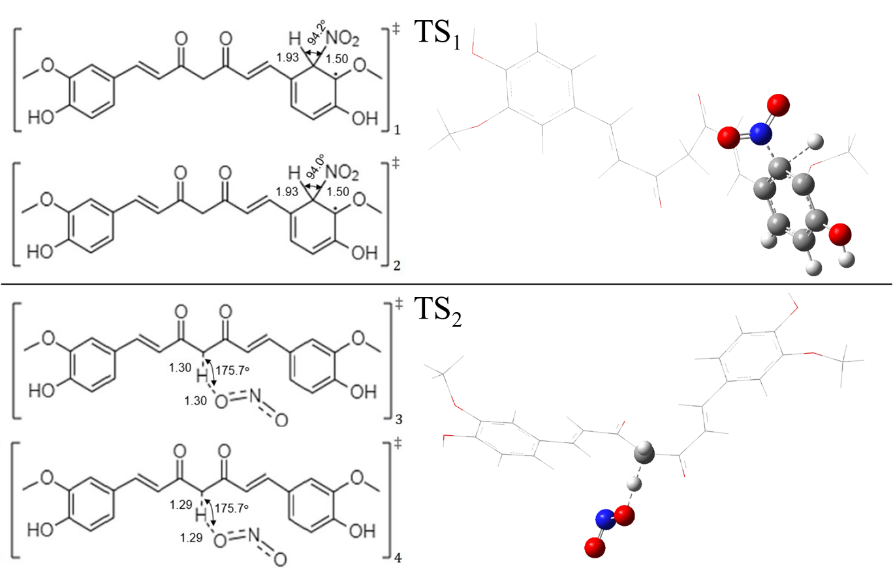

### **Figure 1S.** Angles in degrees and distances in angstroms of the transition state geometries. The index in the bottom right corner of each geometry corresponds to No column in Table 1S. The transition state geometries 1 and 2 present a bond between the ring carbon and the released hydrogen, referred here as the “breaking bond” from R1. The corresponding bonds between this ring carbon and the nitro group are called the “forming bond” from R1. The transition state geometries 3 and 4 present a bond between the center carbon and the attacked hydrogen, referred to as the “breaking bond” from R2. Its respective bonds between this hydrogen and the bonded oxygen are referred to as the “forming bond” from R2.

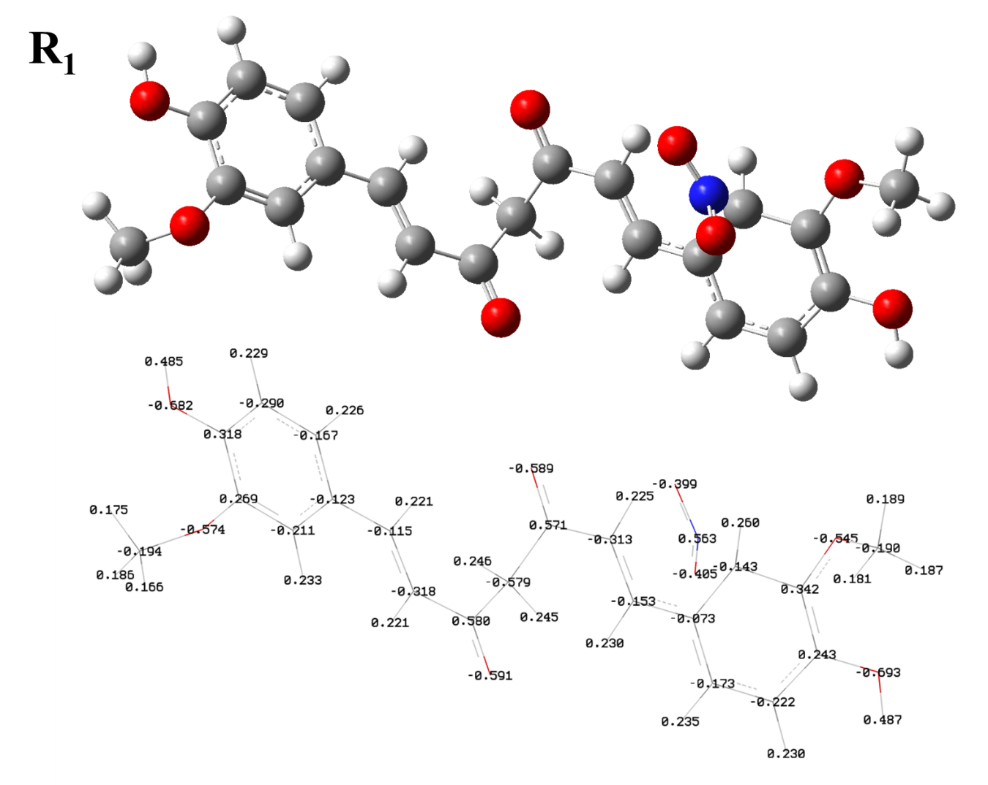

### Figure 2S. NBO Charges of Additional Atoms in Reactant 1 at the M06-2X/6-311G(d) level theory.

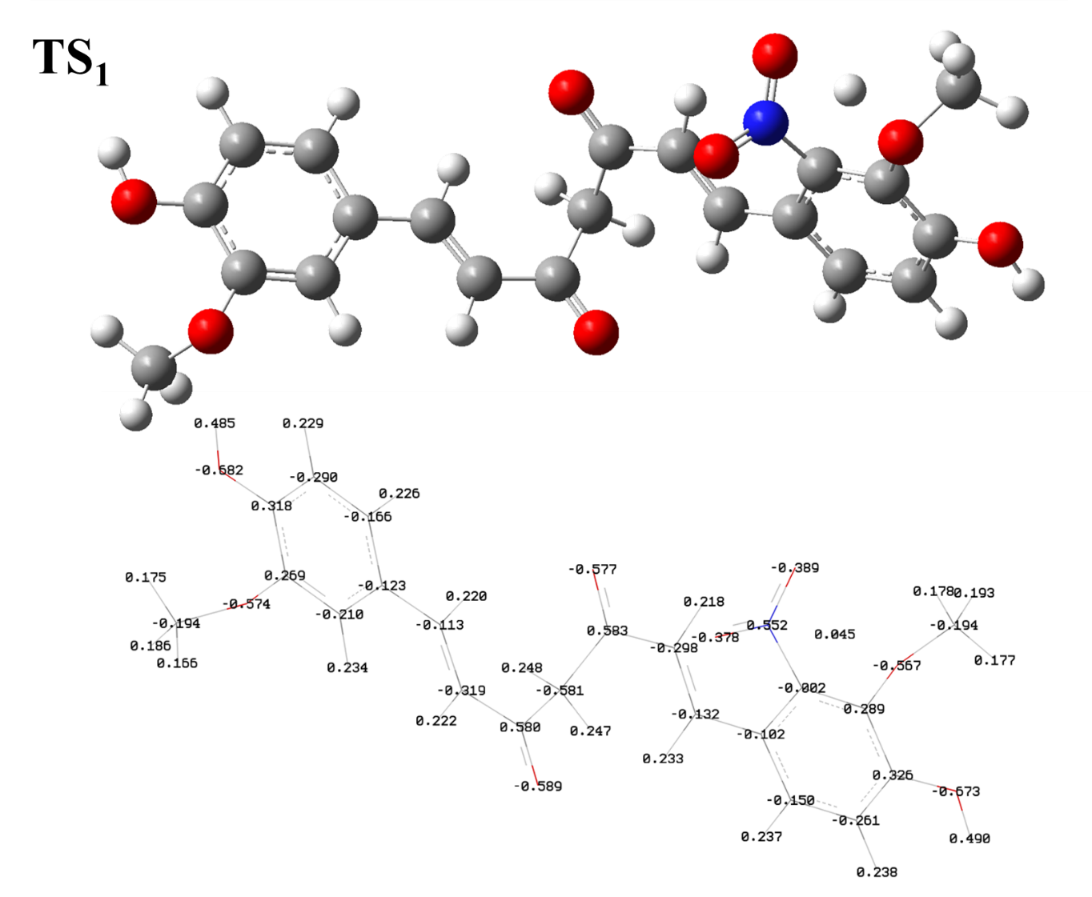

Figure 3S. NBO Charges of Additional Atoms in Transition State 1 at the M06-2X/6-311G(d) level theory.

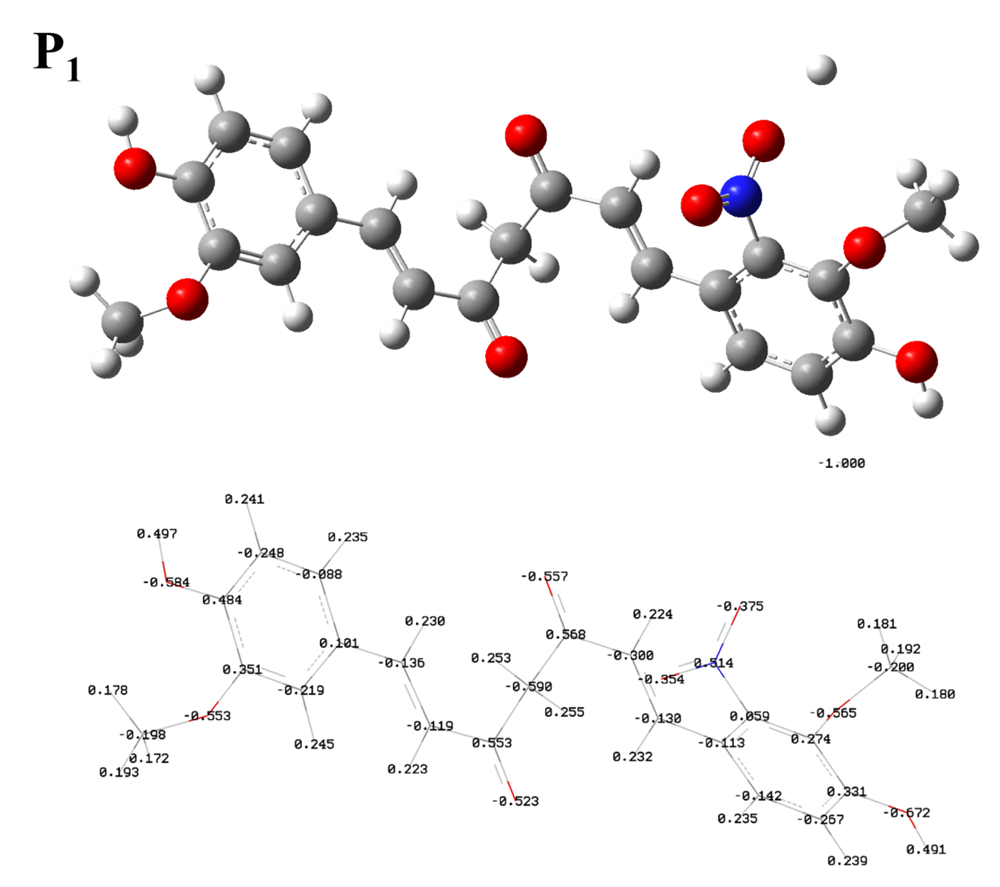

Figure 3S. NBO Charges of Additional Atoms in Product 1.

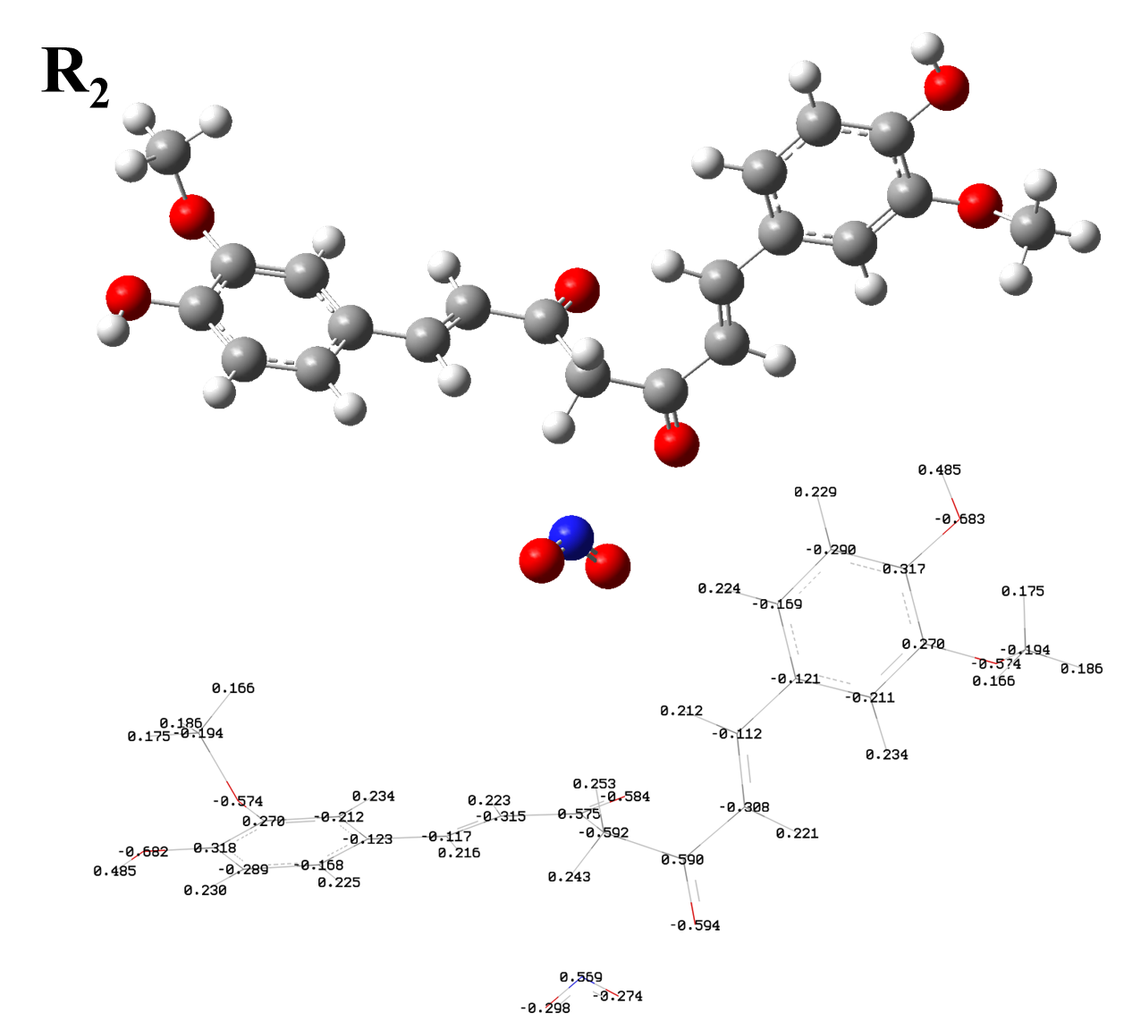

### Figure 5S. NBO Charges of Additional Atoms in Reactant 2 at the M06-2X/6-311G(d) level theory.

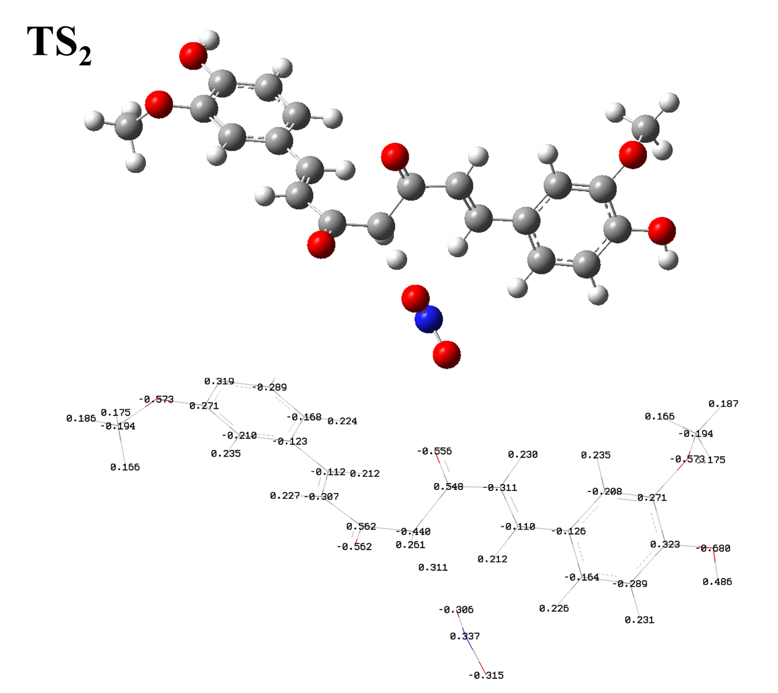

### Figure 3S. NBO Charges of Additional Atoms in Transition State 2 at the M06-2X/6-311G(d) level theory.

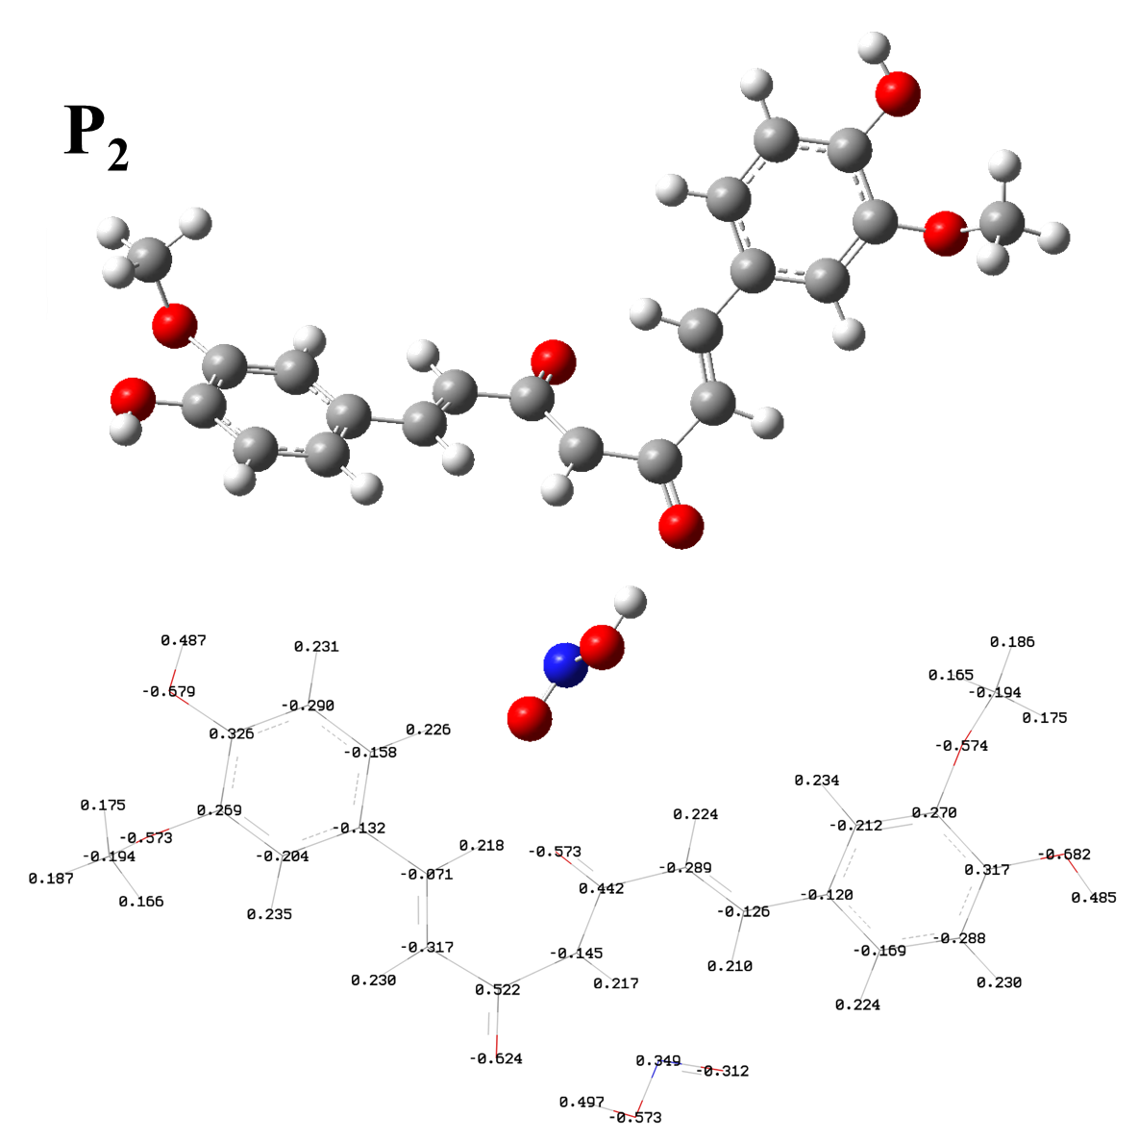

### Figure 3S. NBO Charges of Additional Atoms in Product 2 at the M06-2X/6-311G(d) level theory.