Group members

Matthew Sankey u14157022  
Anneta Wamono u14032512  
David Behr u14017297  
Richard Lubbe u14206642  
Quinton Swanepoel u15245510

Phase 1: Proposal And concept

Floating Goat Games – “We the People”

Contents

Executive Summary 2

Summary of the game 2

Problem 2

Colour scheme 2

Interactivity 2

Layout 3

1. Splash Screen 4

2. Home Screen 4

3. Team Screen 5

4. Gallery Screen https://discord.gg/jaaVMb7 5

5. About Screen 6

References 7

# Executive Summary

The proposal will be following the format set by the *Penn State Learning Factory* (Gordon, 2010). The purpose of this proposal is to put forward the potential design of the website for our game, “We The people”. Our game is set during the later phases of the cold war, where the main character is an insurgent operative attempting to take down the superpowers form the inside. The website will follow the thematic design that is associated with the cold war.

# Summary of the game

As stated above Our game is set during the later phases of the cold war, where the main character is an insurgent operative attempting to take down the superpowers form the inside. The player is tasked with navigating military bases, collecting vital information, and avoiding detection with the end goal of attempting to disable the military bases nuclear weaponry, and thus trying to end the cold war. It is important to note that the character and the character’s organisation does not take a side in the war. The insurgent group is neutral with the end goal of peace.

# Problem

To design a website to effectively advertise and demonstrate our game. The website should effectively communicate the theme of the cold war, but to also communicate the neutrality of the side that the insurgent group is fighting for.

# Colour scheme

“*If the Cold War had a flag, it would be red, orange and green*” (Strukov, 2014). This will be the overtone for our website. The primary colours of our website will include red, orange and green. The red would primarily represent the American propaganda that aimed to distract the public from the politics of colour (Strukov, 2014). The orange would represent competition between the two superpowers in technology, science and human endeavour, as well as represent the fact that the orange spacesuit has always been a symbol of its supremacy in space exploration, which was a big contributing factor of the Cold War. The green represents the financial instability that resulted because of the cold war. “*In this sense green is the colour of another cold war*” (Strukov, 2014).

The website will contain a lot of black to represent the fact that the insurgent group the character fights for is neutral. “*Neutral colours include black, white, grey, and sometimes brown and beige*” (Infoplease, 2000).

# Interactivity

On each page, the background images will slide in and out with a fade effect and animation. This effect can be achieved by using CSS and JavaScript.

When clicking on the various links, the page will appear to pixelate and then fade into the next page. This can be done by using a plugin called charming.js See Mary Lou’s “Animated pieces” for reference. (Lou, 2017)

On each page there will be subheadings, and when that subheading is hovered over and/or click on, the information relating to that subheading will then be revealed through either a fade in animation, a slide animation, or a pixelized animation. This can be achieved through pure JavaScript and CSS.

The image gallery will take the form of a carousel, and when scrolling through, an animation will be triggered to break the pictures up into blocks, and as they move to the centre of the screen, they reform into the original image. This effect can also be achieved through the plugin called charming.js as well as anime.js

When the user moves the mouse, the current background image appears to slightly tilt in the direction of the cursor’s position. This effect can also be achieved through the plugin called charming.js as well as anime.js

The splash screen will have a black background which will have an animated static effect – see limbo’s website for reference to animated rain background for inspiration. (Playdead, 2010).

The team members page will contain a grid of profile pictures of each of the members of the team. When one of the profile pictures is clicked, information about that team member will slide in from the right, pushing the other profile picture to the left to makes space for the information. This animation will take place any time one of the profile is viewed. This can be achieved using JavaScript and CSS.

Throughout the website, there will be hidden Easter eggs for the user to find. Key words will be scattered around the website, visibly noticeable to the user. When these keywords are hovered over or clicked on, the user will either be re-directed to our games introduction video, or a small snippet of game play, changing the background images to fade to red and then fade in the game’s logo, or even just triggering a static interference animation to distort the website briefly to give the effect and feel of espionage, finding clues and discovering new secrets.

# Layout

The proposed layout of the website is displayed in the rough illustrations in the pages to follow

Links will be stored at the top of the page, and information will be grouped towards the left of the page. The images sourced will be those relating to the cold war. The font used will be “vevenda” to give the website an 80’s feel.

The website has been separated into separate pages as opposed to a single page scrollable page. We made this decision as to isolate the required information to their respective pages, making it easier to find and retrieve information about the game

## Splash Screen

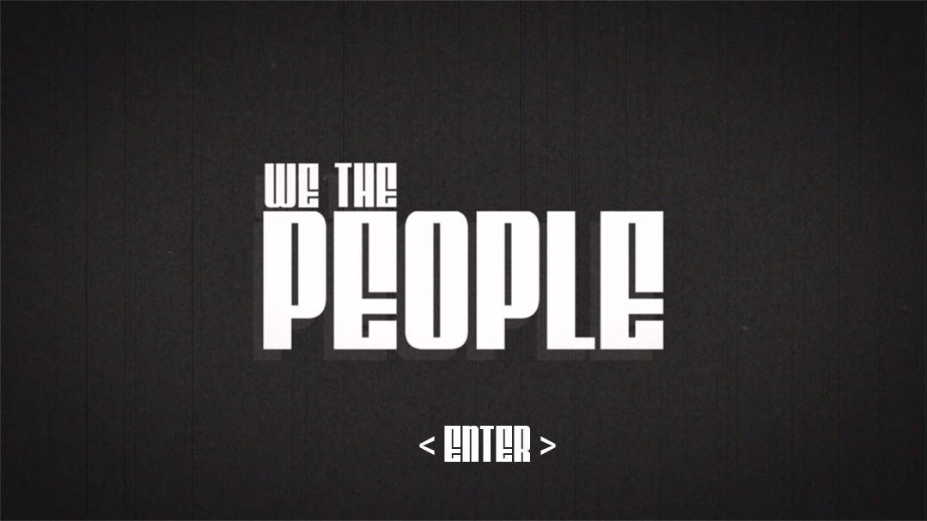

## Home Screen

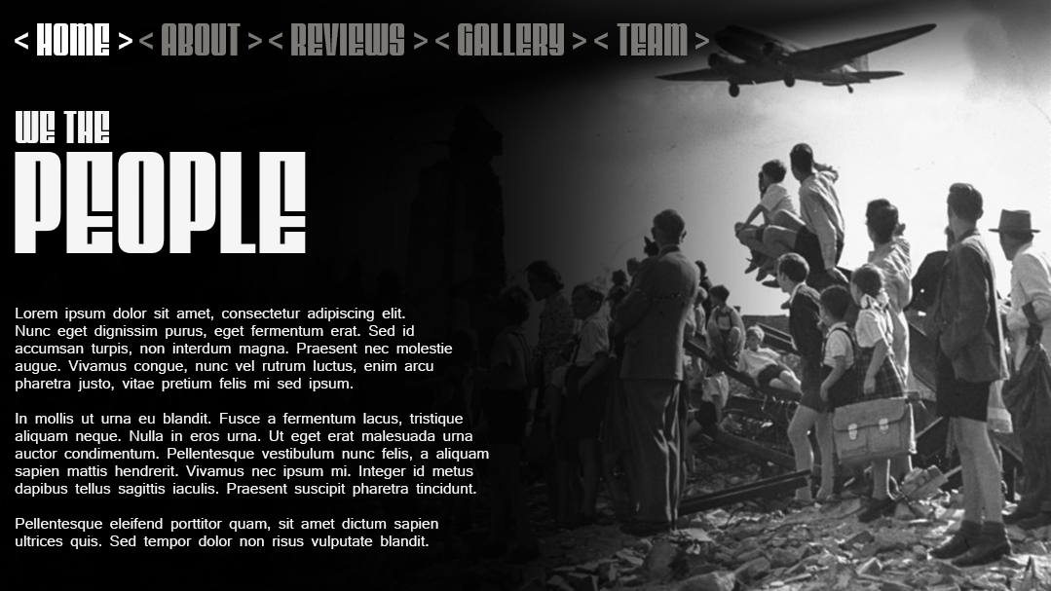

## Team Screen

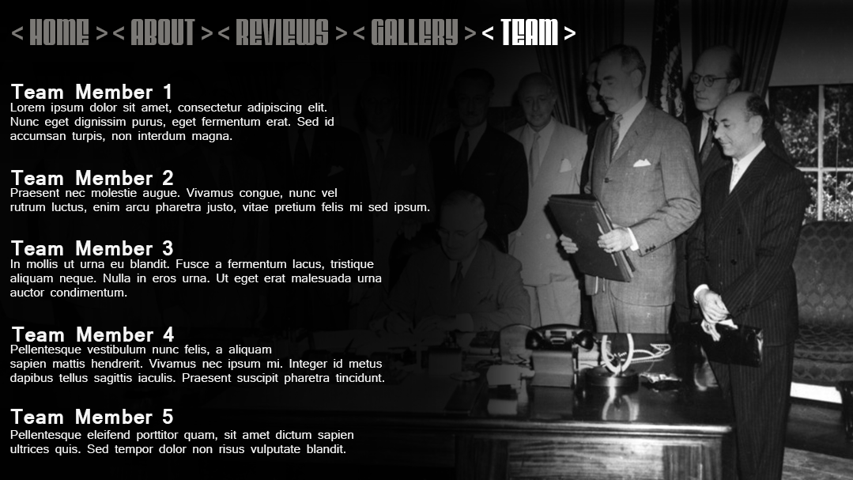

## Gallery Screen https://discord.gg/jaaVMb7

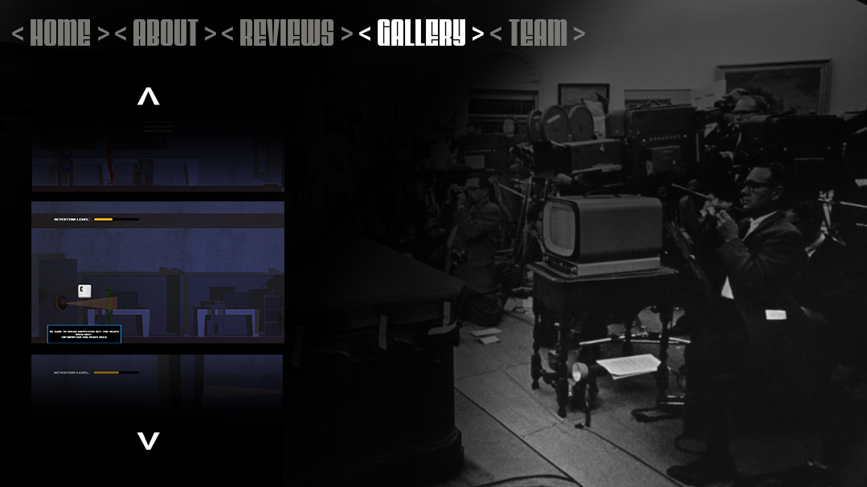

## About Screen

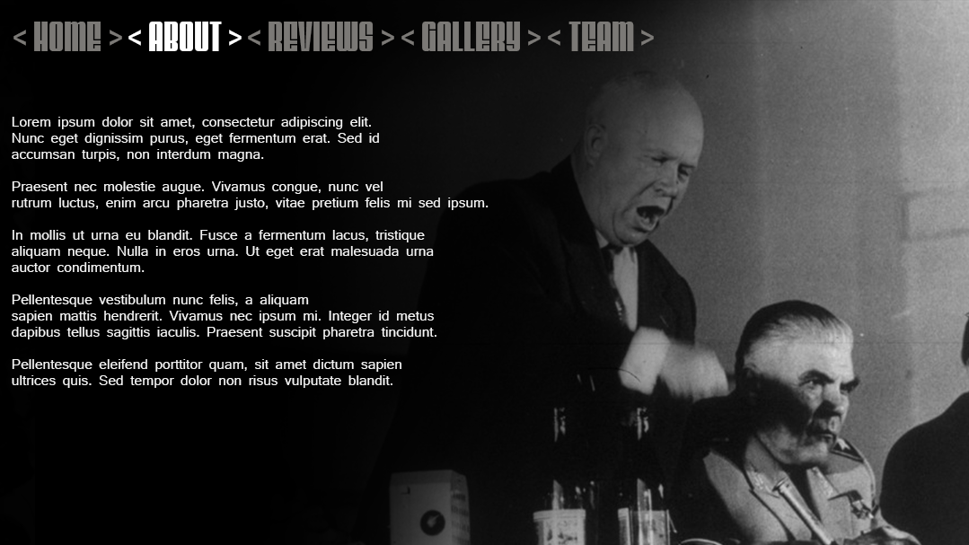

# References

Anon., 2014. *cnn.com.* [Online]   
Available at: http://edition.cnn.com/2014/03/04/world/gallery/cold-war-history/index.html  
[Accessed 20 August 2017].

Gordon, B. M., 2010. *Penn State Learning Factory.* [Online]   
Available at: http://www.lf.psu.edu/  
[Accessed 19 August 2017].

Infoplease, 2000. *Neutral Colors.* [Online]   
Available at: www.infoplease.com/arts-entertainment/neutral-colors  
[Accessed 2017 August 19].

Lou, M., 2017. *Animated Image Pieces.* [Online]   
Available at: https://tympanus.net/codrops/2017/04/18/developerdesigner-page-layout-concept/  
[Accessed 20 August 2017].

Lou, M., 2017. *Developer/Designer Page Layout Concept.* [Online]   
Available at: https://tympanus.net/codrops/2017/04/18/developerdesigner-page-layout-concept/  
[Accessed 20 August 2017].

Playdead, 2010. *Limbo.* [Online]   
Available at: http://www.playdead.com/games/limbo/  
[Accessed 20 August 2017].

Strukov, V., 2014. *Political spectrum: the three colours of the Cold War.* [Online]   
Available at: http://www.calvertjournal.com/opinion/show/3292/red-orange-green-cold-war-colours  
[Accessed 19 August 2017].