Parallel Programming

For this programming assignment I had to observe the differences between the efficiency of sequential, openMP, and C++11 implementations for theoretical medicine creation.

To start, I downloaded the given programs for comparing ligand strings. Later extracting the files for each implementation. The first task required running the default cases for each implementation. So, for the first case I entered the sequential directory to compile the file using make. After an executable was created I ran the program using time -p ./dd_serial in order to record the time it took for the program to complete. Resulting in 128 seconds for it to complete.

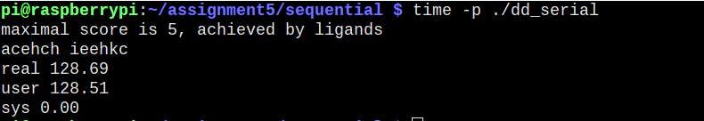

To finish the table for default times I repeated the process of compiling the respective files using make and printing the time each took.

OpenMP:

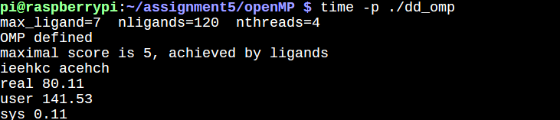

And threads:

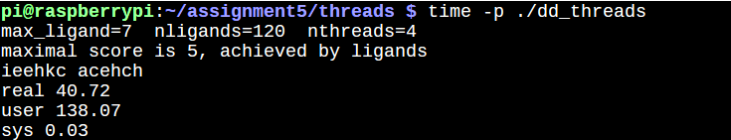

The next task was to record the times for openMP and threads using different thread counts. To do this had to append the specific numerical arguments I wanted for the program’s ligand count, max length , and threads. I noticed that with less threads each took more time to complete, yet the C++11 implementation still ran faster than the openMP version:

openMP using 2 threads:

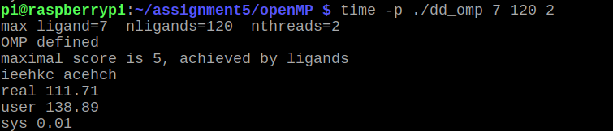

threads using a thread count of 2:

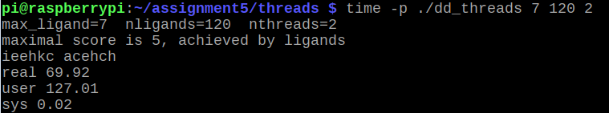

From the discussion questions, I’ve observed C++11 was able to complete the same tasks as openMP swifter, with only a few more lines code used. With this upon observing a larger case with 9 ligands, the difference between them was starker with C++11 completing 10 minutes ahead.

**Initial Data Collection**

Base Time Comparison:

|  |  |
| --- | --- |
| Implementation Used | Time |
| dd_serial | 128.69 |
| dd_OpenMP | 80.11 |
| dd_threads | 40.72 |

Thread Count Comparison:

|  |  |  |  |
| --- | --- | --- | --- |
|  | Time(s) 2 Threads | Time(s) 3 Threads | Time(s) 4 Threads |
| dd_OpenMP | 111.71 | 96.23 | 69.33 |
| dd_threads | 69.92 | 53.46 | 41.87 |

**Discussion Questions**

1. The thread C++11 approach resulted in faster completion.
2. dd_OpenMP = 193 lines | dd_threads = 207 lines. C++11 had only 14 more lines of code than OpenMP.
3. 5 Threads Test:

|  |  |
| --- | --- |
| Implementation Used | Time(s) 5 Threads |
| dd_OpenMP | 64.21 |
| dd_threads | 37.44 |

4. 9 Ligand Test:

|  |  |
| --- | --- |
| Implementation Used | Time(s) 9 Ligands |
| dd_OpenMP | 2672.16 |
| dd_threads | 2075.03 |