Echo, a Memory Game

Christen Ward

CS 449
University of Missouri – Kansas City

Revision History
Author | Date | Revision
Christen Ward | 9/11/2015 | Initial Release
Christen Ward | 9/26/15 | Iteration #1

Table of Contents
Vision Statement 4
Requirements 5
Step #1: Identify Categories of Users 5
Step #2: Create Actor-Goal List 5
Step #3: Identify User Stories 6
Step #4: Write Use Cases 7
Release Plan 10
Iteration #1 11
Iteration #1 Review Meeting 12
Iteration #1 Retrospective 12
Design 13
Coding Standards 14
Project Summary and Retrospective 16

Vision Statement
For mobile users who enjoy playing short, fun and easy casual games, Echo is a mobile game app that is entertaining and simple. Unlike regular memory games such as Simon, my product is simpler yet has compelling added features.

Requirements
Before you can build something you have to know what it is that needs building.
The vision statement sets the direction for the project but isn’t detailed enough to begin high-level planning let alone programming.
Requirements tend to evolve from the general to the more specific. At a minimum, product requirements should be specified as a prioritized list of user stories with effort estimates for each story. Effort may be specified in units of story points or ideal days/hours. Effort estimates are needed so the product owner can prioritize the stories. Accept free form voice commands might seem like a nice feature (high priority item) until the product owner realizes it will cost a small fortune to implement.
Sometimes it helps to elaborate requirements in greater detail before planning project iterations. If requirements aren’t expected to change significantly during product development and can be determined without feedback from early system increments, exploring requirements in greater detail at the start of the project is likely to lead to better estimates and more efficient plans. Detailed requirements are often specified with use cases and system shells.

Step #1: Identify Categories of Users
Casual Gamers – people with enough knowledge to navigate a mobile game and retain simple sequences in memory.

Step #2: Create Actor-Goal List

Actor | Goal
User | Memorize shown pattern
 | Look at buttons to see which one light up and play a sound
AI | Create a pattern
 | Add a random color to the pattern
 | Play the sound and light up the button
AI Listener | Check to see if user input is the correct pattern
 | Make sure the time in between button presses is not too long

Step #3: Identify User Stories

Product Backlog
The collection of stories makes up your project’s product backlog:

Story ID | Story | Story Points | Priority | Status
S1 | Display buttons on the screen to be pressed. | 6 | 1 | Completed
S2 | Make the buttons touch responsive; make them light up and play a distinct sound when pressed. | 12 | 2 | Completed
S3 | Devise AI that will generate a random sequence. | 18 | 1
S4 | Devise an AI listener that will wait for the user to press the correct buttons in the sequence. | 24 | 1
S5 | Track high scores of the user locally. | 12 | 3
S6 | Track high scores of all users in a leaderboard. | 30 | 3
S7 | Let the user pick which kind of sounds the buttons play. | 12 | 3
S8 | Let the user choose a difficulty. | 12 | 3

[Step #4: Write Use Cases]
Use cases describe how users will interact with the system. They are an excellent way of capturing detailed functional requirements. Use cases may be written at the beginning of the project or during the iteration in which the features they describe are implemented.
Example:
Title: | Find and subscribe to quizzes
Use case ID: | UC001
Actor: | Quiz Taker
Description: | This use case describes the system interactions needed to find and subscribe to a new quiz.
Basic Flow:
- This use case begins when a quiz taker elects to search for a new quiz.
- The system responds by showing a complete list of available quizzes. Quizzes that the quiz taker is currently subscribed to are shown but not selectable. Quizzes the user has never taken, or has taken in the past but is not currently subscribed to, are selectable. The system shows the title of available quizzes.
- The quiz taker selects one of the selectable quizzes.
- The system shows the selected quiz as selected.
- The quiz taker elects to exit the search function. The quiz taker is now subscribed to the selected quizzes.
Alternate Flows:
2a. There are no quizzes available.
1. The system displays a message that no quizzes are available.
3a. The quiz taker selects more than one quiz.
1. All selected quizzes are shown as selected.
3b. The quiz taker wants to unselect a quiz.
1. The quiz taker repeats the select operation on the quiz he or she wants to unselect.
2. The quiz is shown as unselected.
Exceptions:
2. There is a format error in quiz data.
- The quiz taker is presented with an error message identifying the quiz or quizzes that are incorrectly formatted. The error message identifies the incorrectly formatted quiz without giving away any of the data on specific questions. Service continues with data from correctly formatted quizzes.
Open issues:
- If there are no quizzes available, should the quiz taker be given instructions on how to gain access to quizzes? This could be useful in situations where the quiz data files have been misplaced, moved or deleted.

When documenting detailed requirements at the beginning of a project, consider using system shalls to specify requirement detail that isn’t conveniently captured by stories and use cases.
There are an incredible amount of detailed decisions that have to be made even for simple applications. For example:
- If a user enters a valid ID but invalid password should the system be helpful and respond that only the password was incorrect or report back a generic “logon attempt failed”?
- How many logon attempt failures for a valid ID are allowed before the system blocks attempts? During what timeframe?
- Should blocking be temporary? If so, how long is “temporary”?
That’s 5 questions that need to be answered and we haven’t even got past the login. Documenting these decisions in use case specifications will likely make them unreadable. These detailed requirements that aren’t part of the abstract or logical behavior of the system can be specified in a long list of “system shalls”.
Example:
- While taking a quiz, a quiz taker shall be able to save partial results.
- The system shall provide the quiz author the ability to create multiple choice, true/false and multiple selection questions.
- The system shall automatically grade multiple choice, true/false and multiple selection questions.
- The system shall provide the quiz author the ability to create essay questions.
- The system shall automatically grade essay questions.
- The system shall give authors the ability to create pass/fail quizzes.
- The system shall give the author the ability to limit the feedback given to quiz takers. (For example, the quiz author might want to prevent the quiz taker from seeing his or her score.)
- The system shall keep quiz answers confidential. Users should not be allowed unauthorized access to answers.

It may also be helpful to document decisions or facts from the problem domain that might be useful in specifying requirements. Doing so helps avoid repeatedly asking the customer and can avoid reopening discussions/debates. For example, here are some general business rules for a loyalty rewards program:
- Customer earns points on every purchase at participating merchants at a rate of 1 point per $1 spent.
- Points are redeemed in units of 100. Every 100 points is worth $5 off select items
- Merchants can decide what items can be purchased at a discount using points
- Customers are not allowed to earn points when redeeming points (on cash balance of transition)

If there are important non-function requirements, consider documenting them separately.
Example:
The system shall be easy to use. A representative user fitting the profile of Volunteer described above without any prior experience with the application should be able to find and subscribe to a specific quiz in less than 2 minutes.

Sprint #1
Before you can plan a sprint you need a prioritized list of user stories (the product backlog). Factors to consider when prioritizing stories include [Cohn, Agile Estimating and Planning]:
- Business value of feature
- Cost of implementation (story points or ideal days)
- Amount and value of new knowledge gained by developing the feature
- Risks resolved as a consequence of implementing the feature

Another important step in sprint planning is estimating project velocity. Project velocity is a measure of how much work is being completed each iteration (sprint). It is usually expressed using the same unit of measure used to estimate story effort (typically story points). For the first iteration, project velocity must be estimated based on past projects. After the first iteration, project velocity can be predicted based on the completed iterations.

The Sprint Backlog identifies stories planned for the sprint along with tasks necessary to complete each story.

Sprint Backlog
Story ID | Story / Task | Estimated  Hours | Actual  Hours
S3 | Display buttons on screen | 2 | 4
S2 | Make the buttons touch responsive | 4 | 6
 | Make the buttons light up when touched | 2 | 4
 | Make the buttons play sound when touched | 3 | 3

Iteration #1 Review

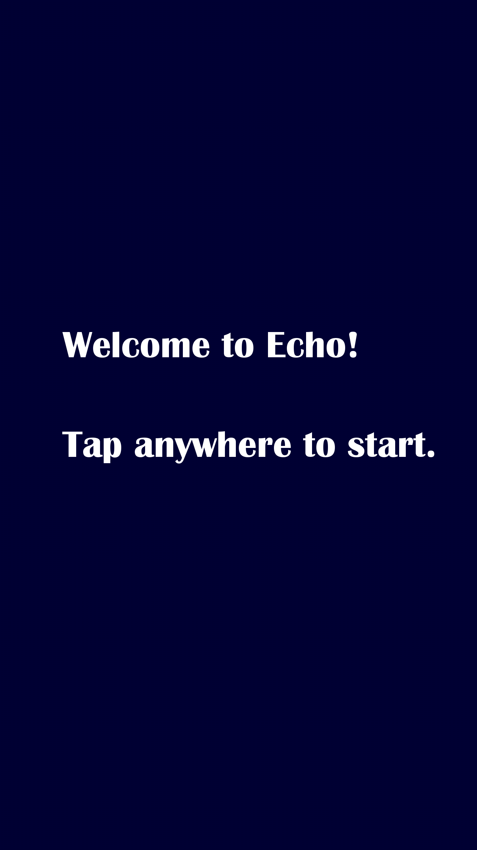


Iteration #1 Retrospective
Displaying the buttons on screen went well. Things that could have gone better was the selection of sounds that play when the buttons are pressed, and implementing better animations for when they light up. I will remedy this by finding a better source of sounds for the buttons.

18
25
20
15
10
5
1
 | Sprint 1 | Sprint 2 | Sprint 3 | Sprint 4 | Sprint 5 | Sprint 6

Sprint #2
Sprint Backlog
Story ID | Story / Task | Estimated  Hours | Actual  Hours
S3 | Devise an AI that will generate a random sequence | 6
S4 | Create a AI listener | 4
 | Make the AI display the sequence | 6
 | Make the AI wait for player input | 4
 | Make the AI able to determine correct input, and add another to the sequence if correct | 8

Design
[What is the overall structure of the solution? What are the major modules of code? What are the dynamics of communication between these modules? The most common way of depicting this information is with static and dynamic models augmented with short narrative descriptions of design.]

Coding Standards
Coding standards improve readability. They make it easier to understand code written by others. Good coding standards also improve reliability.
TBD

