INFSCI 2310 Final Report

**Network Analysis of Flights Between US Cities**

Figure1: Flight Network Visualization

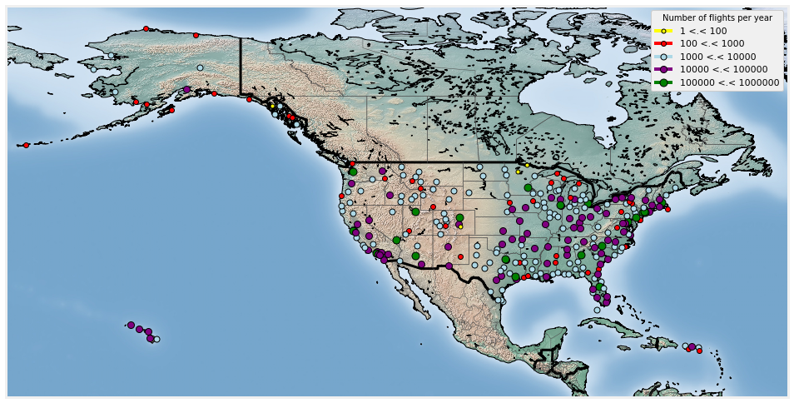

**Legend Explained:**

* Yellow dots: Airports with less than 100 flights per year.
* Red dots: Airports with 100 to 1,000 flights per year.
* Blue dots: Airports with 1,000 to 10,000 flights per year.
* Purple dots: Airports with 10,000 to 100,000 flights per year.
* Green dots: Airports with 100,000 to 1,000,000 flights per year.

**Findings Text Introducing Highlights of the Produced Figure in Bulletin Points:**

* The majority of flight activity is concentrated in specific regions, suggesting major travel hubs.
* There is a clear trend of increased flights in coastal areas, indicating higher travel demand.
* A significant number of airports handle a very high volume of traffic, emphasizing the need for efficient air traffic control in these areas.

**Data Gathered from:**

<https://www.kaggle.com/datasets/vikalpdongre/us-flights-data-2008>, provided through Kaggle.

Figure3: Flight Count

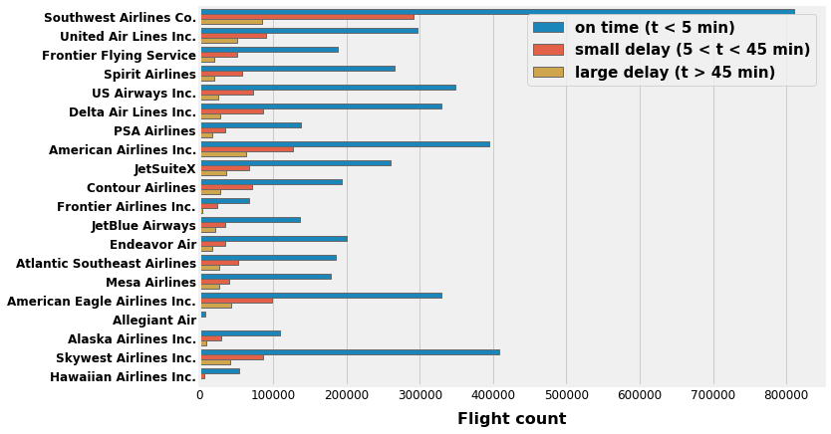

**Legend Explained:**

* Blue bar: Flights on time (t ≤ 5 minutes)
* Orange bar: Flights with a small delay (5 minutes < t < 45 minutes)
* Gray bar: Flights with large delay (t > 45 minutes)

**Findings Text Introducing Highlights of the Produced Figure in Bulletin Points:**

* Southwest Airlines Co. has the highest number of on-time flights, which reflects their operational efficiency.
* While United Air Lines Inc. and Frontier Airlines Inc. show a significant number of flights, they also have a notable proportion of small and large delays.
* Smaller airlines like Allegiant Air and Hawaiian Airlines Inc. have a relatively high on-time performance, suggesting efficient punctuality management despite fewer flights.
* The overall flight count indicates that while larger airlines handle a greater volume of traffic, they also tend to have a higher occurrence of delays.

**Data Gathered from:** <https://www.kaggle.com/datasets/vikalpdongre/us-flights-data-2008>

Figure3: Origin Airport Distribution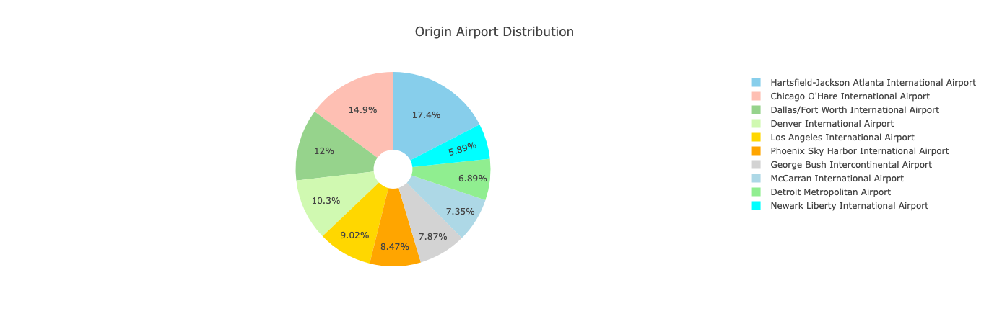

**Legend Explained:**

* Blue: Hartsfield-Jackson Atlanta International Airport - 17.4%
* Salmon: Chicago O'Hare International Airport - 14.9%
* Green: Dallas/Fort Worth International Airport - 12%
* Light Green: Denver International Airport - 10.3%
* Yellow: Los Angeles International Airport - 9.02%
* Orange: Phoenix Sky Harbor International Airport - 8.47%
* Grey: George Bush Intercontinental Airport - 7.35%
* Grey Blue: McCarran International Airport - 6.89%
* Leaf Green: Detroit Metropolitan Airport - 5.89%
* Bright Blue: Newark Liberty International Airport - 4.7%

**Findings Text Introducing Highlights of the Produced Figure in Bulletin Points:**

* Collectively, the top three airports constitute nearly 45% of the origin flights, indicating a high concentration of traffic at these hubs.
* The distribution shows that a small number of airports dominate as starting points for US flights, which may impact national air traffic patterns and resource allocation.

**Data and Method Text Describing the Data and Method Used in This Process:**

* Analytical Tools: Utilized Python for data cleaning, manipulation, and visualization, employing libraries such as Pandas for dataset operations, Matplotlib for creating charts, and geospatial libraries for mapping.
* Methodology: Statistical methods were used to analyze flight distributions and punctuality across US airports and airlines. The visualizations are designed to clearly depict the scale and traits of the flight data.

**Significance Statement on Why the Presented Figures are Important:**

* The geospatial distribution map underscores the spatial dynamics of flight frequencies, highlighting infrastructural and logistical hotspots.
* The pie chart of origin airport distribution offers a clear view of the central hubs of US air traffic, which is pivotal for strategic decisions in capacity planning and route management.
* The airline punctuality bar chart reflects the reliability of different carriers, essential for consumer choice and airline competitive strategy.

**GitHub Link:** [**https://github.com/QuinceyNiu/InfoViz2023Fall**](https://github.com/QuinceyNiu/InfoViz2023Fall)