**Exploration of the Interaction between Human and Digital Information in the Womb Interactive Installation**

Qian Xu

Creative Computing Institute, University of the Arts London

London, United Kingdom

[xuqianapp@gmail.com](mailto:xuqianapp@gmail.com)

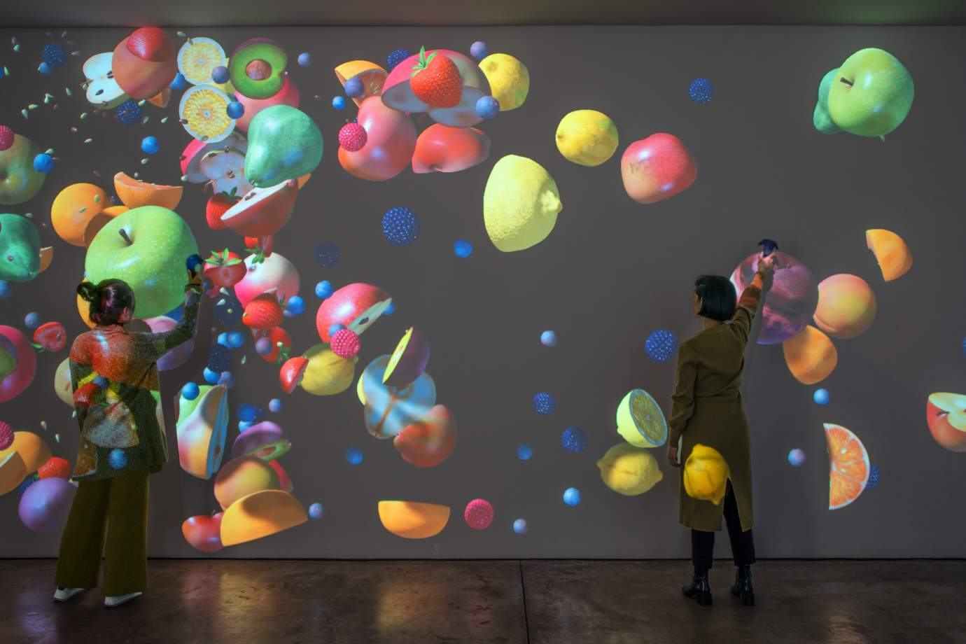

Note: picture is taken from the webpage <https://moody.rice.edu/exhibitions/womb>

**Womb**, 2019  
Interactive installation of VR equipment  
Courtesy of the artist and Lehmann Maupin, New York, Hong Kong, Seoul, and London

The Womb Interactive Installation is an immersive VR device that utilizes projection technology and computer-generated graphics to create a virtual simulation of a womb. The exhibition space consists of a large projection screen and interactive areas where visitors' movements and touch can interact with the screen, manipulating the movement and variation of the computer-generated images. This technology is achieved through computer programming, where the program changes the projection of the images according to the audience's position.

From my understanding, the theme of this artwork revolves around the exploration of the interaction between human and digital information and the exploration of the body and space. Through an elegant art form, the artist offers visitors a unique experience that conveys the fascinating relationship between life and digital technology. The artwork's name is a pun that suggests that the fruit is a mature womb. Overall, this exhibition attracts visitors' attention to the lifecycle of nature and artificial objects.

This theme has also been explored in many other artworks, such as Molmol Kuo and Zach Lieberman's Disrupt, an interactive device that explores the relationship between the body and digital information. However, these artworks employ different methods and techniques to explore similar themes in different ways.

The most attractive aspect of Womb, to me, is the immersive artistic experience it provides to the audience. It creates a virtual ecosystem that feels like a world apart, and through interactions between the artwork and the viewers, it provides enjoyment while also inspiring deeper thoughts.

In my view, while this piece of art is charming, there is still room for further development. For example, in terms of interactivity, traditional VR human-body interaction can feel relatively monotonous, and more interactive experiments can be considered. This can include improving the program to create a unique experience, such as changing the atmosphere through lighting or sound effects, and increasing the contact surface between the user and the artwork by adding more artistic facilities or sensors, for example the sound and heartbeat sensors. By enriching the experience, the immersion of the audience can be further enhanced. Additionally, different projection technologies and materials can also be considered.

Jennifer Steinkamp (born in 1958 in Denver, Colorado; living and working in Los Angeles) holds a Bachelor of Arts, a Master of Fine Arts, and an Honorary Doctorate. She graduated from the Art Centre College of Design in Pasadena, California. Her works have been exhibited in many places. The difference between Jennifer Steinkamp and other artists is notably reflected in the artistic style of her works. As a digital artist, her works aim to explore the relationship between the natural world and digital technology, possessing a unique sense of immersive experience and interactivity, filled with delicate emotional expression. In contrast, other artists may focus more on the work itself and the use of computer technology.

This article has inspired me to see that traditional digital technology can also convey profound artistic concepts. I believe that I should learn from this artist's mindset, study how to combine digital art with other art forms, and perhaps create a special chemical reaction that produces unique and eye-catching art.

As for the background information about the award, Womb Interactive Installation is Jennifer Steinkamp's artwork, which won the American New Media Art Award in 2004. Jennifer Steinkamp has won many awards and honours, including being a Fellow of the American Academy of Arts and Letters and the American Academy of Arts and Crafts, and the American New Media Art Award. Her works have been exhibited in museums and galleries around the world, including the Los Angeles County Museum of Art, the Museum of Modern Art in New York, and the Louvre in Paris. Interview information about the artist can be found on her personal website (<https://jsteinkamp.com/>).