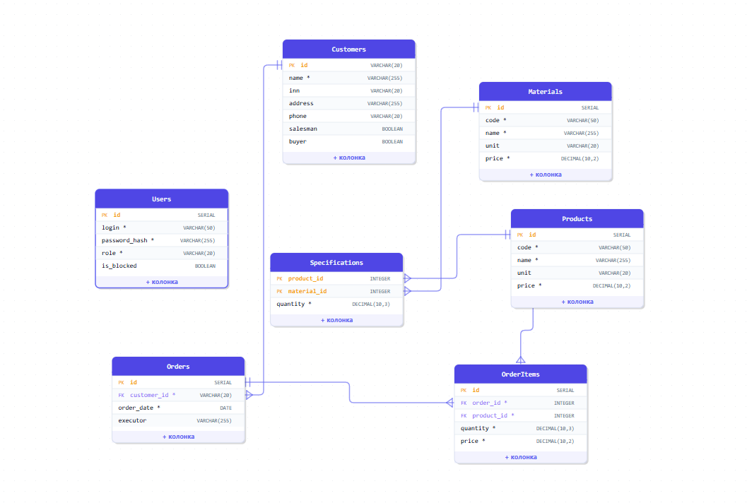
-- 1. ЗАКАЗЧИКИ
CREATE TABLE Customers (
id VARCHAR(20) PRIMARY KEY,
name VARCHAR(255) NOT NULL,
inn VARCHAR(20),
address VARCHAR(255),
phone VARCHAR(20),
salesman BOOLEAN,
buyer BOOLEAN
);

-- 2. ПРОДУКЦИЯ
CREATE TABLE Products (
id SERIAL PRIMARY KEY,
code VARCHAR(50) UNIQUE NOT NULL,
name VARCHAR(255) NOT NULL,
unit VARCHAR(20),
price DECIMAL(10,2) NOT NULL
);

-- 3. МАТЕРИАЛЫ
CREATE TABLE Materials (
id SERIAL PRIMARY KEY,
code VARCHAR(50) UNIQUE NOT NULL,
name VARCHAR(255) NOT NULL,
unit VARCHAR(20),
price DECIMAL(10,2) NOT NULL
);

-- 4. СПЕЦИФИКАЦИЯ
CREATE TABLE Specifications (
product_id INTEGER NOT NULL,
material_id INTEGER NOT NULL,
quantity DECIMAL(10,3) NOT NULL,
PRIMARY KEY (product_id, material_id),
FOREIGN KEY (product_id) REFERENCES Products(id),
FOREIGN KEY (material_id) REFERENCES Materials(id)
);

-- 5. ЗАКАЗЫ
CREATE TABLE Orders (
id SERIAL PRIMARY KEY,
customer_id VARCHAR(20) NOT NULL,
order_date DATE NOT NULL,
executor VARCHAR(255),
FOREIGN KEY (customer_id) REFERENCES Customers(id)
);

-- 6. СОСТАВ ЗАКАЗА
CREATE TABLE OrderItems (
id SERIAL PRIMARY KEY,
order_id INTEGER NOT NULL,
product_id INTEGER NOT NULL,
quantity DECIMAL(10,3) NOT NULL,
price DECIMAL(10,2) NOT NULL,
FOREIGN KEY (order_id) REFERENCES Orders(id),
FOREIGN KEY (product_id) REFERENCES Products(id)
);

-- 7. ПОЛЬЗОВАТЕЛИ
CREATE TABLE Users (
id SERIAL PRIMARY KEY,
login VARCHAR(50) UNIQUE NOT NULL,
password_hash VARCHAR(255) NOT NULL,
role VARCHAR(20) NOT NULL,
is_blocked BOOLEAN
);
-- ЗАКАЗЧИКИ
INSERT INTO Customers (id, name, inn, address, phone, salesman, buyer) VALUES
('000000001', 'ООО "Поставка"', '', 'г.Пятигорск', '+79198634592', true, true),
('000000002', 'ООО "Кинотеатр Квант"', '26320045123', 'г. Железноводск, ул. Мира, 123', '+79884581555', true, false),
('000000003', 'ООО "Ромашка"', '4140784214', 'г. Омск, ул. Строителей, 294', '+79882584546', false, true),
('000000008', 'ООО "Новый JDTO"', '26320045111', 'г. Железноводсу', '+79884581555', true, false),
('000000009', 'ООО "Ипподром"', '5874045632', 'г. Уфа, ул. Набережная, 37', '+79627486389', true, true),
('000000010', 'ООО "Ассоль"', '2629011278', 'г. Калуга, ул. Пушкина, 94', '+79184572398', false, true);

-- ПРОДУКЦИЯ
INSERT INTO Products (code, name, unit, price) VALUES
('НФ-00000001', 'Раф "Имбирный пряник" 400г.', 'шт', 450),
('НФ-00000002', 'Раф "Черный лес" 300г.', 'шт', 440),
('НФ-00000003', 'Эспрессо 450г.', 'шт', 320),
('НФ-00000004', 'Латте "Ваниль" 250г.', 'шт', 210);

-- МАТЕРИАЛЫ
INSERT INTO Materials (code, name, unit, price) VALUES
('НФ-00000009', 'Американо', 'шт', 220),
('НФ-00000010', 'Сироп "Имбирный пряник"', 'кг', 450),
('НФ-00000011', 'Взбитые сливки', 'кг', 210);

-- СПЕЦИФИКАЦИЯ
INSERT INTO Specifications (product_id, material_id, quantity) VALUES
(1, 1, 0.15),
(1, 2, 0.045),
(1, 3, 0.3);

-- ЗАКАЗ
INSERT INTO Orders (customer_id, order_date, executor) VALUES
('000000010', '2025-06-09', 'ООО "Кофейня Темная материя"');

-- СОСТАВ ЗАКАЗА
INSERT INTO OrderItems (order_id, product_id, quantity, price) VALUES
(1, 1, 5, 450),
(1, 2, 4, 440),
(1, 3, 8, 320),
(1, 4, 10, 210);

-- ПОЛЬЗОВАТЕЛИ
INSERT INTO Users (login, password_hash, role, is_blocked) VALUES
('admin', '5e884898da28047151d0e56f8dc6292773603d0d6aabbdd62a11ef721d1542d8', 'admin', false),
('user1', '8c6976e5b5410415bde908bd4dee15dfb167a9c873fc4bb8a81f6f2ab448a918', 'user', false),
('user2', '8c6976e5b5410415bde908bd4dee15dfb167a9c873fc4bb8a81f6f2ab448a918', 'user', true);
МОДУЛЬ 3

WITH material_costs AS (
SELECT
s.product_id,
SUM(s.quantity * m.price) AS cost_per_unit
FROM Specifications s
JOIN Materials m ON s.material_id = m.id
GROUP BY s.product_id
)
SELECT
o.id AS order_id,
c.name AS customer_name,
o.order_date,
o.executor,
ROUND(SUM(oi.quantity * mc.cost_per_unit), 2) AS total_cost
FROM Orders o
JOIN Customers c ON o.customer_id = c.id
JOIN OrderItems oi ON o.id = oi.order_id
JOIN material_costs mc ON oi.product_id = mc.product_id
WHERE o.id = 1
GROUP BY o.id, c.name, o.order_date, o.executor;

