Brainstorm Notepad

26/07/2018
Make movement and all other interactions in a different class that will import all the object types. The SFML class is still a separate entity from this.
I think that the character objects should have an inventory to make the different from the collide objects.
Perhaps the inventory should be a different class so that it is easier for the items to be implemented.
The reason all of the classes have to be connected like this is because I am planning on using a vector to store all objects. This requires every class that deals with this to be connected to the class that fills the vector.

27/07/2018
The following diagram depicts what I think the include hierarchy should look like so that the interact class can understand and have access to all of the objects. I will update this over this day. Any updates on this graph on other days will be displayed if related to the entry.
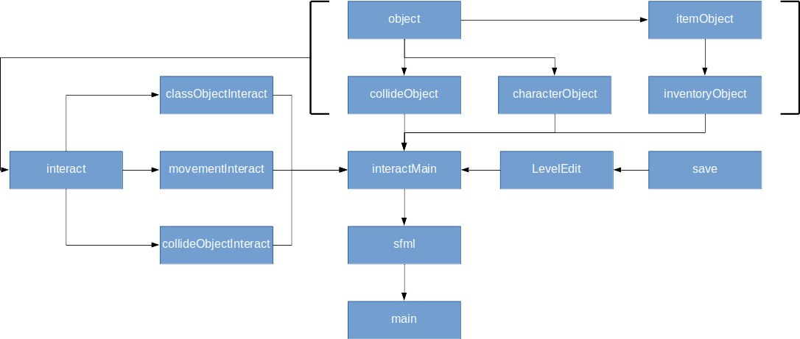
While coding the interact class, I realised that the movement function should not iterate through the character vectors on its own because it would them move every character in the game. I coded some of the other functions in a way that they would accept the vector position rather than generate it. This is what I will use for the move function. The only problem now is how I will determine what should be sent to the functions.
I have decided that a class that is inherited by the interact class should deal with the creation of the objects and filling of the vectors. The amount of objects will be determined upon construction of the interact class.

