# Summary

# 1 – Introduction

This report presents the second in a series from the Aotea Bird Count (ABC) bird survey based on the new data collected in 2020. The first report (Simmonds, 2020) was based on data collected in 2019. This report focuses on analysing the data from 2020 as analysing patterns of change requires more than two years of data. However, in the longer term, the ABC will be a valuable dataset of the birds of Aotea and changes in their abundance and distribution. In addition, data from the ABC can help monitor the success of management plans on, for example, the abundance of key species in managed areas.

## 1.1 – Aotea, Great Barrier Island

Aotea, Great Barrier Island (henceforth Aotea) is a small island (~27,761 ha) located approximately 17 km northeast from the north island of New Zealand (Figure 1) and includes many small surrounding islands (Russell & Taylor, 2017). Aotea comprises ten major habitat types, including wetlands, coastal cliffs, forests, and dunes, making it home to diverse animal and plant life (Armitage, 2004). The east coast comprises primarily of wetlands and infilled marine embayments, and the west coast drops sharply into the sea. A central ridge of mountains reaching an elevation of 627 m.a.s.l runs down the island (Perry et al., 2010). Predator control projects have been developed on Aotea with Genfern sanctuary (83 ha) established as a restoration area in the late 90s, and Windy Hill sanctuary (800 ha) established in 2000 (Clout & Russell, 2006; Perry et al., 2010).

## 1.2 – Birds of Aotea

Aotea is home to many native and endemic bird species ranging from seabirds and wetland birds to open country birds and bush birds. Species include the black petrel, blue penguins, gannets, pateke, banded rails, tomtits, and the iconic tui, kaka and kakariki (Armitage, 2004). This diverse range of bird species is key to both the cultural heritage and biological importance of Aotea.

Aotea is unique in that some of the predatory animals, such as the Norway rat (*Rattus norvegicus*) and mustelids (weasels, stoats and ferrets) brought by Europeans, never became established (Armitage, 2004). The absence of mustelids is important to the survival of species still extant on the island today such as the pateke, kaka and banded rail. Cats (*Felis catus*) and ship rats (*Rattus rattus*) are thought to have been rare or absent from Aotea in the mid 19th century. Thus, species vulnerable to their predation, such as the kakariki persisted better than on the two main islands of New Zealand after European arrival (Armitage, 2004). However, while many introduced pests did not establish on Aotea, rats (*Rattus rattus and Rattus exulans*), mice (*Mus musculus*), rabbits (*Oryctolagus cuniculus*), feral cats (*Felis catus*), and pigs (*Sus scrofa*) are present today, posing a threat to the island’s birdlife (Ogden & Gilbert, 2009, 2011). The last remaining koako on Aotea were moved to the nearby Hauturu predator-free island in 1994, and a number of bird species, including the tomtit and kakariki are at risk of local extinction (Russell & Taylor, 2017). Historically, much of the loss of the native and endemic birdlife was probably due to the introduction of the Polynesian rat (*Rattus exulans*) and dogs (*Canis familiaris*) that accompanied the first human settlers of Aotea, and the loss of forest during Maori and European settlement (Clout & Russell, 2006; Perry et al., 2010).

## 1.3 – Key target species

For species have been identified by stakeholders of Aeotea as key target species for the ABC (Simmonds, 2020). These are the: kākā (*Nestor meridionalis*), kererū (*Hemiphaga novaeseelandiae*), kākāriki (*Cyanoramphus novaezelandiae*), and tui (*Prosthemadera novaeseelandiae*).

Kākāriki is a small endemic parrot once common throughout New Zealand but now almost absent from the two main islands (Ortiz‐Catedral & Brunton, 2009). The kākāriki has a national conservation status of an at risk relict population (Robertson et al., 2016), and one breeding population is confirmed on Aeotea at the Okiwi site.

Kererū are an endemic pigeon widespread throughout New Zealand. They are the fifth largest pigeon in the world and feed on fruits, flowers, and leaves (Wotton & Kelly, 2012). Kererū are important seed dispersers feeding on at least 70 different plant species and, due to their large size, they can swallow large fruits and have a long gut retention time (Clout & Hay, 1989; Wotton & Kelly, 2012). The long gut passage time of the large birds makes it more likely that they disperse seeds futher from the parent plant despite the sedentary behaviour of the kereru (Wotton & Kelly, 2012).

The kākā is an endemic hole-nesting parrot common throughout Aotea, although nationally classed as an at risk, recovering species. The kākā now occupies a fraction of its former range due to predation and habitat loss (Moorhouse et al., 2003). Their abundance on Aeotea is likely due to the absence of stoats (*M. erminea*) and Norway rats (*R. norvegicus*), to which their nests are vulnerable (Armitage, 2004).

The tui is an endemic species common across New Zealand and needs little introduction. Their distinctive calls and white throat feathers make them an easily recognisable New Zealand icon. Tui are honeyeaters feeding primarily on nectar, fruit and invertebrates (Stewart & Craig, 1985). Tui have complex and calls and exhibit regional variability in their song, which is similar to that of the bellbird (Hill et al., 2013; Hill & Ji, 2013).

## 1.4 – Objectives of the Aotea Bird Count

The ABC is a citizen science project providing an island-wide assessment of bird species and their locations on Aotea. The ABC is planned to be repeated biannually or annually, building a dataset that can be analysed for changes in species over time. In the long-term, such information can contribute to monitoring the success of management interventions (e.g., pest control), changes in bird populations across the island, and track the abundances of key endemic species such as the kakariki.

# 2 – Methods

## 2.2 – Data collection

A total of 16 sites across Aotea (Figure 1) were surveyed using the five-minute count method for the bird species present. Each of the 16 sites consisted of 4-5 survey locations approximately 200 metres apart and was surveyed twice with at least a one-hour interval between replicates. Information on the local conditions (wind, rain, noise and temperature) were recorded for each of the two replicates. Groups of up to three observers undertook the surveys with at least one person trained in bird identification. At each point in the site, the species, number of birds, and distance from the observers (inside or outside of a 25-metre radius) were recorded for five minutes. Counting started after two minutes of silence to reduce the disturbance caused by the observers. Additional data on birds flying overhead or observed between the survey locations were also recorded.

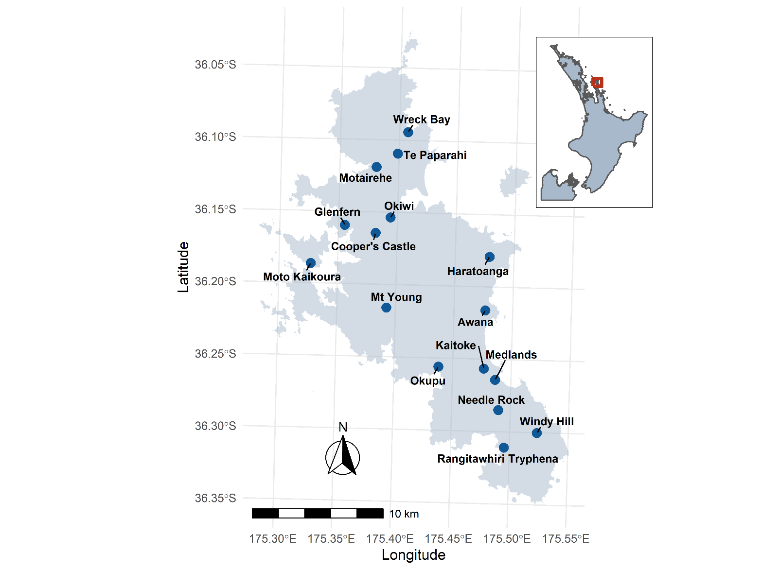

Figure 1: Locations of the 16 sites surveyed in 2020 on Aotea, Great Barrier Island.

Bird names are reported as recorded by the observers with preference to the Maori name if both the European and Maori names were recorded. A list of bird names including their Maori, Latin, and European names can be found in Appendix A.

## 2.3 – Analysis

A range of analyses were used to assess the diversity across the island and differences among sites. Data were analysed at the island-level, site-level and for the differences among sites:

* Firstly, total bird counts were calculated across the island by summing the counts of each species across all sites.
* Secondly, bird counts were analysed at each site by calculating species richness and diversity. Additionally, the occurrence and abundance of the four target species (Kakariki, Kaka, Tui and Kereru) is shown for each site.
* Finally, the dissimilarity among the sites was calculated from differences in their species composition.

All analyses are conducted in R version 4.1.0 (R Core Team, 2021). A list of packages for the analysis is in Appendix XXX

### Richness and diversity

For each of the 16 sites, the richness and diversity of species present were calculated. Species richness is simply the number of species present, while species diversity considers the relative abundances of the species present. Species diversity is calculated using Shannon’s H index. Richness and diversity are mapped to Aotea by site to visualise the results.

### Total count and target species

For each of the 16 sites, the total bird count and the counts of the four target species (Kakariki, Kaka, Tui and Kereru) were calculated.

### Hierarchical cluster analysis

Additionally, we are interested in how different the species composition among the sites is. Hierarchical clustering is one method of grouping data (in this case, the sites) using a distance or dissimilarity measure; here, the Bray-Curtis dissimilarity index was used (Faith et al., 1987). The Bray-Curtis dissimilarity index is commonly used in ecology to quantify the difference among sites via their species composition. Hierarchical cluster analysis was used to group the data into clusters, using the unweighted pair group method with arithmetic mean method. In short, each site is initially considered as a distinct cluster and is successively merged with the next most similar cluster until all sites have been combined.

# 3 – Results

## 3.1 – Overall observations

Across the 16 sites, 2,242 birds were counted and identified from 40 species (excluding some unknown or unidentified to the species level). Of the 40 identified species, 26 were either native or endemic, with the most abundant species on the island being Kaka, Tui, Grey warbler, Kingfisher and Fantail (Figure 2). The figure below shows the 25 most abundant species on Aotea; the counts of all 40 identified species are in Appendix B.

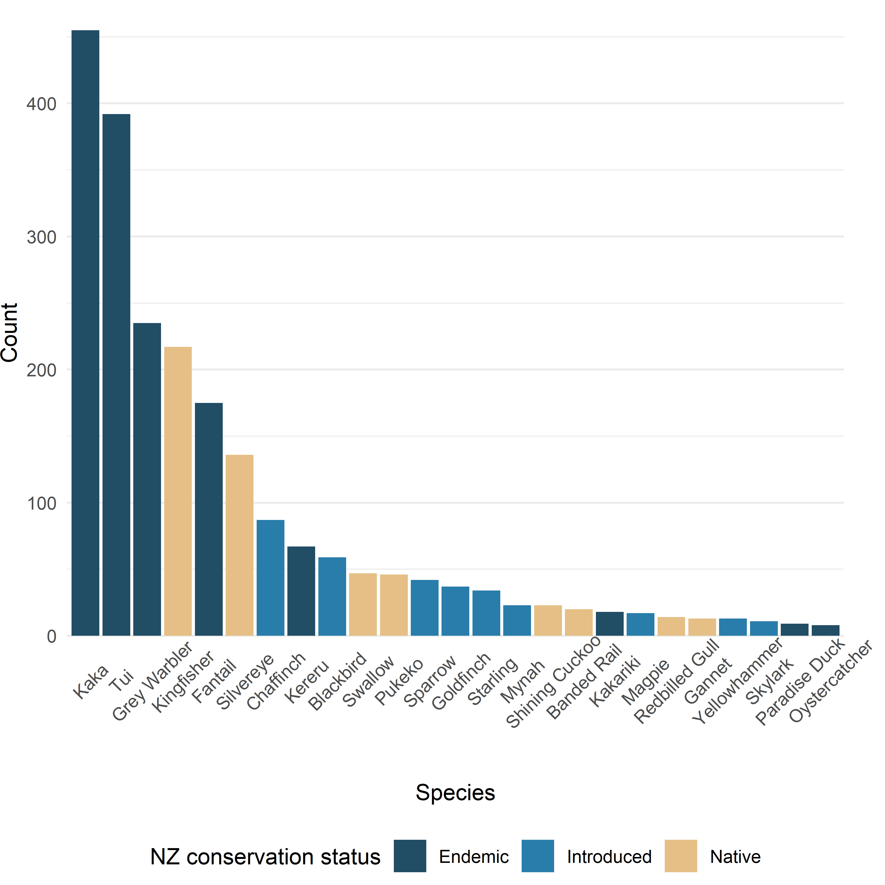

Figure 2: Total counts of the 25 most frequently observed (seen or heard) across all sites.

## 3.2 – Richness and diversity

Patterns of species richness and diversity are similar across the island (Figure 3 A and B), indicating some uniformity of the distribution among species present at each site. If only a few species dominated the species counts, Shannon’s diversity index would decrease while richness would remain the same.

The highest species richness and diversity occurred in the Medlands, followed by Moto Kaikoura, Okupu and Kaitoke (Figure 1 A and B, and Table 1; see Figure 1 for mapped site names). The lowest levels of richness and diversity were observed in Cooper’s Castle and Te Paparahi.

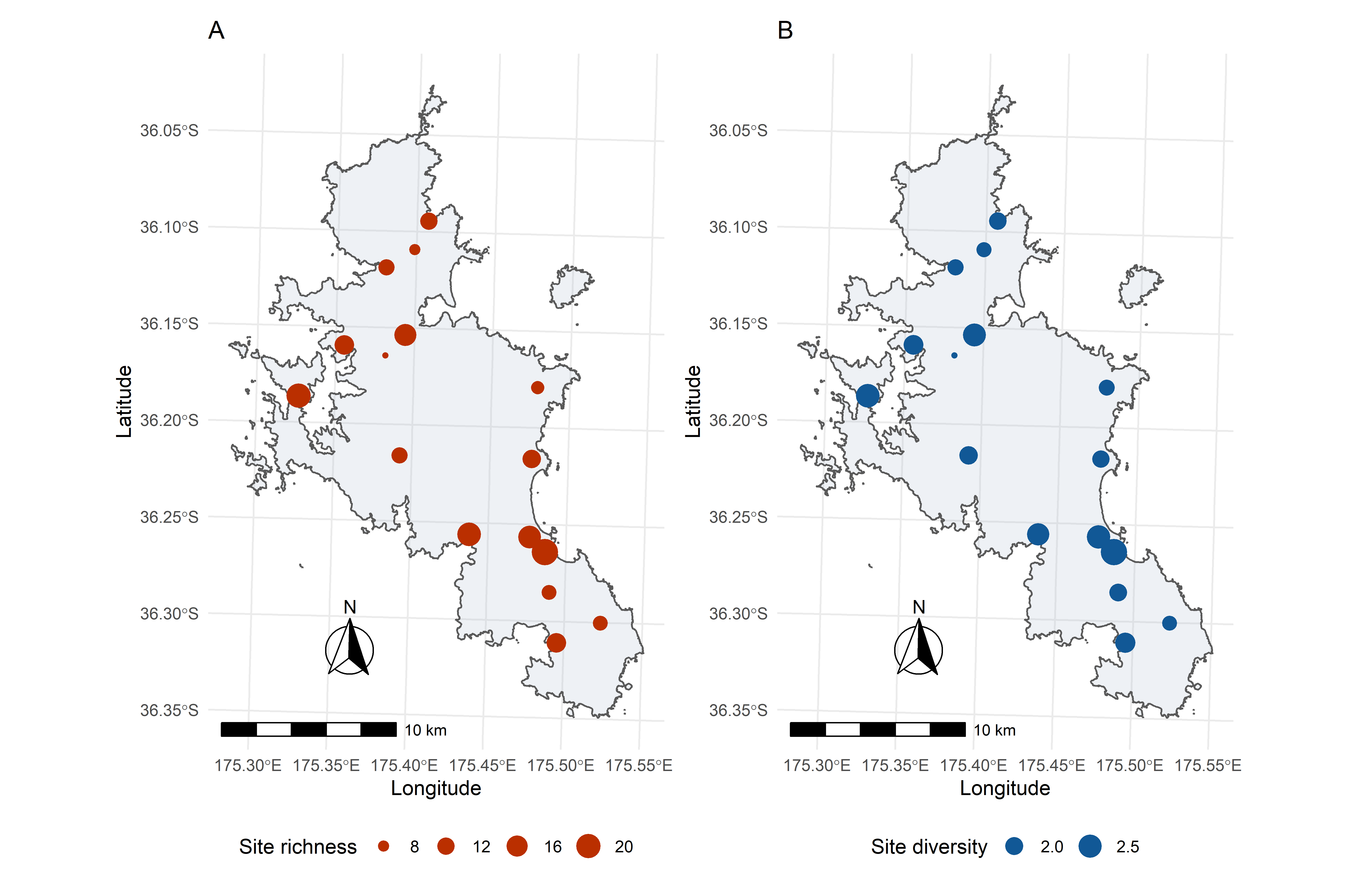

Figure 3: The species richness (A) and diversity (B) of the 16 sites across Aotea. The size of the data points is scaled by value, with larger points indicating a higher value.

Species richness, diversity and total counts vary among sites with ranges of [7, 23], [1.54, 2.89], and [72, 235] (values inside the square brackets indicating the minimum and maximum), respectively (Table 1). Of course, some variation is expected due to local conditions during the observed bird counts and among observer groups. Species richness is likely to increase with the number of species counted at a given site. Rarefaction can account for the differences in richness with sample size (Oksanen, 2020) but, in this case, made little difference (with the exception of a slight reduction in richness at Moto Kaikoura where the count was highest). Thus the raw richness data is reported alongside the total count.

Table 1: Species richness, diversity and count for the 16 sites.

|  |  |  |  |
| --- | --- | --- | --- |
| **Site** | **Species richness** | **Species diversity** | **Total count** |
| Awana | 13 | 1.96 | 72 |
| Cooper's Castle | 7 | 1.54 | 106 |
| Glenfern | 14 | 2.16 | 118 |
| Haratoanga | 9 | 1.87 | 140 |
| Kaitoke | 18 | 2.55 | 141 |
| Medlands | 23 | 2.89 | 165 |
| Motairehe | 11 | 1.88 | 98 |
| Moto Kaikoura | 20 | 2.57 | 235 |
| Mt Young | 11 | 2.04 | 187 |
| Needle Rock | 10 | 1.99 | 116 |
| Okiwi | 17 | 2.47 | 155 |
| Okupu | 19 | 2.41 | 151 |
| Rangitawhiri Tryphena | 14 | 2.21 | 141 |
| Te Paparahi | 8 | 1.80 | 115 |
| Windy Hill | 10 | 1.78 | 185 |
| Wreck Bay | 12 | 1.98 | 117 |
| **Total** |  |  | **2242** |

## 3.3 – Total counts

The highest total bird count was observed in Moto Kaikoura, with 235 birds identified in total (Figure 4 A and Table 1). Moto Kaikoura showed the second-highest species richness and diversity. Medlands, which had the highest richness and diversity, had a total count of 165 birds identified. Kakariki, the endemic species almost absent from the two main islands of New Zealand was observed only at the Okiwi site. This result is consistent with the 2019 ABC report (Simmonds, 2020).

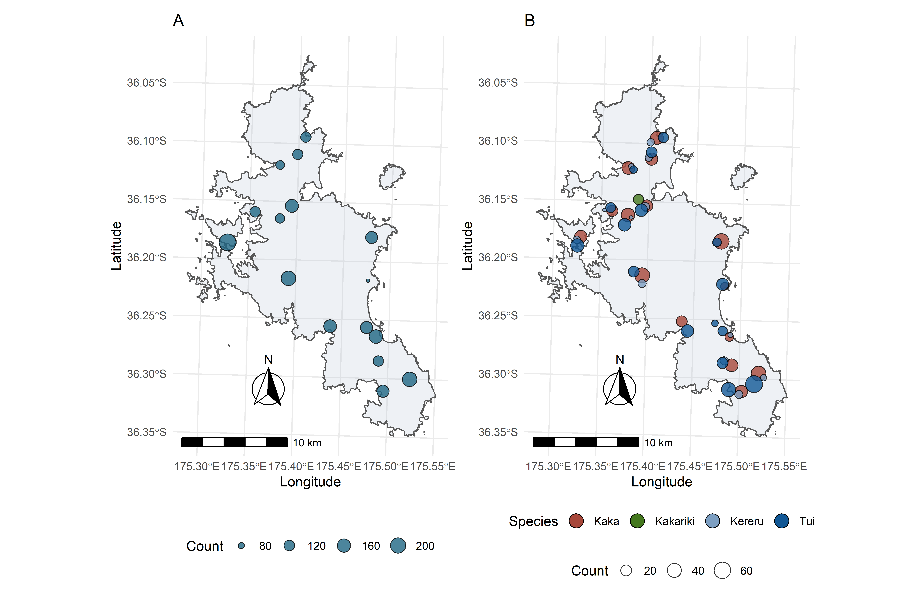Of the four target species (Kakariki, Kaka, Tui and Kereru), Kaka and Tui were observed at almost every site, except for Kaitoke, where no Kaka was observed (Figure 4 B and Table 2). Kereru were observed at 12 of the 16 sites, although in lower numbers than Kaka or Tui. A total of 18 Kakariki were observed, all of which at Okiwi (Figure 4 B and Table 2).

Figure 4: Total counts of birds by site (A) and total count of the four target species (Kakariki, Kaka, Tui and Kereru) by site (B).

High counts of Tui and Kaka were found at Windy Hill, and Haratonga respectively. Okiwi had high abundances of all four species (Figure 4 B and Table 2). Kaitoke, one of the most diverse sites, had few observations of the target species with only 5 Tui.

Table 2: Total counts of the four target species at each site.

|  |  |  |  |  |
| --- | --- | --- | --- | --- |
| **Site** | **Tui** | **Kaka** | **Kakariki** | **Kereru** |
| Awana | 27 | 8 | 0 | 0 |
| Cooper's Castle | 31 | 37 | 0 | 1 |
| Glenfern | 16 | 23 | 0 | 1 |
| Haratoanga | 11 | 53 | 0 | 0 |
| Kaitoke | 5 | 0 | 0 | 0 |
| Medlands | 14 | 11 | 0 | 2 |
| Motairehe | 7 | 32 | 0 | 2 |
| Moto Kaikoura | 36 | 30 | 0 | 7 |
| Mt Young | 20 | 47 | 0 | 9 |
| Needle Rock | 21 | 32 | 0 | 9 |
| Okiwi | 30 | 25 | 18 | 10 |
| Okupu | 31 | 21 | 0 | 0 |
| Rangitawhiri Tryphena | 41 | 29 | 0 | 9 |
| Te Paparahi | 20 | 28 | 0 | 6 |
| Windy Hill | 64 | 46 | 0 | 4 |
| Wreck Bay | 18 | 33 | 0 | 7 |

## 3.4 – Site dissimilarity

Three primary groups emerge from the cluster analysis. Two of the most diverse sites (Figure 1 B and Table 1), Medlands and Kaitoke, are clustered apart from the other sites (Figure 5; red branches). Awana forms its own cluster (green branch) but is related to Okupu Okiwi and Rangitawhiri Tryphena (alternative clustering methods group Awana with Okupu and Okiwi). All other sites form a large cluster indicating that they are similar in species composition. Moto Kaikoura, the second most diverse site, is included in the large cluster rather than with Medlands and Kaitoke (the first and third most diverse sites, respectively).

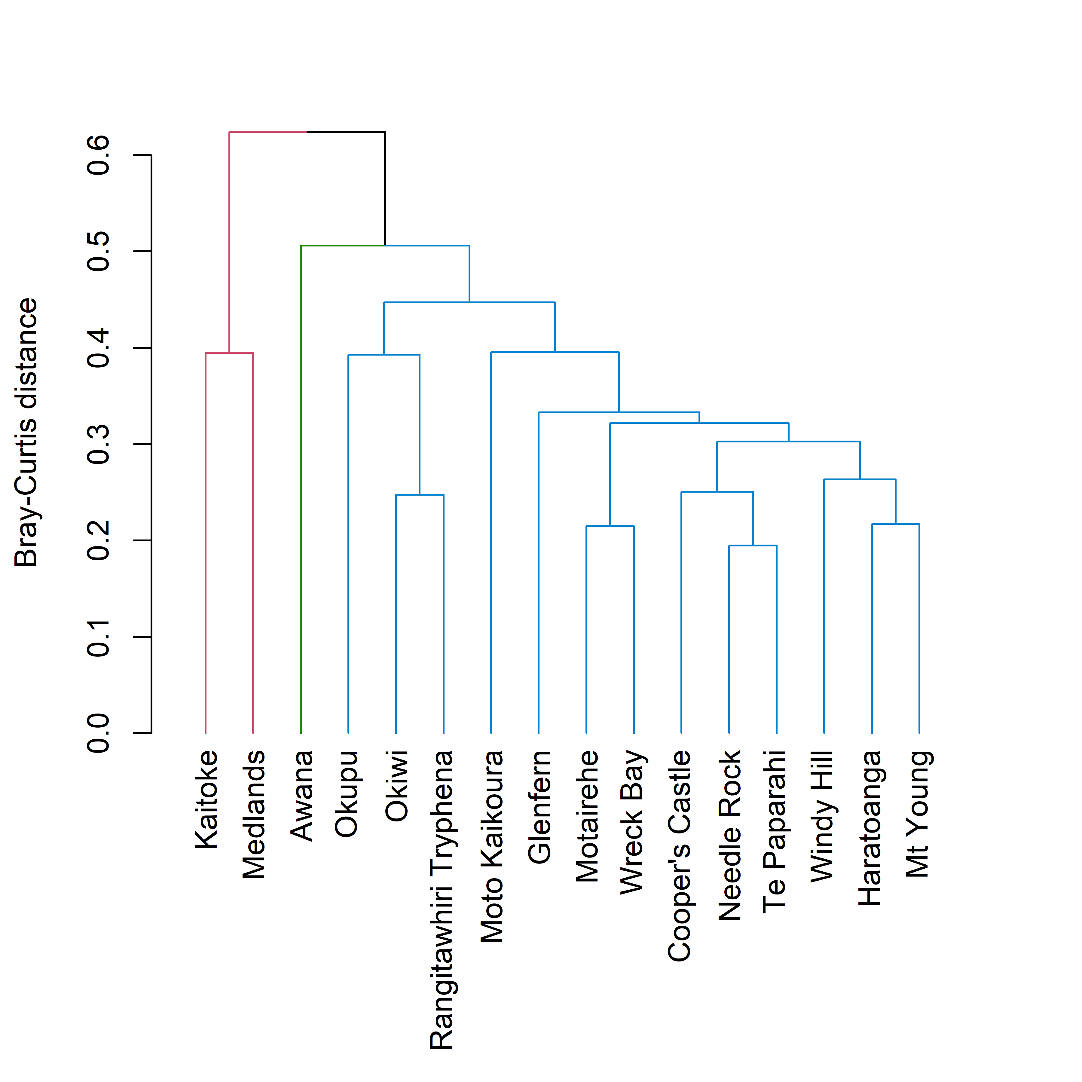

Figure 5: Hierarchical cluster analysis of sites using Bray-Curtis distance and unweighted pair group method with arithmetic mean. Three clusters are identified in the data as indicated by the colour of the branches.

# 4 – Discussion

The bird count data were analysed for the primary, island-wide patterns of abundance; site-specific patterns of abundance, richness, and diversity; and site dissimilarity. The aggregated data show the most abundant species on Aotea to be the Kaka, Tui, Grey warbler, Kingfisher and Fantail (Figure 2). Of course, bird species are not uniformly distributed across the island. For example, Kaitoke had few records of tui, and none of kaka, and the only observations of kakariki were at Okiwi. The hierarchical cluster analysis assesses the differences in species composition among the sites. Not surprisingly, the sites tend to cluster according to their habitat type. Kaitoke is a wetland habitat, hence the lack of bush birds like the kaka and tui, and high counts of pukeko, swallows and kingfishers (Anderson, 2003). The Awana site that forms a single unit in the cluster analysis (Figure 5, green branch) was cleared in the early 20th century for farming and underwent annual controlled burning until about 1940. Awana now comprises mainly of mānuka–kānuka scrubland with some exotic species such as pine (Perry et al., 2010). Awana has a relatively low diversity (Table 1) dominated by tui, kingfishers, and kaka observations. All the other sites were more similar in their species composition to each other (Figure 5).

Of the four target species, tui and kaka were common in all the sites of the large cluster identified by the cluster analysis (Figure 5, blue branches). Although present at most sites, lower counts of kereru were recorded across the island, with the most observations at Mt Young, Needle Rock, Okiwi, and Rangitawhiri Tryphena (Table 2). Kereru prefer a variety of forest typesm, including native forest and exotic plantations. Kakariki, were absent from all sites apart from Okiwi indicating that kakariki populations would benefit from stricter pest management schemes.

## 4.2 – Limitations

Some sources of uncertainty exist in the data collection methods that must be accounted for during analysis and interpretation. The primary limitations in the data are:

* Location bias: survey locations are typically along a track or accessway. Bird counts from such locations may not be closely representative of the true abundance of a given area.
* Observation bias: birds species are not all equally likely to be observed due to size, sound and behavioural differences. Some birds, such as the tui, are conspicuous and loud, while others, such as the tomtit, are small and inconspicuous.
* Identification bias: not all bird species are equally identifiable visually or audibly. For example, some species such as the kereru are visually easy to identify, while ones such as the yellowhammer may be more easily confused with another such as the yellowhead.

While some limitations exist (as with any observational ecological data), some can be mitigated. For example, survey groups have at least one trained observer to reduce identification error, and statistical methods exist to correct observation bias in data analysis. Despite sources of uncertainty, important patterns can be observed from the data.

## 4.3 – Conclusion

d

# Appendix A

Table 3: List of names and conservation status, including their Maori, Latin, and European names. Note some species have multiple Maori or European names that are not included.

|  |  |  |  |  |
| --- | --- | --- | --- | --- |
| **Maori name** | **Latin name** | **European name** | **Conservation status** | **NZ conservation status** |
| Kahu | *Circus approximans* | Harrier Hawk | Not Threatened | Native |
| Kaireka | *Alauda arvensis* | Skylark | Introduced and Naturalised | Introduced |
| Kaka | *Nestor meridionalis* | Brown Parrot | Recovering | Endemic |
| Kakariki | *Cyanoramphus novaezelandiae* | Red-crowned parakeet | Relict | Endemic |
| Karoro | *Larus dominicanus* | Black-backed Gull | Not Threatened | Native |
| Kawau Tui | *Phalacrocorax sulcirostris* | Little Black Shag | Naturally Uncommon | Native |
| Kereru | *Hemiphaga novaeseelandiae* | Wood Pigeon | Not Threatened | Endemic |
| Kotare | *Todiramphus sanctus* | Sacred Kingfisher | Not Threatened | Native |
| Makipae | *Gymnorhina tibicen* | Magpie | Introduced and Naturalised | Introduced |
| Manu Pango | *Turdus merula* | Blackbird | Introduced and Naturalised | Introduced |
| Matuku Moana | *Egretta sacra* | Reef Heron | Nationally Endangered | Native |
| Mioweka | *Gallirallus philippensis* | Banded Rail | Declining | Native |
| Mohua | *Mohoua ochrocephala* | Yellowhead | Recovering | Endemic |
| Ngirungiru | *Petroica macrocephala* | Tomtit | Not Threatened | Endemic |
| Pahirini | *Fringilla coelebs* | Chaffinch | Introduced and Naturalised | Introduced |
| Pateke | *Anas chlorotis* | Brown teal | Recovering | Endemic |
| Pipiwharauroa | *Chrysococcyx lucidus* | Shining Cuckoo | Not Threatened | Native |
| Piwakawaka | *Rhipidura fuliginosa* | Fantail | Not Threatened | Endemic |
| Pukeko | *Porphyrio melanotus* | Purple Swamphen | Not Threatened | Native |
| Putangitangi | *Tadorna variegata* | Paradise Duck | Not Threatened | Endemic |
| Riroriro | *Gerygone igata* | Grey Warbler | Not Threatened | Endemic |
| Ruru | *Ninox novaeseelandiae* | Morepork | Not Threatened | Native |
| Takapu | *Morus serrator* | Gannet | Not Threatened | Native |
| Tarapunga | *Larus novaehollandiae* | Red-billed Gull | Declining | Native |
| Tauhou | *Zosterops lateralis* | Silvereye | Not Threatened | Native |
| Tiu | *Passer domesticus* | Sparrow | Introduced and Naturalised | Introduced |
| Torea Pango | *Haematopus unicolor* | Oystercatcher | Recovering | Endemic |
| Tui | *Prosthemadera novaeseelandiae* | Parson Bird | Naturally Uncommon | Endemic |
| Tuturiwhatu | *Charadrius spp.* | Dotterel | NA | NA |
| Warou | *Hirundo neoxena* | Swallow | Not Threatened | Native |
| - | *Emberiza citrinella* | Yellowhammer | Introduced and Naturalised | Introduced |
| - | *Acridotheres tristis* | Mynah | Introduced and Naturalised | Introduced |
| - | *Vanellus miles* | Spur-winged Plover | Not Threatened | Native |
| - | *Turdus philomelos* | Song Thrush | Introduced and Naturalised | Introduced |
| - | *Ardea cinerea* | Grey Heron | Vagrant | Native |
| - | *Anas platyrhynchos* | Mallard Duck | Introduced and Naturalised | Introduced |
| - | *Carduelis carduelis* | Goldfinch | Introduced and Naturalised | Introduced |

# Appendix B

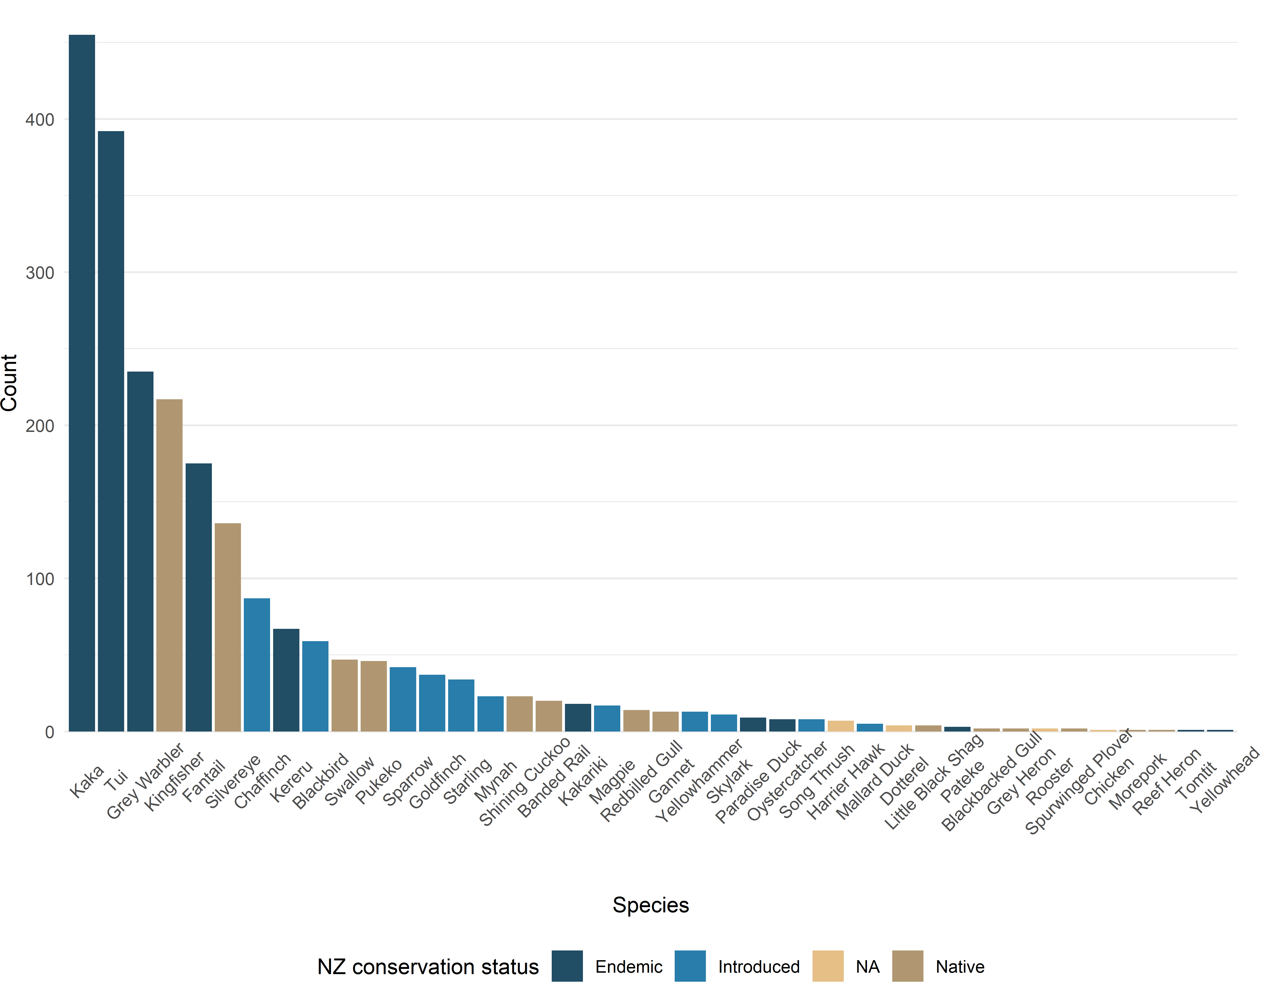Counts of each of the identified species on Aotea. Colours indicate their New Zealand conservation status (native, endemic, introduced, or unspecified for birds unidentified to the species level.

Figure : Counts of all 40 species identified summed across all 16 sites.