# 

Aotea Bird Count

## Results from the December 2020 survey

# Acknowledgements

Thanks to the volunteers who graciously gave their time to participate in undertaking the training sessions for the five-minute bird counts and conducting the surveys across Aotea. Without such enthusiastic individuals, the reports and valuable findings would not be possible.

Thanks also to the hard work from Thomas Daly, Emma Waterhouse, Kate Waterhouse, Judy Gilbert, John Ogden, Jacqueline Beggs and Shanti Morgan for organising the Aotea Bird Count. We are also grateful to George Perry and Kate Waterhouse for their comments on the initial drafts of the report.

We are especially grateful for the expertise and intimate knowledge of Aotea from George Perry, John Ogden and the many scientists who have published work related to Aotea.

# Summary

This report presents the analysis of the Aotea Bird Count (ABC) data collected in 2020. The bird count is organised by the Aotea Great Barrier Environmental Trust, Auckland Council and the sanctuaries located on Aotea and is undertaken by community volunteers. In this report, the bird count data are analysed for:

* Island-wide species abundances.
* Site-level species abundance, richness and diversity.
* Site-level abundances of four key target species (kākāriki, kākā, tūī and kererū).
* Differences in species composition among sites.

Analysis of the data highlight some key patterns in the abundances of bird species across Aotea:

* The most abundant species on the island are the kākā, tūī, grey warbler, kingfisher and fantail.
* The number of individuals observed (seen and heard) among sites ranged between [72, 235]. Species richness (number of species present) had a range of [7,23], and species diversity ranged between [1.54, 2.89]. The highest species richness and diversity were found in the Medlands and Motu Kaikoura, while the lowest values were at Cooper’s Castle and Te Paparahi.
* Of the four target species, kākā and tūī were common throughout Aotea. Kererū were present in low abundances at most sites, and kākāriki were only found at Okiwi.
* Species composition is not homogeneous across the site and forms three primary groups based on statistical analyses for site similarity.

Additionally, a graphical comparison of changes in species richness and diversity between 2019 and 2020 is presented. Results suggest that data from the ABC are a valuable source of information on species abundances and diversity across Aotea. If repeated at regular intervals, data from the ABC can be used to track species abundances and locations through time, especially of vulnerable endemic species such as the kakariki and pāteke. Additionally, such data can inform the success of management interventions such as the proposed Tū Mai Taonga project aimed at promoting the recovery of species, including the black petrel and pāteke.

The ABC is organised by the Aotea Great Barrier Environmental Trust, Auckland Council and the sanctuaries located on the island and is carried out by trained community volunteers. The objective of the ABC is to establish longitudinal monitoring of species abundances in response to management interventions and pressures. A standard five-minute bird count method is used that is employed widely through out New Zealand.

Contents

Summary 2

1 – Introduction 2

1.1 – Aotea, Great Barrier Island 2

1.2 – Birds of Aotea 2

1.3 – Key target species 3

1.4 – Objectives of the Aotea Bird Count 3

2 – Methods 4

2.2 – Data collection 4

2.3 – Analysis 5

Richness and diversity 5

Total count and target species 5

Hierarchical cluster analysis 5

3 – Results 6

3.1 – Overall observations 6

3.2 – Richness and diversity 7

3.3 – Total counts 9

3.4 – Site dissimilarity 11

4 – Discussion 12

4.2 – Limitations 12

4.3 – Conclusion 13

References 14

Appendix A 16

Appendix B 18

# 1 – Introduction

This report presents the second in a series from the Aotea Bird Count (ABC) survey based on the new data collected in 2020. The first report (Simmonds, 2020) was based on data collected in 2019. This report focuses on analysing the data from 2020 because meaningfully analysing patterns of change requires more than two years of data. However, a visualisation of changes in species richness and diversity between the data from 2019 and 2020 is presented. In the longer term, the ABC will be a valuable dataset of the birds of Aotea and changes in their abundance and distribution. In addition, data from the ABC can help monitor the success of management plans on, for example, the abundance of key species in managed areas.

## 1.1 – Aotea, Great Barrier Island

Aotea, Great Barrier Island (henceforth Aotea) is a small island (c. 27,761 ha) located approximately 17 km northeast from the north island of New Zealand (Figure 1) and includes many small surrounding islands (Russell and Taylor, 2017). Aotea comprises ten major habitat types, including wetlands, coastal cliffs, forests, and dunes, making it home to diverse animal and plant life (Armitage, 2004). The east coast comprises primarily of wetlands and infilled marine embayments, and the west coast drops sharply into the sea. A central ridge of mountains reaching an elevation of 627 m.a.s.l runs down the island (Perry *et al.*, 2010). Predator control projects have been developed on Aotea with Glenfern sanctuary (83 ha) established as a restoration area in the late 1990s, and Windy Hill sanctuary (800 ha), established in 2000 (Clout and Russell, 2006; Perry *et al.*, 2010). In addition, the Tū Mai Taonga is currently proposed to encompass the northern half of Aotea to reduce feral cat numbers and protect species such as the black petrel and pāteke (Tū Mai Taonga, 2020). Community projects control rats in some locations, including Okiwi, Awana and Oruawharo Medlands, and Auckland Council and the Department of Conservation carry out feral cat control on roadsides, on Hirakimata and in the Whangpoua basin.

## 1.2 – Birds of Aotea

Aotea is home to many native and endemic bird species ranging from seabirds and wetland birds to open country birds and bush birds. Species include the black petrel, blue penguins, gannets, pāteke, banded rails, tomtits, and the iconic tūī, kākā and kākāriki (Armitage, 2004). This diverse range of bird species is key to both the cultural heritage and biological importance of Aotea.

Aotea is unique in that some of the predatory mammals, such as the Norway rat (*Rattus norvegicus*) and mustelids (weasels, stoats and ferrets) brought to New Zealand by Europeans, never became established (Armitage, 2004). The absence of mustelids is important to the survival of species still extant on the island today such as pāteke, kākā and banded rail. Cats (*Felis catus*) and ship rats (*Rattus rattus*) are thought to have been rare or absent from Aotea in the mid 19th century. Thus, species vulnerable to their predation, such as the kākāriki persisted better on Aotea than on the two main islands of New Zealand after European arrival (Armitage, 2004). However, while many introduced pests did not establish on Aotea, two species of rat (*Rattus rattus and Rattus exulans*), mice (*Mus musculus*), rabbits (*Oryctolagus cuniculus*), feral cats (*Felis catus*), and pigs (*Sus scrofa*) are present today, posing a threat to the island’s birdlife (Ogden and Gilbert, 2009, 2011). The last remaining kōkako on Aotea were moved to nearby Hauturu predator-free island in 1994, and a number of bird species, including the tomtit and kākāriki are at risk of local extinction (Russell and Taylor, 2017). Historically, much of the loss of the native and endemic birdlife was probably due to the introduction of the Polynesian rat (*Rattus exulans*) and dogs (*Canis familiaris*) that accompanied the first human settlers of Aotea, and the loss of forest due to fire and logging during Māori (since the late 13th / early 14th century) and European settlement (Clout and Russell, 2006; Perry *et al.*, 2010).

## 1.3 – Key target species

Stakeholders of Aeotea have identified four bird species as key target species for the ABC (Simmonds, 2020). These are the: kākā (*Nestor meridionalis*), kererū (*Hemiphaga novaeseelandiae*), kākāriki (*Cyanoramphus novaezelandiae*), and tūī (*Prosthemadera novaeseelandiae*).

Kākāriki are a small endemic parrot once common throughout New Zealand but now almost absent from the two main islands (Ortiz‐Catedral and Brunton, 2009). The kākāriki has a national conservation status of an at risk relict population (Robertson *et al.*, 2016), and one breeding population is confirmed on Aeotea at the Okiwi site (Simmonds, 2020).

Kererū are an endemic pigeon widespread throughout New Zealand. They are the fifth heaviest pigeon in the world (c. 650 g) and feed on fruits, flowers, and leaves (Wotton and Kelly, 2012). Kererū are important seed dispersers feeding on at least 70 different plant species (McEwen, 1978) and, due to their large size, they can swallow large fruits and have a long gut retention time (Clout and Hay, 1989; Wotton and Kelly, 2012). The long gut passage time of the large birds makes it more likely that they disperse seeds further from the parent plant despite the sedentary behaviour of the kererū (Wotton and Kelly, 2012). Kererū prefer a variety of forest types, including native forest and exotic plantations.

The kākā is an endemic hole-nesting parrot common throughout Aotea, although nationally classed as an at risk, recovering species. The kākā now occupies a fraction of its former range due to predation and habitat loss (Moorhouse *et al.*, 2003). Their abundance on Aeotea is likely due to the absence of stoats (*M. erminea*) and Norway rats (*R. norvegicus*), to which their nests are vulnerable (Armitage, 2004).

The tūī is an endemic species common across New Zealand and needs little introduction. Their distinctive calls and white throat feathers make them an easily recognisable New Zealand icon. Tūī are honeyeaters feeding primarily on nectar, fruit and invertebrates (Stewart and Craig, 1985). Tūī have complex calls and exhibit regional variability in their song, which is similar to that of the bellbird (Hill and Ji, 2013; Hill *et al.*, 2013).

## 1.4 – Objectives of the Aotea Bird Count

The ABC is a citizen-science project providing an island-wide assessment of bird species and their locations on Aotea. The ABC is planned to be repeated biannually or annually, building a dataset that can be analysed for changes in species over time. In the long-term, such information will be invaluable in contributing to monitoring the success of management interventions (e.g., pest control), changes in bird populations across the island, and tracking the abundances of key target species.

# 2 – Methods

## 2.2 – Data collection

A total of 17 sites across Aotea (Figure 1) were surveyed using the five-minute count method (Hartley, 2012) for the bird species present. Each of the 17 sites consisted of 4-5 survey locations approximately 200 metres apart and was surveyed twice with at least a one-hour interval between replicates. Information on the local conditions (wind, rain, noise and temperature) were recorded for each of the two replicates. Groups of up to three observers undertook the surveys with at least one person trained in bird identification. At each point in the site, the species, number of birds seen or heard, and distance from the observers (inside or outside of a 25-metre radius) were recorded for five minutes. Counting started after two minutes of silence to reduce the disturbance caused by the observers. Additional data on birds flying overhead or observed between the survey locations were also recorded.

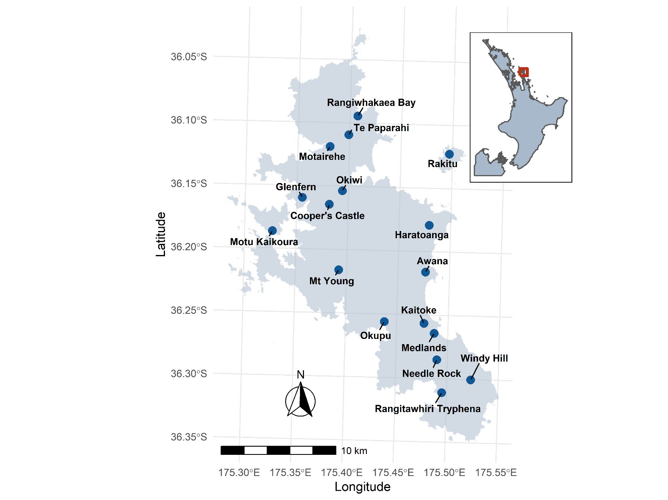

Figure 1: Locations of the 17 sites surveyed in 2020 on Aotea, Great Barrier Island.

Bird names are reported as recorded by the observers with preference to the Te reo Māori name if both the European and Māori names were recorded. A list of bird names including their Māori, Latin, and European names can be found in Appendix A.

## 2.3 – Analysis

A range of analyses were used to assess the diversity across the island and differences among sites. Analyses are conducted on observations including both the seen and heard birds identified by the surveyors. Some records of unknown species or species not identified to the species level (e.g., ‘finch’) are filtered from the data. Data were analysed at the island-level, site-level, and for differences among sites:

* First, total bird counts were calculated across the island by summing the counts of each species across all sites.
* Secondly, bird counts were analysed at each site by calculating species richness and diversity. Additionally, the occurrence and abundance of the four target species (kākāriki, kākā, tūī and kererū) are shown for each site.
* Finally, the dissimilarity among the sites was calculated from differences in their species composition.

All analyses are conducted in R version 4.1.0 (R Core Team, 2021). The vegan package (Oksanen, 2020) is used to calculate the Bray-Curtis index and Shannon’s diversity index (described below). The data and scripts used in this report are reproducible and stored on a public repository (available at 10.17608/k6.auckland.15087717).

### Richness and diversity

For each of the 17 sites, the richness and diversity of species present were calculated. Species richness is simply the number of species present, while species diversity considers the species relative abundances. Species diversity is calculated using Shannon’s H index. Species, richness and diversity are mapped to Aotea by site to visualise the results. Additionally, a visual comparison between the 2019 and 2020 count data is shown for species richness and diversity.

### Total count and target species

For each of the 17 sites, the total bird count (i.e., number of individuals) and the counts of the four target species (kākāriki, kākā, tūī and kererū) were calculated. Count data mapped onto Aotea provide an overall picture of the bird abundance at each site, complementing richness and diversity measures.

### Hierarchical cluster analysis

Additionally, we are interested in how different the species composition is among the sites. The Bray-Curtis dissimilarity index is commonly used in ecology to quantify the difference between sites based on their species composition (Faith, Minchin and Belbin, 1987). Hierarchical cluster analysis groups (classifies) sites into units based on their similarity. To group the data into clusters, the unweighted pair group method with arithmetic mean method is used. In short, hierarchical cluster analysis is a bottom-up clustering method that groups the most similar sites successively until all of them have been grouped.

# 3 – Results

## 3.1 – Overall observations

Across the 17 sites, 2,373 individuals were counted and identified from 42 species (excluding some unknown or unidentified to the species level). Of the 42 identified species, 27 were either native or endemic, with the most abundant species on the island being kākā, tūī, grey warbler, kingfisher and fantail (Figure 2). The figure below shows the 25 most abundant species on Aotea; the counts of all 42 identified species are in Appendix B.

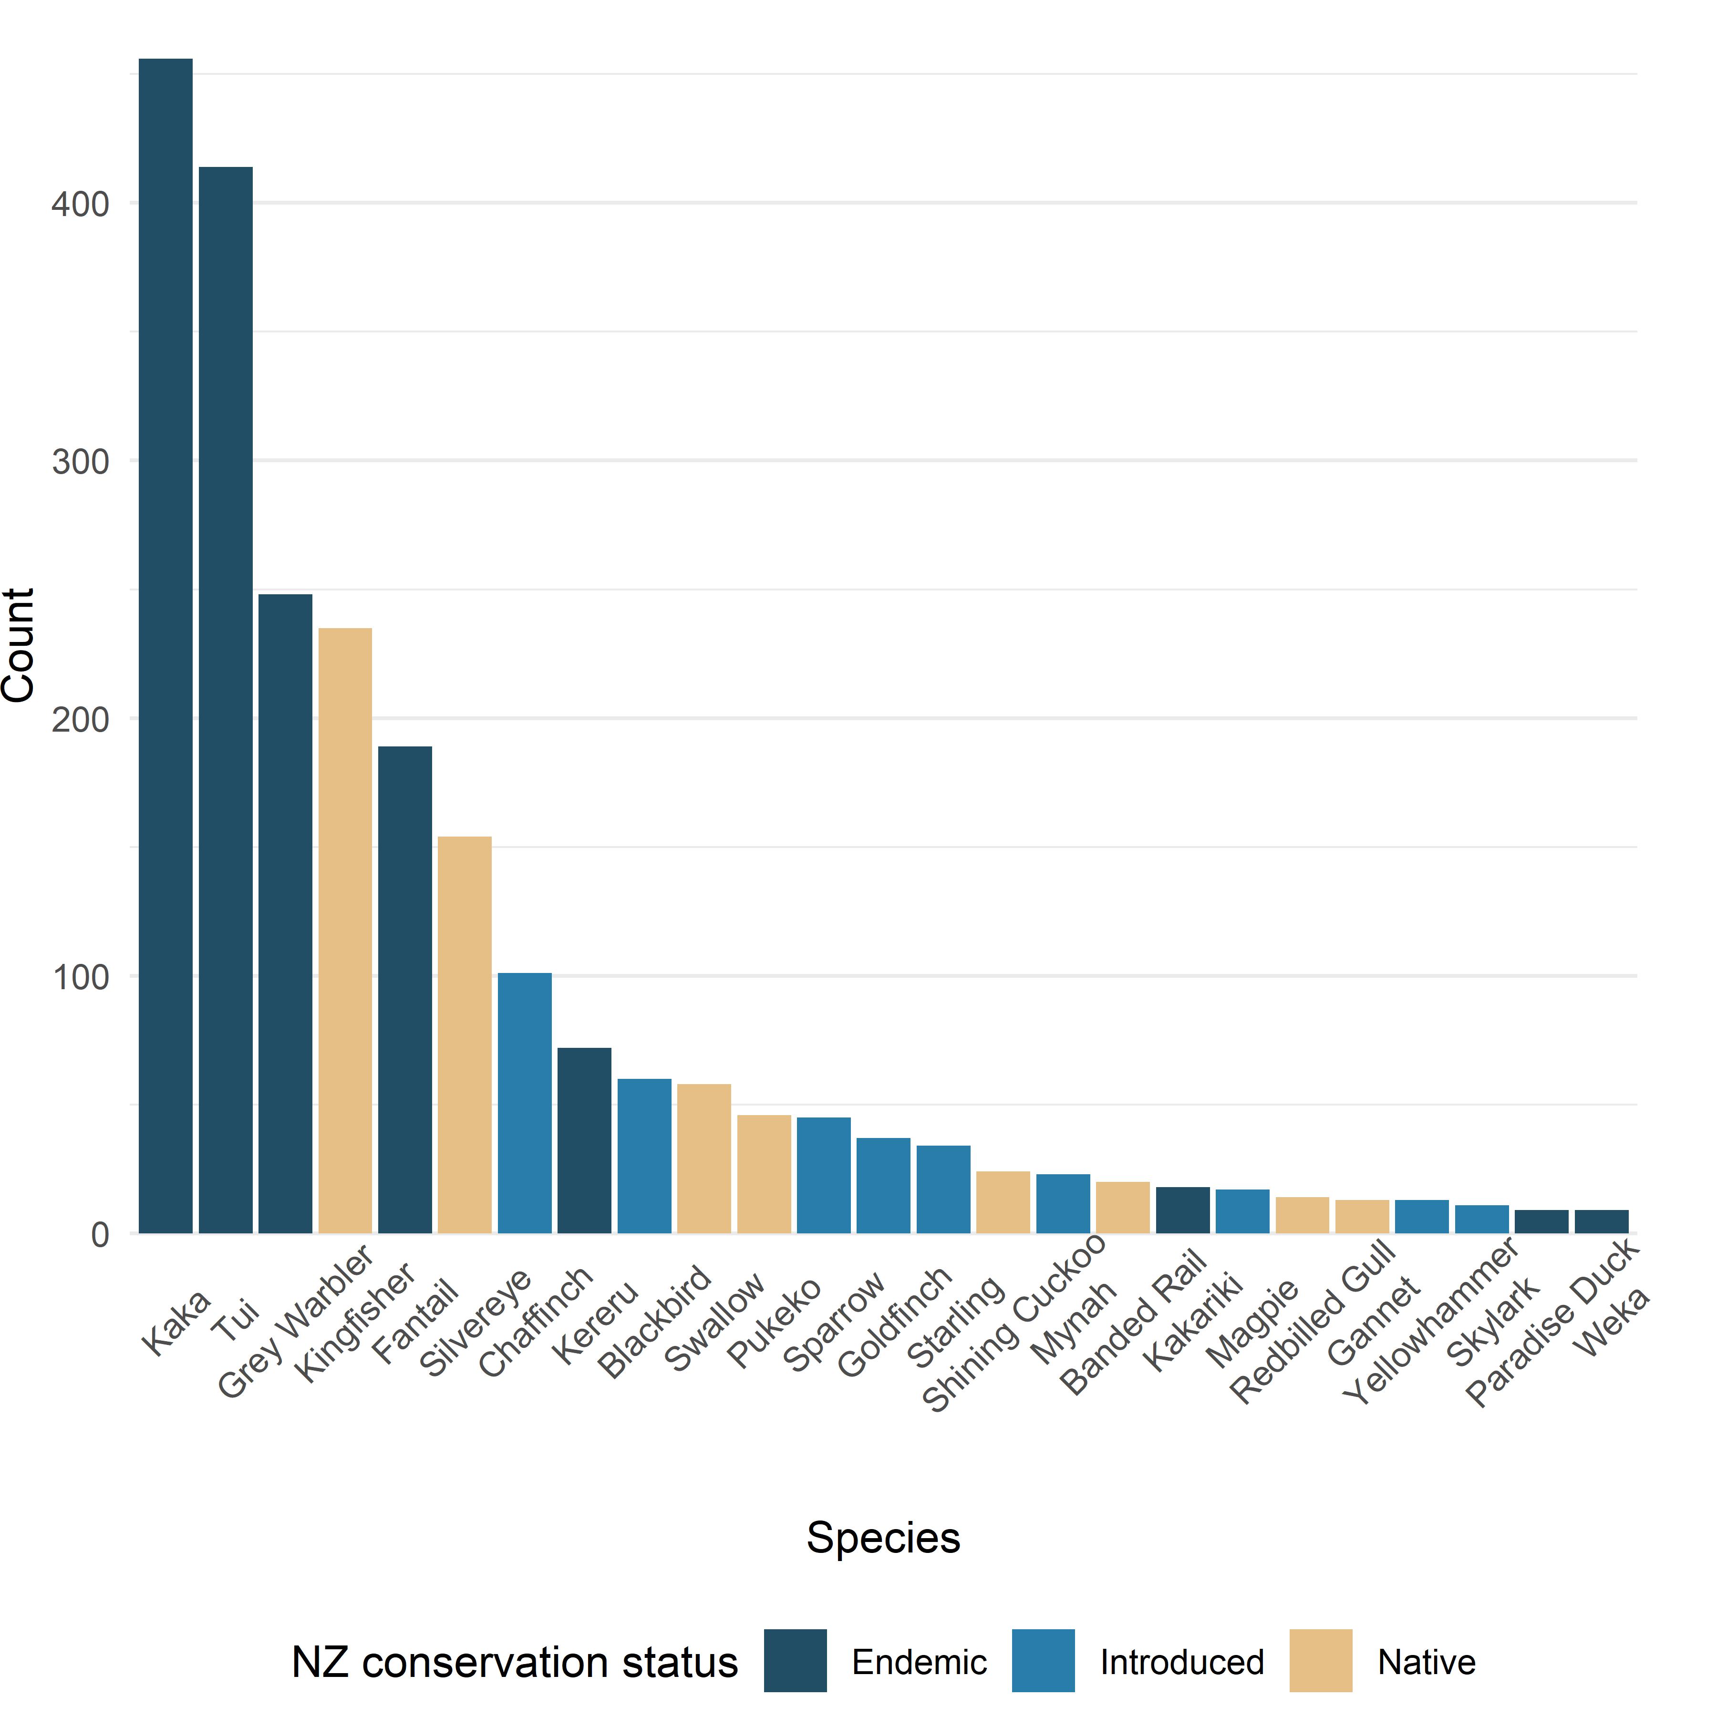

Figure 2: Total counts of the 25 most frequently observed (seen or heard) across all sites. A total of 42 species were identified from 2,373 individuals with the most abundant being the kākā, tūī, grey warbler, kingfisher and fantail.

## 3.2 – Richness and diversity

Patterns of species richness and diversity do not vary much across Aotea (Figure 3 A and B). If only a few species dominated the species counts at each site, Shannon’s diversity index would decrease while richness would remain the same.

The highest species richness and diversity occurred in the Medlands, followed by Motu Kaikoura, Okupu and Kaitoke (Figure 3 A and B, and Table 1; see Figure 1 for mapped site names). The lowest levels of richness and diversity were observed at Cooper’s Castle and Te Paparahi.

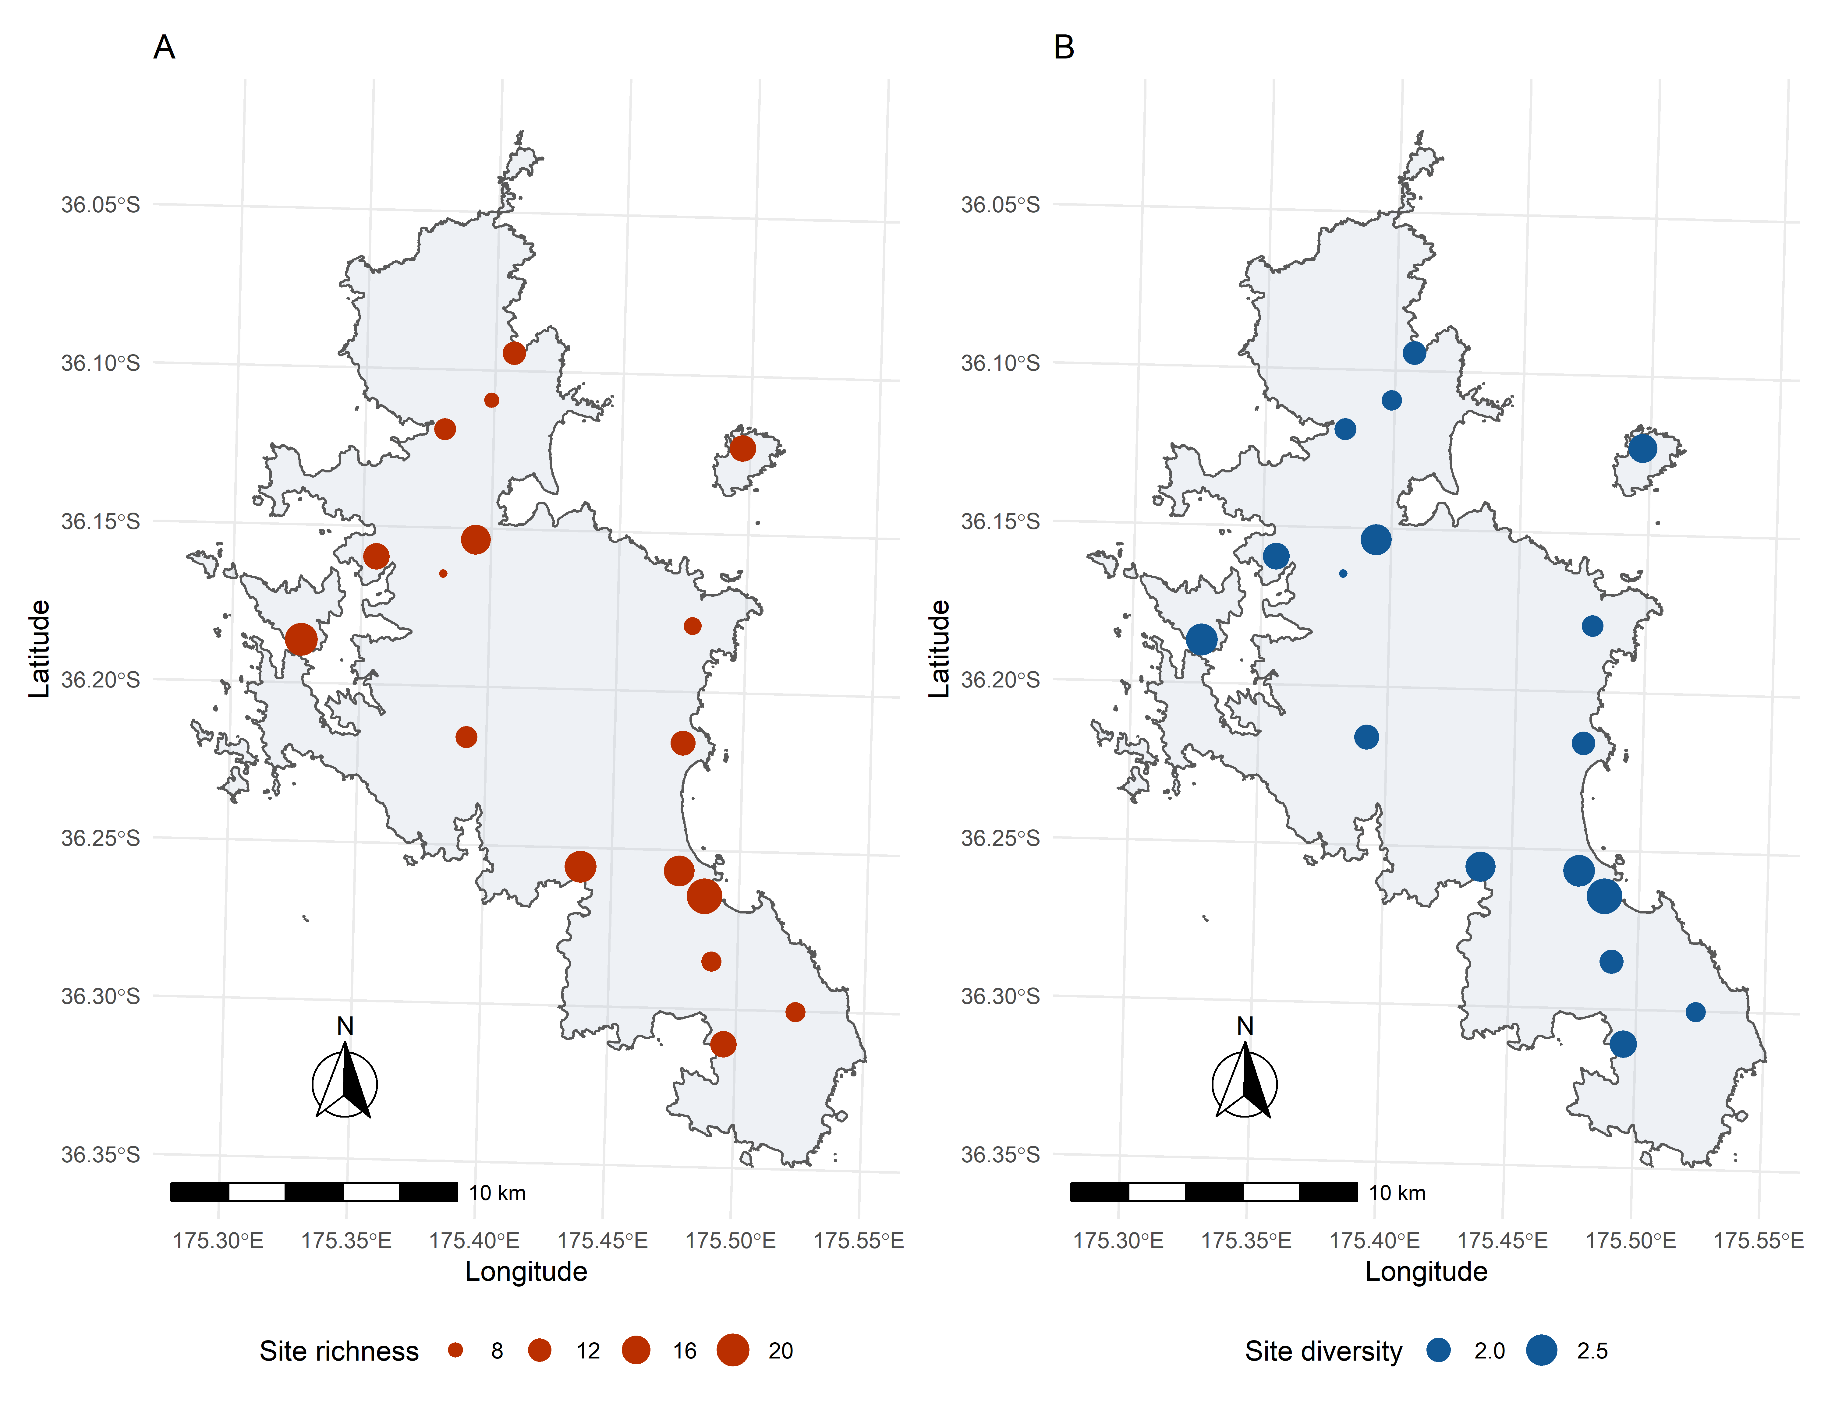

Figure 3: The species richness (A) and diversity (B) of the 17 sites across Aotea. The size of the data points is scaled by value, with larger points indicating a higher value.

Species richness, diversity and total counts vary among sites with ranges of [7, 23], [1.54, 2.89], and [72, 235] (values inside the square brackets indicating the minimum and maximum), respectively (Table 1). Of course, some variation is expected due to local conditions during the bird counts and among observer groups. Species richness is likely to increase with the number of species counted at a given site. Rarefaction (a statistical tool used to correct for such biases) can account for the differences in richness with sample size (Oksanen, 2020) but, in this case, made little difference (except for a slight reduction in richness at Motu Kaikoura, where the count was highest). Thus, the raw richness data is reported alongside the total count.

Table 1: Species richness, diversity and count for the 17 sites.

|  |  |  |  |
| --- | --- | --- | --- |
| **Site** | **Species richness** | **Species diversity** | **Total count** |
| Awana | 13 | 1.96 | 72 |
| Cooper's Castle | 7 | 1.54 | 106 |
| Glenfern | 14 | 2.16 | 118 |
| Haratoanga | 9 | 1.87 | 140 |
| Kaitoke | 18 | 2.55 | 141 |
| Medlands | 23 | 2.89 | 165 |
| Motairehe | 11 | 1.88 | 98 |
| Motu Kaikoura | 20 | 2.57 | 235 |
| Mt Young | 11 | 2.04 | 187 |
| Needle Rock | 10 | 1.99 | 116 |
| Okiwi | 17 | 2.47 | 155 |
| Okupu | 19 | 2.41 | 151 |
| Rakitu | 14 | 2.30 | 131 |
| Rangitawhiri Tryphena | 14 | 2.21 | 141 |
| Rangiwhakaea Bay | 12 | 1.98 | 117 |
| Te Paparahi | 8 | 1.80 | 115 |
| Windy Hill | 10 | 1.78 | 185 |
| **Total** |  |  | **2373** |

## 3.3 – Total counts

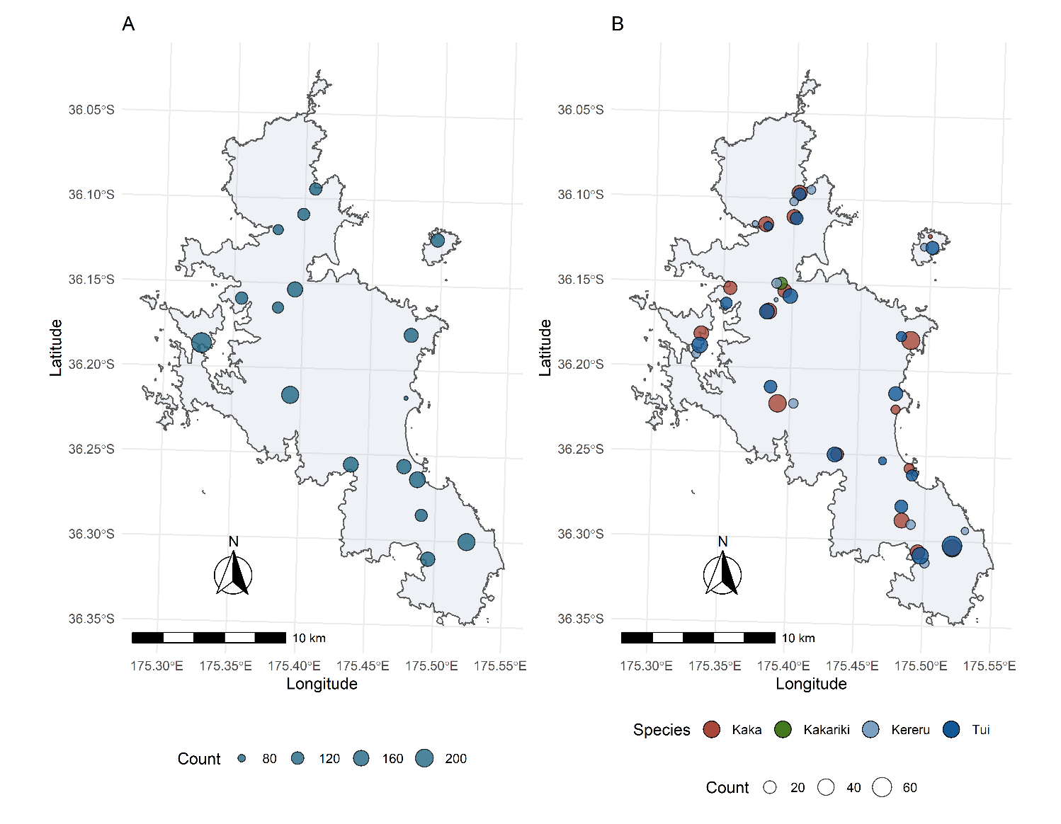The highest total bird count was observed in Motu Kaikoura, with 235 birds identified in total (Figure 4 A and Table 1). Motu Kaikoura showed the second-highest species richness and diversity. Medlands, which had the highest richness and diversity, had a total count of 165 birds identified. Kākāriki, the endemic species almost absent from the two main islands of New Zealand, was observed only at the Okiwi site, where a breeding population is established. This result is consistent with the 2019 ABC report (Simmonds, 2020). There has been a substantial investment in predator control at Okiwi to maintain the existing kākāriki population (Simmonds, 2018). In 2019, Glenfern was surveyed by a single observer but the species present were remarkable similar to observations from 2020.

Figure 4: Total counts of birds by site (A) and total count of the four target species (Kākāriki, Kākā, Tūī and Kererū) by site (B).

Of the four target species (kākāriki, kākā, tūī and kererū), kākā and tūī were observed at almost every site, except for Kaitoke, where no kākā were observed (Figure 4 B and Table 2). Kererū were observed at 12 of the 17 sites, although in lower numbers than kākā or tūī. A total of 18 kākāriki were observed, all of which at Okiwi (Figure 4 B and Table 2).

High counts of tūī and kākā were found at Windy Hill, and Haratonga, respectively. Okiwi had high abundances of all four species (Figure 4 B and Table 2). Kaitoke, one of the most diverse sites, had few observations of the target species, with only five tūī recorded.

Table 2: Total counts of the four target species at each site.

|  |  |  |  |  |
| --- | --- | --- | --- | --- |
| **Site** | **Tūī** | **Kākā** | **Kākāriki** | **Kererū** |
| Awana | 27 | 8 | 0 | 0 |
| Cooper's Castle | 31 | 37 | 0 | 1 |
| Glenfern | 16 | 23 | 0 | 1 |
| Haratoanga | 11 | 53 | 0 | 0 |
| Kaitoke | 5 | 0 | 0 | 0 |
| Medlands | 14 | 11 | 0 | 2 |
| Motairehe | 7 | 32 | 0 | 2 |
| Motu Kaikoura | 36 | 30 | 0 | 7 |
| Mt Young | 20 | 47 | 0 | 9 |
| Needle Rock | 21 | 32 | 0 | 9 |
| Okiwi | 30 | 25 | 18 | 10 |
| Okupu | 31 | 21 | 0 | 0 |
| Rakitu | 22 | 1 | 0 | 5 |
| Rangitawhiri Tryphena | 41 | 29 | 0 | 9 |
| Rangiwhakaea Bay | 18 | 33 | 0 | 7 |
| Te Paparahi | 20 | 28 | 0 | 6 |
| Windy Hill | 64 | 46 | 0 | 4 |

## 3.4 – Site dissimilarity

Three primary groups emerge from the cluster analysis. Two of the most diverse sites (Figure 1 B and Table 1), Medlands and Kaitoke, are clustered apart from the other sites (Figure 5; red branches). Awana forms a cluster with to Okupu, Okiwi and Rangitawhiri Tryphena (Figure 5; blue branches). All other sites form a large cluster indicating that they are similar in species composition. Motu Kaikoura, the second most diverse site, is included in the large cluster rather than with Medlands and Kaitoke (the first and third most diverse sites, respectively).

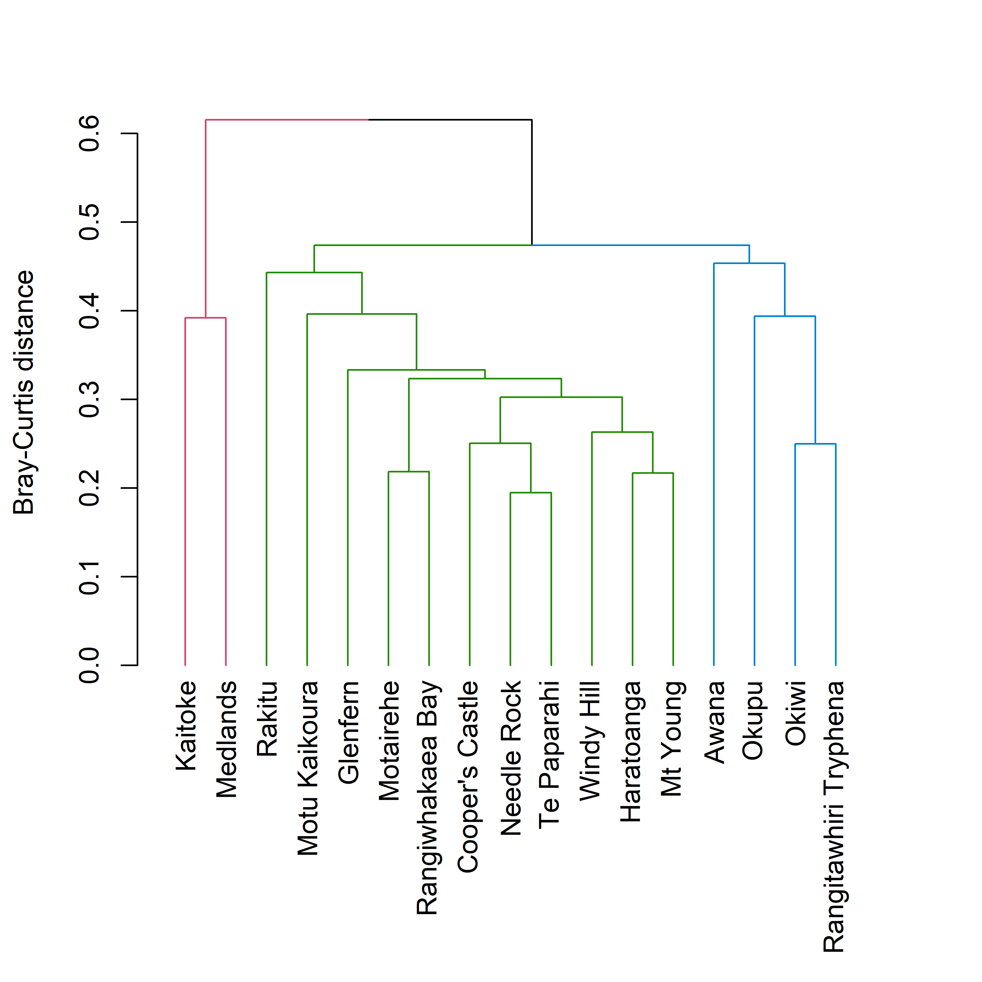

Figure 5: Hierarchical cluster analysis of sites using Bray-Curtis distance and unweighted pair group method with arithmetic mean. Three clusters are identified in the data as indicated by the colour of the branches.

## 3.5 – Comparison between years

In the long term, citizen bird count data can be used to monitor the trajectory of populations and specific species across Aotea. Graphical comparisons of the change in species richness (Figure 6) and diversity (Figure 7) show some differences in sites between 2019 and 2020; however, some variability is expected due to differences in site conditions and observers. Overall, greater species richness was observed in 2019 than in 2020 (Figure 6). Species diversity shows a mix of increases and decreases among sites between years (Figure 7). Caution is advised when interpreting the results of short-term data that have a level of inherent uncertainty and cannot be used to identify trends.

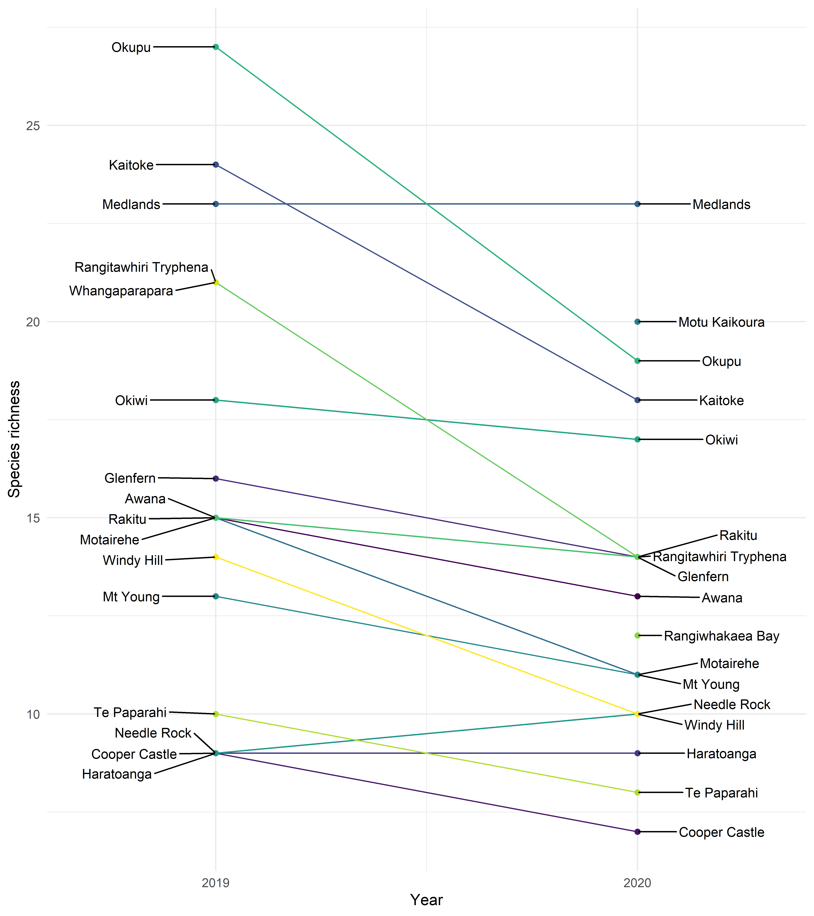

Figure 6: Bump plot of the change in species richness between 2019 and 2020.

If repeated on an annual or bi-annual basis, bird count data from the ABC can highlight long-term trends in richness and diversity and inform the success of management interventions. Additionally, statistical methods that require more than two years of data can be applied to the data in the future. Thus, it is recommended that ABC surveys continue in order to provide a valuable long-term dataset.

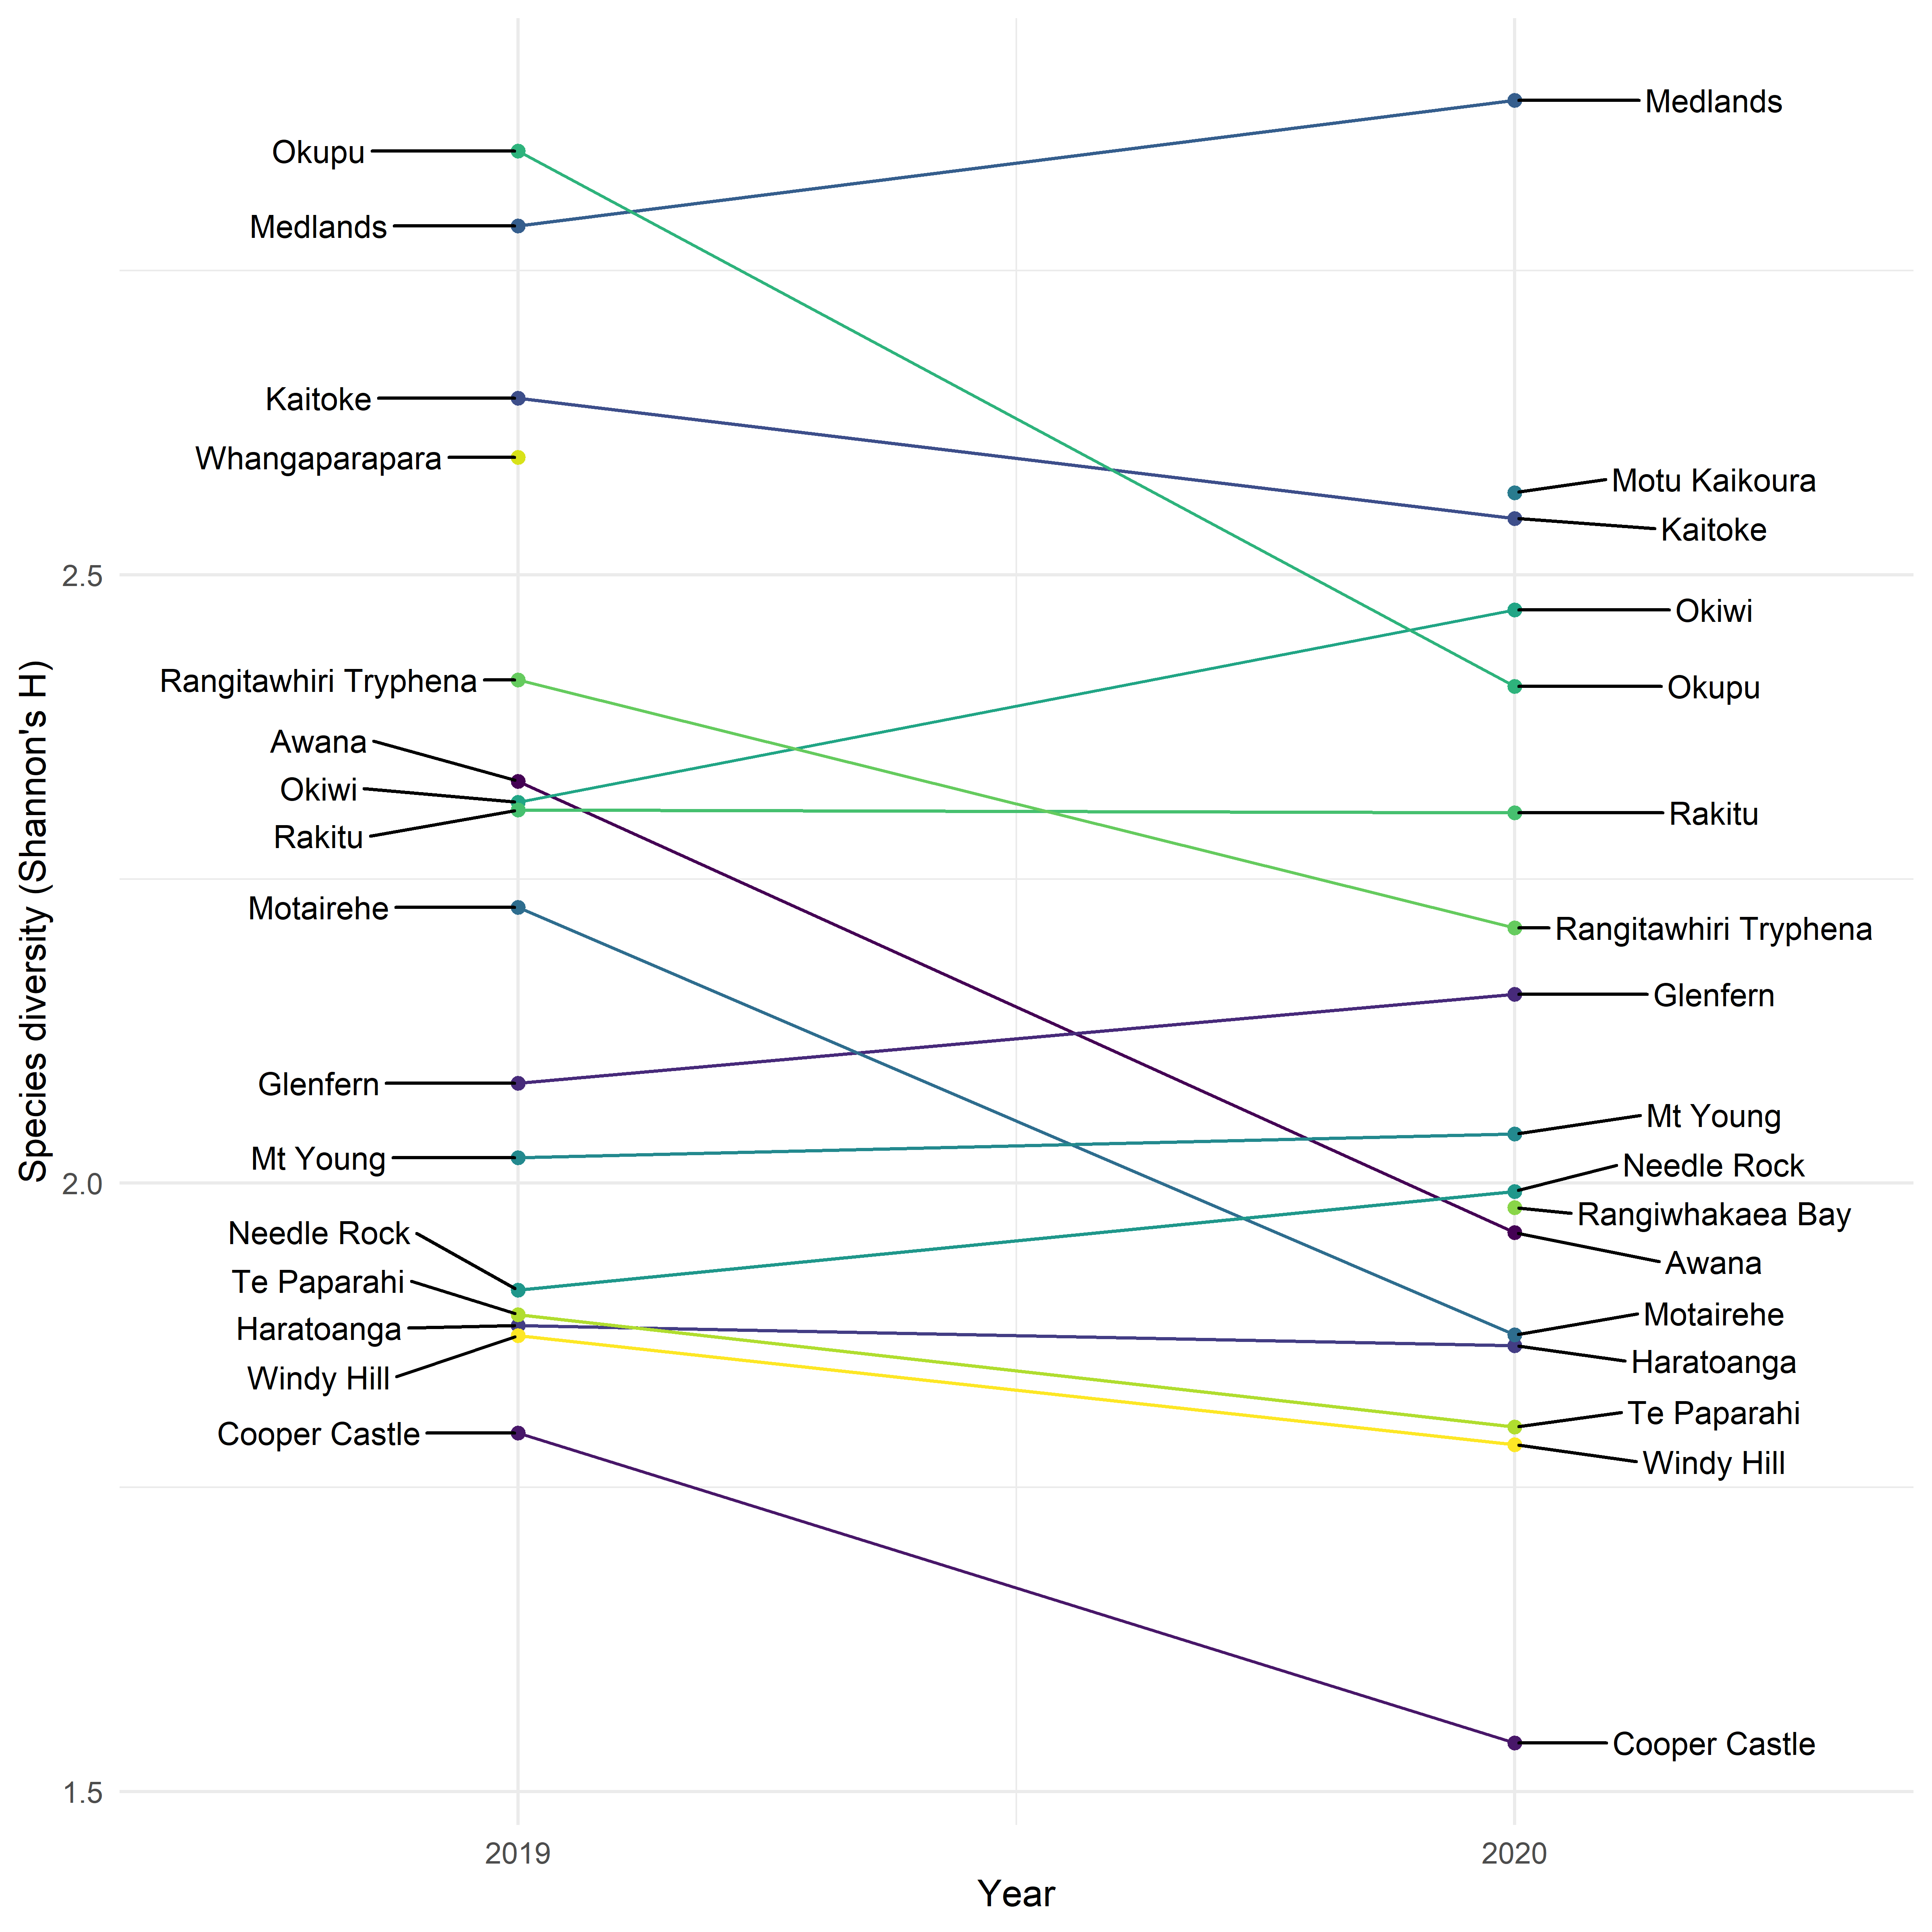

Figure 7: Bump plot of the change in species diversity between 2019 and 2020.

# 4 – Discussion

The ABC data were analysed for the primary, island-wide patterns of abundance; site-specific patterns of abundance, richness, and diversity; and site dissimilarity. Analysis of the aggregated data shows the most abundant species on Aotea to be the kākā, tūī, grey warbler, kingfisher and fantail (Figure 2). Of course, bird species are not uniformly distributed across the island. For example, Kaitoke had few records of tūī, and none of the kākā, and the only observations of kākāriki were at Okiwi. The hierarchical cluster analysis assesses the differences in species composition among the sites. Not surprisingly, the sites tend to cluster according to their habitat type. The Kaitoke and Medlands survey locations are wetland habitats, hence the lack of bush birds like the kākā and tūī, and high counts of pūkeko, swallows and kingfishers (Anderson, 2003). The Awana site that forms a single unit in the cluster analysis (Figure 5, green branch) was cleared in the early 20th century for farming and underwent annual controlled burning until about 1940. Awana now comprises mainly of mānuka–kānuka scrubland with some exotic species such as *Hakea* and pine (Perry *et al.*, 2010). Awana has a relatively low diversity (Table 1), with the community dominated by tūī, kingfishers, and kākā. All the other sites were more similar in their species composition to each other (Figure 5); the branches forming the cluster from Cooper’s Castle to Needle Rock are largely montane sites.

Of the four target species, tūī and kākā were common in all the sites of the large cluster identified by the cluster analysis (Figure 5, blue branches). Although present at most sites, lower counts of kererū were recorded across Aotea, with higher abundances at Mt Young, Needle Rock, Okiwi, and Rangitawhiri Tryphena (Table 2). Kākāriki were absent from all sites apart from Okiwi, indicating that kākāriki populations would benefit from stricter pest management schemes.

Comparisons of species richness and diversity between surveys from 2019 and 2020 must be interpreted cautiously since variability is to be expected in the data. However, they provide examples of how the data can be used to highlight trends if repeat surveys are conducted biannually or annually. Furthermore, as more data become available, statistical methods may also be used.

In the interests of reproducible data analyses and use for the analyses of future bird counts, both the data and the scripts are archived in an online repository. Data can be found at: 10.17608/k6.auckland.15087717.

## 4.2 – Limitations

Some sources of uncertainty exist in the data collection methods that must be accounted for during analysis and interpretation (see MacLeod *et al.*, 2012 for a detailed comparison of methods). The primary limitations in the data are:

* Location bias: survey locations are typically along a track or accessway. Bird counts from such locations may not be closely representative of the true abundance of a given area.
* Detection bias: birds species are not all equally likely to be observed due to size, sound and behavioural differences. Some birds, such as the tūī, are conspicuous and loud, while others, such as the tomtit, are small and inconspicuous.
* Identification bias: not all bird species are equally identifiable visually or audibly. For example, some species such as the kererū are visually easy to identify, while ones such as the yellowhammer may be more easily confused with another such as the goldfinch.

While some limitations exist (as with any observational ecological data), some can be mitigated. For example, survey groups have at least one trained observer to reduce identification error, and statistical methods exist to correct observation bias in data analysis. Thus, despite sources of uncertainty, important patterns can be observed from the data.

## 

## 4.3 – Conclusion

Counts from the ABC are a valuable source of insight into patterns of species richness, diversity and abundance. If repeated annually or biannually, data from the ABC can also be analysed for change over time in the abundance and distribution of species. Thus, it is recommended that the ABC is repeated at regular intervals to build a reliable long-term dataset. Such data can help track changes in the abundance of species (especially endemic declining species such as the pāteke) and the success of management interventions.

# References

Anderson, S. (2003) ‘The bird community of Kaitoke wetland, Great Barrier Island’, *Notornis*, 50(4), pp. 201–209.

Armitage, D. (ed.) (2004) *Great Barrier Island*. Rev. ed. Christchurch, N.Z: Canterbury University Press.

Clout, M. N. and Hay, J. R. (1989) ‘The importance of birds as browsers, pollinators and seed dispersers in new zealand forests’, *New zealand journal of ecology*, 12, p. 7.

Clout, M. N. and Russell, J. C. (2006) ‘The eradication of mammals from New Zealand islands’, p. 15.

Faith, D. P., Minchin, P. R. and Belbin, L. (1987) ‘Compositional dissimilarity as a robust measure of ecological distance’, *Vegetatio*, 69(1), pp. 57–68. doi: 10.1007/BF00038687.

Hartley, L. J. (2012) ‘Five-minute bird counts in New Zealand’, *New Zealand Journal of Ecology*, 36(3), pp. 1–11.

Hill, S. D. *et al.* (2013) ‘A comparison of vocalisations between mainland tui (Prosthemadera novaeseelandiae novaeseelandiae) and Chatham Island tui (P. n. chathamensis)’, *New Zealand Journal of Ecology*, 37(2), pp. 1–10.

Hill, S. D. and Ji, W. (2013) ‘Microgeographic variation in song phrases of tui (Prosthemadera novaeseelandiae)’, pp. 1–3.

MacLeod, C. J. *et al.* (2012) ‘Monitoring widespread and common bird species on New Zealand’s conservation lands: a pilot study’, *New Zealand Journal of Ecology*, 36(3), p. 12.

McEwen, W. M. (1978) ‘The food of the new zealand pigeon’, p. 10.

Moorhouse, R. *et al.* (2003) ‘Control of introduced mammalian predators improves kaka Nestor meridionalis breeding success: reversing the decline of a threatened New Zealand parrot’, *Biological Conservation*, 110(1), pp. 33–44. doi: 10.1016/S0006-3207(02)00173-8.

New Zealand Birds Online (2013). Available at: http://www.nzbirdsonline.org.nz/ (Accessed: 28 June 2021).

Ogden, J. and Gilbert, J. (2009) ‘Prospects for the eradication of rats from a large inhabited island: community based ecosystem studies on Great Barrier Island, New Zealand’, *Biological Invasions*, 11(7), pp. 1705–1717. doi: 10.1007/s10530-008-9398-8.

Ogden, J. and Gilbert, J. (2011) ‘Running the gauntlet: advocating rat and feral cat eradication on an inhabited island – Great Barrier Island, New Zealand’, p. 5.

Oksanen, J. (2020) ‘Vegan: ecological diversity’, pp. 1–12.

Ortiz‐Catedral, L. and Brunton, D. H. (2009) ‘Nesting sites and nesting success of reintroduced red‐crowned parakeets (Cyanoramphus novaezelandiae) on Tiritiri Matangi Island, New Zealand’, *New Zealand Journal of Zoology*, 36(1), pp. 1–10. doi: 10.1080/03014220909510133.

Perry, G. L. W. *et al.* (2010) ‘Vegetation patterns and trajectories in disturbed landscapes, Great Barrier Island, northern New Zealand’, *New Zealand Journal of Ecology*, 34(3), p. 13.

R Core Team (2021) *R: A language and environment for statistical computing*. manual. Vienna, Austria. Available at: https://www.R-project.org/.

Robertson, H. A. *et al.* (2016) ‘Conservation status of New Zealand birds, 2016’, pp. 1–27.

Russell, J. and Taylor, C. (Nick) (2017) *Strategic Environmental Assessment for Invasive Species Management on Inhabited Islands*. SSRN Scholarly Paper ID 3022964. Rochester, NY: Social Science Research Network. doi: 10.2139/ssrn.3022964.

Simmonds, S. (2018) *The kākāriki of Okiwi*, *Aotea Great Barrier Environmental Trust*. Available at: https://www.gbiet.org/en39-the-kkriki-of-okiwi (Accessed: 28 June 2021).

Simmonds, S. (2020) *Aotea Bird Count Results of the December 2019 survey*. Available at: https://www.gbiet.org/bird-count.

Stewart, A. M. and Craig, J. L. (1985) ‘Movements, status, access to nectar, and spatial organisation of the tui’, *New Zealand Journal of Zoology*, 12(4), pp. 664–666. doi: 10.1080/03014223.1985.10428315.

Tū Mai Taonga (2020) *Protecting Aotea Ecology | Tū Mai Taonga*, *Tu Mai Taonga*. Available at: https://www.tumaitaonga.nz (Accessed: 28 June 2021).

Wotton, D. M. and Kelly, D. (2012) ‘Do larger frugivores move seeds further? Body size, seed dispersal distance, and a case study of a large, sedentary pigeon’, *Journal of Biogeography*, 39(11), pp. 1973–1983. doi: 10.1111/jbi.12000.

# Appendix A

Table 3: List of names and conservation status, including their Māori, Latin, and European names. Note some species have multiple Māori or European names that are not included. Names are sourced from New Zealand Birds Online (New Zealand Birds Online, 2013).

|  |  |  |  |  |
| --- | --- | --- | --- | --- |
| **Māori name** | **Latin name** | **European name** | **Conservation status** | **NZ conservation status** |
| Kāhu | *Circus approximans* | Harrier Hawk | Not Threatened | Native |
| Kaireka | *Alauda arvensis* | Skylark | Introduced and Naturalised | Introduced |
| Kākā | *Nestor meridionalis* | Brown Parrot | Recovering | Endemic |
| Kākāriki | *Cyanoramphus novaezelandiae* | Red-crowned parakeet | Relict | Endemic |
| Karoro | *Larus dominicanus* | Black-backed Gull | Not Threatened | Native |
| Kawau tūi | *Phalacrocorax sulcirostris* | Little Black Shag | Naturally Uncommon | Native |
| Kererū | *Hemiphaga novaeseelandiae* | Wood Pigeon | Not Threatened | Endemic |
| Kōtare | *Todiramphus sanctus* | Sacred Kingfisher | Not Threatened | Native |
| Makipae | *Gymnorhina tibicen* | Magpie | Introduced and Naturalised | Introduced |
| Manu Pango | *Turdus merula* | Blackbird | Introduced and Naturalised | Introduced |
| Matuku Moana | *Egretta sacra* | Reef Heron | Nationally Endangered | Native |
| Mioweka | *Gallirallus philippensis* | Banded Rail | Declining | Native |
| Mohua | *Mohoua ochrocephala* | Yellowhead | Recovering | Endemic |
| Ngirungiru | *Petroica macrocephala* | Tomtit | Not Threatened | Endemic |
| Pahirini | *Fringilla coelebs* | Chaffinch | Introduced and Naturalised | Introduced |
| Pāteke | *Anas chlorotis* | Brown teal | Recovering | Endemic |
| Pīpīwharauroa | *Chrysococcyx lucidus* | Shining Cuckoo | Not Threatened | Native |
| Pīwakawaka | *Rhipidura fuliginosa* | Fantail | Not Threatened | Endemic |
| Pūkeko | *Porphyrio melanotus* | Purple Swamphen | Not Threatened | Native |
| Pūtangitangi | *Tadorna variegata* | Paradise Duck | Not Threatened | Endemic |
| Riroriro | *Gerygone igata* | Grey Warbler | Not Threatened | Endemic |
| Ruru | *Ninox novaeseelandiae* | Morepork | Not Threatened | Native |
| Tākapu | *Morus serrator* | Gannet | Not Threatened | Native |
| Tarāpunga | *Larus novaehollandiae* | Red-billed Gull | Declining | Native |
| Tauhou | *Zosterops lateralis* | Silvereye | Not Threatened | Native |
| Tiu | *Passer domesticus* | Sparrow | Introduced and Naturalised | Introduced |
| Tōrea pango | *Haematopus unicolor* | Oystercatcher | Recovering | Endemic |
| Tūī | *Prosthemadera novaeseelandiae* | Parson Bird | Naturally Uncommon | Endemic |
| Tūturiwhatu | *Charadrius spp.* | Dotterel | NA | NA |
| Warou | *Hirundo neoxena* | Swallow | Not Threatened | Native |
| Weka | *Gallirallus australis* | Woodhen | Not Threatened | Endemic |
| - | *Emberiza citrinella* | Yellowhammer | Introduced and Naturalised | Introduced |
| - | *Acridotheres tristis* | Mynah | Introduced and Naturalised | Introduced |
| - | *Vanellus miles* | Spur-winged Plover | Not Threatened | Native |
| - | *Turdus philomelos* | Song Thrush | Introduced and Naturalised | Introduced |
| - | *Ardea cinerea* | Grey Heron | Vagrant | Native |
| - | *Anas platyrhynchos* | Mallard Duck | Introduced and Naturalised | Introduced |
| - | *Carduelis carduelis* | Goldfinch | Introduced and Naturalised | Introduced |
| - | *Carduelis flammea* | Redpoll | Introduced and Naturalised | Introduced |

# Appendix B

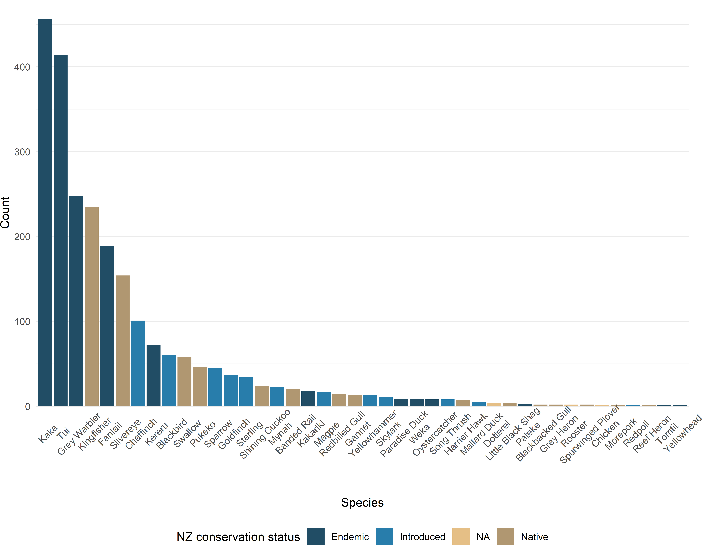Counts of each of the identified species on Aotea. Colours indicate their New Zealand conservation status (native, endemic, introduced, or NA for birds unidentified to the species level).

Figure 8: Counts of all 42 species identified summed across all 17 sites.