How To Quickly Setup
Mal’s E-commerce
for use with the
Stripe Payment Processor

- by -
Quinn Ebert
(#TheLobby on IRC.TBRN.NET)

STEP 1:
CONFIGURE THE PHP SCRIPT

- Open the “stripe4mal.php” file in a text editor.
Windows users should NOT use Wordpad! Notepad or another text editor program (such as Edit Pad Pro from www.jgsoft.com) are reasonable options.
- Look for the line that says the following:
$LIVE_SECRET_KEY = "";
- Between those two quote marks, you’ll want to put your key from the “Your account” page on Stripe’s dashboard. Specifically, here, you need to put the key that is described as “secret” and “live” -- another hint to the right key is that it will have an underscore in it.
- Look for the line that says the following:
$LIVE_PUBLIC_KEY = "";
- Between those two quote marks, you’ll want to put your key from the “Your account” page on Stripe’s dashboard. Specifically, here, you need to put the key that is described as “publishable” and “live” -- another hint to the right key is that it will NOT have an underscore in it.
- Save the file and KEEP IT OPEN -- we have one more minor edit to make later on.
- You’re ready to move on!

STEP 2:
GETTING TO THE RIGHT MAL’S E-COMMERCE SETUP PAGE:

- Yeah, we know, Mal’s setup pages are a bit of a jungle gym to navigate, so that’s why we have this section. Start by logging into your account at Mals-e.com.
- Click the “Cart setup” tab near the top of the page.
- On the left-hand side of the page, find the “Payment methods” section, and click the “Payment gateway setup” link.
- On the right-hand side of the page, under the orange “VIEW YOUR SHOPPING CART” button, you should see a link that reads something like “Custom Payment Gateways” or “Custom Gateway Setup.” Click this link.
- This next page is scary, and we know it. Don’t worry, we’ve got pictures to help you out, and believe it or not, getting it all right only takes about 5-10 minutes and it’s pretty hard to mess up -- read on...

Continued on the next page...
STEP 3:
CONFIGURE MAL’S TO POST TO YOUR PHP SCRIPT

a. The section below shows up at the top of the page. Enter the HTTPS address of where your script will be located into that form field. You should leave the drop-down menu set to POST (or change it to POST if it’s been set to GET) -- you actually can use either one, but, POST is a bit safer for both you and your customers.
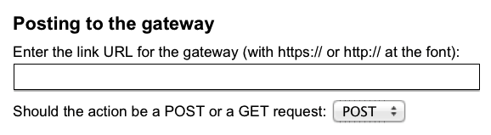b. The section just below that one is labelled “FIXED VALUE FIELDS.” We only need the first row filled out -- just set the values listed below:

If you can’t see the image, that is “enter_data” (without the quotes) in the “Field Name” box and “yes” (without the quotes) in the “Value” box.

All other fields under FIXED VALUE FIELDS should be left blank (or cleared of any other existing data).

- Under “FIELDS WITH VALUES FROM THE CART” copy the following, and if anything else is currently set up, clear it out (NOTE -- graphic has the blank fields edited out):

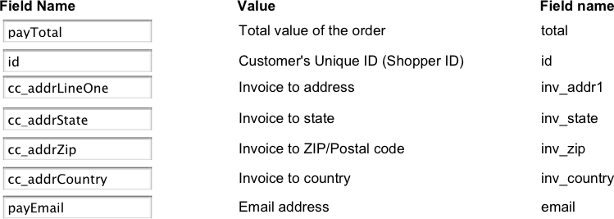
(Textual description on next page -- this is the bottom of a printed page).
For the visually-impaired, the fields you need to set are the following, in the order that they appear (visually) under the “FIELDS WITH VALUES FROM THE CART” section...

- Set first form field to “payTotal”
- Set next field to “id”
- Clear out the next 6 form fields
- Next form field should be set to “cc_addrLineOne”
- Clear out the next form field
- Next form field should be “cc_addrState”
- Next form field is “cc_addrZip”
- Next form field should be set to “cc_addrCountry”
- Clear out the next two form fields
- Set this form field to “payEmail”
- Clear out remaining form fields after that one in the tab order on this section.

- Under the “SUBMIT BUTTON” section here, enter “CONTINUE” on both the “Submit Name” field and the “Value” field.

- Also under the “SUBMIT BUTTON” section, enter “Pay with credit card directly” for “The description to go above or beside this payment option.” You can also edit this to whatever you think might be more appealing to your users.

- Under “Return link to the cart” make sure you’ve selected the “Makes a silent POST, GET or redirect to the cart” option.

- Select, and copy EVERYTHING UP TO BUT NOT INCLUDING THE QUESTION MARK, from the URL given under “LINK BACK URLs.”

That should look something like this when you paste it:
http://ww5.aitsafe.com/gen/return.htm

- You’ll now need to open stripe4mal.php again in a text editor, and paste that URL between the quotes on the line reading:

$URL_UPON_FINISH = "";

- You can now save, close, and upload the stripe4mal.php file to where you intend to put it on your web server.

- We’re getting very close to being done, you’ve done well, take a quick caffeine break now if you need it (you deserve it!)

Continued on the next page...

- OK, now, we need to fill in those three boxes under the REQUIRED FIELDS section:

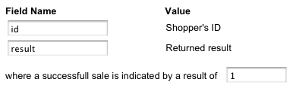
- Set the first field (Shopper’s ID as it’s labelled) to “id” (all lowercase)
- Set the second field (Returned Result as it’s labelled) to “result” (all lowercase)
- The third field (after the text reading “where a successful sale is indicated by a result of”) should be set to “!” (the number one).

- OK, you’re basically home free, just two more very common-sense type steps to handle here.

- Find the “Thank you message” text box (a big, multi-line text box) and enter a message that will thank your customers for their payment through Stripe. You may want to tell them timeframes for order fulfillment, shipping, and return policies (and even provide customer service information) here.

- LAST TEXT ENTRY FOR YOU: edit the “Declined message” text box (the next one after the “Thank you message” text box) and provide a generic message that will be displayed if the customer’s payment information doesn’t pass muster with Stripe. You should probably provide customer service or sales team contact info here to increase follow-through from legitimate customers.

- Press the “SETUP” button at the bottom of the page. Assuming you’ve already uploaded your stripe4mal.php file with the edits I’ve told you to make, you should be good to go, but do run through an order (use the “GO TO PAYMENTS” button on your cart to access Stripe as a payment method -- it’ll be described as “Pay with credit card directly” -- or whatever else you decided to call it earlier in this HOW-TO).

p. Let me know if you have trouble, for about $10, I can take the time to help you figure out what needs to be fixed. I am Quinn on #TheLobby on IRC.TBRN.NET or visit my www.QuinnEbert.net home page.

