Technical Appendix
Autonomous Pancreatic Lesion Detection and Radiologist Review System
Quinn Evans · Supplement to the BSAAI Capstone Proposal
This appendix documents the system design and the data behind the proposal. It exists so a reviewer can assess whether the architecture has been thought through, not only whether the technologies have been named. Every quantity was measured against real files or taken from published documentation; estimates are labeled as such.

A1. System architecture
The project consists of two systems that meet at a shared data layer. The imaging pipeline produces structured findings; those findings become the retrieval context for the knowledge assistant. Neither system calls the other directly.
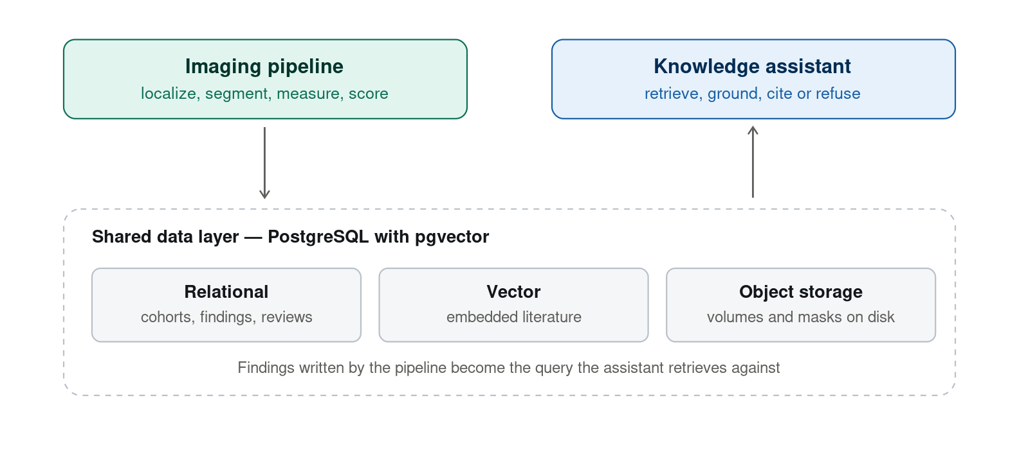
System architecture

A2. End-to-end data flow
The complete path a scan takes. Steps 2 through 5 are the autonomous cascade this capstone builds; today step 2 is replaced by a human-provided region of interest.
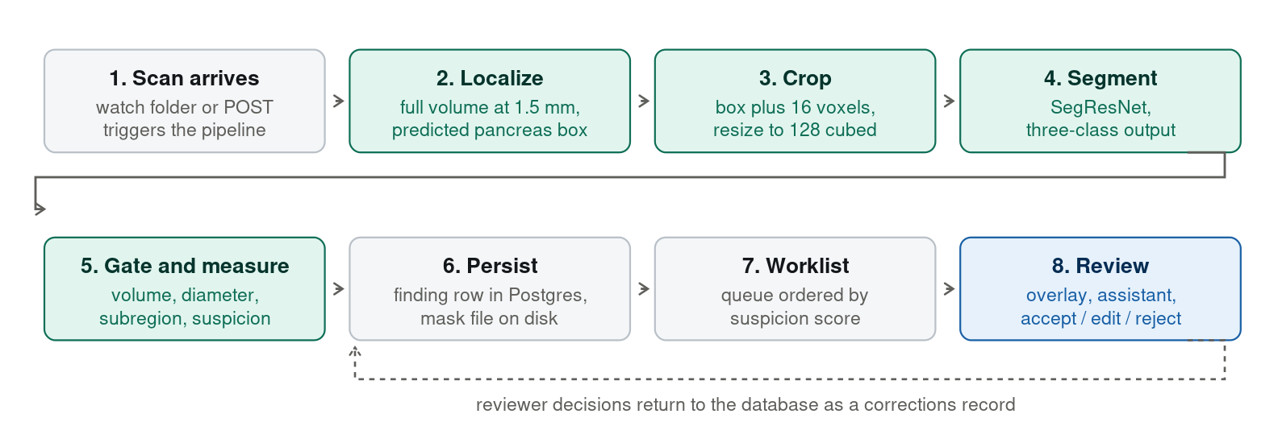
End-to-end data flow
Measured inference cost. A full CT resampled to 1.5 mm isotropic is a median of 253 × 190 × 142 voxels — 6.9 million voxels, 26.5 MiB as float32, computed across all 9,901 scans. Sliding-window localization at 128³ with 50% overlap requires a median of 12 windows per scan. Against a current serving time of roughly 0.6 seconds for the provided-region path, autonomous whole-scan inference should land in the range of several seconds per study.

A3. Relational schema
Abbreviated to the tables that carry the design decisions.
-- Storage roots are configuration, never absolute paths in data.
CREATE TABLE storage_root (
id SERIAL PRIMARY KEY,
name TEXT NOT NULL UNIQUE, -- 'cold_archive', 'warm_cache'
tier TEXT NOT NULL CHECK (tier IN ('cold','warm','cloud'))
);
CREATE TABLE scan (
id BIGSERIAL PRIMARY KEY,
case_id TEXT NOT NULL,
source_dataset TEXT NOT NULL, -- 'pants' | 'panorama'
patient_key TEXT NOT NULL, -- splits group on THIS, not on scan
shape INT[3] NOT NULL,
spacing REAL[3] NOT NULL,
contrast_phase TEXT,
reference_std TEXT, -- histopathology | cytology | radiology | ...
site TEXT,
UNIQUE (source_dataset, case_id)
);
-- Provenance is data, not an assumption. PANORAMA organ masks are machine
-- generated; PanTS masks are expert validated. The model must know which.
CREATE TABLE annotation (
id BIGSERIAL PRIMARY KEY,
scan_id BIGINT NOT NULL REFERENCES scan(id),
structure TEXT NOT NULL, -- 'pancreas' | 'lesion' | ...
provenance TEXT NOT NULL CHECK (provenance IN ('expert','automated')),
volume_mm3 DOUBLE PRECISION
);
CREATE TABLE scan_file (
id BIGSERIAL PRIMARY KEY,
scan_id BIGINT NOT NULL REFERENCES scan(id),
storage_root_id INT NOT NULL REFERENCES storage_root(id),
relative_path TEXT NOT NULL,
bytes BIGINT,
sha256 CHAR(64),
perceptual_hash TEXT, -- 32^3 downsample, cross-dataset dedup
verified_at TIMESTAMPTZ
);
-- A cohort is a materialized query, not a text file. This is the control that
-- makes the validation leak found in the preceding project inexpressible.
CREATE TABLE cohort (
id SERIAL PRIMARY KEY,
name TEXT NOT NULL UNIQUE,
definition TEXT NOT NULL, -- the SQL that produced it
parent_fold TEXT, -- 'train' | 'val' | 'test'
frozen_at TIMESTAMPTZ
);
CREATE TABLE cohort_member (
cohort_id INT NOT NULL REFERENCES cohort(id),
scan_id BIGINT NOT NULL REFERENCES scan(id),
PRIMARY KEY (cohort_id, scan_id)
);
-- Enforced at write time: a patient may never appear in a training cohort and
-- an evaluation cohort simultaneously.
CREATE OR REPLACE FUNCTION assert_cohort_disjoint() RETURNS TRIGGER AS $$
BEGIN
IF EXISTS (
SELECT 1
FROM cohort_member cm
JOIN scan s ON s.id = cm.scan_id
JOIN scan ns ON ns.id = NEW.scan_id
JOIN cohort c ON c.id = cm.cohort_id
JOIN cohort nc ON nc.id = NEW.cohort_id
WHERE s.patient_key = ns.patient_key
AND c.parent_fold IS DISTINCT FROM nc.parent_fold
) THEN
RAISE EXCEPTION 'patient for scan % would cross folds', NEW.scan_id;
END IF;
RETURN NEW;
END; $$ LANGUAGE plpgsql;
CREATE TABLE prediction (
id BIGSERIAL PRIMARY KEY,
scan_id BIGINT NOT NULL REFERENCES scan(id),
model_version TEXT NOT NULL,
lesion_volume_mm3 DOUBLE PRECISION,
max_diameter_mm DOUBLE PRECISION,
subregion TEXT,
suspicion_score DOUBLE PRECISION, -- drives worklist ordering
mask_file_id BIGINT REFERENCES scan_file(id),
UNIQUE (scan_id, model_version)
);
CREATE TABLE review (
id BIGSERIAL PRIMARY KEY,
prediction_id BIGINT NOT NULL REFERENCES prediction(id),
decision TEXT NOT NULL CHECK (decision IN ('accept','edit','reject')),
reviewer TEXT NOT NULL,
decided_at TIMESTAMPTZ NOT NULL DEFAULT now(),
note TEXT
);
-- Literature chunks share the database with imaging metadata, so a single
-- query can combine semantic similarity with structured filters.
CREATE TABLE doc_chunk (
id BIGSERIAL PRIMARY KEY,
pmid TEXT NOT NULL,
title TEXT,
journal TEXT,
year INT,
mesh TEXT[],
chunk_text TEXT NOT NULL,
embedding VECTOR(768)
);
CREATE INDEX ON doc_chunk USING hnsw (embedding vector_cosine_ops);
Why the trigger matters. In the preceding project, cohort membership lived in text files and a script sampled from the wrong column. The result was 266 evaluation cases inside the training set and a headline lesion Dice inflated from 0.415 to 0.528. That number had to be withdrawn. Expressing membership as a constrained relation, keyed on patient rather than scan, makes the same mistake impossible to commit rather than merely possible to detect.

A4. PANORAMA — verification against real files
Everything in this section was read from clinical_information.xlsx and panorama_labels-main.zip. Nothing rests on documentation.

A4.1 The spreadsheet
2,238 rows × 8 columns: PANORAMA_patient_id, PANORAMA_study_id, anonymized_study_date, patient_age, patient_sex, scanner, label, level. First rows as they appear:
patient_id | study_id | date | age | sex | scanner | label | level
100000 | 100000_00001 | 2018-10-04 | 042Y | F | TOSHIBA | non-PDAC | radiology
100001 | 100001_00001 | 2014-04-24 | 068Y | M | SIEMENS | non-PDAC | radiology
100002 | 100002_00001 | 2021-03-02 | 077Y | F | TOSHIBA | PDAC | pathology
100003 | 100003_00001 | 2016-12-28 | 057Y | M | TOSHIBA | PDAC | cytology
100004 | 100004_00001 | 2018-02-09 | 068Y | M | SIEMENS | non-PDAC | radiology

A4.2 The level column identifies imported cases by name
level | n
radiology | 1,212
histopathology | 353
pathology | 210
MSD_dataset | 194
cytology | 183
NIH_dataset | 80
radiology / 3-year follow-up | 6
Cross-check against the published README — “80 patients without PDAC from NIH and 194 patients (98 PDAC) from MSD” — the file gives MSD_dataset as 98 PDAC / 96 non-PDAC and NIH_dataset as 0 PDAC / 80 non-PDAC. Consistent on every figure.
Implementation, with the load-time assertion:
IMPORTS = {"MSD_dataset", "NIH_dataset"}
clean = df[~df.level.isin(IMPORTS)]
assert len(clean) == 1964 and (clean.label == "PDAC").sum() == 578

A4.3 File reconciliation — exact
directory | observed | documented
manual_labels/ | 482 | 482
automatic_labels/ | 1,756 | —
total | 2,238 | 2,238 spreadsheet rows
Decomposes exactly: 676 PDAC = 482 manual + 194 automatic; 1,562 non-PDAC all automatic; 194 + 1,562 = 1,756. One label file per case, none missing or duplicated. Filenames are PANORAMA_study_id verbatim (100002_00001.nii.gz), so the exclusion list applies directly to files with no identifier mapping.

A4.4 Label legend, read from a mask
manual_labels/100002_00001.nii.gz — shape 512 × 512 × 561, spacing 0.709 × 0.709 × 1.0 mm.
value | structure | voxels
0 | background | 146,625,501
1 | PDAC lesion | 37,468
2 | veins | 68,763
3 | arteries | 88,123
4 | pancreas parenchyma | 164,928
5 | pancreatic duct | 32,464
6 | common bile duct | 45,537
All seven documented values present. The remap is verified against data rather than a README. Note the geometry: finer in-plane than the PanTS median with a long z-extent, so resampling to 1.5 mm changes PANORAMA volumes more than it changes PanTS volumes.

A4.5 Annotation quality after exclusion — a corrected estimate
An earlier estimate of 482 expert-annotated tumors was wrong.
tumor annotation | cases
usable tumor cases after exclusion | 578
with expert manual delineation | 382
with machine-generated masks | 196
Cause: 97 of the 98 Decathlon tumor cases carry manual masks — PANORAMA re-delineated them rather than inheriting the original labels. The excluded cases are therefore disproportionately the best-annotated ones, and the exclusion costs 97 gold-standard tumors.
Manual masks by source, all 482: MSD 97 · histopathology 171 · pathology 109 · cytology 85 · radiology 20 · NIH 0.
Revised lever size: 706 current tumors → 1,088 with the expert subset, a 54% increase rather than the 82% the raw 578 figure implies. Still the largest single lever and still the only route to more tumors.
A shortcut refused. Keeping the Decathlon cases would recover those 97 expert tumors, and PANORAMA’s masks are better than the originals. But those scans sit in the PanTS validation split (198 MSKCC cases) and the official test split (195). Training on them would contaminate our own evaluation — the same trade that produced the withdrawn 0.528.

A4.6 Cohort profile and residual risk
746 of 1,964 usable cases (38%) have tissue confirmation — histopathology, pathology, or cytology. Age median 67, range 18–99, zero missing. Sex 1,064 M / 900 F. Scanners: Siemens 938, Toshiba 651, Philips 319, GE 46, Canon 7 — the same four manufacturers already present in PanTS.
Residual risk, disclosed. The level column resolves declared imports. It cannot rule out undeclared duplicates — notably the 533 PanTS records carrying “Radboud” inside a pooled multi-institution provenance string. The pixel-level detector, with recall measured on planted duplicates, is the control for that.
Minor anomalies. Three non-PDAC cases carry manual masks though the README says manual delineation was tumor-only. One of the 98 Decathlon tumor cases has no manual mask.

A4.7 Integration challenges
Merging the two datasets introduces differences that remapping alone cannot resolve. Each is named here with the response it gets.
challenge | response
PANORAMA’s pancreas masks are machine-generated throughout; PanTS masks are expert-validated. The whole-box recipe crops to the pancreas, so those cases would be cropped to a silver-standard mask. | Provenance stored per structure; pancreas Dice reported separately by source.
Lesion quality is mixed — 382 of 578 usable tumors carry expert delineations — and every PANORAMA tumor is PDAC, while PanTS also covers IPMN and neuroendocrine tumors. | Train on the expert subset first, machine-annotated cases as a labeled ablation; report per-type performance where metadata permits.
Portal-venous phase only. A prior experiment showed contrast phase is the strongest driver of this model’s behavior — non-contrast training gave 90% specificity against 10% for portal-venous. | Pre-register the prediction that specificity falls, so observing it is confirmation rather than rationalization.
The negative class differs — PANORAMA negatives are histopathology or three-year follow-up, PanTS negatives are cases with no lesion mask — and label values are incompatible (PANORAMA 1 = PDAC, 4 = parenchyma). | Reference standard carried as a column and reported separately; config-driven remap behind unit tests, verified against real masks.

A5. Storage tiers and compute
Measured across all 9,901 PanTS scans: 297.5 billion voxels.
tier | contents | size | location
cold | original compressed volumes, both datasets | 582 GB | external drive, checksummed, never read during training
warm | preprocessed 128³ arrays, 10.0 MiB per case | 25 GiB for the merged training cohort | internal SSD or cloud volume
index | metadata, cohorts, findings, embeddings | ~1 GB | PostgreSQL
Uncompressed, the imaging archive would occupy 831 GB, and storing all 28 annotated structures as separate full volumes would require 8.1 TB. Neither is necessary: training reads only the warm tier.
Consequence for compute. Moving training to a rented GPU means uploading 25 GiB once, not 582 GB. Three controls preserve comparability: numerical precision stays at fp32, the baseline is re-established on the new hardware before any comparison, and on-demand rather than preemptible instances are used until checkpoint resume is verified end to end.

A6. Knowledge corpus — what the data actually is
The assistant retrieves from peer-reviewed literature, not from patient data. Scope measured against the live NCBI index:
query | records
PubMed — Pancreatic Neoplasms [MeSH] AND Tomography, X-Ray Computed [MeSH] | 8,422
…of those, carrying an abstract | 6,949
PMC Open Access subset — same MeSH terms | 880
PubMed — Pancreatic Neoplasms [MeSH], any modality | 104,140
The committed corpus is the first row plus full text where the Open Access subset provides it. At roughly one to two chunks per abstract and forty per full-text article, that is an estimated 40,000–60,000 chunks and a vector index under 100 MB — comfortably inside pgvector’s range, with no second database service required.
A record as retrieved, unmodified:
PMID 39865461
JOURNAL United European Gastroenterology Journal (2025)
TITLE Artificial Intelligence in Pancreatic Imaging: A Systematic Review
MeSH Humans; Artificial Intelligence; Deep Learning; Pancreatic Neoplasms;
Pancreas; Magnetic Resonance Imaging; Pancreatic Diseases;
Neural Networks, Computer
ABSTRACT The rising incidence of pancreatic diseases, including acute and
chronic pancreatitis and various pancreatic neoplasms, poses a
significant global health challenge. Pancreatic ductal
adenocarcinoma (PDAC) for example, has a high mortality rate due
to late-stage diagnosis and its inaccessible location...
The abstract is chunked and embedded; the PMID becomes the citation displayed beside any statement drawn from that passage; MeSH descriptors and publication year become structured filters, so a query can combine semantic similarity with year >= 2010 in one SQL statement.
Known data-quality issue, quantified. 1,473 of 8,422 records (17.5%) carry no abstract — 39231345, Pancreatic Cysts in the New England Journal of Medicine, is title and MeSH only. Records without retrievable text are excluded at ingest and the exclusion count is reported, rather than embedding empty documents.
Pipeline.
stage | specification
chunking | ~512 tokens, 64-token overlap, section boundaries respected
embedding | sentence-transformer; pre-registered comparison of a general model (384 dimensions) against a biomedical model (768)
index | pgvector HNSW, cosine distance, parameters tuned against a held-out question set
retrieval | top-k passages, filtered by structured predicates in the same SQL query
generation | Qwen instruct via Ollama, temperature 0, executed locally
Query construction. The assistant is not a free-text chatbot. A query is templated from the finding row the pipeline just wrote:
finding: lesion 2.4 cm maximum diameter, 5.3 cm³, pancreatic head,
portal venous phase, organ volume 77 cm³
question: <clinician question>
retrieve: top-k chunks WHERE embedding <=> query_embedding
AND year >= 2010
Cite or refuse. The system prompt permits only statements supported by retrieved passages, each rendered beside the text it supports. If the best retrieval score falls below a calibrated threshold, the assistant returns a refusal rather than generating. This is a testable property, and it is what keeps a literature-lookup tool from becoming unlicensed clinical advice.
Evaluation. Retrieval scored with recall@k (whether the relevant passage appears in the top k results) and mean reciprocal rank (how near the top the first correct passage lands), against a hand-authored question set of clinical questions paired with the documents that should answer them. Generation scored by groundedness rate — the fraction of claims traceable to a retrieved passage — and by refusal accuracy on questions deliberately outside the corpus.
Scope decision. The corpus is deliberately narrow. Widening to all imaging modalities or all pancreatic neoplasm literature would grow it by an order of magnitude while lowering retrieval precision. Corpus breadth is treated as a tunable parameter and becomes the second axis of the retrieval evaluation, alongside the embedding-model comparison.

A7. Risks and fallbacks
risk | likelihood | response
The week 6 experiment returns null — added tumors do not improve lesion Dice | Moderate | Reported as a null result; the baseline cohort is retained. The integration work stands alone as the data engineering deliverable; pipeline and gate are unaffected.
The autonomous cascade loses significant accuracy against the provided-region baseline | Moderate | Both numbers reported side by side, which is the honest comparison regardless. Prior work measured 98% tumor coverage from the predicted region, so total failure is unlikely.
Johns Hopkins does not respond to the external submission | Likely enough to plan for | The submission is a stretch goal outside the critical path. Two alternatives remain: leave-one-institution-out across six sites within PanTS, and the PANORAMA challenge’s own hidden test cohort.
Specificity cannot be raised without breaching the 96% detection floor | Moderate | Report the full operating-point curve rather than a single threshold. A prior experiment established that this axis is movable and located the cost in small tumors.
The clinical stakeholder becomes unavailable | Low | A diagnostic care coordinator has already confirmed. A practicing radiologist is being arranged as primary; the coordinator is the fallback, not a hedge.
Assistant produces an ungrounded clinical statement | Low, and gated | Cite-or-refuse is enforced at generation, not by disclaimer, and refusal accuracy is measured. Any ungrounded output reaching the interface is a defect, not a tuning issue.
Training throughput on local hardware is insufficient | Moderate | The warm cache makes cloud GPU a 25 GiB upload. A profiling pass in week 1 determines whether the bottleneck is compute or input/output before any money is spent.
Scope overruns across two systems | Moderate | Each pillar carries a committed minimum and an optional stronger version, so a difficult week costs sophistication rather than a component.

A8. What already exists
Complete and working before week 1.
- A registered model in MLflow with version, step, and checksum, trained by transfer learning from the SuPreM pretrained checkpoint.
- Evaluation on the official 901-scan held-out test set: lesion Dice 0.474 (95% CI 0.42–0.52), pancreas Dice 0.827, detection sensitivity 96%, specificity 17%, patient-level AUC 0.804. These are provided-region results and are reported as such.
- A FastAPI inference service and a React and NiiVue review interface with prediction overlays and 3D reconstruction.
- Twenty-seven pre-registered experiments with recorded accept or reject decisions, including two rejections and one withdrawn result.
- A localize-then-segment cascade that runs end to end, measured once at 98% tumor coverage from the predicted region.
- Two independent adversarial code audits, one of which found the validation leak described in A3.

A8.1 What is reused and what is new
The preceding project supplies working machinery; the capstone supplies what that machinery could not do.
reused as-is | adapted | new
SegResNet architecture, SuPreM transfer | preprocessing — two label conventions and provenance rather than one | relational schema and vector store
training loop, checkpointing, resume | data loading — database queries rather than a manifest file | entity resolution and duplicate detection
MLflow tracking and model registry | cohorts — constrained tables rather than text files | tumor-presence gate
sliding-window inference | inference entry — predicted region rather than a provided one | literature corpus, embedding, retrieval index
evaluation harness: sweeps, bootstrap intervals, per-case analysis |  | grounded assistant with cite-or-refuse
FastAPI service, React and NiiVue viewer |  | arrival-triggered automation, worklist, review persistence
The reused column is scaffolding. It is why ten weeks is realistic — no time goes into rebuilding a training loop — but none of it answers the question the capstone asks, which is whether the system works without a human supplying the region of interest.

A9. Data use, licensing, and attribution
Both datasets are non-commercial. Compatible with each other and with an academic capstone; the system cannot be commercialized as built.
dataset | license
PanTS — 9,901 public training scans | non-commercial
PANORAMA — public training and development set | CC BY-NC 4.0
Required citations.
Alves, N., Schuurmans, M., Rutkowski, D., Yakar, D., Haldorsen, I., Liedenbaum, M., Molven, A., Vendittelli, P., Litjens, G., Hermans, J., & Huisman, H. (2024). The PANORAMA Study Protocol: Pancreatic Cancer Diagnosis — Radiologists Meet AI. Zenodo. doi:10.5281/zenodo.10599559
Li, W., Zhou, X., Chen, Q., Lin, T., Bassi, P.R.A.S., et al., Yuille, A.L., & Zhou, Z. (2025). PanTS: The Pancreatic Tumor Segmentation Dataset. NeurIPS 2025 Datasets and Benchmarks Track. arXiv:2507.01291
Patterson, J. (2025). Hold On to Your PanTS — There’s a New Pancreatic Cancer Detection Dataset in Town. Johns Hopkins Whiting School of Engineering.
Also cited where relevant: SuPreM (arXiv:2501.11253), the pretrained checkpoint being fine-tuned; Alves et al. (PMID 35053538), the algorithm that generated PANORAMA’s automatic masks; the Medical Segmentation Decathlon (Antonelli et al., 2022, doi:10.1038/s41467-022-30695-9) where Task07 is discussed; and Suman et al. (PMID 33840636), source of the tumor split within the Decathlon import.
Reproducibility note. The PANORAMA labels repository is live and accepts community contributions of new expert delineations. The commit hash is pinned and recorded, or results are not reproducible. A minor upstream documentation error is noted for reporting: the README refers to clinical_information.csv; the file shipped is clinical_information.xlsx.

