**Personal Portfolio Template**

(Team 28)

(Quynh Tran Dang Nhu – n9808281)

(Github: https://quynhtran305@bitbucket.org/299team/ifb299-team-28.git)

**Artefact 1** – Sprint planning

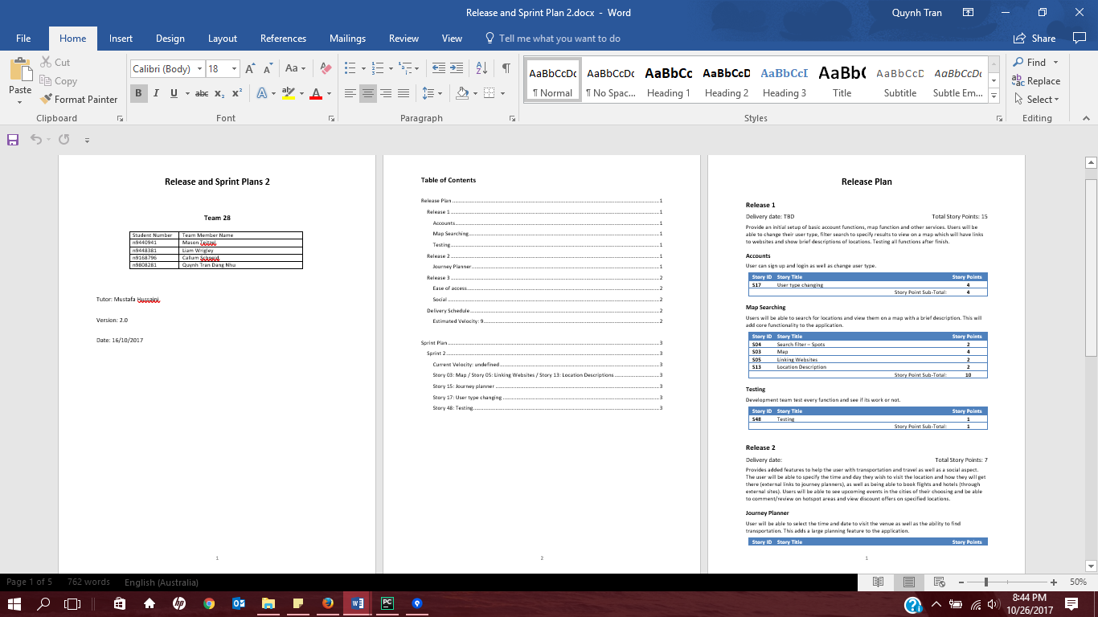

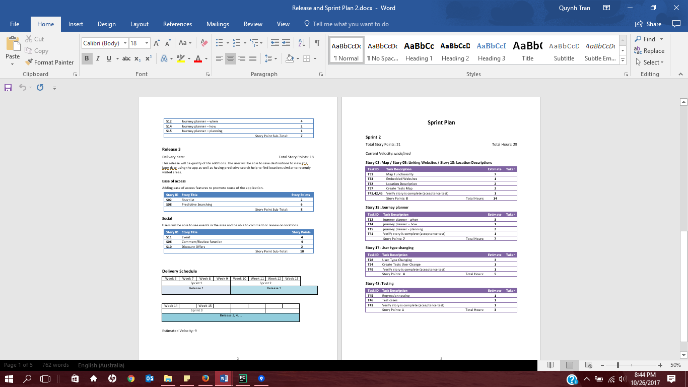

(Credited: Liam)

As a client, I decided upon remaining user stories and create a product backlog which allow development team to know which user stories I want to have in sprint 2, and specific task to do for the project. Product backlog allow us to improved project management process from the beginning until the end.

Git path: https://bitbucket.org/299team/ifb299-team-28/commits/ad224bb0b5d30da9e22f2b4b4b3ff1c582f62f6d

**Artefact 2** – Test case

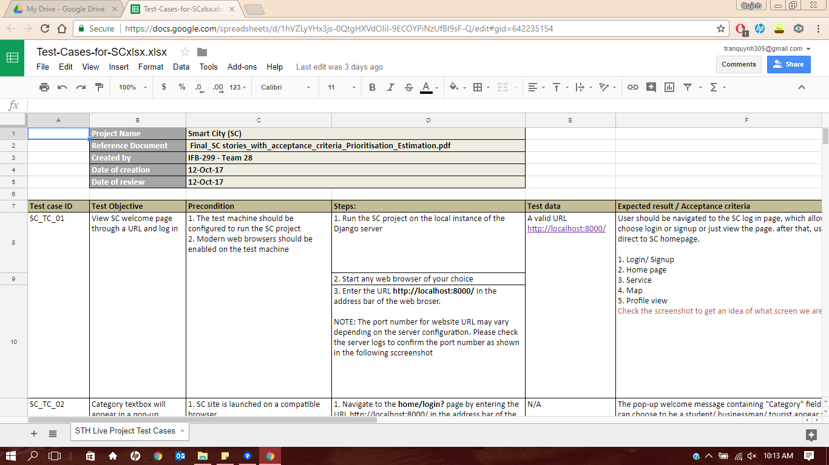

(Credited: Mason)

Test case is used to record all of the stories and tasks description, entry and exit criteria, expected result, actual result and test execution result (pass/fail). It’s used to show the client the result of functions run as expected or not. Mason and I in charge of making test case for map

Git path: https://bitbucket.org/299team/ifb299-team-28/commits/9557cc0a39ee4129f1764525a0571ea1415d836a

**Artefact 3** – Sprint and release burndown chart

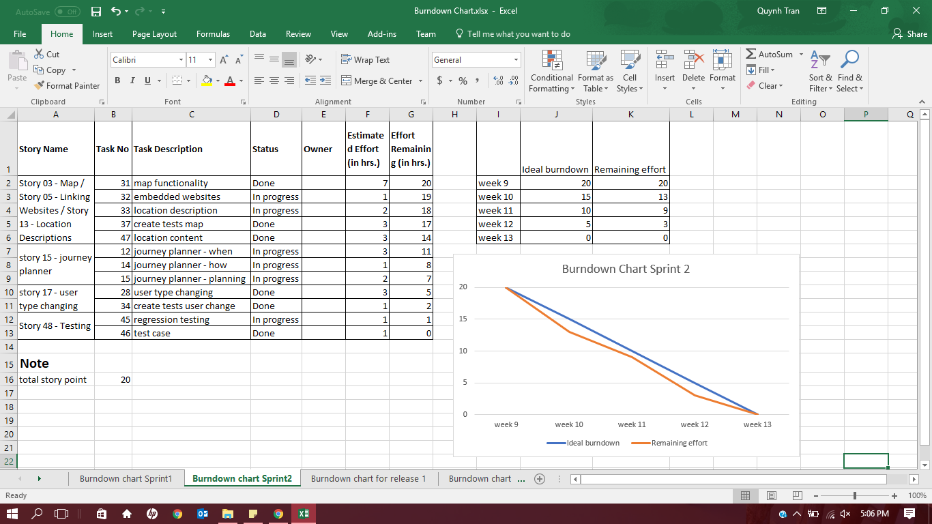

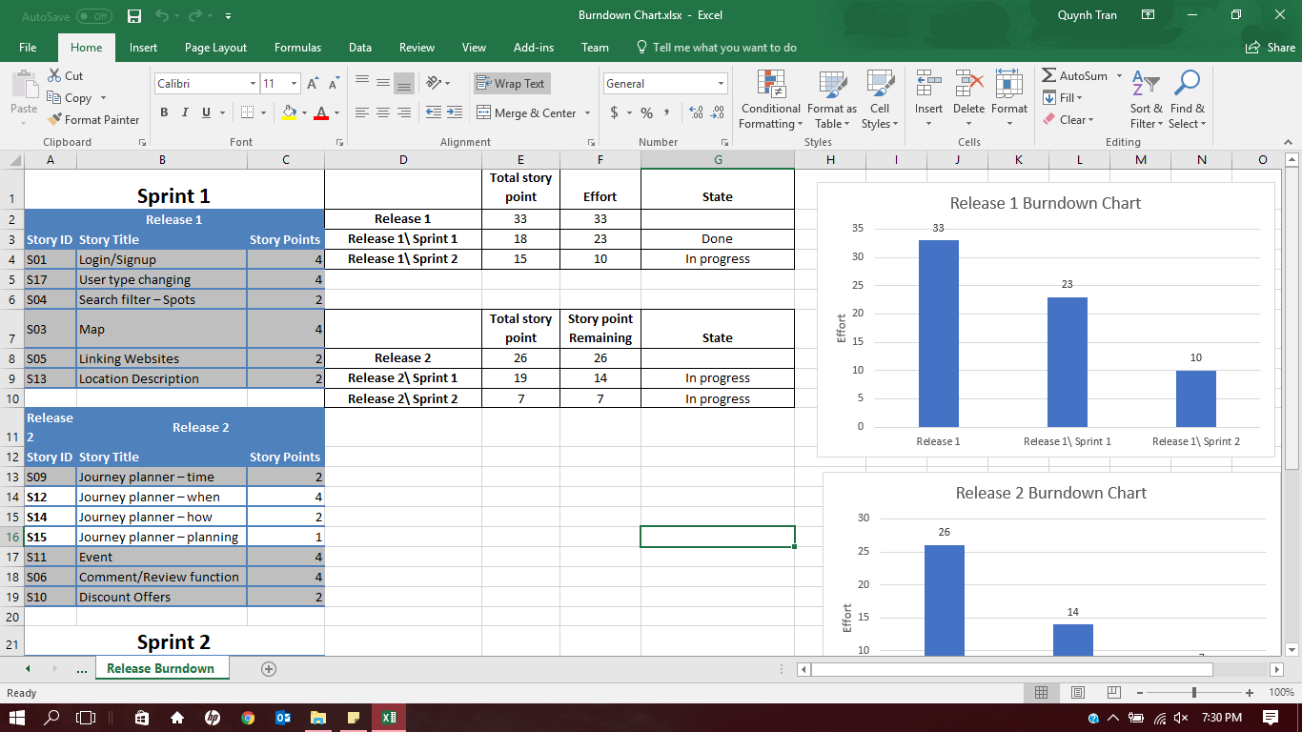

I update a second burndown chart for sprint 2 and releases following the process of my team. The burndown chart help us to track our progress each week and ensure the task we need to finish each week is done.

Git path: https://bitbucket.org/299team/ifb299-team-28/commits/11d3bedb0f4d3aec8e1e5798a336e3479e51a354

Git path: https://bitbucket.org/299team/ifb299-team-28/commits/11d3bedb0f4d3aec8e1e5798a336e3479e51a354

**Artefact 4** – Homepage

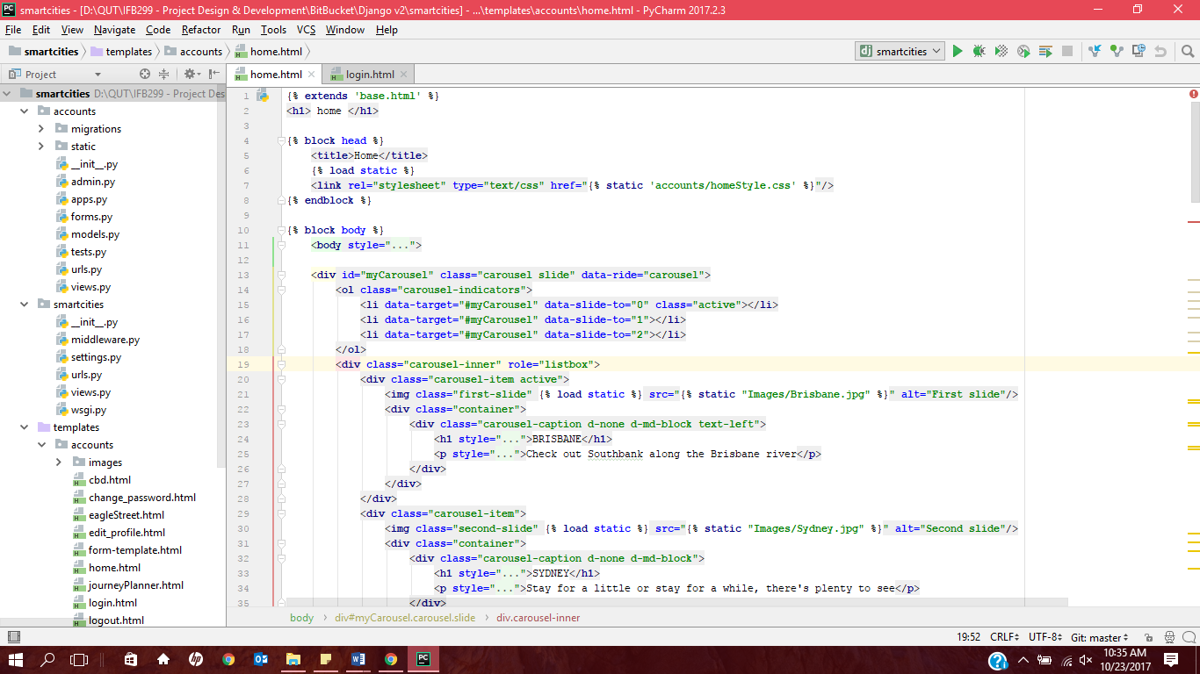

My contribution in webpage is to fix the content and colour in Homepage to an appropriate one. Also what other services should be include in the homepage.

Github path: https://bitbucket.org/299team/ifb299-team-28/commits/dee30b6b83440af66f22712a3821b57100c7ec3c

**Artefact 5** – Map location description

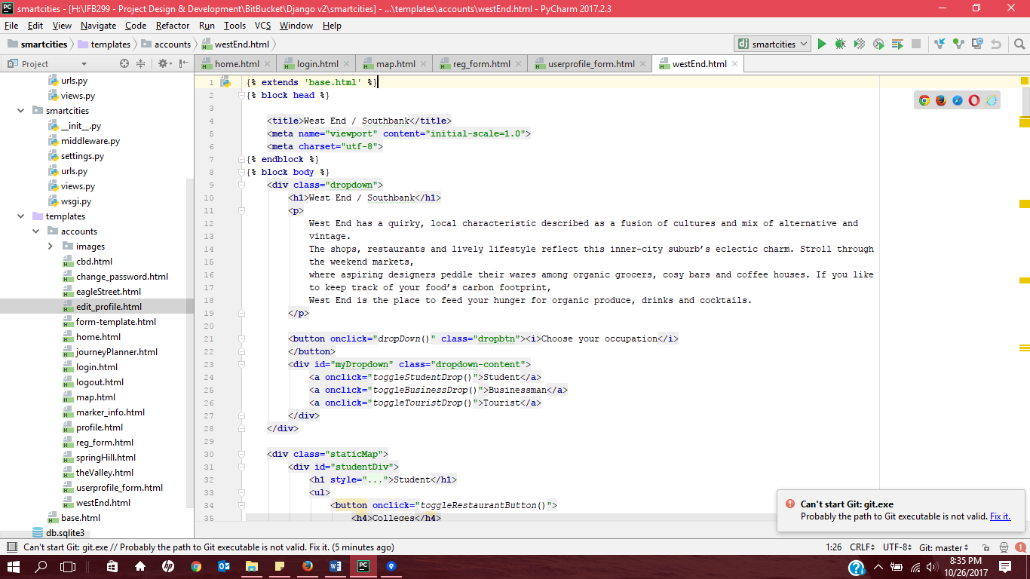

(Credited: Callum)

I helped, as an admin, to choose which location will we have on the map and give the development team what information I want to have in a specific location.

Git path: <https://bitbucket.org/299team/ifb299-team-28/commits/be91ca42744f751f8442d003f1549f2cc229878f>