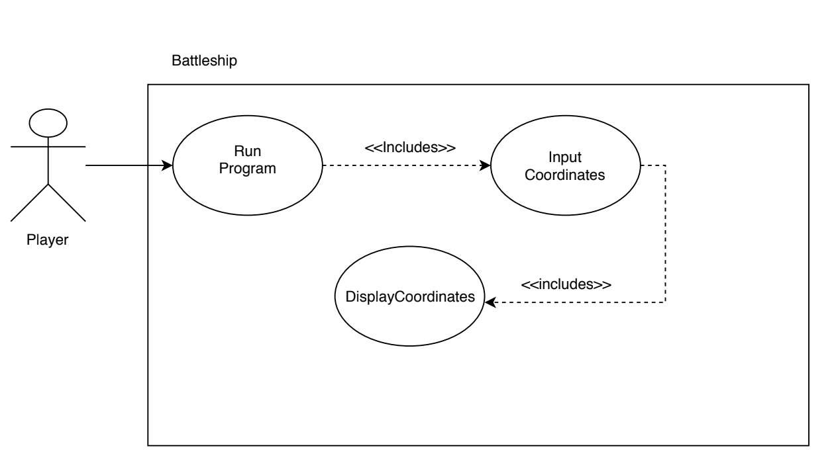

Battleship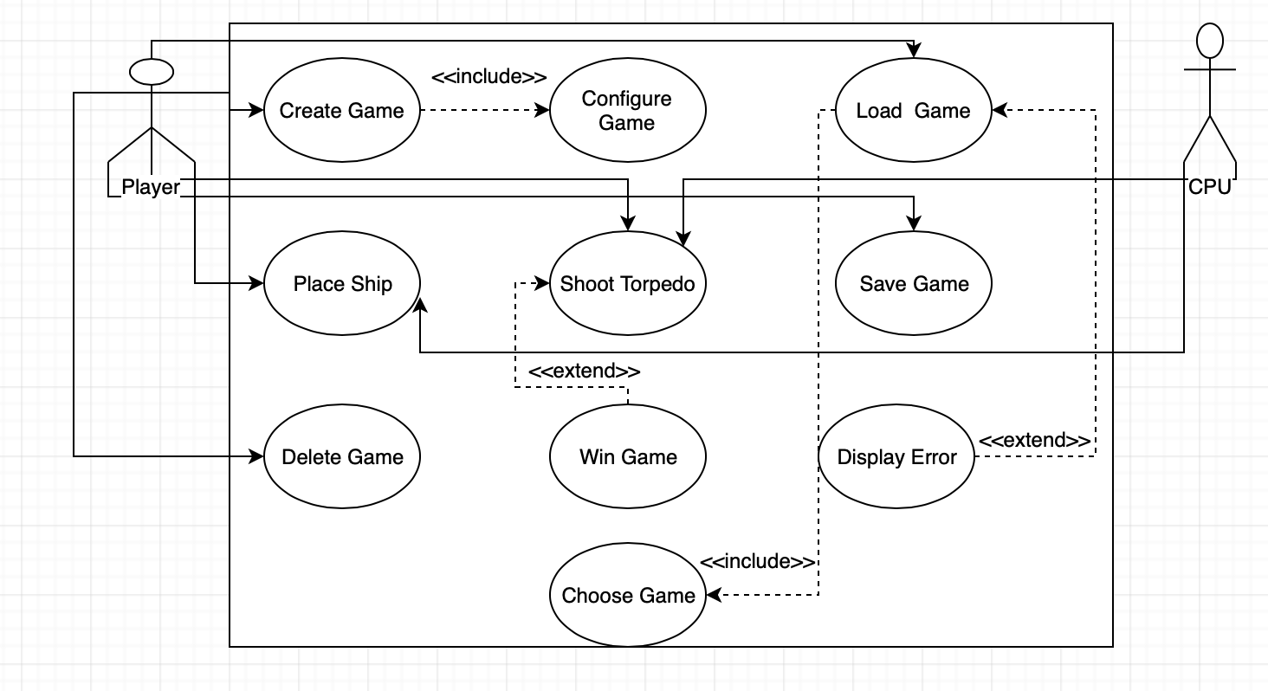

|  |  |
| --- | --- |
| Use Case: Create Game | |
| Description: Player Creates another file of a game  Actors: Player  Precondition: App must be open  Main Scenario: | |
| User | System |
| Runs Program | Creates game board |
| Alternative: | |

|  |  |
| --- | --- |
| Use Case: Configure Game | |
| Description: Player selects settings for the game  Actors: Player  Precondition: Game must be created  Main Scenario: | |
| User | System |
| Sets up the settings they want for the game | Reads the instructions from the user and creates a specific board from said instructions |
|  | |

|  |  |
| --- | --- |
| Use Case: Load Game | |
| Description: Player selects previous saved game to reload  Actors: Player  Precondition: Game must have existed beforehand  Main Scenario: | |
| User | System |
| Selects file to reload | Reads file and displays saved game on the board |
| Alternative:  User selects empty file | |

|  |  |
| --- | --- |
| Use Case: Place Ship | |
| Description: Player selects point to place ship  Actors: Player, CPU  Precondition: Game must be active  Main Scenario: | |
| User/CPU | System |
| Selects point for ship | Places ship on board |
| Alternative:  Point occupied  User resets game | |