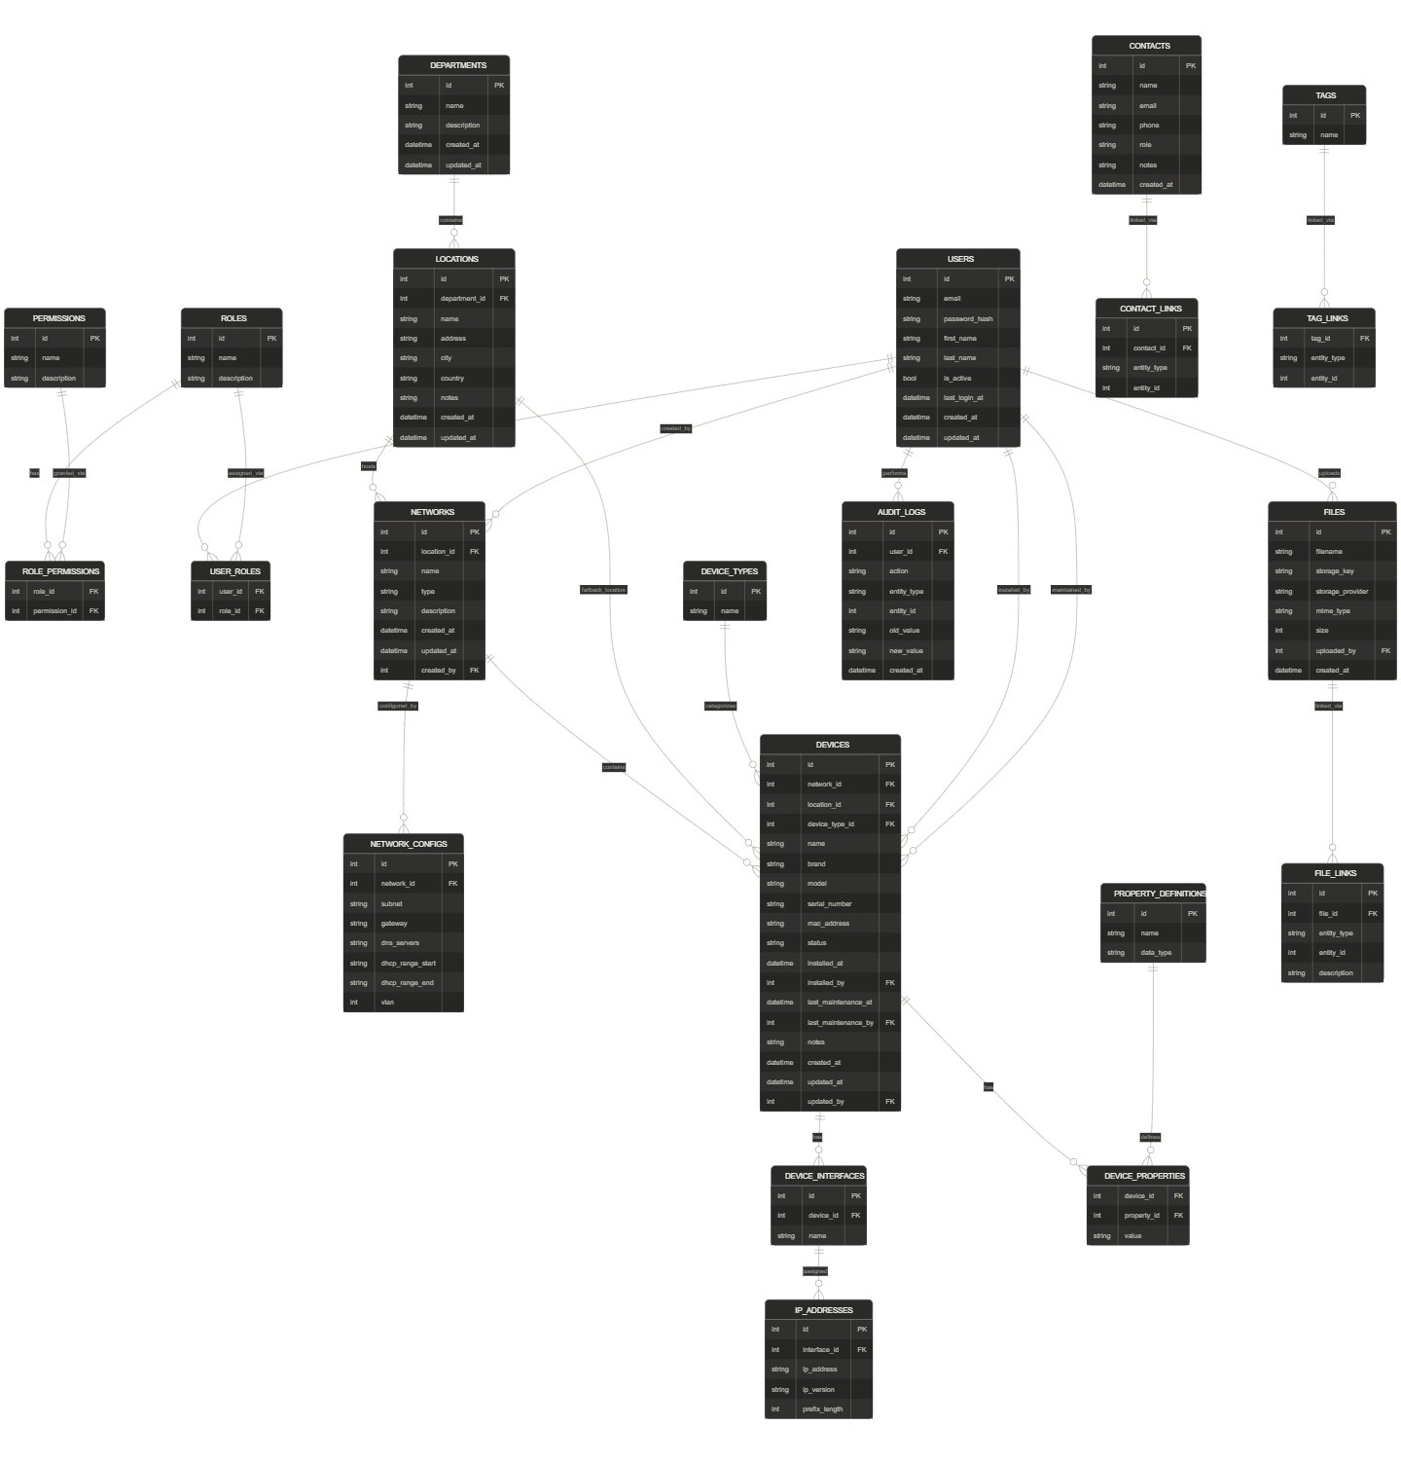

USERS:
id (PK)
email (unique)
password_hash
first_name
last_name
is_active
created_at
updated_at

ROLES:
id (PK)
name (unique) -- Admin, Editor, Viewer
description

PERMISSIONS: individual permissions (fine-grained)
id (PK)
name (unique) -- device.read, device.write, ...
description

ROLE_PERMISSIONS: attaches roles to permissions
role_id (FK → roles)
permission_id (FK → permissions)
PRIMARY KEY (role_id, permission_id)

USER_ROLES:
user_id (FK → users)
role_id (FK → roles)
PRIMARY KEY (user_id, role_id)

----------------------------------------------
DEPARTMENTS
id (PK)
name
description
created_at
updated_at

LOCATIONS
id (PK)
department_id (FK → departments)
name
address
city
country
notes
created_at
updated_at

----------------------------------------------
NETWORKS
- id
- location_id
- name
- type
- description

NETWORK_CONFIGS
- id
- network_id (FK)
- subnet
- gateway
- dns_servers (jsonb)
- dhcp_range_start
- dhcp_range_end
- vlan

----------------------------------------------
DEVICE_TYPES
id (PK)
name -- router, switch, RAP, PC

DEVICES
id (PK)
network_id (FK → networks)
location_id (FK → locations) -- fallback
device_type_id (FK → device_types)
name
brand
model
serial_number
mac_address
status -- active, inactive, broken
installed_at
installed_by
last_maintenance_at
last-maintenance_by
notes
created_at
updated_at
updated_by

DEVICE_INTERFACES
- id
- device_id
- name (eth0, wlan0,...)

IP_ADDRESSES
- id
- device_id (FK)
- interface_id
- ip_address

PROPERTY_DEFINITIONS
- id
- name
- data_type

DEVICE_PROPERTIES
- device_id
- property_id
- value
----------------------------------------------

FILES
id (PK)
filename
path
mime_type
size
uploaded_by (FK → users)
created_at

FILE_LINKS
id (PK)
file_id (FK → files)
entity_type -- 'device', 'location', 'network'
entity_id
description

----------------------------------------------
CONTACTS
id (PK)
department_id (FK → departments)
name
email
phone
role -- bv IT manager
notes
created_at

CONTACT_LINKS
id (PK)
contact_id (FK → contacts)
entity_type -- location, network, device
entity_id
----------------------------------------------

TAGGING
id (PK)
name (unique)

TAG_LINKS
tag_id (FK → tags)
entity_type
entity_id
PRIMARY KEY (tag_id, entity_type, entity_id)

----------------------------------------------

AUDIT/LOGGING
id (PK)
user_id (FK → users)
action -- CREATE, UPDATE, DELETE
entity_type
entity_id
old_value (jsonb)
new_value (jsonb)
created_at

----------------------------------------------

HISTORY
id (PK)
device_id (FK → devices)
change_type
data (jsonb)
changed_at
changed_by (FK → users)

