**The Jiji Swivel**

Hands Free Phone Holder

**Final Project Report**

**Prepared By:**

Claire Burton

Teresa Clark

Ajit Gupta

Santiago Quintero

Jaehyun Shim

*University of Michigan College of Engineering Students*

*Engineering 100, Section 200, Winter 2018*

**Prepared For:**

Dr. Kenneth Alfano

Professor of Engineering 100

Technical/Engineering

Department of Undergraduate Education

Dr. Erik Hildinger

Professor of Engineering 100

Technical Communications

Department of Undergraduate Education

**Project Duration:**

01/11/2018 - 04/12/2018

**Date Submitted:**

04/12/2018

**EXECUTIVE SUMMARY**

Extended use of smartphones can be physically taxing and uncomfortable. This report details how our team, Team 21, has attempted to alleviate this strain on users. We are a group of five undergraduate engineering students at the University of Michigan enrolled in Design in the Real World, the design section of the introductory engineering course Engineering 100. Over the course of the semester, we utilized the engineering design process to select a problem, ideate possible solutions, determine a final design, and create a prototype to be evaluated against set criteria.

We found that young adults spend numerous hours each day using their phone. We knew from personal experience how uncomfortable it can be to support a phone for that long. Existing solutions that target this problem are limited in scope and leave vast room for improvement. We intended to create a product that relieved the strain of supporting a phone, while still allowing for the adjustability that the user would have if they were just holding their phone in their hand.

Prior to constructing our final prototype, we spent hours ideating to ensure we had a broad scope of potential solutions. This started with informal brainstorming and ended with formal evaluation of our most feasible ideas. The ideation method we employed prevented us from being anchored on an initial idea, and helped us ideate a plethora of possible candidates. Our final design is a hinged, telescoping arm that attaches to any surface via suction cup. The product connects to any phone by attaching to an existing product, the PopSocket (a small conical support that attaches to the back of a phone). This design allows the user to orient their phone in any way and angle it to their comfort.

We began prototyping by sketching images on paper. We then created a 2D Google Drawing of our design. Finally, we used SolidWorks to refine a final prototype that we could 3D print into a physical model. We decided to print with ABS plastic, as it is both strong and lightweight. Due to time limitations, our first prototype was not fully functional. However, it successfully attached to the PopSocket and fulfilled our strength constraints.

We performed market research after creating our physical prototype to determine how it appealed to our intended market. This was done by creating a survey asking users if they felt they would benefit from using such a product, and how we could improve our existing prototype. If we were to create a second physical prototype, we would make improvements on functionality and take into consideration the feedback we received from the survey in order to make the best possible solution. We are overall satisfied with the progress we were able to make in the thirteen weeks allotted, and we are confident that our solution has potential to have mass market appeal.

**1. INTRODUCTION**

We are five freshman engineering students at the University of Michigan who joined together to become Team 21. Under the guidance of Dr. Kenneth Alfano and Dr. Erik Hildinger in the introductory engineering class Design in the Real World, we iterated through each step of the engineering design process.

We began by exploring common problems affecting college students, from inadequate storage in dorm rooms to incessant procrastination. We ultimately decided to focus on alleviating the problem of arm fatigue when using a phone for a prolonged amount of time. After deciding on this problem, we wrote a project proposal that explored the issue in detail. After getting the project proposal approved, we created a Gantt chart to map out certain deadlines and tasks which can be viewed in Appendix ().

After weeks of brainstorming solutions and going through the ideation process, we decided that the solution should be a device that could stick to multiple surfaces, be compatible with any phone, and support the weight of any phone. After using a variety of brainstorming methods, we finally were able to come up with our final product, the Jiji Swivel. This product connects to a PopSocket on one’s phone, has a telescoping arm to adjust the length, and has a suction cup which allows it to attach to many surfaces. Our product uniquely solves our problem and is an extension upon the PopSocket.

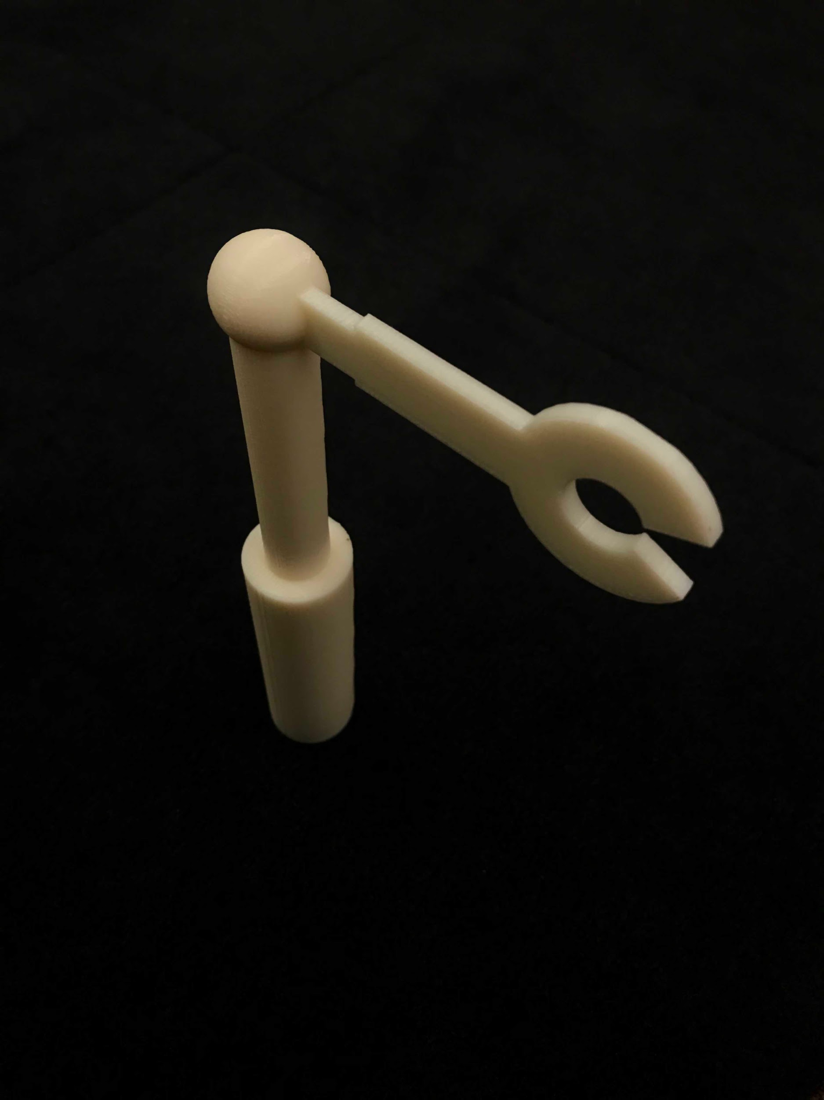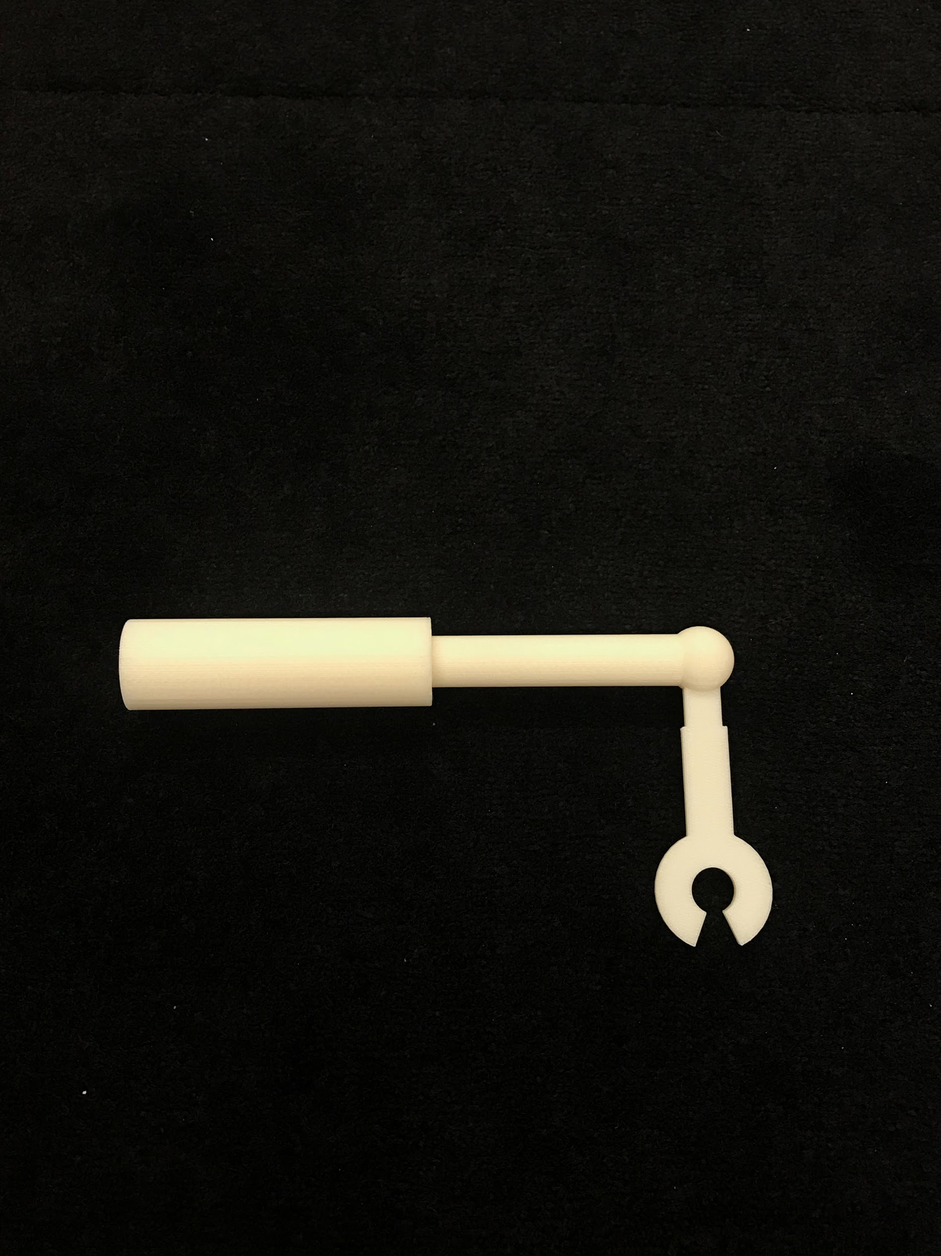

**2. BACKGROUND**

As smartphone usage in modern society increases, so does the huge market for devices that make it easier to use one’s phone. As a result of this, companies have begun creating cases and holders that allow consumers to use their phones for an even longer amount of time. After doing extensive research, we found that young adults on average use their phones between eight and ten hours per day (Wood, 2015). We found this statistic astonishing and realized that our idea would be very successful in this market.

**2.1 Arm Fatigue**

Many students and young adults use their phone in bed or at their desk for an extended amount of time, either scrolling through social media applications or watching videos. From personal experiences, Team 21 found that arm fatigue was a constant problem when trying to use their phones for more than a couple minutes. According to a survey we conducted (appendix()), 87% of college students surveyed use their phone for a prolonged amount of time. Additionally, 63% of those surveyed felt they would benefit from a device that allows them to enjoy content hands free.

**2.2 Problems with Current Solutions**

There are many existing solutions that allow a user to view their phone hands free. However, many of the solutions lack functionality. Many of the existing mobile device holders are stationary and do not allow the user to easily attach their phone. The existing solutions are also not adjustable for a variety of positions. Some devices have features that could be useful, such as a ball hinge and telescoping component, but there is no one solution that combines all of them. The market lacks an all-encompassing solution that addresses what we wanted in a final design.

**2.3 Problems with PopSocket**

The PopSocket is a device that attaches to a phone and allows the user to prop up their phone on a hard surface. They can also be used as a grip while holding a phone, so the product has great functionality on the go. However, a PopSocket does not allow the user to enjoy content in both portrait and landscape orientation. Both orientations are important for a variety of activities: video chatting, watching movies, scrolling through social media. We knew we could improve upon the functionality of this existing product.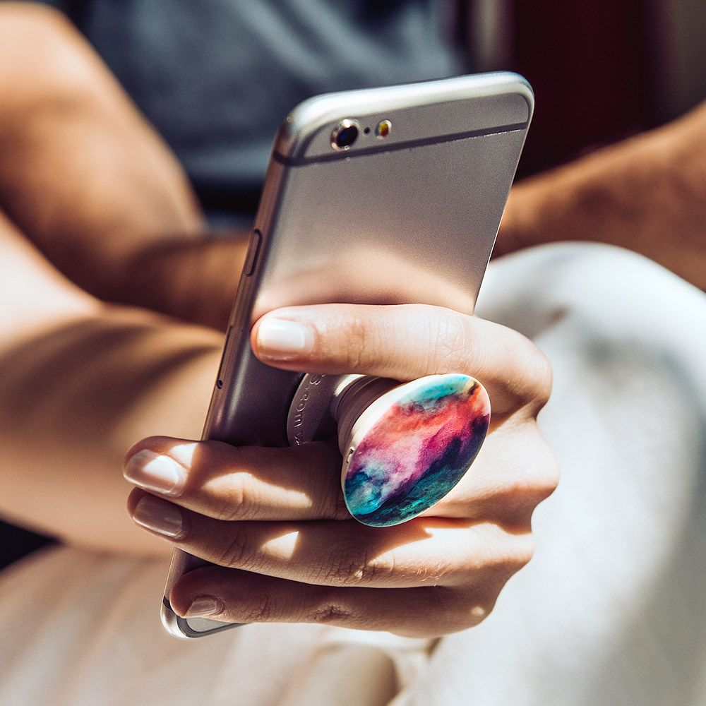

A PopSocket attached to an iPhone

(“PopSockets…”, 2018)

**3. DESIGN REQUIREMENTS**

Before starting the ideation process, we outlined the essential objectives our final design had to meet. We chose the main criteria to evaluate a product that holds the phone in place.

After brainstorming with an objectives tree (Appendix), our team had to find a balance of several objectives, including cost, strength and portability. We used tools to aid this process, but in the end we had to make compromises and decide as a team what we valued the most.

**3.1 Objectives**

The following are the qualitative objectives that we wanted our product to have. They are listed based on their ranking of importance. We decided on objectives that were essential for a successful product and that differentiate our product from competition.

*3.1.1 Hands Free*

This is the most important feature that we wanted our product to have. Arm fatigue occurs when the user must support the weight of their mobile device. Our device allows for hands free content viewing, which means the user can be in a multitude of positions (lying down, sitting at a desk, etc.) and still be comfortable.

*3.1.2 Adjustability*

This is another essential feature since it will be our main differentiator from other competition. We found that other device holders did not allow users to adjust the angle or orientation of their phone. Our aim is to make the product retractable and able to rotate, so the user can always adjust to their most comfortable position.

*3.1.3 Compatibility with Other Phones*

Our group understood that it was crucial to make the product have universal compatibility across all brands and models of smartphones. This will prevent users from having to buy a new holder once they buy a new phone. It also expands our market to all mobile device users regardless of their phone type.

*3.1.4 Ease of Use*

Our product needs to be intuitive and efficient to use. This means it should be portable, so that it can easily be carried in backpacks without occupying too much space. Additionally, it should allow for comfortable phone usage for prolonged periods of time.

*3.1.5 Affordability*

Our main target market would be teenagers and young adults. We would like the price of our product to be reasonably affordable for a college student. When considering cost, we will have to take into account the material and production methods of our product.

**3.2 Constraints**

Our constraints are qualitative and non-negotiable objectives that our prototype must meet. They are ranked by relative importance.

*3.2.1 Support Weight of the Phone*

It is essential that our final product is able to support the full weight of any given phone. If it is unable to do this, it may be unsafe to use. If the arm were to fail, the phone could potentially fall and cause injury to the user or damage the phone. We decided that it should be able to support at least half a pound, as the heaviest phone on the market, the Samsung Galaxy Note 8, weighs around 0.43 pounds (“Galaxy…”, 2018).

*3.2.2 Weight of Device*

Most phone holders in the market weigh between 5 and 10 ounces. Our group came to a consensus that our final design should weigh no more than 7 ounces. This would be something to address in later stages of production.

**4. PATENT SEARCH**

Our team conducted a patent search to ensure that we were not infringing on any ideas. The research helped us to better understand the range of pre-existing solutions. We used keywords like “hands-free” and “device holder” to find hits on the U.S. Patent and Trademark Office website (“US Patent…”, 2018). Because the breadth was greater than we anticipated, we were challenged with creating an original approach to the problem. The IA’s encouraged us that there is always a novel solution. The patent search shaped our ideation process. It helped our team to identify what traits we wanted our product to have and overall refine our problem scope. We used our search in conjunction with analytical brainstorming methods to create our final prototype.

4.1 Analysis of Patent Search

After synthesizing some of the patents, our team saw many shortcomings. For instance, a lot of the devices were bulky and looked cumbersome to use. Many of the patented designs were “wearable” and were not something that our team imagined ourselves using. Some of them also did not solve the problem of watching content while lying in bed. Using the TRIZ separation principle, particularly, the sub-principle of separation of parts and whole, we created a product that is functional with both stationary use and on the go. We also used the combine aspect of SCAMPER, to create our ideal product from various aspects of the patent search. For instance, we really liked the telescoping feature of one phone holder (See Appendix...). We also really liked the customizability of some patents, so we knew that we wanted that to be a characteristic of our design. For this reason, we incorporated the ball joint that gives our device it’s swivel.

**5. IDEATION**

We used many methods for brainstorming. We moved from informal methods (c-sketching, round robin and free wheeling) to more formal methods (TRIZ, SCAMPER, design heuristics and morph charts) to refine our ideas systemically.

**5.1 Informal Techniques**

Our team began with a more organic method of ideation. First, we used informal methods such as c-sketching, round robin and free wheeling. Because we found that there were many existing patents, we decided that these methods would allow us to extend the scope of our idea. Through these informal methods, we were able to explore many possibilities. It was crucial to stay open-minded and not become fixated on one idea. In particular, we found that sketching out potential designs was extremely valuable for generating ideas. We often would brainstorm individually and then collaborate as a team to evaluate them. Although many of these ideas were discarded after thorough assessment, certain components of those designs were utilized. In the end, we incorporated several different designs into our final prototype.

**5.2 Formal Techniques**

We then proceeded to more formal techniques of ideation. We then used a morph chart to help our ideation process by listing different features and morphing different parts into a integral design. The prototype had to be able to support the phone firmly, it should allow the users to view content, it should be able to adjust position, it should be attachable to surface and had to be made of strong material (see appendix A). We also decided to use design heuristics cards, TRIZ, and SCAMPER. The design heuristics cards gave us a plethora of ideas, such as telescoping and applying an existing mechanism in a new way. The TRIZ principle of separation, specifically separation between the parts and the whole helped us pinpoint a function that we wanted. Finally, we used the “combine” and “magnify” elements of SCAMPER to build a novel design based on existing patents. These brainstorming methods helped us to produce more original ideas and refine the scope of our problem.

**6. EVALUATION**

After the ideation stage, we began to synthesize our ideas into cohesive potential designs. We chose three of our most promising designs to evaluate in the Design Evaluation Matrix **(Appendix _____)**. The purpose of this was to determine which design was the most feasible and fit our objectives best. The first candidate supported the user’s phone by attaching to the back of the phone. The phone was attached to an adjustable arm that could extend and retract. It also allowed the user to adjust the angle and orientation of the phone. We called this the Suction Cup Design, and it received a score of 75.6. The next candidate was an arm that hung down from the ceiling and provided similar adjustability to the Suction Cup Design. (Appendix for the pics of 3 final candidates) We called this the Ceiling Design, and it received a score of 54.4. The other design had functionality similar to a tripod, so we called this the Tripod Design and it received a score of 58.4. The Suction Cup Design received the best score by far, and therefore we chose to proceed with that design and develop it further.

**7. PROTOTYPING**

From the begining out team decided to use computer aided design to construct our prototype. Teresa, having prior experience with CAD, was a vital asset to constructing our prototype in Solidworks. As explained in our design requirements section, our primary constraint was to support the weight of a phone. So when considering materials, we had to balance strength with price point. We wanted a three dimensional model to be able to present to people when doing our testing, and also to get a better idea of what it would look like in real life dimensions.

**7.1 3D Printing Process**

There were several things to consider as we transitioned to from CAD to a physical prototype. We utilized the 3d Printing Lab at the Duderstadt Center for our model. At the initial consultation, we learned how to prepare an STL file for the printers and ensure that our model is completely enclosed. We also had to learn how to join different components in assembly, which required some SolidWorks research via online tutorials. Because the free printers are limited to a small plate, we decided to go with the Dimension Elite printer. We submitted a quote to the printing center’s website to get an estimate of the cost, and to ensure our team wanted to proceed with the print. Our total cost for the print was just over $40, which was well within our $80 budget.

*7.1.1 Dimension Elite Printer*

We did not want to scale down our prototype, because we wanted to test its compatibility with the PopSocket. Although more expensive, the Dimension Elite had several benefits. For one, the printer is very accurate, with a tolerance of only a few microns. We could depend on the physical model to represent the measurements that we chose in SolidWorks. The most important measurement was the diameter of the PopSocket, because that is how the phone attaches to the holder. The assistants in the printing center, also assured us that we could sand down our model to make some adjustments. The Dimension Elite was also great for our prototype because we did not have very fine details in our design, and instead prioritized strength (“University…”, 2015).

*7.1.2 3D Printer Material*

The printer uses ABS plastic, which is known for its strength and rigidity, and can also be used in injection mold production ("Acrylonitrile...", 2018). We selected a high-density fill for our model, which increases the tensile strength for a more sturdy device. We also decided on an ivory color of filament for a sleeker and more minimalist model. Another great feature of the Dimension Elite, is that it prints support structures that can later be dissolved off with a sodium hydroxide solution (“University…”, 2015). The assistants in the printing lab helped with adding the supports to the parts that have overhang in our model.

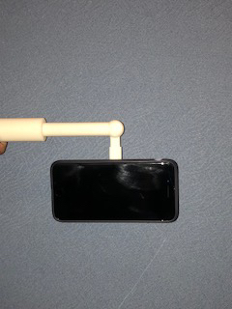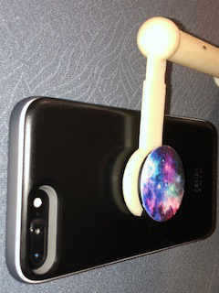

*7.1.2 Prototype Outcome*

As seen in the figure above, the curved edges of our device fit snugly around the PopSocket mount and allow the phone to be completely supported. We had to sacrifice some functionality with our prototype, as it was our priority to use the 3d model for strength testing. For instance, our ball joint does not actually have swivel capabilities, as that required more complex CAD. In further models, we would want all joints and hinges to be functional. The horizontal arm is 7 inches in length and the vertical arm is 4 inches.

**8. TESTING AND REEVALUATION**

After we completed modelling and printing our prototype, we needed to determine how successful we were with our design. We did this in two ways. Before we had even printed a physical prototype, we sent out a survey to college students with questions about the appeal of our design. Then, when our prototype finished 3D Printing, we were able to assess how well our product performed the task it was intended to do.

*8.1 Market Research*

We knew that our product would be primarily used by young people, specifically college students who experienced the same issues that we did. Therefore, we made a survey targeted specifically at college students and sent it out to various groups of college students. We received responses from University of Michigan students, as well as some college students around the world. We asked questions about the need for a product like ours, the benefits of our design, and the ways in which we could improve. In Appendix XXX, the results of this survey are displayed. Overall, the results were favorable and indicated that our prototype would be successful on the market.

*8.2 Physical Prototype*

While our 3D printed model was not functional in some ways, we were able to evaluate some of its features, such as its strength and its compatibility with the PopSocket. The material it is made of is strong and durable, and is able to support the weight of the largest phone we tested it with (iPhone 7+). In the future, we would like to perform further tests with larger phones. It also attaches to the PopSocket as we intended it to. However, it is slightly difficult to separate the two. This is something we intend to improve in further prototypes. We also would like to make the arm attaching to the phone slightly longer, as the phone rubs against the ball hinge when it is oriented vertically. Scaling up the dimensions could also allow the holder to be compatible with larger tablets. We also still need to develop how we would attach the suction cup to the telescoping arm.

**9. MARKET & BUDGET**

Our target market is young adults, specifically college students, as it is the demographic of our group. We decided to approach our market by making our product a complementary good with the PopSocket. The PopSocket is a widely used gadget with over 25 million units sold so far (Bernard, 2017). This is a huge market of existing consumers. In our own survey, we found that 74.5% of the participants were familiar with the PopSocket (Appendix X). If we were to bring our product to market, we would license our design to PopSocket to be sold as an extension of their mounts. We had $80 allotted as a budget for this project, so our prototype cost was suitable. Given our competition however, we need to find a way to produce the Jiji Swivel at a much lower price point. In order to be profitable, our unit cost cannot remain at $40.

**10. RECOMMENDATIONS**

We used 3D printing to create our prototype. However, this is not a realistic method for mass production of our design, as it takes several hours per print. It also has to soak overnight in a solution to dissolve support structures. With that opportunity cost, the estimated production costs will be higher in addition to the materials and printing fee. The cost was approximately $40 for our 3D print using ABS plastic; which would be very cost inefficient at a large scale. Considering that the price for substitute goods of our product are significantly more affordable, we must find alternatives to 3D printing to stay competitive in the market.

The alternative to 3D printing is injection molding. The cost of production using injection molding becomes significantly lower as the part volume increases. Injection molding is also compatible with ABS plastic. As many other manufacturing industries use injection molding for efficient production and precision, it is a potential way to produce the Jiji Swivel (“Is 3d printing…”, 2014). To further cut down the costs, we could try making the prototype with even cheaper plastic.

**11. CONCLUSION**

Mobile devices are used by young adults for hours every single day. Making the user more comfortable during this space of time has the potential to vastly improve user experience for mobile phones. We found that existing products on the market that targeted this problem were flawed and that there was a need for a product that alleviated the strain of using mobile devices for extended periods of time. The design of the Jiji Swivel addresses these flaws. Our first prototype had shortcomings in functionality and compatibility with some larger phones, but it met our strength requirements. If we were to continue, we would be able to fix these issues and also make improvements based on market feedback. Overall, though we were not fully successful, we are satisfied with what we achieved and believe that further prototyping would perfect our product.

REFERENCES

Acrylonitrile butadiene styrene. (2018). Retrieved April 9, 2018, from http://www. plasticextrusiontech.net/resources/what-is-abs-material/

Bernard, Z. (2017, November 14). A giant knob you can stick on the back of your phone is taking off with celebrities - and it's on track to sell 30 million this year. Retrieved April 12, 2018, from http://www.businessinsider.com/popsocket-smartphone-accessories-2017-11

Galaxy Note8 Specifications. (2018). Retrieved April 9, 2018, from http://www.samsung.com/global/galaxy/galaxy-note8/specs/

Is 3d printing a viable and affordable alternative to injection mold production? (2014, November 4). Retrieved April 11, 2018, from http://www.3ders.org/articles/20141106-is-3d-printing-technology-a-viable-and-affordable-alternative-to-injection-molding-production.html

Popsockets Stand and Grip For Phones and Tablets. (2018). Retrieved April 9, 2018, from https://store.gadgetzone.bh/pop-socket-popsockets-stand-and-grip-for--50948051.html

US Patent Full-Text Database Manual Search. (2018, April 10). Retrieved April 11, 2018, from http://patft.uspto.gov/netahtml/PTO/search-adv.htm

University of Michigan 3D Lab. (2015). Retrieved April 9, 2018, from http://um3d.dc.umich.edu/3d-printing/

Wood, J. (2015, October 06). College Students In Study Spend 8 to 10 Hours Daily on Cell Phone. Retrieved April 11, 2018, from https://psychcentral.com/news/2014/08/31/ new-study-finds-cell-phone-addiction-increasingly-realistic-possibility/74312.html