Computer Games Development CW208

Technical Design Document

Year IV

Quintin Furlong

C00218453

Contents

[Game Architecture 2](bookmark://_Toc434308651)

[Features 3](bookmark://_Toc434308652)

[Feature: Player 3](bookmark://_Toc434308653)

[CRC Cards 4](bookmark://_Toc434308654)

[Class Name : Player 4](bookmark://_Toc434308655)

[Class Name : NPC 4](bookmark://_Toc434308656)

[References 4](bookmark://_Toc434308657)

￼

Game Architecture

Game Specific Subsystems and Game Engine Architecture

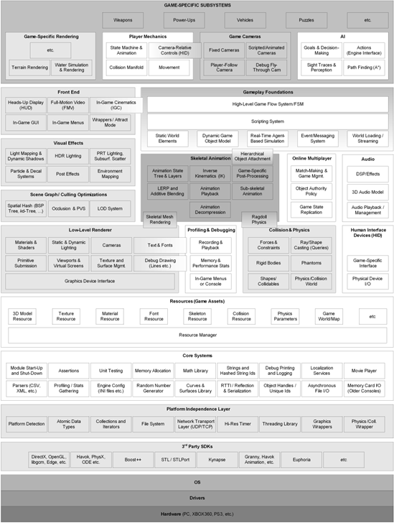

UML

***Class Diagram: RPG Rules***

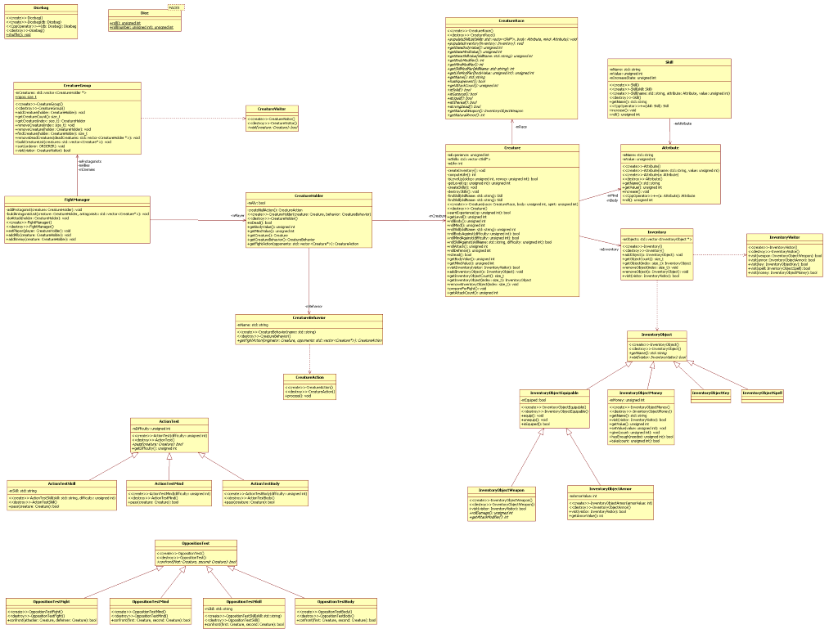Features

***Feature: Player***

Tasks:

1. Create a player class that ….
2. …….

CRC Cards

|  |  |
| --- | --- |
| ***Class Name : Player*** |  |
| Subclasses : |  |
| Superclasses : |  |
|  |  |
|  |  |
| Responsibilities | Collaborators |
|  |  |
|  |  |
|  |  |
|  |  |

|  |  |
| --- | --- |
| ***Class Name : NPC*** |  |
| Subclasses : |  |
| Superclasses : |  |
|  |  |
|  |  |
| Responsibilities | Collaborators |
|  |  |
|  |  |
|  |  |
|  |  |

References

**Book**

Author(s) - family name, initials. (Year). *Title of book.* Edition. Place of publication: Publisher.

[1] Gregory, J. (2014). *Game Engine Architecture.* CRC Press.

**Report**

Author(s) - family name, initials. (Year). *Title of report.* Edition. Place of publication: Publisher. (Series and vol./no.).

[2] Burrows, D., *et al.* (2012). *Global Trends: Alternative Worlds.* Washington: National Intelligence. (Office of the Director of National Intelligence).

**Web-site**

Author(s) - family name, initials. (Year, month day). *Title of document.* [Online]. (URL). Place of publication: Publisher. (Date accessed).

[4] de Valk, J. (2014, May 12). AI for Games. [Online]. (URL <https://www.somesite.com/articles/1234/>). (Accessed 12 February 2014).