Part A: Agent Team Sheet
Agent Name | Job Description | Sources/Tools | What it must NEVER do
Coordinator Agent | Receives all incoming requests, parses the learner’s input, decides which agent works next, and manages all the handoffs to agents and system escalation. | Route logic, recognition models, and access to the learner database in order to check existing users | Must never attempt to answer factual questions. Must never send a message to a learner without fact checking. Never merge records without manual approval.
Information Agent | Finds the objective facts regarding subjects, universities, colleges, and more. | Trust sources only, such as DBE, official prospectuses, SETAs, NSFAS, and more | Must never create data if a fact is missing. Must never search unverified websites or rely on it’s own training data for facts.
Explainer Agent | Takes the raw facts gathered by the Information agent and rewrites the facts into a simple, empathetic reply in the learner’s language. | Payloads from Information agent, language translating models, as well as reading-level simplification guidelines. | Must never add new facts that were not provided by the Information agent. Must never make guarantees about institutions.
Checker Agent | Review the final drafted reply against constraints before the message is sent to a learner. | Reslocate internal rules, South African law, and safety keyword filters. | Must never change the factual accuracy of a message to make it friendlier. Must never approve messages that contain unauthorized information.

Part B: Flow Diagrams (Cases 1 & 3)
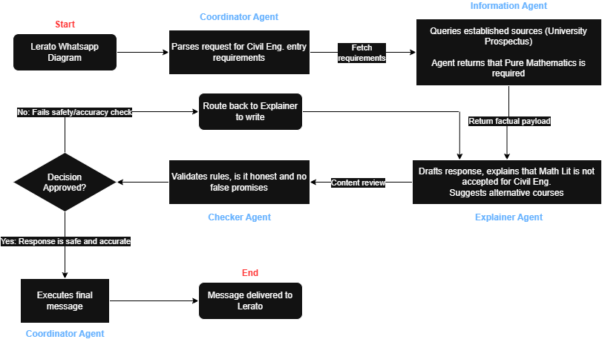
Figure 1: Flow Diagram for Case 1
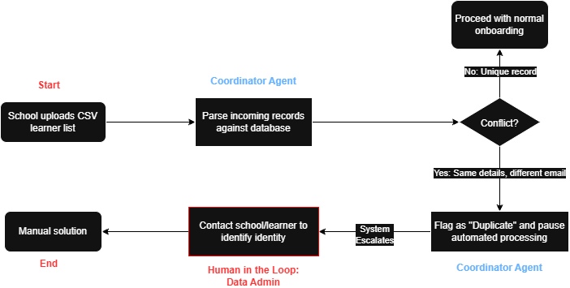
Figure 2: Flow Diagram for Case 3

Part C: Case Scenarios
  - Case 1: Lerato wants to be an engineer
1. Which agents act, and in what order?
The Coordinator agent will receive Lerato’s message and parse her information. The next task is given to the Information agent to query trusted sources such as university databases to find her minimum entry requirements for civil engineering, considering her subjects. The Information agent gets the fact that Pure Mathematics is strictly required; the data is passed to the Explainer agent to draft an appropriate response in the learner’s language. The Checker agent will then review the drafted message against Reslocate’s safety guidelines to ensure inaccurate information or false hope is given. Finally, the Coordinator will dispatch the final reply to Lerato.
2. What may the final reply say, and what must it not say or do?
The final reply must be gentle while factually informing Lerato that civil engineering degree programs in universities strictly require Pure Mathematics, meaning her current enrollment in Mathematical Literacy does not meet minimum entry requirements. The agent can also outline alternative pathways, such as switching to Pure Mathematics while she is still in Grade 11.
The response must never lie in order to protect her feelings or give false hope that universities will make an exception for her, as the agent should not function as a guidance counselor and suggest alternative career paths that do not align with her current plans.
3. Does a human need to take over? Who, and why?
A human is not needed to take over for the initial query because retrieving admission requirements is a rule-based task that the agents can oversee. However, a human career guidance counselor would need to intervene if Lerato’s replies to the AI message show distress about her future, such as subjective advice on what career is best suited for her given her current subjects.
4. What would a “too helpful” agent do wrong here?
A “too helpful” agent might make false claims that she can still easily become a civil engineer without changing her subjects. It might hallucinate non-existent “bridging courses” for Mathematical Literacy or create exception cases for university admission rules to keep the positive and conversational tone.

  - Case 2: The uncle asks for marks
1. Which agents act, and in what order?
After receiving the WhatsApp message, the Coordinator forwards it to the Checker agent for privacy assessment. When the Checker notices an unauthorized request for personal information, it signals the rule violation and assigns the Explainer agent to write an appropriate rejection. The Checker then verifies the refusal before the Coordinator transmits it to Sipho.
2. What may the final reply say, and what must it not say or do?
The response must gently let the uncle know that Reslocate is subject to stringent privacy regulations and is unable to disclose any learner’s account activity or academic records without any permission granted. Lerato’s grades and the courses she is considering must never be disclosed by the agent.
3. Does a human need to take over? Who, and why?
The technology can safely enforce a common privacy rule to prevent unwanted access, so a human does not need to take control. Only in the event that Sipho subsequently presents official legal guardianship papers that an AI is unable to validate would a human administrator or data privacy officer need to intervene.
4. What would a “too helpful” agent do wrong here?
A “too helpful” representative would put customer service before security, promptly retrieving and forwarding Lerato’s Term 2 grades to her uncle. This would be a terrible failure since it would be in direct violation of both Reslocate’s fundamental rule to safeguard the learner at all costs and South African law.
  - Case 3: Two Thabo Mokoenas
1. Which agents act, and in what order?
In this case, the only AI agent that takes action is the Coordinator agent. It analyzes the pupil list that the school has provided and compares the information with Reslocate’s current database to find the precise match in name and birth year, even if the email addresses do not match.
The Coordinator stops the automatic operation as soon as it detects this identification collision. Since routing this issue further creates a serious risk to data privacy, it purposefully does not delegate the work to the Information Explainer or Checker agents.
2. What may the final reply say, and what must it not say or do?
The system cannot respond to either learner since this is a strict internal data conflict. In order to avoid unlawfully disclosing a person’s information to a stranger, the agent must never automatically merge the accounts or email the current Thabo to inquire if the new email is his.

3. Does a human need to take over? Who, and why?
As soon as the Coordinator finds duplicate records, a human must take control. A Reslocate Data Administrator or a Reslocate support staff person with the authority to manage sensitive user data must be notified of the assignment.
Because an AI lacks the real-world authority to confirm legal identities, this manual intervention is necessary. To ensure data integrity and POPIA compliance, the human administrator must safely contact the school or the students via approved ways to verify if these are two distinct students or a single student with numerous emails.
4. What would a “too helpful” agent do wrong here?
A “too helpful” agent may mistakenly believe they are the same person and automatically combine the profiles to produce a seamless experience since they are eager to quickly arrange the data and finish their duty. This terrible mistake might erase important academic records or give one learner complete access to another learner’s.
  - Case 4: “NSFAS says approved”
1. Which agents act, and in what order?
After receiving Ayanda’s communication, the Coordinator recognizes it as a question about financial decisions and financing timelines. It transfers the request to the Information agent, which looks for reliable sources about how and when allowances are normally given to first-year students, including official NSFAS guidelines.
The Explainer agent receives the recovered facts and uses them to craft a thoughtful, precise response. Before the Coordinator sends Ayanda the final response, the Checker agent carefully examines the draft to make sure the system is not making unapproved financial guarantees.
2. What may the final reply say, and what must it not say or do?
While an "approved" status is a start towards the right direction, the response must make it clear that Reslocate is not NSFAS and cannot guarantee when the allowance will be issued. It is imperative that the agent does not guarantee a payment date.
3. Does a human need to take over? Who, and why?
A human does not need to take control for this first communication. By following the fundamental tenet of honesty and explicitly declaring that “we do not know” the precise date the money will clear, the AI team may securely execute the request.
However, if Ayanda replies that she is currently homeless or experiencing a serious crisis as a result of her housing condition, a human should intervene. An AI cannot arrange for her to be referred to the university’s particular financial aid office, student housing liaison, or local emergency resources without the assistance of a human team member.

4. What would a “too helpful” agent do wrong here?
She might be congratulated on the approval and told, “Yes, you should receive it this month; sign the lease," by a “too helpful” agent which is trained to provide encouraging and positive responses. This misleading assurance would be a huge failure since it may lead to her being bound by a legal contract she cannot afford should NSFAS experience a payment delay.
  - Case 5: The company on the SETA list
1. Which agents act, and in what order?
After receiving the request, the Coordinator instructs the Information agent to look for plumbing apprenticeships using reliable sources such as SETA documents. The Explainer agent drafts the response once the Information agent retrieves the document.
Before the Coordinator sends Kagiso the final response, the Checker agent examines the draft message to make sure it complies with the known facts.
2. What may the final reply say, and what must it not say or do?
The response should make it clear that being on this list does not imply that the company is presently hiring apprentices, even though it may explain that the construction company is formally registered or accredited by the SETA for plumbing.
Kagiso must never be informed by the agent that the employer is currently accepting applications, nor should he be told to apply directly on the presumption that a position is open.
3. Does a human need to take over? Who, and why?
For this particular inquiry, human intervention is unnecessary because the AI staff is capable of accurately and reliably explaining how an accreditation directory differs from a functional job portal.
Should Kagiso require direct assistance reaching out to the firm or request job-seeking help that exceeds the AI’s verified data, a human career consultant might then intervene to offer direct application support.
4. What would a “too helpful” agent do wrong here?
A “too helpful” agent might incorrectly presume that a SETA listing equates to current openings and enthusiastically inform Kagiso, “Indeed, this business is recruiting apprentices; you must submit your application immediately."
Such behavior would be extremely reckless, as it offers unfounded optimism rooted in speculation instead of verified information, which would eventually squander the student’s time and breach Reslocate’s directive that representatives must admit ignorance whenever they are not completely certain.

  - Case 6: The college that wants to be first
1. Which agents act, and in what order?
Since this is a business proposal for commercial purposes and not an inquiry from a learner, the agents should refrain from taking action to meet the request. Should the message reach the system, the Coordinator agent would analyze the intent, identify it as an administrative or business issue beyond its scope, and promptly stop automated processing.
The system must be fundamentally designed so that the Information agent fetches data solely on relevance and objective facts, with fixed guardrails totally blocking paid prioritization from impacting its search outcomes.
2. What may the final reply say, and what must it not say or do?
Should the system generate an automated response, it should indicate that it is unable to manage commercial partnerships while also providing the contact information for Reslocate’s management team. The system must never modify its search algorithms, adjust the Information agent’s data retrieval weights, or consent to prioritize the college’s programs.
3. Does a human need to take over? Who, and why?
Yes, a person needs to assume control quickly. The communication should be directed straight to a Reslocate member (e.g., developer), who is permitted to manage commercial relationships.
A team of agents created for the Learner Pathway Service functions solely within established guidelines to safeguard the learner. The agents lack the power to negotiate financial agreements, change company ethics, or jeopardize the platform’s neutrality, necessitating manual intervention.
4. What would a “too helpful” agent do wrong here?
A “too helpful” agent may agree to the college’s proposal and discreetly alter its own results to prioritize that college’s business programs. This would undermine the platform’s integrity, breaching the fundamental principle of safeguarding the learner by providing them with biased, sponsored ads rather than truthful, impartial educational routes.
  - Case 7: “They probably don’t have data”
1. Which agents act, and in what order?
The Coordinator agent manages Neo’s initial registration in the same manner it would for any other student in the nation. It directs the request to the Information agent if information is required, then to the Explainer to formulate the reply, and lastly the Checker agent before dispatching.
The concluding response should either be a typical, inviting onboarding message or a straightforward answer to the specific question Neo inquired about during the onboarding process. It must include all the essential context and details needed to assist a Grade 10 student in outlining their journey.

2. What may the final reply say, and what must it not say or do?
The system must never make assumptions about Neo’s socioeconomic status or the capabilities of his device or even restrict the quality of information based on his location. The agents should not voluntarily shorten their responses or withhold valuable information unless Neo asks for low-data alternatives.
3. Does a human need to take over? Who, and why?
A person is not required to manage the direct engagement with Neo since the AI team can continue with a conventional, impartial onboarding process. Nonetheless, a human project manager or coordinator must intervene internally to confront the team member who proposed this prejudiced rule, making sure that discriminatory profiling is never embedded in the system.
4. What would a “too helpful” agent do wrong here?
A “too helpful” agent could discreetly profile Neo due to his proximity to Giyani and indefinitely limit his account to a much condensed “text-only” mode.
This would result in a detrimental and biased shortcoming. In attempting to be “helpful” and preserve Neo’s data, the agent inadvertently places the learner at the disadvantage by denying access to essential educational materials that students from affluent areas benefit from automatically.
  - Case 8: A message late at night
1. Which agents act, and in what order?
The Coordinator agent takes action initially by obtaining Zanele’s message and assessing its purpose. Identifying urgent distress words that suggest an emergency, the Coordinator instantly activates a safety guardrail protocol and stops any normal transfer to the Information or Explainer agents.
2. What may the final reply say, and what must it not say or do?
The automated response should promptly include emergency mental health contacts, like the South African Depression and Anxiety Group (SADAG) or Childline, along with a short, empathetic tone.
The system must never provide academic pathway advice at this time, and it must not attempt to function as a psychological therapist or deliver subjective life guidance to a vulnerable learner in distress.
3. Does a human need to take over? Who, and why?
Yes, a person needs to take charge right away. The system must discreetly elevate this interaction to a qualified human crisis responder, a specific safety officer at Reslocate, or emergency services.
A team of agents designed for educational pathways functions solely under academic regulations; it does not possess the legal power to safely manage a serious mental health emergency, necessitating prompt human intervention to safeguard the learner.

4. What would a “too helpful” agent do wrong here?
A “too helpful” agent could entirely overlook the mental health crisis and instantly provide options for revising prelims or exploring different universities.
Alternatively, it could try to function as a conversational therapist to uplift her spirits. Both actions pose significant risks as they disregard the urgent danger to her safety and neglect the fundamental principle of prioritizing the learner’s safety above everything else.
  - Case 9: The old prospectus
1. Which agents act, and in what order?
The Coordinator meets Lwazi’s request and directs it to the Information agent, who looks up the BCom requirements for Walter Sisulu University. Since it only locates the 2025 prospectus, it forwards this restricted information to the Explainer agent to create a clear response, which is subsequently confirmed by the Checker agent before being dispatched by the Coordinator.
2. What may the final reply say, and what must it not say or do?
The response can include the 2025 APS as a historical reference; however, it must clearly be mentioned that the 2027 prospectus is currently unavailable and that entry requirements may change.
The agent must never under any circumstances assure, speculate, or fabricate a future APS score based on absolute documents.
3. Does a human need to take over? Who, and why?
A person is not required to manage this inquiry. The agent team can effectively and appropriately manage this situation by following the fundamental evaluation standard of “honesty.”
By just saying, "We are not aware of the 2027 requirements yet," the system accomplishes its role of shielding the learner from false information.
4. What would a “too helpful” agent do wrong here?
A “too helpful” agent could mistakenly believe that the university’s criteria will stay the same and assertively inform Lwazi of the precise APS he requires for 2027 based on the 2025 guidelines.
This would be a significant setback. Should Walter Sisulu University increase its admission standards for 2027, Lwazi could set his academic goals too low, leading to a completely rejected application because of the AI’s mistaken confidence.

Part D: Paragraph
AI agents are designed to be helpful, which means that without any strict, pre-existing rules, an AI agent’s eagerness to answer can cause harm. A good example of this is Case 2, where the uncle asks for Lerato’s term marks over WhatsApp. If the agent is not governed by South African laws and policies, it will fetch and send the marks in order to solve the user’s query, which could violate the learner’s rights to privacy. So, ensuring that rules are established before building any agent is a necessary step to ensure it does not blindly respond.

