***WEB TECHNOLOGIES***

**SET08801**

**QUINTRANELA ANTHONY**

**Coursework**

**Assessment One**

***Introduction***

Online food delivery has become a fast-growing industry, that restaurants owners are hiring more individuals just to take online orders and also delivery to persons. Having put in place the opportunity for customers to place orders and having it delivered to them can be a great asset to one’s company. It increases sales and generates a profitable income. Online food ordering has begun to blossom over the years making it convenient for persons who are unable to do a walk in and have a sit down. Restaurants know that making a first impression is what is most important. Before one visit a restaurant, they research it online first before making a decision.

The first impression is the one that always count whether in a job interview, meeting new people and most important food. Majority of the world’s population are concern with the type of food they intake, so quality and quantity are everything. There is an old saying “People eat with their eyes first”, in order wards, “If it does not look good” it will become a challenge for one to try, taking away from the fact it might taste good. Once that first impression is out the door it becomes hard to gain a second.

***Description***

**2S Pastry Delight**

2S Pastry Delight was named after my two children whose name begins with “S” they are an Inspiration the development to this company. Every so often, we would come together and make at least two of the items specified. Bread pudding was one of our favorites to make, it was a great snack for home or school lunch.

Growing up around my aunts, pastries was one of their specialties, so I became equipped and was exposed to baking and cooking at an early age. At first, making the dough was not easy, but with practice and repetition it got easier. As an adult, I became familiar with the process because indulging my children was worth it. Capturing the taste buds of an individual is a unique task. When you think of pastry, your immediate thought is flour, butter and salt, the basics. One might think all fattening ingredients, which may be true but each bit tickles the taste buds. Pastry has a different taste from bread, its crust is flaky with a crumbly texture. It is light but with a firm crust to hold the filing.

**Background Research**

After researching a few food websites such as Qspices.com a virtual health food restaurant and Jehancancook.com a popular Guyanese food recipe website. I was able to gather the basic about the important of aesthetics in food website building.

**Included Features**

***Drop down menu*** – having a drop down menu enable website manager to compartmentalize each page under one flare tab. Users would be able to navigate the website more smoothly because they would be able to see the name of each page.

***Clickable Links*** – having links connected to different pages enables a smooth transition without having to physically open a new tab.

***Text Box*** – by having text box, customers are able to read and understand the message been conveyed by the website author.

***Images*** – having images is just as important as having a text box because the consumer or reader is able to see what is that they are getting or try to make.

***Social Media Tabs*** – consumers been able to access social media tabs is a win win for both customer and author because it allows them to stay connected and to see what is the latest.

**Here are some examples of pastries that 2S Pastry Delight has to offer.**

Everyday a freshly batch of pastries will be made to enhanced one taste buds making our customers yearning for more. And to ensure that they will visit the website requesting more.

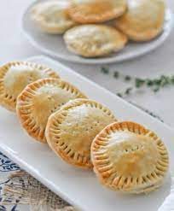**Beef Patties** – the dough is made from scratch with flour, water, butter, shortening, some might put of pinch of salt.

Beef filing – ground beef seasoned with lots of fresh seasonings such as onion, garlic, scallions, parsley, thyme, seasoned peppers and sweet peppers along with black pepper and adobe.

**Chicken Patties** – the dough is made from scratch with flour, water, butter, shortening, some might add a pinch of salt.

Chicken filing – chicken breast stripped and seasoned with lots of fresh seasonings such as onion, garlic, scallions, parsley, thyme, seasoned peppers and sweet peppers along with black pepper and adobe.

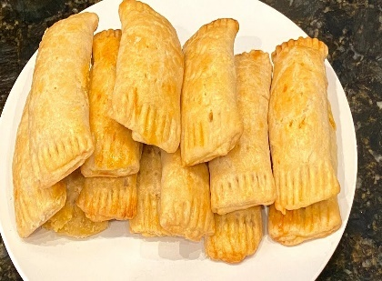**Cheese Rolls** – the dough is made from scratch with flour, water, butter, shortening, pinch of salt, turmeric, curry powder.

Cheese filing – grated sharp cheddar seasoned with parsley, seasoned peppers, onion and mustard mixed well.

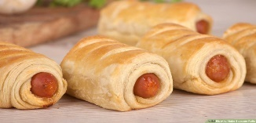**Sausage Roll** - the dough is made from scratch with flour, water, butter, shortening, some might put of pinch of salt.

Filing – chicken or beef franks.

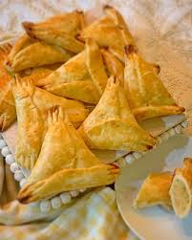**Pinetarts**  - the dough is made from scratch with flour, water, butter, shortening, some might add a pinch of salt.

Tart filing – pineapple, water, sugar.

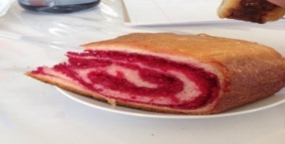**Salara/ Red roll**

Bread dough – flour, butter, pinch of salt, water, yeast.

Filling – freshly grated coconut, sugar, a little red coloring.

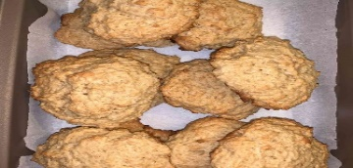**Coconut Buns -** Bread dough mixed with freshly grated coconut and spices.

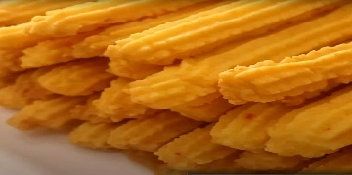**Cheese Straw -** Grated cheddar cheese mixed with flour, mustard, butter, garlic and pepper.

**Bread Pudding**

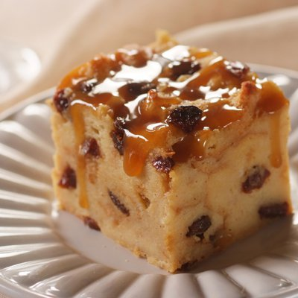Bread mixed with milk, sugar, grated nutmeg, cinnamon, essence, raisins/or without.

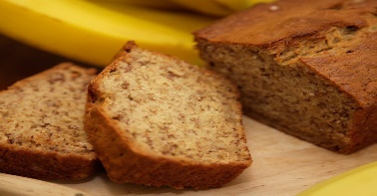**Banana Bread -** A combination banana, flour, spices, essence, baking soda, baking powder.

**Bread** – plait bread, loaf bread, tennis rolls

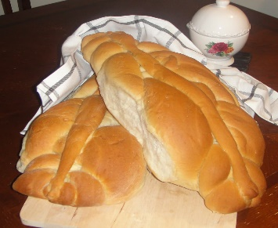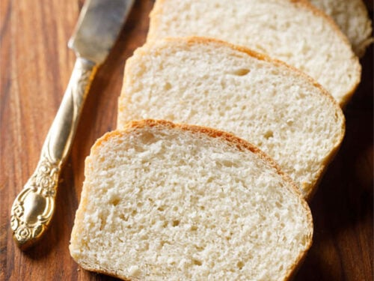 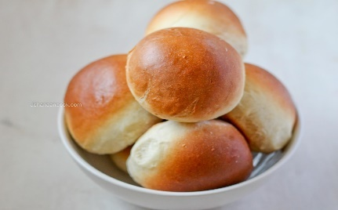

**Navigation Tree Diagram**

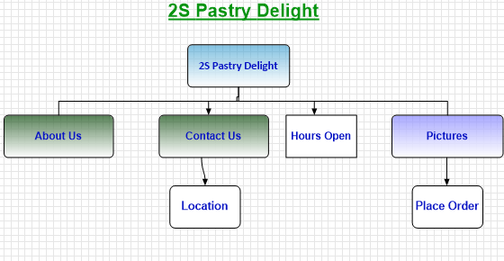

When visiting the website, one would be able to navigate through the various links. **About Us** gives a brief description as to how we got started and the love for pastries. Our **Contact Information** will be available for person to find out more about us, location and other information if needed. Our two **Locations** will be available for individuals would prefer to visit us that way they our **Hours of Open** will indicate. We offer a variety of pastries and breads, navigating through the **Pictures** will show just what we offer and prices which will make it easy to **Place your Order** for delivery.

**User Interface**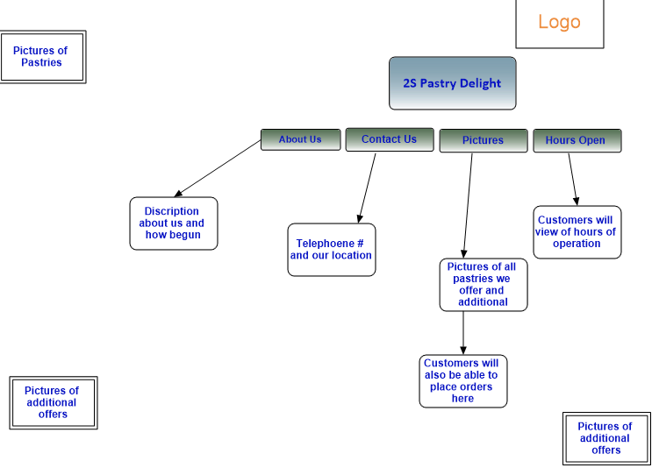

The above diagram describes a User Interface of 2S Pastry Delight. The Logo is placed to the top right-hand corner When customer clicks on any click provided it will navigate to the appropriate page with descriptions of each.

**Reference**

The Restaurant Times. (2022, December 24). *9 steps to improving your restaurant online food delivery sales*. The Restaurant Times. Retrieved March 3, 2023, from <https://www.posist.com/restaurant-times/restro-gyaan/optimize-restaurant-delivery-orders.html>

The Restaurant Times. (2022, December 24). *9 steps to improving your restaurant online food delivery sales*. The Restaurant Times. Retrieved March 3, 2023, from <https://www.posist.com/restaurant-times/restro-gyaan/optimize-restaurant-delivery-orders.html>

Wikimedia Foundation. (2022, December 22). *Pastry*. Wikipedia. Retrieved March 3, 2023, from <https://en.wikipedia.org/wiki/Pastry>