Unit Testing, TDD Implementation and Coverage Report

1. Introduction
This report demonstrates the implementation of Unit Testing, Test-Driven Development (TDD), and Code Coverage using a Student Grade Management module.

2. Objectives
- Understand Unit Testing
- Apply Test-Driven Development (TDD)
- Generate and analyze Code Coverage report

3. Project Description
The system calculates student averages, assigns grades, and determines pass/fail status.

4. TDD Phases Demonstration

4.1 RED Phase (Failing Tests)

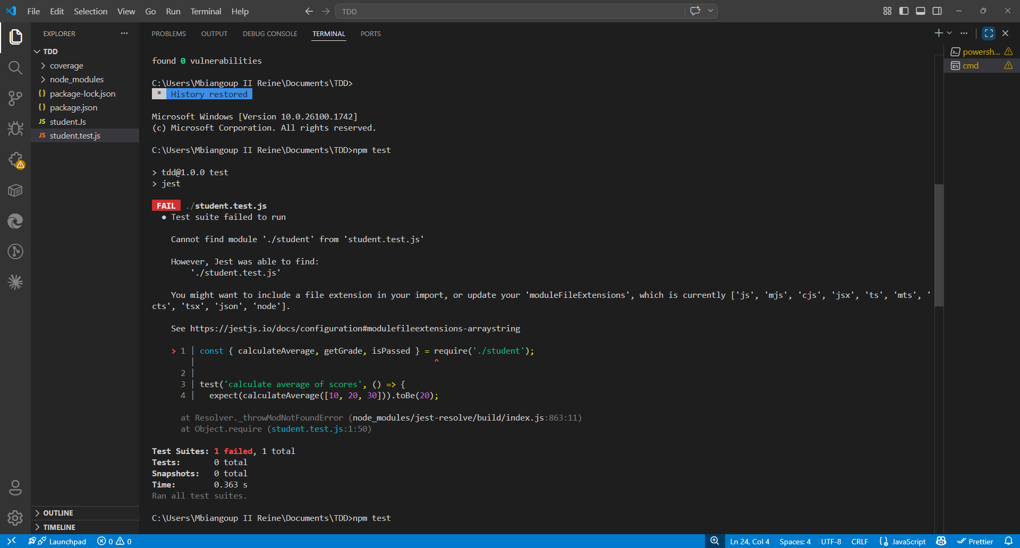
Explanation:
Tests were written before implementation and initially failed.

4.2 GREEN Phase (Passing Tests)

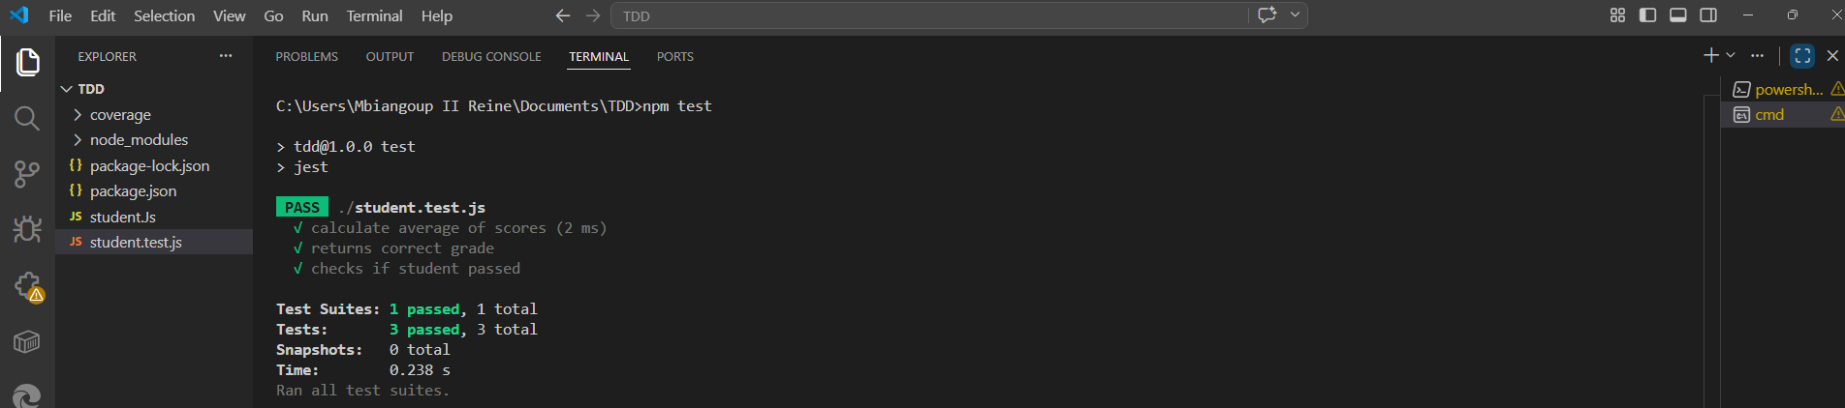
Explanation:
Functions were implemented to satisfy the test cases.

4.3 REFACTOR Phase

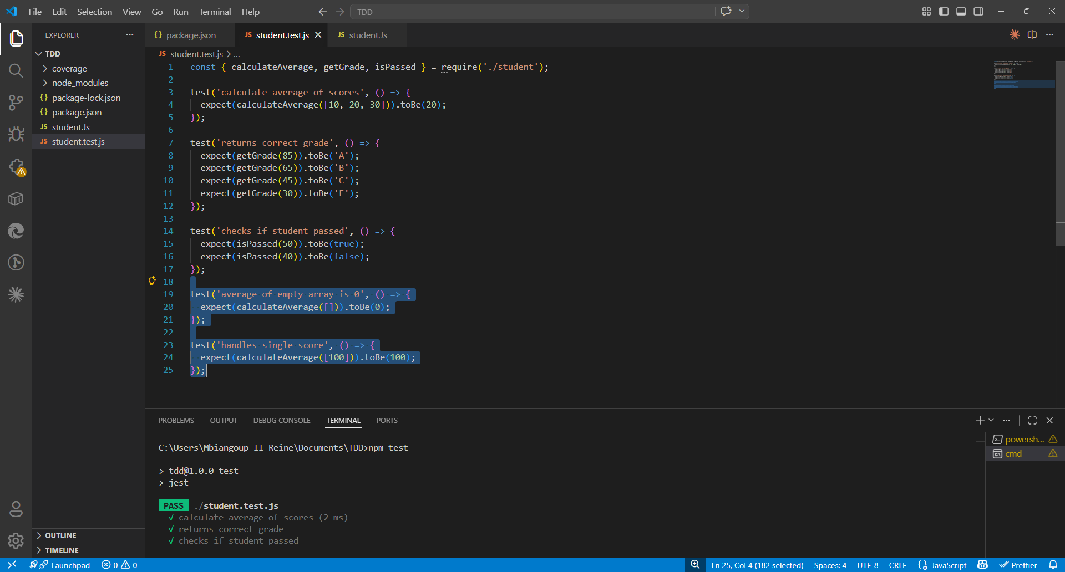
Explanation:
Code was improved without breaking existing tests.

5. Sample Code

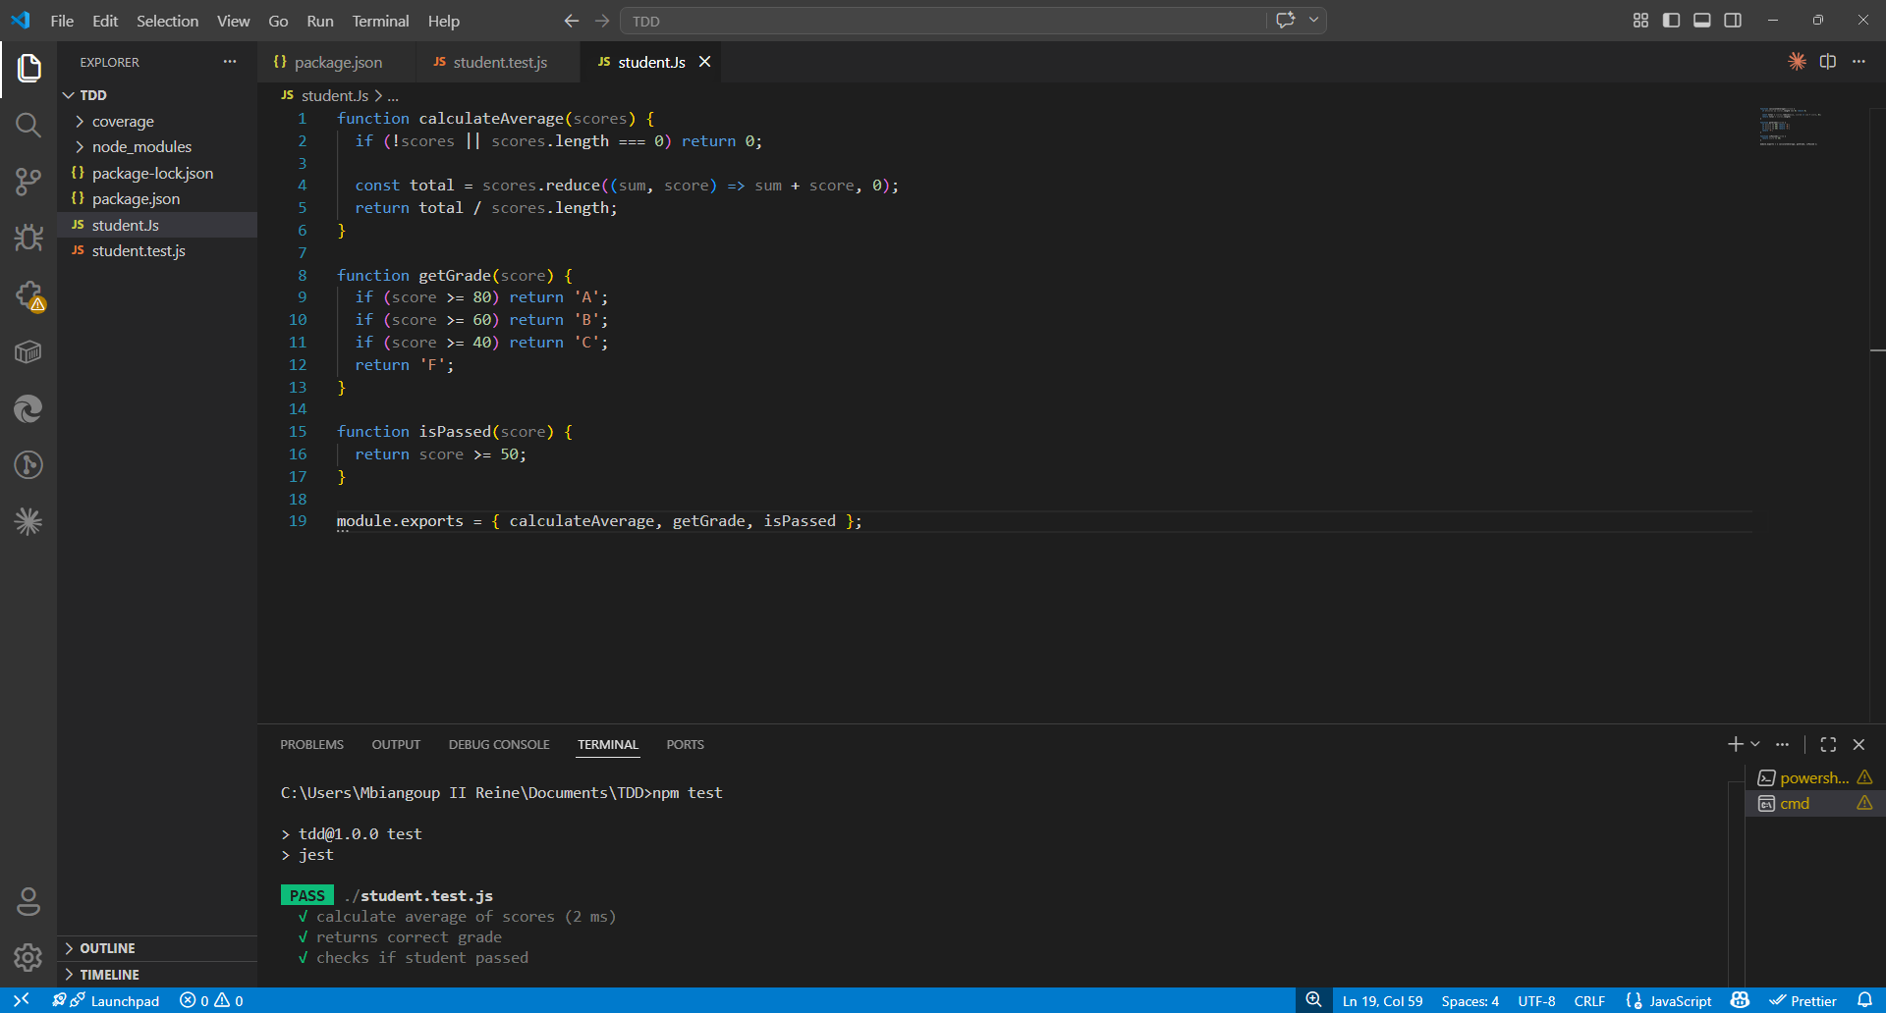

6. Code Coverage
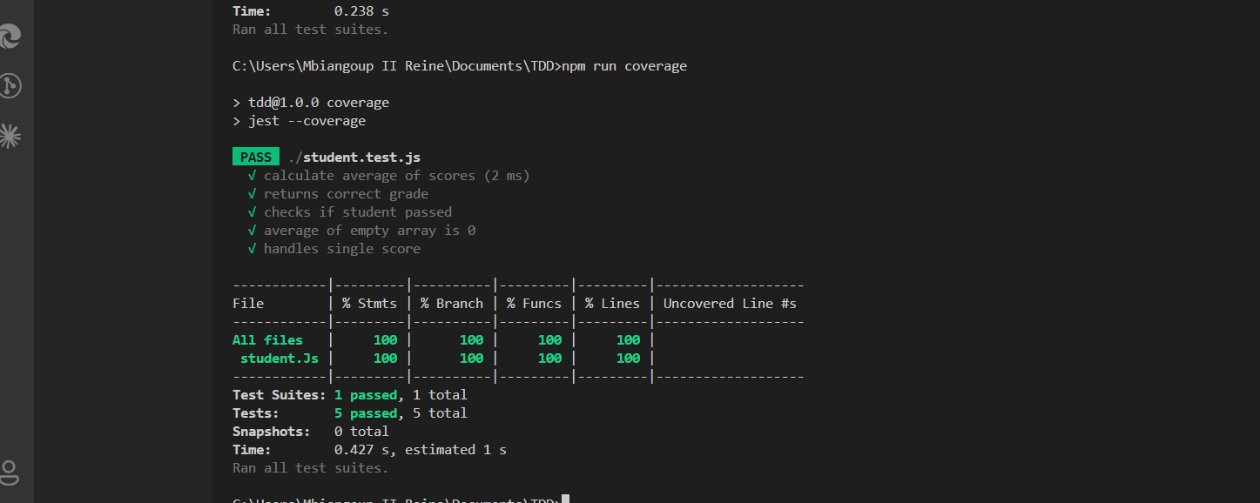
Explanation:
Coverage report shows percentage of tested code.

7. Conclusion
TDD improves code reliability and ensures all functionalities are tested before deployment.

