EX 9: Mini Project

Breast Cancer detection using Deep Learning

Problem statement:

Invasive Ductal Carcinoma (IDC) is the most common subtype of all breast cancers. To assign an aggressiveness grade to a whole mount sample, pathologists typically focus on the regions which contain the IDC. As a result, one of the common pre-processing steps for automatic aggressiveness grading is to delineate the exact regions of IDC inside of a whole mount slide.

Accurately identifying and categorizing breast cancer subtypes is an important clinical task, and automated methods can be used to save time and reduce error.

Abstract:

This project explores the application of Deep Learning techniques in the classification of breast cancer using histopathological images. Breast cancer is a prevalent and life-threatening disease, and early and accurate detection is crucial for effective treatment. Histopathological images provide detailed cellular information, making them an ideal candidate for analysis using advanced machine learning methods.

The primary objective of this project is to develop a Deep Learning model capable of accurately distinguishing between benign and malignant breast cancer tissue from digitized histopathological images. Leveraging convolutional neural networks (CNNs), specifically tailored architectures are constructed and trained on a dataset comprising a substantial collection of annotated breast tissue images.

The methodology involves data preprocessing, including image augmentation and normalization, to enhance the model's robustness. Various CNN architectures, including state-of-the-art models like ResNet, Inception, and DenseNet, are explored and fine-tuned to achieve optimal performance.

Preliminary results indicate promising performance in accurately classifying breast cancer tissues, showcasing the potential of Deep Learning in aiding medical professionals with more precise diagnostics. The implications of this work extend to assisting in early detection, thereby potentially improving patient outcomes and reducing healthcare burdens.

Dataset used:

Image dataset

The original dataset consisted of 162 whole mount slide images of Breast Cancer (BCa) specimens scanned at 40x. From that, 277,524 patches of size 50 x 50 were extracted (198,738 IDC negative and 78,786 IDC positive). Each patch’s file name is of the format: u_xX_yY_classC.png — > example 10253_idx5_x1351_y1101_class0.png . Where u is the patient ID (10253_idx5), X is the x-coordinate of where this patch was cropped from, Y is the y-coordinate of where this patch was cropped from, and C indicates.

(23 X 7 columns)

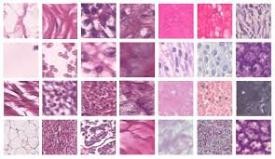

Implementation:

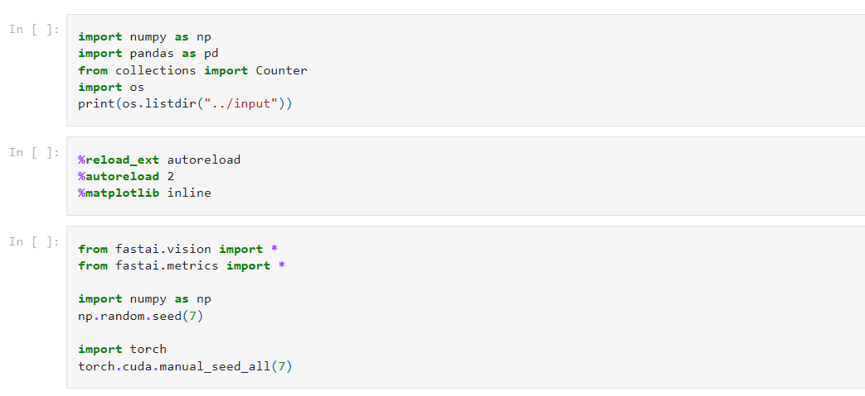

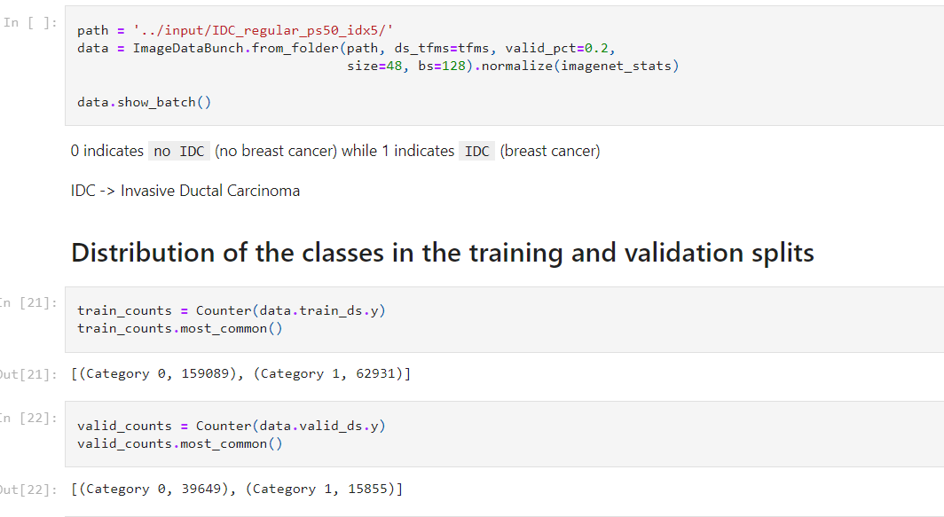

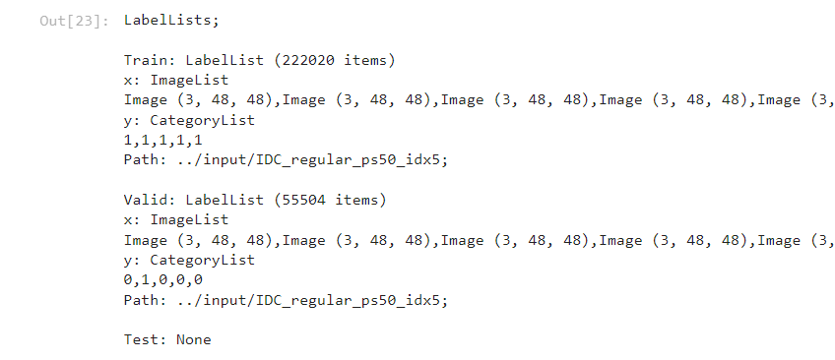

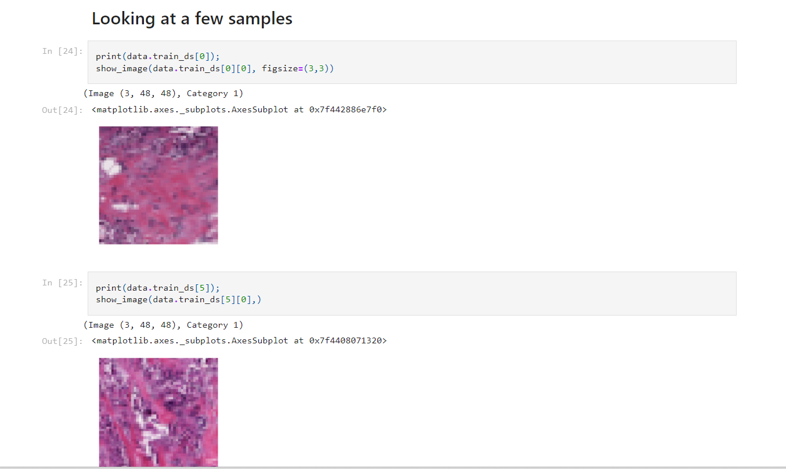

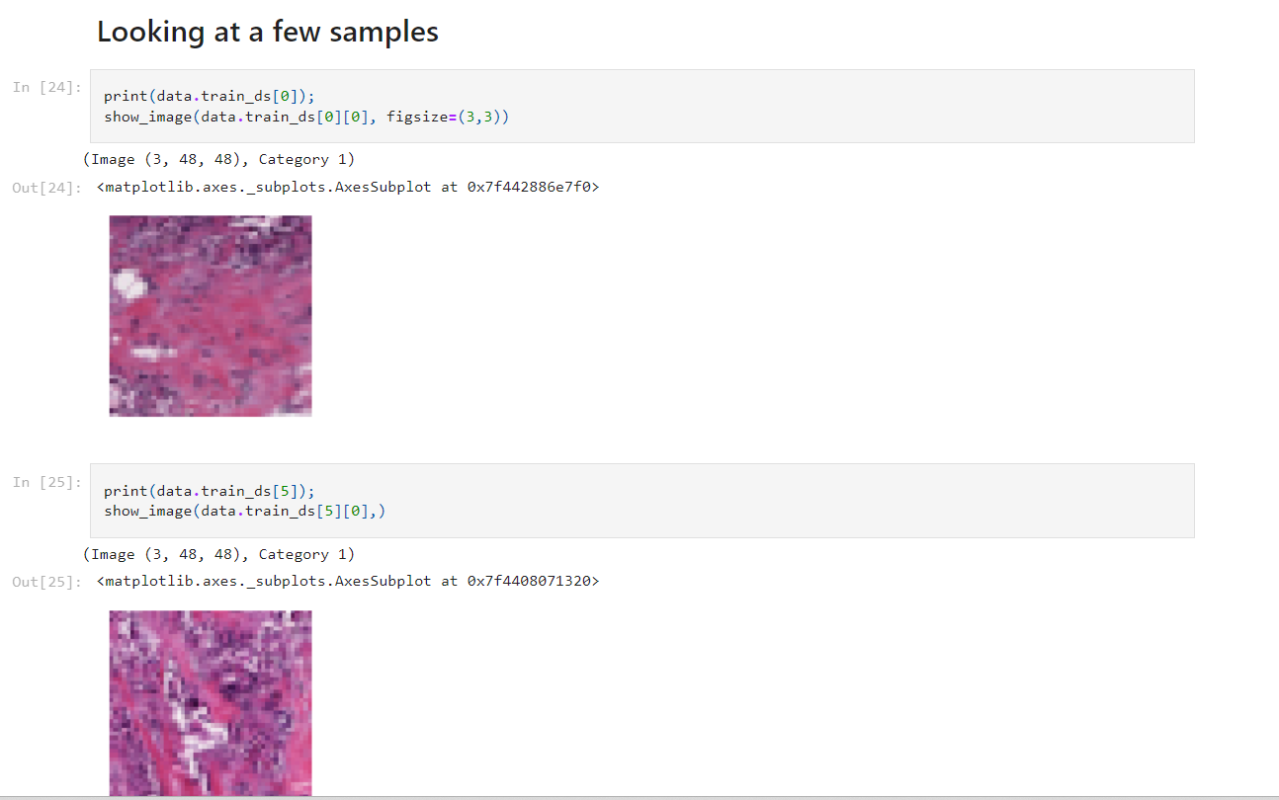

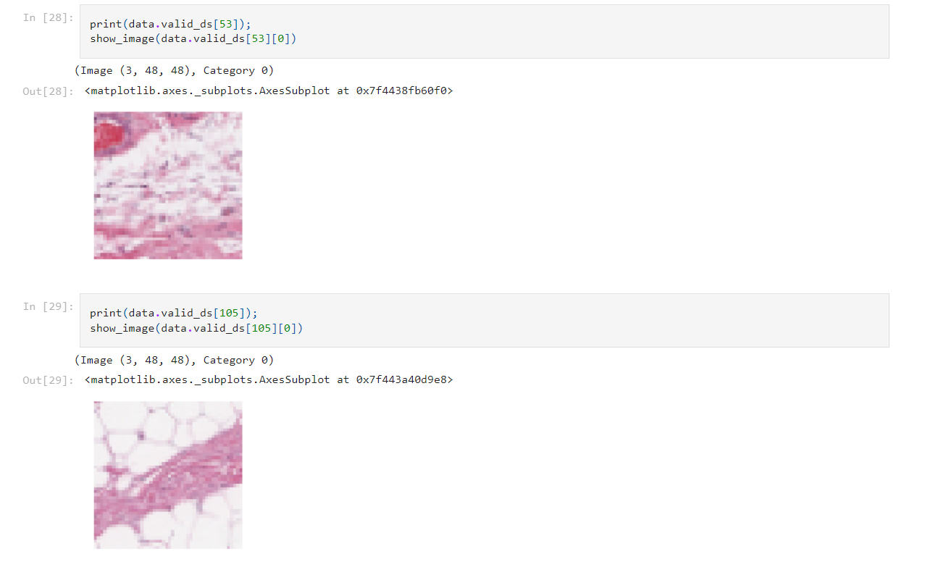

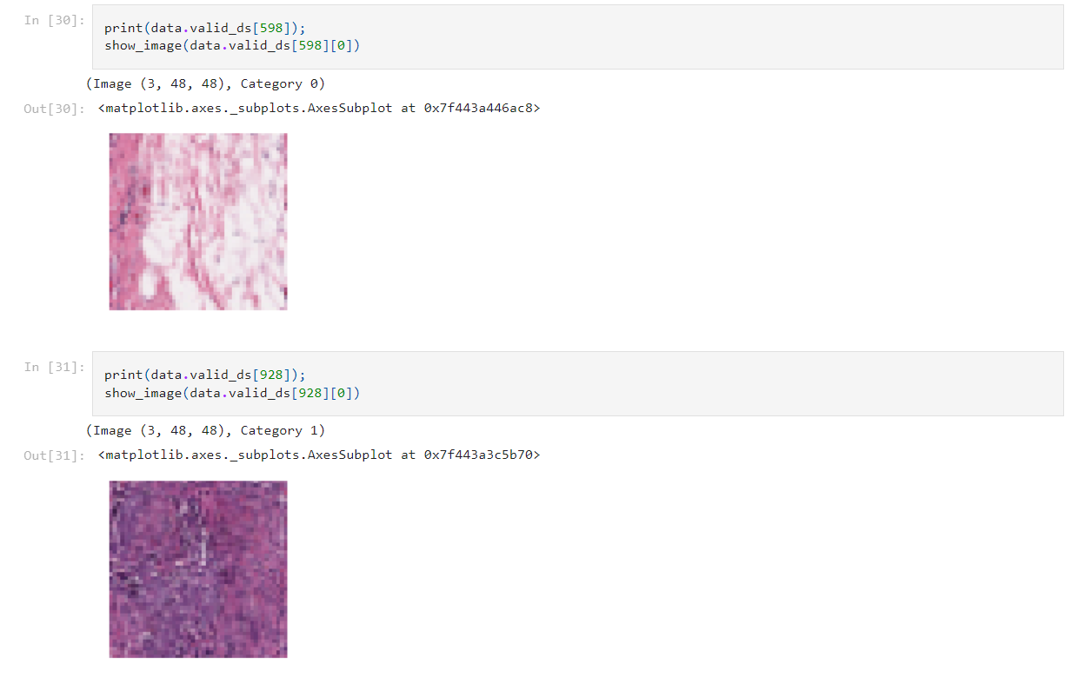

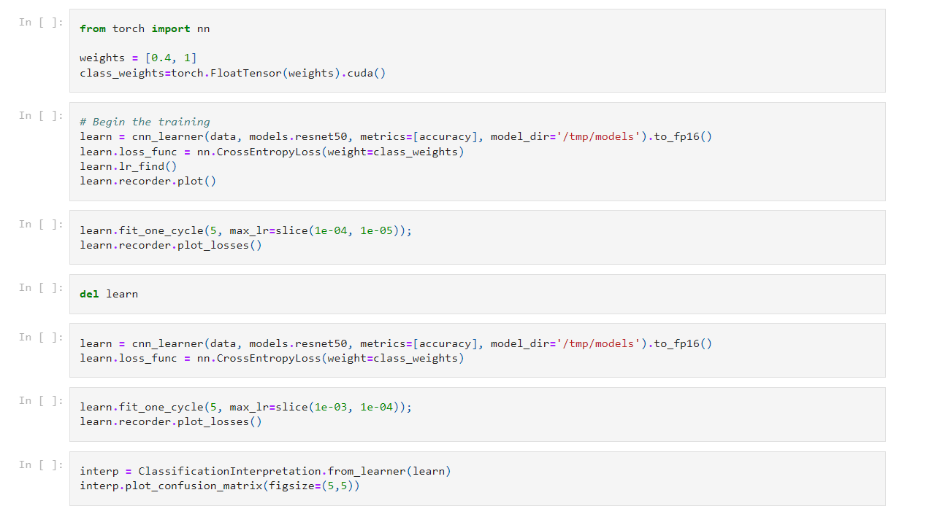

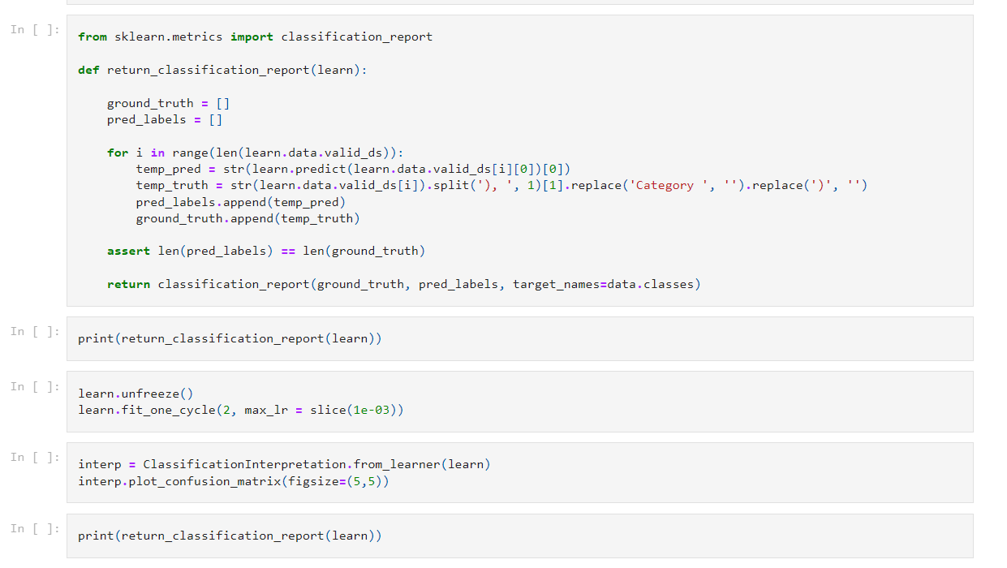

Conclusion:

In conclusion, this project has demonstrated the potential and efficacy of Deep Learning methodologies in the critical domain of breast cancer classification using histopathological images. Leveraging advanced convolutional neural networks (CNNs) and a comprehensive dataset, this study aimed to create a robust model for distinguishing between benign and malignant breast tissue.

The implications of this project extend beyond the realm of Deep Learning research. The developed model holds promise as a supporting tool for medical professionals, aiding in the early and accurate detection of breast cancer. By assisting in precise diagnostics, this technology could potentially improve patient outcomes, reduce misdiagnosis rates, and contribute to optimizing healthcare resources.

Collaboration with medical experts and the integration of diverse data modalities could amplify the model's accuracy and applicability in real-world clinical settings. Moreover, ongoing efforts to enhance model interpretability and ethical deployment remain pivotal for the responsible utilization of AI in healthcare.