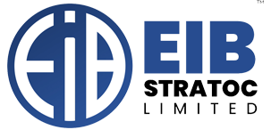 | EIB STRATOC LIMITED  STUDENT INDUSTRIAL WORK EXPERIENCE SCHEME (SIWES)  END-OF-ATTACHMENT EMPLOYER'S EVALUATION & CLEARANCE REPORT  CONFIDENTIAL INDUSTRY-BASED SUPERVISOR'S ASSESSMENT FORM
━━━━━━━━━━━━━━━━━━━━━━━━━━━━━━━━━━━━━━━━━━━━━━━━━━━━━━━━━━━━━━
SECTION A: TRAINEE & ATTACHMENT PROFILE
Student Full Name: | [Student Name] | Matriculation No: | [Matric No]
Institution: | [University / Polytechnic] | Faculty / School: | [Faculty of Science/Eng.]
Department / Course: | [e.g. Computer Science] | Level / Year of Study: | 400 Level (Undergraduate)
Attachment Period: | 14-Apr-2026 to 09-Oct-2026 | Assigned Division: | Operations & Technology
SECTION B: PERFORMANCE APPRAISAL MATRIX (RATING: 1 - 5)
S/N | Performance Evaluation Criterion | Score (Max 10) | Rating | Remarks
1 | Punctuality, Regularity & Attendance Record | 10 / 10 | Excellent | Always on time
2 | Technical Competence & Application of Knowledge | 9 / 10 | Very Good | Quick learner
3 | Quality of Work, Accuracy & Attention to Detail | 9 / 10 | Very Good | Thorough & neat
4 | Initiative, Problem Solving & Creativity | 9 / 10 | Very Good | Proactive attitude
5 | Interpersonal Relationships & Team Collaboration | 10 / 10 | Excellent | Harmonious team player
6 | Compliance with Company Rules & Safety Standards | 10 / 10 | Excellent | Zero infraction
7 | Logbook Documentation & Report Presentation | 9 / 10 | Very Good | Well structured
SECTION C: OVERALL RATING & SUPERVISOR'S RECOMMENDATIONS
Industry Supervisor's Qualitative Remarks:  The trainee showed remarkable dedication, technical curiosity, and professionalism throughout the 6-month internship attachment. He completed all assigned tasks on schedule, worked well with the operations crew, and demonstrated strong leadership potential. Highly commended. | TOTAL AGGREGATE SCORE  66 / 70 (94.3%)  GRADE: EXCELLENT (DISTINCTION)
Industry Supervisor / HR Clearance:  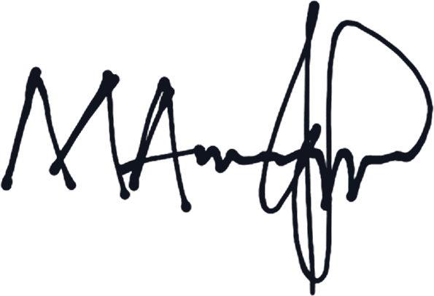  Marquis  Head of Human Resources & Talent Development  EIB Stratoc Limited (EIB Group) | 