 | EIB STRATOC LIMITED  EIB & SAC FACILITY, OFF UNIGAZ, Idu Industrial Area  Abuja, Nigeria  Tel: +234 (0) 900 000 0000  Website: www.eibstratoc.com
━━━━━━━━━━━━━━━━━━━━━━━━━━━━━━━━━━━━━━━━━━━━━━━━━━━━━━━━━━
REF: EIB/HR/2026/042 Date: 12th October, 2026
The Industrial Training Coordinator,
Department of EIE COMPUTER ENGINEERING,
Covenant University,
Ota, Ogun State, Nigeria.
Dear Sir/Madam,
LETTER OF COMPLETION OF INTERNSHIP
RE: ADEMUWAGUN OLUWATIMILEHIN SAMUEL | MATRIC NO: 23CJ03334
This is to formally certify that ADEMUWAGUN OLUWATIMILEHIN SAMUEL, a student of the Department of Computer Engineering, EIE COMPUTER ENGINEERING, Covenant University, with Matriculation Number 23CJ03334, has successfully completed his mandatory 10 weeks internship attachment with EIB STRATOC LIMITED, commencing from 27th July, 2026 to 2nd October, 2026.
During his attachment period, he was deployed to our Research and Analysis Wing. Throughout this tenure, he was thoroughly engaged in hands-on industry workflows, software systems operations, troubleshooting, network diagnostic evaluations, and collaborative client support. He exhibited an exemplary aptitude for rapidly absorbing complex operational guidelines and translating technical theory into high-impact practical solutions.
Throughout his stay at EIB Stratoc Limited, ADEMUWAGUN conducted himself with the highest degree of professionalism, diligence, integrity, and discipline. He was consistently punctual, embraced workplace responsibilities proactively, harmonized well with team colleagues and senior staff, and complied strictly with all corporate and occupational safety standards.
Having met and satisfied all required departmental deliverables and performance standards, he has been officially cleared of all organizational obligations. We hereby commend his exceptional performance and unreservedly recommend him for academic assessment, logbook defense, and future professional pursuits.
Yours faithfully,
For: EIB STRATOC LIMITED
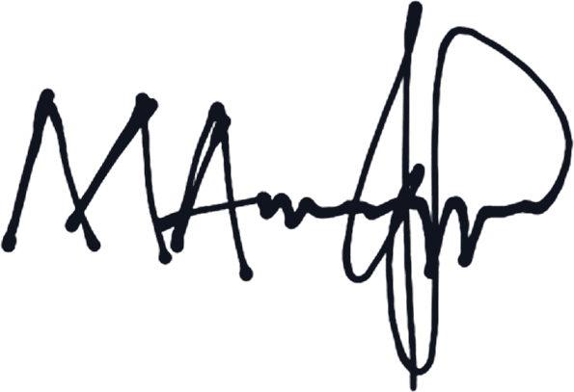  Michael Marquis  Group Head, Training & HRM (DICO)  EIB Stratoc Limited (EIB Group)  Email: hmichael.marquis@eibgroup.com | 