

Student Name | Nguyen Ngoc Qui
Local Student ID | GCS230163
GreenWich ID | 001419354
Module | COMP 1551 –  Application Development
Class | COS1205
Academic Year | 2024-2025
Article Title | Desktop Information System
Due Date | December 4, 2025
Submission Date | December 3,2025
Word Count | 1,860

I. PART 1 – SYSTEM ANALYSIS AND SPECIFICATION 3
1. System Description 3
2. Software Requirements Specification 3
2.1. Introduction 3
2.1.2. Project Scope 3
2.2. Overall Description 4
2.2.1. Product 4
2.2.2. Users 4
2.2.3. Operational Environment 4
2.3. System Features 4
2.3.1. Description 4
2.3.2. Functional Requirements 4
2.4. User Interface Requirements 4
2.5. Platform Requirements 5
2.6. Quality Attributes 5
2.6.1. Performance 5
2.6.2. Security 5
2.6.3. Safety 5
II. PART 2 – SYSTEMS DESIGN 5
1. UML Class Diagram 5
2. UML Use Case 6
2.1. Use Case 1 — Add New Record 7
2.2. Use Case 2 — View All Records 8
2.3. Use Case 3 — View Records by Category 9
2.4. Use Case 4 — Edit Record 10
2.5. Use Case 5 — Delete Record 11
III. PART 3 - Desktop Information System 12

- PART 1 – SYSTEM ANALYSIS AND SPECIFICATION
  - System Description
The education centre intends to move away from its existing paper-based method of storing personal information and introduce a straightforward desktop application that staff can operate on Windows computers. This application will maintain details for three groups of people: teachers, administrative employees and students. Each individual will have basic contact information recorded, including their full name, phone number, email address and their role within the centre.
Beyond these shared details, the system will also capture information unique to each group. Teachers will have their salary and the two subjects they teach stored. Administrative staff will have their salary recorded along with their employment type (full-time or part-time) and the number of hours they work per week. Students will have the names of the three subjects they study saved in the system.
Staff members using the program will be able to add new entries when a person joins the centre, edit existing information when changes occur, or remove a record when someone leaves. They will also be able to display all records or filter the list by role to show only teachers, admins or students. The application is intended for use on ordinary desktop or laptop computers within the centre and does not require internet access or a database server. All data will be stored in memory during runtime, giving the centre a cleaner and more reliable way to manage information compared with their current paper files.
  - Software Requirements Specification
    - Introduction
      - Purpose
This part explains why the Desktop Information System is being described in the first place. Instead of going into technical details, it provides an overview of what the system is meant to do and the types of information it will handle. It also sets some basic expectations so everyone involved, whether they build it or review it, understands the same goals and knows what the finished system should deliver in general.
      - Project Scope
The project aims to create a small C# console program that runs independently, with no additional services or online features. The system stores information about three groups at an education centre: teachers, administrative employees, and students. Every entry includes general personal details, and each group has a few unique fields, such as salary, subjects or working hours. The program lets the user add new records, view existing ones, change details, or delete them. All information stays in memory only while the program is running, since no database or external file is used.
    - Overall Description
      - Product
The system is basically a text menu where the user chooses what to do. It replaces the old method of writing everything on paper and helps keep the information more organised. The application runs entirely on its own and does not require connecting to other software or storage.
      - Users
There are no accounts, passwords or roles in this version. Anyone who opens the console can use every feature. In this document, the word “user” refers to the person typing commands and managing the records.
      - Operational Environment
• Operating System: Windows 10 or above
• Platform: .NET 9 SDK
• Hardware: Standard desktop CPU, keyboard and display
• No networking or database requirements
• Console terminal required for interaction
    - System Features
      - Description
The system supports essential record-management tasks for administrative use.
      - Functional Requirements
FR1 – Add Teacher, Admin Staff or Student records with full details.
FR2 – View all existing records.
FR3 – Filter records by role.
FR4 – Edit any existing record.
FR5 – Delete selected records with confirmation.
    - User Interface Requirements
The interface provides a clear text-based menu. Users choose actions through numeric input, and the system displays prompts, errors and confirmations to guide correct operation.
    - Platform Requirements
Developed in C#, the system runs as a console application on Windows with .NET runtime. No extra installations or network features are required.
    - Quality Attributes
      - Performance
The system responds instantly and supports any number of in-memory records.
      - Security
Input validation prevents incorrect or inconsistent data.
      - Safety
The system confirms deletions, handles errors and prevents unexpected termination.
- PART 2 – SYSTEMS DESIGN
  - UML Class Diagram
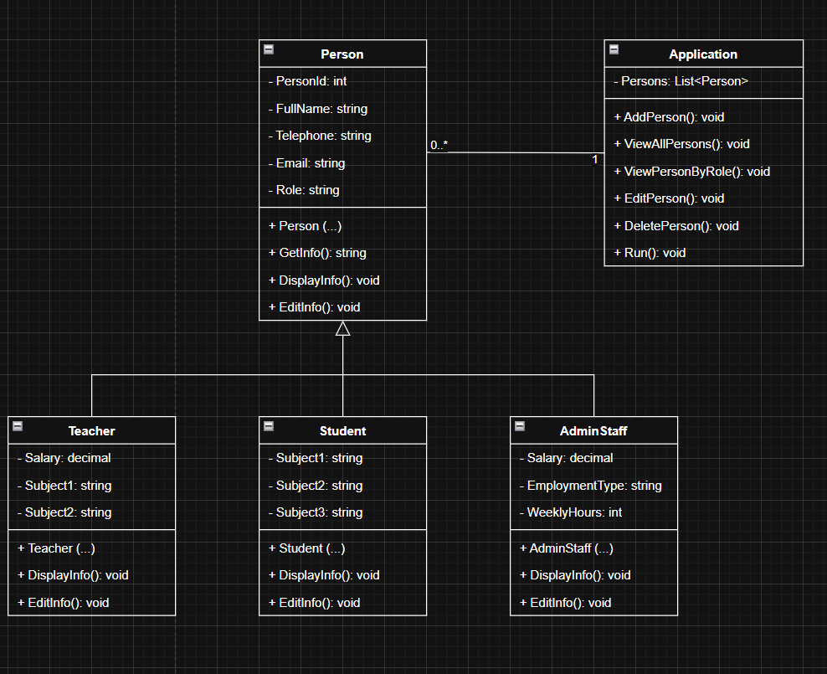
The class diagram in Figure X presents the overall structure of the Desktop Information System using an object-oriented approach. At the centre of the design is the abstract Person class, which stores attributes common to all records, such as PersonId, FullName, Telephone, Email, and Role. By placing these shared fields in one location, the system avoids duplication and ensures consistency. The class also defines the key methods used across the system GetInfo(), DisplayInfo(), and EditInfo() while its construction initialises the core information when a new person is created.
From this base class, three specialised subclasses are derived. A Teacher record includes a salary and the two subjects taught; a Student record contains three enrolled subjects; and an AdminStaff record stores salary details, employment type and weekly working hours. Each subclass provides its own constructor and redefines the DisplayInfo() and EditInfo() methods to fit the needs of each role. This use of overriding demonstrates polymorphism, allowing the system to call the same method name while producing different outputs depending on the object type.
The Application class operates as the central controller. It maintains a List<Person> that holds all records currently in the system. This is an aggregation relationship: the list contains many Person objects, but those objects are not tied to the existence of the Application class itself. The Application class also implements all core features required by users, including adding, viewing, filtering, editing and deleting records, as well as the Run() method that drives the menu interface. These operations match the system’s functional requirements.
Taken together, the class diagram shows a straightforward application of core principles in object-oriented design. Encapsulation is achieved through the separation of data and methods within each class. Inheritance forms the basis of the Person hierarchy, and polymorphism allows each subclass to customise shared behaviours. Aggregation is shown through the Application class, which manages the collection of Person objects. Because of this structure, the system is straightforward to extend, easy to maintain and logically organised for future development.
  - UML Use Case
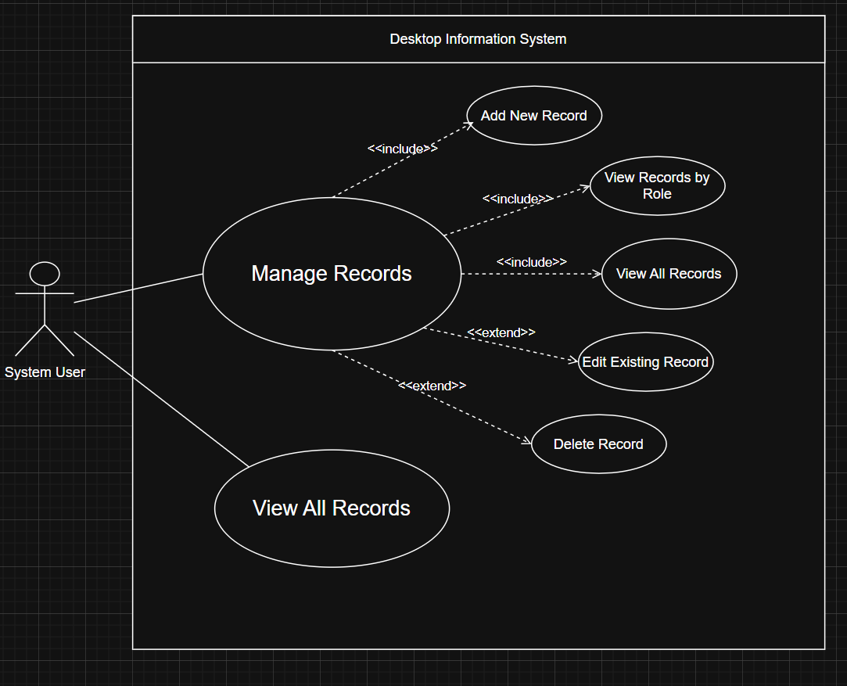
    - Use Case 1 — Add New Record
Use Case ID | UC01
Name | Add New Record
Actor | System User
Flowing events | - System User selects “Manage Records” from the main menu.  - System displays the record management options, including “Add New Record”.  - System User chooses “Add New Record”.  - System prompts for the category of records (Teacher / Student / AdminStaff).  - System User selects a category.  - System requests common personal details (ID, full name, telephone, email).  - System requests category-specific details depending on the chosen role.  - System User enters all required information.  - System validates the input.  - System creates and stores the new Person object in the internal list.  - System displays a confirmation message.
Preconditions | Desktop Information System is running, and the main menu is displayed.
Postconditions | A new record is added successfully to the in-memory Persons: List<Person> collection.
Exceptions | E1 – Invalid Input: Missing or invalid data is detected. System prompts the System User to correct and re-enter the information.  E2 – Operation Cancelled: System User cancels the process before completion. No new record is created.

    - Use Case 2 — View All Records
Use Case ID | UC02
Name | View All Records
Actor | System User
Flowing events | - System User selects either “View All Records” from the main menu or chooses this option inside “Manage Records”.  - System retrieves all Person objects from the internal list.  - System displays the full details of each record, grouped or listed in a readable format.
Preconditions | Desktop Information System is running.  At least zero or more records may exist in the system.
Postconditions | System User can see a complete overview of all stored records.
Exceptions | E1 – No Records Available: If the list is empty, the system displays an informative message such as “No records available” instead of an empty table.

    - Use Case 3 — View Records by Category
Use Case ID | UC03
Name | View Records by Category
Actor | System User
Flowing events | - System User selects “Manage Records” from the main menu.  - System displays the record management options, including “View Records by Role”.  - System User chooses “View Records by Role”.  - System prompts the System User to choose a role (Teacher / Student / AdminStaff).  - System User selects the desired role.  - System filters the internal list and retrieves only records that match the selected role.  - System displays the filtered records with full details.
Preconditions | System is running.
Postconditions | Only records whose Role attribute matches the selected category are displayed to the System User.
Exceptions | E1 – Empty Role: No records exist for the selected role. System displays an appropriate message and returns to the management menu.

    - Use Case 4 — Edit Record
Use Case ID | UC04
Name | Edit Existing Record
Actor | System User
Flowing events | - System User selects “Manage Records” from the main menu.  - System displays the management options and System User chooses “Edit Existing Record”.  - System prompts for the ID of the record to edit or display a list of records for selection.  - System User selects the record by entering its ID or choosing it from the list.  - System retrieves and shows the current details of the selected record.  - System User enters updated values for one or more fields (common or category-specific).  - System validates the modified information.  - System saves the changes to the Person object.  - System displays a confirmation message indicating that the record has been updated.
Preconditions | At least one record exists in the system.
Postconditions | The selected record is updated with the new values provided by the System User.
Exceptions | E1 – Invalid ID: The entered ID does not match any record. System reports errors and asks for a new ID or allows the System User to cancel.  E2 – Invalid Updated Data: One or more updated fields fail validation. System requests correction before saving.  E3 – Edit Cancelled: System User cancels the operation. No changes are applied.

    - Use Case 5 — Delete Record
Use Case ID | UC05
Name | Delete Record
Actor | System User
Flowing events | - System User selects “Manage Records” from the main menu.  - System displays management options, and the System User chooses “Delete Record”.  - System prompts for the ID of the record to delete or display a list of records.  - System User selects the record to remove.  - System shows the details of the selected record and asks for confirmation.  - System User confirms the deletion.  - System removes the corresponding Person object from the internal list.  - System displays a success message and returns to the management menu.
Preconditions | At least one record exists in the internal list.
Postconditions | The selected record is permanently removed from the system.
Exceptions | E1 – Invalid ID: The specified ID does not correspond to any existing record. System notifies the System User and requests a new ID or cancellation.  E2 – Deletion Cancelled: System User chooses not to confirm the deletion. The record remains unchanged in the system.

- PART 3 - Desktop Information System
quinngcs230163/COMP-1551: Part 3 of Coursework

